An evaluation of the Crymlyn Burrows Management Plan
Alex Dunstan 2304994
GIS and Habitat Management
University of Wales Trinity St David

Contents
1.0 Introduction 3
2.0 Site description 4
2.1 Land degradation 4
2.2 Geology 5
2.3 Soil 6
2.4 Habitats 7
2.41 Woodland 7
2.42 Dunes 8
2.43 Grassland 8
2.44 Marshes 8
2.5 Wildlife 8
2.51 Mammals 8
2.52 Birds 9
2.53 Invertebrates 9
3.0 Current site management 10
3.1 Gorse 10
3.2 Trees 11
3.3 Access 12
3.4 Flooding 13
3.5 Invasive vegetation 14
4.0 Future recommendations 15
4.1 Natural Flood management 15
4.2 Invasive species control 16
4.3 Reintroduction 16
5.0 Conclusion 18

1.0 Introduction
Flooding has significant impact for dune systems in South Wales, which has implications for the dunes' surrounding environment and potentially coastal communities. Flood risk from the sea is currently an issue in Crymlyn Burrows SSSI, where the dunes that are situated along the coast can act as a natural barrier against coastal erosion and storms. This risk is likely to increase in future, as sea levels rise and weather becomes more unpredictable due to climate change. The consequences of flooding can be severe for the native vegetation and wildlife that occupy the site, by destroying habitats and causing the loss of biodiversity.
Geographic Information Systems (GIS) and habitat mapping allow for the identification of areas that are prone to flooding and sensitive habitat locations on a site like Crymlyn Burrows. This strategy has been emphasised by the Welsh Government to develop conservation and habitat restoration initiatives through mapping analysis (Welsh Government 2020). GIS can allow informed decisions to be made for the future, on how to deal with flood risk, invasive species control and native species reintroduction (Crampton, 2010). This report will provide an evaluation of current practices in Crymlyn Burrows by analysing its management plan from 2018-2024. It will also give recommendations on how Crymlyn Burrows can deal with the issues and challenges that are detailed in the management plan and maps constructed by the author. Implementing these recommendations allow the environment of Crymlyn Burrows to thrive in years to come, despite the challenges the site faces.

2.0 Site description
Crymlyn Burrows is marked as a SSSI (Site of Special Scientific Interest) meaning it is a protected area because of its biological interest
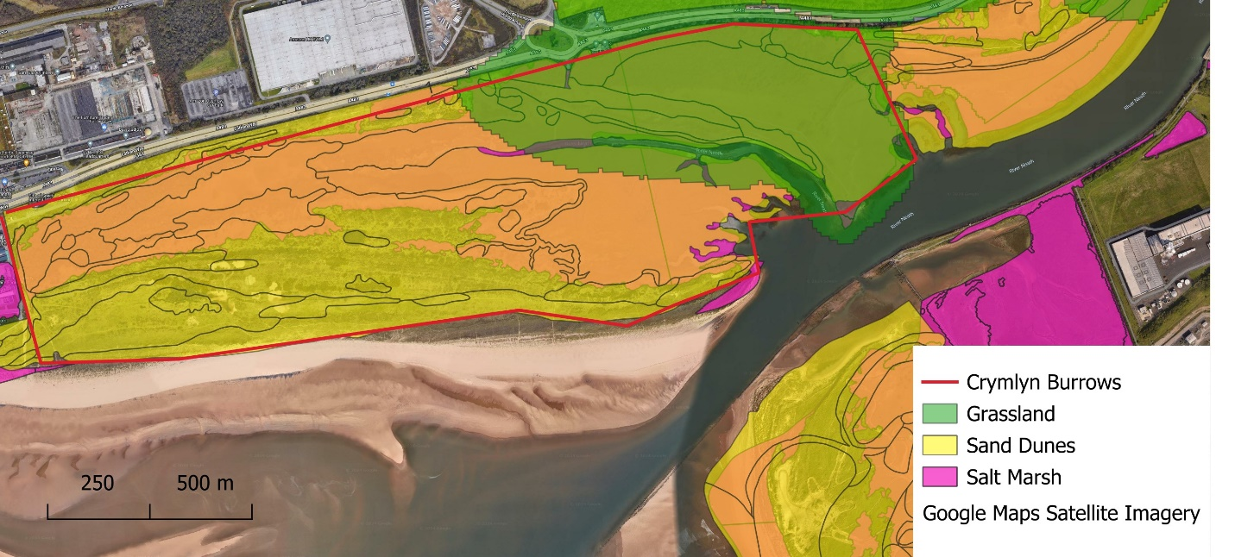
Figure 1 Compartments of Crymlyn Burrows
The site comprises 244ha of sand dunes, grassland, salt marshes and beach on part of Swansea Bay as seen in figure 1, the site is located between Swansea University Bay campus and the Neath River. Footfall on the site is limited to walkers (frequently with dogs), university students, cyclists and horse riders. Other than the University there are no nearby residential areas and access to the sites informal footpaths can be difficult to find without a purpose-built car park, resulting in low levels of footfall throughout the year. The site is currently owned by St Modwen, a housing development firm, who plan on retaining the site as a protected leisure destination, whilst the site is managed by Swansea University (Atkins, 2015).

2.1 Land degradation
The land on which the University Bay Campus was built was previously an oil storage facility for British Petroleum (BP). The land was heavily targeted by bombers during the second world war, which leaves the potential risk of unexploded ordnance on the site. Although Crymlyn Burrows never developed as an oil storage site, there are still active disused underground oil and chemical pipelines running from the East-West boundaries of the site. This leaves a significant risk when carrying out excavation or drilling on the site (MACC, 2017). This can become a potential issue in the future if the dunes were to be excavated for protection against coastal erosion and flooding, due to the safety risk which would require additional risk assessments and training. Unexploded bombs may result in soil contamination, which poses risks to the health of ecology on the site. Soil remediation may be necessary in order to mitigate and assess the risk of contamination. This is important in ensuring habitats on the site are sustainable for future development (Howard et al, 2012).

2.2 Geology

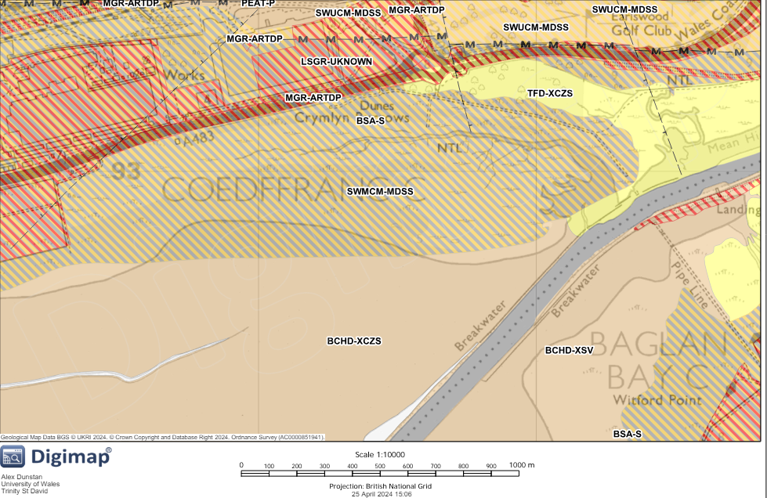
Figure 2 Geological overview of Crymlyn Burrows
Legend
BSA-S | Blown Sand
SWMCM-MDSS | South Wales Middle Coal Measures, Siltstone and Sandstones
TFD-XCZS | Tidal Flat Deposits Clay, Silt and Sand

Figure 2 shows the majority of the sand in Crymlyn Burrows is blown sand, meaning the site is vulnerable to storm surges and extreme weather conditions such as high winds. The Coal Measures suggest past terrestrial environments that have formed coal deposits, whilst the presence of Siltstone and Sandstone suggest deposition in the environment with different energy levels, suggesting a nearby marine setting. Tidal Flat Deposits that hold Clay, Silt and Sand suggest past marine environment that had fluctuating water levels. An understanding of the past geological history of the site can show how resilient the site is to changes from erosion, rising sea levels and storm surges (Tierney et al, 2020).
The sand dunes at Crymlyn Burrows are part of an estuarine complex that has remained as isolated sand dune. Crymlyn Burrows is located on Swansea Bay, backed by a coastal plain, it is further backed by rising hills inland, especially on the east near Port Talbot. A shallow bedrock basin which is infilled partially during the Pleistocene period by glacial, fluvioglacial and lacustrine sediments. The seabed is Devonian and Carbon Ferrous sandstones and mudstones, overlain by deposits of sand, gravel and mud (Price and Brooks, 1980).
The dunes at Crymlyn Burrows were formed from glacial sand deposited in the Irish sea when the ice sheets melted at the end of the late Devensian. The Bay is a shallow area with the inner bay being less than 10 metres, having a tidal range of 10.5 metres. Crymlyn Burrows is underlain by the South Wales Coal Measures of the Carboni Ferrous era, with the Pennant Sandstones to the north of the area (NRW, 2015).

2.3 Soil
Foredunes and mobile dunes, closest to the high water mark have the highest most alkaline PH and lowest humus content at less than 1% compared to most other dune soils. Whereas the scrub and woodland areas towards the North of the site have more acidic soils with a higher humus content at over 40%. The soil depth increases inland across the dune system whereas the calcium carbonate percentage decreases further inland. This can result in a wider range of vegetation growth further inland on the site as there is a greater nutrient distribution when there is greater soil depth. Pioneer plant species can grow in the shallower, less nutritious soils nearest to the beach and initiate dune stabilisation (Pye and Blott, 2014). The inland dune slacks have a higher moisture content due to the limited natural drainage outlets and a lack of vegetation compared to the further inland salt marshes and grassland. This makes the dune slacks more susceptible to flooding, especially during the winter months when there is higher amounts of rainfall or through high tides and storm surges that influence tidal fluctuations. The colour of the soil becomes darker further inland, as a result of organic matter from plant debris and roots accumulating which darkens the soil (NPT Council, 2012).

2.4 Habitats
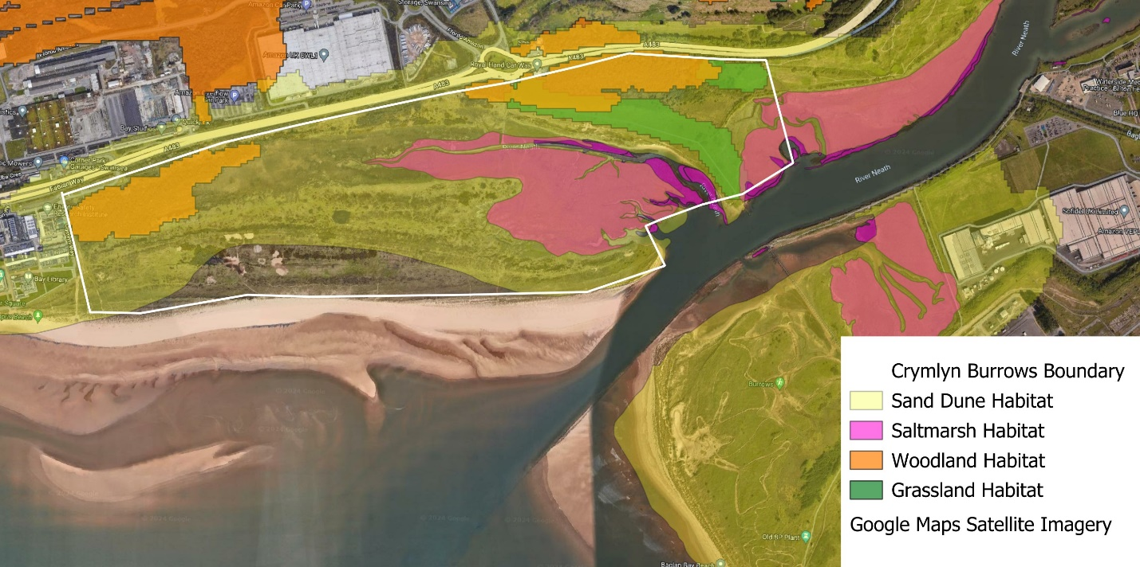
Figure 3 Distinct habitats at Crymlyn Burrows
Four distinct habitats can be found in Crymlyn Burrows as seen in figure 3, including sand dune habitat, grassland habitats, Saltmarsh habitat and woodland habitat. Figure 3 shows the spatial distribution of the habitats on the site and how the site has various habitats that support a unique set of flora and fauna. The site has changed significantly over time due to a lack of management through various ownership changes. This has led to the stabilisation of the dunes and succession towards woodland and scrub.

2.41 Woodland
The woodland on the site is predominately towards the north west (see figure 3) and supports a diversity of plant species and a diverse range of habitat structures which include mature trees, dense undergrowth and young saplings. This provides habitat for a wide range of wildlife including hedgehogs, nesting birds, bats and lichen. This provides soil stabilisation and nutrient cycling which play an important role in the ecological functioning of the site (Provoost et al, 2011).
There are current issues on the site regarding encroachment of non-native trees, including conifers and holm oak that have spread across the northern section of the site. This has been to the determinant of native vegetation, that have to compete for sunlight and has affected open-ground dependent birds such as skylarks which are commonly found in Crymlyn Burrows.

2.42 Dunes
The dunes on the site are highly dynamic, as a result of continuous sand movement which is transported by wind. The strandline and embryo dune habitats change continuously and can be completely absent at times, making it difficult for pioneer vegetation species such as sea stock to establish and thrive, especially during the winter months when storm surges are more frequent (Arens et al 2013). A lack of grazing on the site has led to the stabilisation of the dunes, although this can be beneficial in controlling erosion, it can also introduce non-native vegetation to the site and alter habitat conditions (Pye et al 2014). This is a current issue as invasive Japanese rose, Japanese knotweed and sea buckthorn have spread across the dunes and disrupted the natural process and native plants within the dunes. The widespread invasive plants have likely caused the disappearance of the native sea stock, which only has one flowering plant on the site as of 2023.

2.43 Grassland
The grassland provides important coastal protection for the site by binding soil together with their root system and can reduce water and wind erosion. Marram grass and gorse found in the grassland, help stabilise the sand through their extensive root systems and reduce the risk of dune collapse (Nolet et al 2018). However, the grassland on the site is susceptible to flooding which can cause the destruction of rabbit warrens and marram grass which is well adapted to dry, sandy conditions. The grassland is mowed annually to maintain open grassland and prevent encroachment of the spreading scrub and woodland habitats. This can control invasive buddleia and benefit open-ground dependent birds, allowing the ecosystem to function more efficiently.

2.44 Marshes
The saltmarshes are dynamic habitats that have developed in poorly drained former sand flats, changing from upper saltmarsh to brackish reed marsh over time (Pye and Blott, 2014). Diverse plant species have been identified, including Dotted sedge and Sea stock (Woodhouse, 2011), the marshes also support a wide range of invertebrates, as a survey in 2012 recorded 387 species, many of which are also dependent on the dune habitats (Pye and Blott, 2014).

2.5 Wildlife

2.51 Mammals
Crymlyn Burrows is home to various mammal species including rabbits, red foxes, wood mouse, bank vole, and pygmy shrews. Rabbits are the most common mammals found on the site and are essential by providing the only form of grazing on the site. However, rabbits are vastly distributed across the site, facing many challenges from flooding, disease and poaching using ferrets and dogs. A current issue regarding rabbits is how they benefit from invasive Sea buckthorn and gorse using them for nesting cover. However, plans have been made to cut back on the buckthorn and gorse due to it encroaching on native dune flora. Therefore, this alters the ecosystem dynamic, causing the risk of rabbit populations reducing if buckthorn and gorse are extensively cut.

2.52 Birds
Although breeding surveys have not been carried out for the management plan, observations suggest skylark and meadow pipit nest within the dunes. Among these notable species include kestrel, sanderling, oyster catcher and redshank. Crymlyn Burrows has been increasingly important for overwintering warders as over winter, 1% of the UK’s winter population of sanderlings and oystercatchers have been recorded on the site. It is thought that the warder roost has moved from Blackpill SSSI to Crymlyn Burrows over winter due to the amount of dog walkers in Blackpill (Hipkin, 2016). Therefore, it can be important for Crymlyn Burrows to discourage dog walkers throughout winter and the current low numbers of footfall on the site can be seen as a positive, when regarding overwintering warders. Bird populations on the site have adapted to non-native conifer and holm oak trees which they use for nesting. This leads to conflict, thus, leaving challenges for plans to cut invasive trees if they are occupied by the birds on the site.

2.53 Invertebrates
Invertebrates have been known to assemble within the dunes of Crymlyn Burrows. Notable species include carder bees, dune tiger beetles and dune chafer. The GB endangered strandline beetle was last recorded on the site in 1997 and future plans have been made to reintroduce the beetle back to the site once habitats are made suitable. Carder bees and bumble bees are non-native to the site however, this is not mentioned in the management plan. Reasons for this could be the beehives placed on the university bay campus next to site which has led to non-native bees migrating to Crymlyn Burrows (White, 2022). If the non-native carder bees and bumblebees were to establish larger colonies on the site and their population were to spread, they could modify habitat characteristics and alter the soil composition. However, these risks would likely have been taken into account when the university beehives were being constructed, as non-native bees may benefit the site by contributing to pollination, benefitting plant reproduction (Goulson, 2003).

3.0 Current site management

3.1 Gorse
The management plan aims to cut back on 20% of the site's gorse, whilst allowing the stumps to regrow on a five-year cycle. It was noted that the gorse provides useful cover for rabbits and is essential for nesting and food for birds and invertebrates. Therefore, this vegetation needs to be managed carefully, although there are benefits to cutting back on gorse such as limiting the spread of scrub and improving habitat for dune flora. The importance of gorse for rabbits, birds and invertebrates needs to be considered. It is unclear in the management plan whether extensive surveys on gorse habitats were carried out. Therefore, it is unlikely that an effective understanding on rabbit and invertebrate population dynamics in gorse habitats was collected prior to them being cut. A more extensive survey of habitats in the gorse would gain a greater understanding of which gorse should be cut back depending on their ecological significance. More extensive surveys on each gorse plant can lead to a more informed decision on which gorse to cut depending on if rabbits, birds or invertebrates were found present (Stephenson et al, 2022).

3.2 Trees
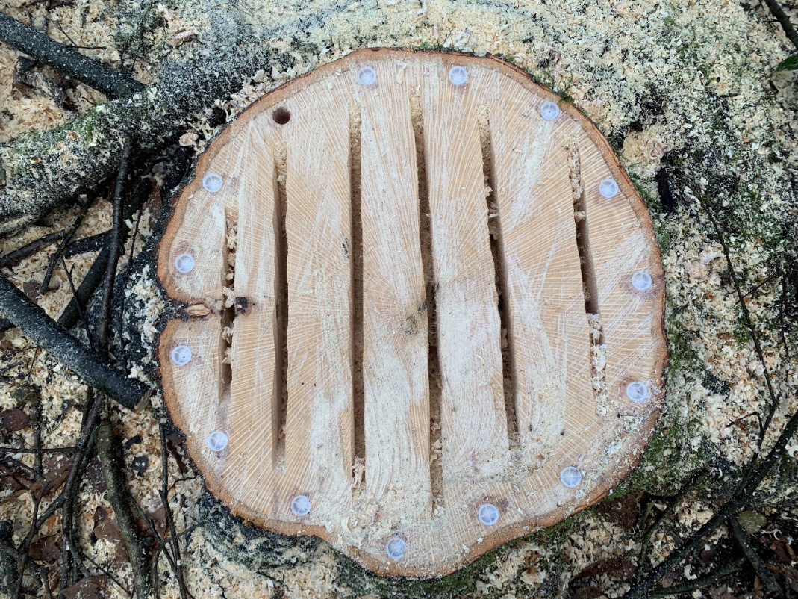
Figure 3 Cut tree stumps at Crymlyn Burrows
To maintain open glades, woodland spread is mitigated by removing saplings and cutting mature trees (as seen in figure 3) to prevent encroachment of priority habitats. This can stimulate regeneration for new trees to establish and can ensure greater accessibility for walkers around Crymlyn Burrows. Before the mature trees were cut the potential presence of bats and lichens was checked. Therefore, more extensive surveying was carried out to gain a better understanding of the mature tree habitats to avoid unnecessary damage to bats or lichens. This is especially important as there is a risk of the 1981 Wildlife and Countryside Act being broken if nesting birds or bats are intentionally harmed (UK Government, 1982). Non-native and invasive tree species (mainly conifers and holm oak) were cut or left as stumps as seen in figure 3, with the aim being to cut them before they became established to reduce the potential impact on birds. An issue is that in some areas there is limited alternative tree cover, meaning if the non-native trees were to be cut and had established bird habitats, they would have to be left alone and their seedlings to be removed regularly. In cases such as these the conservation of bird habitats may need to be prioritised, as woodland areas are limited in Crymlyn Burrows. The bird species listed in Crymlyn Burrows do not typically use conifers or holm oak trees as primary habitat locations. It is still important to consider bird species when managing non-native trees as there is a possibility a few of the birds may use the trees for nesting and cover because of the lack of alternative trees. Ensuring seedlings are removed is an effective strategy in preventing non-native tree growth, whilst protecting bird species in the area. The Neath Port Talbot Council Biodiversity Action Plan aims to prevent encroachment of non-native invasive tree species, rather than suggesting the immediate removal of invasive trees. The Crymlyn Burrows management plan is slightly stricter regarding non-native trees by cutting the conifers and holm oaks even if there were no signs of encroachment. Despite the invasive trees providing nesting for bird species, it can be more effective as a long-term strategy to preserve the natural ecosystem of the site. By ensuring non-native seedlings are removed so they are not outcompeting native vegetation for water and sunlight. Although some bird species may rely on non-native trees for habitat currently, over time they can adapt to utilise native vegetation in Crymlyn Burrows as part of a transition process (Sapsford et al, 2020).
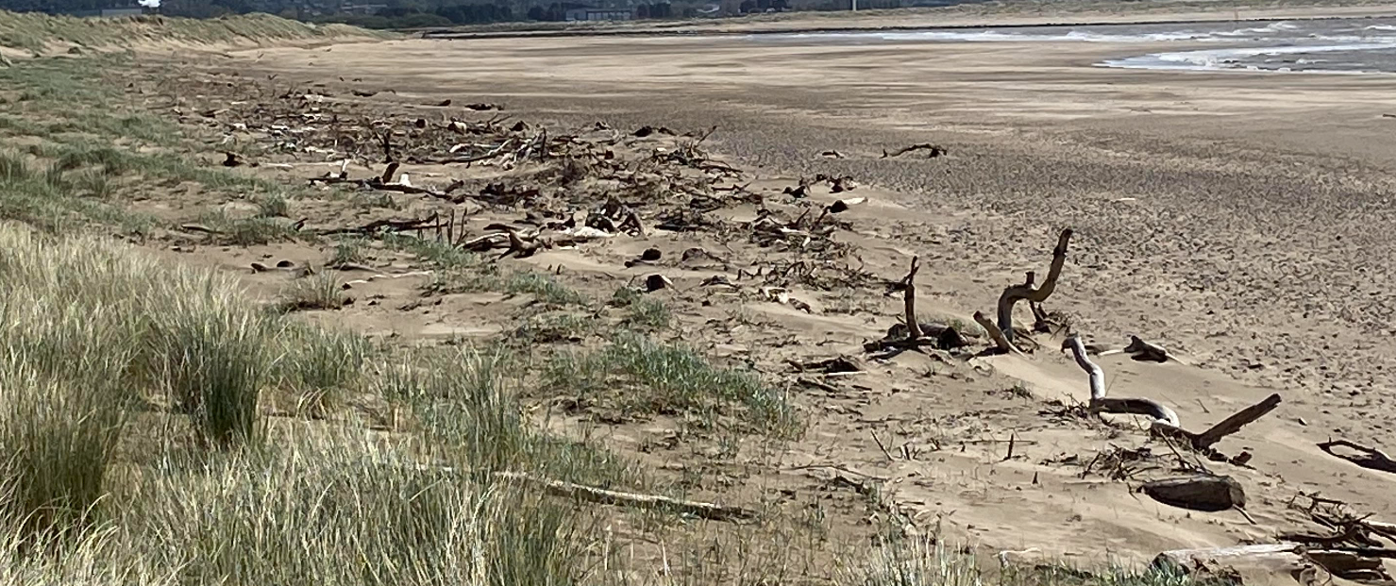
Figure 4 Cut timber added to the strandline

Timber that is cut from mature and invasive trees has been added to the strandline to boost driftwood habitat as seen in figure 3. Driftwood habitat can benefit the strandline beetle species that has not been recorded in Crymlyn Burrows since 1997, as plans have been made to reintroduce this species into the area (Stewart, 2016). Timber has been placed onto the beach next to Crymlyn Burrows, however it is currently unknown whether the strandline beetle has returned. As of 2023 monthly surveys are carried out by volunteers to record any signs of strandline beetles.

3.3 Access
Access to the site is limited as the footpaths are relatively informal and there is no purpose-built car parks or disability access. There are several main pathways that are maintained by cutting encroaching vegetation. However, due to a lack of fencing and signposts the informal footpaths can be somewhat unclear for visitors. This lack of fencing and guidelines can lead to visitors straying away from footpaths and onto sensitive habitat locations of protected rabbit and bird species. Some of the main aims in the management plan were to protect the site from damage and disturbance caused by visitors and removing anthropogenic litter. Litter was described as a key issue throughout the plan however, there were no plans to mitigate this issue other than through semi-regular litter picks. Fencing and bin allocation can be a more effective strategy to mitigate littering issues, as currently there is a risk that litter can cause disturbances to flora and fauna in sensitive habitat areas of Crymlyn Burrows (Cierjacks et al, 2012). Parties were noted as an issue on the beach just outside of the SSSI boundary, although it can be difficult to stop these entirely, fencing can allow parties to occur outside of designated habitat areas, therefore mitigating the potential issue of littering and disturbance near sensitive habitats.

3.4 Flooding
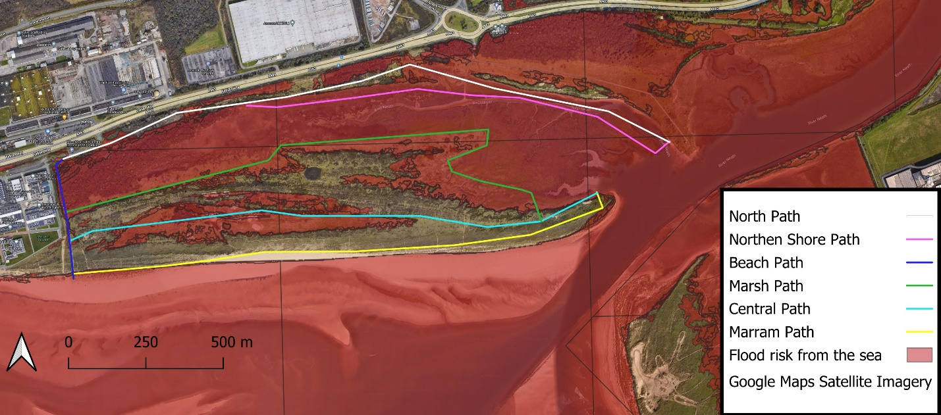
Figure 5 Flood risk from the sea in Crymlyn Burrows
The majority of Crymlyn Burrows is at risk of flooding from the sea as seen in figure 3. However, the risk of flooding was not discussed at all in the management plan despite the danger of several paths becoming unusable for visitors and volunteers. If the flooding was to spread as far as figure 5 shows it could cause the destruction of rabbit and invertebrate habitats throughout the site. This can have extensive impacts on the entire ecosystem as bird species may struggle to feed, after vegetation and invertebrates have been destroyed, leading to forced migration and relocation for indirectly impacted species (Newson et al 2022).
The Neath Port Talbot Biodiversity Action Plan states natural flood management will be used as the strategy to alleviate the flood risk. Although sand dunes can provide a natural buffer against coastal flooding, the grassland along the ‘Northen Shore Path’ is still at risk from flooding as seen in figure 5 around the ‘Marsh Path’. The Crymlyn Burrows management plan follows the Neath Port Talbot Biodiversity Action Plan by relying on the natural flood defences that are on the site, which currently consists of the dunes and saltmarshes. Crymlyn Burrows uses a managed realignment policy and acknowledges that habitats may have to adapt to changing conditions by migrating further inland. However, natural flood management may not be the most effective strategy in the long term, due to the risk of extreme weather events caused by climate change and rising sea levels. The sand dunes and limited woodland may not be sufficient enough to mitigate the impacts of future storm surges and high tides (Nicholson et al 2020).

3.5 Invasive vegetation
A key aim of the management plan is the removal of invasive species that have become widespread across the site, including Rosa rugosa, Japanese knotweed, Falopia japonica and sea buckthorn, that have been to the detriment of native dune communities. Invasive species such as these are to be removed using ‘Roundup ProActive’ a type of pesticide, which is to be used annually. The management plan admits there needs to be caution when using pesticides when removing Sea buckthorn as the larger strands provide cover for rabbit warrens. Therefore, showing consideration for native rabbit populations due to the direct toxicity that pesticides can cause (Damalas and Eleftherohorinos, 2011). There needs to be extensive consideration that using harmful pesticides near rabbit habitats may violate the Animal Welfare Act 2006, especially if more ethical alternative options are available (UK Government, 2007). However, there was no consideration in the management plan for alternative methods to remove buckthorn other than using pesticides. An alternative strategy such as winching may be more time consuming, but can be necessary to ensure rabbit species are not harmed when removing invasive sea buckthorn.
A common issue regarding invasive vegetation in Crymlyn Burrows is how vastly spread non-native vegetation is across the site. This can cause challenges as Crymlyn Burrows relies on volunteers, who are likely to have other commitments and cannot be relied upon to regularly work on removing invasive vegetation. Therefore, there is a limited workforce available to effectively manage invasive vegetation before it spreads and dominates the landscape. A large proportion of the volunteers are made up of university students, who are likely to have studying commitments and are unavailable during the Summer and Christmas periods. The management plan further states that the numbers of volunteers have been “variable” and “disappointing” and a priority should be to “increase the quality and quantity of volunteering”. However, it can be difficult to increase the “quality” of volunteers when they are not paid and will not always be able to attend because of work or studying commitments. Rather than getting ‘higher quality volunteers’, larger numbers of paid expert ecologists should be expected to manage invasive vegetation, due to the long-term risks of invasive vegetation on degrading and displacing native habitats (Muñoz-Vallés and Cambrollé, 2015).

4.0 Future recommendations

4.1 Invasive species control
The current strategy regarding invasive species are to carry out surveys, detecting the presence and extent of invasive species on the site. Surveys detecting invasive species currently occur on an ad hoq basis, or a detailed survey every 6 years. The frequency of detailed invasive species surveys should be increased so invasive threats to the natural habitat of the site can be more effectively mitigated. More frequent detailed surveying can provide more information on making a suitable habitat for species that are being reintroduced to the site such as the strandline beetle (Robinson et al, 2020). Invasive species like Japanese knotweed and Japanese rose which has become widespread across the site, can outcompete native flora for resources and decrease the stability of the soil, leading to the dunes becoming eroded and therefore more susceptible to flooding (Murray et al, 2012). It is important to note that surveys on the site are often carried out by volunteers who can be unreliable due to having other commitments. Therefore, if invasive species surveys were to be carried out more frequently, paid ecologists can be hired to manage the invasive species that are threats to Crymlyn Burrows’ ecosystem (Muñoz-Vallés and Cambrollé, 2015).
Similar extensive surveys should be carried out more often for non-native trees such as holm oak and conifers, due to the risk of its saplings growing and encroaching on native vegetation. Woodland spread is currently an issue on the site, and more frequent surveys can mitigate the issue to prevent encroachment on dune habitats. Extensive surveying should be required for non-native trees in case birds or bats are found to be nesting within the conifers or holm oak on the site. If this is the case the best solution would be to leave the trees alone and ensure seedlings are removed regularly to prevent non-native trees from growing.

4.2 Reintroduction

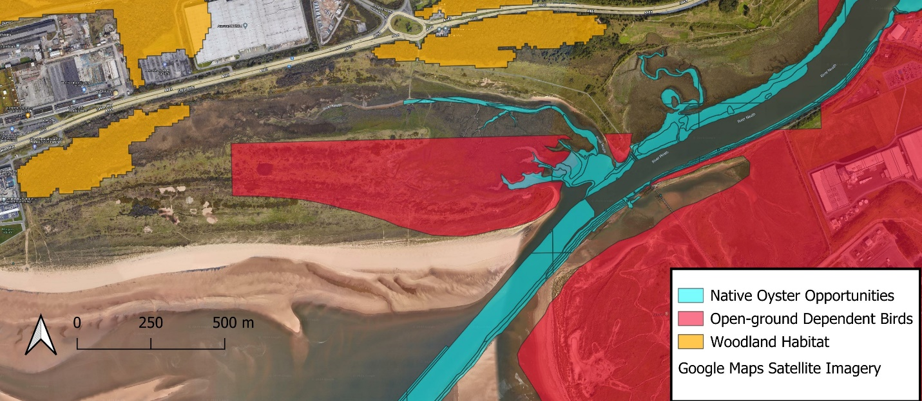
Figure 6 Potential reintroduction of oysters and its threats
One of the main aims of the management plan was to reintroduce species that have not been recorded in the last ten years, but have the potential to be reintroduced to the site given the capable resources are available and habitats are in a suitable condition. This includes the rare strandline beetle which was last recorded in Crymlyn Burrows in 1997. The site has already started to make a more suitable habitat for the strandline beetle by placing cut timber along the beach strandline as seen in figure 6. To further build on this reintroduction strategy, eradicating invasive non-native species around the strandline to the south of the dunes should become a priority and surveying to detect invasive species that can be a threat to the strandline beetle should occur more frequently, because of the strandline beetle being currently endangered (Olds, 2024). Reasons for the decline of strandline beetles have been attributed to tourism on the UK’s beaches, causing littering on beaches within the beetles habitats (Hackston, no date). This is a current issue in Crymlyn Burrows due to the influx of student parties on the beach, therefore fencing can be built around the proposed area to reintroduce the strandline beetle to prevent litter and intrusion from the public.
Figure 6 shows oysters can be reintroduced to the site in the River Neath, this can be an effective strategy to improve water quality by naturally filtering the water and reduce coastal erosion by stabilising sediments. The oyster reef could act as a natural buffer, safeguarding the saltmarshes and sand dunes on the site. Oyster reintroduction has been successful in Milford Haven following Welsh Government plans to improve water quality and support biodiversity in Welsh marine environments (NRW, 2021). It needs to be considered that the oystercatchers on the site are open-ground dependent birds that directly prey on oysters as seen in figure 6. Figure 6 shows the different habitat locations of open-ground dependent birds such as oystercatchers and skylarks and birds with woodland habitats such as starlings. This could hinder the success of reintroducing oysters to the site by limiting population growth and causing disturbance to their habitats. However, this is a natural process and can prevent overpopulation of oysters and provide an ecological balance (Davidson, 2013).

4.3 Natural Flood management
The current strategy to combat potential flooding is using natural flood management by relying on the existing sand dunes and marshes on the site. Coastal flooding management strategies are generally linked to a cost benefit strategy, as Crymlyn Burrows is not a significant tourist or built up site this strategy is likely to continue in the future. Whereas further west on Swansea Bay towards Mumbles, there is a sea wall to alleviate flood risk because of the higher footfall on the footpath and its proximity to a main road, the A4067. The managed realignment policy that is currently used may need to be altered in future to hold the line to the west of the site near the University Bay Campus, as there could be a risk of flooding onto the campus in the future due to climate change consequences. Hold the line may also need to be adopted to the east of the site, to protect the port area of Port Talbot and the navigation channel as seen in figure 6. If oysters are introduced to the River Neath such as in figure 6 it will become a priority to prevent the river from flooding, which could alter their habitat through changes in water depth and quality (Baggett et al, 2015). The hold the line strategy would also benefit the strandline beetle species if they were to be reintroduced to the beach on the south of the site which is their preferred natural habitat This would be more effective, rather than reintroducing the species further north in the dunes where they would have to compete with a larger amount of non-native vegetation such as sea buckthorn and Japanese knotweed (Beasley and Dundas, 2021). A hold the line strategy may be more effective in the long term after strandline beetles and oysters are introduced to the site.
A high narrow dune may initially act as a barrier to potential coastal flooding, especially if there is dense vegetation of ferns and rank grasses to stabilise the dunes and reduce erosion. However, a more effective strategy for the future would be to use several lower ridges of dunes to accumulate more sand and sediment and allow the dunes to stabilise with marram grass, this can replenish and strengthen the dune system (Hanley et al, 2014). Lower ridges would further benefit the open-ground dependent birds such as the skylarks on the site by providing better opportunities for nesting and foraging compared to a high narrow dune. Therefore in the case of Crymlyn Burrows constructing several lower ridges of dunes would be more appropriate to cater towards the existing ecology on the site.
Dune fencing can be used to discourage entry to eroded dune areas where walkers are likely to cause trampling damage to vegetation and disturb the fragile surface layer of the sand. Although footfall is relatively low across the site, visitors numbers may increase during university term times from September-December when wind and rainfall are more likely and dunes are more likely to erode. Therefore, fencing can give the vegetation a better chance to re-establish itself and better act as a flood defence mechanism (Grafals-Soto, 2012). A more ‘natural’ option can be to use dune thatching, where waste timber from mature trees can be used to reduce wind speed and encourage deposition of blown sand (Pye et al 2014). This can be easier to implement as waste cuttings have been used for strandline beetle habitat reintroduction already, as seen in figure 4.

5.0 Conclusion
Crymlyn Burrows faces several challenges as detailed in the maps above, including flood risk, invasive species control and reintroduction of native species such as the strandline beetle and oysters. Crymlyn Burrows have made progress towards mitigating these issues which have been detailed in the management plan, by carrying out surveys on wildlife habitats that surround invasive species and continuing Neath Port Talbot Council’s plan of natural flood management. The management plan focuses on removing invasive vegetation, Japanese knotweed, Japanese rose and invasive trees. Invasive species being an area of particular focus due to the wide implications of various issues such as woodland spread and making suitable habitats for the reintroduction of native species. Valid criticisms can be made of these current practices, by using several lower ridges of dunes and building fencing can help stabilise the dunes, so they can act as a more effective barrier to flooding and erosion. More frequent and extensive surveying should be considered to gain a better understanding of wildlife habitats near invasive species that are being removed. These can be carried out by paid ecologists that are able dedicate more time to managing the site compared to solely by volunteers on an ad hoq basis. Dune fencing can help mitigate several issues by preventing footfall that can trample sensitive habitats such as the reintroduced strandline beetle and help stabilise the dunes.
These recommendations are possible to carry out within the next ten years, however looking into the long term future can be difficult, due to the threats of climate change bringing more unpredictable weather patterns and rising sea levels (Polasky et al, 2011). The recommendations build upon the current Crymlyn Burrows management plan’s aims and objectives, by maintaining key habitats, controlling the spread of invasive species and protecting the site from damage. However, it is also important to consider a greater emphasis on mitigating the flood risk, that could significantly damage the site in years to come.

References
Arens, S.M., Mulder, J.P., Slings, Q.L., Geelen, L.H. and Damsma, P., 2013. Dynamic dune management, integrating objectives of nature development and coastal safety: Examples from the Netherlands. Geomorphology, 199, pp.205-213.
Atkins, 2015. Crymlyn Burrows SSSI Management and Access Plan. Unpublished plan for St Modwen Developments ltd
Baggett, L.P., Powers, S.P., Brumbaugh, R.D., Coen, L.D., DeAngelis, B.M., Greene, J.K., Hancock, B.T., Morlock, S.M., Allen, B.L., Breitburg, D.L. and Bushek, D., 2015. Guidelines for evaluating performance of oyster habitat restoration. Restoration Ecology, 23(6), pp.737-745.
Beasley, W.J. and Dundas, S.J., 2021. Hold the line: Modeling private coastal adaptation through shoreline armoring decisions. Journal of Environmental Economics and Management, 105, p.102397.
Cierjacks, A., Behr, F. and Kowarik, I., 2012. Operational performance indicators for litter management at festivals in semi-natural landscapes. Ecological Indicators, 13(1), pp.328-337.
Crampton, J.W., 2010. Mapping: A critical introduction to cartography and GIS (Vol. 5). John Wiley & Sons.
Damalas, C.A. and Eleftherohorinos, I.G., 2011. Pesticide exposure, safety issues, and risk assessment indicators. International journal of environmental research and public health, 8(5), pp.1402-1419.
Davidson, P.E., 2013. The Oystercatcher—a pest of shellfisheries. The problems of birds as pests, pp.141-155.
Digimap (2024) Geology Digimap , Digimap Discovery Service. Available at: https://digimap.edina.ac.uk/roam/map/geology (Accessed: 04 May 2024).
Goulson, D., 2003. Effects of introduced bees on native ecosystems. Annual Review of Ecology, Evolution, and Systematics, 34(1), pp.1-26.
Grafals-Soto, R., 2012. Effects of sand fences on coastal dune vegetation distribution. Geomorphology, 145, pp.45-55.
Hackston, M. (no date) Eurynebria complanata, UK beetles. Available at: https://www.ukbeetles.co.uk/eurynebria-complanata (Accessed: 25 April 2024).
Hanley, M.E., Hoggart, S.P.G., Simmonds, D.J., Bichot, A., Colangelo, M.A., Bozzeda, F., Heurtefeux, H., Ondiviela, B., Ostrowski, R., Recio, M. and Trude, R., 2014. Shifting sands? Coastal protection by sand banks, beaches and dunes. Coastal Engineering, 87, pp.136-146.
Hipkin, M. (2016) Swansea Bay Waterbird Study 2015/2016. Unpublished report for Swansea University
Howard, B., Aker, J. and Reid, M., 2012. Risk management for unexploded ordinance (UXO) in the marine environment. Dalhousie Journal of Interdisciplinary Management, 8(2).
MACC (2017)Unexploded Ordnance Desk Study T2470, Crymlyn Burrows, Swansea. Unpublished report for Swansea University.
Muñoz-Vallés, S. and Cambrollé, J., 2015. The threat of native-invasive plant species to biodiversity conservation in coastal dunes. Ecological Engineering, 79, pp.32-34.
Murray, J.V., Stokes, K.E. and van Klinken, R.D., 2012. Predicting the potential distribution of a riparian invasive plant: the effects of changing climate, flood regimes and land‐use patterns. Global Change Biology, 18(5), pp.1738-1753.
Newson, M., Lewin, J. and Raven, P., 2022. River science and flood risk management policy in England. Progress in Physical Geography: Earth and Environment, 46(1), pp.105-123.
Nicholson, A.R., O'Donnell, G.M., Wilkinson, M.E. and Quinn, P.F., 2020. The potential of runoff attenuation features as a Natural Flood Management approach. Journal of Flood Risk Management, 13, p.e12565.
Nolet, C., Van Puijenbroek, M., Suomalainen, J., Limpens, J. and Riksen, M., 2018. UAV-imaging to model growth response of marram grass to sand burial: Implications for coastal dune development. Aeolian Research, 31, pp.50-61.
NPT Council (2012) SWW03 shoreline management plan 2 , Swansea and Carmarthen Bay Engineering Group. Available at: https://www.npt.gov.uk/ldpexamination/SWW03%20Shoreline%20Management%20Plan%202%20Main%20Document%20(2012).pdf (Accessed: 26 April 2024).
NRW (2015) Marine character areas MCA 26 Swansea Bay & Porthcawl, Natural Resources Wales . Available at: https://naturalresources.wales/media/674533/mca-26-swansea-bay-and-porthcawl_final.pdf (Accessed: 26 April 2024).
NRW (2021) Natural Resources Wales / new NRW conservation project looks to restore native oysters in the Milford Haven Estuary, Natural Resources Wales . Available at: https://naturalresources.wales/about-us/news-and-blogs/news/new-nrw-conservation-project-looks-to-restore-native-oysters-in-the-milford-haven-estuary/?lang=en (Accessed: 02 May 2024).
Olds, L. (2024) Call for help to find potentially extinct strandline beetle, BBC News. Available at: https://www.bbc.co.uk/news/articles/cg3rwykwwpzo (Accessed: 25 April 2024).
Polasky, S., Carpenter, S.R., Folke, C. and Keeler, B., 2011. Decision-making under great uncertainty: environmental management in an era of global change. Trends in ecology & evolution, 26(8), pp.398-404.
Price, P. and Brooks, M., 1980. Swansea Bay: bedrock geology and its influence over geomorphological development.
Provoost, S., Jones, M.L.M. and Edmondson, S.E., 2011. Changes in landscape and vegetation of coastal dunes in northwest Europe: a review. Journal of Coastal Conservation, 15, pp.207-226.
Pye, K. and Blott, S.J. (2014) Neath Port talbot county borough council Crymlyn ... Available at: https://www.npt.gov.uk/ldpexamination/ED031 Baglanand Crymlyn Burrows Geomorphological Report 06.02.14.pdf (Accessed: 26 April 2024).
Pye, K., Blott, S.J. and Howe, M.A., 2014. Coastal dune stabilization in Wales and requirements for rejuvenation. Journal of coastal conservation, 18, pp.27-54.
Robinson, N.M., Dexter, N., Brewster, R., Maple, D., MacGregor, C., Rose, K., Hall, J. and Lindenmayer, D.B., 2020. Be nimble with threat mitigation: lessons learned from the reintroduction of an endangered species. Restoration Ecology, 28(1), pp.29-38.
Sapsford, S.J., Brandt, A.J., Davis, K.T., Peralta, G., Dickie, I.A., Gibson, R.D., Green, J.L., Hulme, P.E., Nuñez, M.A., Orwin, K.H. and Pauchard, A., 2020. Towards a framework for understanding the context dependence of impacts of non‐native tree species. Functional Ecology, 34(5), pp.944-955.
Stephenson, P.J., Londoño-Murcia, M.C., Borges, P.A., Claassens, L., Frisch-Nwakanma, H., Ling, N., McMullan-Fisher, S., Meeuwig, J.J., Unter, K.M.M., Walls, J.L. and Burfield, I.J., 2022. Measuring the impact of conservation: The growing importance of monitoring fauna, flora and funga. Diversity, 14(10), p.824.
Stewart, B. (2016) The status and distribution of the Strandline Beetle Eurynebria complanata on Whiteford Burrows, Cefn Sidan, Laugharne & Pendine Burrows and Frainslake Sands, Castlemartin in 2016, Natural Resources Wales . Available at: https://naturalresources.wales/media/685037/report-189-strandline-beetle-eurynebria-complanata-whiteford-burrows-etc.pdf (Accessed: 16 April 2024).
Swansea University (2018) Crymlyn Burrows SSSI Management plan 2018-2023, Swansea University . Available at: https://www.swansea.ac.uk/media/Crymlyn-Burrows-SSSI-Management-Plan-2018-2023.pdf (Accessed: 04 May 2024).
Tierney, J.E., Poulsen, C.J., Montañez, I.P., Bhattacharya, T., Feng, R., Ford, H.L., Hönisch, B., Inglis, G.N., Petersen, S.V., Sagoo, N. and Tabor, C.R., 2020. Past climates inform our future. science, 370(6517), p.eaay3701.
UK Government (2007) Animal Welfare Act 2006, Legislation.gov.uk. Available at: https://www.legislation.gov.uk/ukpga/2006/45/contents (Accessed: 02 May 2024).
UK Government (1982) Wildlife and countryside act 1981, Legislation.gov.uk. Available at: https://www.legislation.gov.uk/ukpga/1981/69 (Accessed: 02 May 2024).
Welsh Government (2021) DataMapWales. Available at: https://datamap.gov.wales/info/what-we-do (Accessed: 04 May 2024).
Welsh Government (2020) The National Strategy for Flood and Coastal Erosion Risk Management in Wales, GOV.WALES. Available at: https://www.gov.wales/sites/default/files/publications/2020-11/the-national-strategy-for-flood-and-coastal-erosion-risk-management-in-wales.pdf (Accessed: 02 May 2024).
White, F. (2022) New Wellbeing Project creating a buzz at Swansea University, Swansea University. Available at: https://www.swansea.ac.uk/press-office/news-events/news/2022/10/new-wellbeing-project-creating-a-buzz-at-swansea-university.php (Accessed: 23 April 2024).
Woodhouse, M.A. (2011) Distribution and Ecology of the Red Data Book Plant Mattiola sinuata (Sea Stock) in Neath Port Talbot and Swansea. MSc Thesis, Swansea University, 63pp.

