STRATEGIC MANAGEMENT

Keval Parekh – 1709678

MBA Banking & Finance

Prof: Allison Wylde

Executive summary
The current business strategic report is developed on the ‘Cook trading’ company. ‘Cook trading’ sales frozen ready to eat meals in the UK region through their 83 stores, home delivery or click and collected facility. The business current challenges and opportunity is analysed through the PESTLE and Porter’s five forces analysis. The PESTEL analysis showed that the political and legal situation is now complicated in UK and that is providing uncertain situation for the businesses. But the social and technological developments are providing option for the frozen ready to eat meals products to expand their business by targeting the older generation through the e-commerce platform. On the other hand the Porter’s five forces analysis showed that the market entry barrier for new businesses is high whereas the substitution products do not provide significant threat. The buyer’s power and the business competitive landscape is threatening and needs to be managed. The business internal analysis through performance analysis shows that the financial performance of the business is satisfactory and the growth is encouraging. Business sustainability factors are effectively marinated by providing proper emphasis on the employee, community and environment management. The value chain analysis showed that the business operation, human resource management, infrastructure and outbound logistics are some of the important supporting aspect. The marketing and sale capability, technology application and inbound logistics need to be improved. The SWOT analysis showed that product variety, distribution capability, business financial performance is some of the strength of the business. The lack of marketing capability and technology investment is a weakness for the business. The competitive rivalry from large super market, political and legal situation, and lower real income growth is a threat for the business. on the other hand the better employment rate in UK, positive mindset of the older customer about frozen foods, greater growth prospect are some of the opportunity factor for the business. After this internal and external business analysis the strategic framework like Ansoff matrix, VRIO and Strategic clock is used to develop proper recommendation for business strategy. The recommendations are pursuing market penetration a primary and product development as secondary strategy, continuing differentiation strategy, developing greater marketing capability focusing on the digital marketing, customer knowledge and data resource development, better product delivery capability development, improving product capacity and capability, better packing of the products.

Table of Contents
Executive summery 2
Introduction 4
Strategic challenges analysis 4
Business external environment analysis 4
PESTLE 4
Business internal environment analysis 11
Business performance analysis 11
Value chain 14
SWOT 16
Strategic option analysis 17
Ansoff matrices 17
VRIO 19
Strategic clock 20
Conclusion and recommendation 21
Reference 23
Appendices 27

Introduction
Business strategy is developed by keeping the long term view of the business. In the business strategy the business objects, vision or mission, business competitive advantage, sustainable business position are the most important factors that are considered. In the current report one of the successful business that ‘Cook’ or ‘Cook trading ltd’ would be analysed to underst6and the business challenges under the digital age. Then the strategic option would be evaluated for Cook to provide the appropriate strategic option for the business. Cook is in frozen food business for close to decade. In their current operation the business has close to 850 employees to operate in the UK (thetimes.co.uk, 2018). The operation of the business changed over the years. The customer are reached through three modes of distribution channel that are home delivery, click and collect facility and own shop of Cook (cookfood, 2018). But during this time the business external environment has changed a lot especially the technological implications. In the current report those situations would be evaluated along with the business internal situational analysis. Based on the challenges the following sections are analysed.

Strategic challenges analysis
The strategic challenges of the business under this digital age based market situation can be understood from the business internal and external analysis. The business external situation is out of direct control of the business whereas the internal business factors can be analysed to develop better strategy for the future business of Cook.

Business external environment analysis
The external micro and macro environment would provide the market scenario that would be challenging for the future business. The business macro environment would be analysed through PESTLE analysis and the micro environment would be accessed through the Porter’s five forces analysis.

PESTLE
Political and legal- Cook operates in the Uk market through their dedicated 80 stores and also through the home deliver and click and collect facility based distribution channel. The UK market in recent times is having a political situation which is under turmoil. The situation of Brexit has put business sentiment and hence investment in a quite uncertain situation (Clarke and Griffiths, 2018). This situation would lose the single market access in the EU region because of that reason different supplies for the business would face different legal and economical complications. The current negation of Uk leaving EU is under quite uncertain position as the important ministers in the Uk government has resigned due to this difficult situation (Clarke and Griffiths, 2018). On the other hand the situation would impact the legal environment of the businesses also and till now the UK market is government by the Eu legislations. Under the new circumstances the food safety, marketing and other food industry specific regulations would be formed by the UK parliament. The chances are that the regulation would be developed by keep the Uk’s interest at higher priority. On the other hand the digital world is getting more regulated and the business operating through this technology has to be more cautious. The recent regulation of GDPR is one of such legislation that would force the business to take more proactive role in the data protection and security. The legislation is from EU but the chances are that the legislation would remain in effect after UK leaves EU (Burgess, 2018). Another important legislation for the food industry is the package labelling policy. The government has developed regulatory framework to make the people aware about the choice of food for the cost, taste, health conditions like allergies or obesity, dilatory reason and so on (food.gov.uk, 2018). This aspect needs to be properly showcased to be customers to help them make purchasing decisions.
Economic-
Figure -1
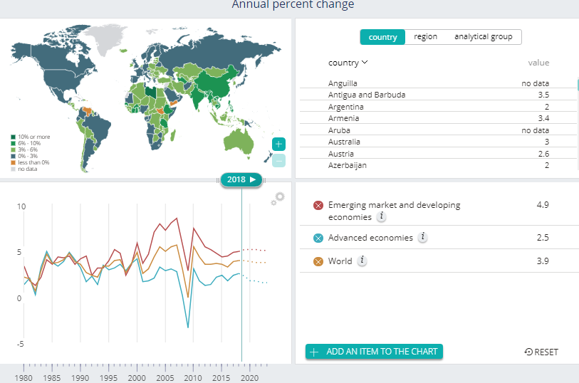
[Source: imf, 2018]

Figure -2
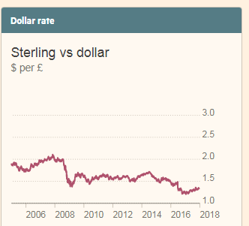
[Souece: Jackson et al., 2018]
In recent times the Brexit is the significant event that has impacted the UK economy. For example the falling Pound is a problem for the food industry where the supplier comes from the outside of Uk. On the other hand the uncertain economic situation and current expected 1% GDP growth is providing relative growth to the economy whereas the world economy is showing sign of faster growth (Jackson et al., 2018). There the world economy is expected to grow by 3.9% and the developed economy by 2.5% (imf, 2018).
Figure -3
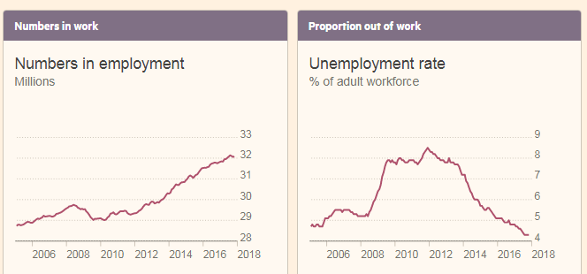
[Souece: Jackson et al., 2018]
The encouraging situation of the UK economy is the internal strength of the economy the rate of unemployment is the lowest in decades whereas the household income is rising steadily (ons.gov.uk, 2017). This situation is expected to keep the growth of the industries stable. The frozen food industry can bank on this better employment rate as people are would remain more busy to chose this ‘quick eat’ option of frozen food. But the in recent time the rate of inflation is also increasing and in comparison to that the rise of real earning is low. This aspect needs to be considered properly by the food businesses as in many cases sudden rise of inflation may not be quickly transferred to the consumer.
Figure -4
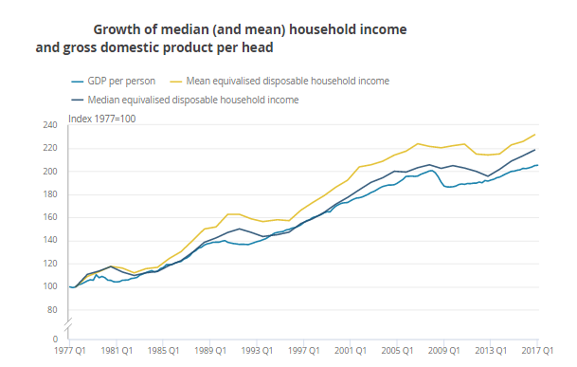
[Source: ons.gov.uk, 2017]

Figure -5
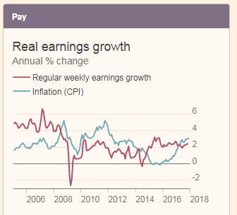
[Souece: Jackson et al., 2018]

The interest rates are kept close to 0% level to keep the demand in the market (Jackson et al., 2018). But the situation may not be stable for long as the FED rate is increasing which is expected to impact the world interest rates.
Social- the consumer taste and preference is changing fast in the markets. The trend of ‘quick eat’ that is to use the half prepared food for preparation of food and consumption is quick manner. The faster lifestyle of the people in UK is producing demand for this industry. One of the important factors of the UK market is the growth of population which are aging faster. Some of the retail market research shows that the around 66% of the contribution in the market growth would come from the above 55 years of age group population in the UK (retailthinktank.co.uk, 2018). The situation is likely to prevail in the frozen food retail markets also. Then a majority of Cook’s business comes from the online order of the business. The intern penetration in the UK region is quite high that is more that 82% (statista, 2016). The generation gap in this part was high in recent time. Survey shows that in recent times the above 45 age groups of people are getting used to the internet technology (ons.gov.uk, 2018). Considering this change in the social factor the frozen food industry can expect higher volume of order from the aging population customer segments. The facility, products and services needs to be developed as per that scenario.

Figure -6
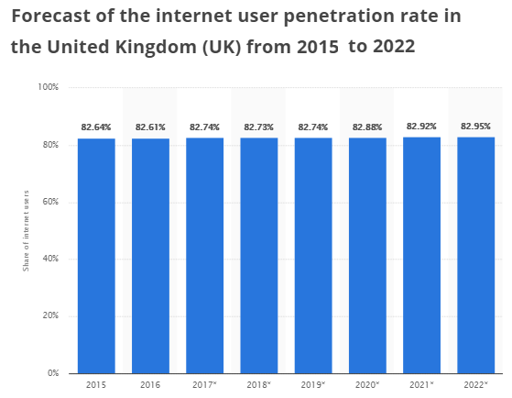
[Source: statista, 2016]
Figure -7
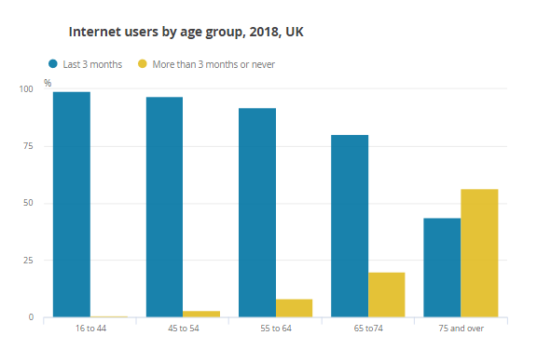
[Source: ons.gov.uk, 2018]

Technological- the technology world is changing fast. In the daily business operation the use of artificial intelligence based automation technology, is simplifying the business operation with increasing efficiency and service quality. The food processing technology improvement provided greater sop to the industry (Knorr et al., 2011). On the other hand the recent development of the information technology the other hand the recent development of the information technology has helped the business to have different distribution and sale channel. But the recent trend is that the greater use of internet is happening through the mobile devices (statista, 2017). Therefore the sales channel designs must be developed by mobile fist approach. Technology is impacting the business in the digital era through the use of big data and the approach of personalisation. This approach helps in driving growth in the online platform based sales for the food business through acquiring greater knowledge about the customers, building greater trust and loyalty, generating greater lifetime value of the customers and maximising customer satisfaction (Chen et al., 2012).
Figure -8
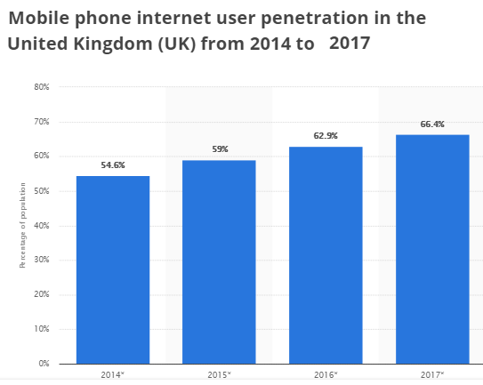
[Source: statista, 2017]
Environmental- packaging of food have higher waste from the food packaging. The reason is that frozen food products need great amount of packaging to keep that in appropriate condition. Therefore environment friendly packaging is one of the needs for the industry. on the other hand the frozen food industry has higher use of refrigeration technology (Zanoni and Zavanella, 2012). Therefore the industry consums lot of energy and produces greenhouse gas. As per the recent climate agreement the UK government has set some ambitious target for the country. Among those one is to reach zero emission targets by 2050 (Pye et al., 2017). To meet this ambitious target the every industry has to contribute. Considering these environmental challenges ‘Cook’ has adopted green energy initiative 100% and also influencing the suppliers and their distribution channel to use the reusable packaging container to improve sustainability factor for the business (thetimes.co.uk, 2018).

Business internal environment analysis

Business performance analysis
Financial performance- The business performance is analysed against the last year’s financial data. In the 2015-16’s financial information the business shows proper growth (Taticchi, 2010). The total revenue of the business stands at £64m which is a growth of £7.6m. This shows a 12.2% growth of revenue for the business (cookfood, 2017). The market report shows that are growth of the industry are 6% (Jahshan, 2018). Therefore the growth of ‘Cook’ is much better than the industry average. The net profit for the business for the year 2017 is £4.5m. This is rise of 9.8% in net profit from the previous year. Therefore in both the sale and profit front the business has made significant improvement. In the 2017’s operation the business expanded through 3 new store format whereas because of the viability problem 2 stores were close and net 1 store added in the operation (cookfood, 2017). Therefore the financial aspect of the business is looking strong in the current operation. But the long term sustainability of the business is depended on the following factor.
Suitability factors- the business is highly aware about their eternal environment and how the sustainability factors can impact the business. Considering this the business has taken proactive steps in this to reduce their environmental impact as seen in the annual report of 2017. The use of natural gas and power consumption through electricity is showing steady reduction. This aspect reduces the carbon footprint of the business (Taticchi, 2010). On the other hand water is one of the important resources. Efficient use of water is a goal of the business but between 2016 and 2017 report not so significant improvement has been seen. The waste management plan of the business is highly successful but the operation of 2016-17 shows an 100% increase in the landfill (cookfood, 2017). The report has recognised the aspect and plans to reduce in the next years of operation. In the packaging of food products cardboard is one of the important substance. In the 2016-17’s operation the business has been able to recycle around 228 tons of cardboard (cookfood, 2017).

Figure -9
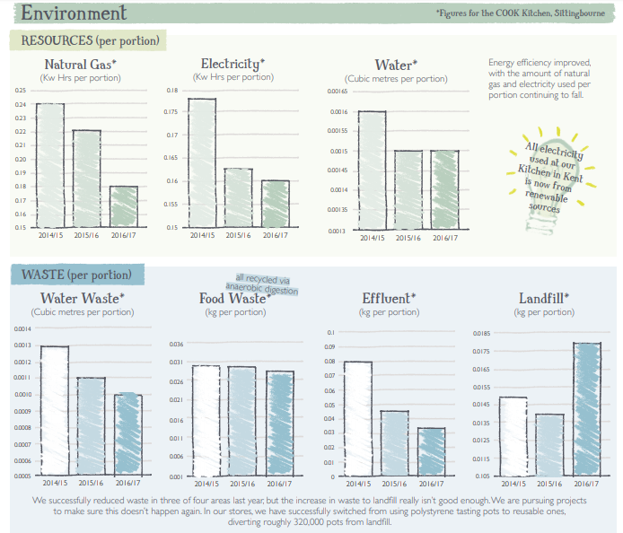
[Source: cookfood, 2017]

One of the important sustainability factors of the business is the people associated with the business (Wagner, 2010). The business recognises that the people associated with the business plays a significant role in the growth of the business and considering this around 5% of profit has been shared with the staffs to keep them motivated and engaged in the work process (cookfood, 2017). Another important aspect is the skill development of the staffs to maintain completive advantage of the business. The training expense of the staffs packed in the 2015-16’s operation but got reduced in the 2016-17’s operation. The significant factor is that the number of staff supported through the training program has increased by 79 people. Out of around 850 staffs of the business 676 people were trained in the 2016-17’s operation (cookfood, 2017).
Figure -10
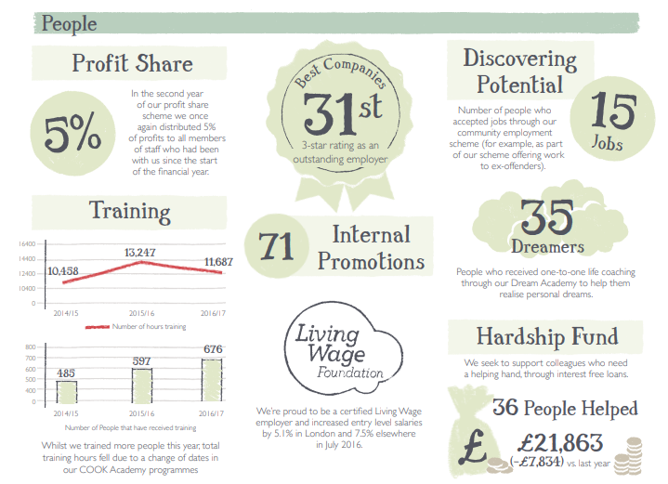
[Source: cookfood, 2017]

The corporate social responsibility is one of the important approaches for the business sustainability. This approach also improves the brand awareness and image among the customers (Wagner, 2010). The figures below provide the significant activity and contribution made by the ‘Cook’ in their operation of 2016-17.

Figure -11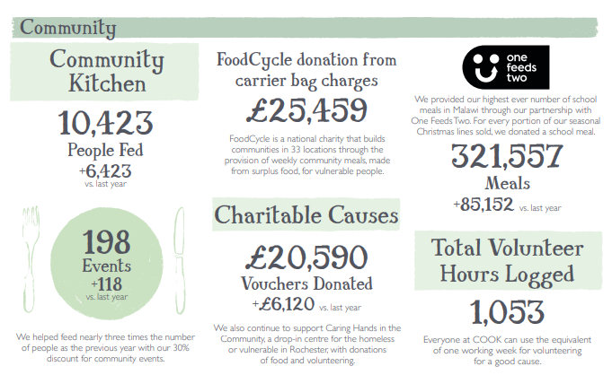
[Source: cookfood, 2017]

Value chain
The industry value chain is important for the analysis of Cook’s firm specific value chain analysis. In the ready meal type frozen food industry the raw food are sourced from the firma based supplies. The firm produced are then processed by some intermediate firms to supply those to the manufacturer like ‘Cook’. After the manufacturing the ready meal in frozen manner are sold in the market through the company distribution channel (Friedrichsen, 2013). In between the market and sales support and after sale support is also provided by the company.
Inbound logistics- in the frozen food industry there are different types of suppler. Cook collect raw material from those firms through their inbound logistics. Quality is checked in this sourcing process. Cook coordinates and provides clear policy to their supplier for sustainable business. The recycling process is followed along with the supplier’s cooperation. First conference for their suppliers was held in the 2015-16’s operation (cookfood, 2016). This approach was aim to improve in bound logistics.
Operation- after manufacturing the frozen ready meals the products are sold through 83 different stores of the business across UK. There are other facilities like the online ordering based home deliver and the click and collect facility. In the 2015-16 operation the business took new initiatives to increase threat capacity by almost half to growth faster in the UK market (cookfood, 2016).
Outbound logistics- for the outbound logistics the business has started a project called ‘Lightyear’ in the 2015-16’s operation for the growth of the business (cookfood, 2016). This process would strengthen this process along with improving efficiency of the process.
Marketing and sales- to improve the marketing and sales operation for the business growth in the 2015-16’s operation new marketing plan and initiative has been taken. Two different market initiatives have been introduced during this time and that would help the business to connect better with the new and old customer base. One project in the ‘More2’ and another is based on the focused trial. In these process customer data based creation and maintenance, email based trigger marketing campaign development was some of the important approach (cookfood, 2016). But the company has recognised in the 2016-17’s operation that the low expense in the marketing section is hurting the business prospect (cookfood, 2017). Therefore the business is focusing on to improve this part especially on the digital platform based improvements and approaches.
Figure -12
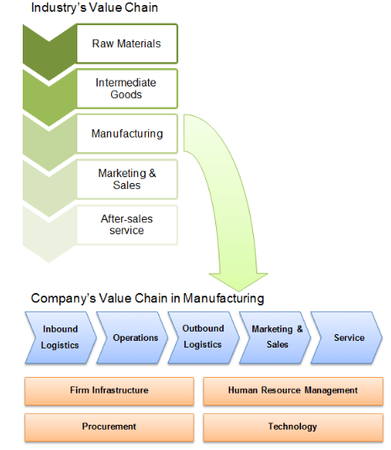
[Source: De Backer and Miroudot, 2014]
To maintain the value chain the firm infrastructure, procurement, human resource and technology use would be important (Friedrichsen, 2013). Infrastructure is one of important part that Cook considers to grow in the market. In the 2016-17’s operation end among the 62 priority project the organisation has been able to end 46 in green. In the 2015-16’s operation 50% of the capacity increment plan was adopted. The investment and growth in project helps the business develop long term resource and completive advantage. For the development of human resource manage the kind of investment and effort in the staffs training is discussed in the earlier section. To improve procurement the supplier meeting is playing an important role. The technology investment is not highly visible in Cook’s annual report.

SWOT
Strength  - The main products of the business are having large variety. These ready meals in frozen type follow different cuisines to provide customer a variety of food options.  - The business is operating with 83 stores around the UK.  - The business operates with different sales and distribution channels like store, home delivery, takeaway and click & collection options.  - They have different price segment products. the Thai meal cost as low as £12.  - The sale growth is 12.2% and profit growth is 9.8%.  - Highly skilled employee as the business invests in the employee development.  - Higher emphasis on business sustainability and CSR activity. | Weakness  - There is lower investment in the technology.  - Recently the business has invested for the customer data base building but much scope is there to improve the digital marketing capability.  - Low budget and emphasis on the marketing capability development which impacted 2016-17’s expected revenue.
Opportunity  - There is higher demand of ‘quick eat’ food products in the market.  - The higher employment rate in UK shows that there would be lack of time in the hand of employed people and demand of these types of food products is expected to rise.  - An appendix 2.0 shows that in the older age group the expectance of the frozen food product is higher in UK as a healthy option. On the other hand the aging population and future retail growth rate contribution of the older age provides a significant opportunity to better target the older generation.  - Improvement in the marketing strategy and plan would provide greater revenue source; especially through mobile first digital marketing approach. | Threat  - The political uncertainty in UK provided barrier in increasing store number.  - The GDPR like data protection measure need greater attention in this regard.  - Current inflation rate along with slower real earnings growth would reduce consumer spending capacity.  - Increasing completion in the market. Large super market’s own label products range and lower price positioning.  - Increasing supply cost of the imported suppliers.

[Source: Clarke and Griffiths, 2018; BURGESS, 2018; Jackson et al., 2018; statista, 2017; ons.gov.uk, 2018; retailthinktank.co.uk, 2018; foodmanufacture.co.uk, 2018; bfff.co.uk, 2018; cookfood, 2017; cookfood, 2016;]

Strategic option analysis

Ansoff matrices
The application of Ansoff matrices would be done here for the strategic option analysis for Cook trading. This matrix provides four strategic options to the business. One of the options is the market development and in this approach the business would use their current product and services to venture into new market for the growth process (Hussain et al., 2013). Cook trading is operating in the UK market for last 20 years but there are futher scops for the business in the Uk market considering the opportunities there. Improvement of their position in the UK market would provide them great capability and strength to venture into new market (Kipley et al., 2012). Moreover it would much risky approach for the business considering its current size. The next option of the business is the diversification. In this strategic approach the business would target new customer section with their different product category. This approach would be highly risky for the business in its current size and expertise. There is much scope for the business to develop their current capability, expertise and resource base. Considering this differentiation option would not be suitable for the business (Taylor, 2012). The next option is the product development. Currently the supermarket has much more product option in the frozen food category. Cook trading provides the frozen ready to eat meals to the customers. Therefore the business can develop other frozen food products. Therefore the current customer segment could be offered other types of products to improve revenue option. Apart from this strategic option the next suitable option for the business would be the market penetration option (Kipley et al., 2012). In this process Cook trading would strive to further penetrate into the UK market and reach lot more number of customers. This option can be done through increasing number of stores or reaching lot more number of customers through digital marketing process.
Figure -13
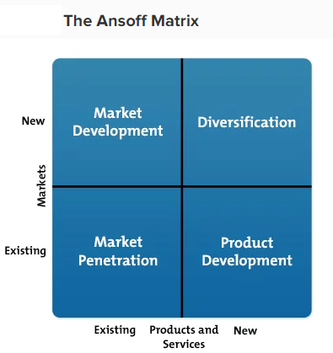
[Source: Taylor, 2012]
Under current business condition Cook trading lacks the marketing strategy and the improvement in the technology and digital marketing capability would provide large revenue source for the business. in current business situation the e-commerce segment in the business is growing by 34% (cookfood, 2017). This process can be fast accelerated through proper digital marketing and delivery process development. This ecommerce segment contributes only 1/10 of the total revenue currently and the business can aim to reach 30-40% mark. The growth process can be addressed by targeting the above 45 years age group population (Hussain et al., 2013). The initial growth came from the internet savvy younger generation and they are also more adaptive. The positive mind set of the older generation towards the frozen food and getting accustom with the internet technology would provide attractive option to the business to target this segment to improve revenue (statista, 2017). On the other hand the application of technology like bid data, CRM process, social media analytics capability, digital marketing capability would help the business to maintain better relation with the old and new customer. This approach would also provide the service personalisation approach to draw more value from each customer. Under the uncertain situation of Brexit where the business states in their annual report their difficult to open more stores, the growth of the business through the digital platform is the best option of market penetration (cookfood, 2017). For the improvement in the e-commerce capability also needs to address the better delivery facility. One of the research shows that younger generation of 16-24 years of age group prefer same day delivery, overall the user prefer same day delivery, around 50% customer wants less packaging, customer wants more reliable and timely delivery (mintel, 2017). Considering this an investment in this regard would be important for the business for further penetration in the Uk market.

VRIO

This framework is useful to understand or decide the sustainable completive advantage developed which would help the business in the long run. The critical resource for Cook trading is the financial resource, material and infrastructure resource, human resource and technical or technology related resources (Killen et al., 2012). Development of these resources is done through the following approach.
Value- the business of Cook trading is able to provide decent return in the form of net profit. But compared to other large retail businesses in the market that are also much larger in size the financial resource of the business is not more than serving the business purpose. On the other hand the human resource and the material resource of the business are able to produce greater value in the business (Killen et al., 2012). the technology, customer knowledge and data base management, marketing capability is under developed in the business. Business sustainability measured is highly focused and that provide positive relationship with the stakeholders which is valuable. The sales and distribution channel of the business is valuable and able to develop loyal customer base.
Rare- the business highly invest in the human resource and make them engaged, satisfied and committed to the business through approaches like profit sharing and training (thetimes.co.uk, 2018). These highly skilled and committee employee in the business is a rare attribute. Business sustainability focus is rare considering the scale and scope of the business. 93% of sold products of Cook trading are produce by themselves (cookfood, 2017). This material and infrastructure resource and capability are a rare aspect for the business. The sales and distribution channel is not rare considering its current size and scope to generate business. This needs to be further developed to make it rare and them costly to imitate.
Imitable- the rare advantage can be of long term competitive advantage developing if that cannot be imitated by others competitors. Currently the human resource of the business is at the stage of non imitable stage. The development of employee friendly and welfare oriented culture in the organisation takes long time and consistent effort and therefore is costly to imitate (Pesic et al., 2013). Apart from this none of the resource and capability is non imitable.
Organisation- the current training and development program, employee benefit and culture is effective in the organisation to sustain this human resource oriented completive advantage. In the 2016-17’s operation there were 71 internal employee promotions (cookfood, 2017). Therefore the scope for growth within the organisation would improve performance of the staffs and also attract good talent from the industry.
Therefore the VRIO framework analysis would seek improvement in some part of the business. Massive improvement is required in the technology, customer knowledge and data base management, marketing capability development. The financial and business infrastructure would develop as the business grows. Consistent effort, investment and focus are required in the sale and distribution channel, production capability to make it sustainable competitive advantage in near future (Pesic et al., 2013). On the other hand current level of support is required in the human resource management to keep this competitive advantage in the long run.

Strategic clock
Figure -14
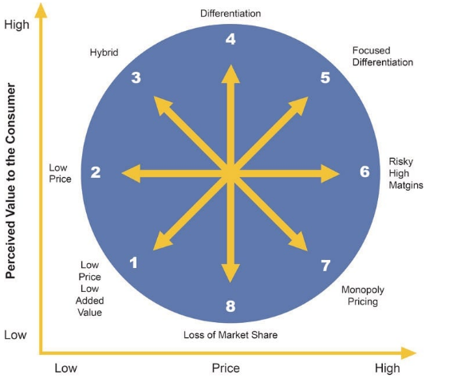
[Source: Tassabehji and Isherwood, 2014]
The first strategy of any business that is low value and low price is not desirable for Cook trading for their long term business growth position. There is almost no scope for monopoly pricing strategy in the industry and the size of Cook makes it highly unlikely. The sixth strategy of high margin risky strategy is discarded in the earlier section. The 8th strategy of market share loss is also not desirable for the business (Tassabehji and Isherwood, 2014). The low price position is used by the large super markets for the frozen food products. the current pricing of Cook trading is based on the value based pricing method where the customers are able to justify the little higher price through high quality, self manufactured, healthy food product products of Cook. Still there are some low priced product options in offer, like Thai takeaway at £12, for the customers. Therefore the business is following mainly the differentiation strategy and the hybrid approach is for offers. The differentiation focused approach would reduce market size for the business to be persuaded through niche marketing. Therefore continuing the differentiation strategy would be useful for the business (Tassabehji and Isherwood, 2014). but for the differentiation strategy to marketing promotion plays an important role. here the customer education and awareness developed is important to showcase the differentiated points and also justify the higher price points. Therefore Cook trading has to improve their marketing promotion especially in the digital marketing field along with customer knowledge and data management capability development.

Conclusion and recommendation
The above analysis shows some of the important challenges and opportunity for Cook trading. The business external environment analysis showed that the uncertain political scenario and somehow positive economic scenario is balancing each other. On the other hand the social and technological advancement provided greater scope for the business to expand their business by targeting the older general and also continuing younger generation separate targeting policy. The competitive rivalry and higher power in customer’s hand needs to be managed by the business. The manufacturing capability with high level of human resource is important aspect of business value chain. The business has to improve the inbound logistic and marketing capability. The business internal analysis shows that financial performance is effective. The emphasis on the human resource development, sustainability and CSR aspect is a strong point for the business brand.

Considering all of these the strategic option is analysed through the Ansoff, VRIO and strategic clock framework to produce the following recommendations.
- Cook trading would use the market penetration strategy for the business growth along with product develop approach as a secondary strategy.
- The market penetrations have to be done through developing the e-commerce business. in this approach the business should target to reach 30-40% sales contribution from the ecommerce segment.
- The older demographic segment of above 45 years age group customers would be specially targeted in this new marketing strategy. The mobile first strategy would have to be followed in the ecommerce market.
- The marketing capability need to be developed in the business to generate the sustainable competitive advantage. The customer information needs to be managed through better CRM system or big data like application. In this part better company policy needs to be developed for the new data security regulation.
- The differentiation strategy would have to be maintained in the future business by developing proper marketing strategy, marketing plan, and marketing promotional approach especially following the digital marketing process. This would be the most crucial recommendation for the business.
- The production capability needs to be increased to develop a competitive advantage developing resource. Business must be able to product 100% products through their manufacturing capability.
- The current emphasis on the business sustainability and human resource managed need to be maintained with same vigour.
- The product delivery mechanism needs to be further developed to provide reliable and timely delivery of products. The same day product delivery capability also should be developed.
- New packaging approach needs to be developed to match the customer demand and also lower waste development.

Reference
bfff.co.uk. (2018). BFFF – HOME. [online] Available at: http://bfff.co.uk/ [Accessed 6 Aug. 2018].
BURGESS, M. (2018). What is GDPR? The summary guide to GDPR compliance in the UK. [online] Available at: https://www.wired.co.uk/article/what-is-gdpr-uk-eu-legislation-compliance-summary-fines-2018 [Accessed 6 Aug. 2018].
Chen, H., Chiang, R. H., and Storey, V. C. (2012). Business intelligence and analytics: from big data to big impact. MIS quarterly, 1165-1188.
Clarke, H, and Griffiths, J. (2018). David Davis resigns from Theresa May's Cabinet in split over Brexit. [online] Available at: https://edition.cnn.com/2018/07/08/uk/brexit-secretary-david-davis-resignation/index.html [Accessed 6 Aug. 2018].
cookfood. (2016). Cook Annual report. [online] Available at: https://cook.blob.core.windows.net/downloads/Annual_Report.pdf [Accessed 6 Aug. 2018].
cookfood. (2017). Annual report. [online] Available at: https://www.cookfood.net/info/Annual-Report/ [Accessed 6 Aug. 2018].
cookfood. (2018). NOURISHING RELATIONSHIPS. [online] Available at: https://www.cookfood.net/info/Nourishing-Relationships/ [Accessed 6 Aug. 2018].
De Backer, K., and Miroudot, S. (2014). Mapping global value chains.
E. Dobbs, M. (2014). Guidelines for applying Porter's five forces framework: a set of industry analysis templates. Competitiveness Review, 24(1), 32-45.
food.gov.uk. (2018). Packaging and labelling. [online] Available at: https://www.food.gov.uk/business-guidance/packaging-and-labelling [Accessed 6 Aug. 2018].
foodmanufacture.co.uk. (2018). Uk frozen food industry set to top £10 bn. [online] Available at: https://www.foodmanufacture.co.uk/Article/2018/02/26/Frozen-food-industry-set-to-top-10-billion [Accessed 6 Aug. 2018].
Friedrichsen, M. (2013). Handbook of social media management: Value chain and business models in changing media markets. Springer.
Hussain, S., Khattak, J., Rizwan, A., and Latif, M. A. (2013). ANSOFF matrix, environment, and growth-an interactive triangle. Management and Administrative Sciences Review, 2(2), 196-206.
imf. (2018). Real GDP growth. [online] Available at: http://www.imf.org/external/datamapper/NGDP_RPCH@WEO/OEMDC/ADVEC/WEOWORLD [Accessed 6 Aug. 2018].
Jackson, G., Tetlow, G., Bernard, S. and Pearson, T. (2018). 44 charts that explain the UK economy. [online] UK economy: GDP growth, interest rates and inflation statistics. Available at: https://ig.ft.com/sites/numbers/economies/uk [Accessed 6 Aug. 2018].
Jahshan, E. (2018). Frozen food retail sales up 6%. [online] Available at: https://www.retailgazette.co.uk/blog/2018/01/frozen-food-retail-sales-up-6-per-cent/ [Accessed 6 Aug. 2018].
Killen, C. P., Jugdev, K., Drouin, N., and Petit, Y. (2012). Advancing project and portfolio management research: Applying strategic management theories. International Journal of Project Management, 30(5), 525-538.
Kipley, D., Lewis, A. O., and Jeng, J. L. (2012). Extending Ansoff’s Strategic Diagnosis Model: Defining the Optimal Strategic Performance Positioning Matrix. Sage Open, 2(1), 2158244011435135.
Knorr, D., Froehling, A., Jaeger, H., Reineke, K., Schlueter, O., and Schoessler, K. (2011). Emerging technologies in food processing. Annual review of food science and technology, 2, 203-235.
Magretta, J. (2011). Understanding Michael Porter: The essential guide to competition and strategy. Harvard business press.
mintel. (2017). 62% OF UK DELIVERY USERS HAVE EXPERIENCED AN ISSUE WITH A DELIVERY. [online] Available at: http://www.mintel.com/blog/retail-market-news/62-of-uk-delivery-users-have-experienced-an-issue-with-a-delivery [Accessed 6 Aug. 2018].
ons.gov.uk. (2017). Household disposable income and inequality in the UK: financial year ending 2017. [online] Available at: https://www.ons.gov.uk/peoplepopulationandcommunity/personalandhouseholdfinances/incomeandwealth/bulletins/householddisposableincomeandinequality/financialyearending2017 [Accessed 6 Aug. 2018].
ons.gov.uk. (2018). Internet users, UK: 2018. [online] Available at: https://www.ons.gov.uk/businessindustryandtrade/itandinternetindustry/bulletins/internetusers/2018 [Accessed 6 Aug. 2018].
Pesic, M. A., Milic, V. J., and Stankovic, J. (2013). APPLICATION OF VRIO FRAMEWORK FOR ANALYZING HUMAN RESOURCES’ROLE IN PROVIDING COMPETITIVE ADVANTAGE. Tourism & Management Studies, 575-586.
Pye, S., Li, F. G., Price, J., and Fais, B. (2017). Achieving net-zero emissions through the reframing of UK national targets in the post-Paris Agreement era. Nature Energy, 2(3), 17024.
retailthinktank.co.uk. (2018). How will demographic trends in the UK affect the retail sector. [online] Available at: http://www.retailthinktank.co.uk/whitepaper/how-will-demographic-trends-in-the-uk-affect-the-retail-sector/ [Accessed 6 Aug. 2018].
statista. (2016). Forecast of the internet user penetration rate in the United Kingdom (UK) from 2015 to 2022. [online] Available at: https://www.statista.com/statistics/553589/predicted-internet-user-penetration-rate-in-the-united-kingdom-uk/ [Accessed 6 Aug. 2018].
statista. (2017). Mobile phone internet user penetration in the United Kingdom (UK) from 2014 to 2017. [online] Available at: https://www.statista.com/statistics/284240/united-kingdom-mobile-phone-internet-user-penetration/ [Accessed 6 Aug. 2018].
statista. (2017). Share of consumers that consider frozen food to be inferior to fresh in the United Kingdom (UK) in 2017, by age. [online] Available at: https://www.statista.com/statistics/706900/consumer-attitudes-towards-frozen-food-united-kingdom-uk/ [Accessed 6 Aug. 2018].
Tassabehji, R., and Isherwood, A. (2014). Management use of strategic tools for innovating during turbulent times. Strategic Change, 23(1‐2), 63-80.
Taticchi, P. (Ed.). (2010). Business performance measurement and management: new contexts, themes and challenges. Springer Science & Business Media.
Taylor, E. C. (2012, January). Competitive improvement planning: using ansoff's matrix with abell's model to inform the strategic management process. In Allied Academies International Conference. Academy of Strategic Management. Proceedings (Vol. 11, No. 1, p. 21). Jordan Whitney Enterprises, Inc.
thetimes.co.uk. (2018). The Sunday Times 100 Best Companies. [online] Available at: https://appointments.thetimes.co.uk/article/best100companies/ [Accessed 6 Aug. 2018].
Wagner, M. (2010). The role of corporate sustainability performance for economic performance: A firm-level analysis of moderation effects. Ecological Economics, 69(7), 1553-1560.
Zanoni, S., and Zavanella, L. (2012). Chilled or frozen? Decision strategies for sustainable food supply chains. International Journal of Production Economics, 140(2), 731-736.

Appendices
1.0 Company profile
‘Cook trading ltd’ is in the frozen ready to eat meal business for more than 20 years. They operate in the Uk market through theory 83 stores and close of 850 employees. The headquarter of the business is in Sittingbourne, Kent. Their main business statement is that the product of food is done by using the home made technique and ingredient. No artificial additive is sued in this process. The franchise business approach is also applied in ‘Cook trading’. The business is highly employee focused. The employees are highly satisfied by the organisational support and benefits. The business shares around 5% of their profit with the employee at the end of the year. The business is highly focused on the sustainability part and they take initiative to reduce their carbon foot print, improve contribution to the immediate community and also invest in the staffs for the long term completive advantage development. There are great variety of product, cussing and ingredients to attract wide range of customers. The business is currently pursuing growth approach. In 2015-16’s operation they aimed to increase their capacity by 50%. The business keep on adding new stored every year. The business leadership is highly focused on the long term business sustainability and ethical way of doing business.

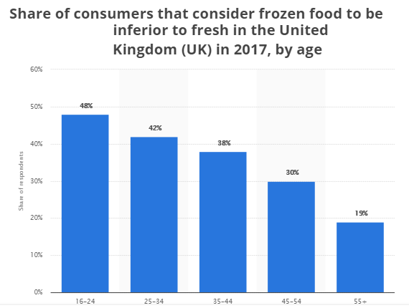
Figure -15

