Global Challenge
Karen McMinn-Davies
1103350

Introduction
International business is where two or more countries liaise together in activities that consist of goods or services. With many growing multinational businesses providing workmanship on a large scale it has become increasingly important for businesses to have positive working structures to be successful individually. Global business interactions continue to increase and have done significantly during the last century, many businesses such as Roche build strong relationships with a variation of countries that in return support the global markets and build a much stronger economy (International realations , 2020). This report will assess the environmental conditions that Roche operates within and explore various economic theories with discussions on actual and potential implications of factors that affect the business operations including internal and external analysis. The report will conclude with recommendations for the business.
International business
Today’s international business is providing the developing countries with better resources such as technology and medicine so therefore the strong global link is of importance to all partners, this can encourage the growth of the historical networks that are in as predicted by the International Monetary Fund, the 6% annual growth in a dozen countries with a combined GDP of $4tn (Guardian , 2016).
However due to the current COVID 19 pandemic there has been a significant shift in resources and medicine that are needed globally. Roche is a company that employs 90,000 employees and operates in more than 100 countries and has recently had to change its strategic direction to support the current pandemic. Roche operates under two divisions, Pharmaceuticals and Diagnostics. The primary role of the company is to research, develop and produce innovative medicines to support public health (Roche, 2020).
The pandemic has and continues to be a challenge for the medical/health sectors globally, one being the workforce and equipment that is needed to save lives. Workforce in the health service are not able to work remotely like other business operations so therefor staff training on the use of equipment such as testing and then supporting patients with the illness is of great priority. (Surge, 2020) states that this will produce added costs for the healthcare sector as they will want to avoid shortages of the necessary equipment that will be needed. This could potentially lead to an issue in supply and demand, therefore Roche will compete with other pharmaceuticals for the contracts to supply, with the already strain financially on the health services, prices may need to be more competitive to gain commitment and contracts for the business.
Roche being the global leader in medical innovation and biotech, the business has a current annual revenue of 61.5 billion which includes an increase of 9% on last year’s sales (Roche, 2019). Roche works closely with the World Health Organisation (WHO) and has recently been involved with supplying leading equipment and medicine to support health authorities worldwide through Covid 19. A recent article in (Guardian , 2016) discusses globalisation and indicates that there are strong links to international trade which should and will continue to increase.

PESTLE

Opening why a pestle is beneficial for business performance
The following pestle has been conducted to identify key areas of the external environment and to support the analysis of business that Roche conducts.
Political
As we know, trade is fundamental to the development of the UK and World economy. With the UK and recent exit from the EU there are new regulations in place regarding trade measures that the World Health Organisation (WTO) has stated must be adthered to for international trade, some examples of these being, anti-dumping measures, anti-subsidy measures and safeguarding measures that are trade imports (Department of International Trade, 2018). We have now seen the new trade bill (UK Parliament, 2020) being implemented to support the UK as a standalone country and support the adaptation and implementation of new legislations to support businesses and the UK. Roche is one the main medicine and equipment suppliers to the National Health Service in the UK as with many other Countries so its imperative that the review regulations are undertaken, the WHO (World Health Organisation , 2020) regulates the safe, effective and prescribed use of the medicines and equipment that Roche will be distributing to partners.
Some advantages to Global regulation include, control of market powers such as monopoly markets, better working conditions and fairness to employees working from various areas of the globe, safety measures that are in place for products in and out of the UK. The one that also stands out for me is the standardised approach or non-discriminatory rules/regulations in place to encourage business to work together, leading to trade increase, positive national welfare of consumers, product variety and an increase in economic growth (Robinson, 2008). With Roche recently expanding its Distribution centres into the UK in southern England, the strategic direction for business will differ from previous operations due to the changes in regulation and all the above would need to be considered.
(Robinson, 2008) also states there are negatives relating to regulations, firstly, there may be many barriers for businesses to operate successfully, resulting in either unsuccessful business trade leading to unemployment or existing businesses having a lower growth on international trade due to the restrictions that are in place. I have also mentioned an increase in national welfare above but this could also be seen as a negative due to the costs being highly concentrated geographically.
In my opinion, global trade does require regulation in place and more so since Brexit, the regulations will assist existing transitions and also offer security for new trade partners for Roche as now operating from the UK. This will lead to a standardised approach and provide the consistency needed to workers, consumers and all involved trading partners in a strong UK economy. With regards to Roche main base and distribution centre in Switzerland and the operations taking place in over one hundred countries there are now tighter restrictions in place due to the recent pandemic, Roche operates in a single market but currently there is a free trade agreement in place for the EU (UK Government, 2020) providing Roche with some stability during the current business situation that businesses are seeing due to the pandemic.
Brexit
In 2019, the UK’s exports of goods and services totalled £691 billion and imports totalled £721 billion. The EU accounted for 43% of UK exports of goods and services and 52% of imports in 2019 (Uk Government, 2019). Roche is the lead supplier for medicine and equipment to the UK, a negative impact from the reduced business being done between Switzerland and the UK until new agreements are in place are expected. Roche (Financial times , 2016) has expressed the concerns already to the UK that there will be a risk if business reduces between the partners the UK could potentially lose its leading role in medical research and the strong partnership it has with Roche, this would lead to patients not having the correct and crucial medical advanced treatments that are in place and Roche could be replaced by another pharmaceutical meaning a large reduction in sales going forward.
There are 70,000 people employed in the pharmaceutical sector in the UK, providing employment in areas, manufacturing, distribution and clinical trials (The association of British Pharmaceutical industry , 2020) . Pharmaceutical manufacturing is experiencing consistent growth in output, productivity and employment over the last decade. Looking ahead, (Department for Business Innovation& Skill, 2017) states that growth rates of 4–10% per annum are expected, so therefore maintaining a relationship with the UK is of great importance for future business opportunities and growth for Roche.
A further effect from Brexit is the impact on Switzerland and the rising pressures on the Swiss franc currency, (Deloitte, 2020) also that the country so f has experience with currently volatility and so far is has been able to keep it under control, however there are still pressures to maintain a minimum standard of trade and the correct costs for partners to continue to purchase from Roche. Over the last twelve months, sales in the first quarter grew by 7%, due to the pandemic the second quarter seen a reduction of 4 %, however over the third quarter the business has seen a positive result of an increase of 1 %, this is largely due to the new medicines and equipment such as Covid 19 tests that have been purchased globally to support patient care (Roche, 2020).
Economic
Roche invested in its pricing by an innovative approach into Personalised reimbursement models ( PRM) and International differential pricing ( IDP), this will increase access to medicines to partners globally and allow the corporation between partners to share data and the tracking of medication and equipment to monitor the outputs. (Roche, 2020) states the idea is to reduce monitory pressures as the medicines will be priced more effectively and will lead to an increase in market share as the medicines will be more beneficial for the masses purchased. This model also worked well for the Italian Medicines Agency (AIFA) with Roche now building on this experience and incorporating some good working practises that the WHO agrees with.
Sales Growth due to inflationary pressures, The business as mentioned earlier has seen a rise over the third quarter this year of 1 %. The pharmaceutical divisions have seen a rise of 35 % over the last nine months of new medicines, which were mainly to support Covid 19 globally and the Diagnostic division has also seen an increase of 9% as it was the only suppler of medical equipment for testing on Covid 19 patients (Roche, 2020)
The diagnostic division have also increased stakeholders globally from the testing equipment supplied but has seen an increase of other medical areas to support and deliver solutions to patients across the globe for all other server diseases. The following table confirms sales for the last twelve months with various countries, with considerations of the current climate, the sales difference between 2019-2020 are not as bad as predicted and infect with the new partnerships in place to support the pandemic the overall figures will become more positive over the coming weeks (Roche, 2020)

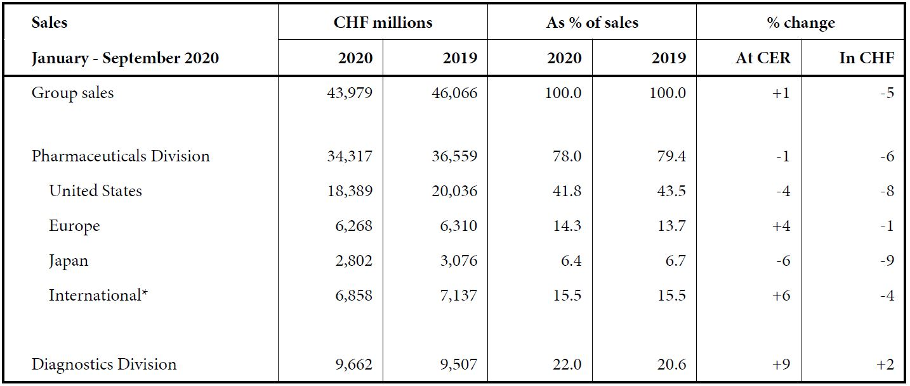
(Roche, 2020)
AstraZeneca that are a main competitor to Roche have already indicated that the Pandemic will have a negative effect on its overall growth for 2020 (Surge, 2020), this downturn can also effect other pharmaceuticals which in return will have a massive effect on the not just the UK but the Global economy.
Social
The world has a growing ageing population which is resulting in the need for medical advances in both medicine and equipment, the alliance between Chugai in Japan and Roche supports the business in operations around sustainability and healthcare. The (World Health Organisation , 2014) stated that they foresee an already aging population with a large percentage of residents over 65 years of age that by 2050 one third of its population will be at least eighty years of age. This is seen as an indicator of improvement in medicine and healthcare, however this has and will continue to result in further daily nursing care needed to support the services that are needed within healthcare.
With Chugai promoting business via sustainability and partnerships with Japan National Council and Social Welfare it’s having a positive impact on the elderly population as free vehicles are provided to ensure the elderly can be supported in the community medically and socially(Chugai Pharmaceutical, 2020), this is also leading to further stakeholder opportunities for Roche as it’s been recognised by the WHO for its sustainable methods as mentioned as well as the developing products that help the standard of care provided for diseases. This is providing a path that other countries may also want to be involved in from what is evident from the success of Roche.
The medical advances in diagnosing and equipment needed to treat sever diseases and improving the healthcare of the world population means that there are further demands to support the growing population, areas such as third world countries there is a larger demand for drugs and diagnosis. Roche as the current market leader is in a strong position for both of these areas which will lead to increase market share and expansion of its business.
There is a strong market for anti-aging products worldwide, the anti-aging market has been growing at a rate of 7.8 % between 2013-2020 (Statista, 2020), with Roche already involved in some production of aging products this is a positive arm for the business as the demand for these products continue to rise so therefore allowing Roche to strengthen its business area (Business wire, 2020).

Technological
All pharmaceutical companies are now using modern day medicines and studies, one being Biotechnology, new innovative medicines are being made and distributed globally for all medical purposes, Roche being a market leader would need to maintain pace with competitors in the study of living organisms and maintain product distribution to the its stakeholders like the NHS. (Bush , 2019) states that this could potentially lead to a decline in the need for medication which would have a sever effect on the pharmaceutical industry, an example of this is that biotechnology is also used to produce different sources and alternatives to meat such as plant extracts, this in the longer term would mean more people would have less health conditions as eating meat is one large factor to develop health problems resulting in decline for medical treatments.
Technology is increasing marketing activities, making it easier for companies to reach out to businesses and produce more effective marketing campaigns to reach a wider audience quickly, by having a digital marketing plan/campaign increased potential profits as the company needs to spend less on traditional marketing methods and could potentially lower customer acquisition costs as a result and increasing new business.
The production of new medicine via the use of medical-technologies is a key aspect of innovation for any pharmaceutical company, these new advances will save lives and also hit new milestones in the world of technology. (Ellis, 2019) who is part of a clinical group providing a list of the top ten advances some of these include, CRISPER, 3-D printing and artificial organs. The machinery also includes key diagnosis equipment such as blood analysers which is something that Roche currently supplies our NHS with.
Legal
Within the Pharmaceutical business Governing bodies and public officials play a key role in the legal element of how business is conducted, therefore to maintain social cohesion, environmental protection and economic stability Roche will need to meet the legal standard (Roche, 2020), there is also an increase in patient demanding further rights within their standards of care and programmes and with the evolution of operating online is also becoming more difficult to manage. With Roche operating over many countries there will be various laws to be adhered to.
Some advantages to Global regulation include, control of market powers such as monopoly markets, better working conditions and fairness to employees working from various areas of the globe, safety measures that are in place for products in and out of the UK. The one that also stands out for me is the standardised approach or non-discriminatory rules/regulations in place to encourage business to work together, leading to trade increase, positive national welfare of consumers, product variety and an increase in economic growth (Robinson, 2008)
(Robinson, 2008) states there are some negatives relating to regulations, firstly, there may be many barriers for businesses to operate successfully, resulting in either unsuccessful business trade leading to unemployment or existing businesses having a lower growth on international trade due to the restrictions that are in place. I have also mentioned an increase in national welfare above but this could also be seen as a negative due to the costs being highly concentrated geographically (Robinson, 2008).
There are instances where some business take part in providing payments to officials in the state to facilitate their operations. This is not good practise and law breaking but unfortunately its common on a local level. Business operations on an international level often get caught from breach of law as above, a recent example being China and the new competition law that many western businesses are breaching the often (Morrison , 2020) , an example of this is GSK, a Chinese business who was fined $500 million dollars. Roche having operations with Changu would mean that there are differences in legal systems that the business is more familiar with in other countries so must be vigilant in the new laws.
In my opinion, global trade does require regulation to be place and with regards to Roche having a strong presence in the UK and Brexit agreements taking place, the regulations will assist existing transitions and also offer security for new trade and alliances in the UK. This will lead to a standardised approach and provide the consistency needed to workers, consumers and all involved trading partners in a strong UK economy. The same also applies to the new regulations for the business that is conducted in China.
Environmental
The current agenda globally for pharmaceuticals is to become friendlier and adapt their ongoing business plans to support improvements environmentally (Shaw, 2011) also states that linking into the Corporate Social responsibilities programmes (CSR) is the way forward for businesses to innovate new products and ways to promote them as eco-friendly.

Porters five forces

Potential entrants
An industry as large as Pharmaceuticals often entices new companies to enter the market, innovate new products and conduct research to support the World Health Organisation. A further point to make is that there can be a lack of knowledge by customers in the purchasing of products in the industry so therefore existing producers being able to set higher prices, Therefore making the threat high.
The industry

Buyers

Suppliers
The medical sector tends to have barriers that are high in areas of research, regulatory restrictions and also legality to enter different countries. Roche is a brand that is known for innovation and the quality of products and services it provides, (Maresova & Kuka, 2014) believes this can result in the purchasers not seeking other company products as they are already satisfied.
Figure 2 Below shows what the expectations are for developments markets in the medical sector.

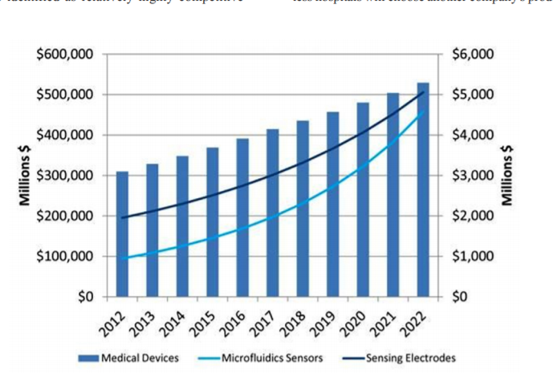
As predicted there has been a continuous rise in the need for these products. Roche has built a strong strategic plan and aligned this with suppliers (Roche , 2020) and strives to achieve the commitment to meet the demand in place for its products. The commitments are shown below.

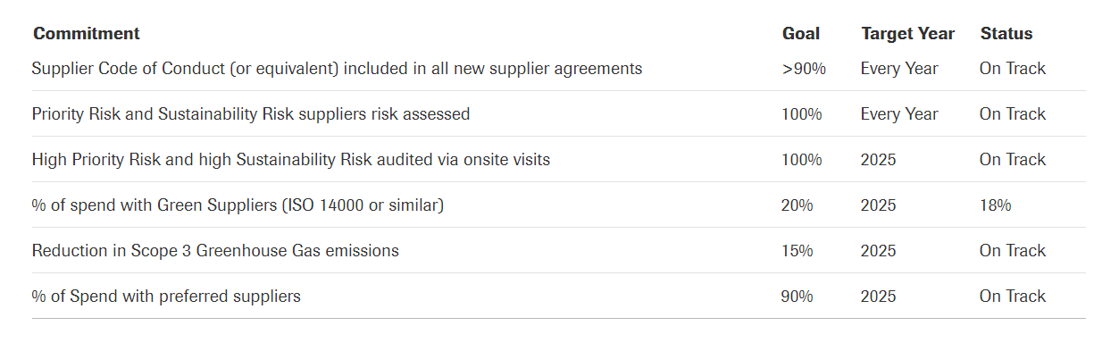
Roche has recently been in the news due to supply chain issue caused from the pandemic, where it has been unable to meet demands to produce the diagnostic kits for its commitments to the UK, this could result in a decline in future contractual business for the organisation, however Roche have formed a recovery plan which has reassured the UK it has prioritised the business needs (Welsh Government , 2019).

Substitutes

Swot
Advantages of swot analysis and why its good for business – intro
The following SWOT analysis on the internal environment has also been conducted to identify various ongoing opportunities for improvements to the business.
Strengths | Weaknesses
New analysis programme developed in partnership with Changai.  Innovative medical technology – discussed above in Pestle.  Presence within global market.  Strong financial background and manufacturing capabilities.  Existing stakeholders and commitment for the NHS UK as well as globally.  Roche-Diagnostic supporting testing for Covid19 | Drug regulation  Medicine regulation and distribution  Rented premises – higher production costs
Opportunities | Threats
New drug policies and regulations will contribute to the growth of the company.  Reduction in imports to support pricing strategies  Strong research and development department. | Existing patents that are expiring  Large companies, GlaxoSmithKline, Pfizer and AstraZenica being recognised.  Price increases – affecting supply chain

Strengths
- The recent development in the Genomic-mutation analysis programme for Cancer treatment has obtained regulatory approval recently (Chugai, 2019), therefore the enrolment of the new treatment on a global scale can proceed.
- Roche Sales have increased significantly over the last few years, as seen in the annual report (2) Core sales increased by 9 % between 2018-2018 resulting in profit-increase of 11% (Roche, 2019).
- The current pandemic we are experiencing means there are large volumes of equipment needed to test patients and provide solutions to the Covid19, (Roche, 2020) are providing resting equipment that is essential to diagnose each individual patient and are being recognised on a global-scale.
- Roche is well known for its sustainability, the business operates with a holistic structure to improve within areas such as environmentally, people’s attraction and retention and social responsibility ( F. Hoffmann-La Roche Ltd, 2020).
Weaknesses
- The regulation of drugs and medicines conducted agreed through the European Medicines Agency (EMA) and the National-medicines authority (Commons, 2019) means that not all epidemiologist findings are put in action so therefore costs can be high.
- Some workspaces are rented premises, this increase costs for consumers as there are larger production costs (Hoq, et al., 2013) stated these prices are reflected in the increased rate in the medicine or equipment that is purchased.
Opportunities
- Reducing the threat to competitors due to the increasing price of medicines, with the growth of pharmaceutical business, new regulations and policies to be placed to decrease the number of imported drugs and medicines (Krylova, et al., 2020).
- Stakeholder engagement and the rise in the new innovative equipment being used to combat the pandemic can be a new opportunity to conduct further business opportunities for the company (Roche, 2020).
- Roche are still working on a vaccine in line with its competitor which are mentioned throughout this report, Roche can sustain its business due to its diversification of business through pharmaceuticals and diagnostics, it’s more sustainable and offering contracts on a diverse basis and attending to the medical needs to people around the world ( F. Hoffmann-La Roche Ltd, 2020)
- Self-regulation is a vital component in todays Global economy. Industries such as health care are using self-regulatory processes to govern practices. (Mikinsey & Company , 2020) said these industry-sector relies on self-regulation to identify different issues and good standards of practice, professional ethics that will build on consumer confidence. It’s evident that this this is important for governing industries and beneficial for consumers, Government, producers and the economy which brings opportunity and flexibility, allowing firms to be more efficient and minimise compliance costs.
Threats
- Pfizer and AstraZenica pharmaceuticals are being recognised for their development in the Covid19 vaccine (AstraZeneca, 2020), the expansions within these companies are already being discussed globally, so there is a larger threat of future business being taken away from Roche within its pharmaceutical sector.
- Prince increases from suppliers are causing a problem in the supply chain and equipment needed can be delayed and cause serious problems both now and in the future (Krylova, et al., 2020) agreed and states that the internal factors can have a negative effect on the development of opportunities for the business and there will be exposure to competitors and having the continuous price-increase on drugs.

Strategic alliance ( put into swot)
Companies decide to form strategic global business alliances for many reasons. One of the most important reasons is to gain access to another company's knowledge or resources. Companies can also decide to join forces to develop new products or to enter a market that neither could enter alone Often, when companies co-operate on a project, they exchange skills. Typically, one partner possesses expertise in one area and vice versa. What that partner needs from the other partner or partners is capital, large distribution systems, marketing expertise, service networks and credibility in the marketplace (Trade ready , 2014).
There will be challenges that businesses will need to consider before any agreement to create an alliance would be completed. One of the biggest disadvantages that occurs within a global strategic alliance is the crossover of employees. When companies come together, you are putting your company at risk. You might lose good people because your strategic partners are able to pay your best people more than you can afford to pay them. Another consideration would be conflict, how and who would have the rights to the product, patents etc. The end results for to some alliances may end up in disagreement and if it’s on a global scale could lead to litigation (BrandonGaille, 2020). Global cultures can also have an impact with two businesses coming together, clashes can occur for example when a Western company and Asia Pacific comes together. If this occurs blame is pushed back and forth which may not solve issues and make tensions that are already there escalate into a further problem resulting in a breakdown of relationships. Finally, I feel that loss of control should be mentioned, forming a strategic alliance and depending on equity stake in the business could potentially mean loss of control for one or more of the businesses, this would need to negotiated correctly at the initial stages (The balance Small business, 2020).
The current economic pressures and the flattening of globalisation could be due to a variety of factors that continue to be discussed, research shows, China and Japan are transforming contemporary economic globalisation and has become the ‘economic globaliser’ for the twenty-first century. An alliance that was formed between Chugais pharmaceutical and Roche to utilise services in Japan (Financial Times, 2020), it’s proving positive and encouraging the way for other such countries, such as Asia and Beijing, that are showing future growth within the Global Economy (Diego Trindade, 2018). China is the largest exporter of medical devices to the US, accounting for 39.3%. Production slow-downs and limitations in supply would inadvertently lead to revenue loss for businesses (Surge, 2020), this could result in a supply issue which currently the world economy cannot uphold due to the pandemic. (Surge, 2020) states this is encouraging more companies to collaborate together and develop things such as new drugs and equipment, such companies include Novavax, Johnson & Johnson and Vir Biotechnology. This leads to further opportunities for business growth.
China overtakes America.
Capitalism and the democratic system we are custom too shows lack of rules and regulations which also links to the recent presidential election and what future positions the US and many other countries may find themselves in with international trading (Guardian, 2016) and future global agreements, we find ourselves in a situation of inequality (Business Insider , 2016)
Acquisition
Roche recently acquired Spark therapeutics in Philadelphia for $4.3 billion in the hope to strengthen their presence in the gene therapy medical sector. (MedCity News, 2019) said that this is a positive move into the American markets to further develop transformational therapies.
On the other hand this type of acquisition could lead to issues or investigations such as the recent one regarding the gene therapies that the individual companies were untaken before acquisition are very different and if one business takes over lead of the other it could harm what therapies are introduced to the market, if concerns like this are identified investigations from (Federal Trade Commission , 2019) and (UK Government , 2019).

Price regulation

Protectism
Protectionism is trying to use restrictions such as tariffs to boost your country's industry, and shield it from foreign competition (BBC, Trump tariffs and protectionism explained ). Protectionist policies are usually implemented with the goal to improve economic activity within a domestic economy but can also be implemented if a Country had quality concerns (Chappelow, 2020) said the policies restrictions on international trade are for the benefit of a domestic economy.
With regards to the US and the shear size of the country, the recent trade war with countries such as China , the classical theory dictates that there could be sever effects and the continuous rise in tariffs (Fajgelbaum,, et al., 2019) states if this continues there would be further negative effects to all consumers and firms who purchase any foreign products and retaliatory tariffs could lead to higher costs. However, there are some advantages to what Trump was trying to achieve for example the protection of jobs for workers in the medical industry and the diversification of the Economy where protectionism is placed to support the new development of internal businesses, this will encourage some foreign companies which are currently producing outside the US to now have an incentive to relocate business within the US borders. The results of which will mean employments, salaries, spending etc will encourage more inward investments and produce more revenue in the longer term for the US Government (Tziamalis, 2017). Roche controls Biotechnology company called Genetch and as we have discussed already has the association with Chugai pharmaceuticals so therefore is paving the way to protect business performance by diversification into the two largest economy’s in the world. Roche must consider its own future performance within all countries it may be purchasing from to avoid unnecessary costs to the business.
Economic Indicators
GDP is a primary indicator of macroeconomic performance. The GDP can demonstrate the health of the economy. The four components within GDP are consumption, investment, Government expenditure and net exports (Corporate Finance Institute, 2020). The chart below shows differences in the GNI, with China having the highest figures which has tripled over the last twenty-years. Comparing this to India, for example, a much lower GNI where living standards are lower. I feel that the analysis carried out every three months is something that provides more insight than some other indicators into future economic growth. With Roche operating Globally following the patterns of GDP and GNI are of great importance to identify the gap between developing and emerging countries and therefore identifying future business investments for Roche.
Figure 1

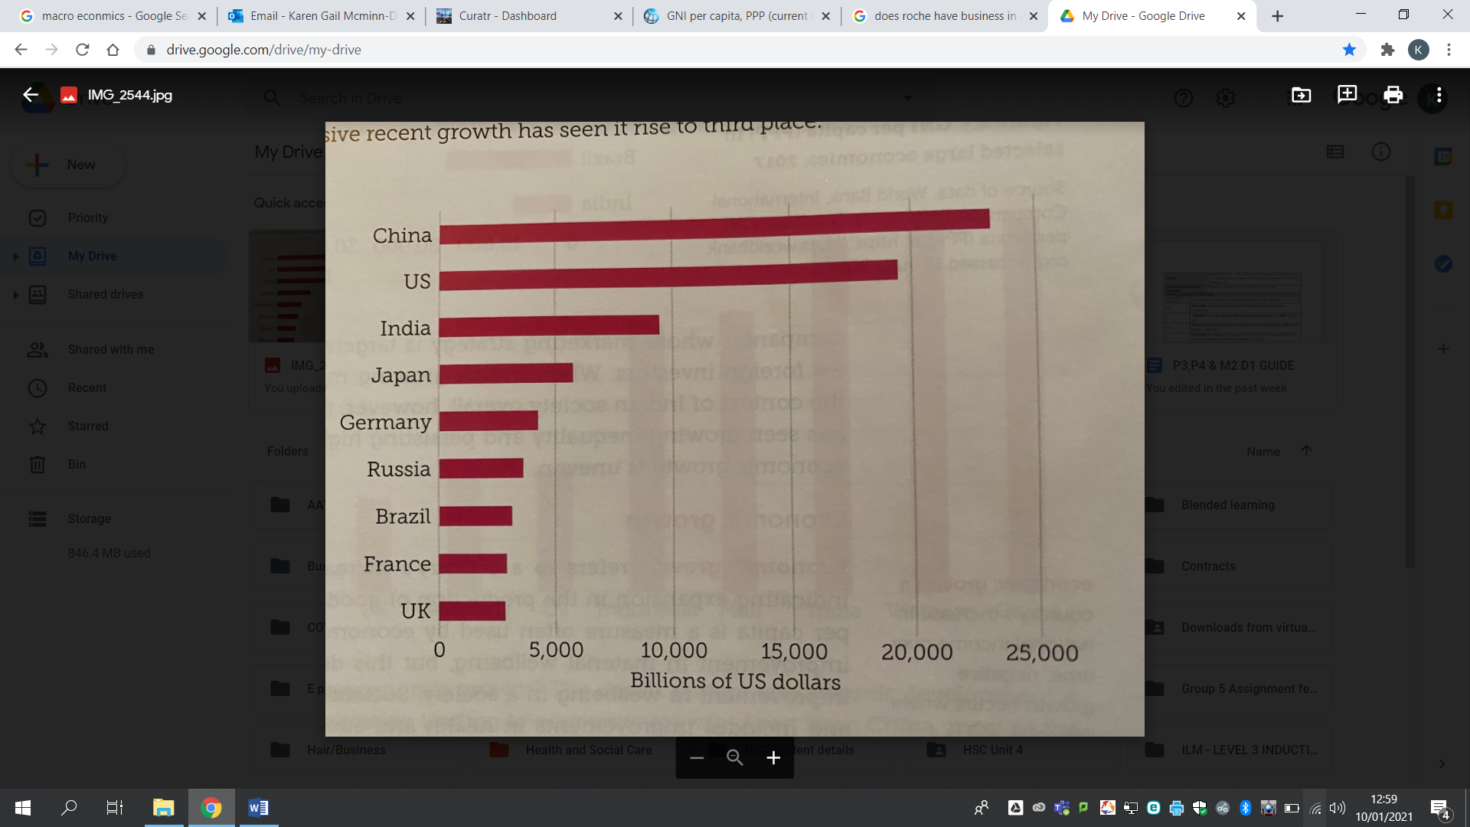
(The World Bank, 2017)
Roche has large investments within two top economic growth produced countries globally, the long term partnership with Changi and investment with US Grenech is beneficial, I feel it’s important to point out that China has now overtaken America as the largest economy in the world (Morrison , 2020, p. 119) stated that its GNI is nearly $4 trillion dollars more, Roches has strong business operations here and again is taking advantage of the business growth in the highest developing countries. Roche will remain in a strong position if it continues to grow business, an example of the current pandemic, Roche have still not produced a vaccine like its competitors however the production of the equipment that is needed to identify and treat Covid19 patients is being supplied on a global scale and business is in high demand for its technological equipment.
International business has increased the demand for technology and they way it is required, technology diffusion and transfer is amongst the advances between developing countries. (Morrison , 2020) states that innovation and the production will grow the economy by providing new jobs, skills and stakeholders for the business.

Capitalism
Capitalism and the democratic system we are custom too shows lack of rules and regulations which also links to the new presidential election and what future positions the US and many other countries may find themselves in with international trading (Guardian , 2016) and future global agreements, we find ourselves in a situation of inequality (Business insider , 2016).
Cultural factors to consider ( see j morrison p219)

Conclusion

6. Conclusion
With fears of a new recession and financial collapse, times like these call for resilient and strong leadership in healthcare, business, government and wider society. Immediate relief measures need to be implemented and adjusted for those that may fall through the cracks. Medium and longer term planning is needed to re-balance and re-energise the economy following this crisis. A broad socioeconomic development plan including sector by sector plans and an ecosystem that encourages entrepreneurship is also needed so that those with robust and sustainable business models can flourish. It is prudent that governments and financial institutions constantly re-assess and re-evaluate the state of play and ensure that the ‘whatever it takes’ promise is truly delivered.

