Comedy is something that I believe comes quite natural to me when acting and performing a comedic scene, but what I find challenging is something that has a negative theme and tone to it, or a very real struggle. A monologue that I really wanted to try was from “The Awkward Years” by (Matthew Bulgo, 2018) . The monologue had a certain flow to it and had a deeper meaning. There was an opportunity to show range well as I thought the monologue showed vulnerability and projection. The character “Lily” has a motivation to embarrass and make another character uncomfortable and to my understanding of the play and the character, this was a projection of her own insecurities. She wanted to make herself feel better and have a false sense of power. The monologue also had natural breaks in her speech with her own memories which was a good opportunity to show range - being able to be in one space and environment then switch back into another.
However, I didn’t achieve this to the best of my ability in the time that I had and so I decided that it was best to have another option. In the future I think I would like to come to a quicker conclusion of what I wanted to show and perform; if I made this decision I feel as though I would have been able to get the work to the standard that I wanted.
From a recommendation earlier on in the process, I came across a monologue from the play “People, Places and Things” by (Duncan Macmillan, 2024). I was drawn to this monologue because of how the character “Emma” talks about acting. Emma, has a substance abuse problem so to understand the character more, I wanted to do some research into substance dependency. I wanted to find real experiences from people. I watched a video, “How Alcohol Took Over My Life: Addiction And Recovery,” (Only Human, 2025) on people talking about their experiences when they were an alcoholic. I do not personally relate to this side of the character, but I do relate to how she speaks and feels about acting. She is great at playing every character but herself, and I really wanted to try and show that fear and discomfort of having to be herself in her own life rather than assuming the role of a character. Another video I watched was a about a woman’s story where she was addicted to prescription drugs. In the video, “Prescription Drug Addiction: One Woman’s Story” (Munson Healthcare, 2011), it focuses on Stacy Salon who states “It was about a year into, to taking the medication when I realised that I couldn’t go more than four hours without taking it and I would start feeling almost like I had the flu.” Understanding the feeling of going without medication helped me realise the motivation to keep taking these drugs.
Something that I have always found hard to do during rehearsals and other work is to stop apologising. I really want to try and only apologise for something that genuinely needs apologising for. The book “Resilience For Actors” by Alexa Ispas, explains this very clearly, “it becomes paralyzing, making the set-back more impactful than it already is.” (Ispas, 2023). This really shows me the damage it can do, but I think that now I am more aware of this problem within myself I can foresee it happening and stop it before it happens. It’s a really small thing that has been a part of my process but important all the same.
Like my previous statement, the route of the apologising problem is through the lack trust in myself that I’m making the right decisions. The professional practice module has, in my opinion, had more freedom in the process so I really wanted to set my own smart goals and have a steady organised process for myself that helps my confidence rise rather than fall. Reading through the book “Resilience For Actors” by Alexa Ispas, has made me understand why something that disrupts a journey to a goal can be such a set-back in confidence. Alexa states, “As you get closer to your target, more dopamine becomes available, leading to an exhilarating feel-good effect that makes you increasingly hopeful and confident. However, when you encounter a set-back, all these positive feelings that are the result of dopamine suddenly stop.” (Ispas, 2023) This is something that I really want to try harder to remember when I feel the need to criticise myself again and again, because I think I just need to remember to keep going and that I can always learn from these mistakes.
During the time on the module I have made a real effort to trust in my own creative decision making. I was determined to give myself the best chance of success when making creative decisions and so I looked for advice on prioritising my work load. A stand-out strategy which worked best for me was the “MoSCoW” method which I found on the website “The Digital Project Manager” written by Hermann Fink. It explains how to use the method in bullet points
“Must: Non-negotiable tasks.
Should: Important but not critical.
Could: Good to have if there’s enough time.
Won’t: Not needed now (revisit later)” (Fink, 2025).
As a result of employing this method to my processes, as we get towards the end of this module, I feel as though I have been able to make a real improvement in my own confidence when it comes to working in a professional environment.
This module has made me realise that there are a lot of options when it comes to monologues and scenes, and this has changed my approach. In the past I would try and find a few monologues at a time that I did enjoy but didn’t love and then it would be a little bit of a scramble to pick one, especially if they all had the same sort of themes and events. With this module I wanted to go into the process having chosen two monologues at a time. That way if at any time something wasn’t working or it was too long, I always have another one that is ready to go and I can start working on immediately. During this time, I found this method of working more useful, because I felt less pressure to find something new if a monologue didn’t work or to try and narrow down a monologue from, four for example.
I feel that this made my time more efficient and productive, and I am very happy with the results that it was given me.
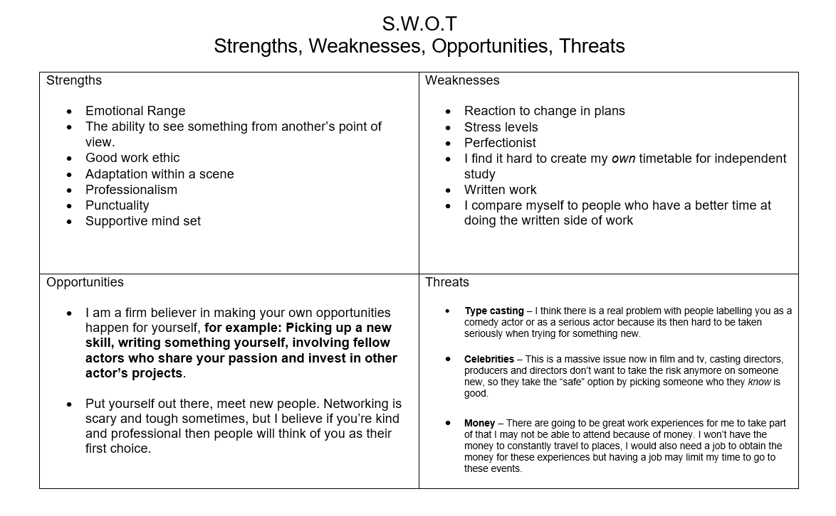

When doing my S.W.O.T Analysis, I wanted to try and make more sense of the “opportunities” and “threats” that I will have and face when leaving university. Like I said in the analysis, I believe you can create your own opportunities for yourself and you can do this by getting more experience and developing your own skills. I am very interested in creative writing and play-writing so there is no reason for me not to write something for myself to act in or for my fellow acting friends. Sophie Kingston-Smith speaks on this subject, (2024). “Write your own plays, short films, or sketches – wherever your strengths lie. Call upon your friends and loved ones to help promote your work, just as you in return can help spread the word about your fellow actors’ projects.” (Kingston-Smith, S. 2024). This is something that I really want to work on, and not just with writing but with other skill sets too just so I can have a wider selection of opportunities.
Networking is a vital part of making your mark in the creative industries and that element of this module has helped me feel better prepared for a real working environment. This level of social interaction has been a challenge for me in the past. I have a lot of fears regarding meeting new people, especially important people on whom I need to make a good first impression as they may have an influence on my future career. Kyle Deguzman, gives some great advice and ideas, “Make sure to attend major industry events like film festivals and acting conferences, where you can meet fellow actors, agents, casting directors, and producers.” (Deguzman, 2024). As part of my efforts to develop my own skills and making new opportunities for myself, I know now I don’t have to wait to be a part of a show case or show, in the meantime I can broaden my network by going to the sort of events Kyle Deguzman has suggested at any time and will endeavour to do this whenever the opportunity is there.
I’ve always found the idea of networking really uncomfortable and unnatural, and I still find it hard. However, I would like to give myself credit for how I approached the hour after the showcase. I did it anyway, with the help of my lecturer Sam, even though it was scary. This is a big part of working within the creative industries and just working life in general, you have to do things anyway even if you find them uncomfortable.
Things that worry me going into the industry are the things that I may not be able to control such as type casting which, in my opinion can be damaging to actors who are in it for the love of the art. Actors who have a label stamped on them by casting directors, producers and directors can be stuck with those kind of roles for a long time. If you are happy with that genre as an actor that’s absolutely fine; but for new actors who are just starting out in the industry, being tied down to one kind of material is, in my opinion, restricting and unfulfilling. Carmichael Phillip gives out pros and cons on type casting, “The most common criticism of typecasting is that it restricts actors’ ability to explore different roles, genres, and character types. Once an actor becomes associated with a certain role, casting directors and audiences may struggle to see them as anything else, preventing career growth and versatility.” (Phillip, 2025) This is what immediately comes to mind when I think of type casting, and this is why one of my goals as an actor is to improve on my range in characters to show that I can play very contrasting roles and I can play them well. I will be aware of this in future in terms of monologue selection for auditions.
Carmichael also talks about the pros, “One of the strongest arguments in favour of typecasting is that it provides actors with steady employment. In an industry known for unpredictability and fierce competition, being known for a specific role type can keep an actor consistently in demand.” (Phillip, 2025). I do understand this statement also, this could help some people who are new to the industry to have a steady job, but this will only work if there is a steady supply of this work which is not guaranteed in the industry when you’re new as we have been taught and warned as students.
A lot of new projects now, whether film, television or theatre, often have the big names in the leads. To me, this shows a lack of confidence and fear of risk. People want their projects to be a massive success and generate profits for investors; the actors for the project are famous and usually very good at what they do, however my argument is that there are also a lot of new actors who are talented and should be given the opportunity. Big names do not necessarily give the best performance. For an example, the website Rotten Tomatoes (No date), gives a list of “100 Worst Movies of All time.” As the title states, there are one hundred movies that have a very low rating with a lot of famous actors who star in them. I just feel as though big projects should have more open casting so they can have more actors and new faces.

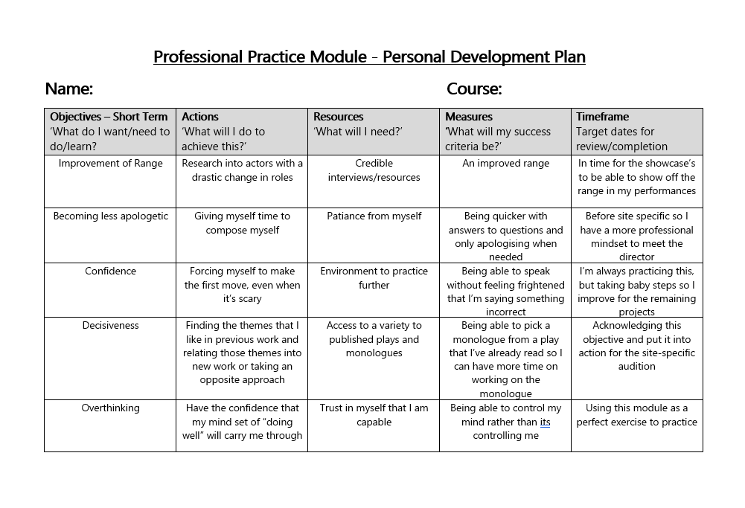

Regarding the PDP, I believe a lot of this has been improved during this module as I have been given the opportunity to be working on these objectives. Working on my CV, I only made a few adjustments from last years work.
CV 1:

CV 2:
CV 3 (Final one):
Comparing the three, I think my experience has grown as well as knowledge on creating a CV. I always wanted to make it more “me” and show my personality which is why I added a small bit of colour, only a little as I didn’t want to seem unprofessional.

Bibliography:
Bulgo, M. (2018) The Awkward Years. Bloomsbury Publishing.
Macmillan, D. (2015/2024) People, Places and Things. Oberon Books/Bloomsbury Publishing.
Only Human. (2025) How Alcohol Took Over My Life: Addiction And Recovery. Available at: How Alcohol Took Over My Life: Addiction And Recovery (Accessed: 6 February 2026).
Munson Healthcare. (2011) Prescription Drug Addiction: One Woman’s Story. Available at: Prescription Drug Addiction: One Woman's Story (Accessed: 6 February 2026).
Ispas, A. (2023) Resilience For Actors. Word Bothy.
Fink, H. (2025) How To Prioritize Task: 5 Proven Techniques. Available at: How To Prioritize Tasks: 5 Proven Techniques (Accessed: 6 February 2026).
Kingston-Smith, S. (2024) How to Become an Actor in the UK. Available at: How to Become an Actor in the UK | Backstage (Accessed: 5 February 2026).
Deguzman, K. (2024) How to make it in the Acting Industry. Available at: How to Make It in the Acting Industry | Backstage (Accessed: 27 February 2026).
Phillip, C. (2025) Is Typecasting Good or Bad? Available at: Acting Magazine Is Typecasting Good or Bad? - Acting Magazine (Accessed: 28 February 2026).
Rotten Tomatoes (2025) 100 WORST MOVIES OF ALL TIME. Available at: Bad Movies: The 100 Worst Movies of All Time | Rotten Tomatoes (Accessed: 28 February 2026).

