Introduction to Web and Database Concepts

Zack Evans – 1908686

Table of Contents
Task 2: Report 3

Introduction
The task was to design and make a responsive website, that is relatable to the current web standards. Then make a report on different aspects of a website such as the usability, accessibility and search engine optimisation and how that was used within the created website.

Requirements
The website was made for a fake photography company named “Precious Moments”. The main aim at creating the website is to show:
- A brief description of the company.
- The employees and their roles.
- Past work they have done.
- Pricing on plans and reviews.
- And different ways that a visitor can contact the company.
The main target audience are big event organisers that want professionally done pictures and edits. This means that the website needed to have a good amount of information about the company and its past while also being engaging and easy to read and trust.
Different type of events that the companies would target towards would be:
- Weddings
- Festivals
- Large parties
- Business Events
To carter for this the portfolio page was made to show off the most impressive moments captured and allows the audience to interact with the elements to gain details on what event it was and a description on what they did.

Implementation
Within this section, the pages will be shown off and the different pages within the website and all the validation problems that were solved.

Home Page
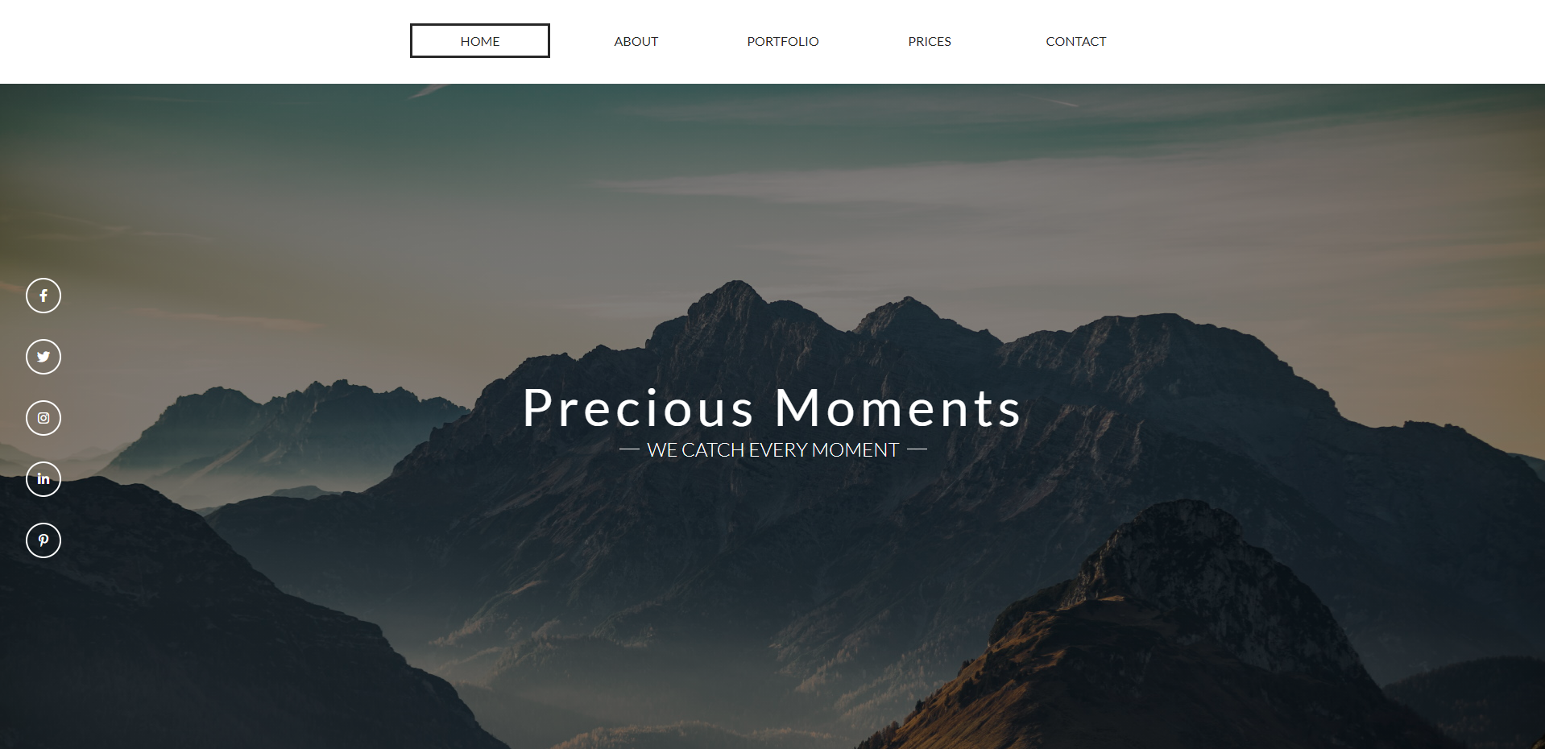
An error within the html was found within this page. Within the HTML tag the lang tag was left out. To solve this issue lang=”en” was added to the page to resolve the problem. No other problems were then found within in the page.

About Page
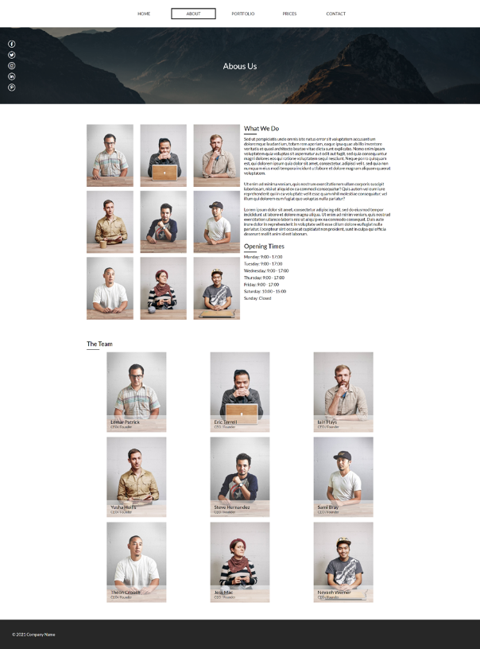
On the about us page. There was a validation error within the HTML. The img elements didn’t contain alt text. Meaning it would not have been optimised for software that help people with impaired vision. To solve this issue, alt tags were added to all images and text that relates to the image.

Portfolio Page
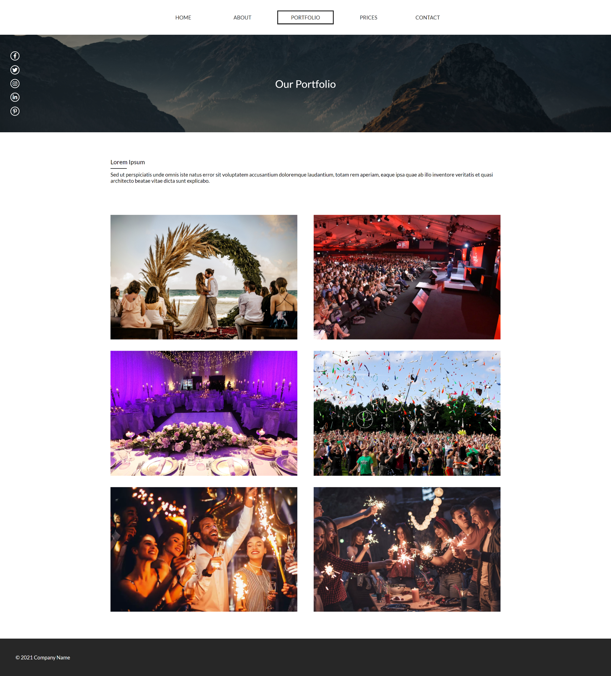
For the portfolio page. A validation warning was given for the HTML. The warning was due to the lack of headings. It consider the use of h2 – h6 elements. To solve this issue, for the hover elements the heading tag was replace with a h3 element instead of being a p.

Prices
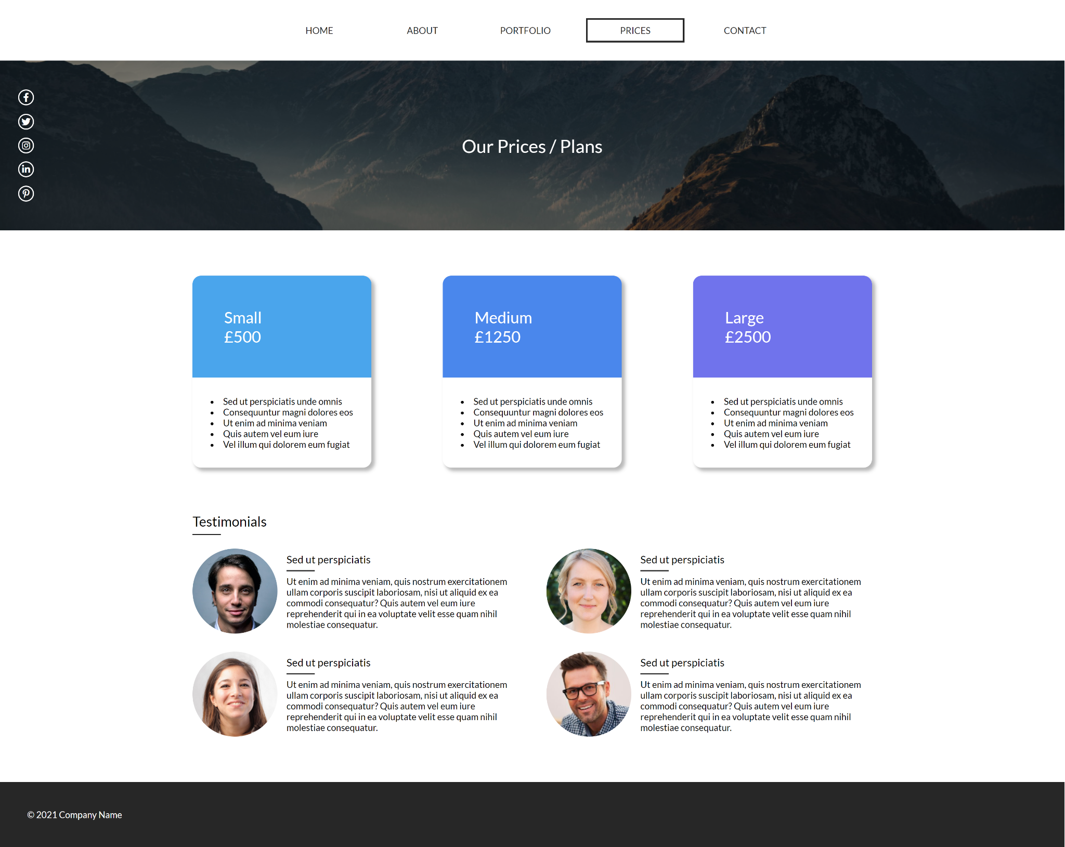
For the pricing page, no errors were found. This is due to the previous errors being found and sorted throughout the website.

Contact
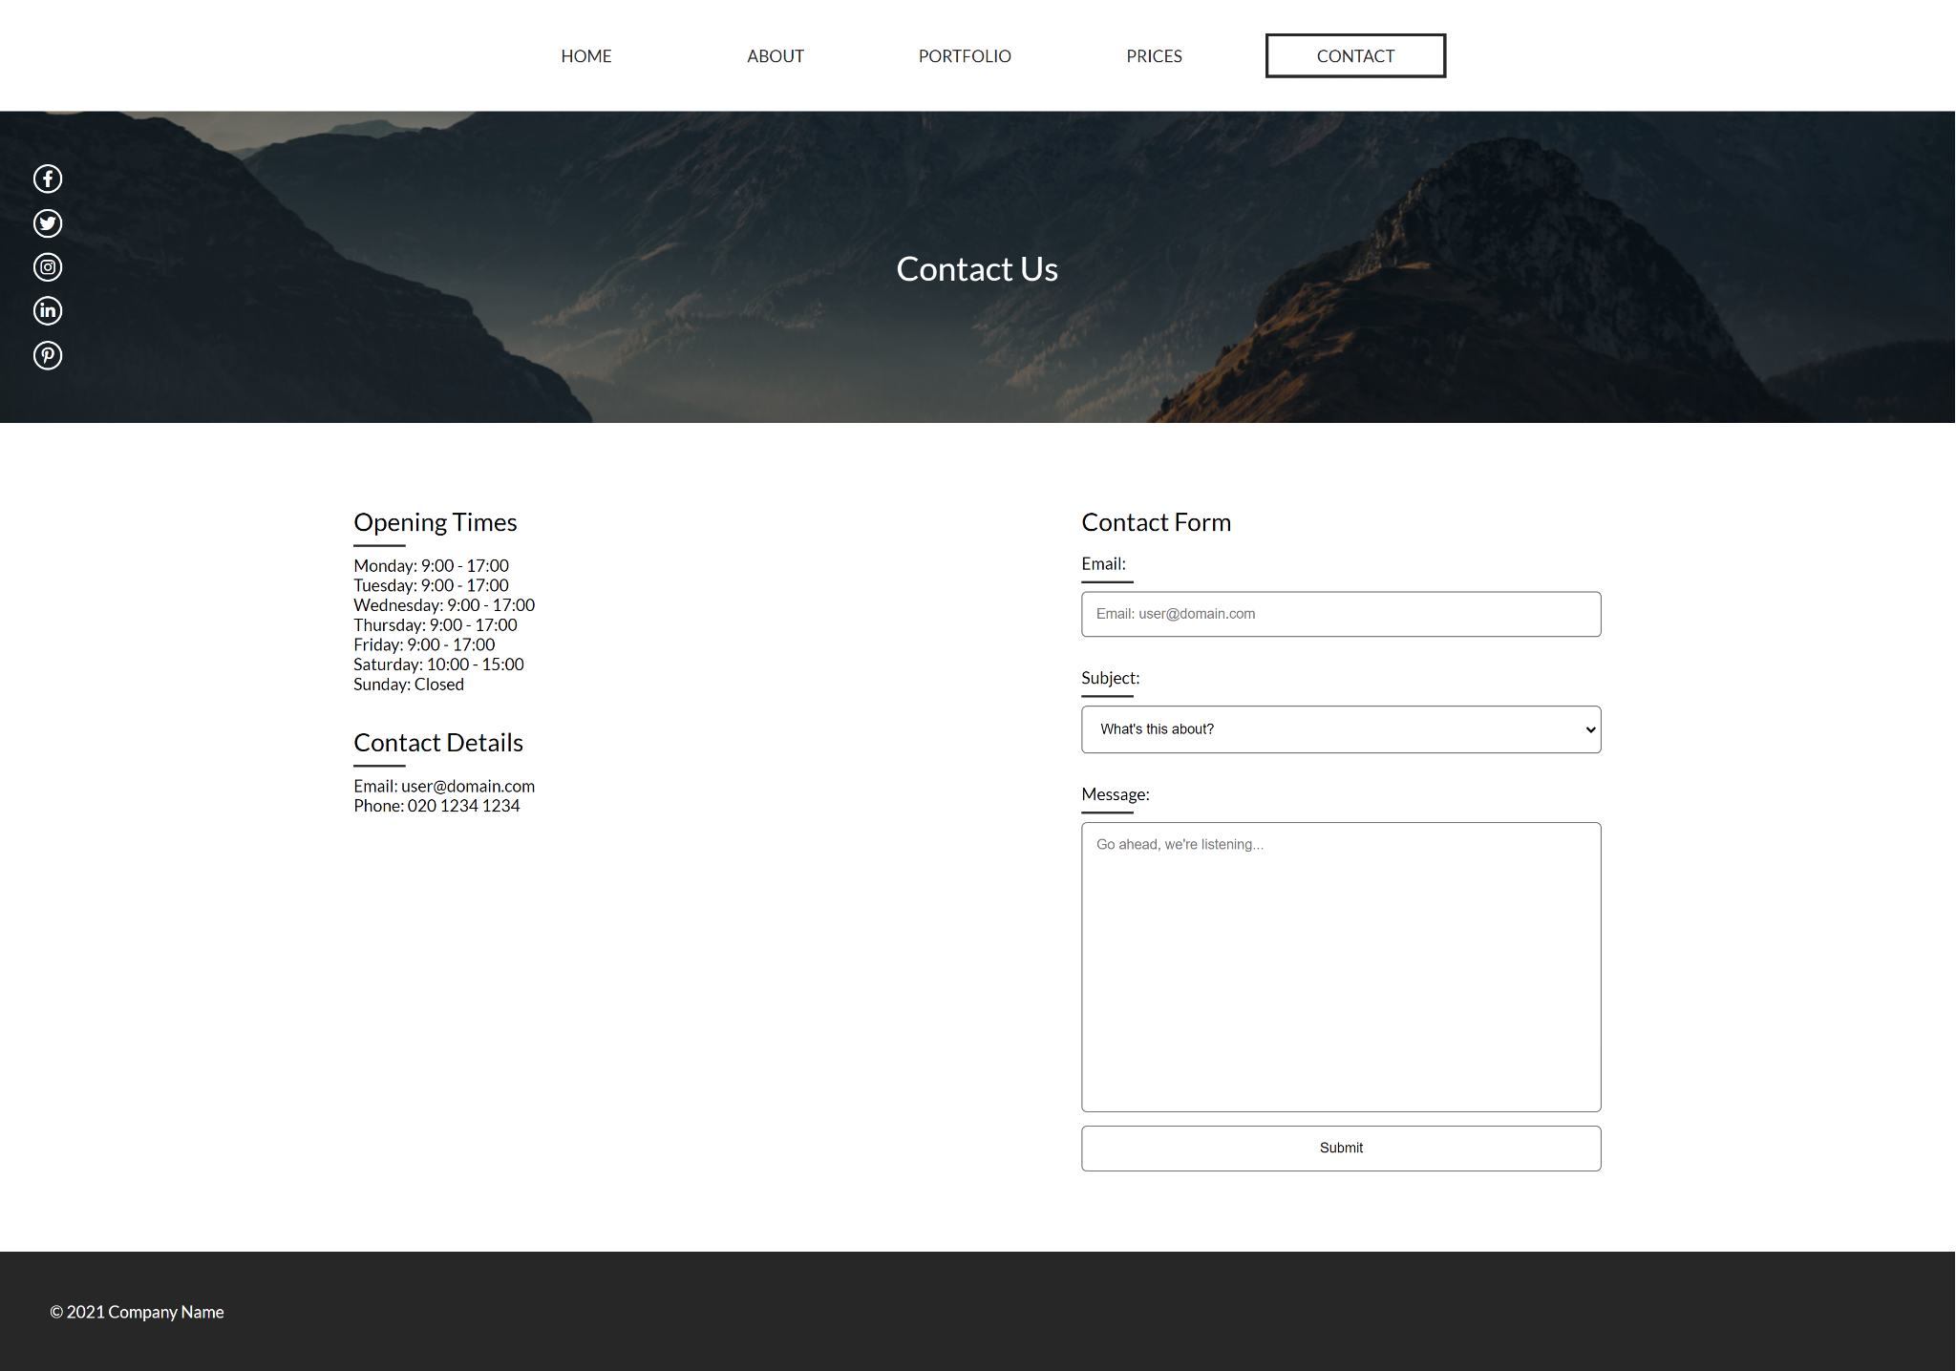
Same as the pricing page. No errors were found due to the fact that the previous errors were resolved from the first initial pages and were done throughout the whole website.

Evaluation

Website Usability
There are different aspects to the usability of a website. Clarity and Relevancy [1] is useful for the usability of the website. If a website is distracting or the colours are harsh on the eyes, then this can distract or confused website visitors. This can lead to increase time to find what they came for, or even forget their original goal making them give up in the process and leaving. There are several points when it comes to clarity [1]:
- Simplicity
- Familiarity
- Consistency
- Guidance
- Direct feedback
- Good information architecture
Having a clear and usable design that is consistent throughout the website allows the users to easily read information on a page without getting distracted or losing their way within the website. Having a straightforward design will allow the user to easily navigate the website to reach their goal.
Having relevant content on a website also helps with the clarity of the website. If a website contains relevant content, then this helps the user with their end goal with the website. If the content on the website was not relevant, then this can lead to confusing and users leaving the website.

Site Implementation
For the implementation of this sector, I made sure that the design of the website was the same throughout the website. This made sure that the users could get used to the design and easily read information within the website while also navigating around the website without any issues. The use of white space also helps divide up the content and helps with users reading and search of content within the website. If this was not there, then it would make it harder for the user to read through blocks of text that are not divided up.
The colour scheme is simple since it is easy to look at and read. If the colour scheme were vibrant, it could have distracted visitors to the website. The layout of the website is formal and straight. This means that when the user is going down the page they do not need to look for to the right or left to read the content. Doing so helps with the readability of the pages and having the formal columns and rows help. All content on the website is related to why the target audience would visit the website.
For the future, the recommended way would be to add a little more colour to the website so that the users of the website would not lose interest due to the dull design. Also adding more functionality like interactive elements would make users curios of the design and the different features it would hold. Lastly, adding widgets that link to social media platforms to display the latest posts would help with showing off more details about the company and even up and coming events without the need of changing anything within the websites HTML.

Accessibility
Having good availability and accessibility, allows users to easily access the website without any problems. If the users try to access the website and it does not work, then the website becomes pointless in the first place. First having a good hosting service will allow the website to stay up most of the time allowing visitors to travel around the website without any issues.
Next, having links that lead to the correct pages within the website help with the accessibility of the website, if links are broken then users will not be able to access useful information within the website. Having all links work will allow users to easily access all parts of the website. To make sure all links work, testing each link on a page is the best way to do so.
Next, having great responsiveness is great for being reliable on all devices. This allows users to view information on all devices without and issues. Having no responsiveness will result in reduced mobile traffic which will take up of half of a normal websites traffic [2]. So having responsiveness for all devices allows all different users to view the pages and could increase purchases.

Site Implementation
For the implementation, testing all links was a top priority to make sure that every link goes to the correct page. If one link was wrong, then this could lead to a decrease in revenue or even visitors to the website. The website was also made for desktop, tablet, and mobile devices so that the target audience can be more diverse and make sure that all types of users would be able to use the website. This can lead to an increase of customers from allowing all devices to access and use the website. Lastly, if the website was to be put online, then using a reliable hosting that guarantees 99% uptime and fast loading times would help with allowing users to access the website without any issues. If the load time were slow then this could lead to users to lose interest and find a different website for their needs. So having a fast host that stays online would help.
For the future, having a different navigation for mobile view would help decrease the clutter on the mobile / tablet views. Doing so would make it easier on the user to go though the pages without getting distracted by the long navigation. Another point would be to start a unit test document so that records of testing links and other aspects of the website is noted down so that it can be referenced to for a later date is something goes wrong.

Search Engine Optimisation
SEO is one of the major’s when creating a website. To get a high ranking within Googles search list a website must have good SEO that relates to its content as well as content that updates on a regular basis. SEO can also define how your website’s show up. From the title, description and subpages within the search result.
Way’s of improving a websites SEO [3]:
- Public relevant.
- Update your content regularly.
- Metadata.
- Have a link-worthy site.
- Use alt tags.
Using quality content is big factor when it comes to search engine rankings. Quality content that is personally catered for the websites users can increase website traffic, which improves the relevance and the sites authority. The use of keywords within the content can help with SEO. An example of this is if a user is trying to search up for “how to apply for scholarships” [3] using that keyword within the content helps increase the rankings within that search. If this relates to the content, then this can be a big bonus to the SEO.
Search engines like websites with content that updates on a regular basis. Regular updates within the content of the website are viewed as one of the best indicators of the website’s relevancy. But remember the content must be unique and relevant to the website. If it is repetitive or not relating to the website this can decrease SEO rankings.
Metadata is responsible for the way you display yourself within a search result. So, it is important to have metadata title and description tags that are relevant and pop out to catch the user’s attention. Having a description that contains two sentences that are appealing and relevant to the user can help with getting them to click onto the website. Lastly, metadata keywords are rarely used but can still help with SEO. Having a variety of keywords help with this. An example of this [3]: “computer science degree”.
A need for focusing on creating relevant links within the content of the website. Instead of including “click here” within the links, trying to a better meaning would help. “Click Here” has no SEO value while “Our University Degree’s” has keywords that help improve the SEO rankings as well as the page that is being linked to. Using descriptive links by using keywords improves the SEO while also making it easier for the users to read.
Lastly, using alt tags to describe the images and video media on the website. This allows search engines to locate your website for those who use text only browsers or screen readers [3].

Case Study
A case study found [4] where a company hired the services of a SEO optimisation company. The SEO optimisation increased sales for the company by 56%.

Site Implementation
For the site’s implementation, the use of meta tags were used. The title tag was used due it being very important for search engines to see the page and display it within the search results. The meta description and keywords were used to help with search engine performance. Where if a user searched different keywords / phrases within the search engine that relate to the websites meta data then this would help display the website as high as possible. The header tags help not only with dividing up content within the website, but it also helps with SEO. This is due to certain header tags being used for certain values within the search engine. An example would be h1 would be used as the websites title and h2 would highlight the topic of the title and so on. If the headers are done correctly this could boost keyword / phrase searches for the website. Alternative tags were also used for images. Search engines cannot determine what an image is by viewing it. So, using alt tags to describe the image helps tell the search engine what it is and how it can be used within searches. Lastly, links within the website are not just click here. They text either relate the page its going to or an icon that relates to the platform.
For the future, a better structured site that uses h1 – h4 tags would help with the optimisation as well as better meta description / keywords would help with the performance of the website as well. Also having external links that go to the website would help boost performance of the website and having references to other websites would help increase the SEO score.

References
[1] The Daily Egg - 5 Key Principles Of Good Website Usability
https://www.crazyegg.com/blog/principles-website-usability/
[2] Statista – Percentage of mobile devices in use of traffic
https://www.statista.com/statistics/277125/share-of-website-traffic-coming-from-mobile-devices/
[3] Michigan Tech – Ways to improve your site’s ranking (SEO)
https://www.mtu.edu/umc/services/websites/seo/
[4] Exposureninja – Company increases sales from SEO
https://exposureninja.com/case-studies/seo/increase-sales-uk-e-cigarette-store/

