William Edwards 2004219

Gobbets for “War made the state, and the state made war”

Dwight D. Eisenhower Order of the Day June 6th 1944
Eisenhower’s speech is concise but very passionate, it is blunt in its realism; talking about how the Germans are well trained, well armed and will fight savagely. He doesn't address the individual nations partaking in Operation Overlord (Britain, France, USA, Poland, Australia etc.), he refers to them as a united nations undertaking a gruelling and gruesome task for the good of the “oppressed peoples of Europe” as well as the “Liberty-loving people everywhere”, his speaking in such tones removes the nationality divide between the troops, changing it from a war of nations, to a one of ideas, and the triumph of freedom over tyranny. He knows the troops must be terrified, they know no amount of training will truly prepare them for the viciousness of real combat, and he does his best to reassure them. He dispels notions of German military superiority by saying how there raids and bombing campaigns have weakened the Germans; he goes on to say how in large scale battles the Allies had beaten the Germans “Man-to-man” further dissuading any notion of the Nazi propaganda idolising the ‘pure aryan superman’, showing that they were all human, and that the Allies were the better soldiers through and through.

Undertones of religion can be found within the speech, Eisenhower uses words like “crusade” and “noble” to describe the actions they are about to undertake, suggesting the idea that utter mercilessness is necessary to rid Europe of the Nazis, this also echoes the old notions of god fighting on their side in a war, which would have bolstered the men’s morale as they knew their actions were supported by divine judgement, his asking of men to pray at the end further trying to raise morale, by trying to make it seem as though they are one in mind, body and spirit, both holy and mortal. It also creates an us vs them mentality in its description of the two forces, the European armies had built up the ideas over centuries that they were honourable and proud forces, who fought hard but surrendered when they knew victory was impossible and wanted to return to their families; Eisenhower dissuades this with phrases like “fight savagely” and “German war machine”, pitting the Germans as honourless brutes who wage wars of aggression, not peace. Compared to the Allied forces, who he describes as “Free men of the world” and “Brothers in arms” which gives off the heir of a force fighting for the goodness of the world, against evil.

This gives an interesting insight into the relationship between the military and other aspects of human life, it taps into the social aspects, into the religious parts of warfare and how the apparent separation of church and state is no more truly revealed when the armed forces supreme commander of the American Republic prays for God to be on their side. Eisenhower’s use of religion makes sense, he was a deeply religious man who grew up in a heavily church-based household, as did many Americans at that time, as such, the symbolism he is trying to achieve would have blended well with the culture of American troops. In particular, his emphasis on freedom and liberty is a social expression of the American mindset, echoing the ideas set forth in the declaration of independence, and how America viewed itself as the shining city on a hill, a paradise of freedom and liberty, even if the truth was and is far from it.
Eisenhower gives a brief summary of the war as well, possibly to indicate the dire situation the allies had found themselves in, driven from mainland Europe in the first two years of the conflict. By this time, Operation Husky had been completed and Italy proper had been invaded, yet the attack was stalling, and the allies needed another foothold, and with the very active and British organised French resistance harassing the Germans, France seemed like a good place to land, as other areas such as Yugoslavia and Norway would not suit the true mechanised army of the Allies. The troops doing the landing would be a mix of veteran and fresh troops, so his telling them that the enemy were well trained and equipped would not alienate the veterans but may unsettle the new troops, he attempts to settle them by saying that the safety of the free world lies upon their success, making them feel of extreme importance

Malplaquet declaration (Wellington entering France during the Hundred Days)

Wellington asking for the French citizens to conduct themselves so that they are not in opposition is almost delusional, a populace are almost never going to be welcoming to a foreign army, which they had been at nigh constant wars for almost two decades, marching through their land; it's proclamation of "an army already victorious" is a poor PR move by him, as it makes it seem as though the French citizens are defeated subjects of foreign powers. Furthermore, he asks them to assist his army in its quartering and supplying, and to conduct themselves well.

He essentially threatens the French civil servants by saying that if you are not in your homes, then they and their possessions are forfeit for the army's sustenance. It is understandable that he wants to shut down all governmental actions and cause bureaucracy to come to a halt, however, it doesn't take into account the individuals who are in charge of the logistics of civilians; additionally, no one knows how long this new war will go on for, and it is unfair to keep people restricted to their houses when they may have to go to far flung locations to get food and other products to continue their lives. He says that his army will conduct itself well, but it was well known by the population that a significant number of the British army were criminals pressed into service, and incidents were bound to occur, especially as an army in foreign territory. In addition to this, Wellington had had to employ military Provost Marshals during the Peninsular campaign in order to keep control of his force, which may have eased the population because at least Wellington was doing something about his troops’ actions when they were not in battle.

He compares the prior Napoleonic conflicts to a yoke of iron oppressing the people, in this way, he attempts to show that what he is doing is merciful and for the good of the French people, when in actuality, it is beneficial primarily for the other European powers, as keeping France weak allowed the others to thrive without serious threat, keeping the balance of power firmly in no one's hands, at least on land in the European theatre. And although the revolution and the Napoleonic period had been a tumultuous time for French citizens, it can be argued that they had a better life than that under the Ancien regime, with every Male citizen allowed political rights, the curtailing of the power of the church, and a new set of laws that applied to everyone equally. To call Napoleon a yoke is accurate, but to say he had oppressed them and harmed them is less so, he had battered the rest of Europe into submission at one time or another, standing against France’s old enemies and besting them, bringing retaliation from the 7 years war, and while many had died in service of him, France was almost without question, the most powerful land power in Europe because of him and his marshals.

Understandably, he asks for local councils and townships to provide his army with sustenance so that he would not have to go foraging or pillaging to gather supplies, this may be straining on the townfolk, but the promises to repay them for their goods is obviously a lot better than having their homes raided. A problem arises when he tells them not to have any correspondence with any of Napoleon’s lackeys or troops, this is an attempt to limit spying or subterfuge of his army, which is a very present risk, one which Wellington himself had enjoyed when the Spanish and Portuguese people helped him during the Peninsular war. However, it can also very easily upset the populace; as it is most likely that some members of the towns and villages would have been in the royal French armies that now flocked to Napoleon. A lack of contact with family can be very stressful to individuals, especially with a war raging on, so it is a great ask of Wellington upon the townsfolk of France to cease contact with anyone who works either in the administration of the French state, or was serving in the French armed forces.

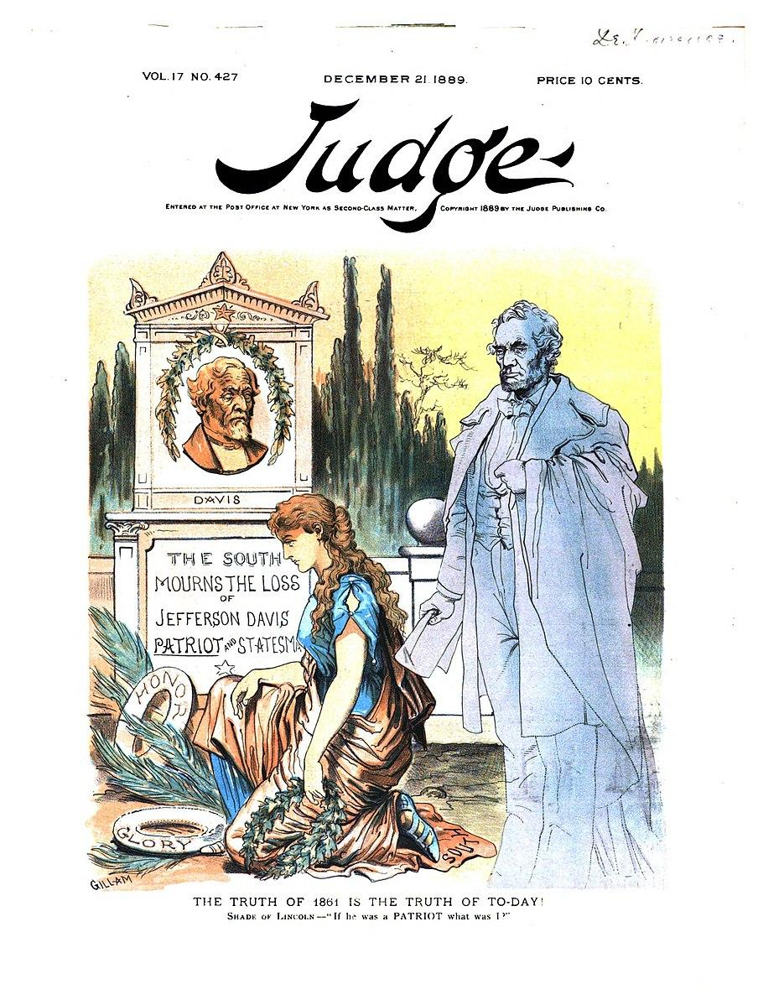
Judge Poster depicting the ghost of Abraham Lincoln after the death of ex-Confederate President Jefferson Davis

The illustration is part of the magazine Judge, a political satirist paper in the USA that ran from 1881 to 1947. The point of the paper is to create political humour, comment on the politics of the day, and to make a mockery of political ideals with social commentary using facial hyperbole or anthropomorphising ideas, indeed an important part of politics has been the type casting and abuse that public figures will inevitably come to face. However, in this case, the lack of cartoonish proportions and grim bleakness in which it portrays its point is blunt and forthcoming. It surrounds the events of the demise of Jefferson Davis, the one and only Confederate President, a controversial and iconic figure of the time, he had led the Confederate States of America (CSA) in seceding from the Union and beginning the American civil war. This came out on the 21st of December 1889, two weeks after the death of Davis, after the funeral and political commentators had had their say and commendations had been made.

The way the different characters are presented is key to understanding the paper's view of the situation. Lincoln, the bold ghost, stands tall and proud in the foreground, dressed neatly and clutching his cloak; the stark contrast between his colouration and the colouration of the background is not only indicative of his presence as a ghost, but also can be construed as his political ideals being of more purity than the rest of reality, his fading can also be seen as the fading of his memory as the lionising of a Confederate becomes mainstream. The clear and tidy image he presents can also show how the public memory of Lincoln was, a clear cut man who was not tainted by any political shenanigans or corruption which mired the image of other past Presidents, the sullen look on his face gives fruition to the idea of him suffering for the union and for the liberation of slaves, and his face weary of fighting still must remain vigilant as he fights Davis’ and white supremacist fantasies from beyond the grave. Beside the monument, a woman is on her knees, this is likely either the personification of America, Columbia, the anthropomorphising of sorrow/victory, or some interpretation of a Greco-Roman goddess. She holds a Laurel wreath in her hand, and seems to have placed rings demarking “Honor” and “glory” at the foot of the monument, which are lathed with reeds bushels.

The memorial of Davis is rich in meaning and symbology, his face is carved in what seems to be copper/brass and is of a grim and grave disposition, his face full of wrinkles and almost a sneer on his face, it reminds one of the line from Shelley’s Ozymandias “..Visage lies, whose frown, and wrinkled lip, and sneer of cold command, tell that its sculptor well those passions read…”. Davis’ face is old and grumpy from anger at losing the war, and being imprisoned as the traitor he was. His image is laden and surrounded by a laurel wreath, a symbol of peace and victory, ironic for the man he was, or perhaps a mockery of his failure? Beneath the visage lies a message “The South mourns the loss of Jefferson Davis. Patriot and statesman”, the words “The South” are emboldened, a not so subtle highlighting of how the USA did not miss him, only the South, and even then, mostly those who fought for the right to keep others as property. He made war against half the country, it would not be appropriate nor correct of a statement to say the country mourned him. The word “Patriot” is also highlighted by the illustrator, this is fitting, as although he was a patriot of the Confederacy, he was definitely not one of the Union, and so the romanticisation of him that ex-confederates viewed themselves and him in is bluntly wrong.

The quote is linked back to the gravestone monument, Lincoln asks that if Jefferson could be named a patriot, what would that make him. This can be seen either as degrading the idea of patriots as to Americans who fight for any cause, or could also be seen as misnaming Jefferson a patriot, when in actuality he should be named a traitor or just as a statesman. Lincoln asks this question because of the Southern pride and deification of people like Davis who led the secession from the Union, the prevalence of the lost cause myth and the lionising of those who killed American soldiers; it is, in a sense, a damning indictment of the smug arrogance with which ex-confederates label themselves heroes of American freedom, and fighting for their rights, their rights to deny others theirs, and kill those who wanted to set all people, of every colour, free from slavery.

Sources (links)

Eisenhower, Dwight, D. Order of the Day (June 6th 1944).
https://www.americanrhetoric.com/speeches/dwighteisenhowerorderofdday.htm

Siborne, William, 1895. The Waterloo Campaign, 1815. 4th Edition (Westminster: Archibald Constable and co.)
https://archive.org/details/waterloocampaig01sibogoog/page/654/mode/2up

Judge Publishing co., Vol 17 No.427, ‘The truth of 1861 is the truth of today’. Judge, Dec. 21 1889
https://babel.hathitrust.org/cgi/pt?id=mdp.39015023538708&view=1up&seq=229&skin=2021

