Impending changes to SEN/ALN legislation in Wales
Contact
Rebecca Collins
1603308
University of Wales Trinity St David
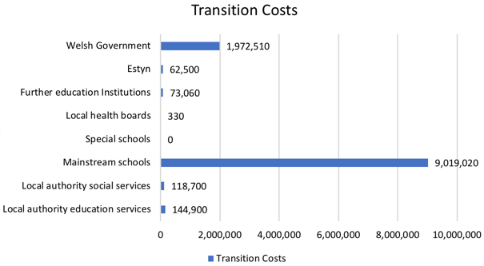
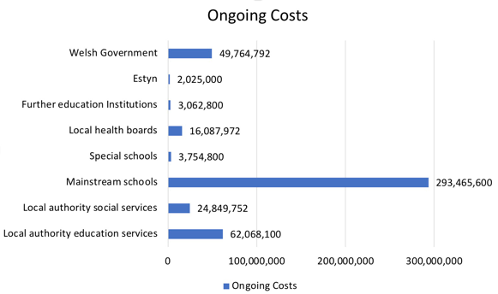
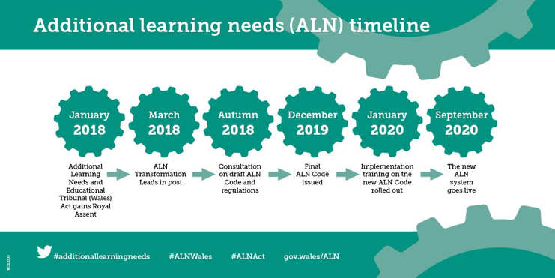
Figure 2 (Modified from Dauncey, 2018).
Figure 1 (Modified from Dauncey, 2018).
Further reading:

SNAP Cymru: http://www.snapcymru.org

Additional Learning Needs and Education Tribunal (Wales) Act: https://beta.gov.wales/sites/default/files/publications/2018-04/additional-learning-needs-and-education-tribunal-wales-act-2018-explanatory-memorandum.pdf

(Source: WG, 2018c)
Introducing the change

The law for children and young people with special educational needs is out of date and is about to change (Welsh Government (WG), 2015a). The current Special Education Needs (SEN) Framework will be replaced with a new system called Additional Learning Needs (ALN) (Dauncey, 2016).The Government wants to take away the current phrase ‘special needs’ to remove stigma and labelling of children with additional learning needs (WG, 2018a). This will promote inclusion and equality for all pupils (WG, 2018a). Hastings and Oakford (2003) suggest that previous research has found teachers attitudes are vital towards the inclusion of children with additional learning needs.
The new legislation also has strong links with the social model as it focuses on removing barriers within society rather than barriers of the ALN (Davis, 2017).

The White paper sets out the plans for the new legislation and its aim is to ensure a multi-agency approach between education, health and social services, and improve communication and support for families (Dauncey, 2015). All settings supporting children and young people with ALN will need to update their policies from SEN to ALN (WG, 2018a). The implications of this transition is its time consuming and costly (WG, 2018a). It is important to make sure the correct information is included and the funding is available to carry out the transition (WG, 2018a).

Costs and Funding

According to Dauncey (2018) the overall costs of this new legislation has been estimated at £7.2 million over a four year period. As seen in Figures 1 and 2, mainstream schools will dominate the costs of the Act, for both transition and ongoing costs, followed by Welsh Government and Local authority education services (Dauncey, 2018).
A £20 million funding package to support and implement the new legislation was announced in February 2017 (Dauncey, 2018).
Individual Development Plan (IDP)

Currently, children have a statement with their Special Educational Needs (SNAP Cymru, 2018).Children and young people with a special educational needs statement will have an Individual Education Plan (WG, 2018b). Under the new legislation statementing will be removed and replaced with an Individual Development Plan (IDP) (WG, 2018b). However, children with existing statements will have the right to an IDP when the changeover happens (WG, 2018b).
The IDP will include targets of what the children need to learn and what support they may need (WG, 2018b). Under the new law the IDP will support individuals up to the age of 25 (WG, 2018a). This will result in an easier transition from school to college as they will be supported (WG, 2015a). The local authority, ALNCO and school/college will be responsible for the IDP and check regularly whether it is working (Dauncey, 2016).
However, there are questions from parents as to whether the ALNCO will have time to complete IDPs as there is already a struggle with IEP’s (SNAP Cymru, 2016).
Parents will have involvement in their child’s IDP and will gain stronger partnership and relationships with teachers and other professionals involved (DfES, 2014). Parents and families will be part of all the decisions made for the plan and provided with information before any meeting (WG, 2015a). However, parents may sometimes disagree with the plan and local authorities will need to support and try to resolve these (WG, 2015a).
SENCO to ALNCO

The new legislation being introduced will result in changes to the Special Educational Needs Coordinator (SENCO) (WG, 2017). This role will be replaced by an Additional Learning Needs coordinator (ALNCO) (WG, 2017). However, this puts added pressure on the ALNCO because they will have the responsibility of deciding whether a child has ALN and will also need to prepare and maintain the IDP (2018b). Furthermore, it is suggested that the ALNCO role will form part of the senior leadership team as a result of these added duties and responsibilities (WG, 2015b). In addition, the role of learning support staff will provide specialist skills and support pupils with ALN (WG, 2015b) They will become an important resource to support the ALNCO role (WG, 2015b). The Welsh Government have stated that the ALNCO will be required to obtain an ALN qualification to become specialists (WG, 2015b).

