17/11/2025
Ana Paula dc



Name: Ana Paula Di Cunto
Student ID: 2334818
Module: Project Management
Module code: LCLM5003_LON
Lecture: Rexon Nting

A Project portfolio.
Project Corridor Reconnect: Rebuilding Hope and Highway 5 A Strategic Initiative to Restore British Columbia's Vital Supply Chain
Part A- Project proposal poster
Part B - Reflections from the feedback received from tutor
Part C: Project Management Plan
Contents
Part A- Project proposal poster 2
Part B - Reflections from the feedback received from tutor 3
Part C: Project Management Plan 5
References 9

Part A- Project proposal poster

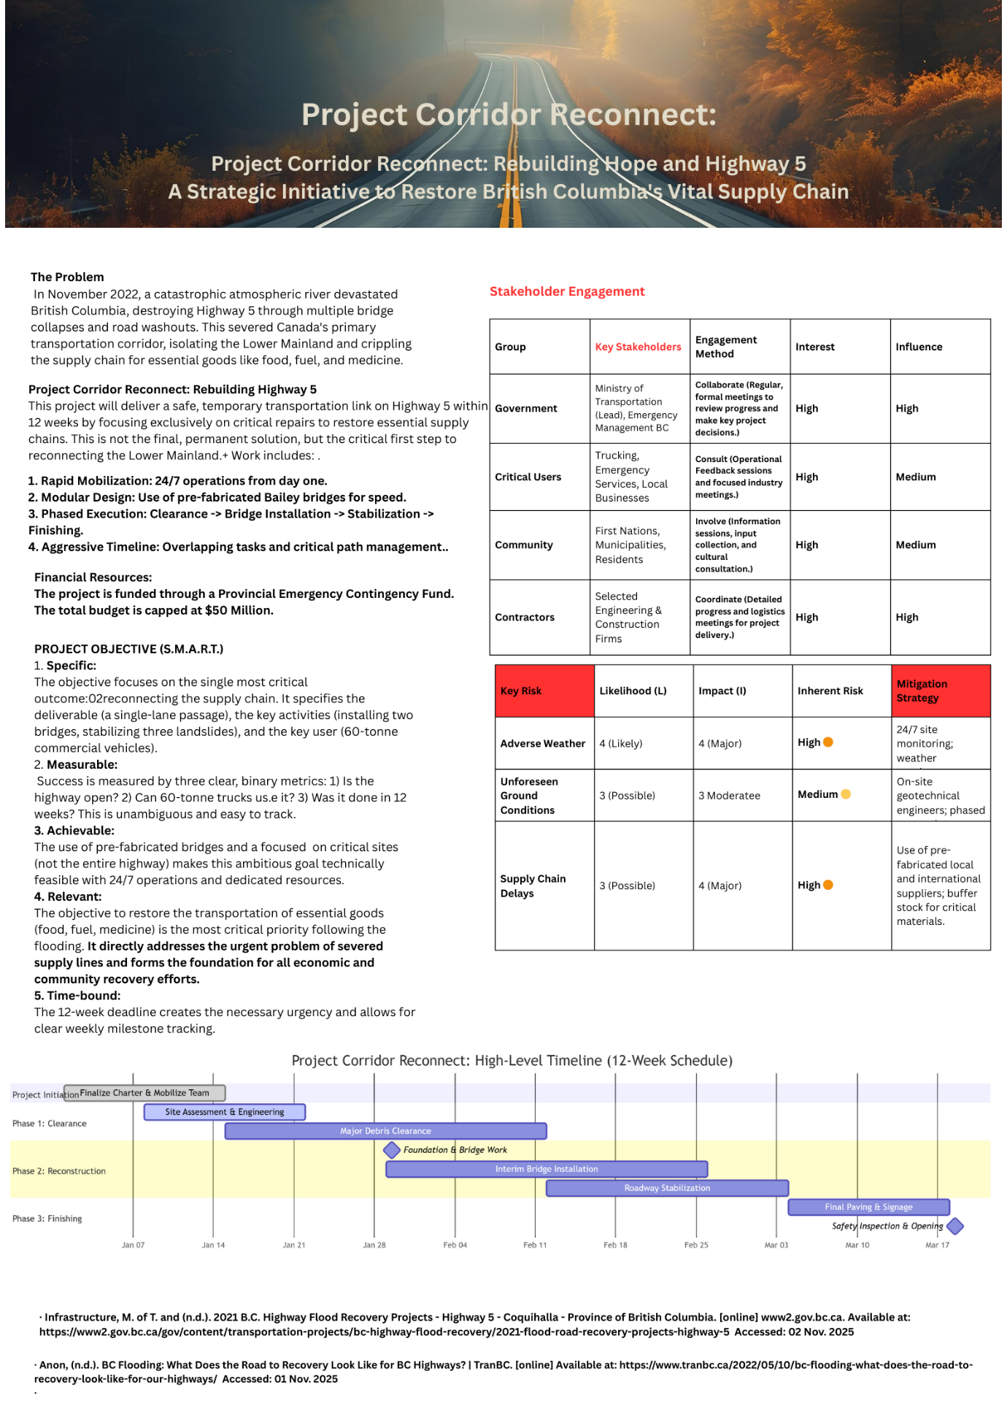

Part B - Reflections from the feedback received from tutor.

The feedback received during the Week 6 poster presentation was invaluable and provided critical insights that will significantly strengthen the final Project Management Plan. The session yielded strong affirmation of the core strategy alongside critical, constructive critiques that highlighted areas requiring significant enhancement, specifically concerning stakeholder engagement, risk analysis, and resource detail.
The feedback positively reinforced that the way the project was presented was effective and worked well as intended. The strategy's clarity and focus a rapid-response project to repair and reopen Highway 5 as an interim solution, created a compelling and easily understood goal. The 12-week timeline for the project’s completion was articulated as necessary to effectively underscore the urgency of the recovery effort. Furthermore, the poster's visual layout was commended for its accessibility, effectively communicating the project's necessity, goal, and execution plan without overwhelming the audience. A specific note from the Tutor correctly highlighted the appropriate use of the Gantt Chart for visual scheduling but suggested that a separate, descriptive table explaining the chart was redundant, a point I will incorporate by removing unnecessary textual explanation.
However, the feedback also illuminated several key areas for enhancement, The most significant critique was the lack of detail regarding stakeholder management. The Lecture rightly pointed out that while the poster listed key stakeholders, it did not articulate a strategy for managing them. The final Project Management Plan will address this by including a comprehensive Stakeholder Engagement Plan. This plan will utilize the Power/Interest Grid to classify stakeholders, which visually categorizes groups to inform tailored engagement strategies. This classification will guide specific communication strategies. For example, a formal weekly briefing cadence is critical for high-power/high-interest stakeholders such as the Ministry of Transportation and the Trucking Association. Conversely, a dedicated community liaison channel will be established for First Nations and local residents to address their specific concerns regarding construction impacts and who will be beneficiaries of the project's resilience efforts.
A second major point of feedback concerned risk analysis. The poster presented the project as a straightforward execution but did not adequately surface the specific, high-impact risks inherent in an aggressive 12-week civil engineering schedule. I will now integrate a detailed Qualitative Risk Analysis Matrix into the Project Management Plan. This matrix will move beyond generic risks to identify specific threats such as supply chain delays for prefabricated bridge components. For each high-probability or high-impact risk, I will develop a specific mitigation strategy, such as pre-qualifying multiple suppliers and having a 24/7 geotechnical engineer on-site.
Finally, there was a suggestion to add the cost of operation. The poster mentioned resources but was not specific.
In conclusion, the feedback was instrumental in transforming the project into a robust, actionable plan. Incorporating insights to deepen the stakeholder, risk, and resource management sections will result in a comprehensive, realistic, and compelling Project Management Plan

Part C: Project Management Plan
Introduction
In November 2022, British Columbia experienced a catastrophic weather event from an atmospheric river, leading to severe flooding and landslides. This disaster resulted in the destruction of critical infrastructure, most notably Highway 5 (the Coquihalla), the primary transportation corridor connecting the Lower Mainland to the rest of Canada. The severing of this route caused a critical disruption to the supply chain, threatening the economic stability of the province and the well-being of its citizens. (Gov.bc.ca, 2025)
This document outlines the Project Management Plan for "Project Corridor Reconnect," a rapid-response initiative tasked with the emergency repair and reopening of Highway 5. The purpose of this plan is to define the project's objectives, scope, deliverables, and overall management approach. It serves as a formal agreement between the project team and key stakeholders, providing a roadmap to successfully restore a safe and reliable interim transportation link within a stringent 12-week time limit.

Project Description
Project Corridor Reconnect is a time-critical infrastructure recovery project. Its primary goal is to repair the most critically damaged sections of Highway 5 to re-establish a safe, temporary route for commercial and essential travel. The project will focus on rapid mobilization, the use of prefabricated and modular solutions, and 24/7 construction operations to achieve its objective. (Expanded Ltd, 2025). Success is defined by reopening the highway to controlled commercial traffic, thereby re-initiating the flow of essential goods, supporting economic activity, and enabling subsequent recovery efforts for local communities and other damaged infrastructures.
This project is classified as a crisis management/fast-track construction initiative. The project's strategy employs Fast-Tracking, where design and construction phases overlap significantly, prioritizing speed and resilience. Key damage sites, including major bridge washouts and multiple debris flow locations will be tackled simultaneously using multiple dedicated construction teams. The project utilizes a hybrid approach, blending the structured planning of a traditional (Waterfall) approach for procurement and design with the agility (Agile/Lean) necessary for dynamic site conditions and expedited execution. (Infrastructure, n.d.)

Key Characteristics:
- Urgency: 12-week fixed deadline (Hard Constraint).
- Focus: Interim, safe, single-lane access for controlled commercial/essential traffic. Permanent, full-scale repair is designated as a separate Phase II project.
- Methodology: Hybrid (Fast-Tracked Waterfall for execution, Agile for risk and change management).
- Constraint Management: The 12-week schedule is the primary constraint (Time). The scope is fixed to interim repair, and budget will be dynamically managed under emergency funding provisions, utilizing a contingency reserve for unforeseen geological instability.

3. Scope Management
The project scope precisely defines the boundaries of the interim repair effort necessary to achieve the objective of opening the Coquihalla to controlled essential traffic within 12 weeks. (Bridge, n.d.)
3.1 Project Objectives
The primary objectives of Project Corridor Reconnect are:
- Safety & Stability: Ensure all restored sections meet or exceed interim safety standards for heavy commercial traffic.
- Timeline: Achieve full, controlled reopening of Highway 5 for commercial traffic within 12 weeks of the project initiation date.
- Functionality: Restore two-way essential travel (at least one lane in each direction) across all previously severed sections.
- Cost Control: Complete the project within the approved emergency contingency budget of $50 million CAD (excluding final permanent restoration work).

3.2. Inclusions (In-Scope)
- Engineering and Design: Detailed geotechnical analysis and temporary structural design for all identified catastrophic washouts (estimated 10-15 critical sites). ( Egbc.ca ,2021)
- Repair Focus: Construction of temporary or modular structures, including Bailey bridges, temporary retaining walls, and rock fall mitigation measures to stabilize slopes immediately adjacent to the roadbed.
- Roadbed Restoration: Re-establishment of a minimum two-lane (one lane in each direction) drivable surface, suitable for commercial transport, at a speed limit reduced from baseline operating conditions.
- Safety Measures: Installation of temporary barriers, clear, high-visibility signage, and temporary lighting for 24/7 operation and safe navigation.
- Traffic Management: Development and implementation of a comprehensive traffic management plan for controlled commercial vehicle access (e.g., specific windows, convoy scheduling).
3.3. Exclusions (Out-of-Scope)
- Permanent Infrastructure: Construction of permanent replacement bridges, long-term stabilization infrastructure, or fully engineered final road alignment. This is delegated to Phase II.
- Non-Highway 5 Infrastructure: Repair of any adjacent provincial/municipal roads, utility lines (power, gas, telecom), or local community water systems.
- Full-Service Restoration: Restoration of the full four-lane capacity, original speed limits, or aesthetic landscaping/finishes.
- Environmental Remediation (Long-Term): Detailed, long-term environmental restoration of riverbeds or affected watercourses beyond immediate necessary stabilization work.
3.4. Project Deliverables
- Functional Road Segment: A fully operational, two-lane (interim) section of Highway 5 connecting the Lower Mainland and the Interior.
- Safety Certification: Certification from the Chief Engineer that the reconnected route is safe for controlled, essential commercial vehicle movement.
- Traffic Management Protocol: A documented and implemented system for escorting or controlling commercial traffic flow.
- Completed Site Demobilization: Removal of all temporary site camps, equipment, and waste material after the 12-week period.
3.5. Acceptance Criteria
Project Corridor Reconnect will be deemed successful and formally accepted upon the completion of the following criteria:
- Operational Status: The entire critical length of Highway 5 is open for controlled, commercial vehicle traffic.
- Structural Integrity: All repaired sites meet the minimum temporary load-bearing requirements for heavy commercial transport (as specified by MOTI engineering standards).
- Schedule Adherence: Completion and opening of the highway occur on or before the 12-week deadline.

4.Work Breakdown Structure (WBS)
The WBS structures the entire project scope into manageable, deliverable-oriented components. It utilizes a hierarchical structure down to the Work Package level (Level 3), which represents the lowest level of management control where costs and durations are estimated. (Anon, n.d.)

WBS Level | ID | Work Package / Element | Description
1 | 1.0 | Project Corridor Reconnect | Complete restoration of interim two-way commercial traffic flow on Highway 5.
2 | 1.1 | Project Initiation and Planning | Mobilize core team, finalize PMP, secure emergency funding, and approve initial access routes.
2 | 1.2 | Site Mobilization and Logistics | Establish command centre, staging areas, secure material laydown yards, and mobilize all heavy equipment for 24/7 operations.
2 | 1.3 | Geotechnical and Hazard Mitigation | Detailed drone and ground surveying, debris removal, immediate slope stabilization, and continuous hazard monitoring.
2 | 1.4 | Bridge and Major Structure Repair | Focus on sites requiring replacement structures. Includes foundation assessment, modular bridge procurement, delivery, and rapid installation.
3 | 1.4.1 | Procurement of Modular Bridges | Work package for selecting suppliers and initiating rapid fabrication/delivery of prefab spans.
3 | 1.4.2 | Bridge Foundation Construction | Site grading, pile driving, and foundation work necessary for modular structure placement.
3 | 1.4.3 | Modular Bridge Placement | Lifting and securing prefabricated bridge spans and deck elements.
2 | 1.5 | Roadway and Embankment Repair | Rebuilding washed-out embankment sections, repair of culverts, and resurfacing affected road segments.
3 | 1.5.1 | Debris Removal and Site Prep | Clearing all major landslide/washout sites to expose the original road footprint.
3 | 1.5.2 | Embankment Fill and Compaction | Importing and compacting engineering-approved fill material to rebuild road base.
3 | 1.5.3 | Paving and Line Marking | Final asphalt layer application, temporary line marking, and guardrail installation.
2 | 1.6 | Quality Assurance and Safety Check | Independent engineering certification, road safety audits, and operational testing of all repaired sections.
2 | 1.7 | Highway Reopening and Transition | Final commissioning, installation of temporary traffic management systems, and hand-off to the operational team (MoTI).
2 | 1.8 | Project Closeout and Reporting | Final financial reconciliation, contract closure, final PMP report, and post-mortem analysis.

PROJECT CORRIDOR RECONNECT QUAD CHART
The Quad Chart provides a high-level, visual summary of the project's most critical elements, enabling rapid comprehension by senior stakeholders.

6. Gantt Chart (Simplified Critical Path)
This simplified Gantt Chart demonstrates the Fast-Tracked approach, where the Design, Procurement, and Construction phases are intentionally overlapped to meet the aggressive 12-week (60 working days, assuming 24/7 operation) schedule. The bolded items form the Critical Path. 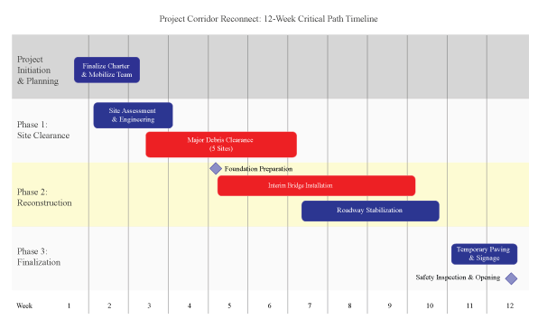
Phase | Major Task / Milestone | Start Week | End Week | Duration (Weeks)
Initiation | Finalize Charter & Mobilize Team | 1 | 2 | 2
Phase 1 | Site Assessment & Detailed Engineering | 1 | 3 | 2
Phase 1 | Major Debris Clearance | 2 | 6 | 4
Phase 2 | Milestone: Foundation Work Starts | 4 | - | -
Phase 2 | Interim Bridge Installation | 4 | 9 | 6
Phase 2 | Roadway Stabilization | 6 | 9 | 3
Phase 3 | Final Paving & Signage | 10 | 11 | 2
Phase 3 | Milestone: Safety Inspection & Opening | 12 | - | -

7. Stakeholders' Involvement
Effective stakeholder management is paramount for a high-visibility, time-critical, and politically sensitive project like this. A Power/Interest Grid analysis has guided the communication strategy.
Stakeholder Group | Power | Interest | Engagement Strategy | Involvement (Specific Role)
Ministry of Transportation (MOTI) | High | High | Manage Closely | Project Sponsor, ultimate decision-maker, budget authority, final acceptance of work.
Executive Steering Committee (ESC) | High | Med | Keep Satisfied | Provides high-level political direction, manages inter-ministry resource conflicts, quarterly reporting.
Contractor & Subcontractors | Med | High | Manage Closely | Responsible for daily execution, quality control, schedule adherence, and resource deployment (24/7).
First Nations communities | Med | High | Manage Closely | Consultation on land use, environmental concerns, cultural sites, and employment/economic opportunities. Daily communication is required.
Commercial Trucking Associations | Low | High | Keep Informed | Input on traffic management protocols, specific needs for cargo flow, receiving daily progress updates.
Affected Local Communities | Low | Med | Keep Informed | Information on construction noise/impacts, road access for local use, public safety warnings. Managed via dedicated liaison officer.
Federal Government Agencies | High | Low | Keep Satisfied | Funding oversight, inter-provincial trade concerns. Monthly summary reports.

Involvement Approach: The Project Manager will establish a daily stand-up meeting with the core design, procurement, and construction contractor leads to maintain situational awareness. A formal weekly briefing will be conducted for the MOTI Sponsor. Crucially, a Dedicated Communications Manager will be assigned to proactively handle all external stakeholder communication (local communities, trucking associations) to manage expectations and perception during the stressful 12-week period.
8. Allocation of Resources
Resources are the lifeblood of this fast-tracked project. The strategy is to heavily front-load resources to support the 24/7 operation and minimize schedule risk. Resources are categorized into Human, Equipment, and Material.
8.1. Human Resources
The project demands specialized, high-intensity labour, necessitating a rotational shift structure to prevent burnout and fatigue risk (Risk 3).
- Project Management Team: 1 Project Manager, 1 Site Superintendent, 1 Scheduler, 1 Cost Controller.
- Technical Staff: 5 Civil Engineers, 2 Geotechnical Engineers, 3 Safety Officers.
- Labour Force: ~200 personnel across two shifts, including equipment operators, ironworkers, carpenters, and general labourers.
8.2 Equipment and Materials:
- Heavy Machinery: 15 Excavators, 10 Bulldozers, 5 Crane Rigs, 20 Dump Trucks, 5 Asphalt Pavers.
- Key Materials: 2 Prefabricated Bailey Bridge sets, 10,000 cubic meters of structural fill, 5,000 tonnes of temporary asphalt, gabion baskets, soil nails.
8.3 Financial Resources:
The $50M budget is managed through an emergency fund and divided into specific cost accounts:
- Contingency Reserve (15%): A dedicated pool of funds ($7.5M) controlled by the PM, allocated specifically for addressing known-unknown risks (e.g., secondary landslides, unforeseen foundation issues). This reserve is separate from the management reserve held by the Executive Sponsor.
- Direct Construction Costs (60%): Labour, equipment rental, and fuel.
- Material and Procurement (20%): Modular bridges, fill material, and paving supplies.
- Management and Safety (5%): QA, security, site management, and safety gear
9. Risk Analysis
Given the emergency context, high geological instability, and aggressive timeline, the project has an inherently high-risk profile. A comprehensive risk management process, including identification, qualitative analysis, and response planning, is implemented. (Gillett et al.)

Risk 1: Further Adverse Weather
- Description: Heavy rain or snow disrupting operations.
- Probability: High
- Impact: High
- Mitigation Strategy: Continuous monitoring of weather forecasts. Implement prepared contingency plans for immediate work suspension and site protection. Pre-stock all necessary emergency pumping and snow removal equipment on-site.
Risk 2: Unforeseen Geotechnical Instability
- Description: Discovery of unstable soil or rock conditions not identified in initial assessments.
- Probability: Medium
- Impact: High
- Mitigation Strategy: Deploy 24/7 on-site geotechnical engineers for real-time decision-making. Employ continuous slope monitoring using lidar and inclinometers. Have additional stabilization materials pre-positioned and on standby.
Risk 3: Delay in Delivery of Bridge Components
- Description: Critical prefabricated components failing to arrive on schedule.
- Probability: Medium
- Impact: High
- Mitigation Strategy: Pre-qualify and contract multiple, vetted suppliers. Secure government priority shipping channels for critical shipments. Implement active GPS tracking for all major component shipments.
Risk 4: Workforce Safety Incident
- Description: An on-site accident causing injury.
- Probability: Medium
- Impact: Very High
- Mitigation Strategy: Implement a rigorous "Zero Harm" safety program, reinforced by daily mandatory toolbox talks. Empower full-time, dedicated safety officers with the authority to enact immediate operational stand-downs in response to any protocol breach.
- Risk 5: Budget Overrun Due to Unforeseen Conditions
- Description: Unanticipated site conditions or scope changes leading to cost escalation.
- Probability: Medium
- Impact: High
- Mitigation Strategy: Establish and protect a dedicated 10% management reserve. Implement rigorous, formal change control procedures for all potential scope modifications. Conduct and review weekly cost versus budget analyses.

9.2. Monitoring and Control
Risk monitoring will be handled through weekly Risk Review Meetings and the maintenance of a live Risk Register. The schedule buffer (10 days) and the Contingency Reserve (15% of budget) are the primary tools for controlling the impacts of known and unknown risks. Earned Value Management (EVM) will be used to monitor schedule performance against the baseline, quickly identifying variances (SV < 0) that may indicate a risk event has occurred. (Transportation Association of Canada (TAC),2024)

10. Conclusion
In conclusion, Project Corridor Reconnect represents a decisive and structured response to a critical provincial crisis. This Project Management Plan establishes the essential framework for delivering the restoration of this vital economic artery under extreme 12-week constraints. Success is contingent upon unwavering adherence to the plan's core principles: a fast-track methodology utilizing modular construction, 24/7 operations, and strict scope control. Proactive management of significant environmental and geotechnical risks, coupled with precise execution guided by the Work Breakdown Structure and the project's critical path, is paramount. Furthermore, maintaining transparent and prioritized communication with all stakeholders is fundamental to aligning efforts and managing expectations. The project team is fully committed to the singular goal: the safe and controlled reopening of Highway 5 for commercial traffic within the mandated timeframe. Achieving this objective will not only restore a crucial transportation link but will also serve as a cornerstone for British Columbia's economic recovery and resilience, demonstrating effective leadership and rigorous project management in the face of adversity.

References
Anon, (n.d.). BC Flooding: What Does the Road to Recovery Look Like for BC Highways? | TranBC. [online] Available at: https://www.tranbc.ca/2022/05/10/bc-flooding-what-does-the-road-to-recovery-look-like-for-our-highways/ (Accessed 2 Dec. 2025)
Bridge, J. (n.d.). British Columbia highway reinstatement program highway 5 -category b project Canadian consulting engineering awards 2024. [online] Available at: https://www.canadianconsultingengineer.com/wp-content/uploads/gravity_forms/47-de298823b81bc934d75007010d9cafbc/2024/04/KiewitBCHwy5.pdf [Accessed 2 Dec. 2025].
Egbc.ca. (2021). Guidelines & Advisories. [online] Available at: https://tools.egbc.ca/Registrants/Practice-Resources/Guidelines-Advisories. (Accessed 28 Nov.2025)
Expanded Ltd. (2025). What are modular bridges? [online] Available at: https://www.expandedltd.com/expanded-bridges/what-are-modular-bridges [Accessed 28 Nov. 2025].
Gillett, Nathan P., et al. “Human Influence on the 2021 British Columbia Floods.” Weather and Climate Extremes, vol. 36, June 2022, p. 100441, https://doi.org/10.1016/j.wace.2022.100441 (Accessed 30 Nov. 2025)
Gov.bc.ca. (2025). Provincial emergency management reports - Province of British Columbia. [online] Available at: https://www2.gov.bc.ca/gov/content/safety/emergency-management/emergency-management/reports#atmospheric [Accessed 28 Nov. 2025].
Infrastructure, M. of T. and (n.d.). 2021 B.C. Highway Flood Recovery Projects - Highway 5 - Coquihalla - Province of British Columbia. [online] www2.gov.bc.ca. Available at: https://www2.gov.bc.ca/gov/content/transportation-projects/bc-highway-flood-recovery/2021-flood-road-recovery-projects-highway-5 (Accessed 27 Nov. 2025)
Transportation Association of Canada (TAC) |. (2024). Safety, Design and Operations | Transportation Association of Canada (TAC). Available at: https://www.tac-atc.ca/en/safety-design-and-operations (Accessed 3 Dec. 2025).

‌

