I
Chance had nothing to do with his death. Not like it would have if he had choked on a fishbone or fell into a river without anyone noticing. No. His death had been by design. A meticulous pocket of time that had yielded the only desired result. Though he never knew that, and he wouldn't ever need to know, for he was dead: and what could the dead do now except haunt what was left of fragile minds until they, too, died?
The Rabbi had told him he had died of his wounds the day before last. In the clinic, said the Rabbi, surrounded by family. And what a sweet way to go, finding the faces of the people who you had most loved right before you found your death. But of course, that luxury hadn’t been offered to him. Supposedly, he would want his family present at his death, but his family wasn’t his brother, his mother, and father in his mind: he would be one of the faces Gersh had seen, or Vera, on their death beds, and he, when his time came, would find his own children around him. Perhaps a wife as well, and maybe his brother, too, if he had been unlucky enough to die before him. Now, however, with the circumstances drastically altered, he wondered if he could ever face his family again: did he even want his family present at his death? To see him hang as they would others.
He had never been a murderer, regardless of everything that led him to this moment. Despite the ruling; despite his own actions. He knew, fundamentally, that he had not the capacity for such a thing. But the body was their proof and his gun had been the one to render it lifeless. And, when he thought too deeply about it, which he did often in his cell, he knew he didn’t regret it. Only, he regretted that he hadn’t done it sooner: Before he sought Lazarev’s opinion: When he had the chance to get out. That he didn’t get out of the theatre in time, or even just said, the morning before they left, that he loved his mother dearly, and his father, too, and if they found themselves in Petersburg before they returned, to send on the message to Vladimir.
But he wasn’t a bad person. He wasn’t evil as they claimed. He wasn’t a murderer.
When Dmitry was a young boy, about only five, his mother had walked him and Vladimir up the Dnieper River. They had spent the day gorging on patisserie in the city, watching the ships come up from Constantinople carrying bolts of silk, and crates of spices like cardamom and ginger, or cloves, cassia, and pepper. Bigger schooners, paid for by the high-class Kievan society, held molasses and tea leaves, and exotic perfumes from as far as Egypt and China. Men in sharply cut suits barked orders at younger men and boys, some of which were roughly his own age, covered in oil, soot, gleaning with sweat, who ran across the harbour directing traffic.
As the boys laughed, Vera stared ahead: her mind had always been on other things, and never had Dmitry asked what or why. She grew increasingly absent, and her absence was increasingly incorrigible. Even at five, Dmitry knew something was wrong, but until he grew up, until he understood, he couldn’t name what it was.
They walked home hand-in-hand, all except Vladimir who balanced on the half-wall skirting the river, as if a gargoyle who found a way to move as stone. He hopped across the jutting stones, brazen and emboldened by adrenaline, and Dmitry felt a pang of jealousy roiling in his gut.
“Volodya, my love, be careful,” said Vera, her eyes trained not on him but the horizon where the sagging neighbourhood of Lybedskaia slowly grew, where a cart trotted by, and Vera held his hand tighter.
Vladimir rolled his eyes. “Da, mama.” He slowed down but only just.
Dmitry wanted to join Vladimir on the wall. He was a small boy, barely reaching his mother’s knees, and he wanted to feel taller, powerful. He wanted to protect his dear mama from whatever scared her; from the police, from the pogroms, from anything he could. Vera told him; however, he was too young to do such a thing. But he didn’t feel young. On the contrary, he felt ready as any young man should: Emboldened by his brother and the love for his mama, he knew he could take anything on. When he told Vera this, however, she finally took her eyes off the horizon and laughed.
“Oh, malen’kiy,” she said. She crouched to his level, held his mittened hand in her own, her eyes wide as China cups. “You will be very big and strong; I know you will. But for now–” and she pulled him into her and kissed him all over “–you’re my baby boy!”
Dmitry had shrieked with laughter, pushing her face away from his to the best of his ability as she kept coming. He slumped into her arms, gasping for air with a smile plastered across his face, and she held him tightly, resting her chin on wisps of brown hair. “If G-d wills it, you will be the strongest of them all.”
Vladimir had hopped off the wall at this point and pouted: “What about me, mama?”
Vera dragged him into their embrace. “Of course you will too, Volodya. G-d is gracious, and he will reward you with the highest praise.”
In the moment, Dmitry believed every word his mother said, but as he grew older and believed less and less in their G-d, he began to doubt her words; no longer were they a lifeline, but a sweet nothing a parent told his or her child to make them feel better in a moment of petty indignance. There was too much at stake for him to take the word of something he could neither see nor speak to, nor the words of his dear mama, and he had always considered himself, if anything, a pragmatist—a man of ideal means and sound enough judgement. Never had he acted recklessly, or restlessly: Never had he any means to. Always, he knew where he was going, what needed to be done, and by the time he was old enough to understand that, he understood, too, that he could serve under no G-d. But, and he thought this often, did that mean he was no longer one of His children? To deny his G-d, did he, too, deny his entire existence? The thought alone made his head throb: the quiet, the inaction, and the only place he could wander, were painful remnants of a short-lived history, coming to a short-lived end, and he only had the Lybid, trickling weakly as it had always done, to accompany the pathetic remnants of nonsensical thought about G-d.
Sequins of sunlight from crevices in stone filtered through the dank cell, penetrating only slightly the darkness that had built up. He wasn’t allowed a torch, and there wasn’t even a window—at least not one that served its given purpose—for him to see through: these were the only slips of light he was allowed (albeit reluctantly), the only way he could discern day from night, and morn to eve. The cell was small, smaller than the room he shared with Vlad in Petersburg, and smaller than his body if he tried to lay flat on the ground which he had no intention of ever doing. The stone floor jutted into every pinch of muscle in his lower body, and the jagged bricks that made up his wall took residence in the curves of his back and the remaining fat in his arms. His eyes blurred and burned with nothing. Only he could see dust motes floating in the daytime, but they faded as the morning turned to afternoon and the sun left his side of the fortress to entertain another. On the first night there, he hadn’t meant to have an accident—the brutal interrogation he received left him floating between consciousness—but he realised no matter what he managed to do, he wouldn’t be permitted a lavatory, or even a bucket to piss in, so he sat in a corner, his trousers crusting with over a week’s worth of urine attacking his skin and senses, understanding the ways in which, truly, Russia worked.
It broke you down until all that was left was a shell of the man before: It humiliated you and put that humiliation on display: a doll for a society’s satisfaction.
His body had grown stiff over the past few days crouched in the same corner until his limbs ached and muscles, blood, and bones congealed into a jellied mess. At least three of his ribs were broken, and [Officer name] had snapped several of his fingers, and hammered his feet until he slumped in his chair, and they dragged him back to the cell. More recently, two men had beat him so hard, he choked out two of his teeth. The officers laughed, one slipped his fingers in Dmitry’s mouth and pulled his lips apart. “Still think he’s handsome, Obraztsov?” the man had called, his accent sharp and quick and distinctly from Petersburg.
Obraztsov seemed unperturbed. “I’m sure there’s a bitch in Plosskaia who’d still find him pretty.”
Dmitry wanted to correct Obraztsov—he wasn’t from Plosskaia, actually—but he couldn’t move his mouth around the other officer’s meaty fingers to get the word across. Nor did they let him.
Men he knew, some he had even been close to once, and those he didn’t took part in his degradation—beatings, jeering, once or twice they forced him to strip to his underwear and suspended him from the ceiling by his feet and watched him hurt himself if they grew particularly bored that day. His nose still bled from one of those occasions.
Dmitry wiped the blood from his nose now and traced the spots of light with his eyes until they grew dizzy. Next, he tried to focus on the timorous dripping of the Lybid: if he were a musician, he imagined he could find a rhythm to it, form some saccadic violin concerto. His brother, however, had been the Bogrov family’s musician. Vladimir had a penchant for the piano which he took from their mother; he ran away with it, became even better than Vera—he could play even the swiftest pieces by mere intuition; he could play blindfolded and get every note perfect—but he never put his skills to good use. In fact, he ran off to Petersburg to become a Jewish politician (he specifically outlined to Dmitry that he would be a Jewish politician and nothing less) and failed so far at succeeding at it. Dmitry wondered what kind of melody Vlad could concoct with the Lybid to guide him.
But something stirred behind the door. Long, careful strides; clicking of heels; an air of authority wafted through slivers between the door’s hinges. The officers were known to be authoritative, of course, but they were as gentle as an Indian elephant who couldn’t find its footing; they were taunting and cruel and tapped their feet with the mere purpose of mocking those trapped in cells. The person there, right that instant, was neither clumsy nor cruel. They had a purpose, but it was not at his expense. A stripe of orange light smudged across the near darkness as the slat in the door shrieked open then clicked against iron with an air of finality. The sensation reverberated against the stones and settled at the base of Dmitry’s spine. And when he finally glanced up, he saw two China eyes, round and kindly, staring back at him.
“Mama?” Dmitry whispered.
The pair of eyes blinked momentarily, then shrank in the orange.
“No– mama–” Dmitry’s throat bobbed and his mouth dried. “Mama, I’m not a murderer. I’m not a murderer, mama.” He scrambled upwards, though he could barely stand, and fell against the stone floor moments later. “I’m not a killer. I’m not–”
“Why did you do it?” said the eyes—the woman to whom the eyes belonged. Said his mama. Her voice was sharper than he remembered, it had a cutting edge to it that he had never once heard before.
Momentarily, Dmitry was confused—his mama disliked Stolypin, and his father disliked him even more so. Over dinners and letter exchanges, they would add in a new reform which Stolypin had introduced, a new law his father disregarded, a new ideology his mother turned up her nose to. It was no great secret that the Bogrov’s disliked Stolypin: In fact, it could be said that they hated him. But then again, they had never wished death upon him. They had never ventured that deep into their hatred. Sickness roiled in his stomach.
Once, deep in the night in Lybedskaia, the Kiev police had broken down the mahogany doors and charged into the family’s home without warning. Seldom had they dared to do so before—Gersh Bogrov was respected throughout the city for his talents in the courtroom—but, and this is what his father surmised over a dinnertime pontification, the police had run out of fun. For the past several days, the police had been harassing, arresting, and raiding homes across Lybedskaia and Plosskaia and they had grown bored of the same faces crying the same prayers, and the same rewards and the severe lack of beautiful things—they had stripped the neighbourhoods’ people of even the most pitiable, most sentimental possessions, except the Bogrov’s home.
As the doors splintered and eventually burst open, and as strange men filed through their home—his home—barking orders and stealing anything they could find, Vera sneaked into the boys’ room. She instructed them to hide under their beds, to press their fingers into their ears until the night was over and the milky white morning spilled over the Kievan sky. Dmitry curled up against his mother as she held him and Vladimir in her arms; the two fell asleep against her and woke up once more in their beds. Did that really happen? Vladimir whispered. Dmitry shrugged against his duvet and asked to stay with him in his bed until Vera returned.
Stolypin never protected them from that; it continued up into his adolescence and he grew bitter and resentful: the most glorious Russia wouldn’t hurt fellow Russians like this.
However, Dmitry didn’t say this. Not because he didn’t want his mother to know his intentions, but when he thought on the question—enough to understand it but not enough for it to make his head throb—he knew deep in his sickly gut, in his horrible little mind, that it wasn’t why he’d done it at all.
“I don’t know,” he said. “I don’t know.”

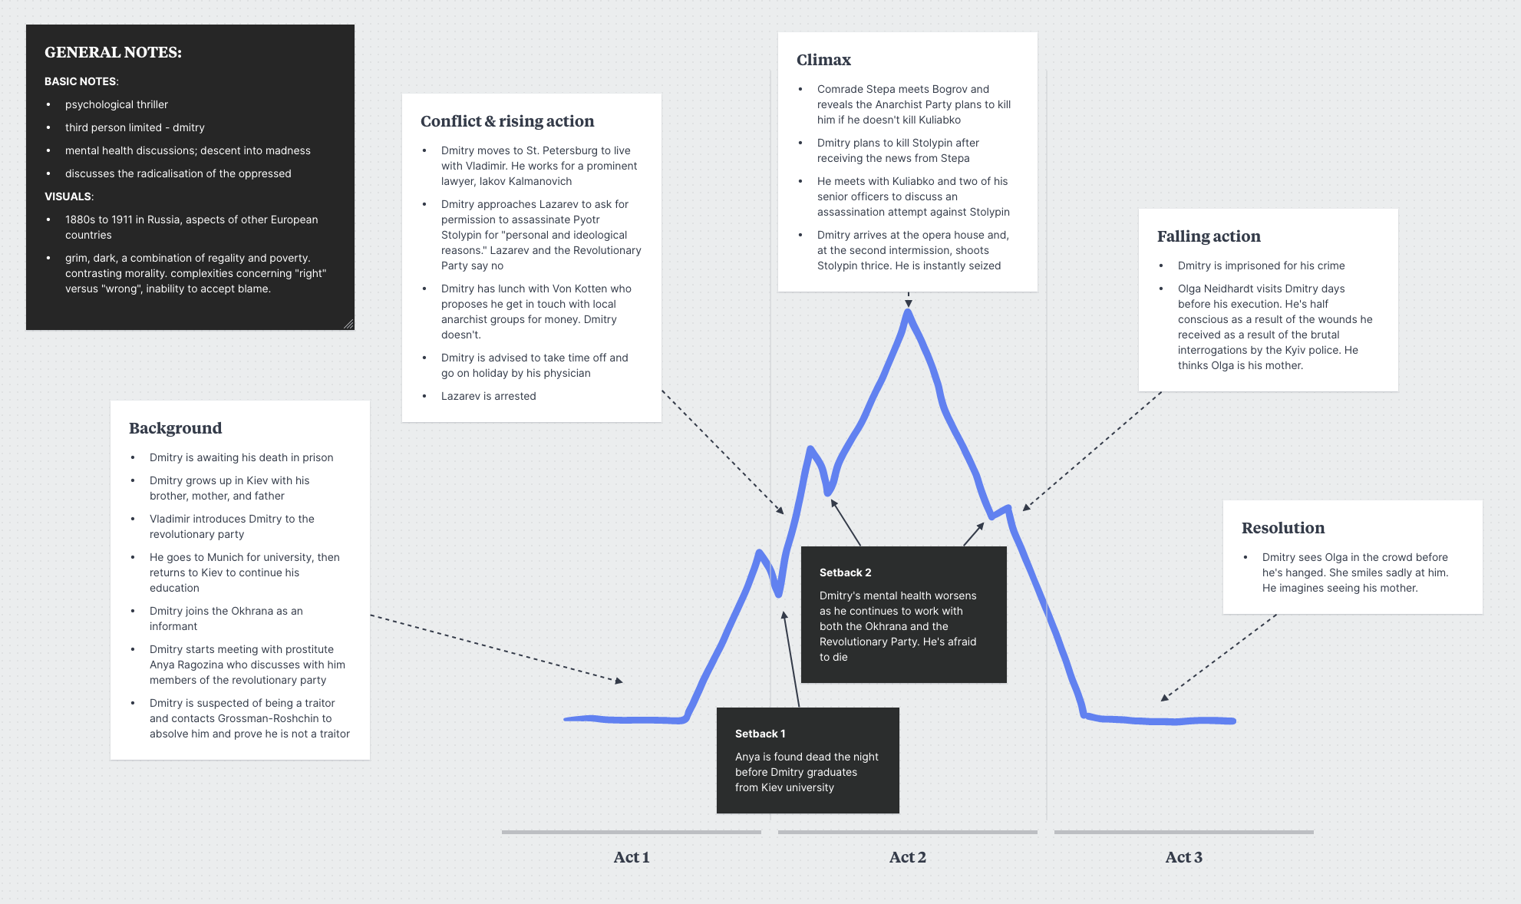
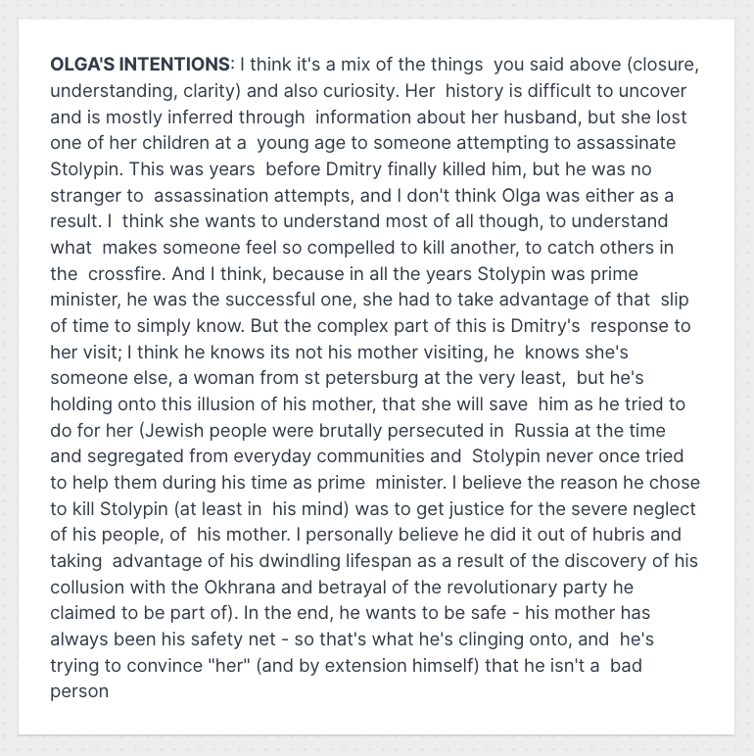
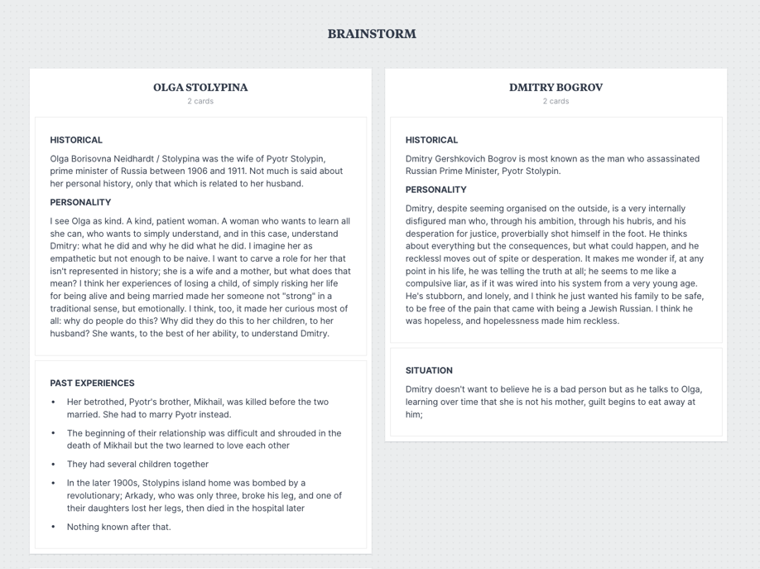
This is my outline for the rest of the novel:

Reflective Essay
By Eden
At first, it is daunting to face popular fiction and the conventions surrounding it. To put yourself in a box upon which expectation is placed and to find yourself working exclusively in it is to surrender aspects of what you wish yourself to write upon. But simultaneously, the conventions we are taught assist in bringing our pieces of work closer to the publishing table. I have been examining, in the past month, three different genres, historical fiction, crime, and fantasy retellings, and the conventions set upon them to make them popular in this current age. I became particularly fixed to historical fiction and chose to pursue it further.
I had known about this historical event for almost a year prior to engaging it as my project so instinctively, my mind turned to it once the project had been announced. This was the assassination of then-Prime Minister, Pyotr Stolypin, by Jewish turn cloak, Dmitry Bogrov. In the beginning, I had two ideas, one of which was Bogrov and Stolypin, and the other depicted famous “baby groupie” Sable Starr. I gravitated towards the former more as I conducted my initial research.
Through my research, I came to learn that Bogrov exploited his connections to the Revolutionary Party for the Okhrana, the Russian secret police, and exposed his so-called allies who were consequently sent, as punishment, to Siberia. However, in one of the articles I studied, titled “Stolypin’s Assassination”, it discussed the toll spying took on Bogrov was to an extent he eventually couldn’t handle. The article had been the most detailed account of Bogrov’s life and his inner turmoil I found, and it fit right in with what I envisioned for my project. It was grim, dark, and embedded in Bogrov’s internal life. It also filled in many blanks I couldn’t connect with before, such as the reason why Bogrov chose to kill Stolypin, and why he did it at exactly the time he did.
Through “Stolypin’s Assassination” and another article detailing the lives of Jews in 1900s Russia (especially Kyiv, now in modern day Ukraine), I bridged all my concepts together. Alongside historical fiction, I realised this story was a psychological thriller. It detailed much of Bogrov’s mental health and his final descent into madness, and eventually, his connection to Stolypin’s wife, Olga Borisovna Neidhardt, who petitioned, in his final days, to have him freed.
A major convention for any novel is additional romance, a romantic subplot to draw in an audience. On the first page of my favourite novel, “A Little Life,” one of the reviews states that it is a “touching, eternal, unconventional love story.” This is to draw in readers who enjoy romance and not to truly encapsulate the meaning of the novel itself. Commonly in historical fiction, romance is included, and as I examined this version of Bogrov’s story, I couldn’t once see an entryway for romance. In fact, reflecting my feelings on the reduction of “A Little Life” to a love story, I decided it was inappropriate and chose to avoid it altogether. This caused slight controversy in the possible conventions of Olga’s relationship with Dmitry. But as I considered them further, Olga grew to become an empathetic figure, a curious figure seeking closure for her husband's death. She evolved into a mother figure for Dmitry, with whom he could reflect on his past and his family, which I deduced to be his driving force.
In the meantime, I studied my favourite historical fiction novels, such as “The People in the Trees” by Hanya Yanagihara, and “A Gentleman in Moscow” by Amor Towles, to explore how they portrayed their own narratives. “The People in the Trees” especially became a beacon of inspiration for me through its own main character, Norton Perina, who too is imprisoned for a different reason. The atmosphere Yanagihara built with the perceived, in her case, notion of being imprisoned drove me to begin my own piece at its end in a prison cell.
As I began writing my piece, I chose to write in third person limited in Dmitry’s perspective. I considered first person perspective originally but as I tried to write, it became obvious to me that it was wrong. I couldn’t get so directly into Bogrov’s mind. To be so direct and so intimate didn’t represent the madness and disconnection from the rest of the world I had built up in his character. Each time I tried to write, both in first and third person, I eventually came to a pause I couldn’t unravel. I grew to doubt my writing skills, furthering my delay, until I succumbed to the doubt and chose to rewrite the original work.
This new version gave me more confidence and allowed me to elaborate on passages I previously skipped through. I still came to a dead end, but this rewrite imbued me with a feeling of satisfaction, and of contentment. It also gave me a chance to develop my own writing and my understanding of the genre conventions I had chosen to explore.
While I believe I still need to work on my understanding of genre, a great struggle of mine as I tend to write more literary pieces, exploring this passage and the weeks that preceded this essay have helped me improve and understand genre expectations and the exploitation of genre by others. No longer do I feel uncertain about genre, but curious about how they continue to work.

BIBLIOGRAPHY:
Amor Towles. A Gentleman in Moscow, 1st edn (UK: Viking, 2016)
Annie Garthwaite, Cecily. (Viking, 2021)
Emma Donoghue. The Wonder. (Picador, 2016)
George Tokmakoff. “Stolypin’s Assassin.” Slavic Review, vol. 24, no. 2, 1965, pp. 314–21. JSTOR, https://doi.org/10.2307/2492333.
Stephen King. On Writing: A Memoir of the Craft, 20th anniversary edn (Scribner, 2020)
Victoria Khiterer. “Jewish Life in Kyiv at the Turn of the Twentieth Century.” UTP Journals. (Unknown pub. Date)
William Strunk Jr, E. B. White. The Elements of Style, 4th edn. (Pearson, 2000 / 1979)
Hanya Yanagihara. A Little Life, UK edn. (London: Picador, 2015)
Hanya Yanagihara. The People in the Trees, UK edn. (London: Picador, 2013)

Tokmakoff, George. “Stolypin’s Assassin.” Slavic Review, vol. 24, no. 2, 1965, pp. 314–21. JSTOR, https://doi.org/10.2307/2492333. Accessed [Unknown Day] Jan. 2024.
Khiterer, Victoria. “Jewish Life in Kyiv at the Turn Of the Twentieth Century.” UTP Journals. Unknown date. pp. 73-75 <https://www.utpjournals.press/doi/pdf/10.3138/ukrainamoderna.10.074>
Yanagihara, Hanya. A Little Life, UK edn. (London: Picador, 2015) Opening page.
Yanagihara, Hanya. The People in the Trees, UK edn. (London: Picador, 2013) pp. 4 Towles, Amor. A Gentleman in Moscow, 1st edn (UK: Viking, 2016)
Yanagihara, The People in the Trees, pp. 6-8

