

Programme: MSc Public Health and Social Care in Practice
LCHS7009: POPULATION HEALTH AND DIGITAL HEALTH PROMOTION
Component 1
Table of Contents
BLOG 1: Impact of Wearable Fitness Trackers in the Fight against Physical Inactivity 3
Public health problem: Physical inactivity 3
Digital technology in promoting health: Wearable Fitness Trackers 4
Impact of digital technology on promoting health 4
Advantages and disadvantages 5
Addressing the shortfall 6
Blog 2: Impact of “MoveMore Smart Floor Tiles”- A Fun Physical Activity Solution for Low-Income Communities 6
Public Health Problem: Physical Inactivity 6
Designed Digital Technology: “MoveMore Smart Floor Tiles” 7
MoveMore Tiles promoting Physical Activity 7
Impact: Advantages and Shortcomings 8
Addressing the Shortfalls 8
References 9

BLOG 1: Impact of Wearable Fitness Trackers in the Fight against Physical Inactivity

Public health problem: Physical inactivity
A growing concern that is becoming a health priority is physical inactivity, as it contributes to several health issues, such as coronary heart disease (CHD). As per the NHS report, in the UK, physical inactivity is one of the major reasons that contribute to premature deaths to one in ten deaths from CHD and one in six deaths from other causes (NHS, 2025). According to the UK government data on adult physical activity and inactivity, there is a disparity between the least deprived and deprived regions of England, as 35% adults in the most deprived areas are physically inactive, while their counterparts are only 15%. There is also a demographic difference in terms of age, gender, income, ethnicity, and disability and long-term health conditions (GOV.UK, 2025).
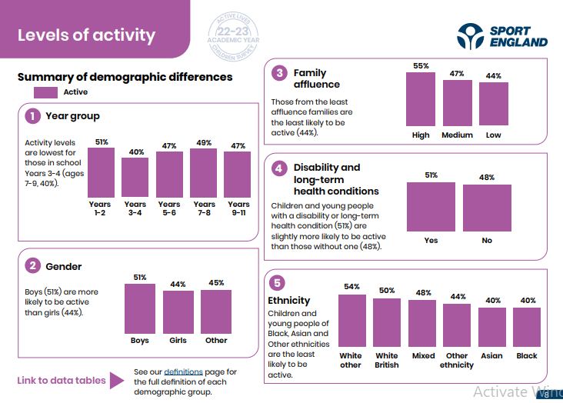
Figure 1: Levels of activity across different demographics
Source: (Sport England, 2025)

Digital technology in promoting health: Wearable Fitness Trackers
The selected digital technology, which is at present being used in the UK to combat this issue of physical inactivity, is wearable fitness trackers such as Fitbit Charge 3, Apple Watch, Samsung Galaxy, Oura Ring 4, Whoop 5.0, Google Pixel and such. Suc wearable trackers help in detecting, preventing and mitigating health concerns by tracking daily activity and encouraging healthy choices. Such wearable trackers allow setting up of personalised activity goals, self-monitoring dashboards, daily reminders and such that give a more independent and self-directed wellbeing approach to their users (Kang and Exworthy, 2022).
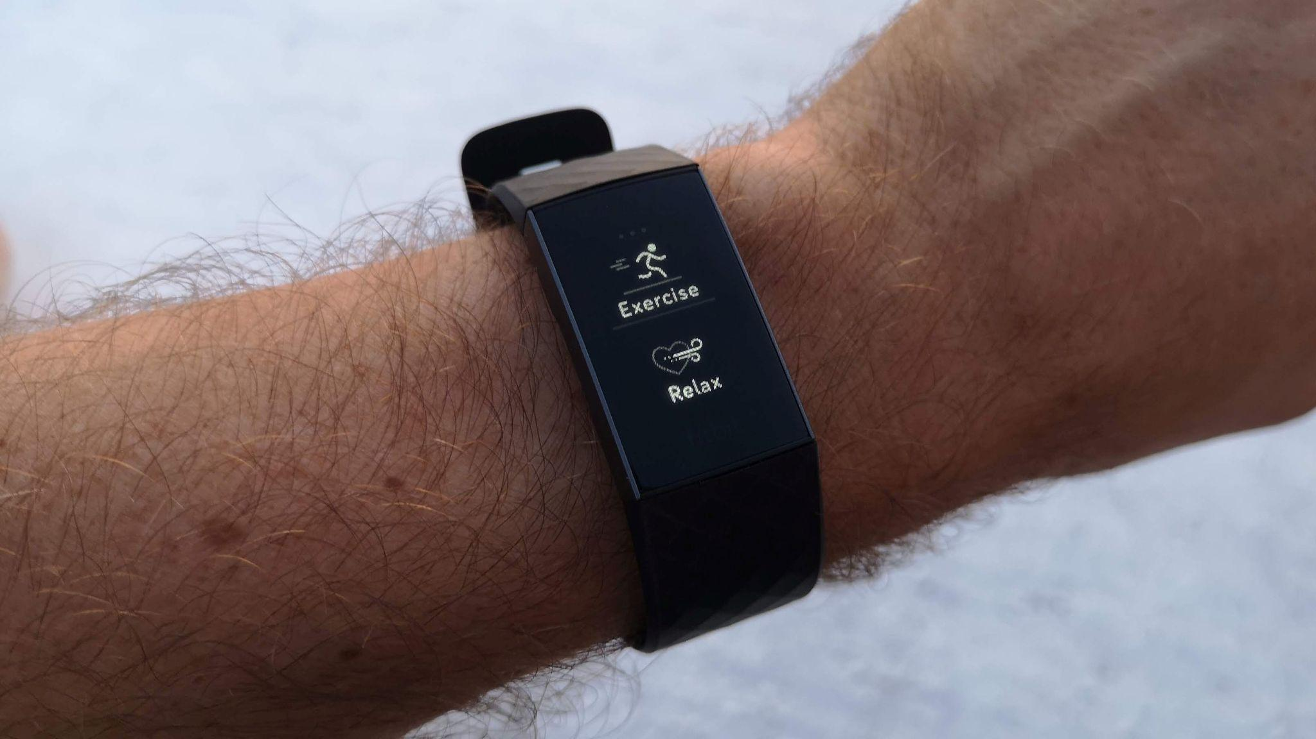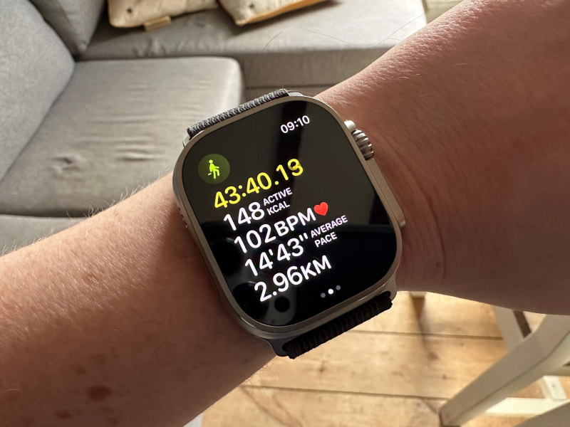
Figure 2: Wearable fitness trackers
Source: Google

Impact of digital technology on promoting health
As per a survey by the Cleveland Clinic, London, a majority of UK adults are presently using health technology to improve their health outcomes. 46% of them use a minimum of one type of technology to monitor their health, which includes wearables that track daily step count, monitor heart/pulse rate, and such. The effectiveness of using such technology in promoting health is also evident in the increased use of such technology as it has helped almost 49% of the UK adults to become more physcially active (Cleveland Clinic, 2025).
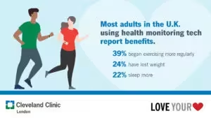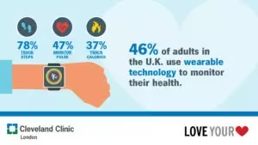
Figure 3: UK Adults using health monitoring tech
Source: (Cleveland Clinic, 2025)

Advantages and disadvantages
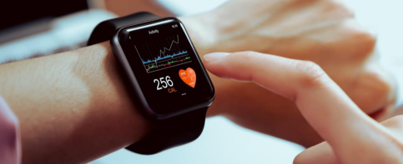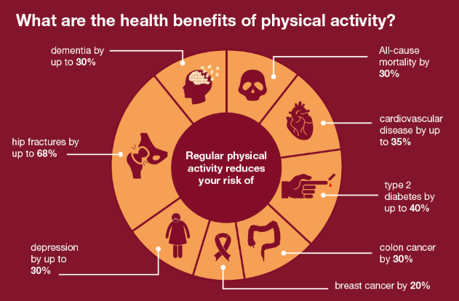
Figure 4: Advantages of physical activity
Source: (GOV.UK, 2022)
The impact of the wearable fitness trackers in health promotion has both advantages as well as shortcomings. This self-directed tool helps in self-monitoring as it provides real-time, immediate, and objective data and feedback. The scalability of the product is also high, as it is easily available to the general public and can be purchased from different online or offline platforms. This real-time objective data can further be integrated into clinical dashboards and healthcare programmes to obtain personalised care services (Chaloupský et al., 2023). However, the digital divide in the UK population in terms of access and skills can also lead to leaving out vulnerable groups such as older adults or people from lower-income households. The BMI and step targets might also not be suitable for different ethnic groups and people with disabilities. There is also the issue of privacy and data concerns during data integration from these wearables to the NHS systems (Schumann and Doherty, 2024).

Addressing the shortfall
Digital health coaches can be introduced across the community centres to teach about the usage of the wearable fitness trackers to the older adults and others from lower-income communities. The adaptive mode feature in the wearables can be introduced for people with mobility impairments to track upper-body movements. An NHS-controlled data management system with end-to-end encryption can also aid in preventing confidential user data breaches.

Blog 2: Impact of “MoveMore Smart Floor Tiles”- A Fun Physical Activity Solution for Low-Income Communities

Public Health Problem: Physical Inactivity
Physical inactivity is one of the growing health concerns around the UK, and it is also affecting the lower-income communities disproportionately. As per the UK government data, from 2015 to 2024, the rate of physical inactivity has increased within the most deprived areas, which has further widened the health inequality aspect over time. In 2023 to 2024 alone, the physical inactivity rate is higher by 2.3 times in the most deprived areas than in the least deprived areas. Mitigating these health inequality gaps is essential, specifically for the low-income communities, through innovative health promotion technologies (GOV.UK, 2025).

Designed Digital Technology: “MoveMore Smart Floor Tiles”
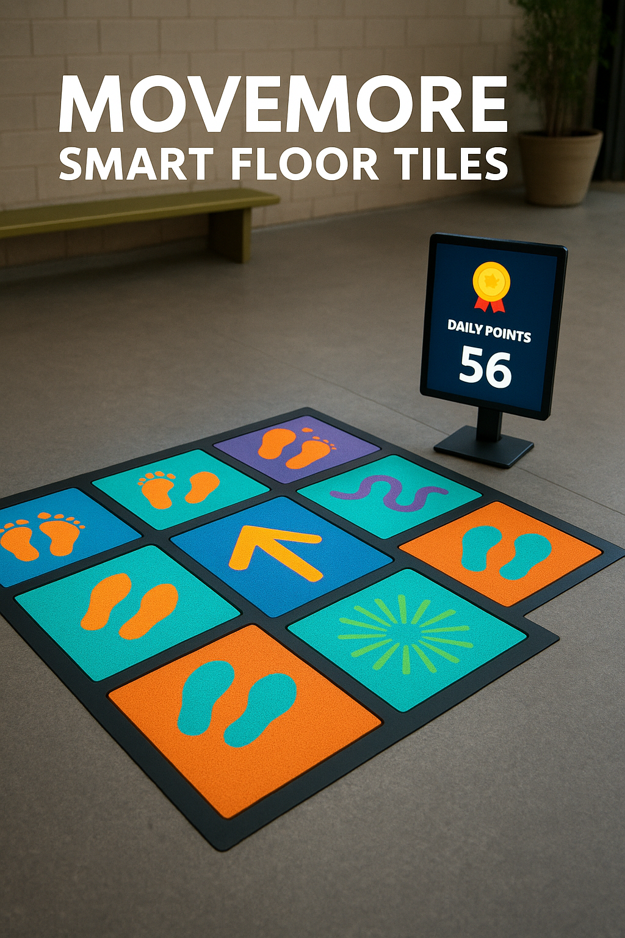
Figure 6: MoveMore Smart Floor Tiles
The proposed digital technological tool that will support health promotion across these communities is called the “MoveMore Smart Floor Tiles”. These Smart Tiles will have pressure and vibration sensors to detect contact through foot or wheelchairs. These sensors will track various movements like light jumps, taps, walking pace, and such. The duration and intensity of the physical activity will be measured through the built-in AI algorithm in the tiles in terms of speed and frequency. The game mode feature in the times with the in-built LED matrix panels will light up in different colours. Furthermore, a digital screen will display the daily points across the leaderboards to gather insight into the total minutes of activity.

MoveMore Tiles promoting Physical Activity
MoveMore Tiles addresses the health issue of physical inactivity by enabling users to indulge in physical movements in a fun and collective way. This game-based digital tool allows people from different age demographics, from children to older adults, to indulge in activities. This tool, installed in larger community spaces, will encourage members of different members of the community to come together in a familiar space and indulge in more physical activity. This also removes barriers such as cost and digital awareness or fear of technology among certain groups, like older adults from the lower-income communities. The AI-integrated adaptive features of this tool also promoted inclusivity among the community by allowing people with different movement requirements to adjust their preferred frequency and intensity of the tool.

Impact: Advantages and Shortcomings
There are various advantages as well as certain shortcomings of this tool. The biggest advantage is that it is highly inclusive as it doesn't focus on catering to a single individual user, rather it is community-based based and it also mitigates the digital skill gap issue. The adaptive intensity and frequency mode also make it suitable for people of different abilities. This community-based health engagement intervention also makes physical activity more enjoyable. Moreover, it will reduce the health inequality gaps in lower-income communities, which are mostly affected by this issue. However, this tool will require a high initial installation cost and regular maintenance. Some members can also face privacy issues in taking part in group activities.

Addressing the Shortfalls
The shortcomings can be addressed through the UK government interventions to manage the initial installation cost. Assistance from the NHS Community Activity volunteers can also be sought for the maintenance and facilitation of group sessions.

References
Chaloupský, D., Chaloupská, P. and Hrušová, D., (2023). Use of fitness trackers in a blended learning model to personalize fitness running lessons. In Personalized Learning (pp. 35-52). Routledge.
Cleveland Clinic (2025) Cleveland Clinic London Survey: Nearly half of UK adults use Health Monitoring Technology , Cleveland Clinic. Available at: https://newsroom.clevelandclinic.org/2024/02/20/cleveland-clinic-london-survey-nearly-half-of-uk-adults-use-health-monitoring-technology (Accessed: 24 November 2025).
GOV.UK (2022) Physical activity: Applying all our health, GOV.UK. Available at: https://www.gov.uk/government/publications/physical-activity-applying-all-our-health/physical-activity-applying-all-our-health (Accessed: 24 November 2025).
GOV.UK (2025) Health Inequalities Dashboard: Statistical commentary, September 2025, GOV.UK. Available at: https://www.gov.uk/government/statistics/health-inequalities-dashboard-september-2025-data-update/health-inequalities-dashboard-statistical-commentary-september-2025 (Accessed: 24 November 2025).
Kang, H.S. and Exworthy, M., (2022). Wearing the future—wearables to empower users to take greater responsibility for their health and care: scoping review. JMIR mHealth and uHealth, 10(7), p.e35684.
NHS (2025) NHS choices. Available at: https://www.england.nhs.uk/ourwork/public-health/harnessing-the-benefits-of-physical-activity/ (Accessed: 24 November 2025).
Schumann, M. and Doherty, C., (2024). Bridging Gaps in Wearable Technology for Exercise and Health professionals: A brief review. International Journal of Sports Medicine.
Sport England (2025) Active lives children and young people survey. Available at: https://sportengland-production-files.s3.eu-west-2.amazonaws.com/s3fs-public/2023-12/Active Lives Children and Young People Survey - academic year 2022-23 report.pdf?VersionId=3N7GGWZMKy88UPsGfnJVUZkaTklLwB_L (Accessed: 24 November 2025).

