Awe and Wonder – Science, Mathematics and The Outdoors.
Part 1. Photograph
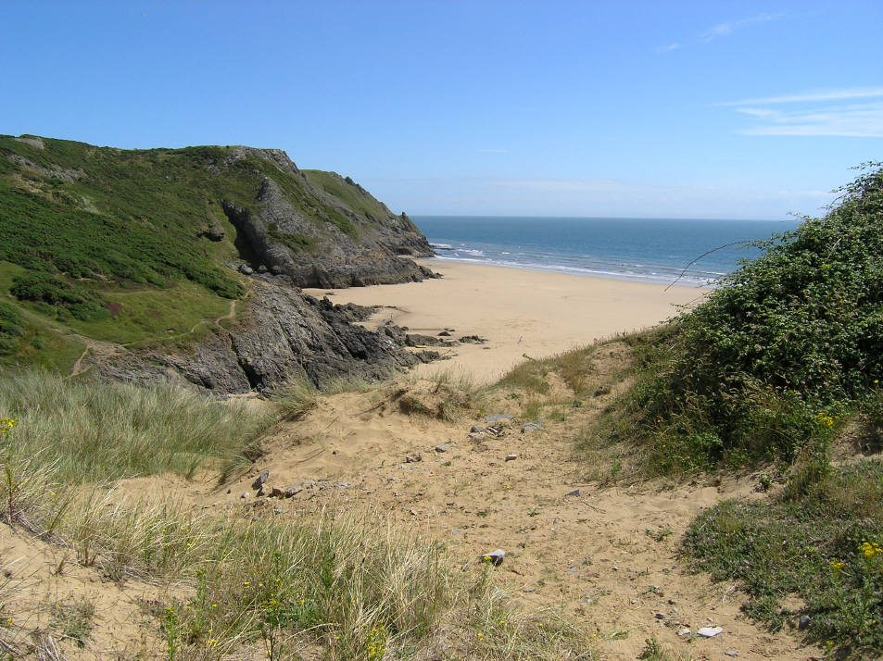

(Source: Gower Holidays, 2023)

Part 2. How the environment in the photograph could be used to develop specific scientific or mathematical concepts.
The photograph above provides plenty of opportunities for mathematic and scientific learning in the outdoors. The image promotes opportunities for curiosity, different gradients, and slopes, explore rockpools, and opportunities to learn about life cycles, along with the use of loose parts. Although it was raining heavily yesterday, today it is a dry day with some sun, and the reception class (aged between five and six) have just got on the bus to make our way to the beach. After working out the staff to child ratio, I have been designated to observe and play with a group of four children.

Exploring uneven ground
Once we carefully climb off the bus, we encounter some uneven ground as we come down to the sandy beach. We had previously mentioned this to the children and had practiced our balancing skills through the use of games such as a steppingstone path, laying rope on the ground and try to balance on it, and we played hopscotch on the school yard, hopscotch. Walking on uneven ground supports children’s vestibular sense, and supports their understanding of different mathematical concepts, such as the use of slopes and gradients, with further enhances their knowledge on forces and energy (Griffin, et al., 2019). Walking on uneven ground, down to the beach will be an opportunity for the children to build strength and coordination, and it will also support their mathematical knowledge. The children will work out how fast or slow they need to walk across the bumpy sand.
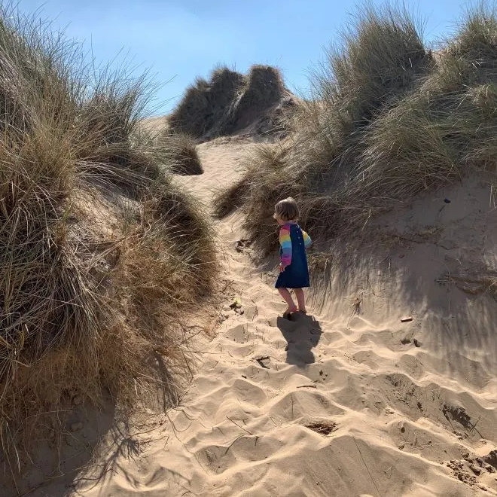
One child in my group had worked out which areas of sand is the easiest to walk on. She told me “Miss, the pale sand is making my feet sink! But the harder sand is easier to walk on”. “Well done!” I say. “Why do you think that is?” I ask her. She tells me “The darker sand is harder because it’s wet from the rain yesterday. And I feel like the whiter sand is harder to walk on because it’s so dry”. The drier sand was causing the children to use more energy to get down to the beach.
(Source: Red Kite Days, n.d)
“You are absolutely right, well done!” I proudly reply. This demonstrated a strong understanding of the scientific principles of wet and dry and relates to the development step "Increasing effectiveness as a learner" in Wales' new curriculum. The development of skills-related resilience and self-efficacy becomes crucial to enable learning through a trial-and-error strategy as problem-solving and design are typically iterative processes. Through this, children improve their ability to apply their skills and their resilience as they come to realise the value of failing in this area to acquire new approaches. Learning becomes more independent throughout time, including peer group learning, which involves dependency (Welsh Government, 2022a).
Scavenger hunt activity
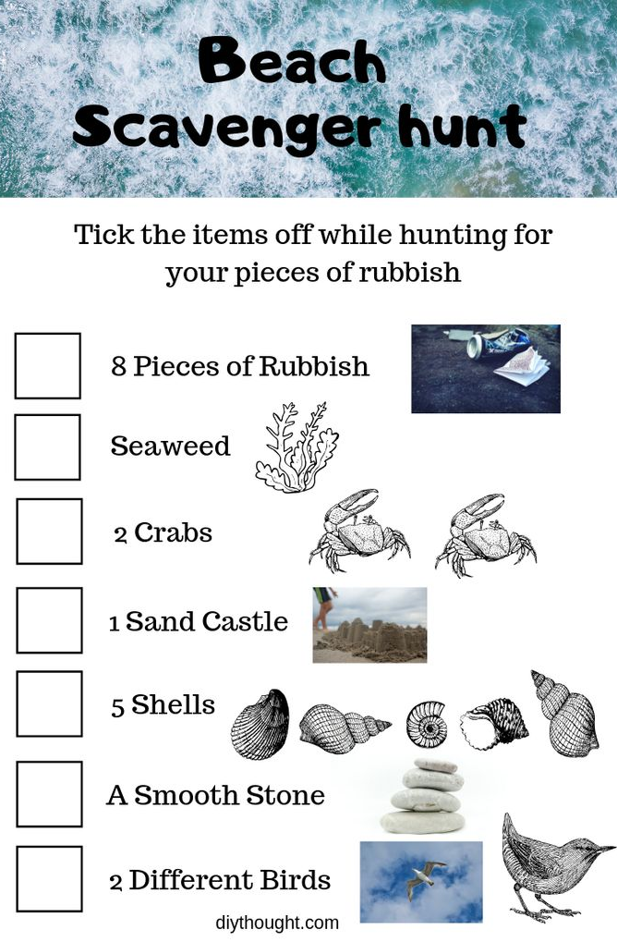
I decided after this that my group will do a little scavenger hunt, as I would like for them to learn about different materials that can be found on the beach. With some printouts and clipboards, I have a checklist of items for the children to find. Excitedly, the children and I firstly begin to look for some seaweed. A scavenger hunt will support children in gaining spatial awareness. The children will be able to distinguish distances between one item and another. This is a mathematical concept being developed, as the children’s estimating skills are being practiced. Child A quickly suggests “We should go by the rockpools, there will be loads of seaweed there!”. As we follow him to the rockpool area, he is now counting how many steps it is taking us to get there. “One, two, three, four, FIVE” he counts with his feet. Trying to think of songs involving counting, linking to the beach, I join in and begin singing “Once I caught a fish alive. Six, seven, eight, nine, ten, then I let it go again!” The children look at me with glee, and together we continue the song, “Why did you let it go? Because it bit my finger sore”. Children can develop their mathematical knowledge in a relaxing
(Source: DIY Thought, 2019)
way by singing songs that include numbers in them
and counting. Children learn through repetition, therefore singing number rhymes will enable them to become familiar with numbers and the patterns between them. I thought to myself whilst singing, that perhaps the opportunity to do this and sing together would have been limited if we were learning about the beach in a classroom.

A learning story about rockpools
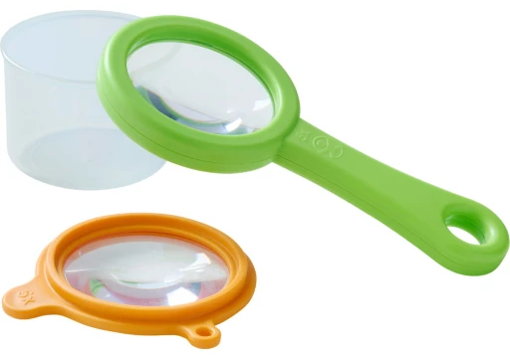
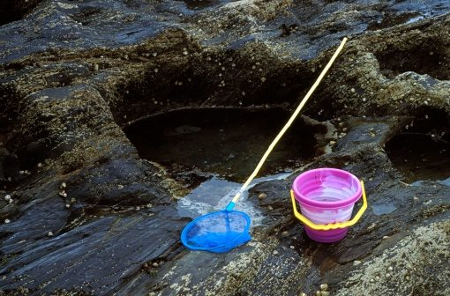
During our scavenger hunt, we get to the rockpools and explored in some that are different shapes and sizes, we quickly found plenty of seaweed, shells, and other natural materials. I introduce some loose parts to the children, such as different sized jugs, magnifying glasses, nets, and some small plastic pots. This can help promote curiosity in exploring the environment.

(Source: playPolis, 2023)
(Source: Countryfile, 2022)

Instantly, one of the children begin to dip a net in the rockpool and has found some insects in the water. To get a better look at what they have found, we decide to put it in a bug pot with some water. “Miss look, look what I’ve found” one of the children shout excitedly. I reply ecstatically with “Oh wow! What do you think that is?”, the child says, “It’s a fish!” they excitedly say. I take some photos on the iPad we have brought of the children curiously exploring the rockpools and using the loose parts. “Oh, but Miss Davey! The fish I have caught looks different to that one!” a child explains. “Hmm, why do you think that is then?” I ask. “I’m not sure, can we find out?” they reply.
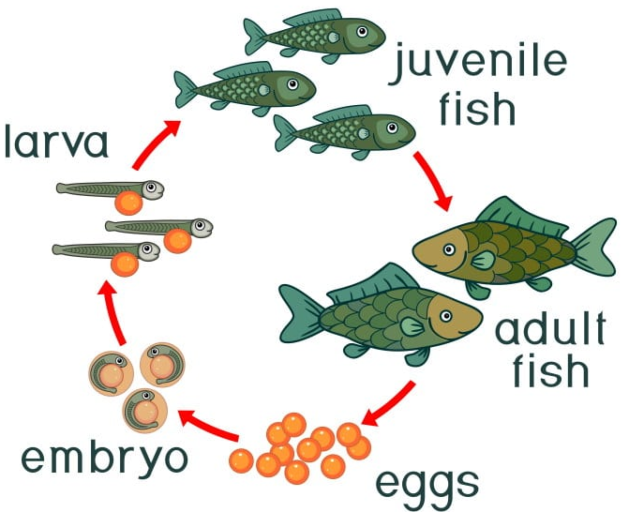
A few feet away from the water, we learn about the life cycle of fish in rockpools, using the books I have brought and researching on the iPads. Excitingly, all the children are interested in learning about fish in rockpools, as they were curious as to why they do not live in the sea with other fish. We learnt that the mother fish will lay eggs, then turn into larva and become fry fish. After this, we learnt that we then get a juvenile fish, for it to then turn into an adult fish. Once a fish is at this stage, we learnt that it could live up to 150 years old! With the help from the diagram, all four of the children were fascinated by this and were curious to learn that this is part of a life cycle for a fish. We also learnt that once the fish are adults, they leave the rockpools, and live in the sea! (Learn about Nature, 2022).
(Source: Learn About Nature, 2022)
Whilst learning about the life cycle of fish, children reach beyond progression step two of the Curriculum for Wales (2022) in science and technology. They learn that through observing the diversity of living things and how they interact with their environment, children can build an understanding of how these have evolved over time. According to the New Curriculum for Wales (2022), having an awareness of the elements that influence an organism enables us to make wise decisions about how we interact with the environment. As a result, children can develop into ethical citizens, one of the four new goals of the New Curriculum for Wales (Welsh Government, 2022b).

Part 3. Risk Benefit Assessment

Location / Activity: | A trip to the local beach | Date: | 14 March 2023
Assessor: | Lydia Davey (1909154) | Review date: | 14 September 2023
Risk rating – Low, medium, or high - based on judgement about whether the Benefits of the opportunity outweigh the Risks.

Opportunity | How will children benefit from this activity? | Hazards and risks | Who is at risk? | Precautions in place to reduce the risk of injury | Risk Rating L/M/H
Uneven ground – such as walking to the bus, beach, and sand | - Supports vestibular sense.  - Promotes sensory integration – walking on different textures.  - Builds resistance.  - Children can safely push themselves and see what their bodies are capable of.  - Supports being aware of different slopes and gradients – which develops more of an understanding of forces and energy. | - Tripping over – resulting in cuts, grazes, bruises, and breaks. | Children and staff | - Discuss with the children that they might want to take more care in their walking if they are unfamiliar with the different surfaces.  - Appropriate footwear and clothing.  - Introduce balancing games to the children – such as using balance boards, hopscotch, and steppingstones.  - First aid kit available always.  - An appropriate ratio of adults to children. | L
Seeing the sea | - Stimulates different senses – such as sound.  - Develops understanding of different habitats that live in the sea – which develops understanding of the life cycle concept.  - Food chains and eco system knowledge is supported.  - Learn about the sinking/flowing motion of water. | - Jellyfish – stings  - Depth of the sea  - Live things that live in the sea that might not be quickly noticeable. | Children and staff | - Check Met office and other weather sources to ensure low tide at the time of the trip.  - Research how far the tide comes in from the designated entrance of the beach.  - Emergency contacts to be always kept with designated persons.  - Discuss with the children what creatures could be harmful | L
Weather conditions – hot and dry, cold, and wet, winds | - Supports understanding of scientific concepts, such as the water cycle.  - Children become aware of different temperatures and can link words such as hot and dry, or wet and cold, and how this can affect or harm themselves and others – monitor their own risk.  - Develop understanding of local tides, weather and climate, temperature changes.  - Stimulating the 5 senses, such as new sights, sounds, and textures which encourage healthy brain development.  - Promotes a basic knowledge of scientific concepts such as the notation and tones and pace of sounds – measurable attributes to promote measurement skills. | - Slips, trips, and falls as a result of wet or slippery ground.  - Becoming too hot or too cold, which in extreme cases could cause hyperthermia/hypothermia.  - Becoming wet - feel uncomfortable and distressed – along with the potential risk of chafing causing soreness or redness of skin.  - Too much sun exposure to cause sunburn or heat stroke.  - Low level branches –head injury, eye injury, scratches. | Children and  staff | - First Aid kit quickly accessible and more than one fully trained First Aider to be available if needed.  - Appropriate clothing to be worn by both children and staff – waterproof rainsuits and coats, along with a spare change of clothes. Hats/caps to be worn on both cold and hot days.  - Have sheltered areas available for children and adults as and when needed – such as UV protected beach tent in the hot weather.  - Staff to regularly check the weather forecast and be prepared for both hot and cold conditions.  - Ensure access to fluids and drink breaks.  - Shorten or modify the trip as necessary.  - Emergency contacts and information to be kept by designated persons at all times. | M
Exploring independently – e.g. Rockpools, sand dunes, the sea, rocks | - Supports children in their understanding of scientific and mathematical concepts - exploring different habitats and life cycles.  - Identify things in the environment that could be harmful and know how to act to reduce the risk of harm to themselves and others.  - Exploring the environment, making observations, and communicating their ideas with others.  - Development of spatial sense later leading to better understanding of geometry – and emergency procedures.  - Becoming aware of other living things and learning to become ethical citizens.  - Having the opportunity to splash in empty rockpools – develops gross motor skills, learning about the patterns made in rockpools and how they can change.  - Children could safely climb up small rocks if confident and appropriately clothed – which would benefit their gravity and force knowledge, as well as height. | - Slips/trips/falls, which could result in cuts, grazes, and bruises.  - Poisonous or irritant plants, slipping on seaweed.  - Allergies to insect bites, or plants.  - Children may wander off and become lost.  - Children may collect inappropriate materials – such as litter.  - Depth of rockpools and the ground beneath it – could be uneven and slippery.  - Sandy water puddles could be difficult to move around in resulting in fall.  - Children may encounter other members of the public, and/or animals.  - Falling from sand dunes/rocks. | Children and staff | - Consider boundaries, ensure that children are made aware of materials they can and cannot collect. A game made by staff of the beach could be used to support this.  - Ensure children know the golden rule of nothing going in their mouths and to wash their hands at the end of exploring.  - Discuss the areas children can and cannot explore – a map for the children to refer to could be made to support this – which would also support understanding of mathematical concepts (identifying and describing positions of things, following a map).  - Staff to assess the depth of the rockpools.  - A golden rule of children walking where they are comfortable in their surroundings, and to only communicate with the staff and peers on the trip, and to ask staff about what they find – such as litter. Verbal reminders of risk.  - An appropriate ratio of adults to children.  - High visibility vests to be worn by pupils and staff. | L
Resources -e.g., magnifying glass, book | - Supports in-depth learning of  - Supports open-ended play.  - Books can help children visualise what creatures they might find look like.  - Measuring jugs can help support scientific and math concepts.  - Promotes mathematical conversations – such as comparing sizes of living things.  - Different sizes of plastic pots could help the children identify and differentiate between different living things. | - Glass in a magnifying glass breaking and harming an individual.  - Resources not being used appropriately or getting lost.  - Paper in books could catch fire if left in the sun for a long period of time.  - Plastic pots could crack and be sharp.  - Resources could get lost/forgotten. | Children and staff | - Plastic magnifying glasses could be used instead of glass ones.  - Resources to be kept in one designated area (in the shade if it’s hot, under shelter if raining). | L

Part 4. The role of the adult to support and encourage children to engage with scientific and mathematical concepts in an outdoor environment.
According to Cooper (2015), an outdoor environment with a variety of natural elements and opportunities to learn and play, enhances, and advances all the holistic developmental aspects important to children's health and wellbeing. A variety of elements are included in a natural outdoor play and learning environment to encourage both structured and unstructured physical activity, play, and learning (Waite, 2010). For children, the outdoors may be a source of surprise, curiosity, and adventure, which results in genuine opportunity for the holistic development of children (Bento and Dias, 2017). Robson (2019) state that adults frequently concentrate on domestic tasks such as resolving conflicts or instructing children to stop doing something. Yet, when caregivers and other adults respond to and engage with children in ways that are in agreement with their hobbies, it can result in deep and meaningful exchanges of concepts (Moyles, 2014).
Additionally, Keith (2017) describes that children could be learning about the same scientific and mathematical concepts outside in the real world and be able to explore it in more depth, whereas they spend most of the school day learning whilst seated at a desk. Keith (2017) further explains that using a curriculum where all subject areas complement one another in the outdoors, the Foundation Phase pedagogy for Wales would emphasise helping children to build their mathematical understanding. The curriculum also provides examples of the various forms of play that children will engage in and the variety of planned activities that incorporate child-initiated experiences. It offers obstacles that promote problem-solving in children and fosters their creativity. The importance of developing mathematical reasoning is emphasised, along with the use of skills in play, choosing useful resources, and utilising mathematical language to express one's own opinions and decisions. Also encouraged are creative explanations by children on their discoveries (Welsh Government, 2022). Additionally, learning outdoors is a great way to encourage physical movement (Solly, 2014). Houser, et al. (2019) further suggest that physical activity in the early years is linked to a variety of physiological, psychological, and socioemotional health advantages that can continue into adulthood, and essentially lower the chance of developing chronic illnesses.
Theorist Froebel understood the significant influence adults have on fostering or stifling children outside participation and curiosity. The role of the adult is to observe the children and help if they have been asked by the child (Fumoto, et al., 2014). Bruce (2021) explains that Froebel observed connections in both the development of children and nature. Tovey (2017) further expands on the Froebelian approach, and states that the outdoors provides room for children to move around freely and widely. The outdoors is an influential environment that is significant and frequently surprising, as well as a space to move, think, feel, imagine, and create. Furthermore, for Froebel, experiencing nature first-hand was crucial. Rather than learning about nature, children learnt in nature. Children are exposed to the natural outdoors through his outdoor play and gardening theory, where they could learn about the development of plants and animals, the contexts between living things and about the value of nature (Tovey, 2021; Pascal, 2021). Furthermore, (Bruce, 2020) emphasises the significance of exposing children to rough ground and uneven surfaces, as well as wild terrain, underlining how important these encounters are for physical growth. A Froebelian setting offers resources that can be altered as opposed to purchased equipment. The transformation process is crucial as it encourages children to use symbolic reasoning by substituting one thing for another (Bruce, et al., 2018: The Froebel Partnership, 2022). Symbolic representation is an element of Bruner’s three stages of representation, which follows from this.
Bruner identified three forms of representations in his 1966 study on the cognitive growth of children: enactive, iconic, and symbolic (Olson, 2014). Ozdem-Yilmaz and Bilican (2020) and Myres (2021) add that from the ages of 7 and above, children begin to represent symbols. Information is stored in this stage of life as code or symbols, such as language. With both words and symbols, experiences can be described. The quintessential image of learning is the development of the ability to think abstractly. Children can physically disconnect themselves from experiences and still think about them as their language skills advance. They can collaborate with others to solve problems and reflect, which Bruner said to be two of the most important qualities essential to the growth of thinking and, specifically, higher order thinking skills (MacBlain, 2018).
Waite (2017) recognised that the value of mathematical representations in the real world for assisting children in creating and using abstractions during their learning outdoors. According to the Welsh Government’s Enabling Pathways Guidance (2021), high levels of wellbeing, confidence, and engagement can result from learning outside. Learners can investigate, practise, and improve their skills outside. For children to fully benefit from being outside, they must have enabling adults who recognise the significance and worth. Children who are able to interact and relate to the natural world can develop a sense of empathy for it and become aware of their possible impact on the living world. Practitioners should consider developing learning environments that will allow children to express themselves physically, creatively, and imaginatively while also allowing them to engage in activities that will allow them to better understand scientific and mathematical ideas (Parsons and Traunter, 2019).
According to Gull, et al. (2019), loose parts are an example of an open-ended material that has no set use and can be used to a variety of diverse uses, such as planks, pipes, guttering, boxes, crates, and ropes. Such adaptable, transformable resources offer a variety of possibilities for problem-solving and inventive, creative thinking. Kiewra and Veselack (2016) further explain that playing with natural materials has the added benefit of teaching children to appreciate the environment. If practitioners help children develop their own creativity and imagination, they will be less likely to rely on the temporary novelty of a new object to inspire imaginative play. Practitioners assist children in acquiring knowledge and principles that encourage better care for the environment and its natural resources (Play Scotland, 2023; Oncu, 2015). Cognitive development is supported by loose parts play, and can act as an incentive to encourage curiosity, imagination, and creativity outdoors (Houser, et al., 2016). According to (Daly and Beloglovsky, 2019), children like to play with loose materials as they have a greater control over their own self-directed play and have numerous possibilities for using their imaginations. Spencer, et al. (2019) explain the advantages of loose parts play outdoors are solely centred on the socio-emotional aspects of play, the healthy conceptualization of risk-taking and risky play, and the ways in which loose parts play stimulates curiosity and imagination, promotes independence and self-assurance, as well as promoting physical movement, while also encouraging cooperative play and the development of leadership skills in the children. Whereas Ward (2018), argue that loose parts can be dangerous due to their size, and the potential use from the child.
Casey and Robertson (2019) explain that Nicholson extends the theory of loose parts into the areas of community interaction and involvement, behaviour planning and design, curriculum development and environmental education. For adults, facilitating and supporting loose parts play requires a sensitive role that recognises children’s play process and resists the urge to step in too soon or too frequently.
Moreover, children interact with objects and spaces in different ways when they play with them, according to Casey and Robertson (2019). They might perceive it in terms of affordances, rather than the intended use. In 1979, Gibson proposed that each individual's perception of an environment and the items included inside determines its values and meaning. All the various uses or qualities that an object or environment can have are referred to as affordances (Ergler, Freeman and Guiney, 2020). For instance, a brick wall may be constructed to clearly delineate the boundary between a sidewalk and a garden, but many kids would use it as a place to sit, walk along, balance, hide behind, or leap over (Carr, 2017). The knowledge of the child's science and mathematical concepts helps the concepts of variables and affordances come to life outside. A play area that is always changing, expanding, and evolving is created by children interacting with the loose pieces, surroundings, elements, and seasons, especially in loved and cared-for natural settings. As well as this, children can have a connection with their environment because they have a sense of independence, spaciousness, and autonomy (Cordovil, et al., 2015; Sisson and Lash, 2017).
Practitioners should use observation regularly in their everyday practice. They will learn more about the requirements, capabilities, and development of learners as a result. It enables educators to determine how children prefer to learn and the most effective strategies to encourage them to take part in the learning process. Also, it can help identify individuals who might require additional support in order to achieve their full potential. Practitioners can develop appropriate provisions that encourage learners' involvement and enjoyment in their learning by making effective observations (Welsh Government, 2021; Play Wales, 2017). To promote learning, adults must grasp as much as they can about why and how children learn, as well as the sensitivity that adults require in order to engage in interactions with children. Adults should be able to recognise the importance of play in their own learning and take initiative to respect and trust children.
Early childhood education is based on the concepts of many great thinkers, according to the Reggio Emilia Approach. Considering this, the Reggio Emilia Approach to early childhood education is guided by the following ideas regarding the learner, the instructor, and knowledge: The instructor is a collaborator and co-learner with the student, a guide and facilitator, and a researcher. Knowledge is seen as being socially constructed, encompassing various forms of knowing, and made up of meaningful wholes (Rinaldi, 2021; Senet, Kelley, and Abo-Zena, 2021). AuCoin and Berger (2021) further explain that Malaguzzi highlighted the emphasis on establishing and maintaining relationships is at the centre of the Reggio Emilia philosophy. To build purposeful projects that serve as a road map for assessment and give instructors a foundation upon which to write, evaluate, and share the children's work, teachers engage with children utilising guided questions, children's thoughts, and reflections. The use of documentation is a potent innovation of visible learning that takes place through community and conversation (Westerberg and Vanddermaas-Peeler, 2021; Becker, Rigaud, and Epstein, 2022).
Furthermore, Davies and Hamilton (2018) describe that practitioners sometimes think of outdoor learning as a subject. There are a variety of factors that have a negative impact on teachers' usage of outdoor green space, from more physical ones rather like shortage of green space or a fear of risks to more abstract impacts such as not appreciating the experience for the children as they have not had it themselves, and therefore believe it is not needed. Robertson (2014) adds that time can be a restriction, as well as a challenging class of children. Despite this, children with challenging behaviour benefit the most from spending time learning outside, as they value the freedom and space. Spencer, et al. (2019) explain that being outside and using several senses can enhance understanding, and not having to read or write can increase confidence, particularly in boys.
To conclude outdoor learning has many benefits for children, such as for their physical, mental, and emotional wellbeing. Taking scientific and mathematical learning outside of the classroom proves to have more in depth learning of these concepts. Visualising and being aware of the environment support children with their problem solving, risk taking, and creative skills. Although there are risks to learning outdoors, precautions can be made, and the benefits outweigh the risk of the outdoor activity.

