Foreign Languages & Cultural Awareness

  - BMIH5003

Foreign Languages & Cultural Awareness BMIH5003
Lecturer: Antoinette Milne
My name: Moryom Qureshi
ID: 2238616

Table of Contents
Component 1: Professional reflection: 3
Component 2: Training Plan 3
Orientation and onboarding programs: 4
Product and Service Knowledge: 4
Safety and Security Training: 4
Technology Training: 4
Component 3: Self-Reflection 4
Feelings: 5
Evaluation: 5
Analysis: 5
Conclusion: 5
Action Plan: 5
References 11

Component 1: Professional reflection:
I was the Sales Acquisition Manager at Holiday Inn Hotel, my role was to market the services and amenities of our hotel to the potential guests. One time, while showing a sales presentation to a group of guests from Scotland at the hotel restaurant, an unexpected cultural misunderstanding took place. The Scottish guests, who were used to being the direct ones, said what they wanted and needed in a way that I saw as brusque and demanding (Lori & Elaine, 2002). Hence, the meeting becomes tense with the guests who do not have the same worldview, which leads to communication breakdown and possible wrong interpretations of the guests' needs. Cultural clashes took place when people from various cultural backgrounds had conflicting interpretations of behaviours, gestures, or communication styles. In this case, the direct and assertive communication style common to the Scottish culture may not be compatible with my unfamiliar cultural background or the expectations as the Sales Acquisition Manager.
After looking back, I realise that the need to be culturally aware and sensitive to different cultures is a must to avoid such misunderstandings in the future. To address this, I identify several skills that I need to develop or behavioural changes I need to make. I have realised in that active listening is one of the most important skills in dealing with cross-cultural interactions and I will henceforth be listening to Scottish guests with attentive listening as a rule. On the contrary, I will not reflexively react this way or misinterpret the direct communication style of the Scottish guests as rude or demanding instead I will try to be very good at listening to their preferences and needs. By asking for clarification whenever needed, I can fully understand the message that is being conveyed by their communication style and hence ensure a thorough and meaningful exchange with them.
I realise the importance of learning the things that are peculiar in the Scottish culture, such as the way of communication, the social norms and the values of the culture; therefore, I am determined to expand my knowledge of Scottish cultural values (Meade, 2003). Through the immersion in the Scottish culture, especially the direct and assertive nature of Scottish communication, I will be able to learn some important things that will assist me in understanding the behaviour of the Scottish guests in the presentations at sales.
The understanding that the learning and development of cultural sensitivity are very important qualities towards fostering it makes me promise to join the cultural sensitivity training sessions. These sessions are a great way for me to expand my knowledge of cultural diversity and perfect my ability to get along with people from different cultures smoothly. Being aware of the fact that reflective practice is one of the ways of cultural competence improvement, I've decided to include this into my life. After each sales presentation with guests from diverse cultural backgrounds, I will take time to reflect on what has been learned. Through the process of thinking about the experience, I will keep on improving myself and I will make a better way for me to interact with other cultures (Mohapatra, 2009).

Component 2: Training Plan
Developing Cultural Awareness and Sensitivity, which is essential for peaceful coexistence and understanding in the international arena, is a primary objective in all education and professional training schemes. At Holiday Inn, we must realise the significance of making our staff capable of handling cultural interactions in a diversified environment effectively (Nawaz, 2012). The insights and lessons learned from the previous experiences have been used to create a training plan which will make sure that the employees will be capable of handling similar problems in the future. Our training program covers various issues, for example, orientation and onboarding, customer service, product and service knowledge, safety and security, technology, cross-training, and compliance.

Orientation and onboarding programs:
New employees will participate in orientation and onboarding programs which are aimed at making the new employees acquainted with the hotel's culture, policies, and procedures. Besides the fact that we stress the need for basic operational guidelines, we also focus on the cultural awareness and the sensitivity of the guests that we deal with. By attending the workshops and participating in the sharp activities, new employees acquire the knowledge of different cultural views and the ways to cope with cross-cultural situations (Ng, Skitmore, & Sharma, 2001).
Communication:
Our customer service training program specialises in primary skills such as communication, active listening, problem-solving, conflict resolution, and empathy. The fact that effective communication is the root of the relationship between guests and employees from different cultures is another step towards giving employees skills for the most appropriate and sensitive way to talk to guests. Through role-playing drills and the simulations of situations, the staff members acquire the confidence and the expertise to provide the right kind of customer service as per the requirements of our standards (Nikhal & Sanjana, 2013).
Product and Service Knowledge:
Product and service knowledge training will equip employees with the necessary knowledge about our hotel's services, facilities, amenities and offerings. Through the provision of in-depth information about the accommodations, dining options, recreational facilities, and special amenities, the staff is enabled to communicate effectively with the guests either by upselling the additional services or by giving recommendations. (Ostermann, Staudinger, & Staudinger, 2009)

Safety and Security Training:
Security and safety training is the most important of all to ensure the safety of both the guests and the staff. The training program consists of emergency procedures, fire safety protocols, and security measures that are aimed at creating a safe and secure environment for the whole community.

Technology Training:
Technology is the key factor that makes hotel operations run. Our technology training program ensures that the staff are fully capable of using hotel management software, point-of-sale systems, and other technological equipment efficiently. The foremost advantage of bringing employees into the modern, technological age is the ease of operations and the boost of efficiency that follows. Besides, we stress the necessity of cultural sensitivity in the realm of digital communication, and, as a result, we remind our employees to be respectful and inclusive in every interaction, whether it is a face-to-face or a virtual one.

Component 3: Self-Reflection
Description:
My start of cultural awareness learning was marked by my first encounters with guests from different cultures at the Holiday Inn Hotel. I have had situations where cultural difficulties resulted in misconceptions and miscommunications and thus, the importance of cultural sensitivity has been emphasised when dealing with guests (Panayotopoulou, Vakola, & Galanaki, 2007). As an example, I was once on a sales presentation with guests from Scotland and I realised that my direct communication style was the opposite of their indirect communication style hence the communication was disrupted and tension was caused.

Feelings:
At first, I was very much upset by the problems I encountered with the cultural diversity in the guest relations. I was sceptical about my capacity to communicate with guests from various cultural backgrounds and I was thinking about how I could enhance my cultural competence. Nevertheless, these emotions of anger were mixed with a sense of curiosity and the will to learn from these experiences and acquire more knowledge about the different cultures.

Evaluation:
Later, I understood that cultural awareness is not only a nice skill but the most important skill for success in the hospitality industry (Ruël, Bondarouk, & Looise, 2004). The appreciation and acknowledgement of cultural diversity can make the guests feel good, and help in communicating with the guests from different backgrounds thus, it will bring about respectful relationships with the guests.

Analysis:
After the analysis of the reasons for cultural misunderstandings, I have concluded that the problem can be solved by improving cultural sensitivity in my interactions with guests. Through analysing my manner of communication, I found out about my cultural heritage and how it affected my self-perceptions and actions. Besides, I noticed that the virtues of empathy, active listening, and flexibility which are the means of crossing cultural differences, are the key in the field of cross-cultural interactions.

Conclusion:
My process of self-evaluation was the reason I came to the point that cultural awareness is an important part of success in the hospitality industry. Through the promotion of cultural diversity and the creation of an environment that is open to everyone, we can make the guest experiences that will be unique and unforgettable and also establish a strong relationship with guests from around the world. From now on, I am at a point of no return planning to strengthen my cultural competence and assimilate cultural awareness into all the services of my role as a Sales Acquisition Manager at Holiday Inn Hotel (Sadri & Chatterjee, 2003).

Action Plan:
Through the cultural sensitivity training and cross-cultural communication workshops, my cultural awareness and sensitivity will be enhanced, therefore, I will be participating in the ongoing learning and development opportunities. Besides, I will reach out to my colleagues and the guests to get feedback to come up with the enhancement areas. Through these actions, I can assure myself that I will be able to keep on moving on as a culturally competent professional in the hospitality industry.

Component 4:

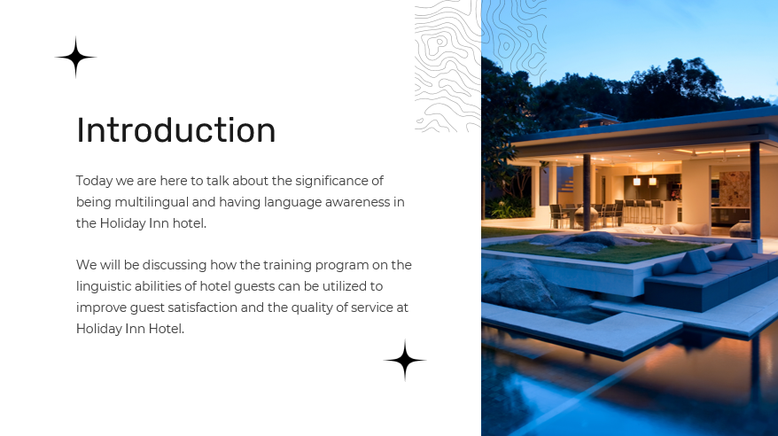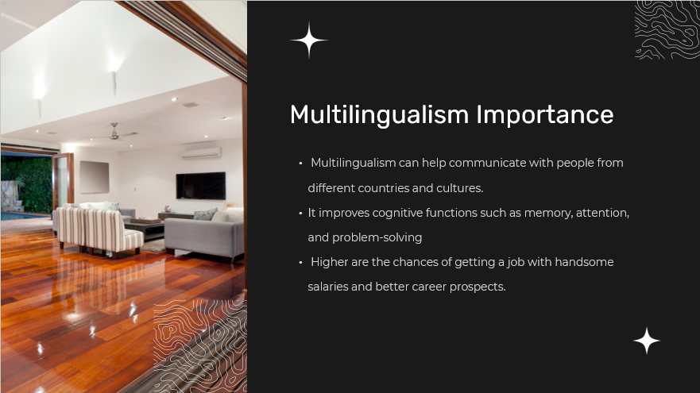
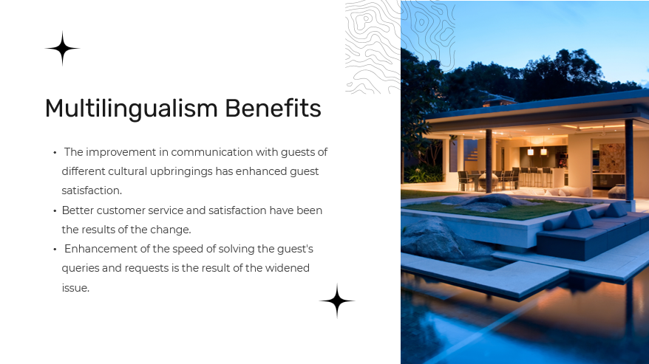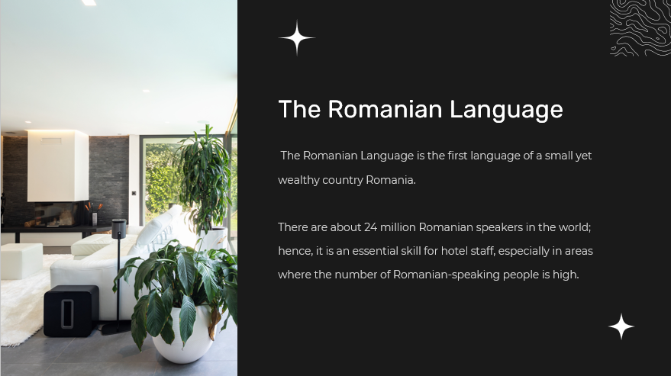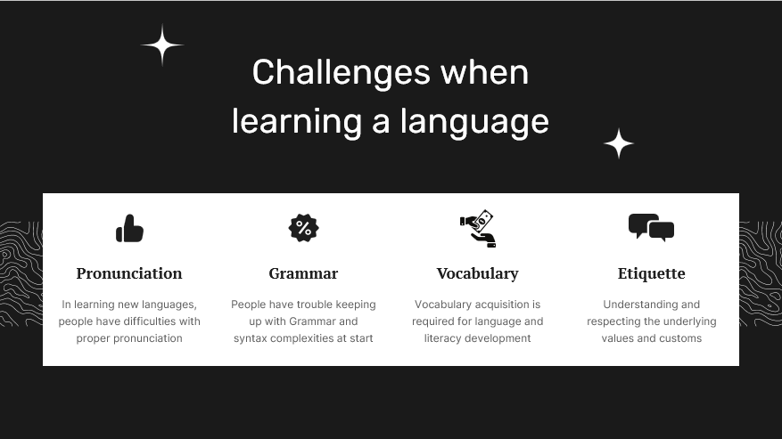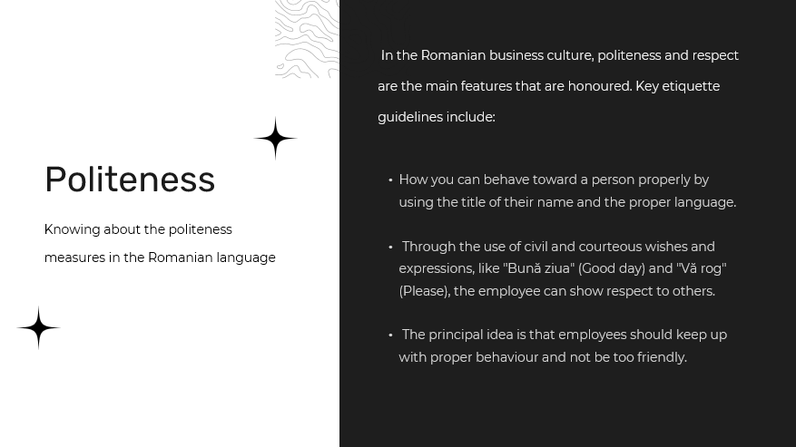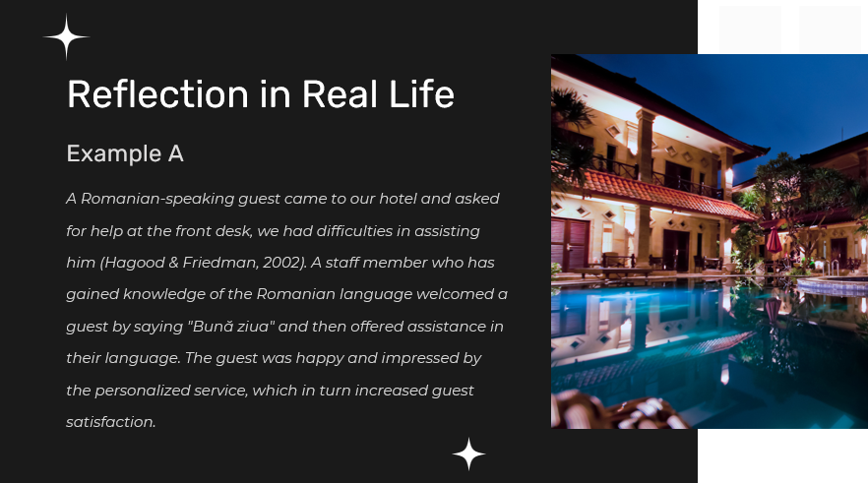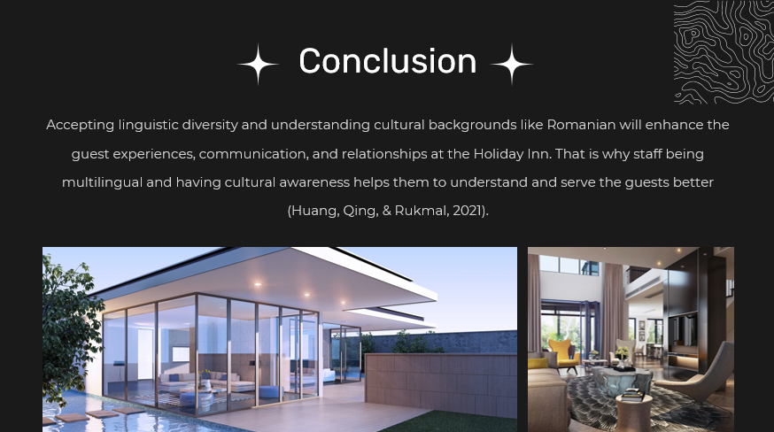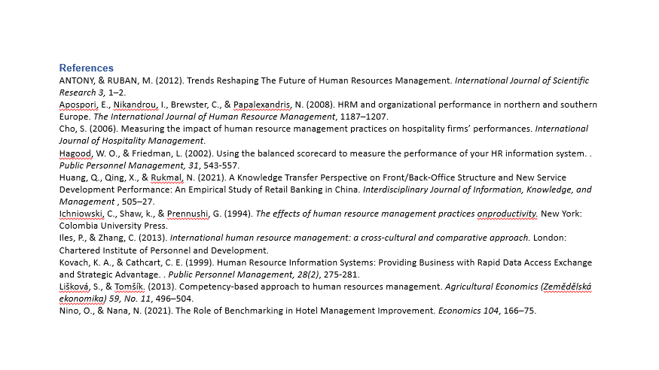

References
Lori, B., & Elaine, D. (2002). Information Systems: The quiet revolution in Human Resource management. The Journal of Computer Information Systems, 17-20.
Meade, J. G. (2003). The human resources software handbook: Evaluating technology solutions for your organization. San Francisco: Jossey-Bass.
Mohapatra, S. (2009). Framework for HRIS implementation in non-IT sector. Journal of Convergence Information Technology.
Nawaz, M. N. (2012). To assess the impact of HRIS in facilitating information flow among the select software companies in Bangalore, India. Research Journal of Management Sciences, 1–8.
Ng, S. T., Skitmore, R. M., & Sharma, T. (2001). Towards a human resource information system for Australian construction companies. Engineering, construction and architectural management, 238-249.
Nikhal, A., & Sanjana, B. (2013). Managerial Perceptions of the Impact of HRIS on Organizational Efficiency. Journal of Economics and Behavioral Studies, 861-87.
Ostermann, H., Staudinger, B., & Staudinger, R. (2009). Benchmarking human resources information systems. Encyclopedia of Human Resources Information Systems, 92-101.
Panayotopoulou, L., Vakola, M., & Galanaki, E. (2007). E-HR adoption and the role of HRM:Evidence from Greece. Personnel Review, 277-294.
Ruël, H., Bondarouk, T., & Looise, J. K. (2004). E-HRM: innovation or irritation: an explorative empirical study in five large companies on web-based HRM. Management Revenue, 364–380. .
Sadri, J., & Chatterjee, V. (2003). Building organizational character through HRIS. International Journal of www.ccsenet.org/ibr International Business , 2014 .

