Activism Poster
“Animal cruelty is one of the most unfortunate and barbaric demonstrations of human beings manipulating ill conceived notions of “power” over other species”- Ian Somerholder, Actor and Philanthropist.
I have personally experienced how animals behave, what they are capable of feeling as well as seeing how much they feel it. This makes it even harder to comprehend and come to terms with the idea of animals then being disregarded for something as barbaric as entertainment or profit. In the centre of the poster I positioned an eye that was filled with money which was meant to give the impression of people being blinded by money and profit, its clouding their vision and they don’t see past it.
In this poster I wanted to draw attention to the way people use animals for money in the form of “entertainment”. I wanted to express how they are blinded by a piece of paper made valuable by people and society, instead of appreciating what is truly valuable and precious, living beings. I went about doing this by creating a collaged background consistent of small photos of animals either held against their will and forced to entertain or even of the actual entertainment event itself. I then edited each photo individual to brighten the images as much as I could then, I took the colour out of them and made them black and white to express the concept of taking the happy, colourful fun from the “entertainment” to show the dark truth and reality behind these events.
I got most of the images from animal cruelty or charity websites and then the rest I got by scanning pages of National Geographic magazines. I did this because it was the photos from the magazines that inspired and compelled me to address this topic in the first place, it inspired me more then any other topic that I considered, not because those topics such as plastic pollution are less important, but the way the images and writing in the magazines were composed just broke my heart. The images were powerful and I wanted to included them in a collage in the hope that people would see what I saw because once I read it I couldn’t think of choosing something else.
Despite having my own ideas about wanting the image to be in black and white I was partially inspired by the artist Barbara Kruger, I had studied her work in the past so I knew who she was and what she did, but when I was completing my research, she came up in a book called A History of Photography. This reminded me of how much I liked the way she composed her poster images and used colour to influence what points of the photo stood out to you and drew your attention. I liked how she used short bold text red and white text to express a political statement because of how eye-catching and powerful it can be if done right, she inspired me to create a similar effect.
Another main source of research I used was from a website called Vegan Souls (https://www.vegansouls.com/cruel-sports) and it seems odd but it’s the one website that gave me lots of ideas of what pictures to include in my background because it had a list of “entertainment” events that have a detrimental effect on animals and their mental health and are classed as cruel. It was a really helpful website and it allowed me to get a better understanding of what to look for and told me about events I did even know existed such as orangutang boxing and bear dancing on the street. I went on to find more images to do with these events and I ended up with a variety of ideas.
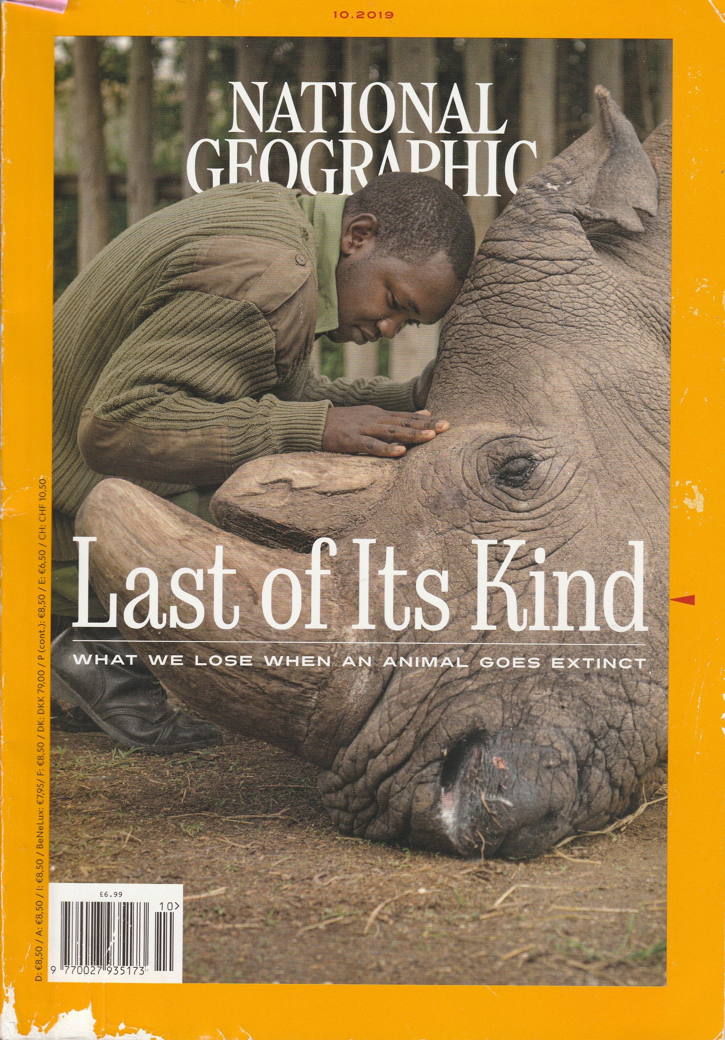
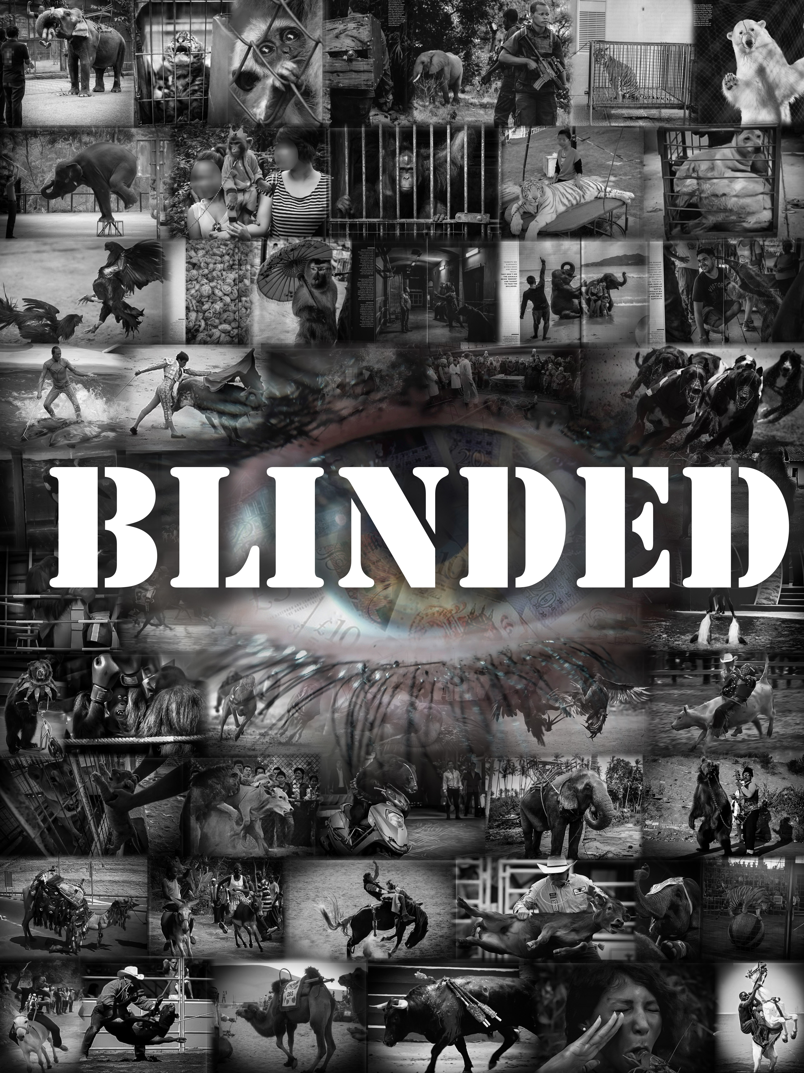
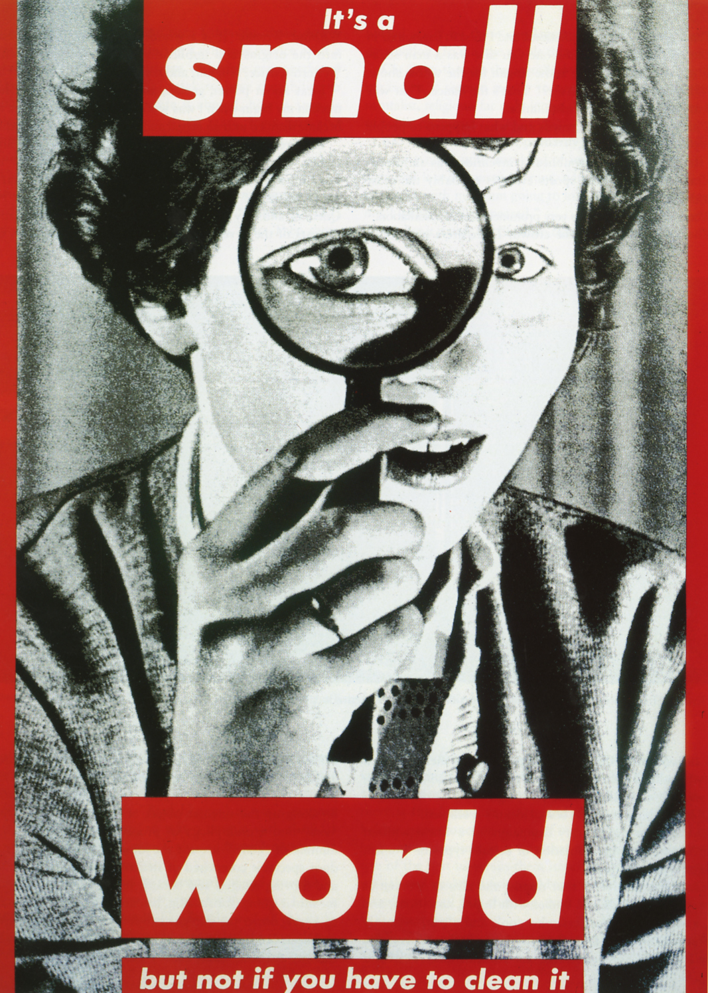

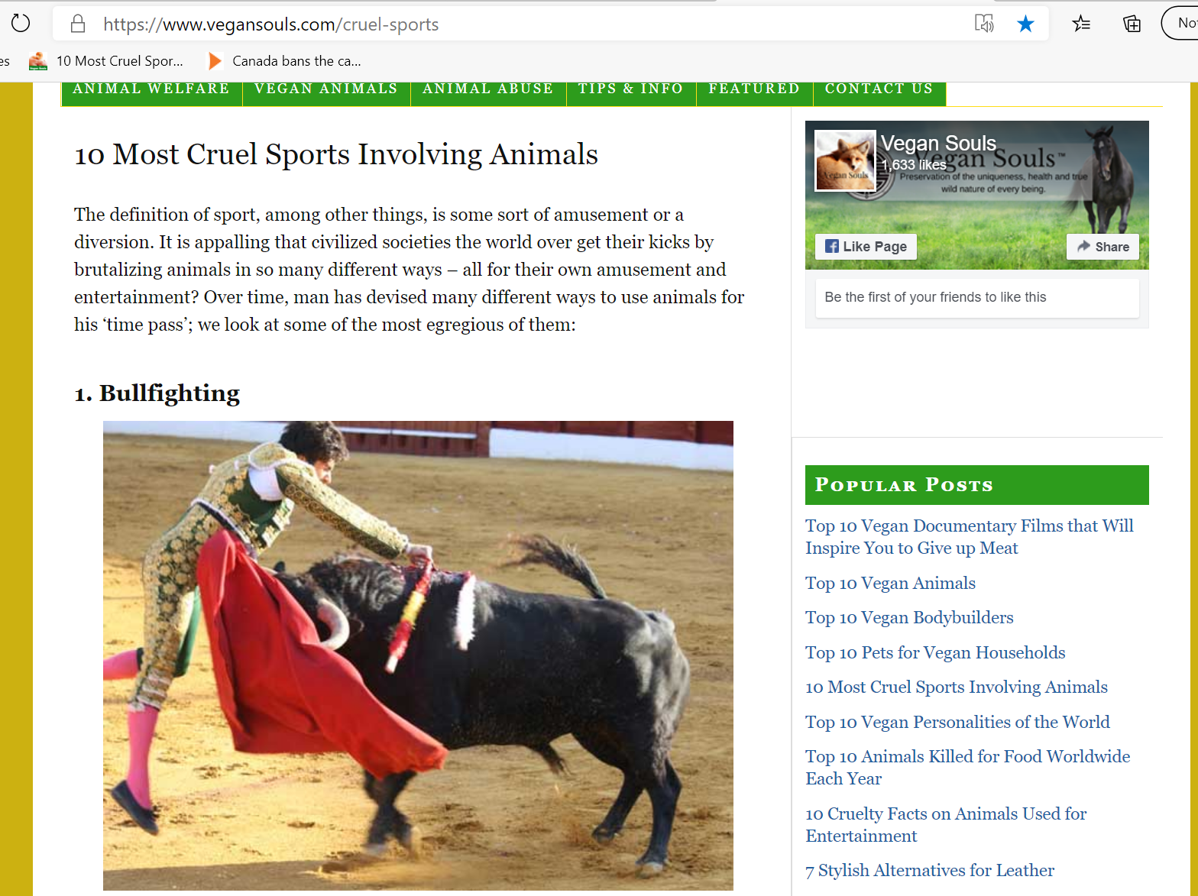
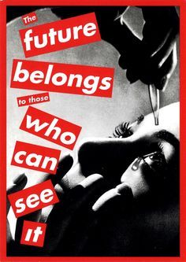

Bibliography | Source of research
Barbara Kruger | A History of Photography- from 1839 to the Present-The George Eastman House collection-Taschen Bibliotheca Universalis-page 724-725
Vegansouls-photos and information | https://www.vegansouls.com/cruel-sports
National Geographic photos and research-magazines | National geographic-The hidden cost of wildlife tourism-06/2019  National Geographic- last of its kind-what we lose when an animal goes extinct-10/2019  National Geographic- Under Jerusalem-12/19
Information about animal cruelty and photos | https://www.worldanimalprotection.org/news/canada-bans-captivity-whales-dolphins-and-porpoises-entertainment
Artist-Steve Rosenfield | http://whatibeproject.com/
Artist-John Berger | https://www.brainpickings.org/2014/04/01/why-look-at-animals-john-berger-about-looking/
Research on animal cruelty and photo sources
Research on animal cruelty and photo sources
Research on animals and cruelty and photo source

