
Presented by Rex AMU ID 2028603
Knowledge management system in practice at Brompton bike ltd
K
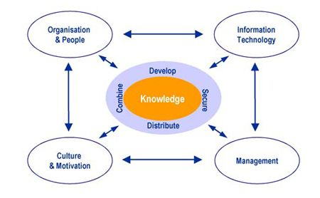
The definition of knowledge in
organisation

knowledge is defined broadly to cover both explicit and codified knowledge as well as tacit or uncodified knowledge. Creating new information within the company from client interactions and exploiting this new knowledge in the firm and in client relationships are the two main organizational learning processes involved in knowledge absorption Organizational from customer relationships.

encourage employees to share knowledge in order to improve the collective workforce, fostering a culture of learning and development.

Objective of knowledge management
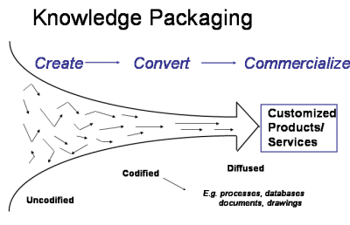
- It boost the efficiency of an organization in terms of decision making abilityCompanies preserve their prior performance by gathering and storing the knowledge of their workers. Additionally, by disseminating this knowledge throughout the company, staff members are made aware of previous methods that have improved performance or better informed new plans.
- The basic goal of knowledge management is to streamline interactions between staff members seeking information or institutional knowledge and those who already possess it.

Knowledge commercialization

References.
- Nonaka & K. Ichijō (eds.) (2007) Knowledge creation and management [electronic resource] : new challenges for managers . New York :; Oxford ;, Oxford University Press.
- Anon (n.d.) Knowledge management and decision support with special focus to process and quality optimisation at flat steel production. https://op.europa.eu/en/publication-detail/-/publication/755eeaf1-84dd-40ba-8906-338278d9c18e/language-en/format-PDF/source-133934022.

