DIGITAL SKILLS AND RESEARCH METHODS

The Impact of Virtual Learning Environment

BMSW4003

Student: Andreea Gradinaru

Student number: 2026721

Lecturer: Koushik Modak

Abstract
The research has followed the proper method of research for analysing the learning experience of the students un the VLE process. In the research there has been focus on the aim and objectives based on the topic of the project. Along with that, the following research ahs also analysed the proper methodology for conducting the product and for making it authentic. There has been focus on the quantitative and qualitative data analysis for making a depth analysis of the project. The project has followed the recommendation for improving the VLE of University of Wales Trinity Saint David London Campus.

Table of Contents
Introduction 4
Rationale 4
Research Objectives 4
Literature Review 6
Research Methodology 8
Research method 8
Data analysis 8
Data collection process 8
Sampling 8
Research Ethics 9
Findings, analysis and discussion 10
Conclusion and Recommendation 16
References 18
Books and Journals 18
Website References 19
Appendices 20
Appendix 1 20
Appendix 2 21

Introduction
The following research project has focused on the VLE and the experience of the students of University of Wales Trinity Saint David London Campus. Virtual Learning Environment is the learning process which has been followed via digital technology. The following research will analyse the impact, importance of the VLE for the students. Along with that, the research project will also focus on discussing the challenges of the VLE. The project will focus on the methodology as well as rationale of the project. The research project will discuss about the questionnaire and the recommendation for the development of VLE at University of Wales Trinity Saint David London Campus will be focused.

Rationale
Recently the VLE process has enhanced the popularity of it due to the lockdown situations after the Covid-19 pandemic. Therefore, the following research would be very useful following the recent learning process related scenario of the Universities. The research would be also helpful for University of Wales Trinity Saint David London Campus to improve the learning experience of the students by following the specie areas of challenges of the VLE. This can help the university to make improvement of VLE accordingly (Snyder, 2019).

Research Objectives
Aim: To understand the impact of Virtual Learning Environment (VLE) – Moodle on students’ learning experience at the University of Wales Trinity Saint David London Campus.
Objectives:
1. To analyse the importance of Virtual Learning Environment (VLE) for students.
2. To understanding the impact of Virtual Learning Environment (VLE) on the learning experience of students of University of Wales Trinity Saint David London Campus.
3. To determine the challenges of University of Wales Trinity Saint David London Campus while conducting the VLE education.

Literature Review
Introduction
The secondary data analysis improves the depth analysis of the research. The literature review is a part of the secondary data analysis. In this case, there will be discussion about the importance of the VLE. Along with that, the literature review will also analyse different scholar articles regarding the challenges of VLE and impact of VLE on students.
Significance of VLE
Increase the technical skill: As per, Puzhevich, (2020), the VLE is completely depended on the virtual set-up for the learning process. The teachers teach the student via technology or internet, which enhances the technological skill of the students. Therefore, enhancing the technological skill of the student is one of the most significant impact of VLE on the students (Kumar, 2018).
Cost and time saving: The VLE process is a complete virtual process. In this case, the teachers as well as the students, would not have to go to the class rooms and also would not have the need to set-up a proper environment for the classroom. This reduces the timing and costing of the learning process of the University.
Impact of VLE on the students
Positive impact: There are a wide range of positive impact of the VLE on the students. According to Alves, (2017), the most positive impact of VLE is that, it develops the interest of the stduents by continuouly beign abel to ask for their needs to the teaers via call or comments. They can learn any time from anywhere. This imporves the flexibility of the learning process.
Negative impact: The major negative impact is that, it demands high technological support. Along with that, the VLE process seems to be difficult for the students who are technologically not very advanced. There can be chances of delayed answers from the teachers hence, it can also create miscommunication during the VLE process (Mohajan, 2018).
Challenges of VLE for education
There are several kinds of challenges of maintaining the VLE in the universities. The major challenge is providing proper training to the teachers; therefore, they can effectively use the VLE for providing the best learning experience to the students. There is also a challenge of developing the confidence of the newly admitted students to learn the various aspects of VLE. The universities also sometime face communication issue during the VLE as often, the teachers ignore the questions of the students (Pererva, 2020).
Summary
The following literature review has focused on analysing the various impacts as well as importance of VLE. The literature review has also focused on the challenges which the VLE brings.

Research Methodology

Research method
The following research project has focused on the mixed method for conducting the project. As per the mixed methodology, the qualitative as well as the quantitative both types of methods have been adopted in the research. The qualitative method has focused on analysing the literature review and detailed information regarding the topic. On the other hand, the numeric numbers have been analysed via the quantitative method (formpl, 2021).

Data analysis
The research project has followed the primary and secondary both kinds of data to analyse the result based on the aim and objectives. The primary analysis has focused on directly collecting the information from the students of University of Wales Trinity Saint David London Campus to know their VLE experience.

Data collection process
The data collection process is very important as proper data collection process can improve the reliability of the research by colleting proper data. In this case, the primary data has been collected by using online survey and sampling. On the other hand, the secondary data has been collected by using different scholar articles (nichq, 2021).

Sampling
The simple random sampling method has been followed during the following project. The sampling method focuses on collecting the random sampling just to avoid any kinds of biasness during the survey. As per the simple random sample, a sample of 20 random students of University of Wales Trinity Saint David London Campus have been collected (Hamutoglu, 2020).

Research Ethics
The research project has followed all the ethical aspects. The project has not harmed anyone. The project has taken concern from all the variables. The research has not intended to harm the community of society as well. All the given information is true as well (Bogusevschi, 2020).

Findings, analysis and discussion
Quantitative analysis
1. Do you know about the new VLE learning process?
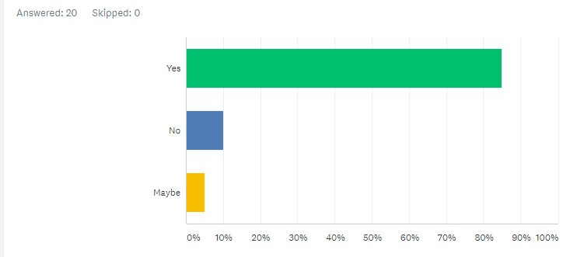
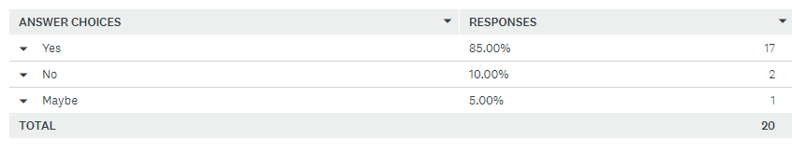
(surveymonkey, 2021)
The VLE process has enhanced during the recent years within the universities. This question has made for analysing the popularity of the VLE. As per the 85% variables, they know about the VLE. On the other hand, as per the 10% variables, they are not aware about the VLE and 5% have stated that, maybe they known about VLE.
2. Are you enjoying the VLE process?
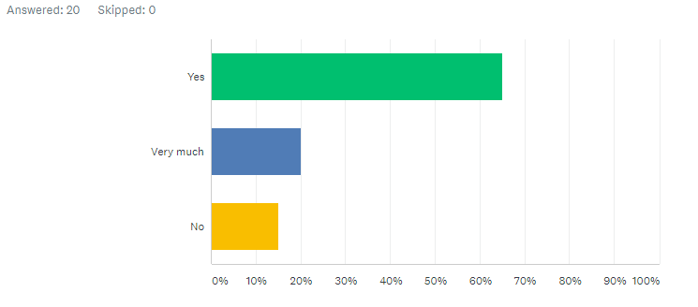
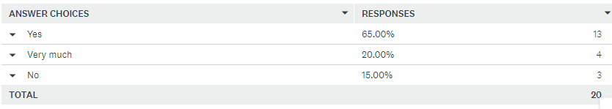
(surveymonkey, 2021)
It is important for the students to enjoy the learning process for gaining proper knowledge via the process. The lack of enjoyment during the learning process can increase boredom among the students, and it also negatively impact on the effectiveness of learning. There were 65% variables, who have stated that, they are enjoying the VLE learning process. On the other hand, 20% variables have stated that, they are very much enjoying the VLE process. The 15% variables have said that, they have not enjoyed the VLE process.
3. Do you think VLE has developed your learning capacity?
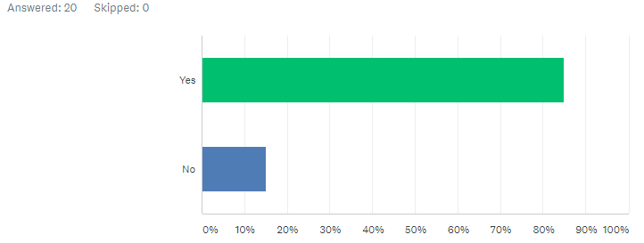
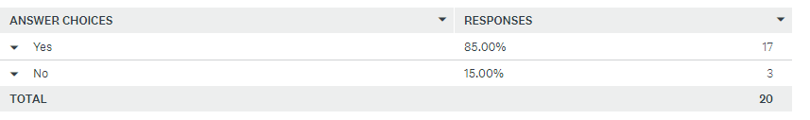
(surveymonkey, 2021)
The learning capacity development is very important for the students. The proper learning process can improve their learning capacity which would also improve their percentage during the module. However, in this case, as per 85% variables the learning capacity of them has developed. On the other hand, the 15% variables have stated that, there learning capacity has not got improved due to the VLE.
4. What do you think is the major advantage of using VLE?
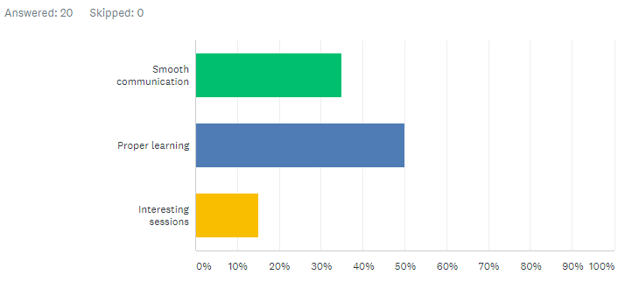
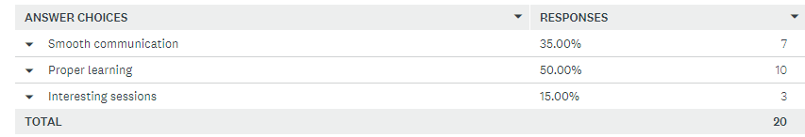
(surveymonkey, 2021)
There are several advantages of the VLE for the students. These advantages increase the learning process as well. There were about 50% responses which stated that, the proper learning process is the most important advantage of the VLE process. Apart from that, as per the 35% variables, the smooth communication is the major advantage which has been seen during the VLE process. There were about 15% variables who have opted for the interesting session advantage of using the VLE process.
5. What is the most recent challenge you have faced during the VLE?
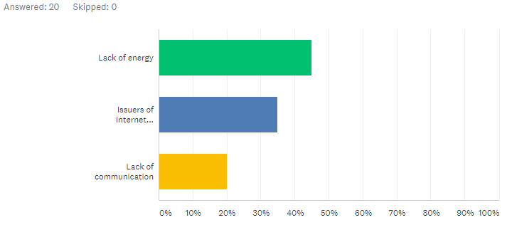
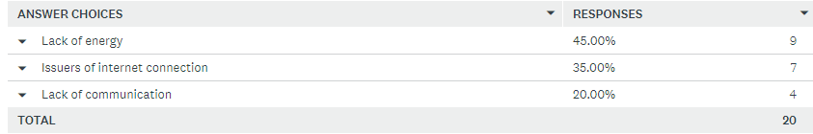

(surveymonkey, 2021)
This question was asked to the students to understanding their challenges during the VLE classes of the university. As per the analysis it is clear that, 45% variables have stated that, the felt lack of energy during the VLE. On the other hand, there were 35% response regarding the challenge of internet connection during the VLE. The 20% variables have stated that, they have faced the issues of communication during the VLE class.
Qualitative Analysis
6. Why do you think it is important for the teachers of University of Wales Trinity Saint David London Campus to use the VLE mostly during the classes?
The question has focused on analysing the importance of VLE for the teachers of University of Wales Trinity Saint David London Campus. As per the analysis it can be seen that, most of the answers were provided by the students regarding the east of learning via the VLE process. Most of the students have stated that, the student engagement would be better for the teachers of the university by VLE process. This would make it interesting for the teachers to teach the students who are interactive during the classes. Apart from that, as per the analysis it can be also said, that the teachers would have a good environment of; learning by reducing all the physical barriers during the classes with the help of VLE (surveymonkey, 2021).
7. What is the most common impact among students due to the VLE?
The question has focused on the common impact related understanding of the VLE process of learning among the students. As per the analysis it is clear that, the major impact would be the better learning process of the students due to the VEL process. Along with that, as per the response it has been also focused that, the VLE would create interest of learning among the students by providing them more study materials as well. It also improves the accessibility of the learning process of the students as well, and also impact positivity on improving the motivation of self-study among the students (surveymonkey, 2021).

Conclusion and Recommendation
Conclusion
The research project has analysed the different aspects of the VLE and has also focused on analysing the experience of the students of University of Wales Trinity Saint David London Campus. The complete research has focused on collecting both the primary and secondary data. The following research has also discussed about the rationale of the product and the methodology based on the topic. As per the data of the primary and secondary research it can be concluded that, VLE is an extremely important part of learning in todays world, due to the restriction of gathering in the schools and college due to the global pandemic. Apart from that, it has been also understood that, there are still certain technological restrictions among the students which is creating the challenges in the VLE process which can be reduced by proper strategic panning of the teachers.
Recommendation
There are several strategies which the University of Wales Trinity Saint David London Campus can apply for improving the VLE learning experience of the students.
1. The university can train the teachers to teach properly in the VLE process. The proper training can develop the student management of the teachers of the university. In this way, the teachers can also reduce the challenges of the VLE process regarding technological difficulties (Chui, 2020).
2. The university can develop the technology-based knowledge among the students. This would develop their knowledge to manage the VLE process.
3. The university needs to focus on improving the communication of the teachers with the students, the teachers must seek for feedback to the students. This can help the teachers to improve their approach during the VLE process for improving the effectiveness of learning.

References

Books and Journals
Bogusevschi, D., Muntean, C. and Muntean, G.M., 2020. Teaching and learning physics using 3D virtual learning environment: A case study of combined virtual reality and virtual laboratory in secondary school. Journal of Computers in Mathematics and Science Teaching, 39(1), pp.5-18.
Chui, K.T., Fung, D.C.L., Lytras, M.D. and Lam, T.M., 2020. Predicting at-risk university students in a virtual learning environment via a machine learning algorithm. Computers in Human Behavior, 107, p.105584.
Hamutoglu, N.B., Gemikonakli, O., Duman, I., Kirksekiz, A. and Kiyici, M., 2020. Evaluating students experiences using a virtual learning environment: satisfaction and preferences. Educational Technology Research and Development, 68(1), pp.437-462.
Kumar, R., 2018. Research methodology: A step-by-step guide for beginners. Sage.
Mohajan, H.K., 2018. Qualitative research methodology in social sciences and related subjects. Journal of Economic Development, Environment and People, 7(1), pp.23-48.
Pererva, V., Lavrentieva, O., Lakomova, O., Zavalniuk, O. and Tolmachev, S., 2020. The technique of the use of Virtual Learning Environment in the process of organizing the future teachers' terminological work by specialty.
Snyder, H., 2019. Literature review as a research methodology: An overview and guidelines. Journal of business research, 104, pp.333-339.

Website References
Alves, P., 2017. The Influence of Virtual Learning Environments in Students’ Performance. [Online]
Available at: https://files.eric.ed.gov/fulltext/EJ1134444.pdf
formpl, 2021. qualitative-data. [Online]
Available at: https://www.formpl.us/blog/qualitative-data
nichq, 2021. qualitative-data-analysis-7-things-researchers-need-know-get-it-right. [Online]
Available at: https://www.nichq.org/insight/qualitative-data-analysis-7-things-researchers-need-know-get-it-right
Puzhevich, V., 2020. the-use-of-virtual-learning-environment-in-education. [Online]
Available at: https://scand.com/company/blog/the-use-of-virtual-learning-environment-in-education/#:~:text=Virtual%20learning%20environments%20help%20teachers,for%20those%20who%20need%20that.
surveymonkey, 2021. analyze. [Online]
Available at: https://www.surveymonkey.com/analyze/wBUfCwGetYGKGSTYo0tn4dzNwl_2B9PvgHL6rM4agjBKI_3D?tab_clicked=1

Appendices

Appendix 1
Quantitative analysis
1. Do you know about the new VLE learning process?
Yes
No
Maybe
2. Are you enjoying the VLE process?
Yes
Very much
No
3. Do you think VLE has developed your learning capacity?
Yes
No
4. What do you think is the major advantage of using VLE?
Smooth communication
Proper learning
Interesting sessions
5. What is the most recent challenge you have faced during the VLE?
Lack of energy
Issuers of internet connection
Lack of communication
Qualitative Analysis
6. Why do you think it is important for the teachers of University of Wales Trinity Saint David London Campus to use the VLE mostly during the classes?
7. What is the most common impact among students due to the VLE?

Appendix 2
1. Do you know about the new VLE learning process?
2. Are you enjoying the VLE process?
3. Do you think VLE has developed your learning capacity?
4. What do you think is the major advantage of using VLE?
5. What is the most recent challenge you have faced during the VLE?

