
Prevention is better than cure.
Whole school approaches are utilised and are most effective (School A, 2017) (Long et al. 2020)

Bullying can lead to an increase in common somatic problems, psychosomatic problems, and suicidal thoughts. Those bullied more frequently showed more adverse effects (Wolke & Lereva, 2015).

MORE THAN MEETS THE EYE
BULLYING

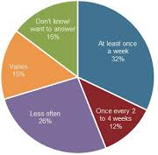
Person centred approaches (Florkowski, 2017) should be used to avoid judging and to provide a source of acceptance and support (Cherry, 2017)

Unconditional Positive Regard
Genuineness
Empathetic Understanding

1 (Department for Education, 2018)
Sensitive
Acknowledge
Take Ownership
Confront
CHANGE
(Cowie et al. 2004)
All children, whatever their race, sex, beliefs, and abilities have the right to be safe and to be free from oppression, humiliation, and abuse” (The Children’s Act, 2004).

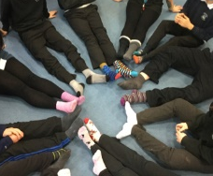


Value differences, skills, and talents (Welsh Government, 2019) (School A, 2017)

References
CHERRY, K. (2017, June 20). What is client centered therapy? A closer look at Carl Rogers’ person-centered therapy. Very Well. Available at: https://www.verywell.com/client centered-therapy-2795999 (Accessed 15th January 2021).
CHILDRENS ACT (2004) c. 31. Available at: http://www.legislation.gov.uk/ukpga/2004/31/contents (Accessed: 15th January 2021).
COWIE, H., BOARDMAN, C., DAWKINS, J. and JENNIFER, D. (2004) Emotional Health and Well-being: A Practical Guide for Schools. London: Sage Publications.
DEPARTMENT FOR EDUCATION. (2018) Bullying in England, April 2013 to March 2018.
FLORKOWSKI, R., (2017) Person-centered approach and rehabilitation. Teaching Crossroads: 12th IPB Erasmus Week, p.81.
LONG, R., ROBERTS, N. and LOFT, P., (2020) Bullying in UK Schools.
SCHOOL A. (2017). Policy Document for Behaiviour, Discipline and Anti-Bullying.
WELSH GOVERNMENT. (2019) Rights, respect, equality: Statutory guidance for governing bodies of maintained schools.
WOLKE, D. and LEREVA, S.T., (2015). Long-term effects of bullying. Archives of disease in childhood, 100(9), pp.879-885.

