University of Wales Trinity Saint David
Wales Institute of Science and Art


How Data Acquisition and Data Analysis Contributes to On-Track Performance
Academic and Laboratory Skills (ACHA4032)

Nicole Crofts
2501478
November 2025

1352 words

Contents
1 Introduction 1
2 Background 2
2.1 The History of Data Acquisition 2
2.2 Key Systems 2
2.3 Different Types of Data Collected 2
2.3.1 Driver Data 2
2.3.2 Mechanical Data 2
2.3.3 Environmental Data 3
3 Results and Analysis 4
4 Conclusions 5
5 References 6

Introduction
Data acquisition and data analysis is a key part of a cars on-track performance as it allows a team of people to identify both where the car is performing well and which aspects are not, as well as providing an insight into the consistency and technique of the driver. This knowledge then allows the team to make a strategical decision or change to improve performance based on the data they have acquired.

This data can be collected in multiple different ways, including sensors on the car, camera footage, driver feedback and live trackers on the car. These sources supply the team with several unique types of data which allows for a broad and detailed understanding of the vehicle performance.

The main aim of this assignment is to thoroughly explore how data is collected and how this data will then affect and contribute to how the car will operate and present on-track. The objectives are to identify key types of data captured, to understand how teams then process, analyse and implement this data, and then how this will enhance the driver and vehicle performance.

Background

The History of Data Acquisition
The idea of collecting data to improve vehicle performance has evolved immensely over the past decades. In the early years of Formula 1, gathering this data was done using simple processes. This has changed through the modernisation of technology, which has introduced more complex and accurate ways to gather information. Historically, people relied heavily on a pocket stopwatch to record lap times and feedback from the driver to help them to understand how the car was behaving on track. This slowly began to change in the 1970s due to the evolution of technology and a rise in finances and expertise in the field. Concepts like telemetry systems, data loggers and sensors were slowly introduced into the sport. (Wright, 2025)

Key Systems
There are multiple different systems which are involved in the acquisition of data in motorsport. Some of these principal systems include sensors which are connected to a data logger or electrical control unit, sensors which measure data on speed, acceleration, wheel rotation, suspension displacement, steering angle and brake pressure. The GPS unit is also used for positional info. It gives the team an accurate mapping of racing lines and lap times. Environmental sensor are also significant as they allow data on track temperatures, ambient conditions and surface grip levels to be collected.

Different Types of Data Collected

Driver Data
The collection of data about the athlete driving the vehicle is crucial in achieving better on track performance as it helps to improve the driver’s performance. Data on driver technique can be gathered through many kinds of sensors placed on the car. These sensors can then determine speed traces, acceleration forces, braking pressure, steering inputs, how the athlete is interaction with the vehicle and conditions and highlight strengths weaknesses in their technique.

Mechanical Data
Mechanical data is another important part of understanding the behaviour of the vehicle and this consists of analysing many different components on the car. Just some of the many components that are analysed are engine RPM and the application of the brakes and throttle.

The engine RPM is one of the things that is tracked and is monitored using a crankshaft position sensor, which measures the rotational speed of the engine and sends this information to the ECU. This is used to the advantage of the team by measuring the spikes and changes in the engine revolution. This data can be plotted onto a line graph to visually show where on track the engine spikes occur. This is useful data as it highlights the technique that the driver is using when shifting gears and can also show the points where driver is not as strong, which can help the team to pinpoint strengths and weaknesses and make changes from them. (Ahmad, 2023) (Figure 1)

Brake and throttle analysis is also used to help a driver to understand where exactly to apply speed or brakes to reach the cars maximum potential and put in suitable lap times. This is measured by pedal position sensors and pressure sensors, which record how much force is applied and where on the track the force is placed. It is crucial to understand how much pressure the athlete puts on the throttle on different parts of the track as too much or too little force can harm lap times. Similarly with braking, if the brakes are applied to early in a corner or too late, the car will be significantly slower. After analysing this data, having the timing and smoothness perfect when using the throttle and brakes is critical to putting in good and consistent lap times. (Ahmad, 2023)

Environmental Data
Environmental data is collected to give engineers an insight of the weather they will be facing when the car is on track. This allows the team to understand what conditions they will be facing and analyse these conditions to use to figure out the best set up for the car based on weather conditions. They look at factors like the weather, surface temperature of the track and track evolution which will all have a big effect on how the car behaves on track.
Weather radars are used to follow the weather conditions and to predict upcoming weather to help decide which kinds of tyres will be put on the car or warn the driver about what conditions they will have to adapt to. Track temperatures are usually measured using infrared temperature sensors.

The direct temperature of the surface of the track has a big impact on tyre grip and wear. The hotter the track, the more slippery it is as well as creating more tyre degradation. This needs to be known before a decision on strategy and set up is made before the car goes out so that the team can use the temperature of the surface to their advantage in gaining more speed.

One of the most important things to be considered in environmental data is possible track evolution. The main element to be tracked for evolution is rain as it produces many factors which will change how the cars perform on track. One of the things to be watching out for is the disappearance of rain as this will lead to more grip. The rain falling on track will lead to rubber being washed off the racing line, meaning less grip, but when that rain starts to clear and the track starts to dry, this will lead to more grip due to the track being less slippery from water but also more rubber being placed on the dry surface which it will stick to. This is a key part of track evolution. All these factors can significantly influence grip and vehicle behaviour and must be considered in the vehicles setup when going on track.

Results and Analysis

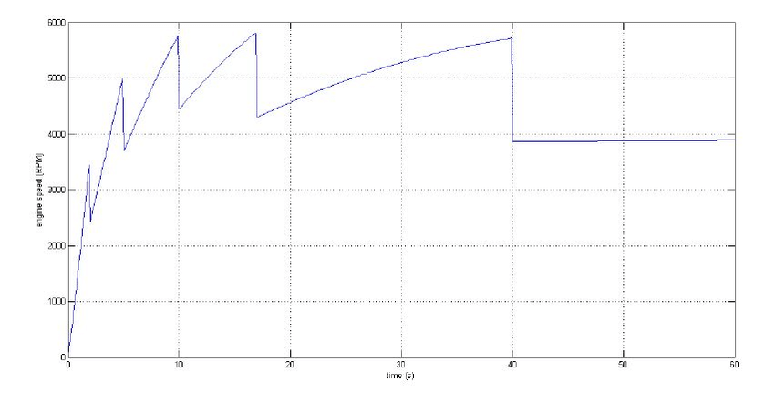
Figure 1: Basic Engine RPM Graph

This basic engine RPM diagram shows how the data gathered can be plotted to understand the engine spikes at certain points on track.

Conclusions
To conclude, it is evident that the acquisition and analysis of data has a big contribution to on track performance as the many different factors stated in this technical report combine to create an accurate and detailed set of information which can be used to enhance setup of the car and improve driver technique to reach the full potential of the vehicles performance.

It can be seen through the key systems which are involved in collecting data that there are several aspects that this data can improve. It is clear that the data on the driver can be used to inform the driver of ways to improve their technique, while the mechanical data can be used to ensure reliability and suggest changes which will upgrade the car. The environmental data is then used to make choices on vehicle setup on the day. All of these sets of data put together create a solid strategy for the car to follow to reach full potential.

References
Ahmad, S. (2023, July 7). Designing a detailed telemetry dashboard for sim-racers. Retrieved November 10, 2025, from University of Twente Student Theses: https://essay.utwente.nl/fileshare/file/95989/Ahmad_BA_EEMCS.pdf
Wright, G. (2025, August 16). From Tapes to Terabytes — Formula 1’s Electronic Revolution. Retrieved November 7th, 2025, from https://medium.com/formula-one-forever/from-tapes-to-terabytes-formula-1s-electronic-revolution-c7d9b8bb1ec7

