Problem Solving and Decision Making

Student’s name : Gianina Adriana Buruiana
I'd number: 1921411
Lecturer name: Yajesh Kumar

Table of Contents
Introduction 3
Scope and Impact of the complex problem at the workplace 3
Porter’s Five Forces: 9
Analyse the identified problem in the decision-making process 12
Alternative solutions for the problem 13
With the help of the Decision-making, technique evaluate the solutions to identify the appropriate option 13
Develop a plan and apply the solution 14
Plan communication with the stakeholders 14
Monitor and review techniques for successful implementation of the solution. 14
Conclusion 14
Reference list: 15

Task 2

Introduction
There are various companies in the world that have a lot of competitors in the market. The companies not only contended with satisfying their customers but also selling their products. The companies make sure they have international environments in the firm to perform pleasant manners and working environments. The output depends on the company's employee satisfaction. Employee satisfaction in a company depends on job satisfaction. Job satisfaction of an employee depends on the performance of the employees at the workstations.
This research paper focuses on achieving the levels of employee satisfaction in organizations. In a firm, it is important for the organization to concentrate on the employee's performance and job satisfaction within the company. The manager should be aware of the employee's satisfaction and comfort at the company. When an employee is satisfied the company benefits by improving its work capacities, capabilities, performance, and profitability of the company are gradually increased. The managers at the organization are responsible for the job satisfaction of an employee where he should be aware of certain tools and technologies which will help the employees satisfy their needs at the organization.

Scope and Impact of the complex problem at the workplace

SWOT Analysis
Strengths | Weaknesses
- Diversity in work culture  - Great communication  - No favouritism policies | - Lack of turnover rates  - Lack of productivity  - Lack of customer retention policies  - Low profit
Opportunities | Threats
- A chance to retain the staffs  - Expansion of the business through the staffs | - Customer-oriented thinking would lead to an issue in problem-solving  - Same business process without any innovation

Providing them with a clear set of instructions and goals: The manager should make sure they give the right instructions to the employees and encourage them to achieve the goals. They should instruct them all over the task, and answer all the queries and issues that occurred in the project.
Providing Employees with different types of work: Employees can be assigned different and repetitive tasks which can be tedious and boring which results in the employee feeling less productive and losing interest in the assignment. The manager should understand the task and provide different and challenging tasks for the employees where they feel much involved in the work and do not succumb to similar works(De Clercq et al., 2019).
Communicating: A manager should communicate with the employees with regard to the work environment and facilities provided by the organization. Open communication with the employees helps them to open up about their opinions and skills that matter and consider them as a valuable part of the organization. Miscommunication can lead to the rise of issues in the organization which might affect the goals and tasks to be achieved in the company. Communicating with employees will help them feel more engaged and important in every task given by the organization.
No Favouritism Policies: A manager is responsible to treat the employees fairly. They should not discriminate against any employee with regards to his work, age, skills, and hard work in the organization. Favouritism leads to a loss of interest in an employee within the organization. A feeling of nepotism in the staff can generate ideas where the employee's hard work is not recognized by the leading employees within the firm. No favouritism helps the organization to view its staff as unique and equal in all aspects and decisions within the organization.
Recognizing and appreciating employees: Recognizing the employee's efforts in an organization and appreciating those efforts will help an employed person to feel more interested and considerate in the organization. Recognizing employee's efforts in an organization helps to enhance employees' performance and productivity towards companies customers by providing them with the best service with the product and services provided to the clients. Establishing a reward system in the organization helps the employee to feel valued in an organization(De Jong, Grundmeyer and Yankey, 2017).

Job dissatisfaction at an organization creates low self-esteem within the workers and no confidence at the work which is undesirable. The employees at the organization feel that their jobs are baseless and boring. This will lead to negative attitudes which conduct low productivity in the organization. If the employees at the organization are not happy with their work and jobs, several workers at the company are affected and the behaviours will impact other employees at the work (Pang and Lu, 2018).

Employee Turnover Rates Employee dissatisfaction creates rising turnover rates with the employees. The impacts of the organization where employees tend to quit their jobs to find better and less stress and job securities. Many organizations suffer from higher turnover rates and the lack of abilities to retain qualified employees at the companies. Small Businesses are the most to suffer these problems and which causes a huge loss to the company. This small business should find a way to improve job satisfaction for employees where the pay is low and jobs are difficult (Chaudhry et al., 2017).
Stress When employees are unhappy with the job at an organization, being work-related or stress within the organization causes the employees to leave the job. The employees experience job stress in the organization for different reasons where the manager should be aware of such situations in the workplace. The basic human nature where an employee who is happy may enjoy the job and doesn't feel dissatisfied in the organization but when an employee does not enjoy the job they always feel stressed even at simple tasks(Muntz et al., 2019).
Lack of Productivity Employees who are stressed at the company is not capable of performing their job properly which leads to low productivity and loss for the company. A company can grow only when an employee is satisfied and happy with their jobs and other staff in the company. When an individual shows disinterest in the task or job it is easier for the employers to feel the same which will cause a lack of productivity(Arvan et al., 2019).
Customer retention When customers start having an issue with the service and products of the company the employees are the one who provides them with the best services to resolve their issues. A happy customer always brings profit to the organization similarly it happens with the employees who are happy with their jobs performed at the organization. Customer retention is difficult to maintain the flow of revenue for the company. Satisfying a customer or a client where the staff consistently possess the ability to increase customer expectations brings more profits and customers to the organization. If the employees are not satisfied then they cannot meet a customer's expectation which will bring a huge loss for both the company and the employees in the organization. Job dissatisfaction affects the company with low quality, less production, bad service, and fewer profits to the company (Irabor and Okolie, 2019).
Low Profit: The production values are based on customer perceptions. Customer product satisfaction depends on employees' commitments provided by the company for better quality. When the employee is not satisfied they give low-quality service to the customers which creates a loss for the company by losing its customers.

Stagnation The workplace provides people with many opportunities. As variety is the spice of life, people work in different fields with the same process like getting up early in the morning, going to the office, working with colleagues and in teams, etc. All these opportunities come from problem-solving and decision making at the workplace.
Overwork Human nature tends to be easily distracted by the things that go on and off the road. People working for companies can have the opportunity to support the work of others rather than hindering their work. Thus, there arises an opportunity to overwork and companies must support such employees.
Making visions tangible Many companies are bound to accomplish their vision, mission, goals and objectives. However, these are written in statements and are displayed somewhere on the walls of the workplace. Employees and companies have the opportunity to make their vision tangible. They have the opportunity to showcase what the company stands for.
The followings are the obstacles or threats that are to be faced while solving a problem and making a decision at the workplace:
- Making assumptions while taking a decision or solving a problem may often prevent the roots of certain solutions.
- People have the tendency to see a problem only through their customary manner. This will pose a big threat to their problem-solving skill.
- While solving a problem it is necessary to differentiate between the relevant information that is needed to solve the issue and the information that is not important. Therefore, finding information is a threat while solving a problem.
- Some people have the tendency to use the solutions which they have used in the past. This is a threat in bringing new innovative solutions to the problems.

PESTLE Analysis

Factors | Details
Political Factors | Different political factors like the stability of the governing body of the country, different alliances, changes of alliances could affect the organisation.
Economic Factors | Different economic factors like change in the trade policies, agreements, employment, inflation rates can also have a severe impact.
Social Factors | Social factors change in the trends in society, social requirements can also have both negative and positive effects.
Technological Factors | Technological factors such as new technologies in the market, improvement of the existing technologies in the organisation can also help the organisation in many ways.
Legal factors | Legal factors such as changes in laws, act, new rules and regulation can take a toll on the organisation for a certain period of time.
Environmental factors | Environmental factors such as the company’s position for the benefit of the environment can also have a major impact on them. However, as a valued employee of the organisation, you have to bear the responsibility to keep up the good work and to be willing to work. This could be the only solution to the tough times and could only be solved with the help of the employees.

FISHBONE Diagram

Job Dissatisfaction
FISHBONE DIAGRAM
No growth prospects
Feel Unappreciated
Uninteresting work
Unavailable growth opportunities
Lack of jobs
Increasing work pressure
Issues with deadlines
Lack of motivation
No specificity
Pressuring environment
Lack of motivation
Unavailable feedback
Totalling 1,791 hours a year


Ineffective leader
Denial of empowerment or influence
On average, UK employees spend 34 hours at work each week
Poor workplace relationships
ROOT CAUSE CONFIRMATION
Lack of work-life balance

Following are the root causes of job dissatisfaction: Poor workplace relationships. On average, UK employees spend 34 hours at work each week, totalling 1,791 hours a year.
Denial of empowerment or influence.
Lack of work-life balance.
No growth prospects.
The work isn't interesting or meaningful.
Feeling unappreciated.
SOLUTIONS
Provide a clear set of goals and instructions for the employees.
Provide employees with a variety of work.
Constantly communicating with the subordinates
Maintain no favouritism policy
Giving recognition to the employees

Diagram 1: Fishbone Diagram
(Source-Created By Learner)

Porter’s Five Forces:
Factors | Details
Bargaining Power of Buyers | - The organisations would always look forward to meet the requirements of their customers, therefore, in some cases they might forget to refer to their employee’s needs. This could lead to dissatisfaction in the employees and a lack of productivity growth.
Bargaining Power of Supplier | - The employees could be regarded as the backbone of the company and if they have been dissatisfied, the work process of the organization would be affected. Therefore, the employees would have the power in the organization.
The threat of New Entrants | - Much new organization could always enter the market and provide better opportunities and pay scale to the employees. It would help them gain the attention of the employees.
Threat of Substitutes | - There would always be the chance to substitute the offers made by the organisations to the employees. This would also make them leave their present organization and strive for a better opportunity
Industry Rivalry | - The market would always be competitive, therefore, there would always be other companies that would try to bribe the employees with better opportunity and pay scale. Therefore, the rivalry would always be there.

Mindmapping Diagram:

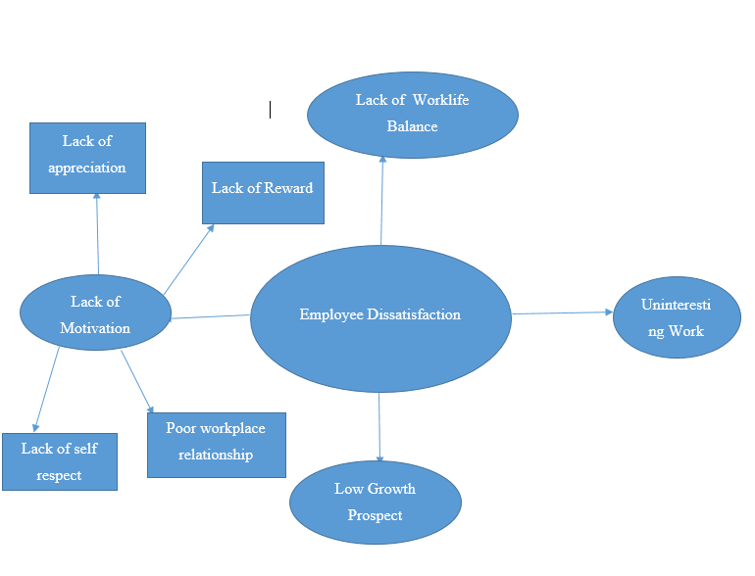

Diagram 1: MindMapping Diagram
(Source-Created By Learner)

Brainstorming Diagram:

Brainstorming could be regarded as a method to identify and generate different ideas and solution to solve the employee dissatisfaction problem. The basic issue in this context is the dissatisfaction in the employees which might lead to different issues for the organisations such as lack of productivity, lack of economic growth, conflicts in the workplace. The main aspect here would be to identify the reasons behind the dissatisfaction which could be lack of appreciation and rewards, improper work-life balance, overtime work, lack of motivation, uninteresting work, and most importantly lack of career prospect. Therefore, the organization should be able to provide the employees with enough opportunities to deal with the issues and to satisfy their needs. This would motivate the employees in their future productive work.

ForceField Analysis:

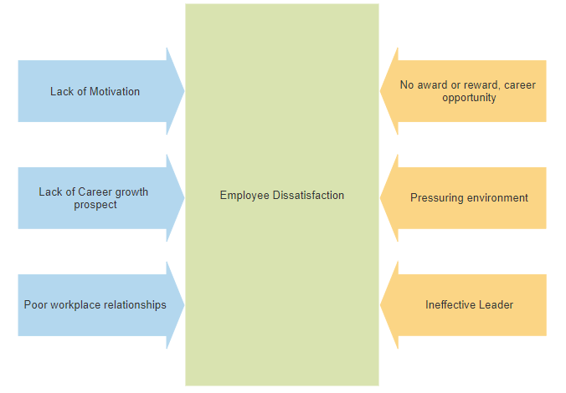

Diagram 1: ForceField Analysis
(Source-Created By Learner)

Analyse the identified problem in the decision-making process
Job dissatisfaction is a huge issue in the organization with the employees feeling dissatisfied with the work, pay scale, environment, or the organization itself. Companies experience employees' lack of commitment towards the goals and implemented decisions given by the top managers which cause serious repercussions on the success of an organization. Many organizations involve the employee's participation to make a decision in the process or a project. The dissatisfaction occurs from the decisions made by the management which leads to negative actions of the employees and such actions create a loss of interest for the employee to do a certain job for achievers task given by the company. When employees are not involved in decision making it affects the productivity and service of the employees in the organization. The decision-making process is identified as a course of action taken by the employees on the higher managers to solve issues that occurred in the given project(Alshmemri, Shahwan-Akl and Maude, 2017). Employee participation is necessary for the decision making where it influences the employees that they are worth it and the decisions they take are really important for the organization which creates a sense of interest in the employee to stick to the job and perform his activities enthusiastically. Decision-making in an organization impacts employee participation where it explains the participation of the employee in a work decision, employee ownership, employee representative participation, consultative participation, short-term participation, and informal participation. Every decision should be passed in the organization to check others' views before making the final decision for the organization(Aydiner et al., 2019).

Alternative solutions for the problem
Employees' attitudes reflect the values of the company. Organization and manager can overcome the employee job satisfaction and prevent the employees from being unhappy in the industry is

With the help of the Decision-making, technique evaluate the solutions to identify the appropriate option
The job dissatisfaction in decision-making within the organization helps a manager to identify the issues and find relevant solutions for those issues for the employees. Job dissatisfaction in the company leads to a loss of employees, growth, and profits in the industry. The manager should handle the issues effectively by following a few steps such as Budgets, Goals and designs, Time Management, Employees, salaries, promotions, wages, demotions, and working hours., The marketing mix(Price, Product, Promotions, Place), and Research and organizational structures.

Finding relevant solutions for every problem faced by the employee in an organization will help them to make the right decisions by using the right techniques and appropriate options for the issues. Finding the best solutions for the employee's wages and working hours which will help the employee to be encouraged and motivated to perform the job with effectiveness(García et al., 2019). Working on feedback in an organization will help the employee to improve and develop the skills lacking for the organization. Feedback will help in bringing awareness of the issues, evaluate the alternative, diagnose the state of the problem, implement and verify the decisions, and develop the best solutions for the issues that occurred in the organization.

Develop a plan and apply the solution
Developing a plan for the issues with the employee's dissatisfaction at work will help the managers to structure the organization. It helps them plan the structure for the employees to be flexible, allow them to skill their roles, stop micro-management, having reward systems, transparency and communication in the team, promoting safety and good health, providing training, encouraging social culture, and investing in work environments. The managers can look into the issues faced by the employees in different areas where they can address them directly or with the help of a meeting in the organization. Creating a plan for the issues will help to reduce job and customer retention in the organization (Shahzad et al., 2018).

Plan communication with the stakeholders
Communication is the key process to discuss the information and ideas with the stakeholders. Communication can be in various forms such as posters, word of mouth, emails, meetings, special events held within the organization. Planning a way to communicate in the organization with the stakeholders leads to a fulfilment of the task. When the organization creates new objectives it should communicate with the stakeholders to create an awareness of new objectives in the team.

Monitor and review techniques for successful implementation of the solution.
Employee job dissatisfaction refers to monitoring which refers to the various methods used by employers. Monitoring employee satisfaction explains how the team really feels about the job. Certain pieces of information that improve things like employee retention, productivity, and culture. Using several methods which accurately measure employee job satisfaction would be Conduct an employee satisfaction survey, Using the ESI(Employee Satisfaction Index), Employee Net Promoter Score(ENPS), Having meetings, Installing a suggestion box, and Using Specialized Softwares
By using the following methods and techniques one can overcome employee job dissatisfaction and improve the organization's profits, growth, and increased customers (Islami, Mulolli and Mustafa., 2018).

Conclusion
The above case study suggests that keeping track of employees' satisfaction at the company helps them to increase the productivity, profit, service, and customer retention employees' satisfaction will help to know the reasons a business is lagging behind to top in the market. Employees are the type of stakeholders where the managers should always keep a check of employee's requirements at the office. Employee satisfaction depends on the way an organization runs and the internal environments, how they treat the employees and how happy they are at an organization. Employee job dissatisfaction can be reduced by the managers by reducing the difficulties and stress at the companies.

Reference list:
Irabor, I.E. and Okolie, U.C., 2019. A review of employees’ job satisfaction and its effect on their retention. Ann. Spiru Haret Univ. Econ. Ser, 19, pp.93-114.
Pang, K. and Lu, C.S., 2018. Organizational motivation, employee job satisfaction and organizational performance. Maritime Business Review.
Muntz, J., Dormann, C. and Kronenwett, M., 2019. Supervisors’ relational transparency moderates effects among employees’ illegitimate tasks and job dissatisfaction: a four-wave panel study. European Journal of Work and Organizational Psychology, 28(4), pp.485-497.
Arvan, M.L., Pindek, S., Andel, S.A. and Spector, P.E., 2019. Too good for your job? Disentangling the relationships between objective overqualification, perceived overqualification, and job dissatisfaction. Journal of Vocational Behavior, 115, p.103323.
Chaudhry, N.I., Jariko, M.A., Mushtaque, T., Mahesar, H.A. and Ghani, Z., 2017. Impact of the working environment and training & development on organization performance through mediating role of employee engagement and job satisfaction. European Journal of Training and Development Studies, 4(2), pp.33-48.
Alshmemri, M., Shahwan-Akl, L. and Maude, P., 2017. Herzberg’s two-factor theory. Life Science Journal, 14(5), pp.12-16.
Aydiner, A.S., Tatoglu, E., Bayraktar, E. and Zaim, S., 2019. Information system capabilities and firm performance: Opening the black box through decision-making performance and business-process performance. International Journal of Information Management, 47, pp.168-182.
De Clercq, D., Haq, I.U., Azeem, M.U. and Ahmad, H.N., 2019. The relationship between workplace incivility and helping behavior: roles of job dissatisfaction and political skill. The Journal of psychology, 153(5), pp.507-527.
De Jong, D., Grundmeyer, T. and Yankey, J., 2017. Identifying and addressing themes of job dissatisfaction for secondary principals. School Leadership & Management, 37(4), pp.354-371.
García, G.A., Gonzales-Miranda, D.R., Gallo, O. and Roman-Calderon, J.P., 2019. Employee involvement and job satisfaction: a tale of the millennial generation. Employee Relations: The International Journal.
Shahzad, I.A., Farrukh, M., Kanwal, N. and Sakib, A., 2018. Decision-making participation eulogizes probability of behavioral output; job satisfaction, and employee performance (evidence from professionals having low and high levels of perceived organizational support). World Journal of Entrepreneurship, Management and Sustainable Development.
Islami, X., Mulolli, E. and Mustafa, N., 2018. Using Management by Objectives as a performance appraisal tool for employee satisfaction. Future Business Journal, 4(1), pp.94-108.

