

How does the portrayal of UK policing on social media impact public perception and confidence in the police?

By

Jake Weeks

2024

Acknowledgements
To my lecturer Laura Knight, I am ever so grateful. The process of this study has been made far simpler with her fantastic guidance and patience which has helped me bring this piece of work to a higher standard.

As well as this, I would like to thank my family and friends who have supported me throughout my university journey, which they have aided in making these 3 years far easier for me.

Declarations

This work has not previously been accepted in substance for any degree and is not being concurrently submitted in candidature for any degree.

STATEMENT 1

This dissertation is being submitted in partial fulfilment of the requirements for the degree of BA/BSc.

STATEMENT 2

This dissertation is the result of my own independent work/investigation, except where otherwise stated.

Other sources are acknowledged in the Reference Section.

STATEMENT 3

I hereby give consent for my dissertation, if accepted, to be available for photocopying and for interlibrary loan, and for the title and summary to be made available to outside organisations.

STATEMENT 4

I hereby give consent for my dissertation, if accepted, to be available on the university’s IT system to those who have consent to use the system.

Jake Paul Weeks

Signed:

Date: 15/04/2024

Abstract

The ever-growing use of social media is undeniable, with the influence it has on the perception of individuals also being substantial. With this comes numerous challenges, especially for the police who are a common talking point online. This study aims to investigate how the portrayal of UK policing on social media impacts public perception and confidence in the police. After reviewing literature from various researchers, an online survey was constructed and posted to social media to gather new information and insight into the police’s social media presence. The respondents were anonymous, with a variety of ages being involved to gather the best range of opinions. Results varied for different individuals, but the common occurrence of a lack of effective online communication from the police was demonstrated. Using the evidence gathered, the results indicate that police use of social media is viewed as robotic and out of touch with modern society. With this, it is recommended that an increased organic approach to social media presentation and communication be looked at by UK police forces. With this research being done on a small scale, additional research on a larger basis will need to be conducted for UK police forces to appropriately seek the best course of action regarding this issue.

Contents
Chapter One: Introduction 5
1.1 Objectives 5
1.2 Scope 7
Chapter Two: Literature Review 10
2.1 Exploring the portrayal of the police on social media in the UK 10
2.2 Evaluating the impact of negative social media coverage on the police 13
2.3 Investigating the improvement of police public perception using social media 14
2.4 Summary 16
Chapter Three: Methodology 18
3.1 Research Onion 18
3.1.1 Philosophy 19
3.1.2 Approach 20
3.1.3 Strategy 20
3.1.4 Choices 21
3.1.5 Time horizon 22
3.2 Techniques for data collection, process and analysis 22
3.2.1 Sampling 23
3.2.2 Survey design 24
3.2.3 Ethical considerations 24
Chapter Four: Analysis 26
4.1 Introduction 26
4.2 Analysis Presentation 26
4.3 Questionnaire Feedback 27
4.4 Conclusion 36
Chapter Five: Conclusion 37
5.1 Introduction 37
5.2 Identifying how the police are portrayed on social media within the UK 37
5.3 Analysing the impact that negative social media coverage has on police perception 38
5.4 Exploring social media use in promoting positive public perception of the police 39
5.5 Limitations 40
5.6 Recommendations 40
Reference List 42
Appendix 48

Chapter One: Introduction

Social media's contribution to advancing transparency, openness, and public engagement within the domain of public policing has gathered significant praise (Bullock, 2018). This acknowledgement underscores the substantial influence of social media in enhancing communication and community participation within the policing sector, marking a significant step towards improved police-community relations.

In today's society, social media plays a prominent role in shaping public discourse, offering a platform for the rapid dissemination of information and fostering engagement (Anstead et al., 2010). However, it is vital to acknowledge that the unchecked use of social media can lead to the dissemination of false or out-of-context information concerning many topics within the UK (Pukallus et al., 2024). The speed and ease with which information spreads through these platforms can sometimes result in misrepresentations, and even the exacerbation of tensions, highlighting the importance of responsible use and media literacy to ensure an informed and balanced public discourse (Fernandez et al., 2017).

1.1 Objectives

By investigating the positive aspects of social media's impact on public policing, the study aims to shed light on the potential for improving transparency, openness, and public engagement in the police. This knowledge is crucial in an era where effective communication between the police and the public is essential for maintaining trust and cooperation (Merry et al., 2010). The research recognises the potential dangers of unregulated social media use, particularly in spreading misinformation about the police. It emphasises the need for responsible use of social media platforms and media literacy in our digital age. Understanding the risks associated with unchecked information dissemination is essential for addressing misunderstandings and tensions that can arise (Chadwick et al., 2019).

This research aims to examine the impact of social media coverage on the public perception of the police in the UK, focusing on both negative and positive aspects. One of the focused areas will consist of analysing the detrimental effects of negative social media coverage on how the police are perceived by the public. Negative social media coverage can significantly influence public perception of the police in the UK especially when instances of alleged misconduct or controversial incidents are widely shared and discussed on social platforms (Colbran, 2018). This can lead to diminish the trust and confidence in the police force, from communities across the UK. The rapid spread of information amplifies negative narratives, leading to a heightened sense of scepticism and criticism. In March 2021, the disappearance and tragic discovery of 33-year-old Sarah Everard in South London unfolded, leading to a Metropolitan Police officer's arrest for her kidnapping and murder (Ali, 2021). Social media played a significant role in amplifying these discussions, with hashtags like #SarahEverard trending across platforms. This case highlights the power of digital spaces in shaping public discourse. These incidents can lead to a false narrative of all police officers being corrupt spread through the UK, making it harder to build trust and to cooperate with the public (Macaulay, 2020).
Additionally, this study aims to investigate the methods in which social media can be effectively utilised by police agencies to promote a positive image. In the UK, social media emerges as a strong instrument for policing agencies to cultivate a positive public image (Crump, 2011). Organisations can leverage platforms to disseminate success stories, community engagement initiatives, and humanise their officers. Positive content, exemplified by officers' involvement in community events or acts of kindness, holds the potential to offset negative perceptions. An example of this is when police forces throughout the UK employ social media to share positive stories and community engagement initiatives. Showcasing officers participating in events, supporting local charities, or positively engaging with community members can lead to major benefits when fostering closer ties between the public and the community (Bullock et al., 2021).

1.2 Scope

This study will focus on the contemporary era, covering the use of social media in public policing in the United Kingdom from the early 2010s to the present day. This time frame aligns with the significant growth of social media platforms and their integration into policing practices during this period (Egawhary, 2019).
This research is not confined to a specific demographic or community within the UK but instead seeks to provide a comprehensive analysis of the impact of social media on public policing that is applicable across various demographics and communities. By taking this inclusive approach, the study aims to understand how social media affects police-community relations on a national scale.

This research aims to evaluate how the portrayal of UK policing on social media impacts public perception and confidence in the police. This study is centred around 3 primary objectives. Firstly, it aims to examine the portrayal of law enforcement agencies and officers on social media platforms within the United Kingdom, conducting an analysis of the content and narratives prevalent in the public discourse. Secondly, it seeks to evaluate the impact of negative social media coverage on the public's perception of the police, delving into how adverse content affects trust and public attitudes. Thirdly, the research explores the role of social media in fostering a positive public perception of the police, with a specific focus on the strategies employed by policing agencies for community engagement and the enhancement of transparency.

To clarify the research approach that will be used for this study, a questionnaire will be posted through social media platforms with the aim of gathering the general public's perspective on how the portrayal of UK policing on social media impacts public perception and confidence in the police. The questionnaire method is a pragmatic choice for efficiently accumulating summarised data from a diverse range of respondents, as noted by Dominelli (2003). The target demographic for this questionnaire will be individuals aged 18 and above, ensuring the acquisition of informed and judicious opinions and responses. This questionnaire will comprise a combination of open-ended and closed-ended questions, facilitating the collection of both quantitative and qualitative data. In addition, a diverse range of respondents will be asked to complete this survey, which will allow for the inclusion of a wide range of opinions regarding how the UK police is portrayed online. To maintain optimal respondent engagement, the questionnaire will be designed to require no more than 5 minutes for completion. Participants will be guaranteed anonymity, thereby promoting open and candid feedback. Moreover, all survey responses will be securely archived within a password-protected Google Docs folder. Prior to initiating the questionnaire, participants will be requested to provide their consent for the utilisation of their responses and will be afforded the option to withdraw from the survey at any juncture. This approach seeks to ensure both ethical research conduct and the integrity of the collected data.

This research provides crucial insights into how the portrayal of the police on social media impacts public perception and trust, aiming to enhance transparency and community engagement in policing. By identifying the potential risks associated with unchecked social media use and misinformation, this study fosters a more informed and balanced public discourse. The research seeks to fill gaps in our understanding of the impact of social media on police-community relations. It is relevant to a wide range of those involved, including legislators, police organisations, and the general public, since it provides practical guidance for social media policing that promotes cooperation and trust. This research is essential in the contemporary era to ensure effective police-public communication and engagement.

Chapter Two: Literature Review

In the UK's evolving landscape, the digital era has instigated significant transformations, shaping police practices through advanced technologies and communication tools (Butcher et al., 2018). Social media, a cornerstone of this digital shift, plays a pivotal role in policing communication strategies. Platforms like X, Facebook, TikTok and Instagram enable rapid spread of information, sometimes allowing for real-time interactions between the police and public (Fletcher et al., 2023). Fortin (2020) believes that understanding the impact of social media on public perception is vital due to its role as a dominant source of information. Evaluating the portrayal of policing on these platforms is a proactive measure to adapt communication strategies, addressing challenges and leveraging opportunities to maintain public trust. Understanding the evolving role of social media in the police force allows for a more knowledgeable approach to communication strategies, ensuring that they align with public expectations and values (Sampson et al., 2023). As social media continues to shape the narrative around policing, police forces must actively monitor and manage their online presence to foster positive relationships with the public and navigate the complexities of the modern communication landscape.

2.1 Exploring the portrayal of the police on social media in the UK
The way that the police use social media and the conversations that take place on these platforms can shape how the police are portrayed online in the UK (Cullen, 2022). In 2008, UK police forces initiated the registration of corporate accounts on Twitter and Facebook, marking the first instance of their use for communication purposes (Egawhary et al., 2019). This was a significant step in the police's efforts for a better community relationship, allowing for easier interactions with the general public. However, around this time Crump (2011) examined the Twitter activities of UK police and proposed that their utilisation of the platform was primarily effective as a one-way communication strategy. The study indicated a limited presence of open communication between the public and the police, concluding that the police were using social media solely as an announcement platform. The limited public engagement identified by Crump (2011) may not necessarily reflect a lack of recognition of the potential benefits of social media by the police. It is important to note that at the early stages of social media, it could be interpreted as a strategic choice in utilising these platforms for specific communication only. Regardless of an intentional choice to use social media platforms like this or not, it is argued by Aitken (2023) that the police are portraying themselves as extremely one-dimensional with little to no intent of two-way communication, being an ineffective social media strategy.
In more modern times, the findings of Cartwright et al., (2020) demonstrate the public's resounding support for police use of social media, with the majority of respondents regularly monitoring the social media accounts of their local police force. This shows evidence of people supporting the idea of the police using social media. However, there seems to be a lack of findings regarding the public's opinion on how effective the police’s communication is with their local community. In addition to this, according to Ralph et al. (2022) the police have started to use strategies on social media such as using images, gifs, memes, and humour as part of their presentational techniques to humanise the force and increase public trust in them. By eliciting positive responses and avoiding criticism, these strategies aim to increase their following, foster stronger ties with the community, and engage with the public in a more relatable manner. Using the studies from Cartwright (2020), a trend of positive public perception towards the police seems to occur more often when they are communicating back with more of a sense of humour and behaving less robotic. Ralph et al. (2022) have also mentioned how police have engaged with the public by regularly releasing information about crimes and community issues. Some have gone so far as to host question-and-answer sessions in an effort to encourage two-way communication. However, barriers like the volume of social media and time constraints have usually resulted in one-way contact rather than meaningful discussion. Another trend can be seen going back to the information that Crump (2011) provided, with the police seeming to have constant challenges for over 10 years to overcome the issues of their one-way communication to the public on social media.
On the other side of the spectrum, social media is a technology used for the public to voice their opinions on numerous things, including the police (Aston et al., 2022). With these platforms being accessible to so many people, it brings forward a wide variety of different positive and negative perceptions towards the police. Colbran (2020) makes the claim that given the police's social media presence and contacts with the media, the public's perception of the police is nuanced. Colbran (2020) states that although the police use of social media can improve public participation and perception, it also gives the police more control over the information flow, which may lessen journalistic criticism and limit the public's access to high-quality information for decision-making.

2.2 Evaluating the impact of negative social media coverage on the police

As noted by Fleet et al. (2022) the media has a significant impact on public opinion and attitudes, as well as the agenda that is set by the country. Legitimacy and strong policing require the backing and the trust of the population (Fleet et al., 2022). When a negative policing situation or narrative is spread online, it can cause serious damage to the populations trust of the police. As of the recent Palestine protests occurring in the UK, it has caused huge divide of opinion on the police across the country. A recent video was posted on X with the caption “Police in Birmingham capitulate to a mob of Palestine supporters who were chanting the anti-semitic slogan of "From the river to the sea". I doubt the police would be behaving so timidly if it was a patriotic protest.” (TPointUK, 2023). This is a prime example of negative police coverage, which will reach a huge audience of people across the United Kingdom. These kinds of negative portrayals seem to be having a big effect in overall confidence in the police.

Statistics were discovered by Yonder (2023) which show that attention brought to police officers’ shortcomings in situations, that could potentially be shared on social media, leads to far greater negativity and distrust from the public towards them. As well as this, Yonder (2023) has discovered that in 2023, 42% of people have negative opinions about the Metropolitan Police, this being the highest degree of animosity since January 2020 (27%). These kinds of impressions being shared on social media from the public towards the police correlate to distrust, lack of understanding and a bad public perception of the police as a whole. This is also stated by Watson (2023), who believes abuse of police officers online has a variety of effects, one being the impact that it can have on a person's professional standing within their field of employment as well as the relationship they have with the community in which they operate.

The discussion of public opinions about the police on social media isn't new, as highlighted by Dencik (2018). Dencik explores the criticism aimed at police tactics on social media, including concerns about undercover officers infiltrating activist groups. Additionally, there were noticeable changes in police strategies after the 2011 London Riots. Williams et al. (2018) also noted that during these riots, authorities faced challenges managing social media, with the police struggling to keep pace with online developments. To address this, the COSMOS 'tension engine' is being employed to improve the situation by identifying tense situations on social media. This approach, known as "neighbourhood informatics," integrates traditional crime data with online sources to gain a better understanding of the situation. This wasn’t taken well by the public majority, who expressed their displeasure with the police on social media, believing that humans cannot be monitored like robots (Williams et al., 2018). A common theme of privacy invasion seems to occur amongst negative police portrayal on social media, with police seeming to upset the public by tracking their activities in an attempt to track organised crime (Daniel, 2014). Even to this day, there seems to be an insufficient variety of recorded information regarding the impact that negative social media coverage has on the perception of the police, with there being a reoccurring answer of damaging trust and confidence in the community.

2.3 Investigating the improvement of police public perception using social media

The Metropolitan Police (2021) state that they want to use social media as a platform to positively engage with communities across the United Kingdom to help build public confidence and trust in their services. The use of social media is effective, with it being “a cheap and effective way for officers to communicate with the public – putting out calls for evidence and interacting with the community” (London Assembly, 2013). Keane (2013) believes that the introduction of social media has allowed for more public participation in police forces across the United Kingdom, allowing for improved community engagement, emphasis on the human aspect of the police force, and simplifying the sharing of legitimate information. The previously mentioned information provided from the studies conducted by Cartwright (2020), supports this statement made by Keane (2013) and shows a growing pattern of an enhanced community relationship with the police over the years for these policing methods used on social media.
Modern-day police forces are using social media as a method to promote a positive public image when out in communities, ranging from helping residents with simple jobs or alerting locals with recent updates regarding a crime (Forsgren, 2018). As well as this, Howlings (2023) states that social media is a useful tool for police investigations since it can be used to gather information about incidents of missing people in communities across the United Kingdom and can be used to ask the public for assistance in aiding with these searches. These kinds of interactions between the community and the police aid in further building a sense of trust and collaboration, as well as pushing a positive public perception of the police (Moore et al., 2023). Ralph (2020) has conducted research which claims that police public perception is vastly improved when the force is honest and genuine regarding ongoing situations. There seems to be a reoccurring theme of positive public perceptions from the community towards the police when they present themselves as honest and show more humanising traits on their social media platforms. A recent example of the police communicating with the public is when the Westminster Police (2023) tweeted “Local Ward Officers are continuing to conduct reassurance visits to faith venues all across Westminster” in a response to the ongoing antisemitic behaviour currently going on in the United Kingdom. This is another key example of the police aiding people of all backgrounds in their respective communities and using social media as a method to promote these gestures.
The communication between the police is now primarily transitioned to social media, meaning that the police have the important responsibility of fully using their platforms (Walsh et al., 2019). The police have a long-standing reputation of being a trusted source, and this is reflected in the United Kingdom “Social Media Perception Survey” conducted by Bailey et al. (2018). The survey provided feedback that stated that when the police respond to a certain topic or situation in the United Kingdom, they are the most trusted source of information for 96% of their followers across all social media platforms (Bailey et al., 2018). This presents evidence that over the years the police have built a trust with many different communities across the UK, which can be seen as a positive perception.

2.4 Summary

The examination of social media's impact on the perception of the police in the UK reveals many complex dynamics (Henry, 2024). Historical analyses highlight the evolution of police engagement on platforms, initially criticised for one-way communication but gradually evolving to incorporate more interactive strategies (Henry, 2023). Notably, modern approaches, such as humour and community information sharing, aim to humanise the force and foster public trust. Regardless, a notable gap in research exists concerning the public's evaluation of the effectiveness of police social media communication. Negative portrayals on social media pose significant challenges, eroding public trust and contributing to increased animosity. Instances like the Palestine protests exemplify how negative coverage can rapidly influence public opinion, with statistics indicating a rise in negative perceptions. The impact of online abuse on police officers' professional standing is also a concern, emphasizing the need for further exploration of these dynamics. The importance of social media in shaping positive public perceptions of the police is second to none (Lawrence, 2023). While evidence supports the idea that social media enhances community engagement, aids investigations, and promotes a positive image, there remains a critical gap in understanding the difference these interactions make in influencing overall public perception. The police's role as a trusted source of information, as evidenced by surveys, underscores the potential positive impact of effective social media use. While research has provided insights into police portrayal, the impact of negative coverage, and the use of social media for positive engagement, the field lacks comprehensive studies evaluating the effectiveness of police communication strategies and the nuanced effects on public perception. There has reportedly been an exponential growth of social media users in the UK, particularly young people (Corliss, 2023). This means that addressing these gaps is crucial for informed policymaking and improving police-community relationships in the future of the digital age.

Chapter Three: Methodology

With the Literature Review chapter showcasing the different types of opinions and incidents that have led to public perception differing. Although there was some useful information discovered, there are heavy gaps in the research that do not provide decisive answers concerning the public's evaluation of the effectiveness of police communication. With the Literature Review being secondary research from other sources, the Methodology focuses on the methods in which all primary research for this study will be gathered (Howell, 2012).

3.1 Research Onion

The research onion, which was first proposed by Saunders et al.,(2023) provides a thorough framework that helps researchers navigate the complexities involved in planning and carrying out a thorough investigation (Flick, 2011). It is divided into layers, each of which stands for an important phase of the research process. Starting from the deepest layer, investigators recognise and explain their research philosophy, which includes ontological and epistemological viewpoints. It is then decided which of the two methodologies to use, inductive or deductive, before deciding on an overall study plan (McNeill et al., 2005). The next step is to choose the time horizon, which can be either longitudinal or cross-sectional. Lastly, the identification, explanation, and defence of data collection techniques comprise the topmost layer.

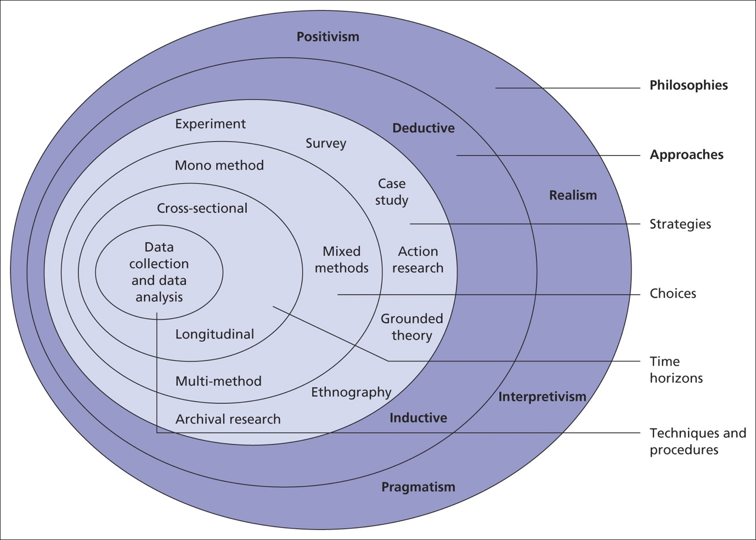

(Saunders et al., 2023)

3.1.1 Philosophy

The research philosophy is crucial due to it creating the framework that the rest of the study is built around (Saunders et al., 2023). It entails determining the ontological and epistemological stances of the researcher and matching them to the goals of the study (Meyer et al., 2016). This part effectively acts as the foundation for all other decisions, promoting a well thought out and coherent study design. For this particular study, an interpretivist perspective will be used, rather than a positivist or pragmatic one. An interpretivist proposal will be more beneficial to the survey that this study is carrying out, which will be taking in subjective opinions from numerous individuals. As well as this, an interpretivist perspective is more suited to the wide range of opinions that people may have, with so many unique perspectives being able to be considered (Mcmillan et al., 2012). This is especially suited to this particular topic, with (Nikolovska et al., 2020) believing that policing is an opinionated topic.

3.1.2 Approach

Meyer et al (2016), states that the approach is an important part of the research study as it sets the different strategies set out to investigate the research question and objectives. It acts as a guide for all research decisions, directing gathering, analysing, and interpreting data. This section determines the overall approach of the methodology, impacting the choice of research techniques and the general structure, regardless of whether a deductive or an inductive approach is taken (Proudfoot, 2023). For this section, an inductive approach will be most appropriate for taking on the research question, where the discovered research will be able to be used to create numerous different theories. With the topic of police perception on social media having numerous gaps, the inductive approach can allow for different theoretical perspectives to emerge. By allowing themes and patterns to organically arise from the data, the inductive approach promotes a more exploratory and open-ended exploration of the research topic (Pellegrino et al., 2021). This is particularly relevant in the context of police perception on social media, where the complexities and evolving nature of online interactions require a significant understanding (Fielding, 2023).

3.1.3 Strategy

The research strategy is crucial in determining the general course of the research project. It describes the overall strategy that will be used to answer the research question, gather information on the chosen topic, and accomplish the goals of the study (Baldwin et al., 2009). The technique used for this study calls for using a survey as the main means of gathering data. A survey will allow for a vast number of opinions and statistics to be used for descriptive writing (Golde, 2019). The survey results in this study will be harnessed for descriptive writing to vividly portray and analyse the diverse perspectives on the police's presence on social media. The study will employ descriptive writing techniques to provide a complex representation of the many opinions on the topic. It will also explore the specifics of how people view and engage with police forces on social media sites.

3.1.4 Choices

Saunders et al. (2023) provides a detailed description of the methodology's choices section, defining research choices in terms of the application of both quantitative and qualitative research methods, as well as using a mixed methods approach. In this study, a mixed-method approach will be taken, which combines qualitative and quantitative data collection techniques (Feilzer, 2010). This decision is significant because it enables a deeper, more in-depth investigation of the study question (Leavy, 2022). Qualitative data, which is obtained through techniques like open-ended survey questions, offers a deeper understanding of the underlying motivations and details within those perspectives, whereas quantitative data from the survey provides statistical insights into the prevalence of certain perspectives (Silverman, 2021). For this particular study, to gather both types of data, open-ended questions will be utilised in a survey. The study intends to leverage the advantages of both qualitative and quantitative data by utilising a mixed-method approach, promoting a more comprehensive and multidimensional examination of the complexities surrounding the perceptions of the police on social media.

3.1.5 Time horizon

The Time Horizon is crucial since it establishes the study's timeline, which affects how data is gathered and examined (Carter, 2018). The Time Horizon selection is essential for determining the timeframe within which the study captures the diverse perspectives and fluctuations in attitudes related to the research question, all depending on how long the data is going to be gathered (Clark., et al 2021). In this chosen study a cross-sectional strategy will be implemented, gathering the needed data all at once. This decision is significant as it aids in answering the research question regarding how people view the police on social media in modern times. Using a cross-sectional approach allows for the most recent possible opinions and statistics to be gathered, which can then be compared with previous data found to see how attitudes and ideologies have changed (Greetham, 2019). This strategy guarantees that a pertinent and current understanding of participants' perspectives, especially considering the dynamic nature of online interactions, is obtained.

3.2 Techniques for data collection, process and analysis

The methods for gathering, processing, and analysing data are essential parts of the research technique since they define the study's overall quality, validity, and depth (Flick, 2018). In the data collection process, a survey will be employed as the primary technique to gather insights related to the research question and objectives. Utilising platforms like Microsoft Forms or Google Sheets will facilitate efficient data collection, ensuring a broad and diverse sample that aligns with the study's scope and objectives. The sampling approach will involve using the snowball sampling method, which allows participants from various demographics to capture a comprehensive range of perspectives (Dosek, 2021). This inclusivity is crucial for addressing the first objective, aiming to identify diverse portrayals of the police on social media. Upon collecting the data, the analysis will follow a thematic approach. The thematic analysis involves systematically organising and identifying patterns within the qualitative data, allowing for a nuanced exploration of the research question (Wiltshire et al., 2021). Each objective will be addressed through the identification of themes related to the portrayal of the police on social media, the impact of negative coverage, and the role of social media in promoting positive perceptions.

3.2.1 Sampling

Sampling plays a crucial role in research methodology, shaping the validity and reliability of study findings (Brereton et al., 2022). Sampling, in this case, the way the UK police is portrayed on social media, directly affects the breadth and depth of insights gained by choosing a group of people or units from a wider population. A representative and varied sample guarantees the collection of a broad spectrum of viewpoints, which is consistent with the goals of the study and improves external validity. As well as that, this study will not allow anyone under the age of 18 to partake in the survey. Furthermore, careful sampling reduces biases and guarantees that the results fairly represent the range of viewpoints within the target population, enhancing the validity and relevance of the research (Neuman et al., 2011).

3.2.2 Survey design

In research, survey design is crucial since it has a direct impact on the calibre and dependability of data that is gathered. An appropriately constructed survey guarantees that the goals of the research are met and that the information appropriately captures the viewpoints of the participants (Braun et al., 2021). It helps researchers by offering a methodical framework for data collection, leading participants through pertinent subjects, and reducing response bias. It is particularly beneficial for the survey design to include both closed-ended and open-ended questions because this enables a thorough examination of participants' perspectives and experiences (Gummer et al., 2022).

3.2.3 Ethical considerations
Surveys that gather data must take ethics seriously to respect the rights, welfare, and privacy of the participants. Prioritising ethical norms is crucial for researchers in order to uphold honesty and trust throughout the study process (Brittan et al., 2020). By safeguarding vulnerable groups, the study's requirement that participants be at least 18 years old contributes to the upholding of ethical norms. Ensuring confidentiality protects the privacy of participants and promotes candid and open communication. Respect for autonomy is demonstrated by voluntary participation, which gives people the freedom to choose whether to participate in the poll without being forced to. By giving participants the researcher's contact information, they can raise questions or voice concerns, encouraging openness and responsibility. These moral considerations support the rights of participants while also enhancing the validity and integrity of the study.

Chapter Four: Analysis

4.1 Introduction

This analysis aims to delve into the impact of social media portrayals on public opinion regarding UK policing, as well as to explore the alignment and discrepancies between empirical findings and existing literature. This study's research objectives revolve around understanding how social media influences public perceptions of UK policing, particularly focusing on positive, negative and neutral portrayals. The data collection methods employed included an online questionnaire, aiming to gather insights from participants with allows their perceptions and experiences to be shared (Kara, 2023).

4.2 Analysis Presentation

This analysis will be structured to present the empirical findings derived from the survey, followed by an interpretation of these results and their integration with the existing literature on the topic. Primary data, acquired through the survey, focuses on public opinions and engagement policing issues on social media. Secondary data includes scholarly research, news articles, and social media content analysis, providing broader context and insights and is important to validate findings from primary sources (Smith, 2008). The empirical results will be structured to align with the research objectives, offering detailed analysis and interpretations of the collected data. This analysis unfolds in the dynamic social media environment of the United Kingdom, which is defined by a range of public perspectives and continuous discussions about police methods (Awan et al., 2019). Social media in the UK is an easily accessible tool that is used by many to voice their opinions, in which many opinions on the police are influenced by a wide range of elements such as news coverage, cultural standards, and personal experiences (O’Reilly, 2024). By shedding light on the relationship between social media dynamics and public opinions of the police, this analysis hopes to help researchers, police organisations, and legislators better understand how social media affects their work.

4.3 Questionnaire Feedback

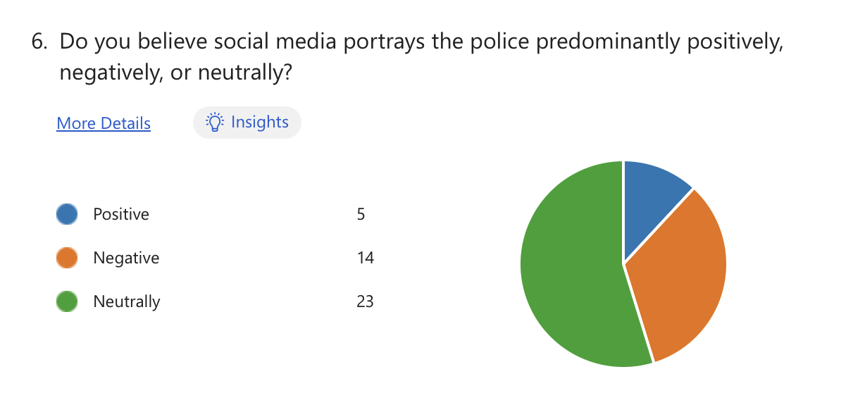In the survey, various questions were asked with the intent to identify how the police are portrayed on social media within the UK. When asked about their perception of police portrayal on social media, respondents provided diverse viewpoints. A significant portion, 33%, perceived the portrayal of police negatively, indicating concerns or criticisms regarding how law enforcement agencies are depicted. For the survey question “Do you believe social media portrays the police predominantly positively, negatively, or neutrally?”, a majority of 55% viewed police portrayal neutrally, suggesting a level of indifference or reservation towards online representations. Only a minority, 12%, reported perceiving police portrayal positively, indicating a limited number of individuals who view policing agencies favourably based on social media content. According to primary data, 55% of respondents perceive the police neutrally on social media, with 12% viewing them positively and 33% negatively. Conversely, secondary data indicates widespread public support for police use of social media, with most respondents regularly monitoring the social media accounts of their local police force (Cartwright et al., 2020). However, concerns regarding corruption, racism, and abuse of power highlighted in the primary data by many individuals suggest nuanced perceptions influenced by online discourse. To follow from this, secondary data discovered suggests that the police have sought to shape their image on social media through strategies like humour, humanising techniques and recognising the significance of digital communication in influencing public opinion (Ralph et al., 2022). Although police forces are making efforts to come across less robotic, the survey respondents reveal that these techniques they are being employed are not working very effectively at all, with a lack of trust being highlighted by respondents from the survey.
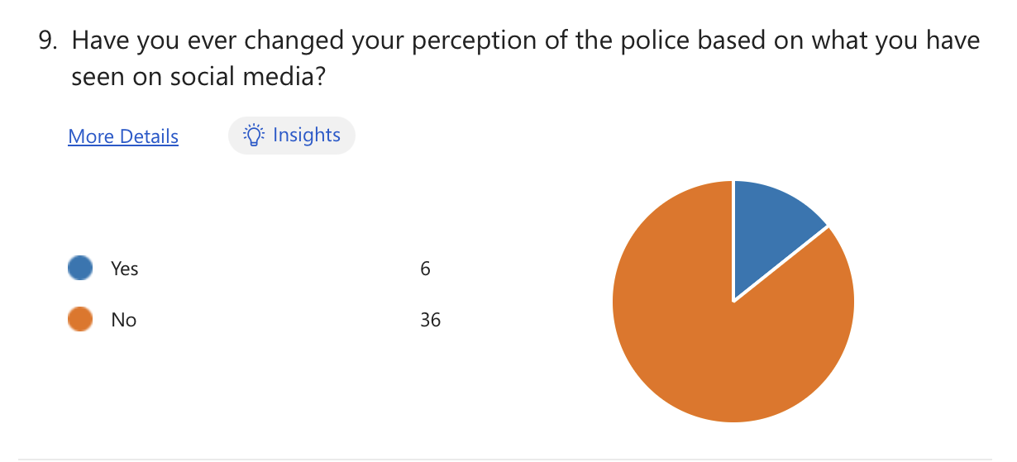

A crucial aspect explored in the survey was the influence of social media on individual perceptions of the police. For the question “Have you ever changed your perception of the police based on what you have seen on social media?” results showed that 14% of respondents admitted to changing their perception of the police based on what they have seen on social media, with 86% answering no. Then when answering the follow up question to this “If yes, can you give an example?” a theme of a lack of trust in the police was regularly occurring from the responders. This indicates that online narratives and portrayals can indeed shape individual opinions and attitudes the police, highlighting the significant role of social media in influencing public perception. With many people being highly exposed to social media, with 64% of children aged 3-17 owning at least 1 account (Ofcom, 2023), it could be that many people are less affected by the content that they see due to too much online exposure. This online questionnaire has helped shed light on how people’s perception of the police changes, with 14% of people believing social media has changed their perception of them. Secondary data can support this minority of people, with studies by Dencik (2018) and Williams et al. (2018) highlighting criticisms of police tactics on social media and difficulties faced by authorities in managing online developments during events like the 2011 London Riots, which lead to public distrust in the police.
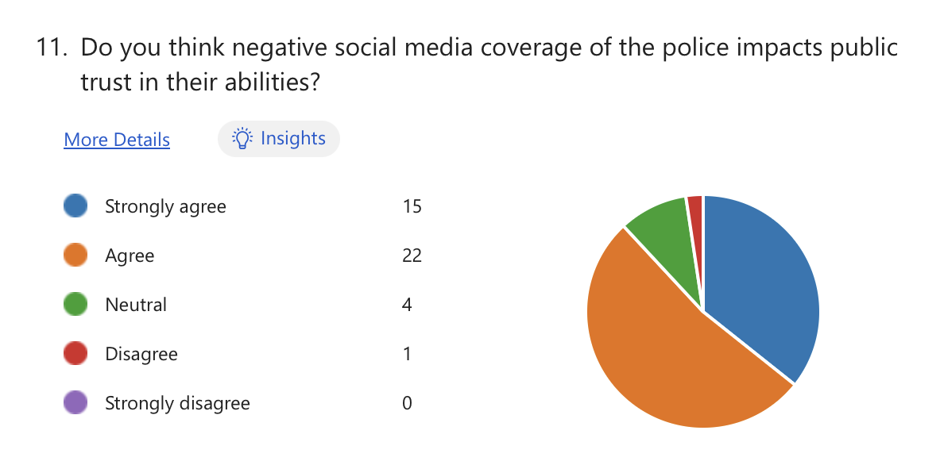
As well as looking at how the police are portrayed on social media, the survey aimed to explore how these implications of social media portrayals, impact public trust in police abilities. This was done by looking into the impact that negative social media coverage has on the perception of the police. The findings revealed a high level of agreement among respondents regarding the impact of negative social media coverage on public trust in police capabilities. A substantial 88% expressed agreement with the question “Do you think negative social media coverage of the police impacts public trust in their abilities?”. This suggests that adverse portrayals and narratives on social media platforms can erode confidence in law enforcement agencies' effectiveness and reliability. When asked “Can you provide an example of a negative portrayal of the police that you have encountered on social media?” a common answer was a use of excessive force being used by the police on videos, some examples being “A police officer was using excessive force against a civilian during an arrest. Despite no resistance from the offender, the officer proceeded to use force against them during the arrest.” As well as this, the answer was given “A policeman using more force than necessary to subdue someone.” This proof of the negative impact social media can have on public perception, may lead into the lack of engagement communities have with them. This primary data highlights instances of negative social media portrayals of the police, including unnecessary force and inappropriate sentencing. Conversely, secondary data suggests a nuanced public perception of the police shaped by social media interactions. While social media offers a platform for the public to voice opinions, Colbran (2020) notes that police presence on social media can influence the flow of information, potentially limiting public access to high-quality data for decision-making. This goes hand in hand with the data collected from the survey, where people answered that they want honesty from the police to improve their public image. If police presence on social media is restricting the flow of information, then it could contribute to the negative perception around them. Statistics from primary data indicate a substantial impact of negative social media coverage on public trust in the police, with 36% strongly agreeing and 52% agreeing that such coverage affects public trust in police abilities. Secondary data corroborates this, with Fleet et al. (2022) highlighting the significant role of media coverage in shaping public opinion and attitudes towards law enforcement.
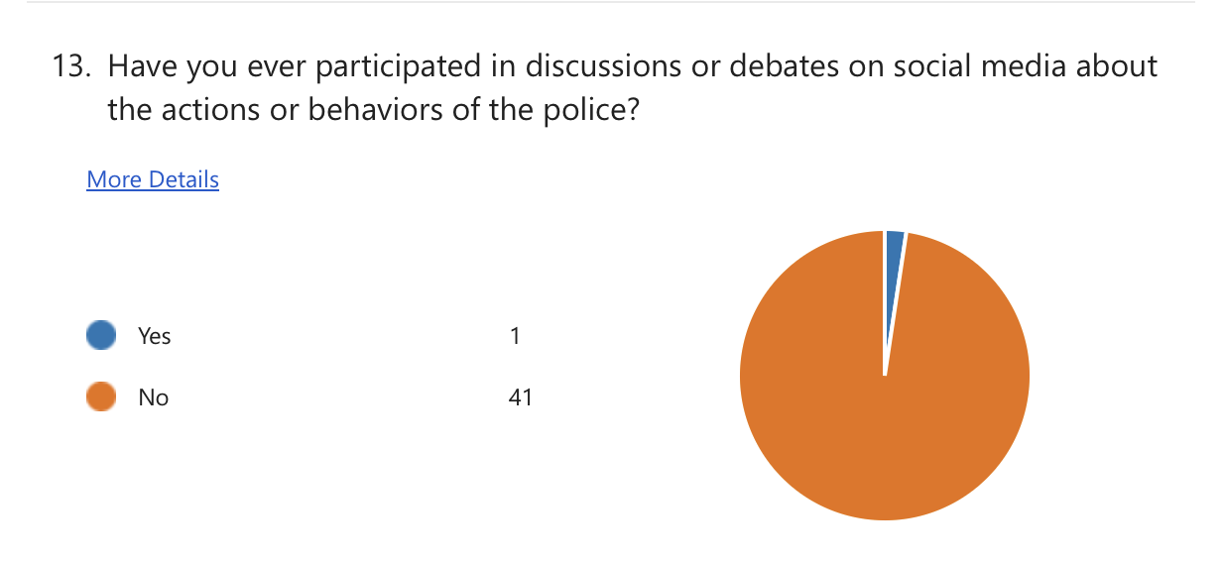
Despite the limited participation in discussions or debates about police actions or behaviours on social media, the survey highlighted strong support for police use of social media as a communication tool. While only 2% of respondents reported ‘yes’ to engaging in discussions for the question “Have you ever participated in discussions or debates on social media about the actions or behaviours of the police?”, a significant majority, 86%, expressed agreement with the idea that police should utilise social media to engage with the public. Survey data has revealed a lack of participation in discussions or debates about police actions or behaviours on social media, with 98% of respondents indicating no engagement. Secondary data indicates initial one-way communication strategies by the police on social media platforms, with recent efforts focusing on fostering two-way communication (Crump, 2011). Using both of this data to create a comparison, it is evident that the efforts to foster two-way communication were unsuccessful. To add to this, critics argue that initial one-way communication strategies by the police portrayed them as one-dimensional and ineffective in utilising social media for meaningful engagement (Aitken, 2023). The answers from the survey can also be used to back this criticism up, with a common answer for the question “How do you believe the police could improve their image on social media platforms?” being more public and community engagement. A common theme from both data has emerged, with both noting that the police do not utilise two-way communication, and when it is used it is not done effectively.
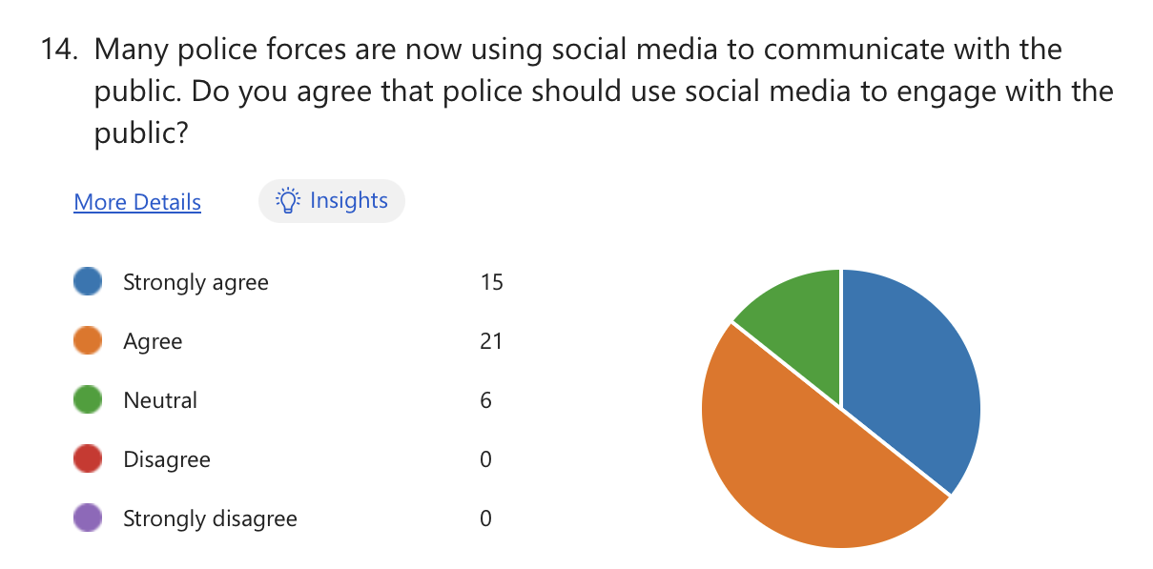
Additionally for the question “Many police forces are now using social media to communicate with the public. Do you agree that police should use social media to engage with the public?”, 50% strongly agreed and 36% agreed that police should use social media to engage with the public. When asked “Please explain your reason” a common theme occurred regarding the use of online engagement with the public would be fast and would reach a wide audience. This indicates a widespread belief in the importance of law enforcement agencies utilising social media platforms to facilitate communication and transparency with the public and could possibly help lessen the negative perception of them on these platforms.
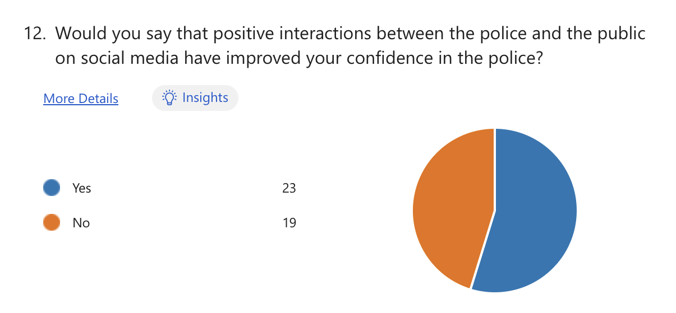
The survey explored the potential of positive interactions between the police and the public on social media to enhance confidence and trust. For the question “Would you say that positive interactions between the police and the public on social media have improved your confidence in the police?” results indicated that a majority, 55%, of respondents reported that positive interactions between the police and the public on social media have indeed improved their confidence in them. This finding underscores the importance of constructive engagement and transparent communication in fostering positive attitudes towards law enforcement agencies.
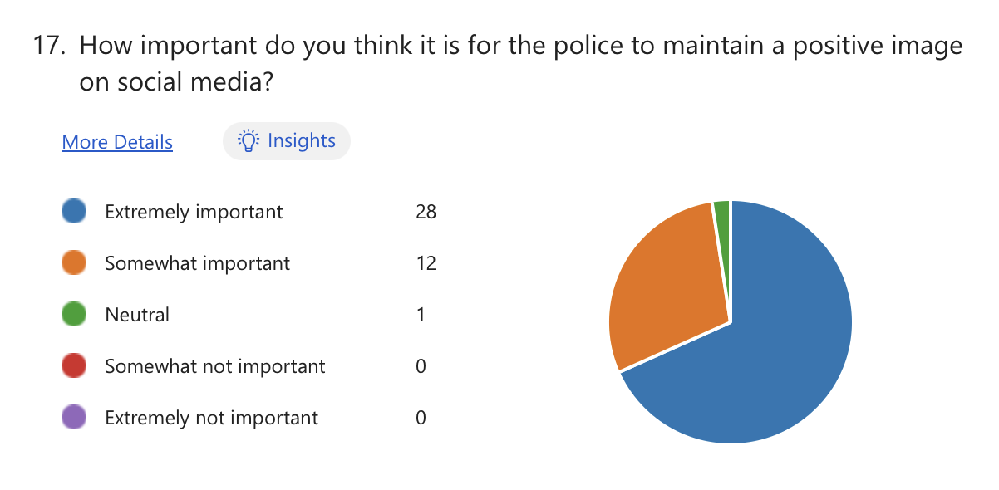
The question “How important do you think it is for the police to maintain a positive image on social media?” was also asked. Results showed a strong consensus among respondents regarding the significance of this aspect. A vast majority, 68%, deemed it extremely important for the police to maintain a positive image on social media. This underscores the recognition of social media as a critical platform for shaping public perceptions and attitudes towards law enforcement agencies.
Survey responses have highlighted instances where police engagement on social media has positively influenced public confidence and trust. Examples include the police force’s swift and effective response during incidents such as car crashes and the Grenfell Tower tragedy, as well as their supportive interactions with families during times of crisis. Furthermore, a significant proportion of respondents (55%) indicated that positive interactions between the police and the public on social media have improved their confidence in law enforcement. Additionally, most respondents (68%) emphasised the importance of the police maintaining a positive image on social media platforms, underscoring the significance of these interactions for building public trust. In contrast, secondary data provides further insights into the effectiveness of police engagement on social media platforms. Studies by Keane (2013) and Cartwright (2020) suggest that social media has facilitated improved community engagement and enhanced public participation with police forces across the UK over the years. Additionally, research by Ralph (2020) emphasises the importance of honesty and genuineness in police communication on social media, indicating that these traits contribute to a positive public perception of law enforcement. The use of social media platforms as a tool for promoting positive public perception is further supported by findings from the "Social Media perception survey" conducted by Bailey et al. (2018), which revealed that the police are perceived as the most trusted source of information across all social media platforms by 96% of their followers in the UK.

4.4 Conclusion

Through surveys and literature reviews, this study explored various aspects of police portrayal on social media, its impact on public trust, and the effectiveness of police engagement strategies. Findings reveal a nuanced landscape where diverse viewpoints coexist, with a significant proportion of respondents perceiving police portrayal negatively. However, positive interactions between police and the public on social media have been shown to enhance confidence and trust in police forces. Despite challenges such as limited participation in discussions and debates, there is strong support for police use of social media as a communication tool. Moreover, the importance of maintaining a positive image on social media platforms is emphasised, highlighting the significance of transparent and constructive engagement. Secondary data corroborates these findings, indicating that social media facilitates improved community engagement and enhances public participation with police forces. A common trend discovered by utilising both primary and secondary data is the lack of trust in the police when they are displayed negatively on social media platforms. Ultimately, the study contributes to a better understanding of the complex dynamics between social media, public perceptions, and policing strategies, offering insights that can inform policymakers, police agencies, and researchers in their efforts to navigate the digital landscape effectively.

Chapter Five: Conclusion

5.1 Introduction

This dissertation sought to expand the overall understanding of the complex relationship between public opinion and social media portrayals of UK policing, as well as the ways in which public perception and trust in the police are impacted by these portrayals. This question was specifically designed with the aim of finding out how the police are portrayed in the UK on social media. In addition to this, it was a priority to analyse the impact that negative social media coverage has on the perception of the police, as well as exploring the use of social media in promoting positive public perception of the police. This section will summarise the main conclusions and insights on the influence of social media portrayals on public opinion of UK policing that were obtained from the primary survey data as well as the secondary literature study.

5.2 Identifying how the police are portrayed on social media within the UK

As a result of exploring previous literature, as well as finding first hand opinions, many new analogies can be formed regarding how the police are portrayed on social media within the UK. Ralph et al (2022) found that the police have endeavoured to mould their public image on social media by employing tactics such as comedy, humanising approaches, and acknowledging the impact of digital communication on public opinion formation. While police forces are trying to project a less robotic image, poll participants from primary data indicate that these efforts are not at all successful in achieving their goals, with a lack of trust being cited as the main issue.
In addition to this, a decade ago Crump (2011) made claims that the police had made additional efforts to increase their two-way communication on social media, looking to improve public portrayal. With the recent primary data stating that most people do not involve themselves in discussions or debates on social media regarding the police, it is clear that the police online portrayal is still seen as robotic, with many people still refusing to engage with them despite the amount of time they have had to address the issue. Aitken (2023) supports this, claiming that the police were portrayed as dull and ineffective in their early use of social media for meaningful engagement, because of their early one-way communication strategies.

5.3 Analysing the impact that negative social media coverage has on police perception

Regarding the negative impact of social media coverage on public perception of the police, while social media provides a platform for the public to voice their opinions, Colbran (2020) notes that police presence on social media can influence the flow of information, potentially limiting public access to high-quality data for decision making. This is consistent with the primary data survey results showing that people desire police integrity to enhance their public perception. This assertion is reinforced by Fleet et al. (2022), who emphasise the important influence of media coverage on public opinion and attitudes towards law enforcement, heavily swaying people’s perceptions on them. With the general consciences about the police being that they restrict the flow of information and are not honest on social media, it has it has a significant negative impact on their online presence and community trust. The primary data has also shown evidence that all negative social media coverage harms public relations with the police, further detaching them from a good community relationship. Police reputations are severely damaged by the general belief that they are information censors and by their lack of transparency on social media, making it fair to state that negative social media coverage can sway individuals’ thoughts on the police in an obstructive way (Colbran, 2020).

5.4 Exploring social media use in promoting positive public perception of the police

The use of social media for promoting positive public perception for the police was explored. With this, it was discovered that interestingly very few people felt their opinion of the police changes based on police content they see on social media, with studies by Dencik (2018) and Williams et al. (2018) supporting this view. In contrast to these findings, primary research suggests that positive interactions, positive interactions, like swift emergency responses and supportive engagements during crises, have bolstered public confidence. Despite the majority 86% of participants originally stating their opinion of the police is unaffected by social media content, 55% of respondents then went on to answer that positive police interactions on social media enhance trust. Studies by Keane (2013), Cartwright (2020), and Ralph (2020) reinforce the importance of genuine communication, and Bailey et al.'s (2018) survey highlights the police's role as the most trusted source of information on social media. Transparency and honesty in online interactions emerge as essential for law enforcement to maintain a positive image in the digital era, with the responses from the primary data heavily leaning into the willingness to trust the police.

5.5 Limitations

The survey presented valuable evidence, however, could have been improved with various factors being implemented. A larger sample size would enhance the validity of the survey. Integrating qualitative methods like interviews could offer deeper insights. Moreover, reliance on self-reported responses may introduce biases. Finally, allowing this survey to run for a longer period would have allowed for more responses and data to be gathered. Despite these constraints, the survey provided valuable insights into public perceptions of police portrayal on social media, underlining the need to address these limitations for a comprehensive understanding of the topic.

5.6 Recommendations

Based on the insights from both primary survey data and secondary literature, recommendations for the UK police force include revising communication strategies to humanise their online presence and foster genuine connections with the public, prioritising transparency and honesty in their interactions on social media, to counteract negative perceptions and promoting positive interactions to showcase achievements and build public trust. Additionally, highlighting instances of swift emergency responses and supportive engagements during crises can bolster public confidence, as evidenced by the primary survey data, and emphasizing the police's role as a trusted source of information can further enhance their credibility online, as demonstrated by Bailey et al.'s (2018) survey. By aligning communication strategies with public expectations and preferences, the police can effectively use social media to promote a positive perception and strengthen community relations in the digital age. To answer the research question, the portrayal of UK policing on social media significantly impacts public perception and confidence. Efforts to humanise police presence often fall short, while negative coverage can erode trust. Promoting genuine communication, transparency, and positive interactions is crucial for fostering trust and enhancing public perception of the police on social media.

Reference List

Aitken, A., Ralph, L., & Robinson, P. (2023). Police use of Twitter during a sporting mega-event. Policing: A Journal of Policy and Practice, 17. (Accessed November 4th, 2023)

Ali, P. (2021). At a Time When The Murder Of Sarah Everard Has Put Violence Against Women At The Top Of The Political Agenda, Why Is It Actually Getting Worse? And What Has Been The Media’s Role–Dissertation. (Accessed November 26th, 2023)

Anstead, N., & O'Loughlin, B. (2015). Social media analysis and public opinion: The 2010 UK general election. Journal of Computer-Mediated Communication, 20(2), 204-220. (Accessed November 30th, 2023)

Aston, E., Wells, H., Bradford, B., and O’Neill, M. (2022). Technology and police legitimacy. In Policing in Smart Societies: Reflections on the Abstract Police. Cham: Springer International Publishing. (pp. 43-68). (Accessed November 4th, 2024)

Awan, I., Brookes, M., Powell, M. and Stanwell, S., (2019). Understanding the public perception and satisfaction of a UK police constabulary. Police Practice and Research, 20(2), pp.172-184. (Accessed November 27th, 2023)

Bailey, D., & York, R. (2018). National Police Chiefs’ Council Social Media Survey 2018. Surrey Police. Retrieved from https://www.surrey.police.uk/SysSiteAssets/media/downloads/surrey/stats-and-data/NPCC_SMSurvey_2018.pdf (Accessed November 29th, 2023)

Baldwin, M.A. and Rose, P. (2009). Concept analysis as a dissertation methodology. Nurse Education Today, 29(7), pp.780-783. (Accessed February 7th, 2024)

Braun, V., Clarke, V., Boulton, E., Davey, L. and McEvoy, C., (2021). The online survey as a qualitative research tool. International journal of social research methodology, 24(6), pp.641-654. (Accessed April 11th, 2024)

Brereton, J.E., Tuke, J. and Fernandez, E.J. (2022). A simulated comparison of behavioural observation sampling methods. Scientific Reports, 12(1), p.3096. (Accessed February 1st, 2024)

Brittain, S., Ibbett, H., de Lange, E., Dorward, L., Hoyte, S., Marino, A., Milner‐Gulland, E.J., Newth, J., Rakotonarivo, S., Veríssimo, D. and Lewis, J. (2020). Ethical considerations when conservation research involves people. Conservation Biology, 34(4), pp.925-933. (Accessed February 5th, 2024)

Bucher, T., and Helmond, A. (2018). The affordances of social media platforms. The SAGE handbook of social media (pp. 233-253). (Accessed November 4th, 2024)

Bullock, K. (2018). The police use of social media: Transformation or normalisation? Social Policy and Society, 17(2), 245-258. (Accessed November 6th, 2023)

Bullock, K., Garland, J., & Coupar, F. (2021). Police-community engagement and the affordances and constraints of social media. Policing and Society, 31(4), 373-385. (Accessed November 3rd, 2024)

Carter, C. ed., (2018). Successful dissertations: The complete guide for education, childhood and early childhood studies students. Bloomsbury Publishing. (Accessed February 3rd, 2024)

Cartwright, A., and Shaw, C. (2020). Evidence-based social media use: an exploratory UK investigation into residents’ perceptions of police Facebook use. Safer communities, 19(2), 61-71. (Accessed November 7th, 2023)

Chadwick, A., & Vaccari, C. (2019). News sharing on UK social media: Misinformation, disinformation, and correction. Loughborough University. (Accessed December 2nd, 2023)

Clark, T. et al. (2021). Bryman’s social research methods. 6th edition. Oxford: Oxford University Press. (Accessed February 4th, 2024)

Colbran, M. P. (2018). Policing, social media and the new media landscape: Can the police and the traditional media ever successfully bypass each other? Policing and Society. (Accessed November 4th, 2023)

Colbran, M. P. (2020). Policing, social media and the new media landscape: can the police and the traditional media ever successfully bypass each other? Policing and Society. (Accessed November 29th, 2023)

Corliss, C., (2023). Selfies, snapchat and keeping safe: Impressions of social media and cyberbullying from looked after children and young people with care experience in Wales. Adoption & Fostering, 47(3), pp.262-276. (Accessed November 25th, 2023)

Crump, J. (2011). What are the police doing on Twitter? Social media, the police and the public. Policy & Internet, 3, 1-27. https://doi.org/10.2202/1944-2866.1130 (Accessed November 25th, 2023)

Cullen, A. (2022). Police and Social Media in England and Wales: Exploring police communications and image work in the digital society (Doctoral dissertation, Cardiff University). (Accessed November 29th, 2023)

Dencik, L., Hintz, A., and Carey, Z. (2018). Prediction, pre-emption and limits to dissent: Social media and big data uses for policing protests in the United Kingdom. New media & society, 20(4), 1433-1450. (Accessed November 28th, 2023)

Dominelli, A. (2003). Web surveys—Benefits and considerations. Clinical Research and Regulatory Affairs, 20(4), 409-416. (Accessed February 5th, 2024)

Dosek, T. (2021). Snowball sampling and Facebook: how social media can help access hard-to-reach populations. PS: Political Science & Politics, 54(4), pp.651-655. (Accessed April 11th, 2024)

Egawhary, E. M. (2019). The surveillance dimensions of the use of social media by UK police forces. Surveillance & Society, 17(1/2), 89-104. (Accessed November 5th, 2023)

Feilzer, M. Y. (2010). Doing mixed methods research pragmatically: Implications for the rediscovery of pragmatism as a research paradigm. Journal of Mixed Methods Research, 4(1), pp.6-16. (Accessed February 5th, 2024)

Fernandez, M., Dickinson, T., & Alani, H. (2017). An analysis of UK policing engagement via social media. In Social Informatics: 9th International Conference, SocInfo 2017, Oxford, UK, September 13-15, 2017, Proceedings, Part I (pp. 289-304). Springer International Publishing. (Accessed November 4th, 2023)

Fielding, N.G. (2023). Police communications and social media. European Journal of Criminology, 20(1), pp.316-334. (Accessed February 1st, 2024)

Fleet, R. W., and Hine, K. A. (2022). Surprise, anticipation, sadness, and fear: A sentiment analysis of social media’s portrayal of police use of facial recognition technology. Policing: A Journal of Policy and Practice, 16(4), 630-647. (Accessed November 28th, 2023)

Fletcher, R., Kalogeropoulos, A. and Nielsen, R.K., (2023). More diverse, more politically varied: How social media, search engines and aggregators shape news repertoires in the United Kingdom. New Media & Society, 25(8), pp.2118-2139. (Accessed November 29th, 2023)

Flick, U. (2011 A beginner’s guide to doing a research project. Introducing research (Accessed February 2nd, 2024)

Flick, U. (2018). The SAGE handbook of qualitative data collection. First edition. Thousand Oaks, California: SAGE Incorporated. (Accessed February 7th, 2024)

Forsgren, E., Gritt, E., and Allen, D. (2018). Investigating the Influence of Social Media on Police Activities. ICIS 2018 Proceedings. 21. (Accessed November 28th, 2023)

Fortin, F., Delle Donne, J., and Knop, J. (2021). The use of social media in intelligence and its impact on police work. In Policing in an Age of Reform: An Agenda for Research and Practice (pp. 213-231). (Accessed December 7th, 2024)

Golde, C.M. and Allen, J.E. (2019). The productive graduate student writer: How to manage your time, process, and energy to write your research proposal, thesis, and dissertation and get published. Routledge. (Accessed February 2nd, 2024)

Greetham, B. (2019). How to write your undergraduate dissertation (Vol. 108). Bloomsbury Publishing. (Accessed February 2nd, 2024)

Gummer, T., Christmann, P., Verhoeven, S. and Wolf, C. (2022). Using a responsive survey design to innovate self-administered mixed-mode surveys. Journal of the Royal Statistical Society Series A: Statistics in Society, 185(3), pp.916-932. (Accessed February 5th, 2024)

Henry, A., (2023). Digital ritual: Police-public social media encounters and'Authentic'interaction. The British Journal of Criminology: An International Review of Crime and Society (BJC), pp.1-16. (Accessed November 28th, 2023)

Henry, A., (2024). Digital Ritual: Police–Public Social Media Encounters and ‘Authentic’Interaction. The British Journal of Criminology, 64(2), pp.452-467. (Accessed February 28th, 2024)

Howell, K.E., 2012. An introduction to the philosophy of methodology. An Introduction to the Philosophy of Methodology, pp.1-248. (Accessed April 11th, 2024)

Howlings, E., and Solymosi, R. (2023). Exploring facilitators, barriers and concerns of police using social media when investigating missing children. International Journal of Missing Persons, 1(1), 104. (Accessed November 26th, 2023)

Kara, H., (2023). Primary data collection: conventional methods. In Research and Evaluation for Busy Students and Practitioners (pp. 135-154). Policy Press. (Accessed April 11th, 2024)

Keane, N. J. (2013). Police Use of Social Media to Support Community Engagement-Its Rise in Police Practice in the UK. Special Issue 1 Eur. Police Sci. & Res. Bull., 101. (Accessed November 20th, 2023)

Lawrence, R. G. (2023). The politics of force: Media and the construction of police brutality. Oxford University Press. (Accessed November 28th, 2023)

Leavy, P., (2022). Research design: Quantitative, qualitative, mixed methods, arts-based, and community-based participatory research approaches. Guilford Publications. (Accessed April 11th, 2024)

London Assembly (2013). Smart policing: How the Metropolitan Police Service can make better use of technology. London: London Assembly. Available at: https://www.london.gov.uk/sites/default/files/gla_migrate_files_destination/Police%20technology%20report%20-%20Final%20version.pdf (Accessed April 5th, 2024)

Macaulay, M., & Rowe, M. (2020). Happy ever after? Making sense of narrative in creating police values. Public Management Review, 22(9), 1306-1323. (Accessed January 7th, 2024)

McMillan, K. and Weyers, J. (2012). How to write dissertations & project reports. Pearson Education. (Accessed February 9th, 2024)

McNeill, Patrick. and Chapman, S. (2005). Research methods. 3rd ed. London: Routledge. (Accessed February 1st, 2024)

Merry, S., Power, N., McManus, M., & Alison, L. (2012). Drivers of public trust and confidence in police in the UK. International Journal of Police Science & Management, 14(2), 118-135. (Accessed December 28th, 2023)

Metropolitan Police. (2021). Social Media Policies and Filming Fees. Available at: https://www.met.police.uk/cy-GB/SysSiteAssets/foi-media/metropolitan-police/disclosure_2021/august_2021/social-media-policies-and-filming-fees2 (Accessed November 29th, 2023)

Meyer, J.P. and Morin, A.J.S. (2016). “A person-centered approach to commitment research: Theory, research, and methodology,” Journal of organizational behavior, 37(4), pp. 584–612. Available at: https://doi.org/10.1002/job.2085. (Accessed February 7th, 2024)

Moore, A.F. and Johnstone, R., (2023). UK Metropolitan police: reverse mentoring in a small pilot programme aiming to build community trust. The CASE Journal. (Accessed December 27th, 2023)

Neuman, W.L., Nardi, P.M., Berg, B.L., Jackson, W., Varberg, N., Robson, K., Christensen, L.B., Johnson, R.B. and Turner, L.A. (2011). Research Methods in Communication. (Accessed February 5th, 2024)

Nikolovska, M., Johnson, S.D. and Ekblom, P. (2020). “Show this thread”: policing, disruption and mobilisation through Twitter. An analysis of UK law enforcement tweeting practices during the Covid-19 pandemic. Crime science, 9(1), pp.1-16. (Accessed February 4th, 2024)

O’Reilly, C., (2024). Understanding police legitimacy and public confidence. In Neighbourhood Policing (pp. 23-38). Policy Press. (Accessed December 28th, 2024)

Ofcom (2023): Media consumption and attitudes among children and parents in 2023. Available at: https://www.ofcom.org.uk/__data/assets/pdf_file/0027/255852/childrens-media-use-and-attitudes-report-2023.pdf. (Accessed April 11th, 2024)

Pellegrino, J.W. and Glaser, R., (2021). Components of inductive reasoning. In Aptitude, learning, and instruction (pp. 177-218). Routledge. (Accessed April 11th, 2024)

Proudfoot, K. (2023). Inductive/Deductive hybrid thematic analysis in mixed methods research. Journal of Mixed Methods Research, 17(3), pp.308-326. (Accessed February 5th, 2024)

Pukallus, S. and Arthur, C., (2024). Combating Hate Speech on Social Media: Applying Targeted Regulation, Developing Civil-Communicative Skills and Utilising Local Evidence-Based Anti-Hate Speech Interventions. Journalism and Media, 5(2), pp.467-484. (Accessed April 3rd, 2024)

Ralph, L. D. (2020). The dynamics of police legitimacy and social media in Scotland (Doctoral dissertation). (Accessed November 28th, 2023)

Ralph, L., and Robinson, P. (2023). Assessing police social media practices through a democratic policing lens. International Journal of Police Science & Management, 25(3), 237–249. https://doi.org/10.1177/14613557231169391 (Accessed November 29th, 2023)

Sampson, F. and Lyle, A., (2017). Legal considerations relating to the police use of social media. Application of Social Media in Crisis Management: Advanced Sciences and Technologies for Security Applications, pp.171-190. (Accessed November 30th, 2023)

Saunders, M., Lewis, P., & Thornhill, A. (2023). Research Methods for Business Students. (9th ed.) Pearson. (Accessed February 5th, 2024)

Silverman, D. (2021). Doing qualitative research. Doing qualitative research, pp.1-100. (Accessed February 6th, 2024)

Smith, E., (2008). Using secondary data in educational and social research. McGraw-Hill Education (UK). (Accessed February 5th, 2024)

Walsh, J. P., and O'Connor, C. (2019). Social media and policing: A review of recent research. Sociology compass, 13(1), e12648. (Accessed March 2nd, 2024)

Watson, S. (2023). Investigating the role of social media abuse in gender-based violence: The experiences of women police officers. Criminology & Criminal Justice, 23(5), 829-844. (Accessed November 24th, 2023)

Williams, M. L., Edwards, A., Housley, W., Burnap, P., Rana, O., Avis, N., Morgan, J., and Sloan, L. (2017). Policing cyber-neighbourhoods: tension monitoring and social media networks. In Policing Cybercrime. Routledge. (pp. 53-73). (Accessed November 28th, 2023)

Wiltshire, G. and Ronkainen, N., (2021). A realist approach to thematic analysis: making sense of qualitative data through experiential, inferential and dispositional themes. Journal of Critical Realism, 20(2), pp.159-180. (Accessed April 11th, 2024)

Yonder (2023) Independent Office for Police Conduct (IOPC) IOPC public perceptions ..., policeconduct.gov.uk. Available at: https://www.policeconduct.gov.uk/sites/default/files/documents/IOPC-public-perceptions-tracker-report-2022-23.pdf (Accessed November 30th, 2023)

Appendix



