Cynllun gwers / lesson plan

Blwyddyn / Year:  2/3 | Maes Dysgu a Phrofiad / Area of Learning and Experience:  Languages, Literacy and Communication. | Amcan y wers / Aims of the lesson:  WALT: Practise weather vocabulary in Welsh and use it in simple sentences to describe the weather.
Gwybodaeth flaenorol / Previous knowledge:  Learners have encountered simple greetings, days of the week and some simple descriptive words. Learners have spoken about weather but not in detail. | Geirfa allweddol / Key vocabulary:  - Sut mae’r tywydd heddiw?  - Mae hi'n bwrw glaw – It’s raining  - Mae hi'n heulog – It’s sunny  - Mae hi'n wyntog – It’s windy  - Mae hi'n bwrw eira – It’s snowing  - Mae hi'n gymylog – It’s cloudy  - Mae'n oer – It’s cold  - Mae'n boeth – It’s hot | Gweithgareddau addysgu a dysgu / Teaching and Learning Activities:  - Starter: Greet the class in Welsh and introduce the day’s topic with a weather song. – Learners have sung this song before, and this will be a good way to activate their prior knowledge and get learners thinking about weather vocabulary. We’ll also use scarves during this activity to make it more engaging and interactive.  - Show weather picture flashcards and model pronunciation and meaning of weather terms. – Showing learners pictures can give them an iconic representation to help them remember the vocabulary.  - Call and response and matching games with vocabulary. – Call and response is a quick way to use repetition and get the learners used to saying the vocabulary.  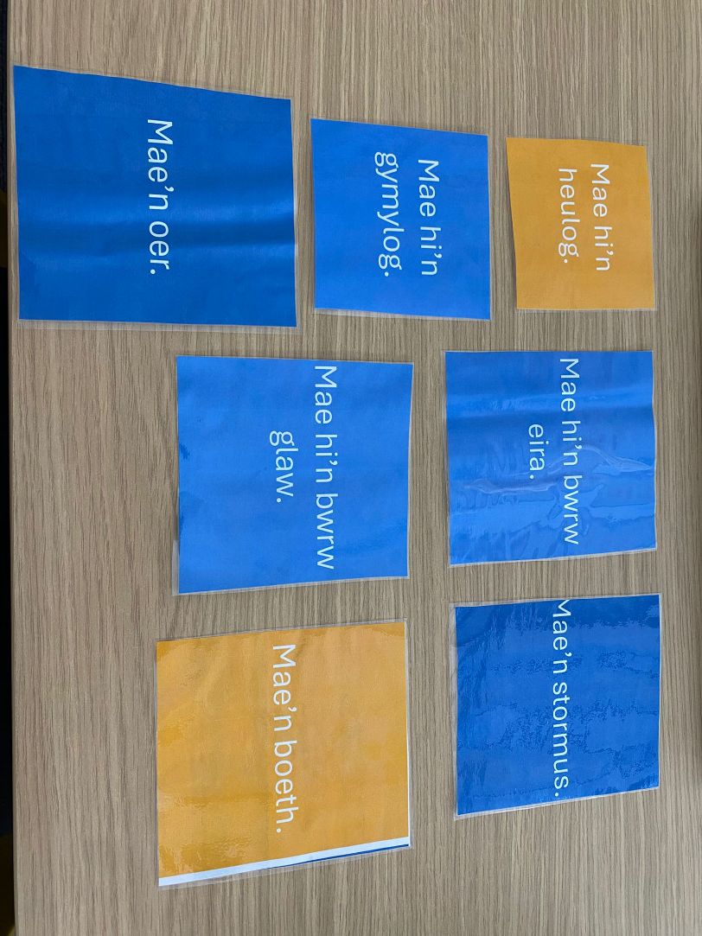  - Pair work – ask and answer “Sut mae’r tywydd heddiw?” using sentence patterns and vocabulary.- This gives the learners another opportunity to practice the vocabulary and feel confident using it.  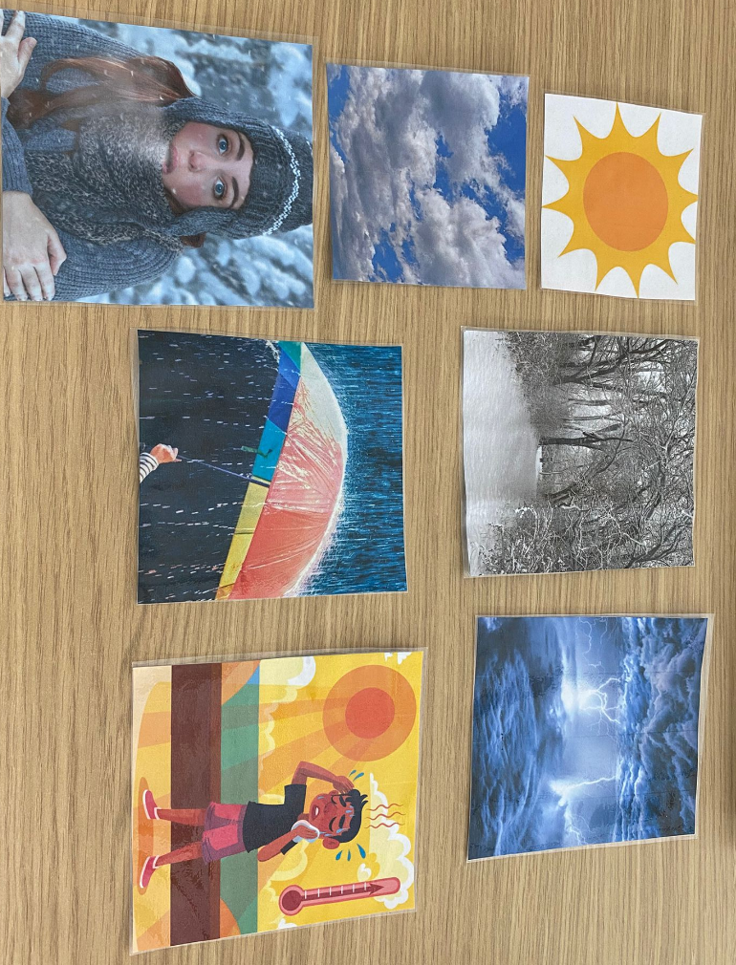
Adnoddau / Resources:  - Weather song and lyrics.  - Welsh weather flashcards.  - Weather matching game. | Ffocws iaith / Language focus:  - Sentence patterns: “Mae hi’n…”  - Asking and answering: “Sut mae’r tywydd heddiw?” – “Mae hi’n…”

