Learning in the Digital Era

Contents

Task 1 3
Task 2 4
Academic Writing 4
Importance of Academic Writing 4
Task 3 6
Critical Analysis 6
An understanding of Critical Analysis and how it enhances the quality of work produced. 6
Task 4 8
References 12

Task 1
One must write a report in an appropriate tone and style because it is an official document. The report must be written entirely in the third person (Macnow, 2018). The words "you" and "yours," as well as first- and second-person pronouns, are forbidden. Instead of writing from a biased, subjective perspective, the report should be written from an impartial, objective one-
An official report typically follows a common structure such as-
Front Page: The title of the report, the names and affiliations of the writers, the host and publishing company, and the publication date are all included on the front pages.
The Executive Summary: It provides a brief overview of the complications or obstacles the writer was assigned to solve. The main conclusion drawn should also be incorporated in this part.
Table of contents: A list of sections and subsections, each of which links to a separate page, is provided on the table of contents page.
Terms of Reference: This part includes the individual who requested the report along with the date of the request, the report's purpose, author, issues it addresses, and the date it was or will be submitted (Powell et al., 2023).
Findings: This portion of the report should provide a detailed and explicit explanation of the presented information or situation, broken down into its own subsections. Evidence from scholarly books, papers, and websites must be provided in the form of citations, paraphrases, or direct quotes. It is absolutely illegal to use exclusive internet sources for research reports.
Conclusion: This is the last portion which may be provided as a paragraph of its own, or the writer may divide the tasks into various sections which later can be contrasted with the demands of possible employers (Johnson et al., 2017). The conclusion must solely be based on the information provided in the findings section and should not be supported by any other information in the report.
References List: For undergraduates who are working on reports, they should include all sources they consulted, including any excerpts from books and scholarly periodicals along with the identity of the author.

Task 2

Academic Writing
Scholarly writing usually referred to as academic writing, comprises nonfiction writings written for academic purposes (Kong & Lai, 2017). This might range from reports on actual fieldwork or research carried out at centres aimed at the natural or social sciences to articles or monographs used by scholars in order to examine culture, put out fresh theories, and create interpretations based on historical sources (Giltrow et al., 2021). Academic writing across genres and publishing formats is featured by a formal prose register, frequent allusions to earlier academic writing, and the use of largely consistent rhetorical gestures to define the project's scope, situate it in the pertinent literature, and develop a new contribution.

Importance of Academic Writing
Academic writing allows for the creation, codification, transfer, assessment, revision, teaching, acquisition, and many other aspects of information and theories in academic subjects. Success in academic life depends greatly on knowing how to write by following an academic manner, which is a must for mastering any field (Godfrey, 2015). Graduate students who tend to struggle with academic assignments and writing may find it difficult to communicate what they have learned or understood when studying sophisticated concepts. Essays come up with a chance for students to show that they have a solid comprehension of the subject and a mastery of suitable language and presentational standards, both of which are crucial when writing with an intended audience in mind.
Also, the emphasis on style and approach distinguishes academic writing from other, less strict types of writing. It investigates how form and style could be used to convey a message. If a student is familiar with the necessary framework and structure of academic assignments before attending college, university-level writing will be much easier to manage (Convery et al., 2014). In order to write a paper that would impress their supervisors, students must be aware of any formatting requirements or preferred styles that certain lecturers may possess. Students who are struggling with their strategy may always ask for help from senior students regarding academic essays and writing.
Moreover, papers that only provide one side of a contentious concept are usually discouraged from being written by students. Learners need the ability to view all concepts and research via a fresh perspective in order to excel academically, and academic papers give them this opportunity (Zemach & Rumisek, 2019). Students must assess concepts from diverse perspectives and offer arguments to support their claims. It is advantageous to learn this at an early age. A crucial talent that will be useful to them in many circumstances is the ability to step back and evaluate a situation objectively. Graduate students who write academically improve their research skills. Research goes further than a straightforward Google search in the case of scientific articles (Bailey, 2018). It might require a lot of time to conduct extensive research, gather pertinent data, and process all of that data. One can discover new topics that are immediately relevant to their field of study, making it a thrilling trip. One may develop the ability to think with more precision and make more well-rounded judgements as a result of this. Research skills are necessary for writing an academic paper and are helpful to both learners as well as practitioners.

Task 3

Critical Analysis
In general terms, critical analysis refers to the detailed assessment and testing of a particular idea or work. The process is subjective and it explains the interpretation of the one who analyses the work or task by breaking it into smaller parts for better comprehension. A person with a critical thinking ability considers all the available data before drawing a decision (Zemach & Rumisek, 2019). Although there are several meanings of the term given the complexity of the subject, they all place a strong focus on thorough consideration, healthy scepticism, and an open-minded attitude to the evidence. Such people must be self-correcting, self-disciplined as well as self-reflective. It necessitates compliance with stringent standards of excellence and deliberate mastery of their implementation(Convery et al., 2014). It further necessitates the capacity for clear communication, problem-solving, and the courage to rise above one's inherent self-centeredness and sociocentrism.

An understanding of Critical Analysis and how it enhances the quality of work produced.
Since they allow one to question the facts, concepts, and claims made in their chosen profession, critical thinking abilities are crucial in higher education. One could get a deeper comprehension of the subject matter by using critical thinking. Academic disciplines remain active via reflection, discussion, and concept refinement (Kong & Lai, 2017). The upkeep and advancement of any field of study thus require rigorous analysis. While attempting to create an essay with the intention of conducting a critical analysis, a writer may open up new avenues of investigation. The writer needs considerable information on a wide variety of pertinent subjects and subtopics in order to form a well-grounded view or evaluation. The procedure is streamlined and organised by critical analysis, despite the fact that it broadens the field of research.
Most often the best decisions are made by critical thinkers in the workplace as well as places where the method of task completion, coordination, and syncing with colleagues have significance (Strongman, 2013). Using critical thinking in jobs can entitle an individual as a problem solver that can be valuable career-wise as well as building leadership skills within an individual. In order to achieve this one needs to approach every situation with an open mind and receive all kinds of information that can be grasped regardless of personal biases. Critical thinking emphasizes the analysis of every situation with independence and after finishing this step, the next step requires the individual to coordinate it appropriately. Having a very good comprehension of critical thinking can develop necessary skills in certain ways that can enhance the quality of work. These skills may incorporate the following-
Enhanced language and presentation skills: Thinking clearly allows a person to break down larger portions of texts and conversations by making an individual enhanced in comprehension of a concept.
Promotes innovation: Critical thinking also makes an individual able to come up with ideas that are unique and can be analysed in future to adjust them according to any situation required.
Increase self-reflection: Thinking rationally gives more meaning to life and everyday actions that can assist to justify our methods of daily life and opinions (Powell et al., 2023). This process provides access to tools that can assess one’s inherent abilities in the way one desires.

Task 4
Video Link: short video.mp4

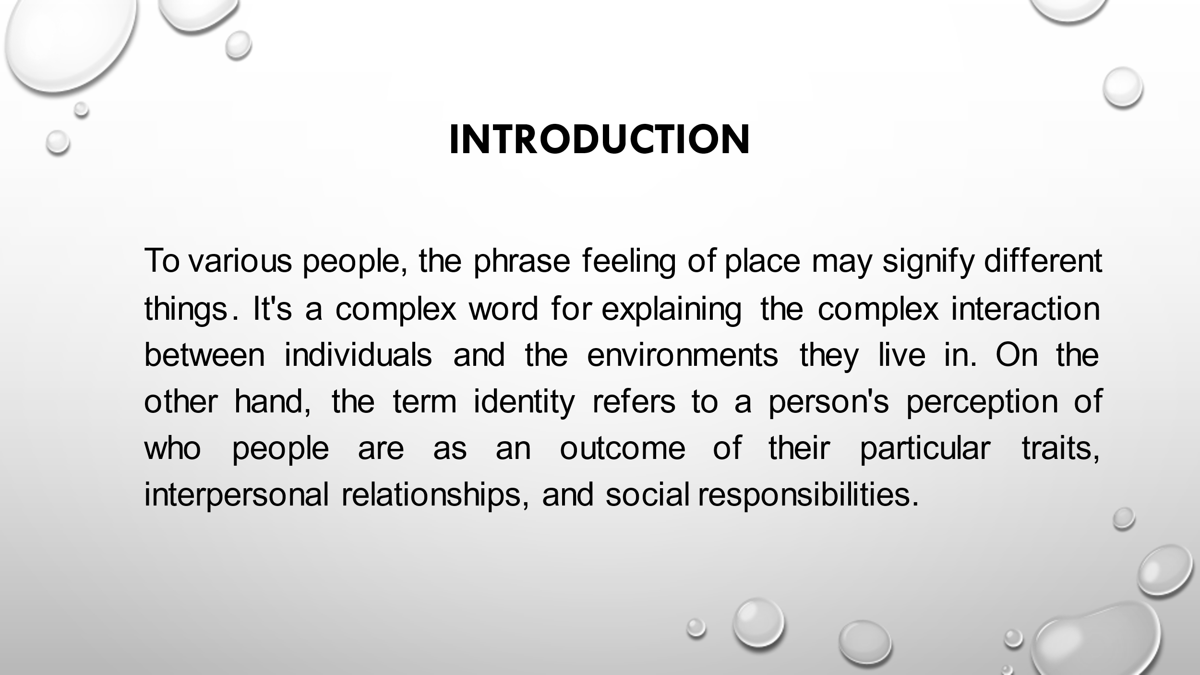
To various people, the phrase feeling of place may signify different things. It's a complex word for explaining the complex interaction between individuals and the environments they live in (Macnow, 2018). On the other hand, the term identity refers to a person's perception of who people are as an outcome of their particular traits, interpersonal relationships, and social responsibilities.
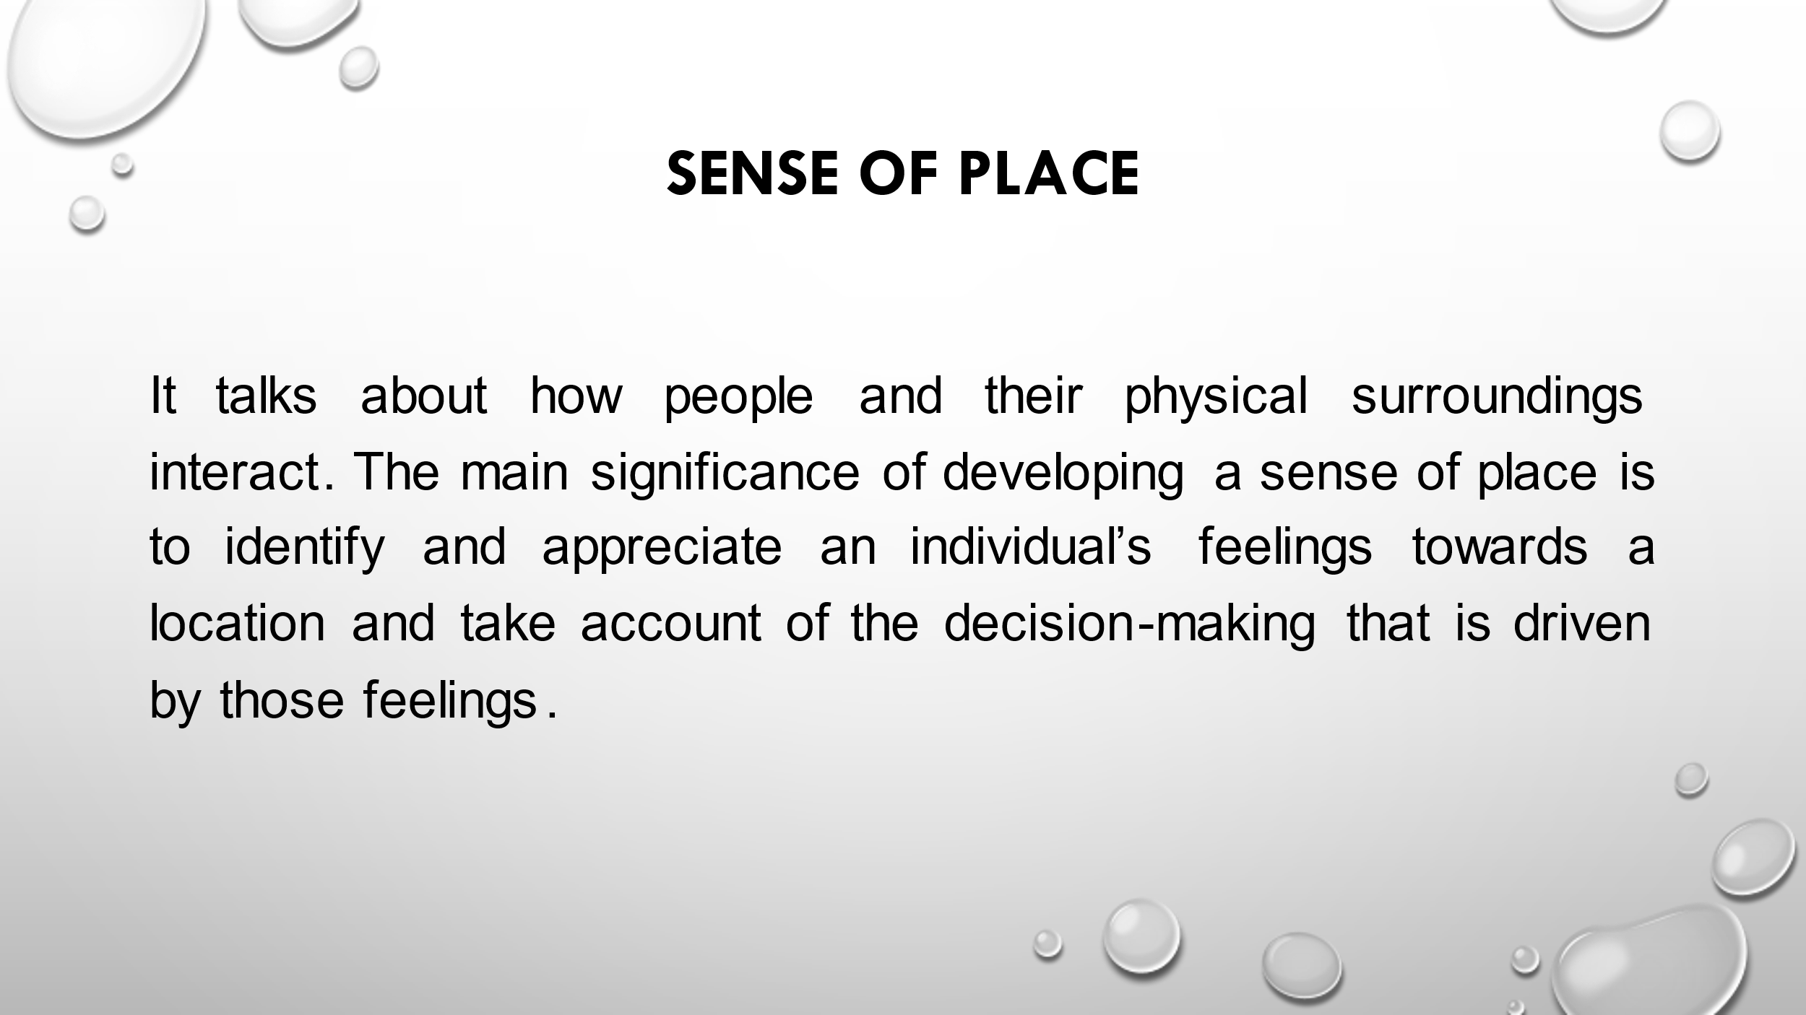
A feeling of place can be interpreted in a number of different ways. It is a challenging idea to characterise the interaction that occurs between individuals and the environments in which they live on several levels (Godfrey, 2015). Some areas simply attribute this trait to the locals, while others think it is due to the location itself, either as a result of assumptions people have made about the location or as a result of the locals. It's a term that's frequently used to describe features of a location that make residents feel more at home and connected to the neighbourhood. The bonds between people and places are expressed in the term Topophilia and the opposite of this feeling is referred to as Topophobia which generally explains the anxiety felt by a location and its surroundings. These feelings rise within individuals due to previous experiences with the place. Positive feelings towards a place can give birth to the urge of reinforcing such feelings by going back to the place or visiting it. It may appear as an urge to protect those places at random times too. In contrast, negative feelings can construct fear and a feeling of dread towards a place and make people want to avoid those places (Johnson et al., 2017). The main significance of developing a sense of place is to identify and appreciate an individual’s feelings towards a location and take account of the decision-making that is driven by those feelings.
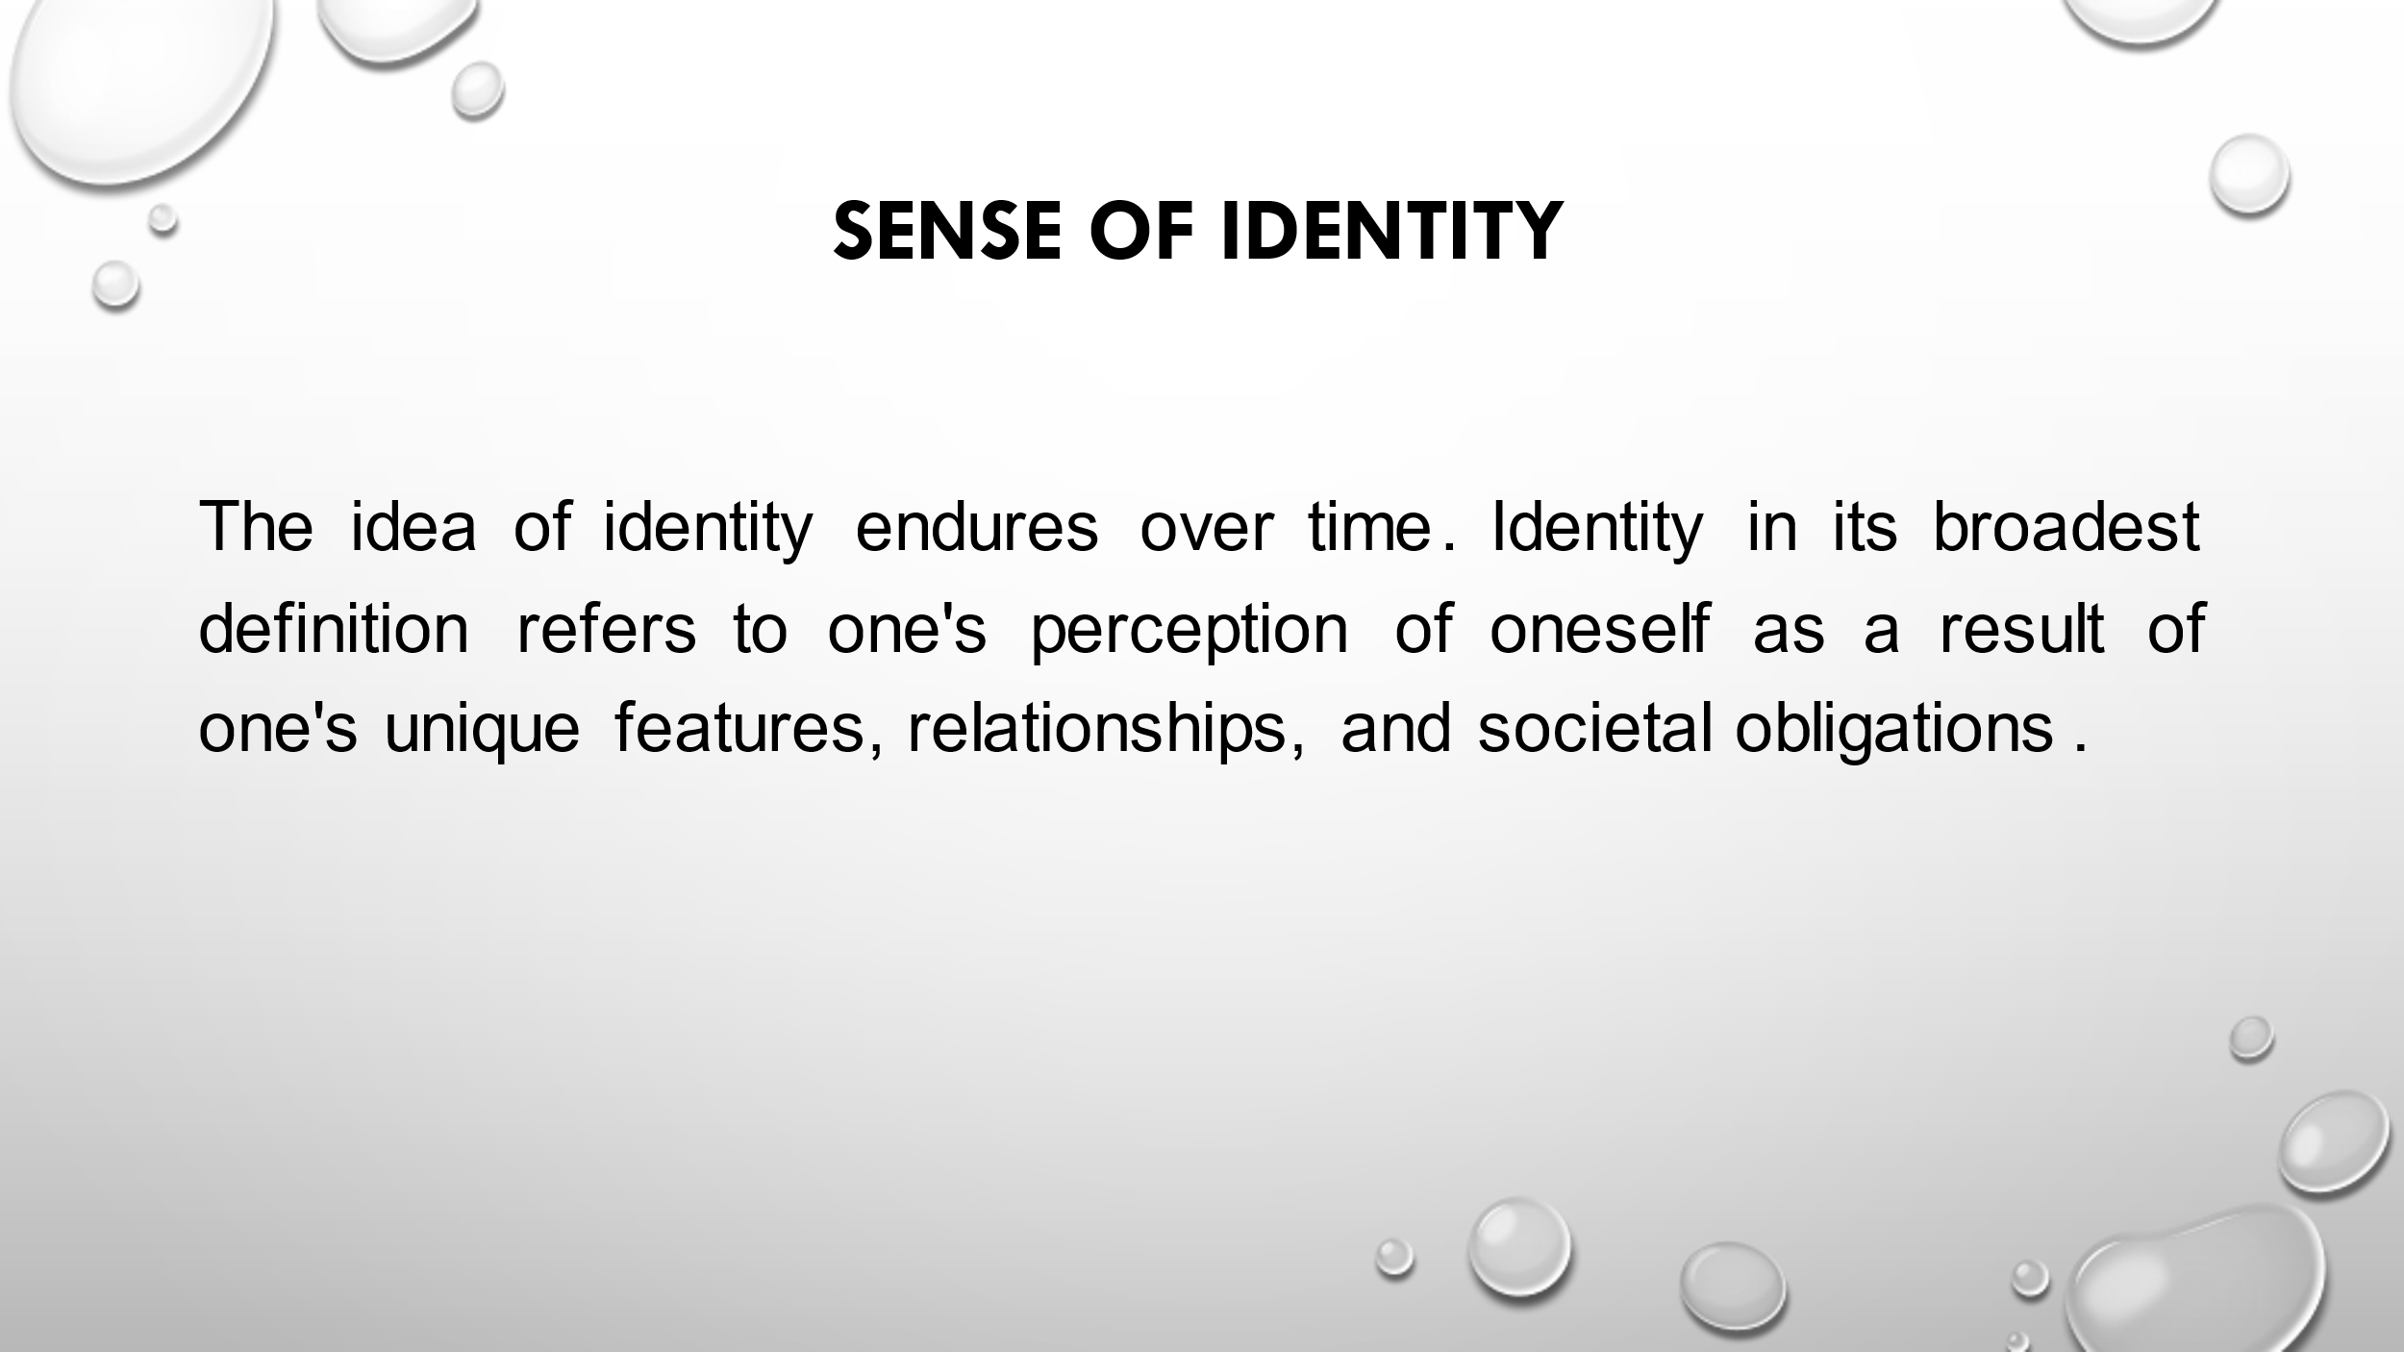
Identity in its broadest definition refers to one's perception of oneself as a result of one's unique features, relationships, and societal obligations (Strongman, 2013). Likewise, even if a person's exterior circumstances may change over time, their sense of identity never changes. A child's carers have the greatest impact on their process of growing up and developing and it also represents the time when they sow the seeds of their identity. During the transition from infancy to maturity, people begin to wonder who they are and how they fit into the world. This is a typical aspect of what it means to be human. Teenagers experiment with a variety of personalities and interests in their search for their own identity. In spite of the fact that individuals are always reassessing who they are and how they should conduct their lives, the truth is that they don't actually end up drastically altering their real identity throughout their lifetime (Giltrow et al., 2021). Because of this, renowned psychologist Erik Erikson believes that it is crucial for young people to experience a time of significant identity development in their growing or adolescent years. This gives them the opportunity to clearly comprehend their true identity and desires from life at that particular time in their lives.
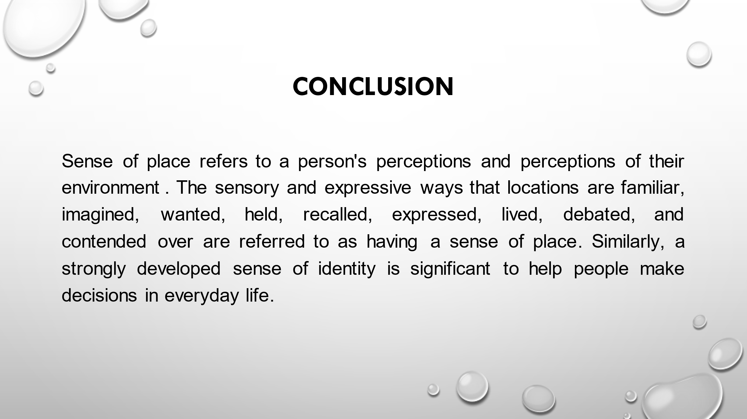
Sense of place refers to a person's perceptions and perceptions of their environment. The sensory and expressive ways that locations are familiar, imagined, wanted, held, recalled, expressed, lived, debated, and contended over are referred to as having a sense of place (Bailey, 2018). Similarly, a strongly developed sense of identity is significant to help people make decisions in everyday life.

References
Bailey, S. (2018) Academic writing: A handbook for international students. London: Routledge.
Convery, I., Corsane, G. and Davis, P. (2014) Making sense of place: Multidisciplinary perspectives. Woodbridge: The Boydell Press.
Giltrow, J., Gooding, R. and Burgoyne, D. (2021) Academic writing: An introduction. Peterborough, Ontario: Broadview Press.
Godfrey, J. (2015) Academic writing. Basingstoke: Macmillan Education/Palgrave.
Johnson, H., Mathis, J. and Short, K.G. (2017) Critical content analysis of children's and Young Adult Literature: Reframing perspective. New York: Routledge, Taylor & Francis Group.
Macnow, A.S. (2018) MCAT critical analysis and Reasoning Skills Review 2019-2020. New York: Kaplan Publishing.
Powell, D.J. et al. (2023) Learning in the digital era: 7th European lean educator conference, ELEC 2021, Trondheim, Norway, October 25-27, 2021. Cham: Springer.
Strongman, L. (2013) Academic writing. Newcastle upon Tyne: Cambridge Scholars.
Zemach, D.E. and Rumisek, L.A. (2019) Academic writing: From paragraph to essay. London: Macmillan.
Kong, S.C. and Lai, M. (2017) “Scholarship of learning and teaching in a digital era: The way forward,” Emerging Practices in Scholarship of Learning and Teaching in a Digital Era, pp. 365–373. Available at: https://doi.org/10.1007/978-981-10-3344-5_22.

