
Module Title: Financial Management
Module Code: LCMB7002

Student Name: Nikhilkumar Ashokkumar Suryavanshi
Student ID: 2333792
Words: 5192
List of Abbreviations
PR: Profitability Ratios
GR: Gross profit Ratio
ROCE: Return on Capital Employed
LR: Liquidity Ratios
CR: Current Ratios
QR: Quick Ratios
ER: Efficiency Ratios
GR: Gearing Ratios
ART: Accounts Receivable Turnover Ratio
APT: Accounts Payable Turnover Ratio
BAT: British American Tobacco
PMI: Philip Morris Inc
Table of Contents
Part A: Introduction 4
Company Overview 4
Recent Events 5
Part B: Financial Performance Review 5
Ratio Analysis: 5
Comparison to major competitors 11
Recommendations 16
Part C: Investment Appraisal 17
Result Evaluation 17
Advantages and disadvantages of Payback Period, ARR and NPV 19
Consideration of Non-Financial Factors 21
Conclusion 22
Reference List 23
Appendix 29

Part A: Introduction

Company Overview
The British American Tobacco Company, popularly known as "BAT," is one of the largest tobacco manufacturers across the globe, and the firm is present in over 180 global countries (BAT, 2024). The firm was established in 1902 on the current tobacco market; British Tobacco Company has become a key player in this industry. The key competitors of British American Tobacco are Philip Morris Inc. and imperial brand Plc. On the contrary, British American Tobacco has also produced some well-known sub-brands such as Dunhill, Kent and Pall Mall. The operations of British American Tobacco include the manufacturing, marketing and distribution of tobacco products. These products include both cigarettes and smokeless tobacco. In the recent period, the company has also produced e-cigarettes and heated tobacco. Therefore, E-Cigarettes refer to liquids which highly contain nicotine without tobacco. On the other hand, heated tobacco refers to the heating of the tobacco to release vapour.

Figure 1: British American Tobacco’s Logo
(Source: British American Tobacco, 2024)
The business model of British American Tobacco is more focused on product differentiation and leveraging its extensive portfolio to align with the different forms of consumer preferences. The company has also invested in innovation, specifically for adapting to changing consumer behaviour and regulatory pressures. British American Tobacco operates highly in a regulatory environment with compressive controls on advertising and product placement (Hardie, 2023). This process poses challenges and opportunities for the company in the current business environment. Additionally, British American Tobacco supplies premium cigarettes, which entails higher pricing and developing stronger consumer loyalty. This segment is highly crucial for maintaining profitability in the markets with the declining cigarette volumes.

Recent Events
Recently, British American Tobacco has faced significant challenges and opportunities. In this regard, the global decline in cigarette consumption is due to health concerns and stringent regulations (Flor et al., 2021). This process has impacted on the company's traditional business model. Nevertheless, British American Tobacco has become highly proactive in its response, which integrates a higher amount of investigation on its next-generation products. These products include Vuse, Glo, and Velo and these producers are aligned with the growing consumer demand for the potential reduced-risk alternatives for smoking-based solutions. The opportunities for British American Tobacco are focussing on investing in the developments of E-Cigarettes to reduce the health risks of consumers.
Along with that, the company has also made an acquisition of Reynolds American Inc. in 2017 (BAT, 2024). This acquisition has become a significant move for the company to enhance British American Tobacco's position in the US market and expand its portfolio of premium brands. In this aspect, British American Tobacco has balanced its presence in the high growth-based markets by combining direct access to the US market. In order to emphasise this, the Reynolds shareholders will receive about $29 in cash without interest (BAT, 2024). The rest of the ordinary shares may be represented over the depositary shares of British American Tobacco.
Moreover, British American Tobacco has been taking the initiative to increase regulatory scrutiny, specifically on the marketing practices and the health implications of Next Generation Products (Sircar and Bialous, 2024). The company is assured that it is committed to sustainability, setting achievable targets to reduce its environmental impact. It has become a highly crucial aspect of British American Tobacco's corporate strategy.

Part B: Financial Performance Review

Ratio Analysis:
Ratio analysis is a quantitative data analysis in which the data has been gathered from the financial report of the company. The ratio analysis provides the opportunity for understanding the financial performance based on the data. The analysis is very impactful for developing multiple decisions regarding the investment. By using the data of the organisation the financial stability of the company can be quickly evaluated by ratio analysis. The analysis provides in-depth knowledge about the financial performance of the company. The ratio analysis can be utilised as a comparison tool for comparing the performance of the company with the competitors. The management of the organisation has developed different decisions regarding the analysis of the financial ratios of the company.
Profitability Ratio:
The PR is one of the essential financial metrics which can be utilised for understanding the profitability performance of the company in the market. By using this ratio, the investors can evaluate the capability of the organisation to generate profit from the business. The management of the organisation has also evaluated the ratio to understand the growth of the business in the market (Pratama et al., 2022). The ratio can also be used as a comparison tool for understanding the competitive advantages of the business in the market. The organisation can develop multiple decisions for the business by utilising this ratio.
Formula: GP ratio = (Gross Profit/Sales revenue) X 100
The GP is also an important ratio which can be utilised by the company to understand how the management is controlling the manufacturing cost of the business. The ratio is one of the most important profitability ratios for comparing the revenue and the gross profit of the business (Nariswari and Nugraha, 2020). By monitoring the ratio, the management of the organisation has developed multiple decisions regarding control of the manufacturing cost of the company. The organisation can develop the pricing strategy which is very important for increasing the revenue of the company.
Figure 2: Profitability Ratio of BAT
(Source: Self-Developed)
The GP ratio of the organisation has been excellent in the last 5 years. The ratio of the BAT company in 2019 was 68.19%. In the following year, the ratio improved to 70.33%. In 2023, the ratio of BAT was 70.04%. The improving ratio indicates that the management of the organisation has developed essential decisions which can help to control the manufacturing cost of the company (WSJ 2023). The sales and the gross profit of both elements of the company are increasing slowly.
The ROCE is also an essential profitability ratio, which can help to understand the capability of the management regarding the capital efficiency of the business. By implementing this ratio, the investors can recognise the ability of the owner to generate profit by using the capital of the business (Investopedia, 2024). The ratio can be utilised to compare the performance of different companies and development decisions for the investment.
Formula: ROCE= EBIT/ Capital Employed
The ratio of British American Tobacco in 2019 was 9.02%. In 2022, the ratio declined to 8.77%. In the following year, the ratio improved to 12.18%. The primary reason behind improving the ratio in 2023 was improving the EBIT of the organisation. The management has reduced the current liability of BAT in 2023 which creates a direct impact on the ROCE ratio of the business (WSJ 2023). The management is ready to focus on increasing the EBIT of the organisation by controlling the oppositional cost of the company. The improving ratio Can attract multiple investors and raise the capital for the business.
Liquidity Ratio:
The LR is also an effective financial tool for the business to determine the financial help of the company in the market. By using this ratio, the creditors can understand how quickly the company can pay all the debt for the business. By using the ratio, the investors can understand the operation of efficiency of the industry and the liquidity position ‌Markonah et al., 2020). The ratio has a crucial role in cash flow management and identifies multiple risks in the business.
The CR is also a practical financial stability indicator which can help to compare the current assets and liability of the business. The improving ratio of the organisation indicates that the company can quickly pay the short-term depth to the creditors. The ratio has a very crucial role for the creditors and develops multiple decisions regarding giving debt (Novyarni and Permana, 2020).
Formula: CR = Current assets/Current liabilities
Figure 3: Liquidity Ratio of BAT
(Source: Self-Developed)
The ratio of BAT in 2019 was 0.70. After this year the ratio of the organisation enhanced slowly, which is a very positive sign for the business. The management of the organisation can collect the debt from different markets by this ratio. In 2023, the ratio of the company was 0.90. The primary reason behind this improvement was the declining current liability of the company in 2023 (WSJ 2023).
Formula: CR = Current assets (excluding inventories)/Current liabilities
The QR is also an effective current ratio which can help to understand how quickly the organisation can convert the current asset for paying the debt. The ratio is significant for identifying different types of risk in the business and developing the decision of the investment (Sari et al., 2022). The organisation can utilise this ratio for benchmarking against different computers to understand the liquidity position. In 2020 the ratio of British American Tobacco was at 0.49. In the following year, the ratio of the company is almost the same. In the previous year, the ratio of the organisation was 0.59. The company has to increase more current assets such as trade receivable, inventory, etc, to improve the ratio and manage the financial stability of the company in the market.
Efficiency Ratio:
The ER is also a social ratio which can develop an understanding regarding the operation and efficiency of the business. By using the ratio, the in-depth knowledge of the company can be evaluated and understand how the organisation is managing the debtors and creditors of the business (Team, 2023).
The ART ratio indicates how quickly the management is collecting money from different debtors and introducing it into the business to control all over the operation. The ratio has a very crucial role in understanding the relationship between the debtors and the management of the company (‌ Binsaddig et al., 2023). In 2019, the ratio of BAT was 6.1. In the following years, the ratio slightly improved; however, in 2021, the ratio declined to 6.32. in 2023, the ratio of the company was 7.2. the overall analysis defines that the management should more frequently collect money from different debtors and introduce it in the business to enhance efficiency.
Formula: ART Ratio = Net Sales/ account receivables
Figure 4: Efficiency Ratio of BAT
(Source: Self-Developed)
The APT ratio is also an effective efficiency ratio which can provide the opportunity for understanding how quickly the organisation pays to the creditors. The ratio is significant for evaluating the relationship between the organisation and the creditor in the market. In 2019, the ratio of British American Tobacco was 2.01. In the next year, the ratio of the company was almost the same, which is a positive sign for the business.
Formula: APT Ratio = COGS/ Account payable
In 2023, the ratio of the company was 0.84. It can be said that the organisation has to improve this ratio by paying more frequently to the creditors and developing a suitable relationship (WSJ 2023). The management of the company has to understand the differences and establish multiple news strategies based on that.
Gearing Ratio:
The GR is also a decisive financial metric for the organisation, which can help to understand the risk in the capital structure of the business. By evaluating this ratio, the stakeholders can understand the debt management capacity of the business. The high ratio means that the management is using more debt to develop the capital structure of the business.
Formula: Debt-equity ratio = Total liabilities/ Shareholder's Equity
The Debt-equity ratio is the competition between the total equity and total debt of the company in the market (Investopedia, 2024). The capital structure of the company has been developed by utilising equity and collecting the depth from the different financial institutions. In 2019, the ratio of BAT was 1.97. In 2022 the ratio declined heavily, which was 1.02. it defines that the company is using low debt in the capital structure. In the previous year, the ratio slightly increased to 1.24. It has been ablebited that the organisation is using almost the same liability and equity for managing the capital structure of the company.
Figure 5: Gearing Ratio of BAT
(Source: Self-Developed)
Formula: The liabilities to assets ratio = Total liabilities/ Total assets
The liabilities to assets ratio is the detailed comparison between the total liabilities and the assets of the company in a financial year. By utilising this ratio, the financial stability of the company can be quickly evaluated and developed by multiple decisions. In 2019, the ratio of the organisation was 0.54. in 2021, the ratio declined to 0.50. and in 2023, the ratio improved to 0.55 (WSJ 2023). The total analysis defines that British American Tobacco holds more assets compared to the liabilities of the business, which is a very suitable sign in this current market condition.

Comparison to major competitors
The portion will critically compare the performance of the BAT with its completed imperial brand and PMI by using different ratios. All the companies are operating in the tobacco industry and facing fierce competition. The management of the company has introduced multiple new strategies for improving the revenue of the business.
The GP ratio of the company is improving slowly, and in 2023, the ratio was 70.04%. On the other hand, the ratio of the imperial brand was 34.78% in 2023, which was improved compared to the previous year. The issue of the PMI in 2023 was 62.07% which declined compared to the previous year. The analysis defines that the management of BAT company has closely managed all the manufacturing costs and focused on improving the ratio of the business (WSJ 2023). Thus, The ratio of the BAT company is higher compared to the competitors. The imperial brand should focus more on controlling or managing the manufacturing cost and improving the gross profit of the business in the market.
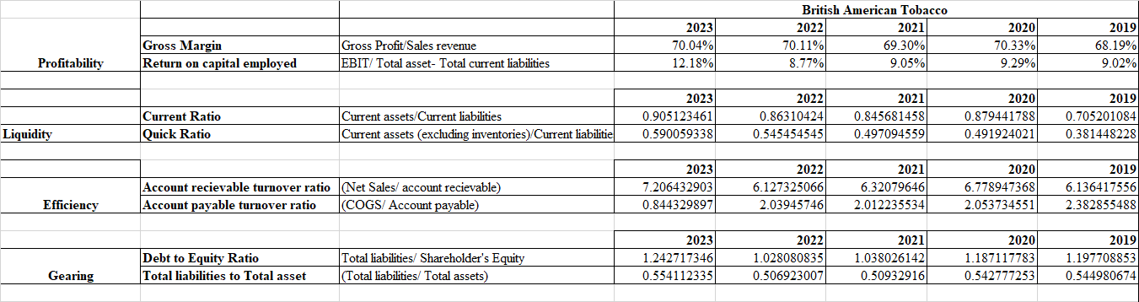
Figure 6: Ratios of BAT
(Source: Self-Developed)
The ROCE is also an essential ratio for comparison in the performance of all the companies in the tobacco industry. In 2023, the ratio of the BAT was 12.18%. This year, the ratio of the imperial brand was 19.62%, which was improved from the last 4 years. The ratio of Philips is higher compared to the other two competitors which was 36.39%. However, the ratio of Philip declined in 2022 and 2023. The management of the Philip company is using the capital to generate profit from the business very efficiently (WSJ 2023). The management of BAT and the imperial brand should focus on improving the EBIT for the ratio.
The CR has been compared for evaluating the financial stability of the company in the market. In 2023, the ratio of the BAT was 0.90, which was improved from 2022. The ratio of the company was 0.86 in 2022. The ratio of the imperial brand in 2023 was 0.72 which was decreasing compared to 2022. In 2019, the ratio of the organisation was 0.89 which was excellent in this industry. The company has to introduce multiple decisions for improving the ratio to maintain financial stability (WSJ 2023). The ratio of the PMI in 2020 was 1.09, which maintained the industrial standard. However, in the next few years, the ratio started to decline. In 2023, the ratio of the company was 0.74.
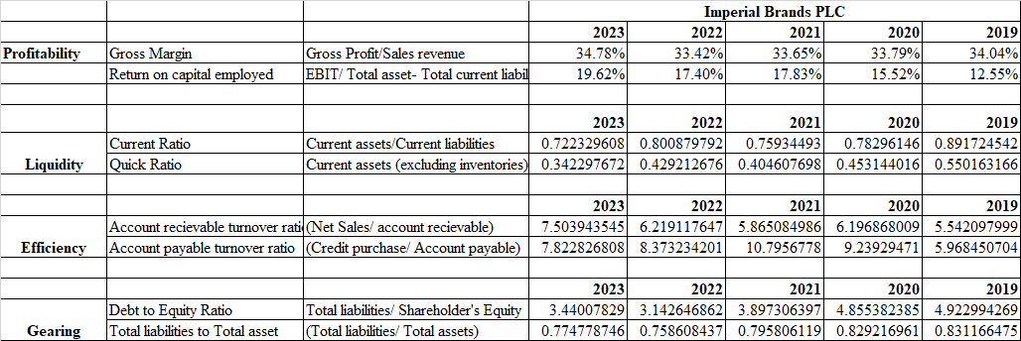
Figure 7: Ratios of Imperial Brand
(Source: Self-Developed)
The QR also has an effective liquidity ratio which has been evaluated by excluding the inventory of the company. The ratio of the BAT company in 2023 was 0.59, which was improved compared to the last years. The ratio of the imperial brand in 2019 was 0.55 which continuously declined. In 2023, the ratio of the company was 0.34 (WSJ 2023). It has been available that the company is constantly increasing its inventory to manage the manufacturing flow of the business. The ratio of the PMI in 20-19 was 0.59. In the following year, the ratio improved to 0.60. However, in the last year, the ratio of the company was 0.34. The organisation has to improve this ratio by reducing the inventory and increasing the other current assets of the company.
The ART is also an important efficiency ratio which can be introduced for understanding the management capability for controlling the operations of the business. The ratio of the BAT company improved in 2023 which was 7.20. The management is collecting money from the debtors more quickly than in the past years. The ratio of the imperial brand was slightly better in 2023, which was 7.50. The organisation enhances the efficiency of collecting money from the debtor’s day by day (WSJ 2023). The ratio of the PMI in 2023 was 7.98. The overall comparison defines that all the companies are collecting money at almost the same frequency and introduced in the business for managing different operations.
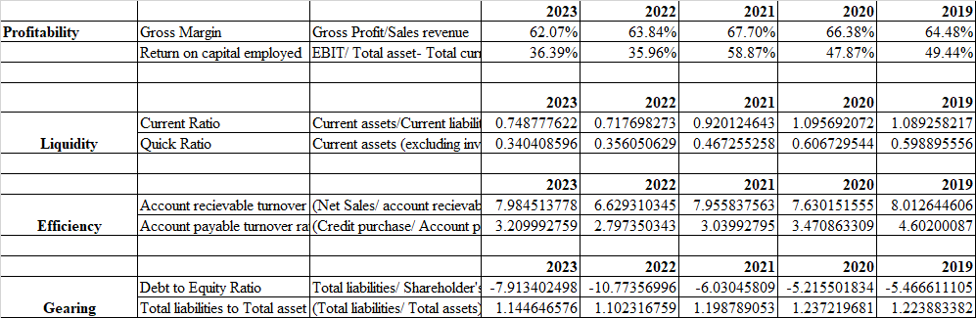
Figure 8: Ratios of PMI
(Source: Self-Developed)
The APT will be compared to understand the relationship with the editors of different companies. The ratio of the BAT in 2019 was 2.38. in 2023, the ratio reduced to 0.84. the ratio of the imperial brand in 2022 was 8.37, which declined from 2021. In the previous year, the ratio of the organisation was 7.82. it defines that the organisation is quickly paying the creditors to maintain a healthy relationship. In 2023, the ratio of the PMI was 3.20, which was improved from 2022. The company should pay more to the creditors and improve this ratio which can help to get the money from different creators.
The debt-to-equity ratio is a crucial part of the gearing ratio and understanding the different risks of the business over time. The ratio of the BAT company in 2023 was 1.2. This means that the organisation is using the same debt and equity for developing the capital structure. The ratio of the imperial brand is higher compared to the BAT. The ratio of the imperial brand in 2023 was 3.44 which was reduced from 2020. It defines that the company is reducing the debt to manage the overall business operation (WSJ 2023). However, the ratio of the PMI is negative. It defines that the liabilities of the company are higher compared to the assets of the business. The risk is very high for investing in the PMI company.
The total liabilities to assets ratio helps to determine the financial stability of the business in this tobacco industry. The ratio of BAT every year is almost the same, which was 0.5. the ratio of the imperial grand is 0.77 in 2023, which declined from the previous year. It defines that the management reduced the current liabilities and created a direct impact on the ratio of the business (WSJ 2023). However, the ratio of the PMI is higher from the other company which was more than one. The investment in the company is very risky as the management is holding huge liabilities.
The overall analysis defines that the condition of the BAT is better compared to the imperial brand and PMI.

Recommendations
The recommendations of the study for British American Tobacco are fostered for the improvement of its different forms of ratios. In order to improve the probability ratio, the company has focused on managing the overall cost of the business (Kliestik et al., 2020). In order to manage this cost, the company has controlled the industry by focusing on developing sustainable cigarettes. Most of the revenue of British American Tobacco comes from UK and US markets. In this regard, the company should focus on following the regulatory practices of the business markets. The company should also focus on the development of new forms of products for British American Tobacco. In order to increase the current ratio of British American Tobacco, the administrative members of the company should introduce different forms of strategies. Therefore, the debt-to-asset ratio of the company has become stable in the last five years. However, the account payables and receivables of the company stayed on the fluctuation between 7 in 2023 and 6 in the previous four years of 2022, 2021, 2020 and 2019.
In order to improve the current ratio of the company, the company should focus on a different process to manage its debt efficiently (DAHIYAT, Weshah, and Aldahiyat, 2021). In this regard, the company has to improve its asset management capability. This process can become a significant part of improving the current ratio of the businesses. In this regard, the management of the company should also focus on increasing the current assets of the firm. In the past, British American Tobacco has focused on reducing its expenses on the manufacturing of tobacco and focusing its operational change to deliver a sustainable solution. In order to achieve this aspect, British American Tobacco has to optimise its cash flow to boost the overall revenue.
In order to improve the ARR of British American Tobacco, the company may have to revise the previous invoice of the transactions that are manned on a regular and accurate basis. The process of managing regular invoices British American Tobacco can maintain the overall process of the calculation along with the reduction of human errors. Apart from this, to maintain and improve the payable ratios of the company, British American Tobacco can develop a suitable relationship with multiple suppliers (Darshna, 2020). In order to manage this task effectively, British American Tobacco should pay regularly to the creditors and manage the payment schedules.

Part C: Investment Appraisal

Result Evaluation
The evaluation of the results demonstrates Project 1 and Project 2. However, the effectiveness of the project is represented and compared with the condition of considering different forms of financial metrics (Olayinka, 2022). From the calculation aspect, it can be described that the payback period for Project 1 is 2.18 years. In comparison, project 2 has demonstrated that the payback period is 3 years. In this aspect, it is clear that Project 1 has a shorter payback period, which is different from Project 2. In this regard, project 1 is highly preferable for British American Tobacco since it can reduce the chances of the financial risk which can occur to the organisation. It can also allow the organisation to reinvest the extracted profit within the projects represented over the capital.
Along with that, the shorter payback period for Project 1 demonstrates that the company is able to improve its liquidity factors and minimise its exposures towards the chances of losses due to the dynamic changes in the market conditions (Mohammad et al., 2020). In this regard, the swift recovery of the capital employed is presented over the high number of advantages for British American Tobacco. This statement has occurred due to experiencing short term restrictions over the cash flow for the company if it faces any neediness related to the capital deployment. Focusing on Project 1 may help to improve the financial stability of the firms as it takes less time for the capital employee. This process can also increase the investor’s confidence to invest in the company.
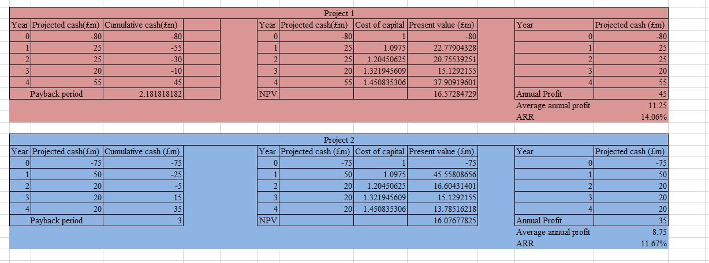
Figure 9: Investment Appraisal of British American Tobacco
(Source: Self-Developed)
Establishing the statement over the present net present value of British American Tobacco. It can be demonstrated that investors may experience a return of £16.57 million for Project 1 as well as £16.07 million for Project 2. In this aspect, Project 1 demonstrates that it has a higher net present value, and it can be preferable to select for the retail investors. The higher level of net present value for the company demonstrates that it will add to the overall valuation of the company (Kadim, Sunardi, and Husain, 2020). Also, it is crucial for the long-term growth of the organisation. Therefore, choosing Project 1 can extend the profits earned from the overall project, and it will improve the financial performance of the company.
In order to focus on the accounting rate of return, it is demonstrated that Project 1 has an ARR of 14.06%, compared to the ARR of Project 2, demonstrated over 11.67%. In this aspect, the higher rate of ARR for Project 1 compared with Project 2 demonstrates that Project 1 has superior profit-earning capabilities. Thus, it can be suggested that the company will be able to generate higher amounts of profits, which are connected to their higher efficiency in the utilisation of capital employed (Anton, and Afloarei Nucu, 2020). This process can enhance British American Tobacco’s profitability towards higher reinvestment rates along with robust competitive positioning. Thus, the adoption of Project 1 for the British Tobacco Company is highly recommended as it commits to delivering a quicker payback along with increased annual profitability.

Advantages and disadvantages of Payback Period, ARR and NPV
Payback Period (PBP)
The payback period for the companies calculates the time required for an investment to generate cash flow sufficiently to recover the initial expenses for the company (Olaniyi and Prause, 2020). It is a straightforward and easy-to-understand measure which can provide quick insights into the liquidity and risk associated with a financial project.
Advantages: The advantage of the Payback Period is having an excessive level of simplicity and clarity (Riayatsyah et al., 2022). The Payback Period method is highly straightforward, and it makes a more accessible option for British American Tobacco's management to apply for the retail investors. It requires less financial expertise, which can be demonstrated over facilitated decision-making. Then the second advantage is the risk assessment; the Payback Period is highly useful for assessing the liquidity risk of an investment, specifically in highly volatile markets. In these markets, a shorter Payback Period can be desirable, as it implies quicker recovery of the investment and reduced exposure to market risks.
Disadvantages: The main disadvantage of having a payback period is the limitation of not considering the value of time and money (Dai et al., 2022) for a company such as British American Tobacco, which invests in long-term projects with future cash flow. The ignorance of the time value of money can lead to misleading the assessment of the project's actual values. The next disadvantage is the lack of profitability insights about how to recover the initial investment.
Accounting Rate of Return (ARR)
The accounting rate of return refers to comparing the average annual accounting of British American Tobacco to the initial investment cost (Alayli, 2023). It can be presented over the percentage and reflect on the profitability of a project from the accounting perspective.
Advantages: The advantages of the ARR refer to simplicity and familiarity and it is straightforward to understand and calculate (Akaishi et al., 2022). It is highly accessible to managers without advanced financial training. Furthermore, it is based on accounting information that is readily available in British American Tobacco's economic systems. The second advantage of the ARR is that it aligns with the financial reporting standards, providing a measure of profitability that can be compared to British American Tobacco's overall return on assets. This process can help the organisation with targeting and assessing the relative profitability of the different projects.
Disadvantages: The disadvantages of the ARR are demonstrated by not considering the time value and money which are generated for a project (Bagheri Khoulenjani, Talebi, and Karim Zadeh, 2024). This may lead to the misinterpretation of the project's primary economic value, specifically for British American Tobacco's long-term investments. However, ARE highly relies on the accounting profits which can be demonstrated over the non-cash products such as the depreciation. For British American Tobacco, this process results in the distortion of the perceived profitability of a project, specifically in industries which require a higher capital investment.
Net Present Value (NPV)
Net Present Value is a discounted cash flow method that calculates the present value along with the future cash flows generated by an investment, deducting the initial investment cost (Shou, 2022). It considers the time value of money and provides a comprehensive measure of a project’s profitability of British American Tobacco.
Advantages: It highly considers the value of time and money, providing an accurate measure of a project’s value over time. This process is essential for British American Tobacco, which often deals with long-term investments in markets with varying economic conditions. Next, focusing on cash flows, The NPV evaluates the actual cash flows generated by a project, offering a realistic view of its profitability (Kipkirui and Kimungunyi, 2022). This process is highly crucial for British American Tobacco, as it aligns with the company's focus on cash flow management and financial sustainability.
Disadvantages: NPV is more complex to calculate and understand compared to PBP and ARR (Siziba and Hall, 2021). This might require more enhanced financial analysis and could be challenging for managers who are less familiar with discounted cash flow measures. Moreover, NPV is highly sensitive to the discount rate used for British American Tobacco. Nevertheless, NPV determining the appropriate discount rate can be difficult, especially in uncertain regulatory environments or volatile markets.

Consideration of Non-Financial Factors
In investment decision-making, the financial metrics are highly critical for British American Tobacco. In this section, the study will demonstrate the non-financial aspects of the company, focusing on the regulatory impact, brand reputation and alignment with the sustainability goals.
Regulatory Impact: The regulatory environments for British American Tobacco in both of the markets, including the US and UK, are concerned with the manufacturing and distribution of tobacco-based products. In the UK, the regulations for tobacco are applied in the name of 'Tobacco and Related Products Regulations 2016" (Stead et al., 2021). This practice imposes stringent advertising restrictions, which highly impact British American Tobacco's overall operations. Apart from the UK, in the US, the Food and Drug Administration focused on tight control over tobacco product marketing, labelling and distribution (Hatsukami and Carroll, 2020).
Brand Reputation: Brand reputation is another crucial non-financial factor for British American Tobacco. It highly emphasises the markets with higher public health awareness. In this regard, British American Tobacco’s investments in new products, mainly Next-Generation Products (NGPs) like vaping devices, must align with efforts to enhance its brand image as a responsible and forward-looking company (van Buuren, 2022). Nevertheless, the negative public perception of harmful products can damage brand equity. This may lead to reduced customer loyalty. Along with that, investors should consider how investment decisions will impact British American Tobacco’s brand reputation, particularly in markets where consumer sentiment heavily influences purchasing behaviour.
Strategic Evaluation: British American Tobacco’s commitment to strategic evaluation includes reducing carbon emissions and promoting sustainable farming practices (Geist, 2021). It must be reflected in its investment strategies. However, the investors should evaluate whether the proposed investments align with British American Tobacco’s long-term sustainability goals. In this regard, the projects that enhance sustainability contribute to positive social and environmental outcomes along with reducing regulatory risks. Additionally, it improves the company’s attractiveness to ESG-focused investors.
Employee Satisfaction: As of 2024, British American Tobacco has been recognised as the Top Global Employer for the seventh consecutive year by the top employee institute. The company has been named the top employer in Africa, Asia Pacific, the Middle East, Latin America, North America and Europe (BAT, 2024).

Conclusion
The study covered a ratio analysis along with explaining the overall background of British American Tobacco, a tobacco manufacturing company. The company mainly operates in the UK and US. Recently, the company has focused on transforming its business towards developing and supplying cigarettes which are sustainable. On the global aspect, the advertisement of tobacco-based products is prohibited as it concerns a high amount of health concerns. In order to mitigate this challenge, the study has demonstrated the financial management of the company by showing the last five years' financial performance. After that, the study discussed investment appraisal methods to know about their advantages and disadvantages for British American Tobacco.

Reference List
Akaishi, T., Ishii, T., Aoki, M. and Nakashima, I., (2022). Calculating and comparing the annualised relapse rate and estimating the confidence interval in relapsing neurological diseases. Frontiers in Neurology, 13, p.875456. https://www.frontiersin.org/articles/10.3389/fneur.2022.875456/pdf
Alayli, S., (2023). The impact of capital budgeting practices on the financial performance of Lebanese banks. The EUrASEANs: journal on global socio-economic dynamics, (1 (38)), pp.29-39. https://euraseans.com/index.php/journal/article/download/401/420
Anton, S.G. and Afloarei Nucu, A.E., (2020). The impact of working capital management on firm profitability: Empirical evidence from the Polish listed firms. Journal of risk and financial management, 14(1), p.9. https://www.mdpi.com/1911-8074/14/1/9/pdf
Bagheri Khoulenjani, A., Talebi, M. and Karim Zadeh, E., (2024). Feasibility Study for Construction Projects in Uncertainty Environment with Optimization Approach. International journal of sustainable applied science and engineering, 1(1), pp.1-15. https://bgsiran.ir/journal/ojs-3.1.1-4/index.php/IJSASE/article/download/103/84
BAT (2024). British American Tobacco - Life at BAT. [online] Bat.com. Available at: https://www.bat.com/who-we-are/our-people/life-at-bat#:~:text=In%20January%202024%2C%20we%20were [Accessed 10 Aug. 2024].
BAT (2024). British American Tobacco Caribbean - British American Tobacco Group. [online] www.batcaribbean.com. Available at: https://www.batcaribbean.com/DOBTXKRD.html#:~:text=BAT%20is%20a%20leading%2C%20multi.
BAT (2024a). British American Tobacco - Jul 25 - BAT Completes Acquisition of Reynolds. [online] www.bat.com. Available at: https://www.bat.com/media/press-releases/_2017/july/Jul_25-BAT_Completes_Acquisition_of_Reynolds.
‌Binsaddig, R., Ali, A., Al-Alkawi, T., and Ali, B. J. (2023). Inventory Turnover, Accounts Receivable Turnover, and Manufacturing Profitability: An Empirical Study. International Journal of Economics and Finance Studies, 15(1), 1-16. https://agbioforum.org/sobiad.org/menuscript/index.php/ijefs/article/download/1394/314
DAHIYAT, A.A., Weshah, S.R. and Aldahiyat, M., (2021). Liquidity and solvency management and its impact on financial performance: Empirical evidence from Jordan. The Journal of Asian Finance, Economics and Business, 8(5), pp.135-141. https://koreascience.kr/article/JAKO202112748674891.pdf
Dai, H., Li, N., Wang, Y. and Zhao, X., (2022), March. The analysis of three main investment criteria: NPV IRR and payback period. In 2022 7th International Conference on Financial Innovation and Economic Development (ICFIED 2022) (pp. 185-189). Atlantis Press. https://www.atlantis-press.com/article/125971510.pdf
Darshna, D.K.P., (2020). Impact of foreign exchange rate movements on company profitability in the tobacco sector. A case study of the British American Tobacco Kenya limited. https://su-plus.strathmore.edu/bitstream/handle/11071/12667/Impact%20of%20foreign%20exchange%20rate%20movements%20on%20company%20profitability%20in%20the%20tobacco%20sector.%20A%20case%20study%20of%20the%20British%20American%20Tobacco%20Kenya%20limited...pdf?sequence=1
Flor, L.S., Reitsma, M.B., Gupta, V., Ng, M. and Gakidou, E., (2021). The effects of tobacco control policies on global smoking prevalence. Nature Medicine, 27(2), pp.239-243. https://www.nature.com/articles/s41591-020-01210-8.pdf
Geist, H.J., (2021). Tobacco and deforestation revisited. How to move towards a global land-use transition?. Sustainability, 13(16), p.9242. https://www.mdpi.com/2071-1050/13/16/9242/pdf
Hardie, L.F., (2023). E-cigarette Marketing and Policy in New Zealand (Doctoral dissertation, ResearchSpace@ Auckland). https://researchspace.auckland.ac.nz/bitstream/handle/2292/66344/Hardie-2023-thesis.pdf?sequence=4&isAllowed=y
Hatsukami, D.K. and Carroll, D.M., (2020). Tobacco harm reduction: past history, current controversies and a proposed approach for the future. Preventive medicine, 140, p.106099. https://www.ncbi.nlm.nih.gov/pmc/articles/PMC7581601/
Investopedia. (2024). Equity Financing vs. Debt Financing: What’s the Difference? [online] Available at: https://www.investopedia.com/ask/answers/042215/what-are-benefits-company-using-equity-financing-vs-debt-financing.asp [Accessed 10 Aug. 2024].
Investopedia. (2024). How Useful Is ROCE As an Indicator of a Company’s Performance? [online] Available at: https://www.investopedia.com/ask/answers/011315/how-useful-roce-indicator-companys-performance.asp [Accessed 10 Aug. 2024].
Kadim, A., Sunardi, N. and Husain, T., (2020). The modeling firm's value based on financial ratios, intellectual capital and dividend policy. Accounting, 6(5), pp.859-870. http://m.growingscience.com/ac/Vol6/ac_2020_48.pdf
Kipkirui, L.P. and Kimungunyi, S., (2022). Effect Of Net Present Value Investment Appraisal Practice On Financial Performance Of Cement Manufacturing Firms In Kenya. International Research Journal of Economics and Finance, 4(2). https://www.irjp.org/index.php/IRJEF/article/viewFile/79/99
Kliestik, T., Valaskova, K., Lazaroiu, G., Kovacova, M. and Vrbka, J., (2020). Remaining financially healthy and competitive: The role of financial predictors. Journal of Competitiveness, (1). https://pdfs.semanticscholar.org/5400/0fcd811eb1a5259be85f9ce9d03d9c24a15c.pdf
‌Markonah, M., Salim, A., and Franciska, J. (2020). Effect of profitability, leverage, and liquidity to the firm value. Dinasti International Journal of Economics, Finance and Accounting, 1(1), 83-94. https://dinastipub.org/DIJEFA/article/download/225/164
Mohammad, S., Asutay, M., Dixon, R. and Platonova, E., (2020). Liquidity risk exposure and its determinants in the banking sector: A comparative analysis between Islamic, conventional and hybrid banks. Journal of International Financial Markets, Institutions and Money, 66, p.101196. https://durham-repository.worktribe.com/preview/1273092/30597.pdf
Nariswari, T. N., and Nugraha, N. M. (2020). Profit growth: impact of net profit margin, gross profit margin and total assests turnover. International Journal of Finance and Banking Studies (2147-4486), 9(4), 87-96. https://www.ssbfnet.com/ojs/index.php/ijfbs/article/download/937/712
Novyarni, N., and Permana, R. Y. (2020, March). Effect of Current Ratio, Return on Asset, Net Profit Margin and Debt to Equity Ratio on Dividend Pay Out Ratio (For company listed in the LQ45 on Indonesian Stock Exchange). In Annual International Conference on Accounting Research (AICAR 2019) (pp. 41-45). Atlantis Press. https://www.atlantis-press.com/article/125936028.pdf
Olaniyi, E.O. and Prause, G., (2020). Investment analysis of waste heat recovery system installations on ships’ engines. Journal of Marine Science and Engineering, 8(10), p.811. https://www.mdpi.com/2077-1312/8/10/811/pdf
Olayinka, A.A., (2022). Financial statement analysis as a tool for investment decisions and assessment of companies’ performance. International Journal of Financial, Accounting, and Management, 4(1), pp.49-66. https://goodwoodpub.com/index.php/ijfam/article/download/852/289
Pratama, A. Z., Sutopo, W., and Rochani, R. (2022). Financial performance analysis and business strategy using profitability ratio analysis: A case study. Proceedings of the 3rd Asia Pacific International Conferenc on Industrial Engineering and Operations Management (hal. 1266-1273). Johor Bahru, Malaysia: IEOM Society. https://doi. org/10.46254/AP03, 20220238. http://ieomsociety.org/proceedings/2022malaysia/238.pdf
Riayatsyah, T.M.I., Geumpana, T.A., Fattah, I.R., Rizal, S. and Mahlia, T.I., (2022). Techno-economic analysis and optimisation of campus grid-connected hybrid renewable energy system using HOMER grid. Sustainability, 14(13), p.7735. https://www.mdpi.com/2071-1050/14/13/7735/pdf
Sari, W. N., Novari, E., Fitri, Y. S., and Nasution, A. I. (2022). Effect of Current Ratio (Cr), Quick Ratio (Qr), Debt To Asset Ratio (Dar) and Debt To Equity Ratio (Der) on Return On Assets (Roa). Journal of Islamic Economics and Business, 2(1), 42-58. https://journal.uinsgd.ac.id/index.php/jieb/article/download/20173/7770
Shou, T., (2022), July. A literature review on the net present value (NPV) valuation method. In 2022 2nd International Conference on Enterprise Management and Economic Development (ICEMED 2022) (pp. 826-830). Atlantis Press. https://www.atlantis-press.com/article/125975449.pdf
Sircar, N.R. and Bialous, S.A., (2024). Tobacco industry’s human rights makeover: an archival review of British American Tobacco’s human rights rhetorical veneer. Tobacco control, 33(1), pp.67-73. https://escholarship.org/content/qt96g6f4h6/qt96g6f4h6_noSplash_6ad51fd93f38ea0e4f03c99275c3325a.pdf
Siziba, S. and Hall, J.H., (2021). The evolution of the application of capital budgeting techniques in enterprises. Global finance journal, 47, p.100504. https://repository.up.ac.za/bitstream/handle/2263/74586/Siziba_Evolution_2020.pdf?sequence=1
Stead, M., Hitchman, S.C., Angus, K., Aleyan, S., Ford, A., MacKintosh, A.M., Purves, R., Mitchell, D., Hammond, D., Fong, G.T. and Driezen, P., (2021). E-cigarette marketing in the UK: Evidence from adult and youth surveys and policy compliance studies. https://www.storre.stir.ac.uk/bitstream/1893/32971/1/e-cigarette_marketing_in_the_uk_-_full_report_march_2021.pdf
Team, C. (2023). Efficiency Ratios. [online] Corporate Finance Institute. Available at: https://corporatefinanceinstitute.com/resources/accounting/efficiency-ratios/ [Accessed 10 Aug. 2024].
van Buuren, A., (2022). How Philip Morris manages disruptive regulations and what other industries can learn from them (Doctoral dissertation). https://repositorio.ucp.pt/bitstream/10400.14/41060/1/203133129.pdf
www.wsj.com. ((2023). IMB.UK | Imperial Brands PLC Annual Balance Sheet - WSJ. [online] Available at: https://www.wsj.com/market-data/quotes/UK/IMB/financials/annual/balance-sheet .
‌www.wsj.com. (2023) PM | Philip Morris International Inc. Annual Income Statement - WSJ. [online] Available at: https://www.wsj.com/market-data/quotes/PM/financials/annual/income-statement .
www.wsj.com. (2023). BTI | British American Tobacco PLC ADR Annual Income Statement - WSJ. [online] Available at: https://www.wsj.com/market-data/quotes/BTI/financials/annual/income-statement .
www.wsj.com. (2023). BTI | British American Tobacco PLC ADR Annual Balance Sheet - WSJ. [online] Available at: https://www.wsj.com/market-data/quotes/BTI/financials/annual/balance-sheet .
www.wsj.com. (2023). PM | Philip Morris International Inc. Annual Balance Sheet - WSJ. [online] Available at: https://www.wsj.com/market-data/quotes/PM/financials/annual/balance-sheet
www.wsj.com. (2023.). IMB.UK | Imperial Brands PLC Annual Income Statement - WSJ. [online] Available at: https://www.wsj.com/market data/quotes/UK/IMB/financials/annual/income-statement
‌

Appendix
British American Tobacco
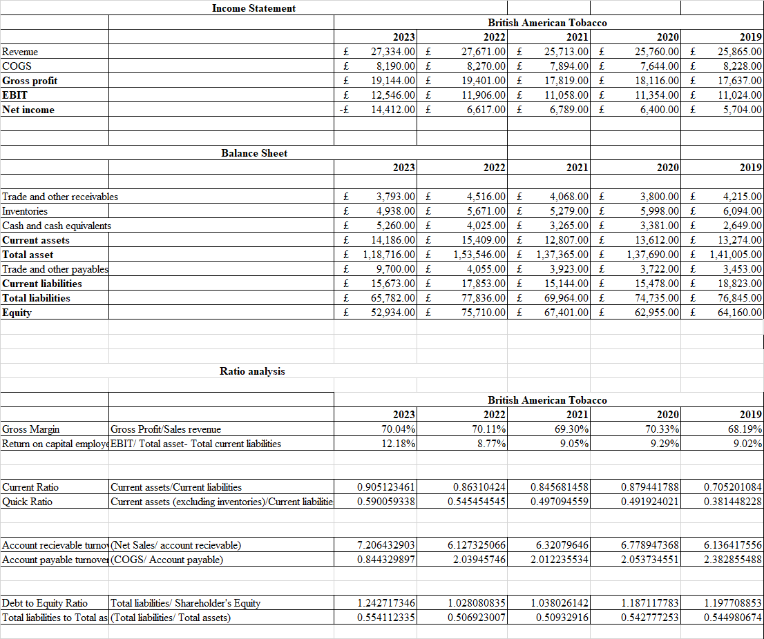

Imperial Brands Plc
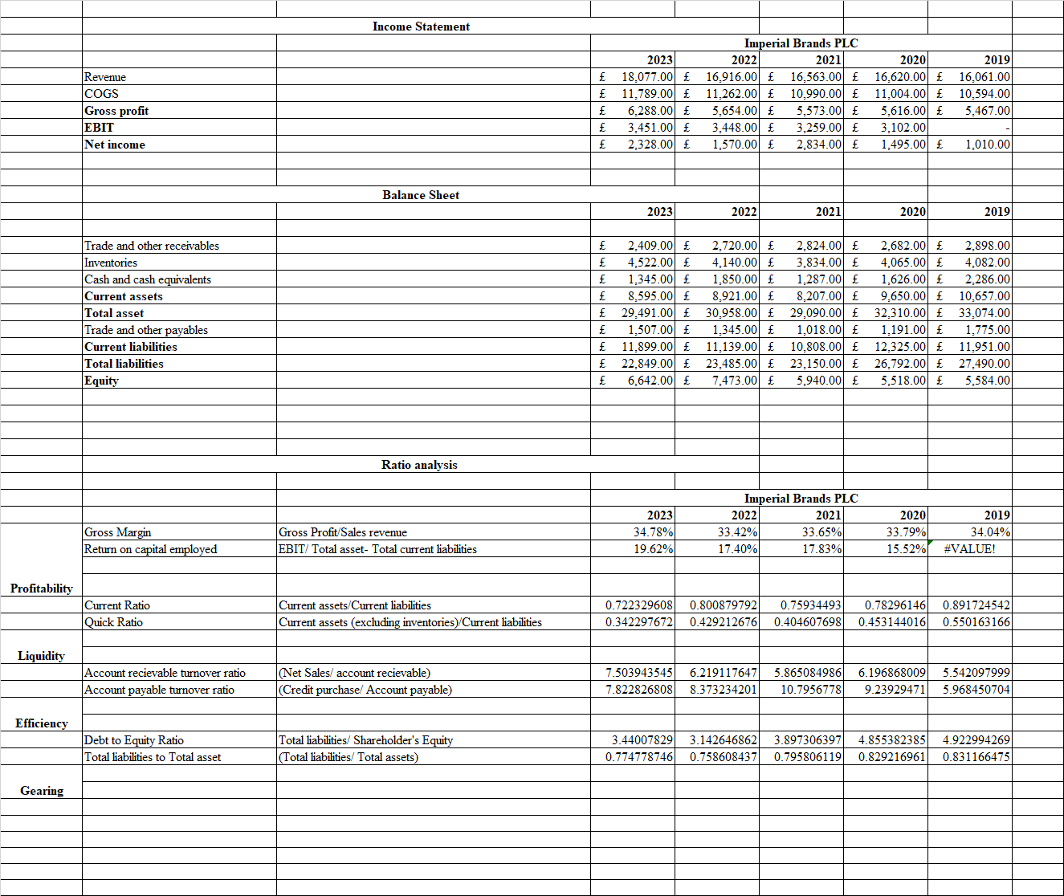

Philip Morris International Inc.


