

BSc Health and Social Care

Module: Mental Disorder and Psychopathology
Module code: BMHP6006
Lecturer: Bianca Sanfilippo
Student: Aniko Balogh 2018980

Debate and Supporting Paper

Table of content:

- Introduction 3
- Causes 3
- Diagnosis 3
- History and past treatment 4
- Current treatment 4
- Recommendation for improvement 5
- Conclusion 5
- Appendix 6-9
- References 10

Introduction:
I have identified disorders of psychological development F80-84; this report will discuss Autism which is F-84. The definition within the ICD-10 is “A group of disorders characterised by qualitative abnormalities in reciprocal social interactions and patterns of communication and by a restricted, stereotyped, repetitive repertoire of interests and activities. These qualitative abnormalities are pervasive in the individual's functioning in all situations.” (ICD-10, 2010) It is classified as a Mental and behaviour disorder under Chapter V.
Autism is a lifelong spectrum disorder that affects the ability to communicate and interact with the world.
More the one in 100 people has autism spectrum disorder in the UK, adults and children. Still, this date is only an estimated number as many are waiting to be also diagnosed; many do not even know they are suffering from this disorder. (The National Autistic Society, 2023)
Qatar has the highest rate of diagnosed people, and France has the lowest number of people diagnosed with Autism. (Schiller, 2022)

Causes
Causes are still unclear, but anyone can be affected by autism spectrum disorder; some factors can increase the possibility. For example, if an older parent gives birth, has infections during pregnancy or has a difficult birth, beyond those factors, some people are at higher risk. Men are four times more likely to suffer from autism spectrum disorder. Beyond this, family history of other conditions is essential to know as that can also affect the possibilities. For example, if someone has in their family a learning disorder, intellectual disability, or attention-deficit Hyperactivity disorder (ADHA). Also, people who already have an existing disorder such as X syndrome or Down syndrome are more likely to have Autism as well. (Centre of disease control and Prevention, 2022)
Symptoms and signs
Signs can show as early as 18 months, but reliable diagnoses will happen around the age of two or three. The symptoms in children can be, Issues with communication, the child preferring to be alone, will not respond to their name, trouble understanding what others feel and repetitive movements.
Diagnosis:
If parents can identify any of the symptoms, they will need to contact their GP or health visitor, who will carry out a ‘screening interview’ called M-CHAT (Modified Checklist for Autism in Toddlers). If positive, they will refer the child to a developmental specialist. (NHS,2022)
The developmental specialist will conduct more formal assessments of the child, including a speech and language therapist, a paediatrician and a specialist psychologist. (National Autistic Society, 2023)
History and past treatment
Dr Leo Kenner observed children who were thought to have mental retardation and identified that those children had behaviour patterns that were common in all of them. At around the same time, he (Dr Kenner) received a letter from the father of Donald Gray, an American-born boy whose father wrote about the same symptoms that Dr Kenner identified in the children he was observing. Later in 1943, Donald Grey became the first person in History who was diagnosed with Autism, which he called back at the time “Autistic Disturbances of Affective Contact- ‘infantile autism.” (Fischbach, 2007)
In the beginning, the thought was that Autism happened in a child whose mother was too cold and uncaring, so the child was traumatised and became Autistic; the term refrigerator mum was used to describe those mothers. Parents were shamed to have children with any Psychological disorder; therefore, the children were sent away to live their lives in institutions away from the public eye and society. In those homes, they suffer from abuse and often die younger than they should have.
Autism only in 1960 has been identified as a separate disorder from schizophrenia. And from 1970, it was treated by electroconvulsive therapy, LSD, and behavioural modification techniques (Zaky, 2017)
Current treatment:
Today we know it is not true; thankfully, for the ever-improving Health Care and research, we know it is a disorder that can affect anyone; today, we have many ways to help those with Autism. In November 2009, the government introduced the Autism Act 2009, with the main point being increasing awareness and understanding of autism and developing a clear and consistent pathway for diagnosis. Improving access to the services and support people need to live independently within the community (Legalisation gov, 2009). Get more adults into Employment. There are many organisations that can help the parents of an Autistic child or the Autistic Adult—for example, Child Autism, NHS autism support, and the National autistic society. In addition, children can attend a special need school, or if their parents prefer them to attend a non-special school, then the child will get teacher support only for them. Personal centre care has also become widely accepted for people with developmental disorders. It focuses on the person with the disorder and their individual needs and puts them at the centre of care (SCIE, 2011).

Recommendation for improvement:
There are many people on the waiting list to see a specialist, but there need to be more developmental specialists who could help with the diagnosis process. As awareness grows, the number of people who suspect their loved one, child or even themselves are affected is ever-growing. As there is a scheme to qualify as many Social workers, there could be something similar for becoming a diagnosis specialist. As sooner people get help more likely they can have full, happy lives as anyone else. But without an accurate diagnosis, the depression of the affected people will grow, which will increase different difficulties for the NHS. Another therapy that helps to calm people with autism is Yoga. Research shows the positive effect of practising yoga regularly. Research has shown that after yoga, people, as special children with autism, are a lot calmer and more relaxed (Jyoti, 2019)
Conclusion:
Much research still needs to be done so people who feel different will get an accurate diagnosis and help as soon as possible. Autism is an ever-changing concept; the name is adapted to our newest information as we learn more about it.
Autism, therefore, will be an ever-changing concept, and awareness is really important.
The autism awareness day is the 2nd of April, and the colour is blue.

Appendix
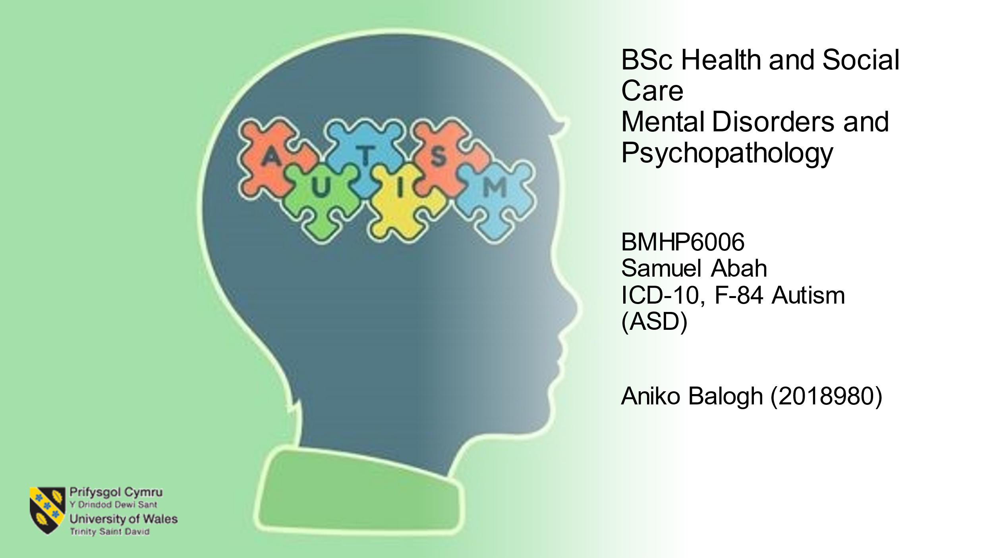

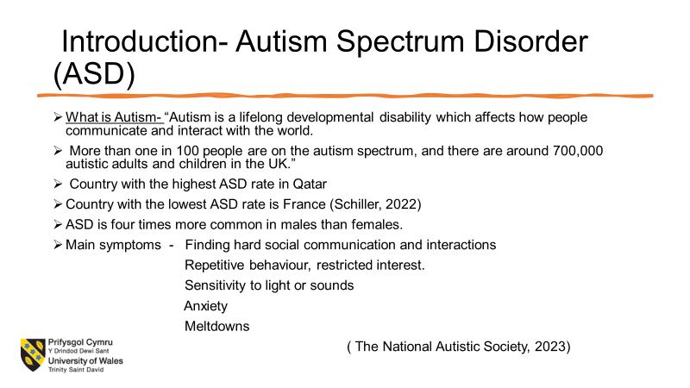

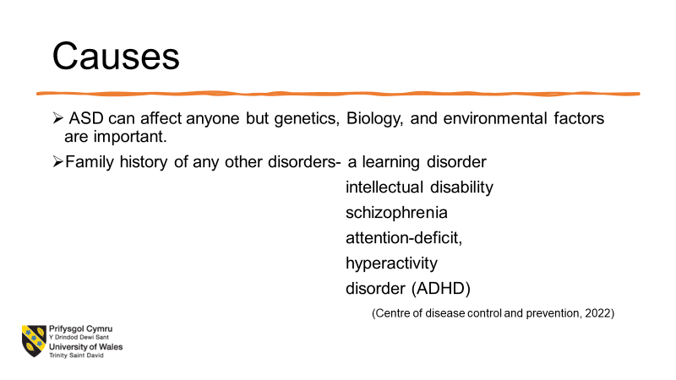
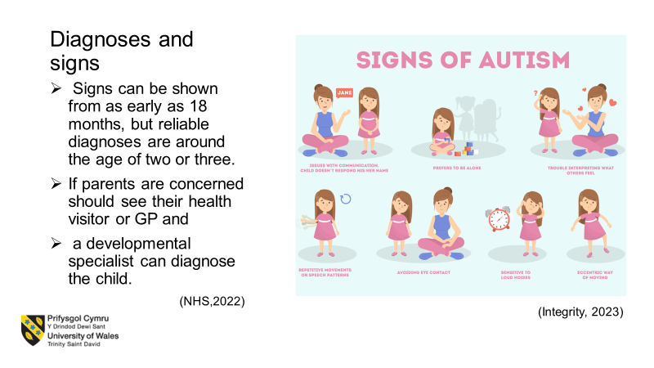

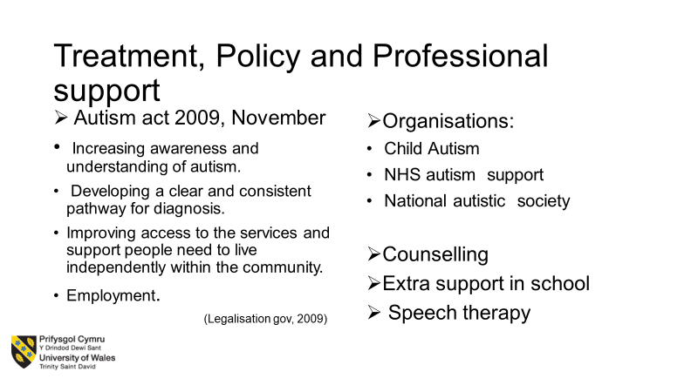
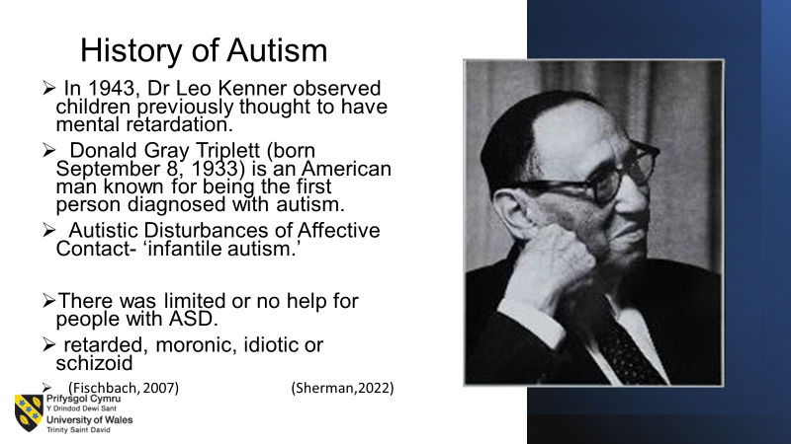

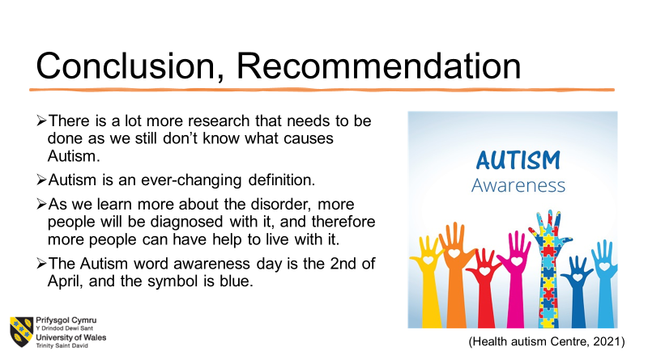
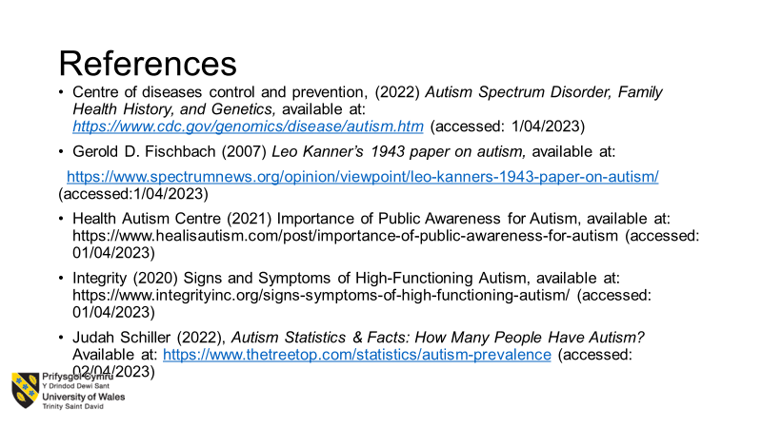

References:
Centre of diseases control and Prevention, (2022) Autism Spectrum Disorder, Family Health History, and Genetics, available at: https://www.cdc.gov/genomics/disease/autism.htm (accessed: 1/04/2023)
Eman Ahmed Zaky (2017) ‘Autism Spectrum Disorder (ASD); The Past, The Present, and The Future’ Journal of Child and Adolescent Behavior, Available at: https://www.omicsonline.org/open-access/autism-spectrum-disorder-asd-the-past-the-present-and-the-future-2375-4494-1000e116.php?aid=88774 (Accessed: 23/04/2023)
Gerould D. Fischbach (2007) Leo Kanner’s 1943 paper on autism, available at: https://www.spectrumnews.org/opinion/viewpoint/leo-kanners-1943-paper-on-autism/ (accessed:1/04/2023)
Judah Schiller (2022), Autism Statistics & Facts: How Many People Have Autism? Available at: https://www.thetreetop.com/statistics/autism-prevalence (accessed: 02/04/2023)
Jyoti Manuel (2029) Using yoga with autistic pupils. Available at: https://www.autism.org.uk/advice-and-guidance/professional-practice/yoga-schools (Accessed:23/04/2023)
National Autistic Society (2023), Pre-diagnosis support - a guide for parents and carers. Available at: https://www.autism.org.uk/advice-and-guidance/topics/diagnosis/pre-diagnosis/parents-and-carers?gclid=Cj0KCQjwla-hBhD7ARIsAM9tQKs3VeK-WNOCecUelSjTSbc2edwZW0s0daFK0NVwp68C7ZfhuA6lrQIaAi5nEALw_wcB (Accessed: 04/04/2023)
National Autistic Society, (2023) What is autism? Available at https://www.autism.org.uk/advice-and-guidance/what-is-autismt:, (accessed: 1/04/2023)
NHS (2022) Signs of autism in children, Available at: https://www.nhs.uk/conditions/autism/signs/children, (accessed: 1/04/2023)
SCIE. (2011) Personalisation: Implications for people with autistic spectrum conditions and their family carers. Available at: https://www.scie.org.uk/personalisation/specific-groups/autistic-spectrum-conditions (Accessed: 23/04/2023)

WHO - World Health Organisation (2010) ICD-10 - International Statistical Classification of Diseases and Related Health Problems 10th Revision. Available at: https://icd.who.int/browse10/2010/en#/V (date accessed: 1 March 2022)

