LA LLAR CATALANA
Business Plan

Programme: Level 4 Higher Business Certificate
Module:LCLM4006
Assignment Title: Business Plan
Student Name: Marita Ioana Pirvu
Student ID: 2508930
Lecturer:
Date: July 2026
Executive Summary
La Llar Catalana is a new independent restaurant located in central Birmingham, UK, dedicated exclusively to serving authentic cuisine from Catalonia and the city of Barcelona. The business is built around three core values: preserving traditional culinary heritage, operating with full environmental sustainability, and actively supporting the local community. This model directly responds to investor preferences, which prioritise ventures that deliver financial returns alongside positive social and environmental impact.

Total startup funding required is £12,500. This is sourced from a £10,000 UK Government Start-Up Loan, £2,000 personal investment from the owner, and £500 from initial opening-week sales. First-month operating costs total £12,000, including £500 allocated to bathroom renovation to ensure compliance with UK health, safety, and accessibility regulations. The business is projected to reach break-even by Month 4, with stable and growing profitability from Month 5 onwards.
- Table of Contents
. Overview of the Business Idea

. Market Research & PESTEL Analysis

. Competitor Analysis & Target Market

. Marketing & Communications Strategy

. Financial Plan

. Risk Management & Future Development

. Reference List
Overview of the Business Idea

Business Name: La Llar Catalana – meaning “The Catalan Home”, designed to convey a warm, welcoming atmosphere where customers feel like guests in a traditional Catalan household.
Legal Structure: Private Limited Company (Ltd). This structure is the most appropriate for a small hospitality startup in the UK, as it separates the owner’s personal assets from business liabilities, limiting financial risk and simplifying tax and regulatory compliance.
Location: Central Birmingham, in close proximity to the university quarter, main train and bus stations, office districts, and residential neighbourhoods. This location ensures high footfall from students, professionals, tourists, and local residents.

Products & Services

The menu focuses entirely on genuine, traditional recipes from Catalonia and Barcelona, prepared using original methods and high-quality ingredients. No pre-made mixes or artificial flavourings are used. The offering includes:

• Tapas & Starters: Pan con tomate (fresh bread rubbed with ripe tomato, extra virgin olive oil, and sea salt), patatas bravas with traditional spicy sauce, calamares a la romana, escalivada (roasted aubergine, peppers, and onions), and butifarra (Catalan pork sausage).

• Main Courses: Suquet de peix (rich fish stew typical of the Barcelona coast), paella de marisco following authentic Catalan preparation, mongetes amb butifarra (white beans with sausage), and fideuà (noodle dish similar to paella, originally from the coastal region).

• Desserts: Crema catalana (the iconic caramelised cream dessert), mel i mató (fresh sheep’s cheese served with honey and walnuts), and seasonal fruit tarts, Coca de llavaneres (a very slim slice of cake with some cream inside and icing sugar on top)

• Drinks: Catalan cava, artisanal vermouth, wines from the Penedès and Priorat regions, and natural, low-sugar soft drinks.

Sustainability & Community Focus

Environmental Responsibility: We source 75% of fresh fruit, vegetables, dairy, and meat from small family farms across the West Midlands. This reduces carbon emissions from long-distance transport and supports local agriculture. We operate a strict zero single-use plastic policy, using only fully compostable packaging and recycled materials. All food waste is separated and sent for industrial composting, and we use energy-efficient ovens, fridges, and LED lighting to lower utility consumption. Imported ingredients such as olive oil, rice, and spices are sourced from certified fair-trade suppliers to ensure ethical production.
Community Support: La Llar Catalana has a formal partnership with Birmingham Central Food Bank to donate all safe, unsold food at the end of each service, reducing waste and helping people facing food insecurity. We host free monthly events including Catalan language taster sessions, cultural talks, and cooking workshops, turning the restaurant into a social space rather than just a place to eat. We also offer a permanent 10% discount to students, NHS staff, emergency workers, and senior citizens, making authentic food accessible to a wider range of people.

Management Structure

The business operates with a lean but skilled team to keep overheads low while maintaining high standards:

• General Manager: Oversees daily operations, financial management, supplier contracts, and compliance with health and safety regulations.

• Head Chef: Trained in traditional Catalan cuisine, responsible for menu design, ingredient quality control, kitchen hygiene, and staff training.

• Front of House Supervisor: Manages table bookings, customer service, rosters, and ensures the dining area meets cleanliness and comfort standards.

• Support Staff: Two part-time waiting staff and one kitchen assistant, employed on flexible contracts to match peak trading hours, reducing labour costs during quieter periods.

Market Research & PESTEL Analysis
PESTEL Framework
• Political: The UK hospitality sector is regulated by the Food Standards Agency (FSA), which sets clear standards for hygiene, labelling, and food safety. Under current post-Brexit trade rules, small-scale imports of food products from the EU follow simplified procedures, making it easier to source authentic staples from Catalonia without excessive costs or delays.

• Economic: Birmingham has the second-largest economy in the UK outside London, with a growing population of over 1.2 million people and more than 80,000 university students. While the cost-of-living crisis has made consumers more price-conscious, independent research shows that customers remain willing to spend 10–15% more on food that is authentic, high-quality, and produced ethically.

• Social: There is a strong and growing trend in the UK towards exploring different cultures through food. Mediterranean diets are widely recognised as healthy and balanced, and interest in regional Spanish and Catalan culture has increased in recent years. Additionally, 68% of UK diners say they actively choose restaurants that demonstrate environmental responsibility and support local communities (Mintel, 2025).

• Technological: Digital tools allow us to operate efficiently with low costs. We will use a cloud-based booking system, social media platforms for marketing, and a digital point-of-sale system to track sales, inventory, and customer preferences. These tools reduce administrative work and allow us to reach customers without expensive traditional advertising.

• Environmental: Climate change and sustainability are now mainstream concerns. By building eco-friendly practices into the business model from day one, we reduce long-term costs such as waste disposal and energy bills, while also meeting the expectations of modern consumers.

• Legal: The business will hold all required licences: food hygiene registration, alcohol licence, public liability insurance, and employer’s liability insurance. The planned bathroom renovation is specifically designed to meet Health & Safety Executive guidelines and Disability Discrimination Act requirements, ensuring accessibility for all customers.

Competitor Analysis

Birmingham has a range of Spanish and Mediterranean restaurants, but almost all offer a general menu covering dishes from across Spain. There is no dedicated Catalan restaurant in the city centre, creating a clear gap in the market. Our main competitors are:

• Chain tapas bars: Offer standardised menus but lack authenticity and community connection.

• Independent Spanish restaurants: Serve generic Iberian dishes, with no focus on Catalan culture or sustainability.

Our Unique Selling Points (USPs) are:

• Exclusive focus on authentic Catalan and Barcelona recipes.

• Full transparency regarding ingredient sourcing and environmental practices.

• Active community involvement and affordable pricing.

• A comfortable, welcoming environment with upgraded facilities.

Target Market

• Students & Young Professionals (18–35): Form the largest group, looking for good value, atmosphere, and new food experiences.

• Local Families & Residents: Prefer independent businesses over large chains and value quality and consistency.

• Cultural Enthusiasts & Expats: Catalan, Spanish, and other European residents looking for familiar, authentic food.

• Tourists & Visitors: People exploring Birmingham who want to try regional, high-quality cuisine.
• ⁠
This positions La Llar Catalana as mid-range, affordable for students, and competitive with other independent restaurants.

Marketing Channels

• Social Media: Instagram and Facebook will be the main platforms, used to share high-quality photos of dishes, behind-the-scenes kitchen content, updates on events, and customer reviews.

• Local Partnerships: Collaborations with universities, language schools, travel agencies, and cultural associations to reach targeted audiences.

• Loyalty Scheme: A simple stamp card offering one free Crema catalana after ten visits, encouraging repeat custom.

• Launch Promotion: 15% discount on all food and drinks for the first two weeks of opening, plus a free small tapa with every main course to attract initial customers and build positive reviews.
- Financial Outlook

• Net cash remaining at end of Month 1: £500, held as a working capital buffer.

• Monthly fixed costs stabilise at approximately £5,360 from Month 2 onwards.

• Average spend per customer is estimated at £17.

• Break-even point: approximately 315 customers per month, which is expected to be achieved by Month 4 as awareness grows.

• Net profit forecast to reach around £2,400 per month from Month 5, which will be reinvested into the business to expand the menu, add new services, and increase marketing reach.
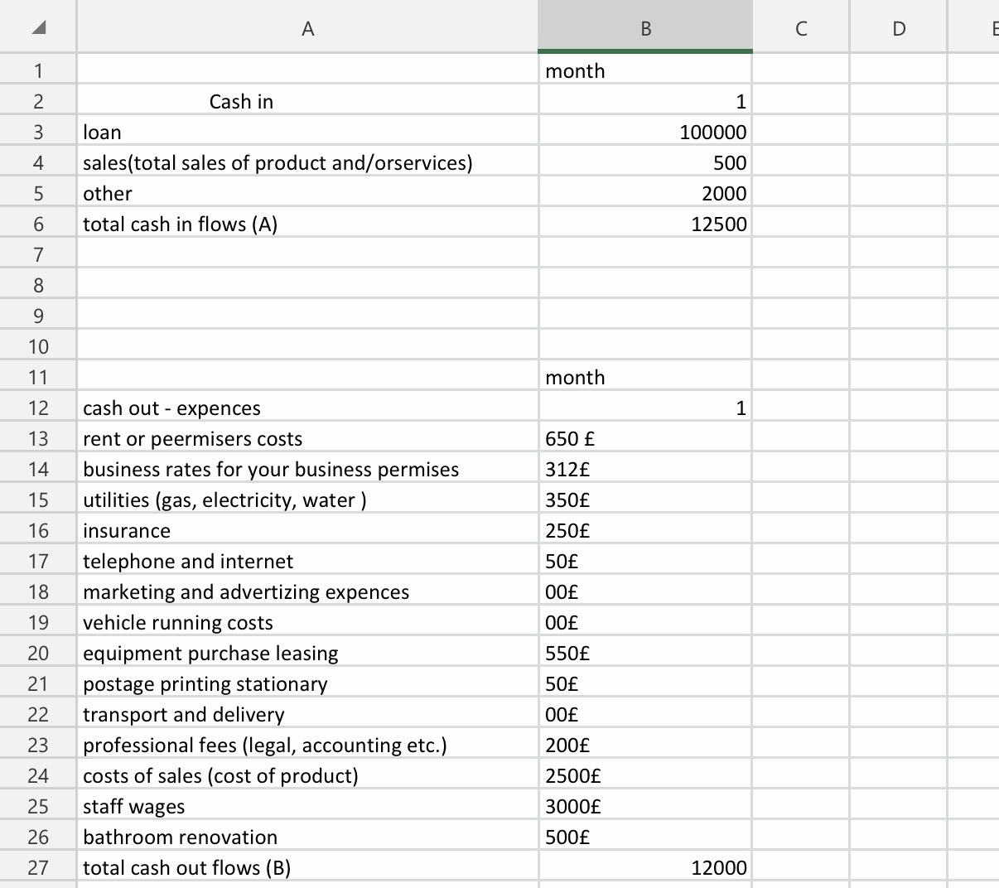
- Risk Management & Future Development

Key Risks & Mitigation

• Low initial footfall: Mitigated by launch offers, social media promotion, and local partnerships.

• Rising ingredient costs: We use fixed-price contracts with local suppliers where possible and adjust menu prices gradually if needed.

• Seasonal fluctuations: We will introduce seasonal dishes and themed events to keep customers coming back throughout the year.

Future Plans

Once the business is profitable, we plan to:

• Expand the menu to include more regional Catalan specialities.

• Introduce a takeaway service using sustainable packaging.

• Host larger events such as Catalan wine and food pairing evenings.

• Create a small retail section selling high-quality olive oil, spices, and sauces
.
• ⁠8. Reference List
• Food Standards Agency (2025). Safer Food Better Business. UK Government.

• IBISWorld (2026). UK Restaurants & Food Service Industry Report.

• Mintel (2025). Dining Out Trends: Authenticity, Sustainability & Value.

• Start Up Loans Company (2026). Guide to Starting a Business.

• Catalan Tourist Board (2025). Gastronomy and Traditions of Catalonia.

