Rubens Malaguti (2501521)
Computer Architecture and Operating Systems: Operating Systems Assignment

Table of Contents
Introduction 2
Task 1: Key functions of general Operating Systems 3
Task 2: Use of Windows OS CLI commands 8
Task 3: Use of Linux OS CLI commands 13
Task 4: Use of Windows OS scripts 19
Task 5: Use of Linux OS scripts 21
Appendices 24
Operating Systems Basics course interaction on Cisco Networking Academy 24
Conclusion 28
References 29

Introduction
The aim of this project will be to research the core purposes of general-purpose Operating Systems and to demonstrate practical, hands-on skills using the Command Line and Scripting to configure systems. The document will first provide a summary of the essential functions of an Operating System; then, it will document step-by-step directions for a number of fundamental activities associated with Windows PowerShell and Linux Bash as they relate to process management, file management, user management, and Task Management. This document will then provide details on scripting capabilities in Windows and Linux environments, illustrating how automation can improve system monitoring and enhance the efficiency of the System Administration process.

Task 1: Key functions of general Operating Systems
General-purpose operating systems such as Microsoft Windows and Linux are the foundation of modern computing. They allow the management of hardware resources while also providing a platform for applications to run efficiently. Some of the core tasks for an operating system include: process management that create, schedule, execute, and terminate processes, memory management that allocates and deallocate memory and uses virtual memory and paging, file system management that manages files and folders on local and network drives, device management which manages all input/output devices, user interface support that provides graphical or other user interface support, networking that supports communication over local or wide area networks, and security that protects the system from unauthorised access [1], [6].
Process management is perhaps the most important task of an operating system. An example of a tool that displays information about running processes in the Windows environment is Task Manager, which provides real-time CPU, memory, and disk usage statistics for applications. In the Linux environment, the top or htop command can be used to display and manage processes. Effective process management provides means for multitasking and provides fair allocation of CPU time for different applications [1].
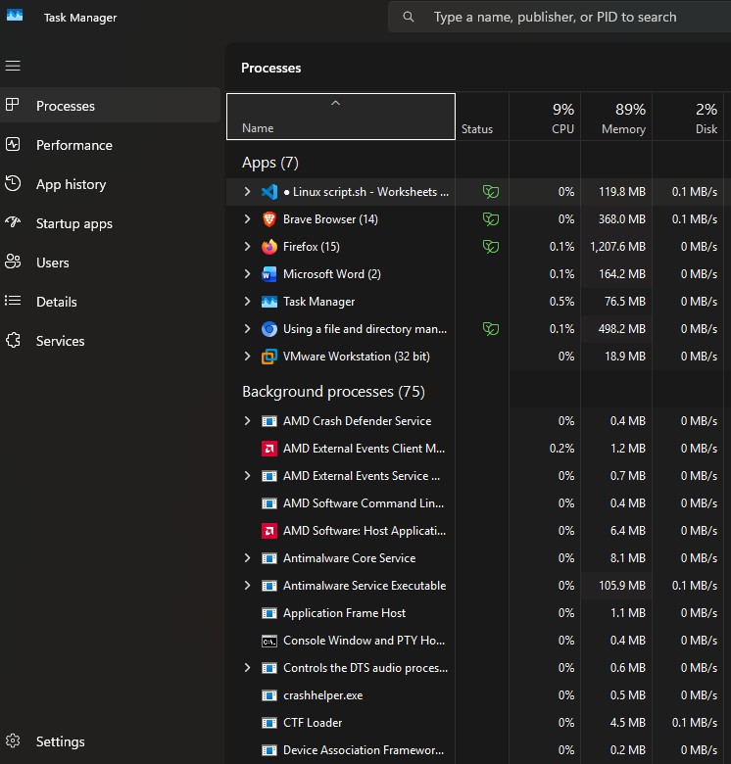
Fig 1 (Windows task manager showing real-time processes management and resource usage)
Memory management in an operating system is necessary to allow multiple applications to run simultaneously without interfering with each other. Both Windows and Linux use advanced memory management systems that allow multiple applications to run at the same time. To monitor memory usage, administrators can use the Windows Resource Monitor and the Linux free -h command, which are shown in the figures below [6].
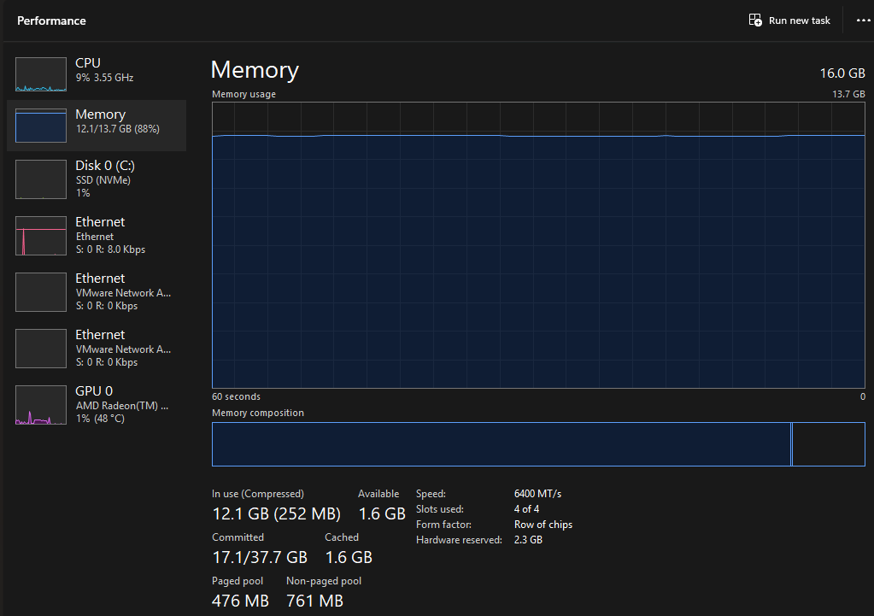
Fig 2 (Resource Monitor displaying memory and CPU usage in Windows)
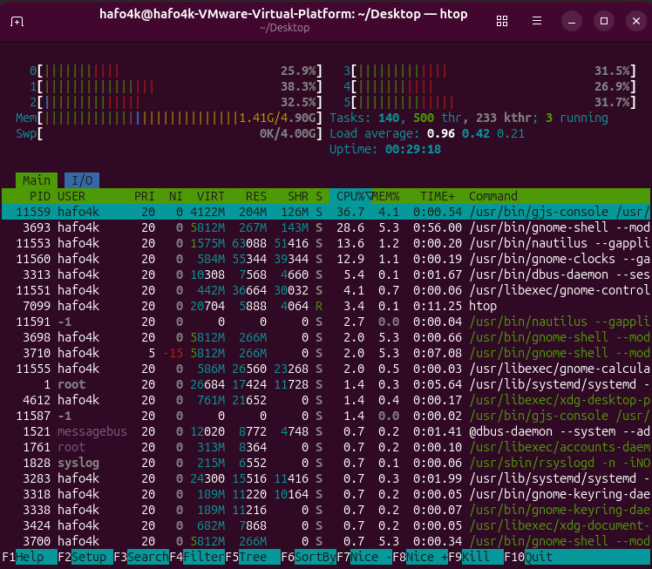
Fig 3 (Htop utility showing process management in Linux)
Using a file and directory management system, users and applications can create, read, write, and organise data on various types of storage devices. Windows uses the NTFS file system, whereas Linux uses the ext4 file system. Both Windows and Linux users can access these systems using Windows File Explorer or the Linux commands ls, cd, and pwd or tree as shown in the figure below. Device management is the ability for the operating system to communicate with all hardware devices via device drivers, while networking is the ability for the operating system to connect to local area networks or internet services. Tools such as ipconfig in Windows and ip addr in Linux can be used to determine network status [1].
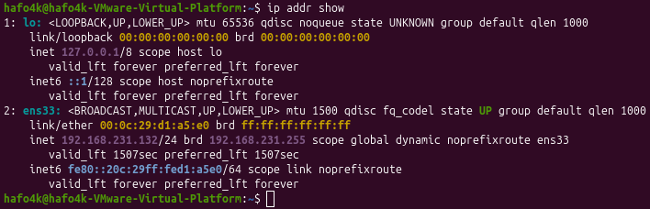
Fig 4 (Memory usage free -h and network interface information in Linux with ip addr show)
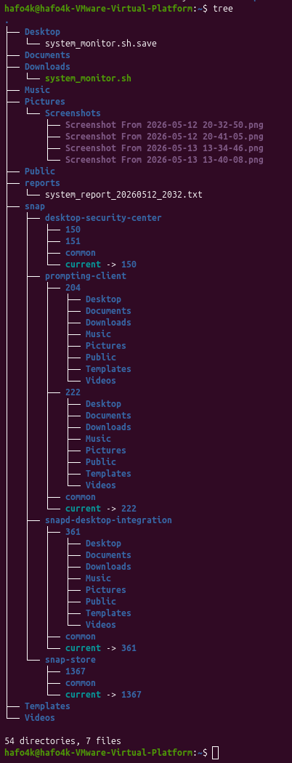
Fig 5 (tree Linux command)
Security and access control are becoming increasingly important to operating system managers. They accomplish this by implementing rigid user authentication, file access permissions, data encryption, and other measures. In Windows operating systems, the User Account Control feature is present for this purpose, while in Linux operating systems, file access permissions and the use of sudo are used. Together, the core functions of an operating system provide a stable, secure, and user-friendly computing environment. A thorough understanding of these core functions is critical for an operating system administrator and will assist in troubleshooting problems that may arise when using Windows or Linux [1], [6].

Task 2: Use of Windows OS CLI commands
Command-Line tools on Windows operating systems provide an interface through which users can interact with their computer, and provide command-line access to all computer functions via the traditional command prompt and PowerShell. This allows efficient, powerful system administration by giving users the ability to control system functions directly from their computers, such as system processes, files, network connections, user accounts and permissions, and scheduled tasks.
Regarding the management of Processes and Services, there are two primary commands one would want to utilise: Get-Process and Stop-Process. The cmdlet Get-Process lists and provides detailed information about all currently running processes and allows filtering by name, such as Get-Process -Name ‘chrome’, which returns data on Chrome processes, such as CPU and Memory utilisation. Stop-Process -Name ‘notepad’ -Force; the Force switch overrides confirmation dialogues when applied and can be used to terminate a process in Windows via PowerShell. With Get-Process and Stop-Process, administrators can have real-time control over the resources on their systems. [2]
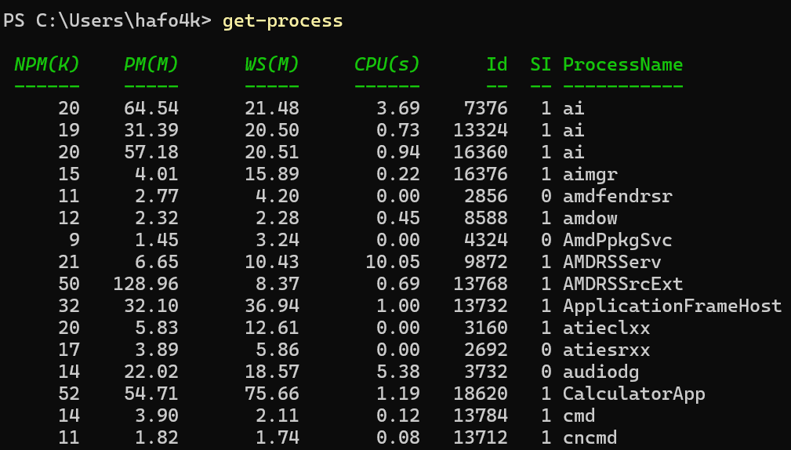
Fig 6 (get-progress command)
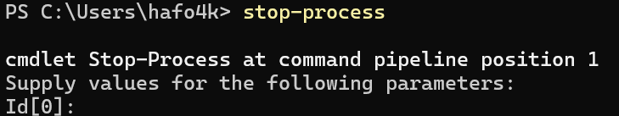
Fig 7 (stop-process command)
File and directory management covers a wide range of PowerShell cmdlets, such as Get-ChildItem, Copy-Item, and Remove-Item. The command Get-ChildItem -Path C:\Users\username\desktop -Recurse -File | Select-Object Name, Length, LastWriteTime lists all text files in the Users directory and its subdirectories in the oldest to newest order, as shown in the figure below.
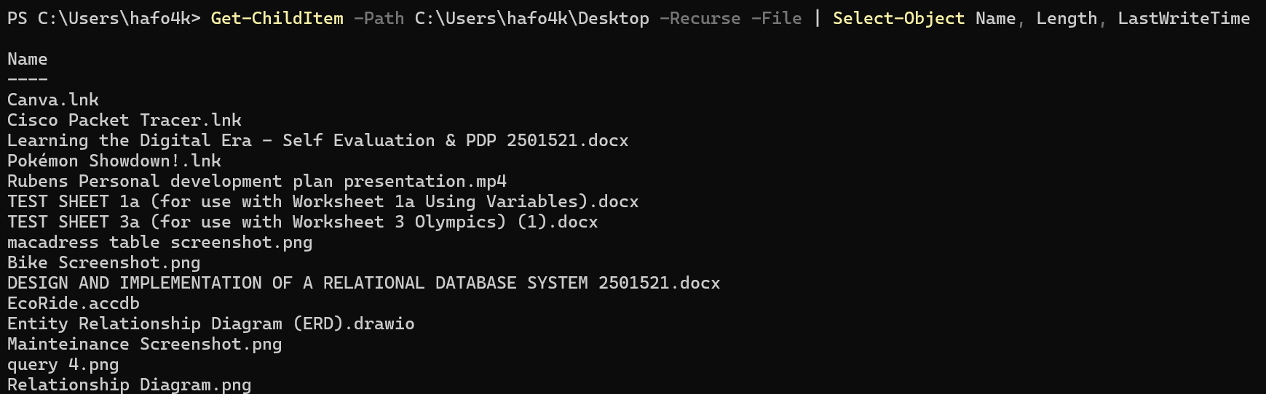
Fig 8 (Get-ChildItem Command)
Files can be copied to another folder by using the command Copy-Item -Path C:\file -Destination C:\Backup\ -Force, and files that are no longer required can be deleted by using Remove-Item -Path .\tempfile.txt -Recurse -Force. These commands, coupled with the -Recurse and -Force parameters, guarantee a productivity boost during huge file operation tasks [2], as shown in the figures below.
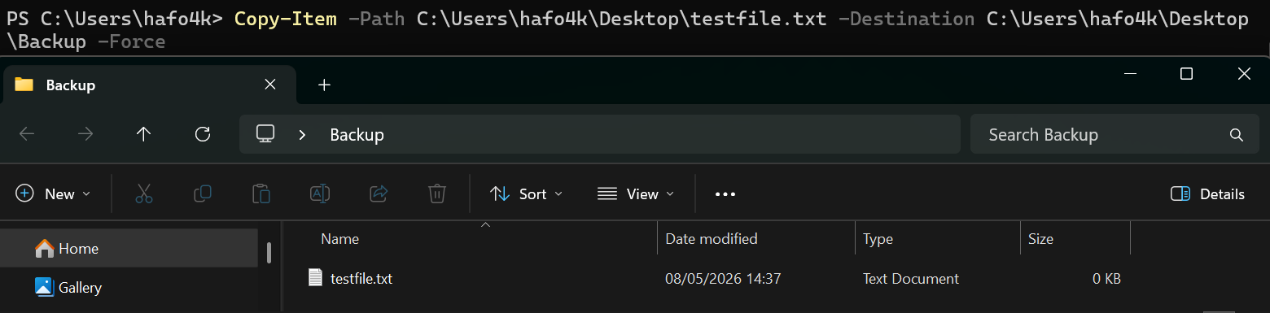
Fig 9 (Copy-Item Command)
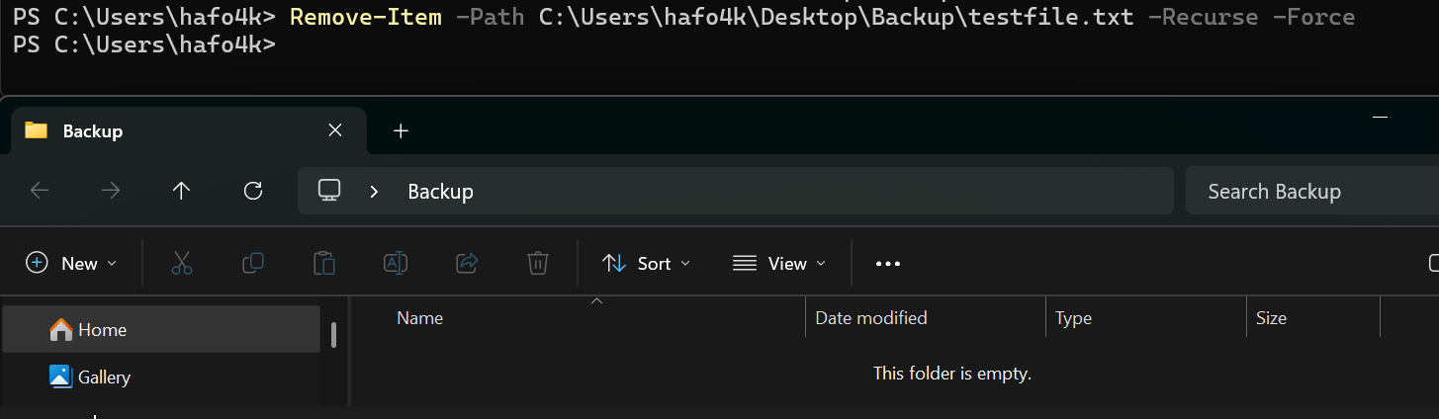
Fig 10 (Remove-Item Command)
Network testing and monitoring are efficiently performed by using the Test-Connection, ipconfig, and Get-NetAdapter commands. Sending four ICMP echo requests to google.com to test connectivity mimics the operation of the ping command on the command line, only that the output is received in the form of objects, as shown in the figure below.
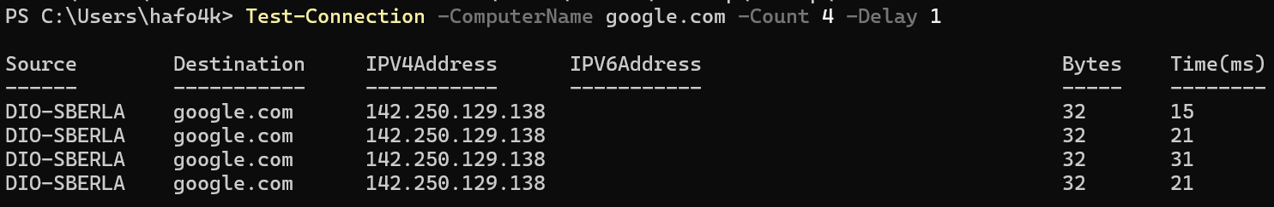
Fig 11 (Test-Connection Command)
Secondly, the command “ipconfig /all” provides detailed network configuration information about the various network adapters on the PC, as shown in the figure below.
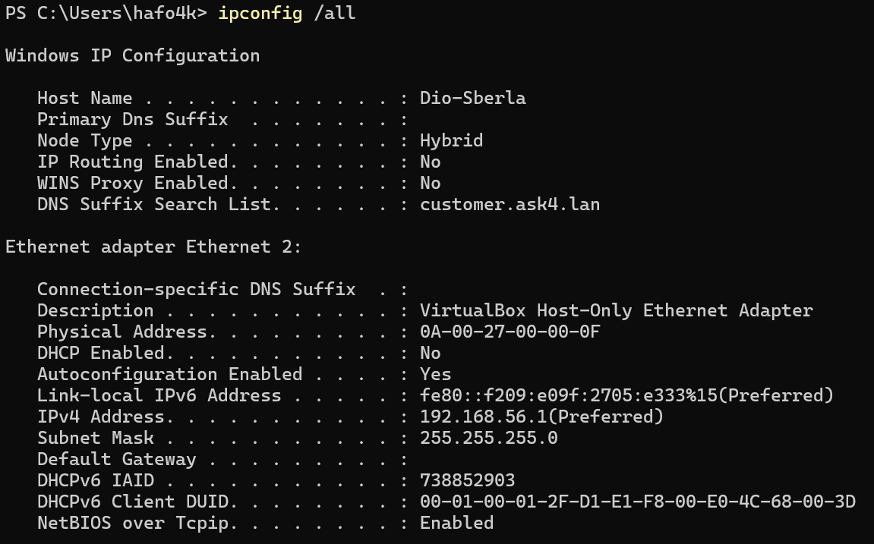
Fig 12 (ipconfig /all)
Lastly, the command “Get-NetAdapter” shows all network interfaces along with their statuses and attributes, as shown in the figure below. These tools are useful for diagnosing connectivity issues [5].
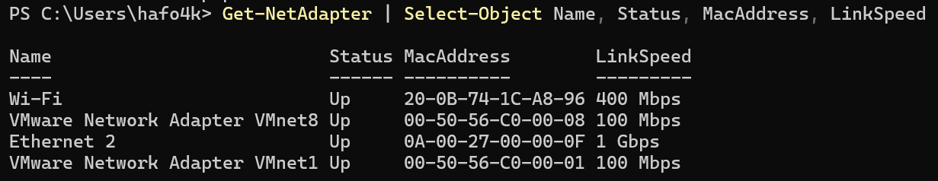
Fig 13 (Get-NetAdapter Command)
In user management, administrators most commonly can use the Get-LocalUser and New-LocalUser commands. The Get-LocalUser cmdlet alone returns a list of local user accounts, while the -Name Administrator parameter provides some details on the differences between them as shown in the figure below
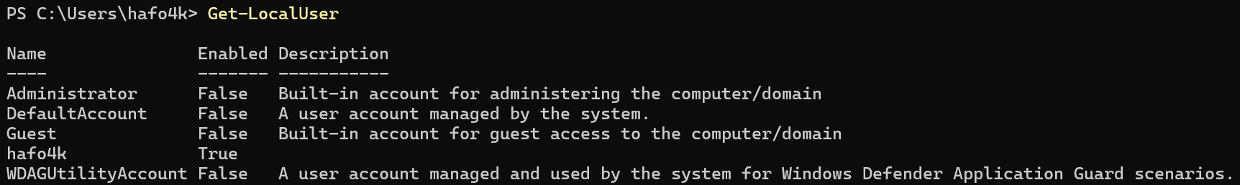
Fig 14 (Get-LocalUser Command)
A new user account in PowerShell can be created by using the following command: New-LocalUser -Name “TestUser” -Password (ConvertTo-SecureString “P@ssw0rd” -AsPlainText -Force) -FullName “Test User” -Description “Temporary account.” The reason it failed is that PowerShell wasn’t running as an administrator, as intended and shown in the image below
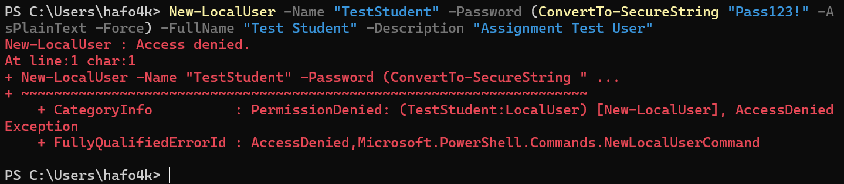
Fig 15 (New-LocalUser Command)
Task scheduling was demonstrated by using the schtasks command. The command schtasks /create /tn "MyDailyTask" /tr "C:\Windows\System32\notepad.exe" /sc daily /st 09:00 /ru System successfully created a daily task that launches Notepad every day at 9 AM under the System account as shown in the figure below. This shows how administrators can automate repetitive tasks [2].
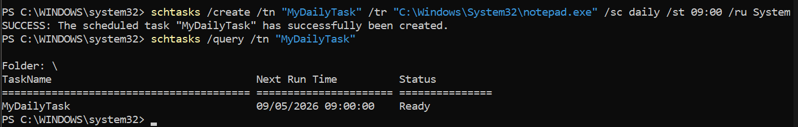
Fig 16 (schtasks create command)

Task 3: Use of Linux OS CLI commands
Command-line usage in Linux is based on Bash, which has become the default shell for administrative tasks. Bash commands give users a lot of power and precision for controlling processes, files, networks, users, and scheduling tasks. For example, ps aux shows all running processes with various details, while top -u user shows real-time statistics on how much resource each user is using on the PC, like the Windows task manager, as shown in the figures below.
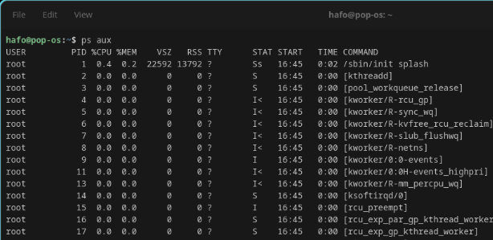
Fig 17 (ps aux command)
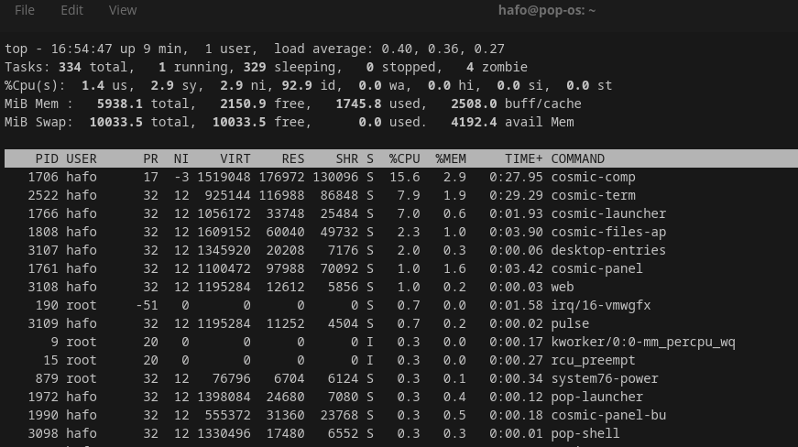
Fig 18 (top -u Command)
To forcibly kill a process in the top -u manager view, a user can use the kill -9 “PID” command, and they can use the pgrep -f processname command to find a specific process to kill [1].
For file and directory manipulation, we use ls -la to list all files and directories, including their permissions and any hidden files.
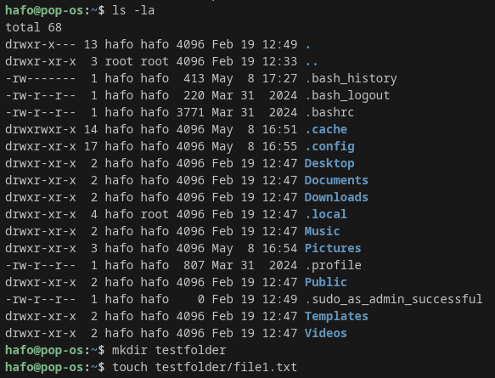
Fig 19 (ls -la0 command)
cp -r and source + the destination will copy directories along with any subdirectories or files recursively from the source to the destination folder, as shown in the figure below.
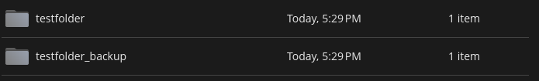
Fig 20 (cp -r command result)
Another useful linux command is mv - oldname newname, which can be used to rename or move a file. rm -rf directory/ can be used to forcibly delete files and directories, as shown in the figures below. [1].
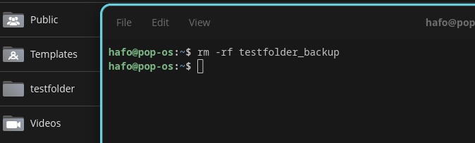
Fig 21(rm -fr testfolcommand result)
The commands used for testing and monitoring the network on Linux operating systems include ping -c 4 google.com, which pings google.com with four 64-bit packets and looks for the time in milliseconds to establish a connection latency, as shown in the figure below
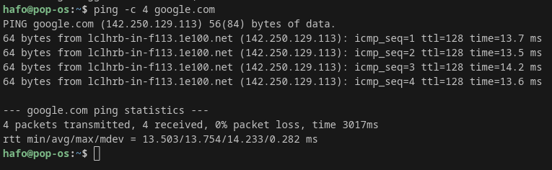
Fig 22 (Ping -c 4 google.com command)
To check for more connectivity, we use the ip addr show command to show the details of the various network interfaces.
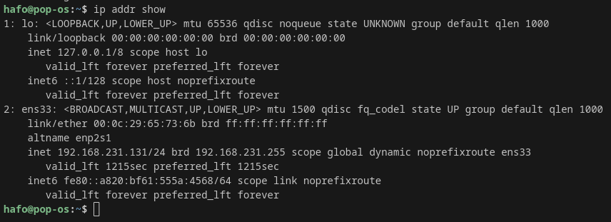
Fig 23 (ip addr show command)
The command ss -tuln displays the list of all of the ports being used and highlights the listening ports and current connections, whereas the command traceroute google.com traces the path to the remote host google.com.
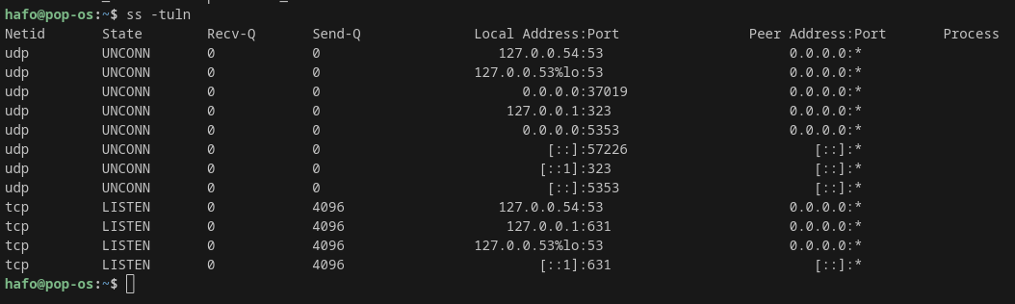
Fig 24 (ss -tuln command)
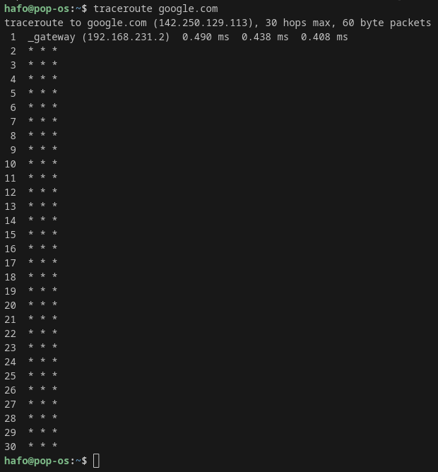
Fig 25 (traceroute google.com command)

In the area of user management, the command whoami will display the OS ID information about the current user, like account name and times sudo has been used, as shown in the figure below.
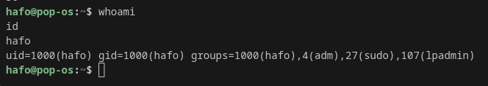
Fig 25 (Whoami command)
The command sudo useradd -m user creates a new OS user, and then the sudo passwd newuser command sets a password for the new user. Lastly, the command usermod -aG sudo newuser adds the user to the sudo group, as shown in the figures below
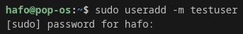
Fig 26 (sudo useradd -m)
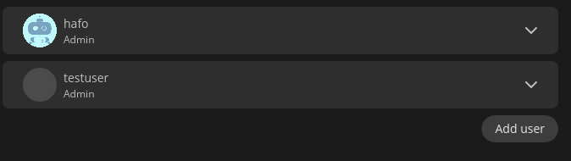
Fig 27 (testuser added as new user with sudo privileges)
Task scheduling was demonstrated by using the “at” command. The command echo "echo 'Task executed at $(date)' >> ~/at_scheduled.log" | at now + 2. This creates a small command that writes the text Task executed at the current time to a file called at_scheduled.log in the home folder. After 2 minutes, it is executed as shown in the figures below. Lastly, the atq command is used to view pending tasks. This method is useful for scheduling one-time tasks in Linux environments [1][4].
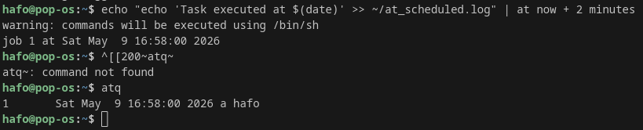
Fig 28 (echo task command)
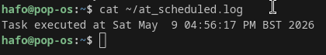
Fig 29 (Cat ~/ command)

Task 4: Use of Windows OS scripts
Windows OS administration uses PowerShell as its preferred scripting language because it supports object-oriented programming, numerous cmdlets, and automated functionality. PowerShell offers complex logic through supported error handling and the ability to integrate with the .NET Framework, compared to Batch scripts [2].
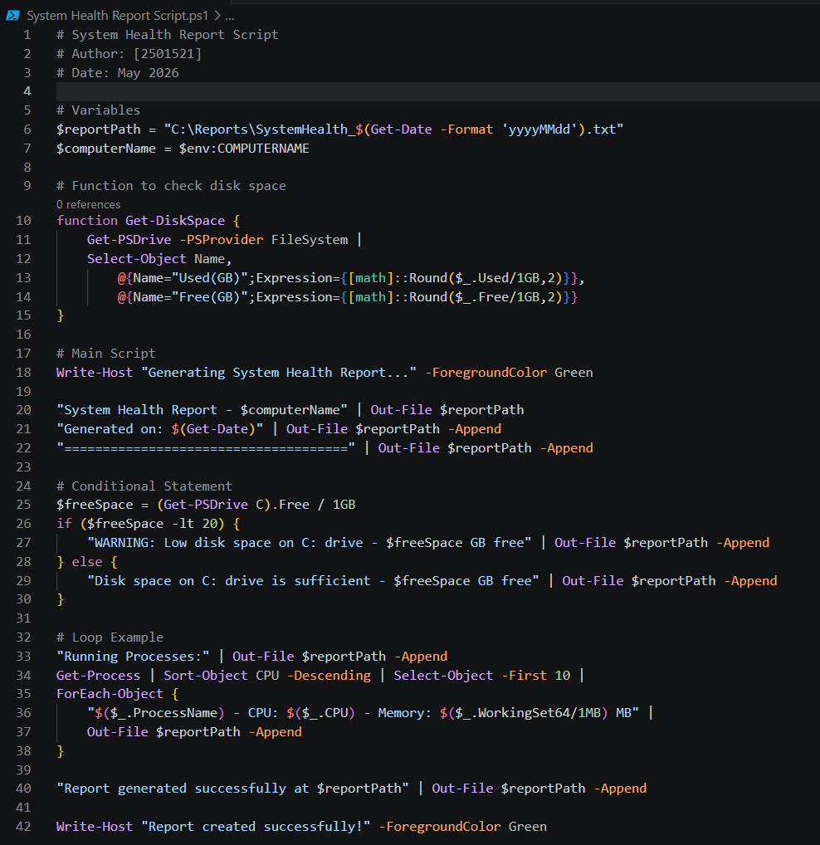
Fig 30 (System health report PowerShell script)
A sample script called SystemHealthReport.ps1 was developed to illustrate some of the primary scripting capabilities of PowerShell, as shown in the figure above. Specifically, this script collects data on the computer, checks available disk space, retrieves the ten highest CPU usage processes, and produces a report on the computer's health. The script creates a few variables at the beginning to hold information such as the report path and the computer name. To retrieve and format disk space information, the script defines a function called Get-DiskSpace. After defining the function, the script's main body uses an if/else statement to evaluate the amount of free space on the user’s C: drive. An if/else statement is also used to trigger a warning message if the amount of space on the C: drive is less than 20 GB. In addition, the script uses a loop to process the ten highest CPU-usage processes currently running on the system.
Secondly, the script asks the user to enter to create the text document for the report, and finally, the script uses output redirection to write the results to a text file at the path specified by the report path variable. As shown in the figures below
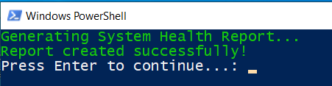
Fig 31 (PowerShell user input request)
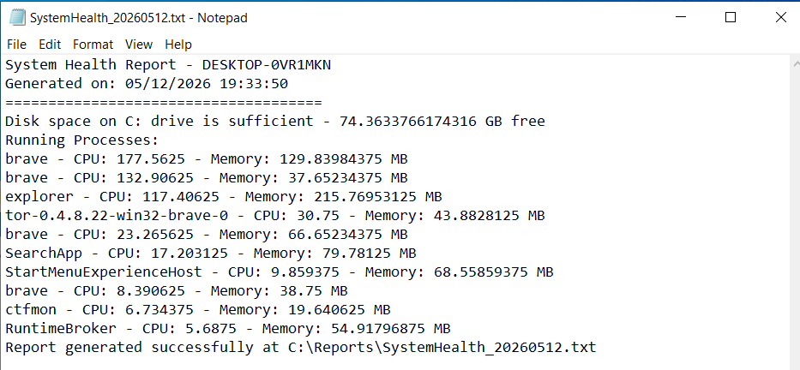
Fig 32 (System health report printed)
This script demonstrates several important elements of PowerShell syntax, including creating and using variables, defining and using functions, using if/else statements, using ForEach-Object loops, and using output redirection. Each of these elements enables an administrator to automate repetitive monitoring tasks and produce professional-looking reports with very little manual effort [2]. In this example script, PowerShell automates true administrative functions, such as monitoring and reporting on the life cycles of specific systems. Combining variables, functions, conditionals, and loops makes PowerShell an extremely useful tool for system administrators managing Windows systems. [2][5].

Task 5: Use of Linux OS scripts
Linux system administrators can automate repetitive tasks by using Bash scripting. By creating a script called “system monitor”. The examples of essential Bash scripting features will be highlighted, including monitoring system health by checking disk utilisation, identifying the top resource-consuming processes, and generating a timestamped report file [1], [4].
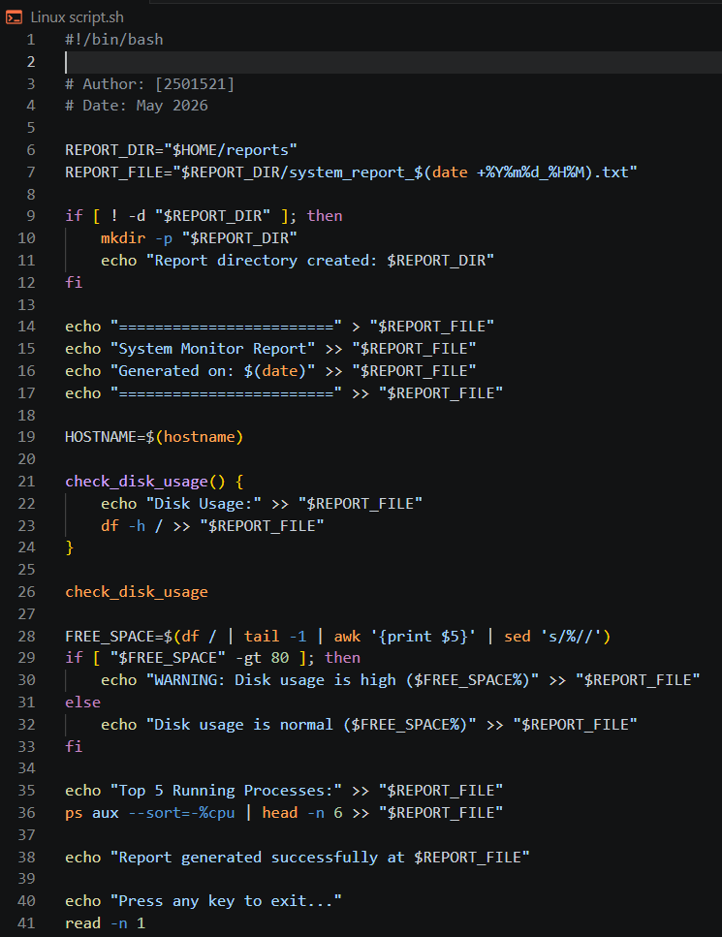
Fig 33 (System monitor script)
The script starts with the line #!/bin/bash as shown in the figure above, which specifies that this script should be run by the Bash interpreter. The script will use variables for both the Report Directory and the Report File Name, including a date command that is substituted to generate a unique timestamp. The first step in the script checks whether the report directory exists; if it doesn’t, it creates it using a conditional statement and the mkdir -p command.
To improve code organisation, a function is defined to encapsulate the script's main logic, with the main action an if/else statement that determines whether the current disk usage for the root directory is above or below 80%. If disk usage exceeds 80%, the script writes a warning to/var/log/system.log. The script then loops through a combination of the ps aux, sort, and head commands to get the top five CPU usage processes, with all output redirected to a text report file using the >> operator. The script then waits for the user to read the results before terminating via the read command.
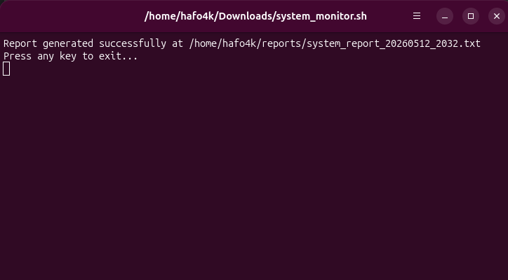
Fig 34 (program output)
Lastly, upon execution, the script produces a report that includes the hostname, date and time, disk usage status, and a list of the top 5 CPU-intensive processes. It can be automated by running manually or scheduling for regular monitoring of the system.

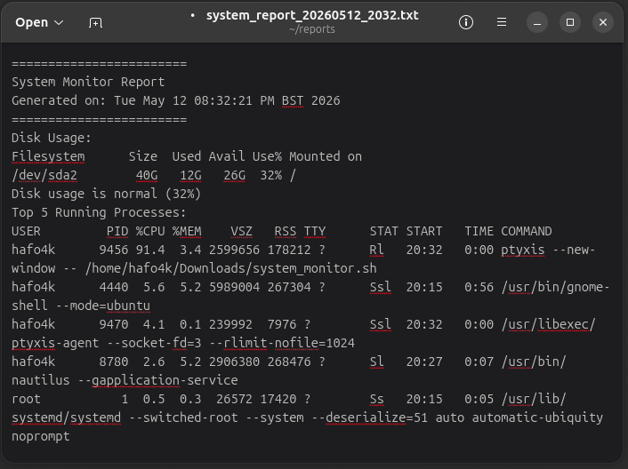
Fig 35 (Linux system report)
This Bash script effectively demonstrates the use of variables, functions, conditionals, command substitution, and output redirection to illustrate how powerful and flexible Linux shell scripting can be used for real-world system administration tasks [1],[4].

Appendices

Operating Systems Basics course interaction on Cisco Networking Academy
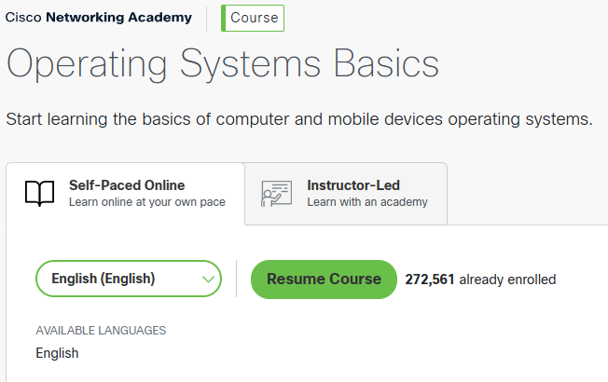
Appendix 1 (Enrollment confirmation for the Operating Systems Basics course on Cisco Networking Academy)
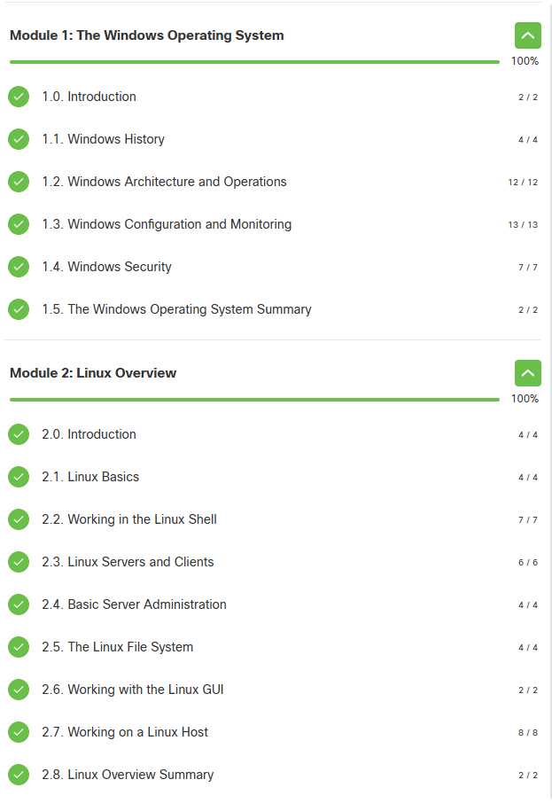
Appendix 2 (List of course modules with the completion status)

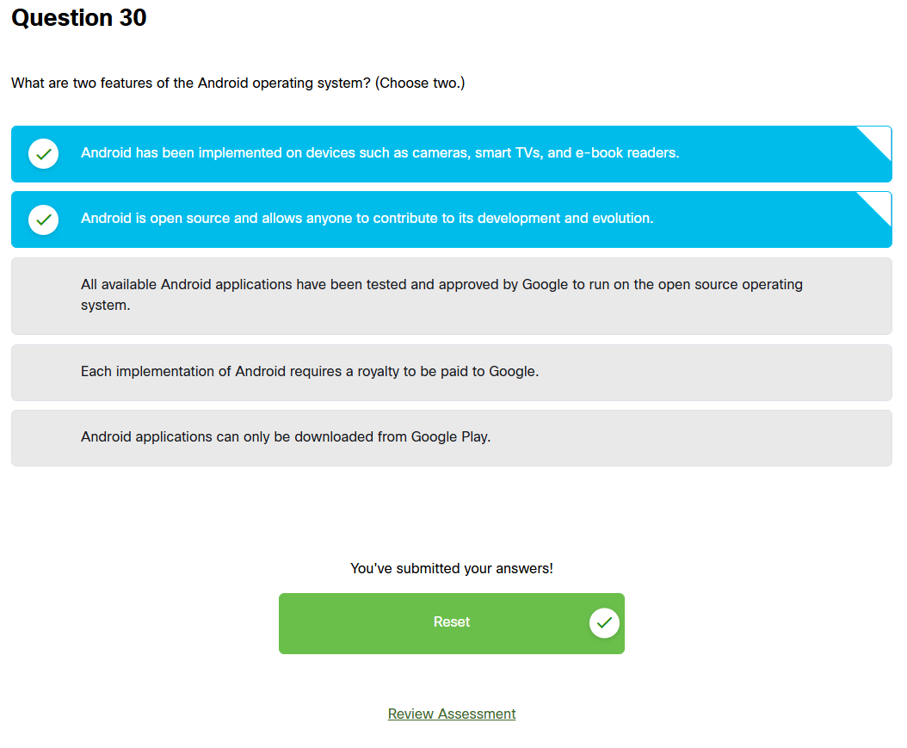
Appendix 3 (quiz completion evidence)

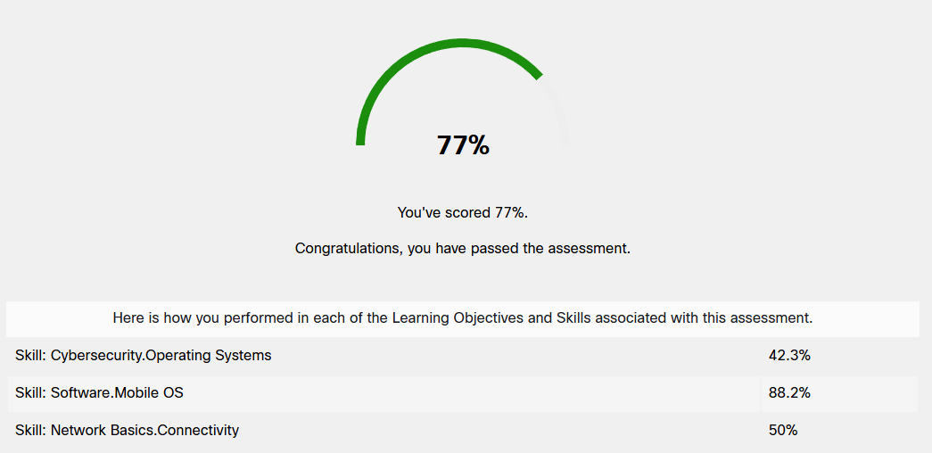
Appendix 4 (final exam quiz completion evidence)
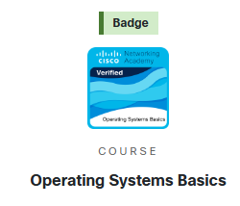
Appendix 5 (Operating systems basics achieved)

Conclusion
The components of an OS were discussed, and the ability to perform administrative tasks was demonstrated using Windows and Linux. The OS functions covered included POSIX-compliant processes, memory management, file system management, networking availability/security, and the general way these functions operate in Windows and Linux [1], [6]. The use of a Command Line Interface was demonstrated to be the most effective for performing administrative tasks through examples of using the Windows PowerShell CLI and the Linux Bash CLI to manage processes, files, networks, users, and tasks. In addition, the PowerShell and Bash scripting examples demonstrated how automation can improve both system monitoring and administrative efficiency. As a whole, this assignment provided hands-on experience with modern operating systems, and the experience and knowledge gained will help in future studies and careers in the information technology industry, especially in Command Line Interface and Scripting for effective system administration.

References
[1] J. Hao, Y. Xiao, W. Zhou and P. Wang,Operating System Basics and Practice : A Hands-on Approach with openEuler, 1st Ed. Singapore: Springer Nature Singapore, 2026. doi: 10.1007/978-981-95-2185-2
[2] D. Tuličić, et al., "Windows Admin GUI Model for Learning PowerShell Commands", 2023 46th MIPRO ICT and Electronics Convention (MIPRO), pp. 590–595. [Online].doi: 10.23919/MIPRO57284.2023.10159862.
[3] A. Kartuzov, T. Kartuzova and M. Sirotkina, "Installing and Configuring Windows Subsystem for Linux in Cloud Computing", 2025 International Russian Smart Industry Conference (SmartIndustryCon), pp. 104–108. [Online].doi: 10.1109/SmartIndustryCon65166.2025.10986105.
[4] P. Feng, N. Xi, J. Jin, J. Zhang and J. Ma, "Flash: Federated Graph Learning-Based Malicious Bash Script Detection for Industrial Cyber–Physical Systems," vol. 21, no. 6, pp.4979–4989, 2025, doi: 10.1109/TII.2025.3552649.
[5] P. A. Vasilevskiy and E. V. Bulgakova, "Exploring the Use of Machine Learning to Identify Threats in Powershell Scripts", 2025 Systems of Signals Generating and Processing in the Field of on Board Communications, pp. 1–5. [Online].doi: 10.1109/IEEECONF64229.2025.10948055.
[6] A. S. Thyagaturu, P. Shantharama, A. Nasrallah and M. Reisslein, "Operating Systems and Hypervisors for Network Functions: A Survey of Enabling Technologies and Research Studies," vol. 10, pp.79825–79873, 2022, doi: 10.1109/ACCESS.2022.3194913.

