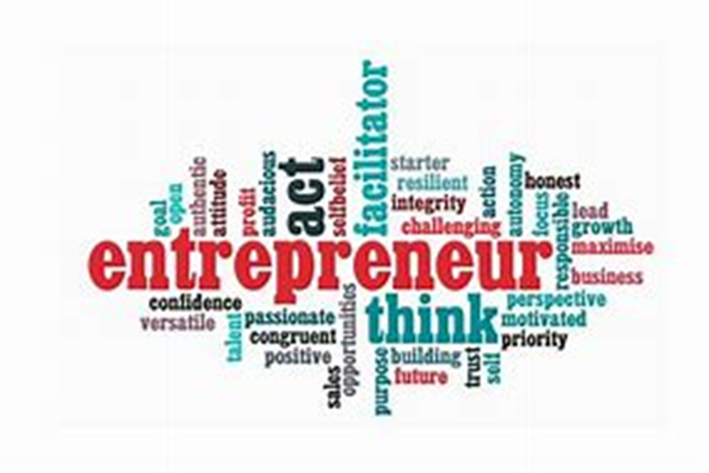

Changemakers: Creativity and Value Creation
  - Assignment 2
  - BA Business Management
Sarah Carr | Student ID - 2107448 | January 2023
Reflection essay
We learn from our experiences, however if we do not reflect on them and evaluate on how we could do better next time it can be difficult to learn or improve on anything. To reflect on my experiences during the changemakers: creativity and value creation module I will be using the Gibbs reflective cycle.
The Gibbs Reflective Cycle was first recognised in 1988 by Professor Graham Gibbs (Smith, 2021). This model of reflection reinforces learning from experience and then reflecting on those experiences by critically thinking using the six stages description, feelings, evaluation, analysis, conclusion, and action plan.
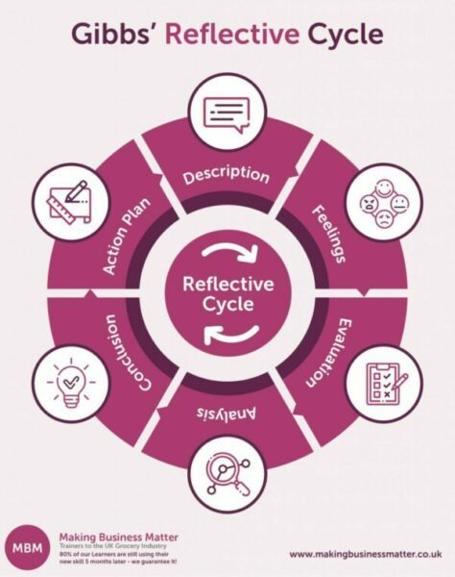
(Smith, 2021)
Using the Gibbs Reflective Cycle, I will critically evaluate myself during part of our first assessment on the Changemakers: Creativity and Value Creation module.
Description
As part of our first assessment, we were given the task to create a business idea competition for the Students of Coleg Sir Gar on 18th November. We were given around one month to plan and organise the event and told that around 58 students would be participating in the event. The purpose of the event was for both groups of students to develop their skills, us as university students by creating and organising the event, and college students by taking part and competing in the competition. As a group in one lecture, we all sat down and created job roles for each other to focus on during the challenge given to us. I was tasked along with Ben to organise the food that would be available to the students visiting. This would entail us getting a final number of students and other people who would be at the event, getting quotes from the vendors for the University to approve, checking with Coleg Sir Gar staff with regards to any allergies or intolerances, putting in the final orders and arranging collection or delivery of the food items on the day of the event.
Feelings
When we first got given the task I was very apprehensive. I had some experience with organising smaller events but nothing on this scale with this amount of people. When we first got together as a group I wanted to jump in and work out everything, but I remembered that I wasn’t the only person doing this task. I stepped back and let other people in the group take charge. Looking back on that decision, I should have taken more of an active role in the planning stages. It is an area that I have experience in, but I did not want to come across as to overbearing and demanding to the other students.
Evaluation
The event itself was a success. The feedback we received from the students and staff at Coleg Sir Gar and the University where all positive, and there was also talk about other events being planned by students in the future. In terms of evaluating the event I believe the following things went really well.
The communication between the students involved in the organisation of the event was great. We created a forum on the Moodle website where we were able to communicate how our progress with our task for the event and that also allowed us to question each other on their progress and offer help if needed. However, there was a breakdown in communication with some students. They were at the original meeting we had when we assigned tasks and then they didn’t communicate their progress on the forum and did not come to further classes. As a precaution to them not coming to the event we assigned their tasks to other members of the team in order to make sure every base was covered so the event could run smoothly.
At the original meeting we came up with a short outline of what we wanted the students to include in their task. We then gave the job to Laura to write a brief for them. It was well structured and clear, and all of the students knew exactly what they needed to include in their presentations. We had feedback from the students and their teachers, and they all enjoyed the event and participated really well.
Not everything went as well as It could have. Last minute we were informed that the students from Coleg Sir Gar did not want to present in front of the other students like we had originally planned for. We were told that we needed to find other room for them to present. Sally who had organised the student union for us to hold the event, managed to secure the upstairs of the same building for the students to present from. A little time before the event took place we were informed by Jess that the students will be using the same room that they had been in the morning to do their presentations from as it was all set up and ready to go. I know a lot of students where a little upset by this as they had spent a lot of time organising and readjusting the plan to deal with this last minute change.
Myself and Ben’s part of the event, organising the food went really well. Ben organised pizza from his job at Dominos, while I was going to bring doughnuts from my place of work. We worked together to get the final number of people who would be attending and received quotes and passed them onto the University. With continue contact with Nav at Coleg Sir Gar I found out that one of the students had a severe airborne nut allergy. Unfortunately, due to this allergy I was unable to supply the donuts for the event as once hoped.
Due to a member of the team testing positive for Covid a few days before the event we were left a team member down and I stepped in to take on her role, floor manager, as mine was completed. As everything was so well organised by Sophie and Vic before the event, on the day I played more of a supporting role to Sophie, by helping to set up the venue and anything else that she needed help with.
Analysis and Conclusion
Overall, the day was a success. Like any other events there are always things that can be improved on for next time. There where issues during the day that where out of our control but I believe as a team we quickly adapted, rectified and we adjusted the plan to accommodate everything that came up.
Action Plan
If I was to do this event again, I believe that we would need to have more than one sit down meeting to arrange everything. While the system we had in place worked ,personally I believe more face to face communication would be beneficial. I would also have spoken to the students at Coleg Sir Gar in person, possibly sending a few students to their campus to explain the competition to them in person, answer any questions they may have and also check to see if they are happy presenting in front of each other, so we do not have a last minute issue in finding another room like we did a day before the event.
I do not see myself as an entrepreneur, I don’t have my own business, or have creative ideas that lead to something however, after researching and learning about the skills required from this module, I believe I have many skills that an entrepreneur has.
I have good communication skills whether it be in person or in written form. However, I do need to improve on my presentation skills. I have no issues talking to a large group of people in a relaxed, unformal setting but I do get very nervous when speaking or presenting in a formal setting. I’m not sure how best to overcome this issue but it’s possible that with more experience in participating in these types of situations I can improve.
I believe that my organisation skills are very good. As a mum of two, working two jobs and being a full time student, I need every part of my life to be organised to the last detail. I have taken those skills into my work and have organised that part of my life in the same way. I could improve by structuring my study time better and try not to leave things to the last minute. With my organisation being so regimented my time keeping skills I believe are excellent. I always aim to be at least ten minutes early to anything I do, however as I don’t drive sometimes relying on other people to take me places can affect that. In order to improve on this, I am taking driving lessons and hope to pass my driving test within the coming months.
Being from a large family I am no stranger to working as part of a team. I prefer to be working in a team than independently. I believe that working as part of a team is more beneficial to solving problems. From my experience people are more likely to take calculated risks to reach new possibilities if they have the support of a team behind them and also working as a team increases job satisfaction and reduces stress.
Being resilient is a key quality to be an entrepreneur. Being able to withstand or recover from challenges put in front of you whether it is through mental, physical, or behavioural flexibility is the answer. I have not been in a position in a business sense that I have need to be resilient, however personally I have. Fourteen years ago, I was a young mother with two children aged 1 and 6 months, when my husband was involved in a major motorcycle accident. Overnight I became a carer to my husband and for six months while he was recovering in hospital a single mum to our children. That experience has taught me that anything can happen and it’s how we deal with the aftermath of the situation is what matters.
I am not a highly creative person. I believe I am someone who helps the creative person to achieve the dreams or ambitions. There is nothing wrong with that and I great immense pleasure seeing other people succeed. Last year a friend came to me and asked me to give up my stable job to help her launch her new business. At first I was really worried, due to his injuries from his motorbike accident my husband is now unable to work, and I am the sole provider for our family. Giving up that regular source of income for a business that could fail in six months was a big decision to make. After much discussion with my husband, we both decided that I needed to do it not just for my friend but to give me a new opportunity. Thankfully, the business is going from strength to strength, and I am also growing in confidence and my abilities to run a successful business.
In the future I hope to continue to improve on many other skills that are key for an entrepreneur, not only to excel at my job as a manager but personally to become more confident, creative, and innovative.
Word Count – 1898

References
Herrity, J. (2020, February 25). A Guide to Entrepreneurial Skills: Definition and Examples. Retrieved January 3, 2023, from Indeed: https://www.indeed.com/career-advice/career-development/entrepreneurial-skills
Mind Tools. (2021). Gibbs Reflective Cycle. Retrieved December 27, 2021, from Mind Tools: https://www.mindtools.com/ano9qiu/gibbs-reflective-cycle
Smith, C. (2021, August 23). Gibbs Reflective Cycle:Feel the Benefit of Experiential Learning. Retrieved December 27, 2022, from Making Business Matter: https://www.makingbusinessmatter.co.uk/gibbs-reflective-cycle/
TedTalk:Cameron Herold: Let's raise kids to be entrepreneurs. (2010, June 17). Retrieved January 2, 2023, from You Tube: https://www.youtube.com/watch?v=nx3GuO41Jyg
The University of Edinburgh. (2020, November 11). Gibbs Reflective Cycle. Retrieved December 27, 2022, from The University of Edinburgh: https://www.ed.ac.uk/reflection/reflectors-toolkit/reflecting-on-experience/gibbs-reflective-cycle

