Introduction
Community engagement is an important element for a society to be fully functioning. Kingma (2011), defines community engagement to be a vehicle that allows for collaborative work to talk place within a close environmental proximity being a catalyst that can change and improve the health and well-being of a certain community of people and their members. Murphy (2018), expands on this as they state that community engagement allows for a higher level of social stability enabling a more productive life, raising the living standards. As stated in the previous needs analysis, health and well-being is a large triggering element to the way in which a community runs, if the correct support and guidance is not in place for the individual There is a growing concern for the mental health of children and teenagers as in recent years there has been a large growth in the number of mental health disorders being diagnosed in children, the needs analysis discussed the 70% growth in children going to A&E in a psychiatric state, which has doubled since the year 2009 (Bedell 2007). This report is going to provide a proposal for a potential project that should be taking place in schools.

Aims and objectives and who its aimed at
With this prior information, it is evident that there is a need and also space for intervention within the younger demographic needed. Therefore, it would be appropriate to enforce a project that enables children to always have someone there for them to discuss issues and problems with. This project is strongly needed due to the lack of support that can currently be seen in the schooling system which could potentially help conditions develop further. This project has aims and objectives that will hopefully result in individuals feeling like they have someone to talk to which is up most important as so many suffer in silence.
These aims are:
- Educate individuals about mental health.
- Ensure that all students feel like they have someone to talk to in confidence.
- Create awareness.
- Offer action plans and support to the individual so when they are out of the session they have a plan to refer to and know how to act upon condition.
Project details: A brief outline
This project will work with children in Swansea West Glamorgan Secondary schools and will filter through the use of 1:1 sessions with pupils in PSE sessions. Personal and Social Education is an important component of the Welsh curriculum which is vital for children to attend and is part of their weekly scheduled timetable. Referring to appendix A, which states the aims of personal and social education in the curriculum, this is where a project such as this would fit in and would be the most beneficial. Due to the fact that PSE if about making students understand how to have a happy and fulfilling life, this is the most accurate time to present the project to individuals. The project is going to be aimed at year 11 students, therefore the age of 15-16 years old where they may be sitting exams and completing intense coursework. This is the target group chosen as this could be seen as the most detrimental age for provision to be implemented and to be the most effective on a young adult’s life and well-being. Even though there are statistics stating that suicide rates are the highest with the older demographic which are provided in the needs analysis, it could be seen that if earlier prevention was put in place then it could perhaps reduce the number of suicides (Talk to Me, Suicide and Self Harm reduction strategy for Wales, WAG, 2008). Schooling is a very difficult time for children and this is a time where help should be provided for individuals that are struggling with the process. The initial stages of the project will see councillors having assemblies to discuss what mental health actually is as at this age, students may not to be aware that the feelings and thoughts they have may be diagnosable with a condition and that there are strategies and professionals that can help. The project will also involve volunteers from sixth form that are involved with related subjects. This is beneficial on both accounts as it is good for the students to document on their CV as well as building on their personal skills. Students may feel more comfortable talking to individuals slightly older than themselves as they may have more to discuss with them therefore can be more open. This report will discuss elements regarding this project such as:
- Health and safety regarding working with children
- Why it is needed
- The budgeting and costs that would be put in place.
- Where and how it will be run
- Implementation
- Challenges
- Funding resources
- Aims for the future of the project

Format of the project

This project will be called ‘Let’s talk’, to reflect the purpose of it. The project will work around the idea of the school year having 39 school weeks and PSE sessions running weekly. The project will focus on one school within Swansea and depending on the progress of that will potentially consider expanding to other schools in the area. The sessions will be taken by a qualified counsellor who for the first few weeks will address mental health and what it actually in an assembly type format to the whole year group which will make it identifiable to the individuals in the year group the conditions and the symptoms of these mental health problems, ranging from home issues, exams, environment and relationships. Also a topic that will be discussed intensively is the topic of removing the stigma from having a mental health illness, as mentioned in the previous needs analysis, stated by Corrigon and Watson (2002), who believed that the hardships of living day to day with mental health is to be considered difficult enough without having to deal with others being prejudice towards them due to the misconception of what mental health is. The other sessions will then be left for a 1:1 session with the councillor and volunteers to be taken in a private room in the school, this enabling the individual to have someone to talk to about any issues they may have in complete confidence. The 1:1 session will have a running time of somewhere between 30-60 minutes depending on the number of individuals following the assemblies believe that they could benefit from seeing a councillor. Any second sessions will be available to run throughout lunchtimes to benefit anyone wanting a second session. Within the actual 1:1 session, there will be some activities in place for the councillor and the individual to get to know each other and form a bond of trust before opening up. This could be considered crucial for the certain type of individual depending on whether they are shy or are not aware how to open up to someone. These activities can be important to enforce a positive environment which will allow for them to calm down and relax and potentially break any social barriers that they may subconsciously have. They also allow for individuals to think outside of the box meaning they may escape their reality helping them to communicate. The activities can be included in every session to initially make a positive atmosphere. In these sessions there will be information given out which will allow for a student to understand that there is always help and a number of different resources that are out there to guide them. Additionally, made in sessions will be action plans for the individual which will incorporate how the potential mental health issue could be resolved and discussed. These will be tailored by the councillor, volunteers and the individual so that they are happy with it and feel like they could use this in day to day life in order to try and have structure in knowing what to do.

Identifying the need
In order for a community to be fully functioning, the needs must be understood. When considering the needs in a community, Thomas, Donovon and Sigma (2009) states that an identified need for a community enables a framework for potential problems to be developed and solved involving the citizens and organisations available, helping to further develop and support children and families. It is evident that there is a need for a project such as this to be put in place in schools. As mentioned in the needs analysis there is a heavy duty on teachers to be able to understand and work with these children outside of the already pressuring curriculum. As stated by Bedell (2016), the 2016 survey stated that 93% of teachers saw a large increase in student’s mental state change and a further 90% of these students actually deteriorating stating that they themselves were spending time dealing with students and their mental health. This is a further reason as to why a project such as this should be put in place to prevent cases from getting worse. Furthermore, the current provision in Wales is seen to be under high amounts of pressure. As previously mentioned in the needs analysis research from Mental Health Wales (2012), the specialist child and adolescent mental health service in Wales (CAHMS), has been under considerably more stress than in previous years seeing the referrals and need for help increase by 100%, CAMHS referrals has seen figures increase from 1204 in April 2010 to July reaching figures of 2,342 meaning numbers almost doubled showing that help is urgently needed, and this said project identifies a need in the community and provides what could be a solution. With this in place it is evident that the issues are still ongoing and the true core of the problem is not being explored. When looking at appendix 2, it shows the mean mental health average was a lot lower than the welsh average which points out that that Swansea is significantly suffering regarding mental health. From this data, it suggests that the current provision does not cater towards the real needs that are requested or that the timescales are not quick enough in acting towards the issue, this is evident in data provided in the analysis provided by Children’s Society (2008), who provided statistics stating that 70% of young children aged 5-16 who are experiencing signs of mental health have not or will not have had any interventions from a young age that were successful in order to show guidance that would allow any sense of recognition of these signs before the grow into further problems which this project should hopefully be able to address. From this data it that the lack of prevention in younger life has a large knock on effect towards adult life with statistics from World Happiness Report (2017), which states that over 50% of children who suffer with mental health and well-being will continue to have this in their adult hood if there is no prevention in place. Also, the report goes on to state that these conditions can develop into physical health problems later in life such as arthritis and asthma due to that person not being knowledgeable of how to get help or maybe being too anxious to speak to any other individuals with the stigma attached. Thus again reinforcing the need for a higher number organisations and charities to become more aware that people may not want to speak out. This data shown allows for a project such as ‘Lets talk’ to be made active in order to make every individual feel safe and that they have someone to talk to.

The staff involved
In order for this project to be successful it would involve the use of a fully qualified Councillor. Appendix C states the requirements of what is needed to become full qualified, this includes a three stage training programme and not a degree. The Councillor will have to have experience of working with children before as there’s a certain sense of confidence and security within that individual that the child needs to feel within the individual in order to open up as this could be seen as a potential issue if not. Also incorporated are volunteers from the sixth form, students who are studying subjects in A level such as Sociology and Psychology. Both Volunteers and staff would need a full CRB check in order to work with the students. The volunteers will be required to go on related courses throughout the project in order for their knowledge of the situation to become more defined and also create a heightened level of awareness. This will be included in the budget as this is necessary for the volunteers to have a wise understanding of how to deal with mental health issues, especially if they take an interest in it personally. Courses such as ‘Students and Mental Health’ and ‘Mental Health Awareness training’ which are provided by the charity called Mind are potential courses that could be explored and made an essential for the volunteers to go on to broaden their awareness and sensibility to the project. Courses such as these are important to remove the stigma from mental health and make more individuals aware of what it really is to have a condition.

Health and Safety
The said project has a number of points to consider when regarding the health and safety of an individual such as safeguarding. Appendix D discusses the importance of Safe Guarding. When working with children it is important that there is a high level of trust between parties, but safe guarding revolves around the purpose of if for any reason that the professional feels that the child is unsafe then there must be an extra level of care and protection there for them and they can possibly be referred to exterior educational stakeholders. This project will focus largely around the element of confidentiality between both parties but this must be considered if a councillor was to feel that there was a reason that the child was in danger. Schools will have a policy that covers safeguarding, what is involved and when to take action. Appendix D looks at this and gives an example of what a safeguarding policy would look like for the councillor to follow. The element of having a safe place to speak is considered a high importance of the project. As mentioned, confidentiality is something that will be valued but is cannot be absolute due to the safeguarding framework and could be broken for the individual’s safety. There will be a heavy emphasis on supporting the child and making them understand the need for external sources to be involved which will be documented correctly. Due to this, it would be necessary for people working with children to sign a confidentiality form regarding the staff and individuals in the school to respect the privacy of these. An example of this can be seen in appendix F (Make one or put it in).
Funding sources
The costing of this project is relatively low as elements such as space will be in a private classroom in the school which will be agreed on within a school meeting. This project purely focuses on the idea of a safe space for the individual therefore it will not be necessary to have to hire out space. The resources will be basic within the space as overcrowding takes away from the individual. The initial stages of the project will be taken in the form of an assembly as previously mentioned where leaflets will be handed out and in addition to this, posters will be placed around the school to create awareness of the project and its activity in the school. This is important in order for individuals to become aware and sign up. Regarding the funding process, The Welsh Government are currently looking for applicants to apply for funding revolving around mental health, appendix H shows the needs that the Welsh Government are looking for. What is requested by the Welsh Government fits this project successfully therefore this would be the ideal way for the project to be funded. Another element to consider in the project is perhaps the most expensive part is the cost of having a counsellor for a whole day once a week. According to Appendix I, the hourly rate of a councillor is between the figure of £30-50. This cost projection would all work within the funding potentially provided by the Welsh Government.

What are the barriers and challenges to this project?
When considering the project, it is important to consider the potential barriers that may be in place that stop the project from fully functioning. One particular challenge that could be in the way is getting individuals to come forward to someone that they do not know. Over time this will not be such an issue as the school community will be able to recognise this individual as a person they can trust but initially it may be considered difficult to open up to a stranger. Even with the spoken about tasks such as activities, it may be complicated for a student to feel comfortable.
Another possible barrier and challenge is the logistics of the project. There is certainly room for recommendations and improvements here. An issue with the logistics running smoothly is the timetabling of PSE sessions as it revolves around this quite heavily. If for example the lesson was cancelled one week, the scheduling could be made complicated as there would not be enough time to see all the individuals that were required to be seen. For this project to be implemented successfully there would need to be a schedule that was signed by all the staff involved such as pastoral team and head of year to ensure that full efficiency could take place working with the councillor.
Aims for the future of this project
The future aims of this project must focus of being able to provide a sense of security and happiness for any individual involved. In order for this project to be successful it must require full participation from the individual and all other educational stakeholders involved. The aims of this project are:
- To enable the individual to be prepared and equipped for a happy future, being knowledgeable of how to deal with any type of emotion that they may experience.
- Make people aware of the different types of mental illness’, as some have similar characteristics but are diagnosed differently.
- To break the stigma through conversation and creating awareness in the school.
- To provide a safe place where an individual can always go.

To conclude
The element of community engagement is very important to have a fully functioning society. Mental health and well-being is a very important element to the way in which a community runs, if the correct level of prevention is not in place than levels of mental health and illness will increase and not see any improvement. This project focuses on the mental health and well-being of the individual with aims to provide social mobility. By providing a source such as said project it enables an individual to have the chance to work through their conditions with a councillor and talk openly about it without feeling perhaps embarrassed or confused. This will also enable productivity to happen in adult life without being held back by having a mental illness. There is also room for improvements and recommendations ensuring that the project has a high level of success. The project holds positivity and the element of always having someone to talk to in confidence at its core, making it different to other organisations and projects that are currently in action.

Appendices
Appendix A
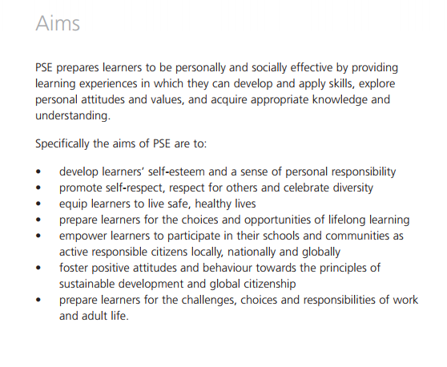
Figure 1REFblb
Appendix B
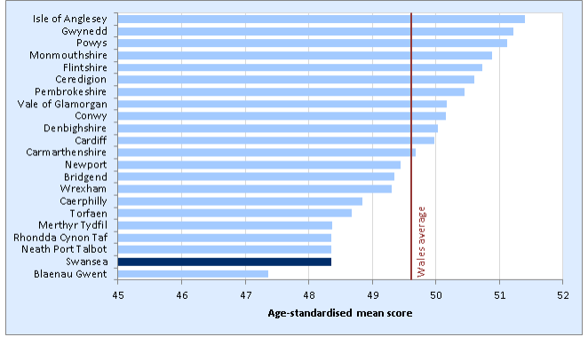
WAG (2014). Local Area Summary Statistics. [online] Gov.wales. Available at: http://gov.wales/docs/statistics/2014/141218-local-area-summary-swansea-en.pdf [Accessed 13 Jan. 2018].
Appendix c
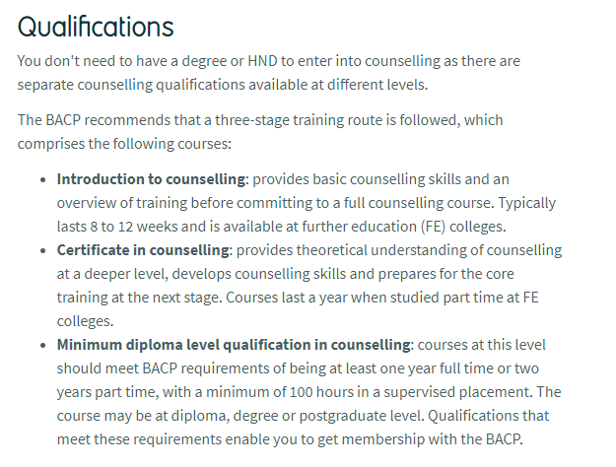
Prospects (2018). Counsellor job profile | Prospects.ac.uk. [online] Prospects.ac.uk. Available at: https://www.prospects.ac.uk/job-profiles/counsellor [Accessed 9 Jan. 2018].
Appendix D

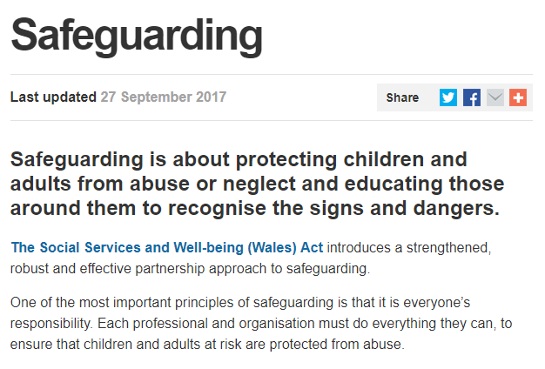
WAG (2018). Welsh Government|Safeguarding. [online] Gov.wales. Available at: http://gov.wales/topics/health/socialcare/safeguarding/?lang=en [Accessed 7 Jan. 2018].

Appendix E
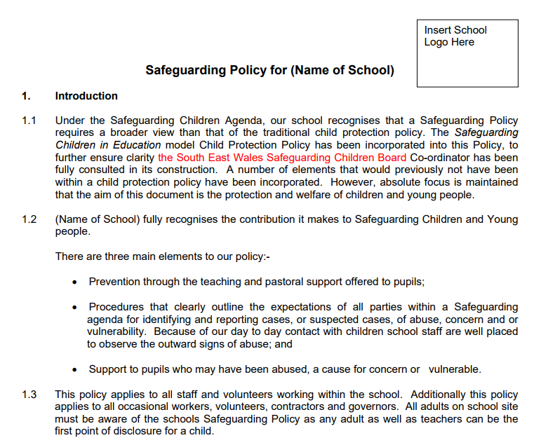
Directorate of Education and Lifelong Learning (2013). Safeguarding Children and Young People Policy for Schools. [online] Sewales.org.uk. Available at: https://sewales.org.uk/Governor-Support-Development/Governors%E2%80%99-Guidance/Guidance-Policy-Docu
Appendix F – Consent form
Appendix G - 
:Mind (2018). Courses for anyone | Mind, the mental health charity - help for mental health problems. [online] Mind.org.uk. Available at: https://www.mind.org.uk/workplace/training-consultancy/courses-for-anyone/?ctaId=/workplace/training-
consultancy/lan

Appendix F
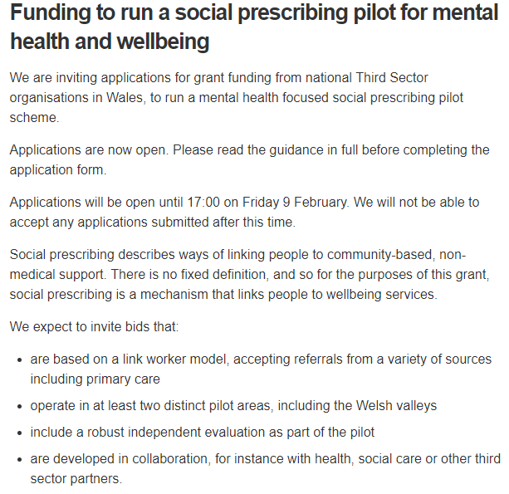
Figure 2WAG (2017). Welsh Government|Mental health. [online] Gov.wales. Available at: http://gov.wales/topics/health/nhswales/mental-health-services/?lang=en [Accessed 9 Jan. 2018].

Reference

