Utilising the Entrecomp Framework, critically evaluate your own creativity and enterprise skills and consider how you might be able to develop the creative and enterprising skills of primary learners through your own pedagogy.

The response to this question will be split into two sections. The first section will explore developing creativity from a teacher's perspective, utilising the Entrecomp Framework to critically evaluate the writer's personal creativity and enterprise skills. The second section will then explore developing primary learner's creativity considering how my personal pedagogy may be used to help develop their creative and enterprising skills.
To start it is clear to see like many brain-based concepts, creativity itself is difficult to define with there being no single perspective on the matter. Through-out history creativity has often been conceptualized as the ability to produce a piece of artistic work through self-expression or communication (Cropley 2001). With outdated research from Pickering (1976 cited in Duffy 1998) suggesting that creativity is simply what is demonstrated through production of creative work. From personal experience the writer would often be told to ‘be creative’ when painting a picture and composing a piece of music but never in other areas of the curriculum, the term has been used so sparsely that the concept has become uncertain (Fisher 2002). However, with recent global development creativity has moved forward, with it now being a core aspect of all learning as opposed to just a feature of ‘the arts’ (Craft 2005),(Donaldson 2015), (Grigg 2015). The term can be explored in a variety of concepts. Guilford (1967) and Lucus (2001) suggests that creativity is linked to intellectual development, with need for divergent thinking with all intelligences working together, as opposed to linear convergent thoughts. While NACCE (1999, p.30) and Robinson (2001) suggest that it is the imaginative process fashioned that produces outcomes that are original and of value. The writer understands that the question ‘what is creativity?’ is difficult to answer due to there being many opinions on the process, however the writer appreciates the idea that “creativity is as much an attitude as it is a set of mental processes” and favors the idea that creativity can be developed in all individual's if exposed to the right attitude and environment (Bowkett 2007,p. 3), (Craft 2005). Therefore, for the purpose of this writing, the writer believes that creativity is closely defined as the ability to “connect knowledge to create ideas, grasp opportunities, take risks, re-frame and problem solve” (Education Scotland 2013). Within evolving education creativity is closely related with enterprise skills “the application of creative ideas and innovations to practical situations” a generic definition which is used across many areas of business and education (QAA 2012, p.8). Enterprising education is therefore the process of equipping learners with skills and tools that will help them generate original ideas to succeed in life after school (Young 2014), (QAA 2012). Creativity is seen as one of the key enterprising skills needed to enhance children’s capacity to lead a successful life, along with initiative, motivation and decision making (Millard, Menzies and Baars Unknown), (QAA 2012). However, within education developing these enterprising skills can often be confused with the teaching of entrepreneurship skills. Entrepreneurship education is whereby children are equipped with a mind set to apply enterprising skills in context of setting up a new business or venture (Eurydice 2016), (QAA 2012). This concept is not discussed in the evolving curriculum as Donaldson (2015) emphasises the importance of enterprising skills e.g creativity within the real world not entrepreneurship. Therefore, this will not be the focus for this writing and has been purely discussed to highlight the difference.
From a teacher's perspective in a century with vast social and economic development, the need for change in the landscape of creativity is necessary. Creativity allows us to change what is presented to us, to think beyond the world of necessity and create other possibilities (Fisher 2004), (Cowley 2005). Not only this but within the evolving curriculum Donaldson (2015, p.28) emphasises how children need to be prepared for the uncertain future and highlights how “creativity and enterprise are central features of modern life that should be developed and extended throughout a school” by educationalists. This is furthered by The World Economic Forum (2019) who highlight that creativity is a key skill children of the 21st century need to have to be successful. However, for teachers trying to develop these skills within education there is a prominent debate as to whether ‘creative teaching’ or ‘teaching for creativity’ is needed for teaching creativity. The concept of ‘teaching creatively’ involves “using imaginative approaches to make learning more interesting” (NACCE, p.89). Teaching with interesting, engaging methods has always been a key aspect for good pedagogy as Desailly (2015) and Shellcross (1981) suggests that creative teachers provide authentic contexts, with variety and flexibility in teaching approaches and assessment. This in turn encourages children's autonomy over their learning, improving attainment and commitment, while also improving children's self-esteem and motivation (Estyn 2017, Estyn 2018). This is favoured by Bronlin (1992) who suggests that these are key personality traits of creative individuals that need to be fostered by teachers. However, it could be argued that including the factors mentioned above within your teaching does not necessarily mean the teaching is effective, as there are many other contributing factors to consider e.g. content, context and progression. Moreover, on the other side of the debate is the idea that ‘teaching for creativity’ is equally important. This is a "form of teaching that are intended to develop young people's own creative thinking” whereby educators focus on fostering children's creative abilities (NACCE, p.89). Costa and Killick (2008) favour the idea suggesting there are 16 habits of mind that individuals need to be taught in order to be successful, focusing on how children respond when they do not know an answer in order to indicate effective thinkers. One habit includes teaching ‘creating, imagining, innovating’, however, Land (2001) research argues that creativity is innate and consequently non-creative behavior is learnt. The writer would argue that this is only due to poor teaching environments and curriculum boundaries that restrict creativity, believing that creative behaviors can be learnt and developed when fostered correctly. This is supported by Bowkett (2007) and Seelig (2012), who believe that anybody can be creative if we are given the opportunity to develop it.

Nevertheless, if we focus both sides of the debate on key features that define ‘creative teaching’ we can begin to see a relationship between the two, as they both allow for increased relevance and interest to children's learning. Woods (1990) and Jeffrey and Woods (2009) suggest that there are the same characteristics between learning and teaching creatively: innovation, ownership, control and relevance, which the writer believes are clearly developed in both sides of the debate. Supported by Bowkett (2007) who emphasises how creativity is a natural human ability with everyone having the potential to express it, however we need to be exposed to both models who develop our creative attitudes, but also offer situations that fire the imagination. However, from personal experience the writer believes this is not always the case in the current education system, due to lack of teachers creative understanding and a conforming education system where children often look for the ‘right answer’. Sommer (2014) suggests that schools are suppressing creativity through uninspiring teachers with intense, standardized teaching methods. While research by Adobe (2012, p.4) highlights a gap in creativity globally, discovering that out of 5000 adults surveyed “less than half describe themselves as creative”. This therefore could suggest that many teachers themselves do not feel creative and as a result are not giving children the opportunity to gain competencies to close the creative gap. This supports Land (2001) and Robinson’s (2006) idea that non-creative behavior is learnt, and creativity in learners is therefore declined throughout schooling and age due to uncreative methods of teaching. However, Leuing (2016) disagrees suggesting that real creativity is based on the knowledge we know, and therefore schools are not killing creativity but instead are providing the basis for individuals to go on and be creative in the future. Not only this but it could be argued that school is not the only factor affecting creativity, as home and social environment could also be a contributing factor, for example the debatable question does technology hinder or help creativity?
Overall, the writer can clearly see there are many benefits and limitations to consider in becoming a creative teacher and the definition of what it is, is unclear. Nevertheless, the writer understands that te main factor in becoming a creative teacher is the need to “widen the understanding of your own creativity” Cremin (2009, p.37). Supported by NACCE (1999) and Fisher (2002) who suggests that children's creative abilities are more likely to be developed where the teacher's ability is engaged, if the teacher's ability is stifled then children's creative abilities will have no development. The knowledge and confidence of a teacher has always been perceived as essential requirements in teaching, therefore the rationale behind the next part of writing is to reflect on my personal creative ability and explore how I can improve, to in turn support children's creative development.

Evaluation of Personal Creativity.
Individuals can assess their creative and enterprise skills through tests or self-evaluation, but for the purpose of this assignment the writer will use the Entrecomp Framework. The Entrecomp Framework is a model that identifies and offers an overview on competences that make someone entrepreneurial (Bacigalupo et al 2016). Within the framework there are three key strands each of which are broken down into competences, 15 in total (see figure 1). The framework is then further broken down into key thread descriptors within each competence, you can then assess yourself against these threads using the 8 level progression steps that start from foundation up to expert (see figure 2). Although as previously discussed this writing focuses on creative enterprising skills as opposed to entrepreneurial skills, the framework is very adaptable with there being very similar competencies needed to be successful in both e.g creativity, motivation and initiative and therefore only the relevant competencies will be explored. However, I personally feel the framework does have limitations as it is a ‘best fit’ model whereby it doesn’t allow you to fall in between categories, not only this but some of the top levels 7 and 8 are specifically linked to business and entrepreneurial skills and therefore are not relatable to teaching and the purpose of this writing.
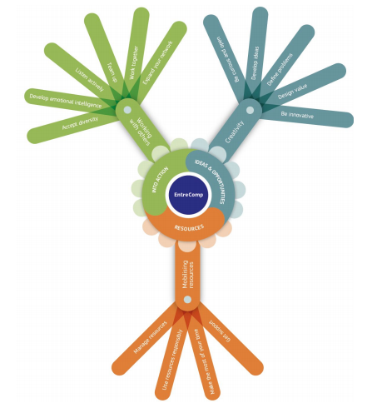

(Figure 1 from McCallum,E. et al 2018)
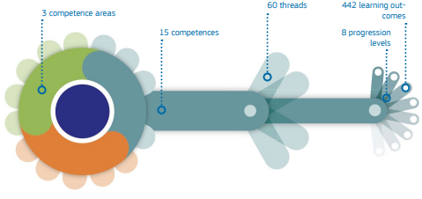

(Figure 2 from McCallum,E. et al 2018)

The model offers potential for individuals to see where their skill levels are at and see how they can improve personally. As previously highlighted, it is important as an educator to know your professional ability as well as how you can improve it in order to be a successful creative teacher. Ongoing professional development allows a “culture of learning throughout the school” and as a teacher I hope to drive creative learning throughout the school (Craft 2000), (Mizell 2010, p.18). Therefore, in this section I will assess myself against the 5 threads in the creative competence, while also exploring additional threads from 2 different competencies that I feel are closely related to creativity.

The first thread in the creativity competence is the ability to ‘be curious and open’. From reflection against the framework I believe that I am at level 3, as I am actively curious about discovering new things, while also able to explore and experiment with them in new exciting ways (Bacigalupo et al 2016). I could see this during escape room learning in university, as it required me to think beyond existing ideas, both individually and with peer support e.g. using a key as a screwdriver. This shows strength in my ability to overcome functional fixedness, the ability to use objects in a novel way during creative problem solving (Dunker 1945). Clarke et al (2017) believes that escape room learning helps overcome functional fixedness by fostering creative problem solving and allowing individuals to think ‘outside the box’. In addition, to be able to overcome the fixedness requires confidence in being able to take risks to experiment with ideas that may push you out of your comfort zone (Dunker 1945). Dacey (1989) and Brolin (1992) suggest that creative people have certain personality traits compared to those less creative, one of these traits is risk taking. However, Costa and Kalick (2008) and Trimpop (1994) suggests risk-taking behaviors are not part of someone's personality and instead are habits that can be increased in different situations. I agrees with this as I do not believe I have always been happy to take risks, but the more I gain confidence in my role as a teacher the more I am doing it, especially in situations that foster it such as escape room learning. Comments during personal teaching experience (PTE) from tutors also suggested I have the ability to overcome risk factors stating “You are not afraid to 'give things a go', which is a very good attribute to have in teaching” and “the school and staff complement you on your 'have a go' mindset” (Appendix 1). Nevertheless, to improve and progress to level 4 I need to be able to actively search for new solutions to meet my needs (Bacigalupo et al 2016). Ok Go (2017) believes that creative individuals do not just wait for an idea, they actively go out and find them. Therefore, to do this I will begin to use different techniques to help brainstorm ideas as Shellcross (1981) suggests that individually brainstorming ideas is a vital aspect in stimulating creative solutions. I will need to ensure to have a conducive environment and take breaks to relax my mind to generate ideas. This is supported by Idea Sandbox (2019) who suggest performance = potential-interference and recommending relaxing the brain help generate ideas e.g. cloud gazing.
Although the focus of this reflection is creativity, as I stated previously within the Entrecomp Framework there are several other competencies that closely relate such as motivation and perseverance, with the thread to ‘be resilient’ and being able to ‘cope with uncertainty and ambiguity’ I believe these are equally as important skills to have to be a creative teacher as, to be creative you must have resilience, persistence and control over your surrounding environment (Craft 2005), (Woods 1990). I believe I am at level 3 on both threads as I can persevere and overcome simple adversities and identify what factors can help reduce uncertainty (Bacigalupo et al 2016). A particular time I demonstrated this was during an observed lesson on PTE, I had planned to teach an introduction in the lesson prior to being observed but due to schedule change the children visited the local church instead and therefore I had to change my plans the morning of observation. Comments from my tutor stated “you demonstrated your professionalism and flexibility as your plans had to adjust quickly for today’s session” as “the children had been out on a visit and this had shortened your session – you coped well” (Appendix 2). In my ARC I also highlight how after the session I was initially disappointed with the lesson but proud of myself for overcoming the problem, I also highlight how I was able to discuss with my Tutor ways to help be more resilient and cope with uncertainly, it also highlights how I could have postponed the experiment to make sure I taught the introductory session in greater detail (Appendix 3). Therefore, to progress to level 4 I need to be able to establish when things are not worth continuing with due to the risks and uncertainty being too much (Bacigalupo et al 2016). To do this I will ensure to develop a positive mind set and stay prepared to have a clear mindset about the learning. This is supported by Coutu (2020) and Scott (2019) who believes resilience and uncertainty can be emotionally draining and therefore need a clear mindset and attitude to identify when ideas are not worth continuing with, there in lessons I need to consider if there is too much input needed for little outcome and progression from children.
Moreover, another thread in the creativity competence is the need to ‘define problems’. From looking at the framework I believe I am at level 3 as I am good at identifying and experimenting with my problems (Bacigalupo et al 2016). I know this as while on PTE I completed daily ARCS, end of week reviews and action plans to define problems in my teaching (see appendix 4), not only this but formative comments from mentors support stating I have “continually reflected on your teaching, you openly discuss how you feel your lessons have gone noticing issues and you take any constructive criticism well” and I also “accept advice on problems and develop these targets immediately.” However to reach level 4 I need to improve my ability to define problems by reframing them to fit my skills (Bacigalupo et al 2016). To do this I need to ensure to consider all possibilities and not disregard options as Desailly (2015) highlights an element of creativity is putting different or disparate ideas together and therefore is important to encourage all ideas in the first instinct. Albert Einstein once said, “If I were given one hour to save the planet, I would spend 59 minutes defining the problem and one minute resolving it.” emphasising the need to focus on defining problems with a range of solutions. This is supported by Lash (2009) and Careerbuilder (2017) who states that creativity is dependent on the ability to define and reframe problems, as If you define problems too narrowly the possible solutions may be uncreative and limited.
The next thread is the ability to ‘develop ideas’, the writer believes they are at level 2 as they are able to develop and expand ideas alone or as part of a team to create something relevant (Bacigalupo et al 2016). I know this as I have completed multiple tasks within university that supports this such as ‘how many uses are there for a shoe’. As you can see from Appendix 5, I developed many ideas and elaborated them also. My ability to develop lots of ideas and expand on them with others incorporates three elements of divergent thinking, fluency, collaboration and elaboration. Torrance (1974) believes that two of these elements can be used to assess creativity and therefore supports the fact I have a foundation to being creative. However, to improve my development of ideas and reach level 3 I need to begin to experiment with more techniques and look for alternative solutions for problems (Bacigalupo et al 2016). Therefore, I need to use solutions such as prototyping to help develop ideas to see if they will be successful or fail. Berend, Dijk, Benammar (2014) supports highlight that testing and evaluating prototypes and ideas is a key aspect of successful ideas. I could see this when completing the marshmallow challenge (see appendix 6), I failed to refine my ideas until the last minute causing my product to fail. This can also be seen during my creative teaching as during a session I failed to refine my ideas resulting in children lacking understanding “Caitlin needs to be clear and refine the best way to introduce a challenge.” Therefore, when developing ideas, I need to ensure to continually prototype, evaluate and refine my ideas prior to executing them to ensure success.

An additional thread is the ability to ‘design value’. I feel that the Framework has limitation in relation to creative teaching as some strands do not closely relate. I believe this strand has a more direct focus on the ability to design an entrepreneurial product as opposed to creative teaching. Therefore, I believe I have not had enough experience designing creative objects and feel that this is an area of creativity I struggle with. I believe I am at level 2 within my teaching as I can assemble and use objects that create value for me and my pupils and adapt them to fit my needs (Bacigalupo et al 2016). An example of this would be on PTE, while in Year 6 the children were used to having a male teacher and therefore, I initially struggled with classroom management. However, to overcome this I re-arranged the layout of the classroom and changed the seating plan to help fit my needs as a teacher. To get to level 3, I need to “identify the basic functions that a prototype should have to illustrate the value of my idea” (Bacigalupo et al 2016, p.24). As I previously highlighted, improving my ability to prototype and refine ideas to increase creative value is an aspect I need to work on.
The final thread in the creativity competence is to ‘be innovative’. Another limitation with the model is that it is a best fit, whereby you have to put yourself at one level. However with this thread I feel that I can do aspects in many of the levels but would not say I had a competence in them and therefore feel restrict from judging myself as higher. Nevertheless, on reflection I believe I am at level 2 as I can identify innovative products and how they impact me and society; however I am not very good at discovering or experimenting with different types of innovation (Bacigalupo et al 2016). De bono (1985) highlights that at times lateral thinking is needed to focus creativity towards the process of innovation, while Moyles (2007) highlights how products of creativity need to be innovative to be truly creative. However innovation itself is measurable as it is “the process that transforms those forward-looking new ideas into real world” (Smart Storming 2018) therefore, to get to level 3 I need to explore in more detail aspects of innovation and strategies that can be used and incorporated into my creative ideas. To do this I will use Seelig (2017) innovation engine (see appendix 6) who suggests that to be innovative you need to develop 6 components and spark them all together to create something innovative. I believe if I focus ideas on each component I will improve my ability to be innovative.
Overall, I feel that I do have the ability to be a creative teacher and have good understanding on the matter; however I found reflecting on my creative ability very difficult as I felt the Entrecomp Framework in some instances was difficult to relate to teaching and therefore reluctant to mark myself higher due to uncertainty.
How to Improve Children's Creativity
As previously discussed changes in external pressures now demand for children to be equipped with more ‘soft skills’ and attitudes that will help them in the uncertain future. Donaldson (2015, p.29) emphasises this through his 4 purposes for the curriculum, stating how children need to be “ambitious, capable learners” who are “enterprising, creative contributors” in order to be successful in life. Creativity and enterprise skills allow children to have freedom with their learning, to be able to problem solve and build confidence in their abilities through life (Craft, Jeffrey and Leibling 2001), (Wilson 2009) and (Fisher and Williams 2004). However, there are many factors that can affect whether learners do develop these competencies or not.
From personal experience many children in the 21st century are confident, experimentative individuals who enjoy challenges and taking risks, however this cannot be said for all. In Maslow's hierarchy of human needs, ‘self actualisaion’ and the ability to be creative is at the top of the triangle and therefore will only be achieved if other basic needs are met. In some cases, children have low self-esteem while others do not have basic psychological needs, which as a result inhibits creativity. Dacey and Lennon (2000) suggests there are four distinctive attributes for creative learners: self-control, sustained hard work, determination and perseverance. This is further supported by Brolin (1992) who believe creative individuals have a set of clear personality attributes which allow them to be successful. This suggests unless children have these attributes, they will not be creative. Nevertheless, all children have the same creative rights, Beetlestone (1998) and Bowkett (2007) emphasises how not all children will respond to creativity in the same way due to personal qualities but should still be given the same opportunities to develop skills as others. Estyn (2014) highlight how teachers cannot develop a child's understanding if they do not support the needs of the child first. Suggesting the importance of ensuring each stage of Maslow’s hierarchy is achieved before pushing a child to be creative. Therefore, I believe a way to support children is by using instructional approaches that provides memorable tools to help them think creatively and improve attributes. This is supported by Eberle (2008) who developed the SCAMPER newmonic (see appendix 7) as a creativity tool to help children's thinking. By giving children something to remember it should help all learners even those who find ‘thinking outside the box’ difficult.
Moreover, the learning environment in which creativity is developed can both improve and stifle the creative process within school, as Fisher and Williams (2004 p.1) highlight “children need the right conditions for creativity to flourish”. Therefore, as a teacher I need to be aware of conducive creative environments. One way I will support this is through developing a greater pupil led environment to learning, providing situations where children can actively input and experiment with ideas. Craft, Jeffery and Leibling (2001) and Craft (2005) support this, suggesting that creative environments should not involve teacher control towards achievement, but rather provide an environment for learners to take control of their learning and flourish with encouragement and motivation. This is further supported by Eaude (2009) who highlight that children need to be in control of their learning to allow improvement in both personal attributes and academic achievements. Furthermore, Knowles (1975) highlights that learners as well as the instructor should be involved in planning and learning process where both teacher and learner contribute, known as an andragogy approach. Therefore, if I ensure a greater andragogy approach alongside my pedagogy, it should encourage greater learner involvement which allows for greater creativity. This is supported by Biggs (2013) who believes that learners should construct their own learning. Though both Knowles and Bigg’s research are based on adult learners and therefore could be argued as not relevant for children’s learning. The writer has observed aspects of child led environment implemented into school with success e.g. pupil voice curriculum, over to you time’ and therefore believes it can be applied to younger learners. However, before introducing this approach I need to ensure the classroom is a safe place where children are happy to interact with and explore their ideas. Beetlestone (1998) and Holt (19990) suggest that without a supportive creative environment where children feel immersed to experiment, take risks and input ideas without fear of failure, creativity will not be supported. Furthered by Dweck (2012) who states that children with fixed mindsets will struggle to be creative and think beyond the box if the environment does not support failure and growth mindset. The Humanistic approach to teaching highlights that children's emotional needs must be supported first to ensure effective learning; therefore I will firstly aim to establish a safe, welcoming environment where risk-taking and failure is desired and supported. By developing a constructive approach, it will give children the opportunity to complete a task, make mistakes and then have time to reflect and learn from it. Allowing children to do this will improve resilience, as “the willingness to take risks and to go get it wrong plays a key part in the ability to be creative” (Cowley 2005, p.4).
The role of the educator is to scaffold and support creativity in the classroom, as Wilson (2010) highlights that children initially may find it difficult to think creatively beyond their own needs without significant support. Therefore, when children are completing set tasks, I will work alongside children to scaffold them until they can begin to think creatively independently. Vygotsky (1978 cited in Duffy 1998) emphasises how children need social interaction from adults for them to be able to provide opportunities that match and extend their level of development. This is supported by Cocklin et al (1999 cited in Jeffrey and Woods 2009) who suggests that children need opportunities to engage with significant others such as teachers, to nourish their creative understanding. However, as an educator it is also important not to stifle creativity and therefore would need to be cautious with my interaction. Non-interventionist approach suggests that children should be left to be creative as intervening adults can harm natural creativity (Duffy 1998). This is supported by Cropley (2001) and Russ (1996) who suggests that too much social influence from teachers can affect the way in which a child presents ideas, if teachers are overly prescriptive or discourage unexpected, unusual ideas, it can cause ridicule and therefore limit children's creativity. In addition, although modelling is often favoured in teaching methods, it could be argued that modelling creative behavior as opposed to scaffolding them is reducing students own thinking, as they are replicating teachers in tasks where imagination and creative thinking is vital (Agnes 2000). Therefore, as a teacher I will need to intervene with sensitivity, ensuring to create a balance between supporting children to be creative while not stifling it by modelling examples or being over prescriptive with comments. Furthermore, I also need to ensure not to give incentives to children who do not want to complete tasks, as Gluckberg (1962, cited in Pink 2009) suggests that teacher's interaction to provide rewards and incentives for completing or taking part in creative work limits creative thinking. The focus shifts from creative motivation to the incentive and creative thinking is narrowed, therefore, I would also ensure not to give children incentives to finish or complete work, when setting tasks.
Moreover, a key factor for helping children to become more creative is to develop and support their ability to think divergently, as Guilford (1967) suggest we need to give children the skills and opportunity for divergent thinking as opposed to convergent to improve creativity. A way in which I will do this is by ensuring children have both ‘incubation and separation’ time whereby I expose and immerse them in an idea but then also give time for them to go and think about it. This is supported by Desailly (2015) and Craft (2005) who highlights that learners need time to think creatively, with teachers making decisions and observation on the needs of class and learners to ensure balance. Furthermore, DeGraff (2015) also emphasises how teachers need to ensure balance, as teachers can limit creativity by expecting on demand creativity. Therefore, I recommend giving children thinking time prior to completing tasks or giving them enough separation time to relax and reflect between activities. This is supported by Oppeszzo (2017) who states that children have a creativity boost when they are walking, research suggests that output is increased by 60% which can continue to boost after you stop walking. Furthered by Limb (2010) who suggests that if you are relaxed and in alpha state of mind e.g walking, divergent thinking is most effective. However, as a teacher I also need to be aware of the dorsolateral prefrontal cortex (DLPFC). This is an area of the brain that activates to help you plan and filter ideas when faced with a problem, which stops some ideas surfacing therefore stifling creativity. Research by Limb (2010) suggests it becomes deactivated during improvisation. Therefore, if I feel children in my class are filtering ideas, I need to provide children with more improvisation activities to encourage creative thinking e.g fortunately/unfortunately (See appendix 8)
To conclude, throughout this writing it has been clear to see there are many benefits and limitations to teaching and learning creatively, with there being numerous opinions and research into how it can be fostered effectively. Although the approach requires rigorous commitment and reflection, the writer does appreciate the importance of it in the 21st century education, due to the ever-increasing demands for confident creative children within the world of work. The writer appreciates how creative approaches inspire children and their learning and can open a world of opportunities for the future (Desailly 2015), (Craft 2001) (Duffy 1998). As Donaldson (2015) proposes a direct focus on creativity and enterprise skills within the 4 purposes of the curriculum, the writer hopes that the overall perception of these skills and their need to be developed within education will increase through the implementation of the new curriculum. The writer looks forward to becoming a more creative teacher, as it allows for a greater stimulating, engaging environment, however, does still require the need for balance and integration with other aspects of learning e.g. knowledge.
Word Count: 5443

Reference List

Agnes, M. (2000) Webster’s New World College Dictionary. Foster City CA: IDG Book Worldwide Inc.
Bacigalupo,M. et al (2016) Entrecomp Framework The Entrepreneurship Competence Framework, Luxembourg: Publication Office of the European Union.
Beetlestone, F. (1998) Creative Children, Imaginative Teaching, Buckingham: Open University Press.
Biggs, J.B. (2003). Teaching for quality learning at university (2nd ed). Buckingham: Open University Press/Society for Research into Higher Education.
Bowkett, S. (2007) 100+ Ideas for Teaching Creatively. London: Continuum Publishing Group.
Brolin, C. (1992) Creativity and critical thinking. Tools for preparedness for the future in Krut,53, 1992, pages 64-71
McCallum,E. et al (2018) EntreComp into Action: get inspired, make it happen (M. Bacigalupo & W. O’Keeffe Eds.) Luxembourg: Publications Office of the European Union.
Clarke, S. J et al (2017). EscapED: A Framework for Creating Educational Escape Rooms and Interactive Games to For Higher/Further Education. International Journal of Serious Games, 4(3).
Costa, A., Kallick, B. (2008) Learning and Leading with Habits of Mind, Virginia: ASCD.
Craft, A (2009) ‘Changes in the Landscape for Creativity in Education, in Wilson,A. Creativity in Primary Education 2nd ed, Exeter: Learning Matters.
Craft, A. (2000) Continuing Professional Development: A Practical Guide for Teachers and Schools, London: Routledge.
Cowley, S. (2005) Letting the Buggers Be Creative, London: Continuum.
Craft,A. (2005) Creativity in Schools, Oxon: Routledge.
Craft,A. Jeffery,B. and Leibling,M. (2001) Creativity in Education, London: Continuum.
Cremin,T. (2009) Creative teachers and creative teaching, in Wilson,A Creativity in Primary Education 2nd ed, Exeter: Learning Matters.
Cropley, A. (2001) Creativity in Education and Learning. Oxon: Kogon Pages Ltd.
Dacey, J.S. (1989) Fundamentals of Creative Thinking, Lexington: Lexington Press.
DeBono, E. (1985) Six Thinking Hats: An Essential Approach to Business Management, New York: Little, Brown and Company.
Desailly, J. (2015) Creativity in the Primary Classroom, 2nd ed. London: Sage Publications.
Donaldson (2015) Successful Futures. Cardiff: Crown.
Duffy, B. (1998) Supporting Creativity and Imagination in the Early Years. Buckingham: Open University Press.
Duncker K. (1945) On problem-solving. Psychological Monographs. 1945;58(5) Whole No. 270).
Eaude,T. (2009) Creativity and Spiritual, Moral and Social Development, in Wilson,A. Creativity in Primary Education 2nd ed, Exeter: Learning Matters.
Eberle, B. (2008). Scamper: Creative Games and Activities for Imagination Development. Texas: Prufrock Press.
Education Scotland (2013) Creativity across learning: 3-18. Available at: https://education.gov.scot/improvement/Documents/cre39-impact-report.pdf (Last Accessed 2nd January 2020).
Eurydice (2016) Entrepreneurship Education at School in Europe: Eurydice Report, Luxembourg: Publications Office of the European Union.
Fisher, R (2004) ‘What is Creativity?’ in Fisher,R. and Williams,M. Unlocking Creativity. London: David Fulton Publishers Ltd.
Fisher, R. (2002) Creative Minds, Building Communities of Learning for the Creative Age, Hong Kong: Pantaneto Press. Available at: http://pantaneto.co.uk/creative-minds-building-communities-of-learning-for-the-creative-age-robert-fisher/
Fisher,R. and Williams,M. (2004) Unlocking Creativity. London: David Fulton Publishers Ltd.
Glucksberg, S. (1962). The Influence of Stength of Drive on Functional Fixedness and Perceptual Recognition. Journal of Experimental Psychology, 63(1), 36-41.
Grigg, R, (2015) Becoming an Outstanding Primary School Teacher, Oxon: Routledge.
Guilford, J. P. (1967). The nature of human intelligence. New York: McGraw-Hill.
Holt, J. (1990). How children fail (2nd ed.) London: Pengiun
Jeffrey, B. and Craft,A. (2004). Teaching creatively and teaching for creativity: distinctions and relationships. Educational Studies, 30(1) pp. 77–87.
Jeffrey,B. And Woods,P. (2009) Creative Learning in Primary School. Oxon: Routledge.
Knowles, M. (1975). Self-Directed Learning. Chicago: Follet.
Lucas, B. (2001) Creative teaching, teaching creativity and creative learning, in: Craft, A. Jeffrey, B. and Liebling, M. (eds.) Creativity in education pp. 35-44, London: Continuum
Mashlow,A. (1945) Motivation and Personality. New York: Harper and Row.
Millard,W. Menzies,L. and Baars,S. (Unknown) Enterprise Skills, Unknown: Enable Enterprise LTD. Available at: https://uploads-ssl.webflow.com/5a86b2cd68b41700017162ca/5abd04cb79ff8ea7be2e5140_Enterprise%20Skills%20Teachability%2C%20Measurability%2C%20and%20Next%20Steps.pdf (Last Accessed 2nd January 2020)
Mizell, H. (2010) Why Professional Development Matters, Oxford : Learning Forward.
Moyles, J. (2007) Beginning Teaching, Beginning Learning: London: Open University Press / McGraw-Hill Education.
NACCE National Advisory Committee on Creative and Cultural Education (1999) All Our Futures: Creativity, Culture and Education. London: DfEE.
Robinson, K. (2001) Out of Our Minds, learning to be Creative. Oxford: Capstone.
Russ, S.W. (1996). ‘Development of creative processes in children’. In: RUNCO, M.A. (Ed.)
Creativity from Childhood through Adulthood: The Developmental Issues, San Francisco, CA: Jossey-Bass.
Shellcross,D. (1981) Teaching Creative Behaviours. New York: Pretice Hall.
The Quality Assurance Agency for Higher Education (2012) Enterprise and entrepreneurship education, Gloucester: QAA.
Torrance, E. P. (1974) The Torrance Tests of Creative Thinking: Norms-Technical Manual. Princeton, NJ. Personal Press.
Trimpop, R. M. 1994. The Psychology of Risk-taking Behavior. Amsterdam: Elsevier.
Wilson, A. (2010) Creativity in Primary Education, Exeter, Learning Matters Ltd.
Woods, P. (1990) Teacher Skills and Strategies, London: Falmer
Young, D. (2014) Enterprise for All: The Relevance of Enterprise in Education, London: Department
for Business, Innovation and Skills (BIS).
Websites

Adobe (2012) A state of create study, Available at: https://www.adobe.com/aboutadobe/pressroom/pdfs/Adobe_State_of_Create_Global_Benchmark_Study.pdf (Last Accessed 2nd January 2020)
CareerBuilder (2017) What are problem-solving skills and why are they important? Available at: https://www.careerbuilder.com/advice/what-are-problemsolving-skills-and-why-are-they-important (Last Accessed 2nd January 2020).
DeGraff,J. (2015) The Myth of Creativity On-Demand, Available at: https://www.psychologytoday.com/us/blog/innovation-you/201504/the-myth-creativity-demand (Last Accessed 2nd January 2020).
Dweck,C. (2014). Developing a Growth Mindset with Carol Dweck [video], Available at: https://www.youtube.com/watch?v=hiiEeMN7vbQ (Last Accessed 2nd January 2020)
Estyn (2014) Understanding children and identifying needs, Cardiff: Crown. Available at: https://www.estyn.gov.wales/effective-practice/understanding-children-and-identifying-needs (Last Accessed 2nd January 2020)
Estyn (2017) Creative strategies that encourage thinking and high attainment. Cardiff: Crown. Available at: https://www.estyn.gov.wales/effective-practice/creative-strategies-encourage-thinking-and-high-attainment (Last Accessed 2nd January 2020)
Estyn (2018) Developing pupils’ skills and enthusiasm towards learning by creative planning and teaching. Cardiff: Crown Available at: https://www.estyn.gov.wales/effective-practice/developing-pupils%E2%80%99-skills-and-enthusiasm-towards-learning-creative-planning-and (Last Accessed 2nd January 2020)
George Lucas Educational Foundation (2020) Boosting Resilience Through Creativity, Available at: https://www.edutopia.org/article/boosting-resilience-through-creativity (Last Accessed 2nd January 2020)
Hilberts,B,J. Van Dijk,M., Benammar,K. (2014) Prototyping. Available at: https://www.thnk.org/insights/prototyping/ (Last Accessed 2nd January 2020).
Idea Sandbox (2019) Generating ideas, Available at: https://idea-sandbox.com/blog/idea-generation-great-ideas-looking-up/ (Last Accessed 2nd January 2020).
Land,G. (2011) George Land The Failure Of Success, Tedxtalks [video] Available at: https://www.youtube.com/watch?time_continue=4&v=ZfKMq-rYtnc&feature=emb_logo (Last Accessed 2nd January 2020)
Lash, J. (2009) Define the problem before solving it, Available at: https://www.goodproductmanager.com/2009/03/09/define-the-problem-before-solving-it/ (Last Accessed 2nd January 2020)
Leunig,T. (2016) Why real creativity is based on knowledge, Tedxtalks [video] Available at: https://www.youtube.com/watch?v=vajIsWwHEMc&feature=emb_title (Last Accessed 2nd January 2020)
Limb,C. (2010) Your Brain on Improv, Tedxtalks [video] Available at: https://www.ted.com/talks/charles_limb_your_brain_on_improv/transcript?language=en (Last Accessed 2nd January 2020).
Ok Go (2017) How to Find a Wonderful Ide, Tedxtalks [video] Available at:
https://www.ted.com/talks/ok_go_how_to_find_a_wonderful_idea?language=en#t-542157 (Last Accessed 2nd January 2020)
Oppeszzo,M. (2017) Want to be More Creative? Go for a Walk, Tedxtalks [video] Available at: https://www.ted.com/talks/marily_oppezzo_want_to_be_more_creative_go_for_a_walk?language=en (Last Accessed 2nd January 2020)
Pink, D. (2009) The puzzle of motivation Tedxtalks [video], Available at: https://www.ted.com/talks/dan_pink_the_puzzle_of_motivation (Last Accessed 2nd January 2020)
Robinson. K (2006) Do Schools Kills Creativity Tedxtalks [video] Available at: https://www.ted.com/talks/sir_ken_robinson_do_schools_kill_creativity (Last Accessed 2nd January 2020)

Scott, E. (2017) How to Cope With Stress and Become More Resilient. Available at:https://www.verywellmind.com/cope-with-stress-and-become-more-resilient-3144889 (Last Accessed 2nd January 2020).
Seelig,T. (2012) Tina Seelig: "InGenius", Talks at Google [video], Available at: https://www.youtube.com/watch?v=Dle_GvFIbqY (Last Accessed 2nd January 2020)
Smart Storming (2018) The Relationship Between Creativity and Innovation, Available at:https://www.smartstorming.com/the-relationship-between-creativity-and-innovation/ (Last Accessed 2nd January 2020).

Sommer, L. (2014) Cannes Lions 2014 workshop presentation. Available at: https://www.slideshare.net/leonardsommer3/classroomthinktankcanneslions2014 (Last Accessed 2nd January 2020)
World Economic Forum (2019) What are the 21st-century skills every student needs?https://www.weforum.org/agenda/2016/03/21st-century-skills-future-jobs-students/ (Last Accessed 2nd January 2020)

Appendix 1- Formative assessments from PTE.

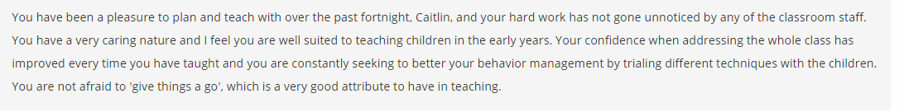

Appendix 2- Formative assessment from PTE

Appendix 3- ARC

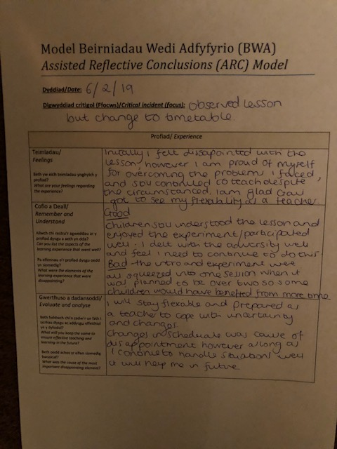

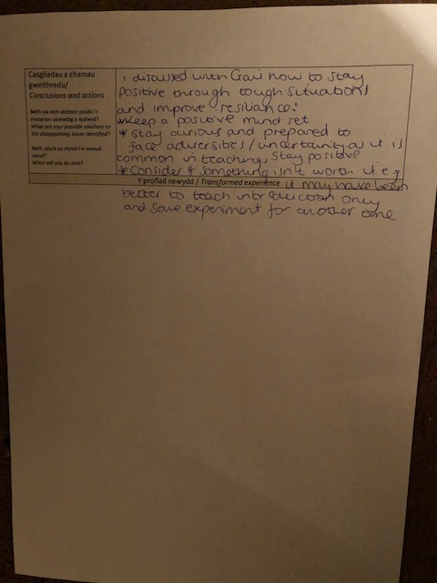

Appendix 4- End of Week Review / Action Plans

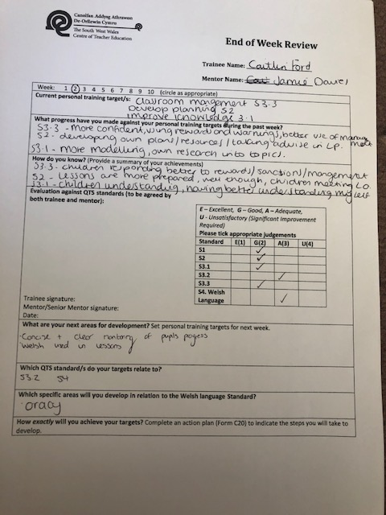

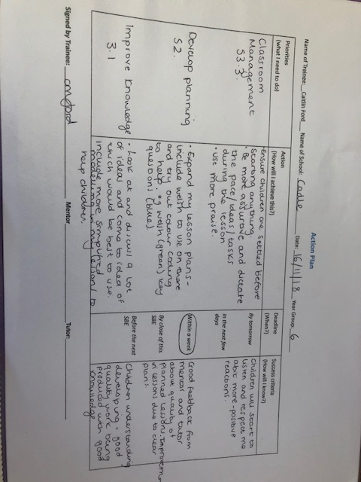
Appendix 5- How many uses for a shoe?
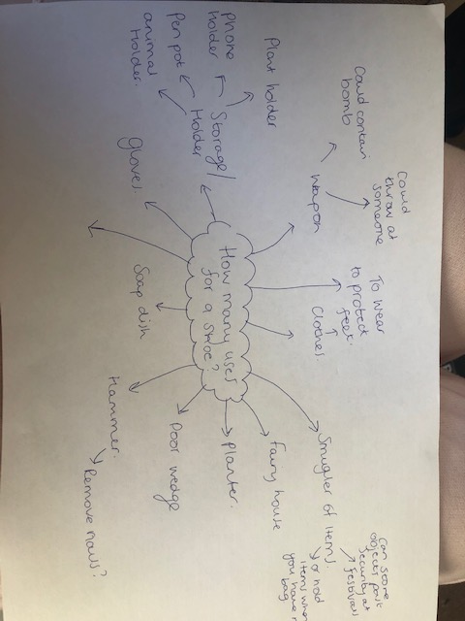

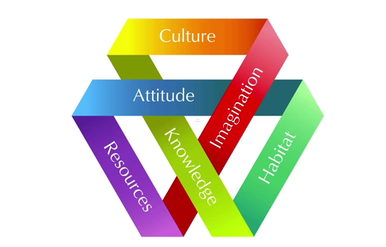
Appendix 6- Tina Seelig Innovation Engine

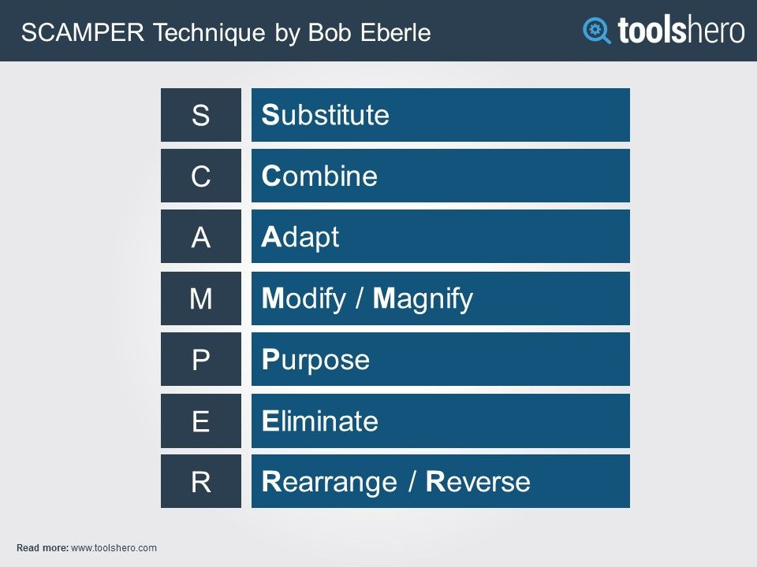

Appendix 7- Eberle’s SCAMPER Model
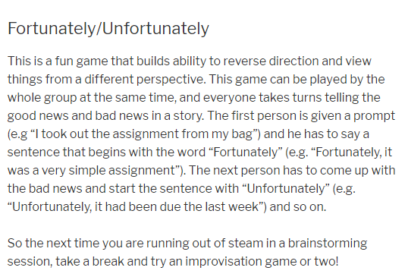
Appendix 8- Improvisation activity

