
Celebrating Language and Culture belonging to Wales.
By Sarah Hill.
(Silhouette Pics, 2020)

Contents

Rationale Pages 3 - 4

Overview Pages 5 - 6

Evaluation Pages 6-7

Appendices Pages 8-12

References Page 13

Schools is Wales are responsible for ensuring that each learner has a sense of personal and cultural identity that is responsive and respectful to others. “Under the United Nations Convention on the Rights of a Child (UNCRC) and the Rights of the Children and Young Persons (Wales) Measure 2011, all children and young people must be provided with an education that develops their personality and talents to the full.
(Welsh second Language in the National Curriculum for Wales, 2015)
The vision of Wales for a sustainable future is to enable Wales to be the “best place to live, learn and work” (Welsh Government, 2014). In the 2015 Future Generations Bill, the Welsh Government set out to achieve a better quality of life for the people in Wales. It is hoped that Wales will be a country with its population being “healthier, happier and more bilingual” (Welsh Government, 2014). The Welsh Government hopes to achieve this by the year 2050 by encouraging and promoting the welsh language to be spoken more widely.
The welsh language is one of the treasures of Wales. It is part of what defines us as people and as a nation. Our ambition as Welsh Government is to see the number of people able to enjoy speaking and using welsh reach a million by 2050.
(Cymraeg 2050: A Million Welsh Speakers, 2017).
Educating the younger generation and raising the awareness of the importance of living in Wales is a necessary element in encouraging them to achieve their full potential and to assist in making Wales a more equal and diverse society. Kirsty Williams AM (2017) stated “A nation’s prosperity, cohesions and well-being are built on a successful education system” this puts an immense amount of pressure onto schools to ensure that these elements are addressed and put into practice whilst educating todays and future generations on the importance of being welsh and promoting the welsh culture.
The Welsh Assembly was voted into power in 1998 and has played a large part in rekindling Cymraeg and nurturing it into a growing language. Welsh was included in the National Curriculum following the Education Reform Act 1988, and became a compulsory subject for all learners in Key stage one, two and three in 1990. In September 1999, welsh became compulsory for all learners across Wales at Key stage four. Investing six million pounds into teaching welsh in schools, The Welsh Assembly are actively encouraging children to speak welsh in the playground, unlike in the 1930’s where it was the only place in school that a child was able to speak welsh. As highlighted in the Donaldson report on Successful Futures (2015) “The current national curriculum arrangements no longer meet the needs of children and young people of Wales. The case for fundamental change in powerful”. Teaching welsh as part of The National Curriculum of Wales is important as it keeps the language alive which is vital for the nation’s cultural identity. It is also practical and useful for young people in Wales to understand the language of their home country. Through the new curriculum all children and young people in Wales will be “ambitious and capable learners who can communicate effectively” (Welsh in Education: Action Plan 2017-2021, 2017).
Schools in Wales have become increasingly conscious of their role in building and maintaining the welsh language. In all subjects there is a huge emphasis being placed on planning and developing activities and lessons that promote Wales and the welsh language, including cultural, geographical and historical rudiments. This not only educates the children on their local areas, it is intended to instil some pride into their local community, encourage them to be ambitious and embrace their national identity, providing them with the necessary skills to have a successful future in Wales.
The national strategy will help to develop a school system that will instil in our learners an ambition to make the most of their potential, lay the foundation for a lifetime of learning and achievement and equip them with the right skills for a changing world.
(Education in Wales, Our National Mission, 2017).
Learners explore and consider ideas through speech and language, this is in line with the National Literacy Framework and the school Literacy policy “Literacy describes a set of skills, including speaking, listening, reading and writing, which enable us to make sense of the world around us”. (National Literacy and Numeracy Framework, 2013). This provides learners with the opportunity to establish and apply knowledge and understanding of Wales’ cultural, economic, environmental, historical and linguistic features. The aim is to develop and embed literacy and Welshness across the curriculum to raise the standards of reading and writing in both languages and to understand the heritage of Wales. Lessons are delivered with the intention of all learners engaging and communicating through oracy and allowing learners to access relevant skills, knowledge and understanding of their communities and the wider curriculum of school activities.
In preparation for the implementation of the new curriculum, the school in which I am based promotes “Welshness” through activities that are historically, geographically and culturally based. Local areas are visited for Geography projects such as visiting beaches to study longshore drift, drawing the contours of local historical sites such as Pen Dinas. History trips are organised for visits to welsh castles and Celtic sites and traditions are linked with subjects such as Welsh, Drama and Music with entries for Urdd competitions and Galas giving learners an awareness of Wales’ cultural heritage. In Key stage four, learners are taught about homelessness in Wales and the various charities that help in their English lessons which links with political and social aspects of Wales. In Art they learn about various welsh artists and explore their backgrounds which links the cultural aspects of learning, other Art projects include landscapes of Wales. In Design and Technology there is focus on the economic aspects of Wales. However, in subjects such as Mathematics and Science the focus on welsh and Wales is non-existent, the main priority is to engage the pupils in learning the various mathematical problems and scientific formulas.
The activity I have focussed on is a project created in Information Technology lessons, the title of the project is Gwlad Gwlad, the resource is available for teachers to use on the Hwb website (Hwb, 2020). It is a project aimed at Key stage three pupils to create a campaign about Wales in order for learners to have a sense of belonging through exploring their knowledge of Wales. Learners are encouraged to explore and gain a sense of identity from a local, national and global perspective. Using information technology (IT) skills and research to create the project, learners learn about different aspects of wales and being Welsh. Learners are asked to identify a range of characteristics of being welsh that include history, geography, culture, tourism, language and the learner’s own personal connection to Wales. Their aim is to communicate a clear message about what it is to be Welsh and what it means to them. The project connects to various subjects such as Humanities and links with Literacy and Numeracy as is in line with The National Literacy and Numeracy Framework to interlink subjects across the curriculum. The first task is for learners to research and explore areas of Wales using various strategies, this helps learners to develop their thinking skills for “planning, developing and reflecting” (Welsh Second Language in The National Curriculum for Wales, 2015). This aspect connects with Bruners theory of “learner centre approach” (Bates, 2019). Learners are asked to watch a television advert about Wales, (see Appendix 1) then discuss what it conveys about Wales using the template (see Appendix 2). Learners are asked to consider what sort of message it is sending out about Wales and whether it is effective. Learners are encouraged to discuss their finding through Turn and Talk” as with the schools Literacy policy. This also connects to Vygotsky’s “scaffolding technique” to engage learners in the subject. (Bates, 2019). Once they have looked at the questions on the template and discussed the questions they are given a power point to gather any themes and generate what welsh identity means (see Appendix 3). Pupils are then required to create a list of specific examples of Wales or Welshness and research for further information including facts and figures. There are formative assessment opportunities within this stage of the project with Humanities, Literacy and Welsh Dimension and International Perspective. The aim is to scaffold and feed ideas into discussions so that learners can form an appropriate additional stimulus. However, the project is about choosing a message to convey through a campaign and give learners the opportunity to explore what being Welsh means to them from a personal perspective.
The second task involves planning and designing their campaign, learners are asked to design their campaign using different ideas and criteria. Learners are then required to revisit themes from the first task and add any fresh ideas to their campaign. They are then expected to design an assessment criterion for their project using the template given (see Appendix 4). Once the pupils have devised their criteria for the campaign they are then asked to create and evaluate the project. This stage of the project is a bout developing a single idea from many ideas they have produced, and learners are asked to justify their choices from their ideas. The third task engages learners with their digital competence, again connecting this to The National Literacy and Numeracy Framework (LNF) and allows learners to develop their ICT skills by “finding, developing, creating and presenting information and ideas” (Welsh Second Language in the National Curriculum for Wales, 2015). Formative assessments are given for numeracy in this stage of the project. Using Adobe Spark tools to design their brand, promotional video, graphics and webpage using wakelet .com (wakelet, 2020) for their campaign resources. (see Appendix 5). Learners continue to evaluate their ideas and designs against their criteria and adapt their work or refine it. This stage of the project gives an opportunity for a formative assessment based on digital competency. Once pupils have redefined their work, they are required to conduct a final evaluation and then finalise their ideas for the campaign. The next step is to share and reflect, learners are asked to share their campaign with the rest of the class. Once they have delivered their campaign to their peers they are requested to conduct a survey to gather feedback and reflect on the impact of their campaign using the template provided (see Appendix 6). More formative assessment opportunities are given for Literacy and the Welsh Dimension. Dewey’s belief is that “people should have a personal interest in the subject matter” (Bates, 2020). This way of working on a project allows the learner to take an interest in the cultures and traditions of their own community. Once the project is completed pupils analyse their results and complete the evaluation. The focus of this stage is to share the resources they have gathered and reflect on how effectively their project met the criteria.
The implementation of this project and the various strategies used to create the campaign follows the Curriculum Cymreig in applying the knowledge of historical, geographical and cultural aspects of Wales and Welshness.
A Curriculum Cymreig helps pupils to understand and celebrate the distinctive quality of living and learning in Wales in the twenty-first century, to identify their own sense of Welshness and to feel a heightened sense of belonging to their local community and country.
(Developing the Curriculum Cymreig, 2003)
It is important to the future generation of Wales to explore the heritage of the country, giving children and young people a sense of belonging and pride in their culture. Touching on this in the curriculum and their everyday learning gives children and young people the knowledge they need to become informed citizens. A sense of national identity is fundamental to repairing the loss of Welshness in historical events such as The Act of Union Wales 1535. To be proud of the country in which you were born is vital to the growth and understanding of children and young people that are the future of the nation. The Welsh Government aims to have one million welsh speakers by 2050, in promoting Wales and the welsh language in schools and cross curricular subjects the Welsh Government may set out to achieve what they hope to.
Within this strategy we set out our ambition for the Welsh language to be used more extensively and for the number who speak it to grow. We also set out our commitment to work towards one million people speaking the Welsh language by 2050 and to continue to invest in encouraging more people to use and speak Welsh in their daily lives.
(Cymraeg 2050: A Million Welsh Speakers, 2017)

Appendix 1
Find your Epic TV Advert 2016Visit Wales at https:/www.youtube.com/watch?v=VNL4M0IVT3g&feature=youtu.be;
(YouTube, 2020)
Appendix 2
Find Your Epic – Template 1
What message does the video clip tell us about Wales? | Do you think the video clip is effective in conveying those messages? Why?
Do you agree with the message? Is this how you see Wales? | What is the purpose and who is the target audience of the clip in your opinion? How can you tell?
(Hwb, 2020)

Appendix 3
Find Your Epic – Template 1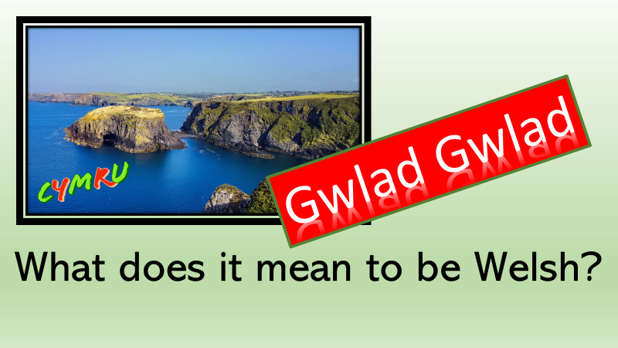
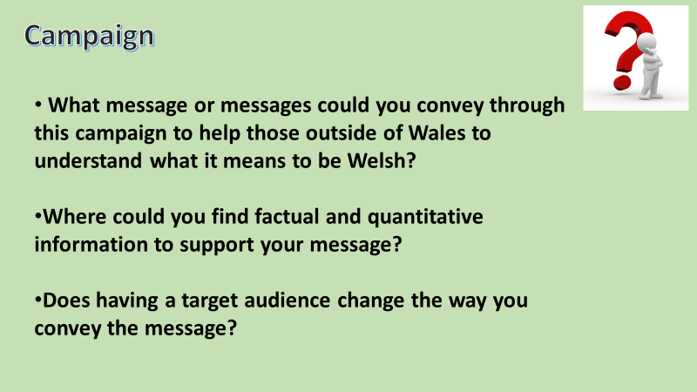
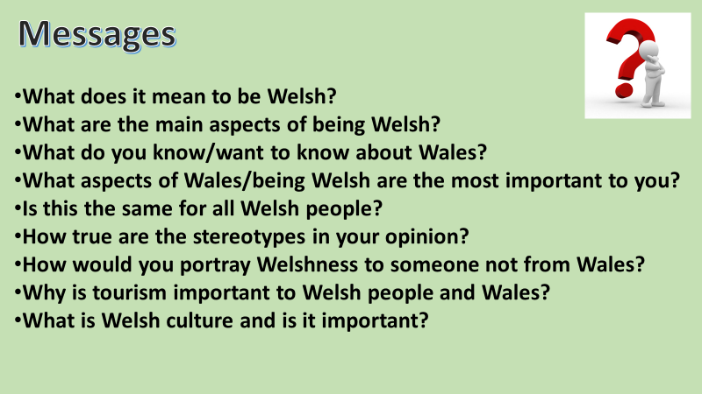
(Hwb,2020)

Appendix 4
Developing Success Criteria
Use the reflection points below to help you devise success criteria for the campaign:
Message

How will you know the message is clear?
Audience

How will you know if the campaign resources are right for the chosen target audience?
Design

How will you measure the quality of design in your resources?
Impact

How will you know if your campaign has achieved its aims?

(Hwb, 2020)

Appendix 5
https://wakelet.com/
(wakelet, 2020)
Appendix 6
Use this reflection template to take an overview of the whole project by responding to the questions in the table below. Remember this is about the learning journey through each step of the project.

Reflection Questions | Responses
Have you enjoyed this project?

What knowledge about Wales and Welshness have you learned?

Has the project enabled you to explore creativity and what this means to you?

Are you satisfied with the resources you have produced?

Did they have the response you expected from your target audience?

If you were to re-do this projects, would you do anything differently?

What advice would you give to someone who was thinking about creating a campaign?

Please note any other relevant points about the project!

(Hwb, 2020)

Reference List
Bates, B., 2019. Learning Theories Simplified. 2nd ed. London: Sage, p.44.
Bates, B., 2019. Learning Theories Simplified. 2nd ed. London: Sage, p.48.
Bates, B., 2019. Learning Theories Simplified. 2nd ed. London: Sage, p.56.
2017. Cymraeg 2050: A Million Welsh Speakers. [eBook] Cardiff: Welsh Government, p.2. Available at: <https://gov.wales/sites/default/files/publications/2018-12/cymraeg-2050-welsh-language-strategy.pdf> [Accessed 9 November 2020].
2017. Cymraeg 2050: A Million Welsh Speakers. [eBook] Cardiff: Welsh Government, p.8. Available at: <https://gov.wales/sites/default/files/publications/2018-12/cymraeg-2050-welsh-language-strategy.pdf> [Accessed 13 November 2020].
2003. Developing The Curriculum Cymreig. [eBook] Cardiff: ACCAC, p.4. Available at: <https://hwb.gov.wales/api/storage/8e68e2f5-851f-43b8-af24-9eb38cf62482/developing-the-curriculum-cymreig.pdf> [Accessed 13 November 2020].
2017. Education in Wales, Our National Mission. [eBook] Cardiff: Welsh government, p.3. Available at: <https://gov.wales/sites/default/files/publications/2018-03/education-in-wales-our-national-mission.pdf> [Accessed 10 November 2020].
2017. Education in Wales, Our National Mission. [eBook] Cardiff: Welsh Government, p.6. Available at: <https://gov.wales/sites/default/files/publications/2018-03/education-in-wales-our-national-mission.pdf> [Accessed 10 November 2020].
Hwb.gov.wales. 2020. Hwb. [online] Available at: <https://hwb.gov.wales/> [Accessed 13 November 2020].
2013. National Literacy and Numeracy Framework. [eBook] Cardiff: Welsh Government, p.18. Available at: <http://Literacy describes a set of skills, including speaking, listening, reading and writing, which enable us to make sense of the world around us.> [Accessed 12 November 2020].
Silhouette Pics, 2020. Welsh Dragon. [image] Available at: <https://www.silhouette.pics/173170/welsh-dragon-silhouette.php> [Accessed 21 October 2020].
Wakelet.com. 2020. Wakelet – Save, Organize and Share Content. [online] Available at: <https://wakelet.com/> [Accessed 13 November 2020].
2015. Welsh Second Language in The National Curriculum. [eBook] Cardiff: Welsh Government, p.5. Available at: <https://hwb.gov.wales/curriculum-for-wales-2008/key-stages-2-
2015. Welsh Second Language in The National Curriculum. [eBook] Cardiff: Welsh Government, p.6. Available at: <https://hwb.gov.wales/curriculum-for-wales-2008/key-stages-2-to-4/welsh-second-language-in-the-national-curriculum-for-wales/> [Accessed 13 November 2020].

2017. Welsh in Education: Action Plan 2017-2021. [eBook] Cardiff: Welsh Government, p.16. Available at: <https://gov.wales/sites/default/files/publications/2018-02/welsh-in-education-action-plan-2017%E2%80%9321.pdf> [Accessed 23 October 2020].
Youtube.com. 2020. YouTube. [online] Available at: <https://www.youtube.com/> [Accessed 13 November 2020].

