Assignment 1: Portfolio
Article Review:
Human rights and youth justice reform in England and Wales: A systemic analysis.
Cunneen, Chris; Goldson, Barry; Russell, Sophie. London, England: Sage Publications, Criminology & Criminal Justice, 2018-09, Vol 18 (4), p.405-430
The article written and researched by Cunneen, Goldson and Russell can be found as a part of the Criminology and Criminal Justice journal published by SAGE (They are an independent company which primarily publishes many scholarly books and journals in many different academic fields including criminology). According to the journals description on the SAGE Journals website it aims to focus on the broad field of criminology and criminal justice by providing a number of peer-reviewed scholarly articles for those who are interested. In addition to being the official journal for the British society of Criminology and Criminal Justice it also aims to add articles from an international background if they are of interest to the readership of the journal (SAGE 2020).
According to the abstract of the article one of its primary aims is to critically examine the relationship between youth justice reform in both England and Wales as well as the provisions of international human rights instruments. It explores this relationship by delving into different subjects such as the Human Rights Framework, Youth Justice Reform in England and Wales between the years 1991 -2016 along with an analysis into how the criminal justice system deals with human rights standards, law and policy.
In the introduction it explains how that the article and its research is taken from CYPP (The Comparative Youth Penality Project). This projects aim according to its official website is to study and to understand the developments of how the youth have been punished in the past quarter of a century in both Australia, England and Wales (UNSW Australia 2016). The Research team involved a partnership of different professors from both the University of New South Wales including those mentioned at the beginning of the review as well as the University of Liverpool. Although they researched and published this article on England and Wales, almost all of the other published material made by the CYPP has been solely focused on Criminal Justice issues in Australia.
Prior to delving into the main body of the article and discussing the subject matter, it states that within the context of looking at youth justice reform in England and Wales you would first look at the Criminal Justice Act of 1991. This act would be seen as the last legislation made by the United Kingdom government before they took a major turn and implemented major changes to the Justice system. In the CJA act of 1991 added many new legislations which gave new powers to the courts on how they would deal with offenders, how the prison system releases prisoners and how the Justice system deals with both children and young persons.
According to Barry Goldson (2020, pp. 323-324) in one of his research articles on the subject of Youth Justice reform in England and Wales, the Conservative Government of the 1980’s and early 90’s (led by former Prime Minister Margaret Thatcher) aimed to try and reduce the number of criminal convictions of the youth of the United Kingdom (Goldson 2020, p.323 – 324). To achieve this task they introduced new legislations within the Criminal Justice Acts of 1982, 1988 and as previously mentioned the Act of 1991. These new legislations included allowing the Police service to give out warnings and other cautions instead of having officers arrest younger people which would have boosted the youth conviction statistics. The decision to allow the police to decide how they would approach cautioning and prosecuting young offenders/children can also be traced to the legislation found in the Home Office Circular 59/1990 (Home Office 1990).
The first section of the article delves into the subject of the Human Rights Framework. The research team explains how that the youth justice of both England and Wales belongs within the ‘contemporary international human rights framework’. They explain how there are three critical aspects to the framework, the ‘Beijing Rules’, the ‘Riyadh Guidelines’ and the ‘Havana Rules’. These instruments led to the creation of the United Nations Convention on the Rights of the Child (UNCRC) in 1990. The UNCRC consists of a total of 54 articles which detail out all the basic human rights all children are entitled to in their lives, these would include the protection from all discrimination that a child could potentially face e.g. their race or religious beliefs (UNICEF 2016). This convention has been signed and agreed by all of the countries belonging to the United Nations (excluding the United States of America).
One of the most interesting questions raised in this section of the article is brought up by Goldson, he asks how the benefits of the UNCRC convention possibly extend out to children globally who are still in the margin of being poor. He also brings attention to the reader multiple statistics about child poverty which are quite alarming. These statistics would include how over 28,000 children died everyday due to causes related to poverty In 2004, how in 2015 there were over 1 billion children who did not have access to clean drinking water or a competent health care service in case of illness or injury(Goldson and Muncie, 2009). This could possibly raise the question of the reader that if the UN member states signed up to the UNCRC in aims of protecting the rights of children globally, why is there still such a high number of children still living in poverty throughout the world?
The second main section of the article is titled ‘Youth Justice Reform in England and Wales 1991 – 2016’. The aim of this section is to give a brief 2 page explanation to the reader on how Youth justice reformed in the 25 years between the introduction of the Criminal Justice Act of 1991 to the year 2016, it does this by splitting the 25 year gap into three key time periods, 1991-1997, 1998-2008 and 2009-2016. Once again Goldson uses the CJA 1991 as the foundation of his discussion on how youth justice was reformed in England and Wales, he give examples as to how this happened e.g. the act erased prison custody of boys aged 14 years old and how it also ended remands for boys aged both 15 and 16 years old.
Although he gave the aforementioned examples as to how the youth justice had changed, he claims that this article is not the place for him to discuss and analyse the ‘principle drivers’ of the youth justice reform past the year of 1991 when the CJA 1991 had been introduced. Instead of discussing it in the article and giving the reader more of an understanding into the subject matter, Goldson instead notes that the reader should look at another one of his published pieces of literature titled ‘The circular motions of penal politics and the pervasive irrationalities of child imprisonment’. By doing this he has given any reader of the article who may not be too familiar with the topic of Youth Justice with a clear piece of literature in which they can gather a further understanding and insight into the work that Goldson has done.
The research team implemented the use of a line graph within this section of the article to show the number of Child imprisonment within England and Wales between the years 1992 – 2016. We can see that between the years of 1992 to 2008 the number of children who were being imprisoned grew from approximately 1400 to over 3000. Goldson believes that the reason for this dramatic increase of child imprisonment between this period would primarily be because of the introduction of ‘New Labour’ under the leadership of Tony Blair being elected as the government of the United Kingdom. He states that this new tougher approach by the elected New Labour can be clearly seen from the White Paper titled ‘No More Excuses: A New Approach to Tackling Youth Crime in England and Wales’ (Home Office 1997), these new approaches to youth Justice included localised child curfew plans, detention and training orders and Anti-Social behaviour orders(Goldson 2010).
The third and final section titled ‘A Systemic Analysis’ contains the bulk of the research article. It states that prior to having a decent understanding of the relationship between human rights and youth justice reform in England and Wales, you must first look at and analyse each point of the system and how it works. These different points of the system include looking at the Minimum age of criminal responsibility, Policing, Freedom of movement and association, Courts and judicial proceedings, Privacy, Criminal Records and Penal detention.
In the subsection titled ‘Minimum age of criminal responsibility’, Goldson and the rest of the research team bring up one significant issue that the youth justice system in England and Wales face. This issue being that the doli incapax doctrine (this is the belief that children aged between 10 to 13 years old are not mature enough to understand the difference between right and wrong) had been removed by the New Labour government with the Crime and Disorder Act of 1998 (Cunneen, Goldson and Russell. 2016, page 410). Unfortunately England and Wales fall below the standard of MACR compared to the European Union with their minimum age of criminal responsibility being the age of 14 years old. To reiterate the point that the youth justice system needs to be reformed, the research team (2016, p.411) mentions that the United Nations Committee on the Rights of the Child (UNCRC) advised the UK to raise its MACR to an acceptable international standard and that they have seen minimal prospect of there being any form of progressive reform.

The analysis continues to point out how the children and the youth population of England and Wales are suffering due to the fact that the Youth Justice system in the United Kingdom is flawed compared to many of the other UN member states in Europe. The article explains that since the introduction of new police powers over the past 25 years with such practices as Stop and Search and keeping offenders in police cells overnight, it has clashed with many of the rights the United Nation has set out for Children (Cunneen, Goldson and Russell. 2016, Page 411). They also explain that one of the major issues the UNCRC had with the police services in England and Wales is their practise of retaining the DNA of Children, guilty or those who are innocent (2016, page 414).
The article concludes by overviewing many of the issues which surround the Youth Justice system in England and Wales. These issues would include the approach New Labour took with being stricter with young offenders and the fact that it was raised by the UNCRC that the United Kingdom’s minimum age of criminal responsibility is not on par with the international standard. They also state that although child imprisonment has declined in England and Wales post 2008 when the new Conservative government was elected under David Cameron (this decline can be seen in the graph previously mentioned in the article) this does not mean that the human rights issues for children have reduced or if the youth justice system has improved dramatically. They then end the article with the conclusion that England and Wales ‘scant regard for the human rights, needs and prospects of a profoundly disadvantaged population of children’ (2016, p.425).
Overall the article gives an informative insight into the relationship between youth justice reform in England and Wales with international human rights instruments over the 25 year period of 1991 to 2016. It introduces the reader into the important human rights framework by explaining how the United Nations have brought forward many legislations over the years to protect the livelihood of children. The research team also highlight very well how the Youth Justice system in England and Wales is deeply flawed and how instead of it improving over time it instead has remained being problematic and continues to fail children and the youth of this country. This research article would be ideal for both beginners to the subject as well as those who are well versed in Youth Justice Reform as it contains plenty of references to in depth research conducted by the members of the research team.

Article Review - Bibliography
Cunneen, Chris; Goldson, Barry; Russell, Sophie. London, England: Sage Publications, Criminology & Criminal Justice, 2018-09, Vol 18 (4), p.405-430
Goldson, B. (2010) The sleep of (criminological) reason: Knowledge—policy rupture and New Labour’s youth justice legacy. London: Sage.
Goldson, B. (2020), Excavating Youth Justice Reform: Historical Mapping and Speculative Prospects. The Howard Journal of Crime and Justice, 59: 323-324.
Goldson, B., & Muncie, J. (2009). Youth Crime and Juvenile Justice Volume 3: Children's Rights and State Responsibilities. London: Sage.
Home Office (1990), Circular 59/1990: The Cautioning of Offenders (London: HMSO)
Home Office (1997) No more excuses: A new approach to tackling youth crime in England and Wales. London: The Stationery Office
SAGE Journals, (2020). Journal Description: Criminology & Criminal Justice: SAGE Journals (ONLINE). Available at: https://journals.sagepub.com/description/crj. Accessed 11th November 2020
UNICEF (2016). The United Nations Convention on the Rights of the Child (ONLINE). Available at: https://www.unicef.org.uk/wp-content/uploads/2016/08/unicef-convention-rights-child-uncrc.pdf. Accessed on the 12th November 2020
UNSW Australia, (2016). About the Comparative Youth Penality Project (ONLINE). Available at: https://tinyurl.com/y4uaeamu. Accessed on the 11th November 2020

Portfolio: Academic Poster

Introduction
Prison design in England and Wales and its effects on the mental health of Inmates.

Super Prisons
Victorian Prisons
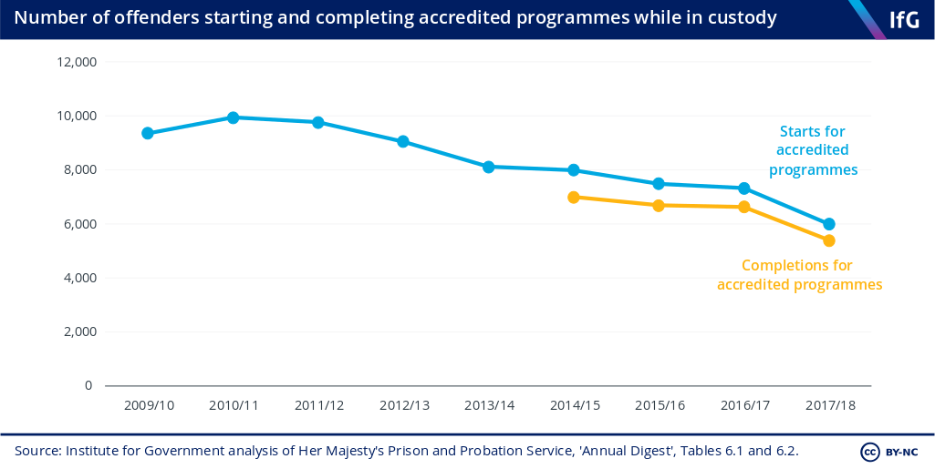
Since the turn of the millennium the number of those who are imprisoned in England and Wales has increased significantly. Although the British government under the leadership of the Conservative party have made a number of cuts to public services including prisons, they have tried to combat the rising number by following the example of the US and building larger more secure prisons.
HMP Berwyn located in Wrexham, North Wales (built in 2017) is currently one of the largest prison in the United Kingdom. It is designed to hold a total of 2,106 prisoners at one time, however it has yet to reach maximum capacity (See Figure 2 & 3 for prison population statistics as of 2019). In March 2019 the Chief Inspector of Prisons led an inspection of the prison to see how effective it was being run. He came across a number of issues which affected the mental health of inmates being imprisoned (Justice Inspectorates 2019):
- Prisoners who were forced to self-isolate were lacking their basic requirement of social contact, fresh air and food.
- Access to drugs in the prison were too readily available for prisoners.
- The prison staff did not have an action plan to try and reduce incidents of violence taking place.
- Staff inexperience had a major negative effect on life in the prison and caused the prisoners to be frustrated.
Unfortunately from the issues raised by the Chief Inspector of Prisons the standards of the mental wellbeing of these inmates have not been met and there is plenty of room for improvement.
Although these new prisons have been built within the past decade, according to Professor Yvonne Jewkes (Prison Service 2017, p.18) states that “one of the astonishing features of new prisons is how similar they look and feel to their Victorian predecessors”. She continues to state that although they may look modern and bigger, they still share similarities with the inclusion of cells, barred windows and lack of spaces for inmates.

The Victorian prison system (which became the basic prison model which many nations followed and still use to this day) is an outdated problematic method in dealing with those who are convicted. The British government enforced a punitive system in which inmates were treated with no remorse and confined in overpopulated prisons with worryingly poor health conditions (Godfrey & Price 2019). Prisoners were also forced to perform tasks of hard labour while serving their prison sentences in hopes it would instill a work ethic once they reform and be released after their sentences.
The first prison which the government officially built was Pentonville (Located in London) which opened in 1842. Although it was primarily used as a holding area for convicts which were transported on Prison Hulks to Australia, it became the archetype model for all future prisons which were built in this period (Moore 2019, p.61).
As we can see from figure 1, Prisons during the Victorian era were designed to securely confine inmates within the walls. Similarly to castles and other fortified buildings, these prisons had high walls and were protected by armed guards. The deprivation theory would be linked to the Victorian prison system as its main goal was to punish inmates by removing their freedoms. American Criminologist Gresham Sykes (1958) believed there were five factors of imprisonment which lead to inmates developing negative attitudes and beliefs which prevented them from reforming, these included:
- Deprivation of Goods and Services
- Deprivation of heterosexual Relationships
- Deprivation of Liberty
- Deprivation of Security
- Deprivation of Autonomy
Although the Justice system has reformed in the United Kingdom since the first introduction of prisons in the Victorian era, the prisons themselves have not drastically changed in design or practice since the 2000’s.
Since the beginning of the 18th Century prisons have become the primary means of punishment for those who have been convicted of crime in England and Wales. The prison system and prisons themselves have evolved over the centuries from the older outdated Victorian designs to the modern ‘Super’ prisons and the Rehabilitation prisons.
Studies over the years have shown how different prison architecture design can have a significant effect on the mental health of the prisoners. This poster aims to show how the older more well-known prison design which has been in use since the Victorian era may cause negative mental health effects compared to the newer Rehabilitative prisons.
According to researchers there are two primary theories when it comes to how prison design can effect prisoners mentally, these are the Deprivation Theory and the Situational Theory.

Figure 4: The Number of prisoners who start and complete accredited programmes

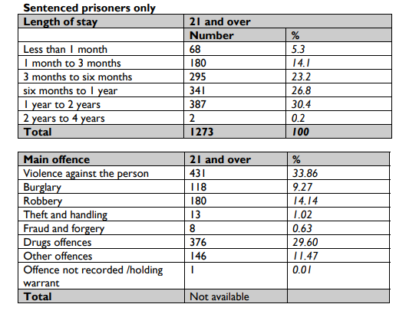
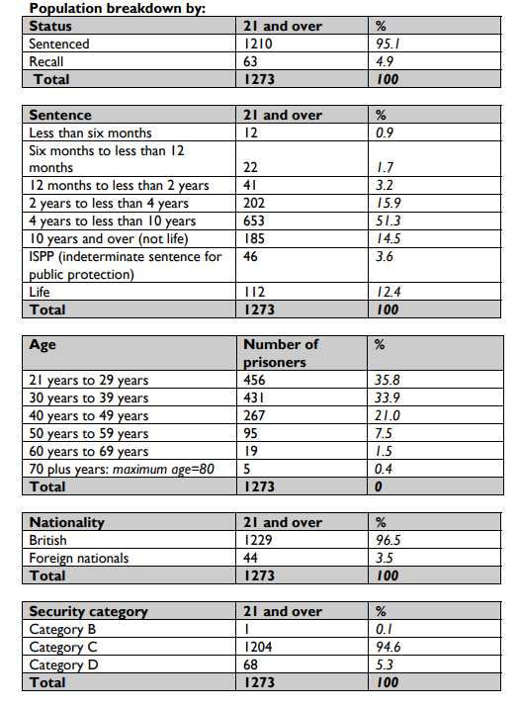
Figure 3: Berwyn Prison Population Statistics 2019
When it comes to the mental health of prisoners it is clear to see that when you incarcerate them in overpopulated prisons their mental health is going to suffer tremendously. The deprivation model which prisons in England and Wales have used since the Victorian era can be seen as being incredibly flawed, this being because the prison population has increased significantly in the past 30 years (Commons Library 2020) and 48% of adults are reconvicted within one year of being released (Ministry of Justice 2019). The Rehabilitative approach which countries like Norway have taken has been seen as the successful alternative to dealing with those convicted. Although the British Government has tried to implement some rehabilitation methods in the newer prisons like HMP Berwyn, they still have a long way to go before they reach the success of the Norwegian Justice System.
Figure 1: Pentonville Prison Victorian Era
Figure 2: Berwyn Prison population statistics 2019
Conclusion
Rehabilitation has become one of the primary aims for prisoners who have entered the prison system. The United Kingdom (as seen from figure 4) over the past decade has become less efficient in its approach to rehabilitate inmates with qualifications for when they are released. The HM Prison service has tried to combat this by introducing rehabilitate measures in many of their prisons including HM Berwyn. Within most cells of the prison, inmates have access to an en suite toilet and their own personal laptop. Although they have included these new additions, inmates are still facing many issues within these prisons as seen from the report by the Chief Inspector of Prisons in Berwyn.
When it comes to rehabilitation in prison most would look at the Norwegian justice system as the model to follow. Instead of punishment they use prisons as a means of rehabilitating offenders for when they are released back into society. Unlike the United Kingdom and the United States, the Norwegian justice system spends a significant amount more money per inmate:
- Halden Prison, Norway - £70,000 (Benko 2015)
- Berwyn Prison, Wales - £36,000 (The Guardian 2019)
- United States average - £23,400 (Benko, 2015)
They invest this extra funding into educational programmes which give inmates to find employment and integrate back into Norwegian society with ease. These educational programmes can lead to inmates receiving diplomas and in turn allowing them to achieve degree level qualifications (BBC 2019). This extra funding also allows for there to be an increased amount of staff to work alongside the inmates which would allow more 1 on 1 interactions and healthier relationships. This ties in to the situational theory of prison design and how if the inmates have a positive prison experience there is more chance of them reforming and not reoffending once released.
Rehabilitative Approach
Deprivation Theory
This is the theory that when prisoners are put in an environment which restricts them from the many liberties that they had prior to imprisonment, they must adapt to this new harsher lifestyle. This new adaptation to the prison lifestyle leads to negative values and attitudes towards fellow inmates and the authorities that imprison them ((Paterline & Petersen, 1999; Sykes & Messinger, 1960).
Situational Theory
This theory suggests that the situational circumstance (e.g. the relationship between inmate and prison staff as well as the prison environment) can affect the attitude of those who are imprisoned (Endler & Magnusson, 1976). A negative prison environment and experience could lead an inmate to not reform and instead continue their criminal nature which caused them to be imprisoned in the first place.

Prison Design Theories
Academic Poster – Bibliography

BBC (2016). How Norway turns criminals into good neighbours. Available at: https://www.bbc.co.uk/news/stories-48885846. Accessed on 15th November 2019
Benko, J. (2015). Big Home: The strange and radical humaneness of Norway’s Halden Prison. New York Times Magazine; New York.
Commons Library (2020). UK Prison Population Statistics. Available at: https://commonslibrary.parliament.uk/research-briefings/sn04334/. Accessed on 15th November 2020
Endler, N. S., & Magnusson, D. (1976). Toward an interactional psychology of personality. Psychological Bulletin
Godfrey, B., Price, K. (2019). Victorian Systems will not solve modern prison health problems. LANCET, vol 393.
Justice Inspectorates (2019). Report on an unannounced inspection of HMP Berwyn by HM Chief Inspector of Prisons. Available at: https://www.justiceinspectorates.gov.uk/hmiprisons/wp-content/uploads/sites/4/2019/07/Berwyn-Web-2019.pdf. Accessed on the 13th November 2020
Ministry of Justice (2019). Proven reoffending statistics quarterly: April to June 2017. London: Ministry of Justice
Moore, J.M. (2019). Behind Victorian Bars. History Today Ltd. Vol.69, p.60-66
Paterline, B. A., & Petersen, D. M. (1999). Structural and social psychological determinants of prisonization. Journal of Criminal Justice
Prison Service Journal (2017). Prison Service Journal: The Future of Prisons. Available at: https://www.crimeandjustice.org.uk/sites/crimeandjustice.org.uk/files/PSJ%20231%20May%202017.pdf. Accessed on the 13th November 2020
Sykes, G. M. (1958). The society of captives. Princeton, NJ: Princeton University Press.
Sykes, G. M., & Messinger, S. L. (1960). The inmate social system. In R. Cloward (Ed.), Theoretical studies in social organization of the prison. New York: Social Science Research Council.
The Guardian (2019). Epic jail: inside the UK's optimised 'super-prison' warehouses. Available at: https://www.theguardian.com/artanddesign/2019/sep/02/epic-jail-inside-super-prison-warehouses-architecture. Accessed on 15th November 2020

Figure 1: A drawing of Pentonville Prison (Online). Available at: https://2326gprisons.wordpress.com/new-surveillance/. Accessed on 13th November 2020
Figure 2 & 3: Justice Inspectorates (2019). Report on an unannounced inspection of HMP Berwyn by HM Chief Inspector of Prisons. Available at: https://www.justiceinspectorates.gov.uk/hmiprisons/wp-content/uploads/sites/4/2019/07/Berwyn-Web-2019.pdf. Accessed on 13th November 2020
Figure 4: Institute for Government (2019). Prisons. Available at: https://www.instituteforgovernment.org.uk/publication/performance-tracker-2019/prisons. Accessed on 15th November 2020

