The Impact of WEF’s Global Risks on Global Efforts for Sustainable Development.

Economics of Sustainability – BMSP6007

Billy Clarke

2004276

Word count: 2734

Contents
Introduction 3
1.1 Sustainable Development 3
1.2 W.E. F 3
The WEF Report 4
2.1 Introduction 4
2.2 Climate change and Malthus. 4
2.3 Biodiversity loss and ecosystem collapse. 6
2.4 Natural Resource Crisis 7
Recommendations 9
3.1 Introduction 9
3.2 Recommendation 1: 9
3.3 Recommendation 2: 9
3.4 Recommendation 3: 9
Conclusion 10
References 11

Table of Figures
Figure 1: The 17 Sustainable Development Goals (United Nations, 2023).
Figure 2: ‘Global Risks’ in terms of severity (WEF, 2023)
Figure 3: Malthus Principle of Development
Figure 4: Malthusian Model

Introduction
1.1 Sustainable Development
Sustainable Development Commission, 2023, define sustainable development as the process of developing where the needs of the present are achieved whilst ensuring the needs or potential needs of future generations remain uncompromised. The concept simultaneously ensures the current population live in a way which does not impact future generations whilst their current demands or needs are met. The process of sustainable development involves adapting and altering current activities and resources in order to discover more sustainable forms of operating, consuming or resources. It is an adaptation of how we do things but still achieving the same result or purpose. United Nations, 2023, explain within the “2030 Agenda for Sustainable Development” a blueprint for how organisations, communities and countries should develop and progress. The agenda focuses on seventeen sustainable development goals. For all United Nation Member states their development must focus on the achievement of the goals or remain in accordance to the differing areas of protection. These areas include social issues such as ending hunger, poverty and gender equality as well as environmental issues such as climate action, life on land and life below water. The goals essentially focus on protecting or improving the world we live in through how we develop. The seventeen goals form together to provide a holistic purpose to improve life in general for everyone on a global scale.
1.2 W.E.F
WEF, 2023, annually complete ‘The Global Risks Report’ which explores and identifies some of the risks we may face over the coming decade. The World Economic Forum define “Global Risk” as the possibility of an event or condition occurring which would negatively impact a proportion of GDP, a population or availability of natural resources. The report assess a “Risk” in five areas to discover what is placing the stability and health of our global economy at greatest uncertainty or threat. MarshMclennan, 2023, explain how through the differing risks identified within the report it is possible to gain an understanding of the potential limitations to sustainable development. The differing risks each represent an area in which sustainable development could be prevented through the presence of a crises, natural disaster or alteration in conditions. The differing risks have great potential to impact the achievement of one or multiple SDGs.
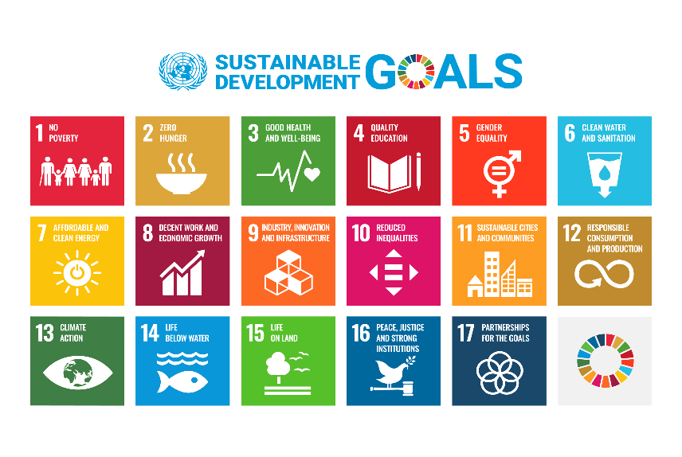
Figure 1: The 17 Sustainable Development Goals (United Nations, 2023).

The WEF Report
2.1 Introduction
Through Figure 2 it is possible to gain an understanding of the 10 most severe risks which we will potentially experience over the next decade, with a clear focus being placed on the environment. Six of the ten most severe risks are all focussed on environmental issues. Environmental health and resource availability. According to the report we as a global population are placing the viability of our environment and its function as both a resource and resource provider under great risk. Akpan et al., 2023, explain how “The world is now living through climate change, not watching it draw near”, detailing the presence and likelihood of experiencing many of the risks identified by the W.E.F. The two sources detail the potential seriousness and presence of our current environment and its predicted progress to a weaker quality of health and the resulting risk this poses to both the economy and society on a global scale. Along with the environmental concerns there are also four additional ‘Global Risks’, these risks focus on a range of areas such as societal, technological and political conditions or events. Federation of European Risk Management, 2021, explains how each of these differing risks or issues will negatively impact the achievement of sustainable development and how if these risks occur the attainment of the sustainable development goals becomes much more difficult.
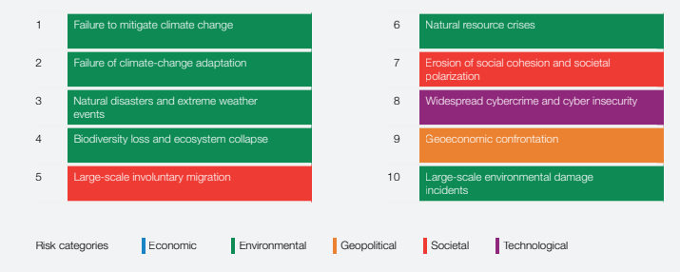
Figure 2: ‘Global Risks’ in terms of severity (WEF, 2023)

2.2 Climate change and Malthus.

Malthus, 1798, explains how we as a global population are currently consuming, producing and living in a way which is un-sustainable. The image below displays the correlation between consumption represented through population and development through resources. Malthus, 1798, explains how if we are in a form of development or progression over the ‘point of crisis’ then it no longer becomes sustainable. For development to become sustainable, the rate of consumption must be below the resource availability. Development can no longer be sustained after the point of crisis.
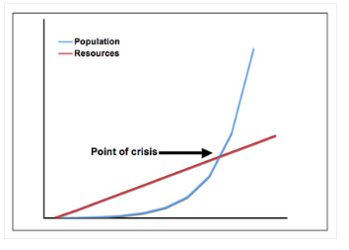

Figure 3: Malthus Principle of Development

Therefore, at this point, development progresses to what we see in figure 4. Within figure 4 it is possible to understand how development is no longer sustainable. The rate of development fails to increase and begins to decrease with the higher demand or consumption levels. The Earth and its resources can no longer sustain itself. Malthus, 1798, explains through the Malthusian theory or model that through consumption, Earth simply reaches a point where it is no longer viable to continually sustain provision and function. It can no longer continue to develop in a sustainable form.
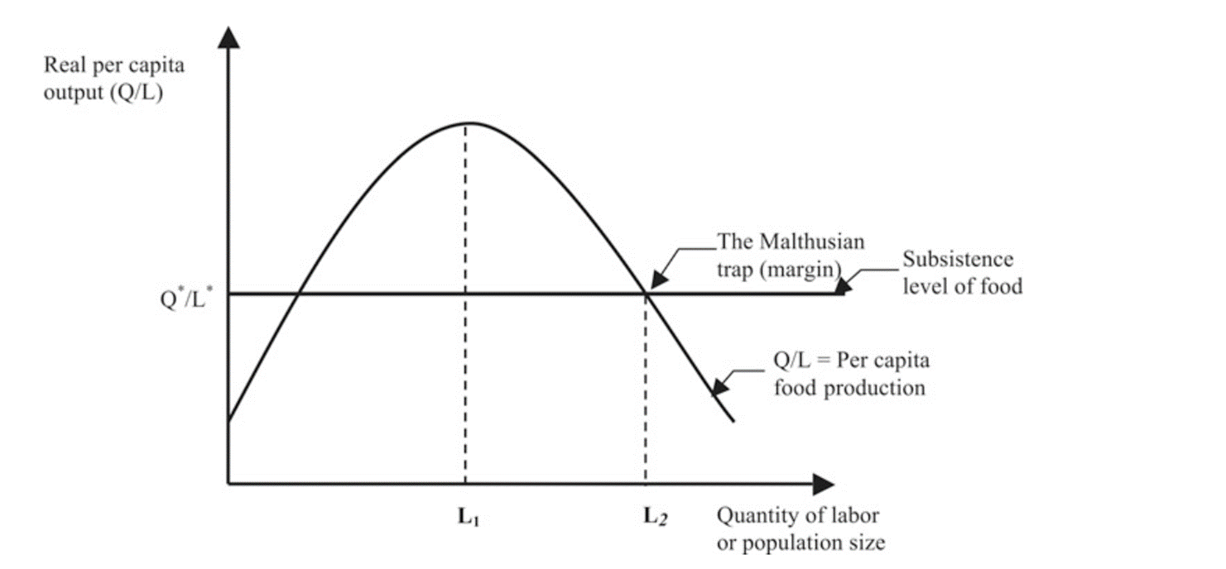
Figure 4: Malthusian Model
United Nations, 2021, explain how currently we are reaching the breaking point in terms of our climate and climate change. Which correlates with the W.E.F, 2023, in their report's identification of ‘Global Risk’ one and two. Currently the health and future of our climate is at a defining moment, which in reference to Malthusians theory, displays the environmental point in relation to global sustainable development. The environment is reaching the turning point of no longer being able to facilitate and provide sustainable development. Any additional development will now take place on the decreasing curve of Malthusians model. Through the current failure to mitigate and adapt to climate change there is a clear failure of sustainable development with particular focus on SDG 13.

2.3 Biodiversity loss and ecosystem collapse.
In terms of adhering to and achieving sustainable development, Rose et al., 2019, explains how through bio-diversity loss and eco-system collapse we as a global society will fail. There is a reliance or necessity for biodiversity to enable both sustainable development and general life, we rely on biodiversity and our eco-systems for commodities such as clean air and water as well as more complex resources such as medicines, food and raw materials. World Health Organisation, 2015, explains how biodiversity loss is happening at an unprecedented rate, with Einhorn, 2020, expressing the current failure of society to address the collapse, threatening the underpinning of all life on Earth. World Health Organisation, 2015, explain how for a community to thrive and be considered healthy there is a reliance on well-functioning eco-systems. The ‘Global Risk’ of biodiversity loss and ecosystem collapse holds extreme potential to prevent achievement of many SDGs.
Wentworth, 2021, explains how the risk of biodiversity loss and ecosystem collapse presents many changes and challenges. One of the sustainable development goals placed under threat through the loss of biodiversity includes ‘Good Health and Wellbeing’, Wentworth, 2021, explains how the services of biodiversity and ecosystems are vital to maintain human health. Quinney, 2020, explains one aspect in which the loss of biodiversity prevents the achievement of sustainable development is through the impact on food, water and air quality. Biodiversity provides organisms of all ranges of sizes and purposes which work together to provide health and nutritional security. Through the threat, these differing species and organisms are under threat which in cause would harm the security of clean air, water and nutritional products which our health relies upon.
Quinney, 2020, also explains how through the loss of biodiversity the prevalence and impact of many diseases increases. Ostfeld, 2017, details the presence of high biodiversity as reducing the rates of pathogen transmission and lowers the disease risk for humans. Through the loss of biodiversity, the overall health of individuals decreases whilst the probability of contagious diseases increases. Quinny, 2020, explains how overall biodiversity protects us, making Earth habitable. It is through biodiversity and ecosystems we are provided with the land in which we live, the resources we require to live and the nature-based solutions to prevent us from natural disasters such as floods. It is through ecosystems our soils regenerate and water becomes recirculated. The ‘Global Risk’ in biodiversity loss and ecosystem collapse prevents sustainable development through its implications to the health and well-being of society. If when developing any activities potentially increase the risk or impact to biodiversity and ecosystems it equates to a non-sustainable development.
Two further sustainable development goals or requirements which are contradicted through biodiversity and ecosystem loss are ‘Life on Land’ and ‘Life Below Water’. Green, 2019, explains how for the achievement of sustainable development biodiversity loss and ecosystem collapse would be devastating, currently, the level of species, plants and organisms disappearing is at an alarming rate. Green, 2019, explains how we must preserve biodiversity and prevent ecosystem loss if we are to sustainably ensure the survival of ourselves, species, organisms and plants of which global survival is reliant. EU Science Commission, 2022, explain how the issue of biodiversity loss is real through the predictions of losing between 6% and 11% of vertebrate species by 2050. Sustainable development will not be achieved through biodiversity loss due to the implications on the two differing environments of which we rely upon. These two goals state how to sustainably develop it is imperative to conserve and sustainably use marine and terrestrial ecosystems, resources and organisms. Our Shared Seas, 2021, highlight the risk and its consequences with marine biodiversity declining at a greater rate than ever experienced. Through biodiversity loss it's possible to see the failure of sustainable development with over 50% of coral reefs being already lost due to the past actions of society. Through past development there is a clear failure of protecting, conserving and sustainably utilising our natural resources.

2.4 Natural Resource Crisis

W.E.F, 2023, within their report identified additional aspects of how environmentally, global sustainable development will be impacted. Greenfield & Weston, 2021, explain how currently we as society have an insatiable and unattainable demand for the resources of our planet. This is currently equating to our demand levels out balancing the supply levels of which our planet can meet. The source explained how we are on course for an “ecological credit crunch” due to the over-using of natural resources. The ‘Global Risk’ of a natural resource crisis is seen as highly likely to occur through the current over consumption of resources and the exhaustion of our planet's environment and systems which enable us with commodities such as clean water (Friends of the Earth, 2023). The current level of consumption is enabling the future risk of extinction of materials critical to our health and quality of life.
In terms of achieving or adhering to sustainable development, exhausting raw materials contradicts the concept entirely. I.I.S.D, 2022, define sustainable development as “development that meets the needs of the present without compromising the ability of future generations to meet their own needs”. UN Environment Program, 2019, explains the risk of a resource crisis through the current over consumption of resources as preventing the availability of resources for the future generations. The current approach to resource use is contradicting the main principle of sustainable development and ecological economics.
Nelson & Coffey, 2022, explains the ecological approach of sustainability as adhering to several key principles. Through the ecological approach there is an acceptance of global environmental limits, the approach recognises the Earths inability to continually provide resources as an infinite source. Gowdy, 2009, explains how within the ecological approach to sustainability resources are not consumed in greater quantities than the environment can sustain. Opposing the current situation and ‘Global Risk’ of exhausting resources through over exploitation. The current absence of ecological or ‘strong’ sustainability, where the consumption of resources equates to the reproduction or sustainable level, is currently failing to enable sustainable development. The current over consumption or ignorance of ecological sustainability is resulting in our development failing to meet the needs of sustainability.
McCarthy & Sánchez, 2019, explain how the current annual rate of resources is far beyond the current planet’s ability to sustainably regenerate. With our current consumption level representing the resource supply of 1.75 Earths. Therefore, currently we as a planet are failing to reach sustainable development through the inability to responsibly consume our resources. Global sustainable development will be unviable due to the inability to attain goal number twelve in responsible consumption and production, through our irresponsible over consumption of resources.
Magdalena, 2015, also expresses a failure of sustainable development through the resource crisis in SDG number two. Globally food is seen as a resource, if we are to suffer from a predicted resource crisis, then the required levels of food to end hunger will be non-existent. Our current overconsumption and exploitation of food as a resources is placing the nutritional security of the globe at risk. Through over harvesting and exploiting the land we have available currently, we are risking incapacitating our food source for future generations. Overall, it is clear to see the risk of over consuming our resources both in terms of the actual food and the land we require to produce the food as devastating to the overall achievement of sustainably developing as a globe. The resource crisis places our function as both individuals and a planet under great threat, disabling and removing key resources which both the environment and we as people need to survive or live a higher quality of life. In essence, the resource crises removes what we currently need and use to live from future generations, countering the whole purpose of sustainable development.

Recommendations

3.1 Introduction
The overall attainment and accomplishment of the seventeen sustainable development goals are targeted by 2030. UN Global Compact, 2023, explains we as a global community are currently behind schedule to successfully achieve the sustainable development goals and progress as a planet in a sustainable way. Overall, the source explains how we as a planet both as businesses and individuals have not progressed as efficiently or effectively to achieve sustainable development.
3.2 Recommendation 1:
It is possible to see the clear risks identified within the environment as potentially impacting the achievement of sustainable development. Therefore, a recommendation to improve or limit the impact of these risks to achieve sustainable development would be to work in partnership with organisations such as the Ellen MacArthur Foundation, 2023, to promote the circular economy and therefore tackle issues such as climate change, biodiversity loss, waste, pollution and reduce the over consumption of resources. Through generating partnerships for the promotion and increase in utilisation of concepts such as the circular economy it will only benefit the achievement of sustainable development and the SDGs.
3.3 Recommendation 2:
European Environment Agency, 2017, explains the benefits of command-and-control regulations to enforce organisations to meet specific regulations and requirements. The introduction of command-and-control regulations enforcing organisations to adhere and work to the parameters of the seventeen sustainable development goals would ensure the compliance instead of the current optionality of meeting the goals.

3.4 Recommendation 3:
Schröder & Raes, 2021, explain two financial improvements required for the achievement of global sustainable development. Initially, on an individual country basis, there is very little funding available to support organisations to transition from a linear business model to a circular economy. There is a necessity to both support and incentivise the transition from unsustainable practices to a form of operating which enables sustainable development. The second aspect to the financial requirement or limitations is the difference in financial resources between developed countries and those still developing or incapable of development. For some countries their financial resources are restricted to only affording basic capabilities or requirements, therefore, altering to a more sustainable form of development may simply be financially unviable. These countries need support in conducting sustainable development to ensure global sustainable development.

Conclusion

Overall, the World Economic Forums identified ‘Global Risks’ over the next decade have the potential to prove extremely detrimental to global sustainable development. Each of the differing risks identified hold potential to either directly contradict the overarching concept of sustainable development or fail to allow the successful attainment of a singular or multiple sustainable development goals. The clear requirement of society to improve in our current development is imperative for the successful survival and quality of life for future generations. If we fail to achieve the SDGs and sustainable development, future generations will suffer from a lack of resources, a weaker environment and overall, a weaker quality of life. Their lives will suffer socially, environmentally, economically and generally on a holistic scale.

References

