Gobbet: - Auschwitz Gas Chamber
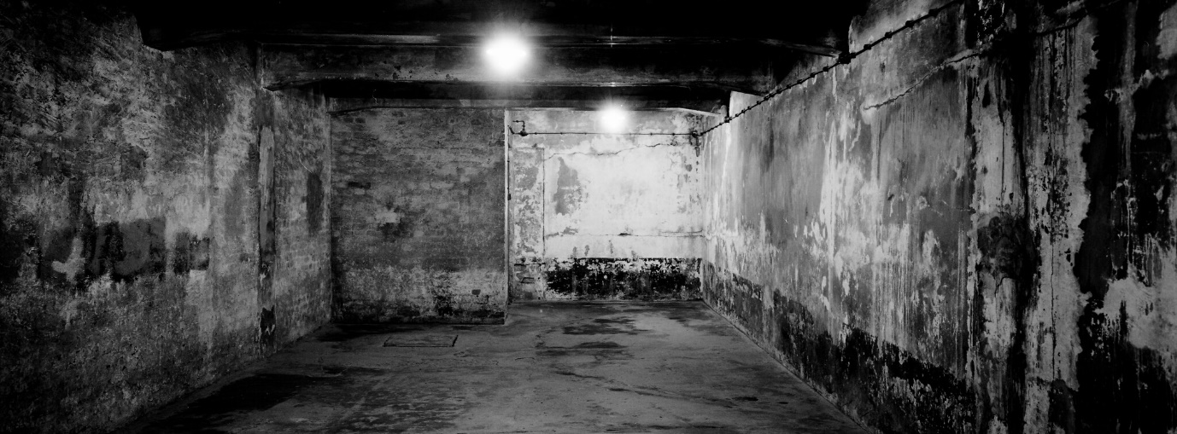

The holocaust is the most well-known and devastating example of genocide, where 11 million people lost their lives, 3 million having lost their lives in the concentration camps. The photograph – depicting gas chamber one at Auschwitz 1 – was taken in 2019 (75 years after liberation) by Markus Schreiber, who was born in Germany and began his photojournalism career in 1991 (world press photo). This essay will discuss the horrific use of this room and the events surrounding it.
Hitler is possibly the world’s most notorious anti-sematic. He came to power in 1933, when he was appointed chancellor of Germany and then became Fuhrer in August 1934 and had absolute power of Germany until his death by suicide in 1945 (National WW11 museum). According to the Holocaust encyclopaedia, it is not known exactly when the “final solution” (so named for the destruction of the Jewish people) was implemented: “The genocide, or mass destruction, of the Jews was the culmination of a decade of increasingly severe discriminatory measures.” (Holocaust encyclopaedia). The “final solution” focused on the killing of the Jewish people living in and surrounding Germany, however prejudice was not limited to the Jewish people alone. Hitler also rounded up Homosexuals, Jehovah’s witnesses, slaves, the mentally ill and Roma (Gypsies) (National WW11 Museum).
The photo is from Auschwitz 1, in Oswiecim, Poland and its “construction began in April 1940 in an abandoned Polish army barracks in the suburbs” (Holocaust encyclopaedia). 1.1 million people were killed, 1 million of which were Jews. Many were sent to gas chambers like this on their arrival with their files marked “return not desired” or “do not transfer” (BBC 2018). Those who were not sent to the gas chambers right away were put to work as “forced labourers” to expand the camp. (Holocaust encyclopaedia).
An article by the United states holocaust museum, states that individuals could be incarcerated and eventually put to death without ever being charged of a specific act or after being acquitted of charges relating to a certain crime (Holocaust encyclopaedia).
It was in September 1941, that first tests were carried out by the SS of the use of Zyklon B for mass murder. “Zyklon B is a highly poisonous insecticide originally used to kill rats and insects. When exposed to air, Zyklon B pellets are converted into lethal gas. This proved to be the quickest gassing method and was chosen as the means of mass murder at Auschwitz” (Holocaust encyclopaedia).
According to the holocaust encyclopaedia, it was in March 1942 that Jewish men, women and children were murdered in this gas chamber for the first time.
Upon arrival, prisoners were told they were to clean themselves up with a shower and were even instructed to fold their clothes neatly under their assigned numbers, so they could find them easily upon their return. This was to avoid a panic amongst the prisoners. After their execution, it was left to the prisoners (who could meet the same fate at any time) to remove the hair, jewellery and any gold or metal fillings from the deceased. “The Auschwitz Museum, in Oświęcim, Poland, are grappling with a more practical problem: how to preserve those four thousand pounds of human hair on display in their museum.” (Ryback 1993).
“Between may and the beginning of July 1944 some 200,000 to 250,000 Hungarian Jews were put to death in the gas chambers” (Pressac 1994). Others were executed through shooting, starvation and hanging. On average, around 6,000 Jews were gassed at Auschwitz each day (Blakemore 2018).
In November 1944, Heinrich Himmler “head of the SS and one of the architects of the holocaust” issued an order to destroy the gas chambers to cover up their heinous deeds. A group known as the Sonderkommando – a group of Jews who were forced to run the gas chambers – were forced to dismantle the gas chambers piece by piece (Blakemore 2018). As the Russians were closing in that January, the remaining buildings were blown up using dynamite, However the ruins remained. About 7,000 prisoners were left behind, while 60,000 (who were deemed healthy enough) were made to march through snow, ice and blizzards. This was dubbed by the prisoners as the “death march” and was intent on taking the prisoners to, again be forced labourers for the Reich (Blakemore 2018).
An SS order was given to execute the remaining prisoners who were to weak or unfit for work and 700 more lost their lives due to this.
The holocaust is such a devastating part of history, that shamed humanity. This is evident by an article by Erin Blakemore who states the camps did not even make the front page of the New York Times in Jan 28, 1945. It was to horrific to bare and the voices and testimonies or the victims live on and remind us of the evil that can take hold through fascism and tyranny. Nie Wieder!

Auschwitz, Holocaust encyclopaedia, 2015
Auschwitz: How death camp became centre of Nazi holocaust, Article by the BBC, 2018
Auschwitz: Technique and operation of the Gas Chambers, University Pennsylvania Press, 1994
Evidence of Evil, Timothy W. Ryback, The Newyorker, 1993
How the Nazi’s tried to cover up their crimes at Auschwitz, Erin Blakemore, A Marvel channel, 2018
The National WW11 Museum, Google search engine
World press photo, google search engine, 2020

