Component 1 – Report on Effective Teamworking for business success

Name: Wilangela da Graca Garcia Vaz
Student Number: 2017020
Module code: BMSW 4002
Module name: Effective team working & communications
Lecture’s name: Akash Puranik

Content page

Introduction …………………………………………………………………………………………03
Overview of team working…………………………………………………………………………04
Models of team development……………………………………………………………………...05
Barrier to effective teamwork……………………………………………………………………...06
Importance of team roles ……………………………………………………………………….…07
Conclusion…………………………………………………………………………………………..10
References…………………………………………………………………………………………..11

Introduction

This report is being written for students at University of Wales Trinity Saint David who were chosen to do group work but faced each other with many differences that created some failures and conflicts in communication. Therefore, it will cover building an effective team, the impact effective teamworking can have for team success, Barriers to effective teamwork and the types of roles that are needed to ensure to create a cohesive and effective team.

Overview of team working

A team is a number of individuals working as one to achieve a particular goal to which they are mutually committed (Morgan, 2017, p.204). Therefore, to have a team which works effectively there are factors which contribute to it, including:
- Communication: can be defined as a way of exchanging knowledge, particularly when it improves comprehension between individuals or organisations. (Walter,1995) So, it is possible to say that communication plays a crucial role by allowing members of a team to express ideas and understanding each other so that the team works effectively.
- Clear Goals: goals are described as the target or purpose of a certain activity. So, clear goals can be seen as explicit aims or objectives that a team may have so that they succeed when doing a determined activity.
- Trust and respect:
- Trust- trusting in someone or something resembles honesty, power, ability, assurance, and so forth. (Dictionary.com, 2021)
- Respect- appreciation felt or expressed for something or someone you feel contains brilliant ideas or traits. (Walter,1995) Considering the idea of trust and respect, it is plausible to say that they are very important factors to ensure that a good relationship is maintained between the members of a team.
Also, about the team we have five conditions that contribute to effective teamwork.
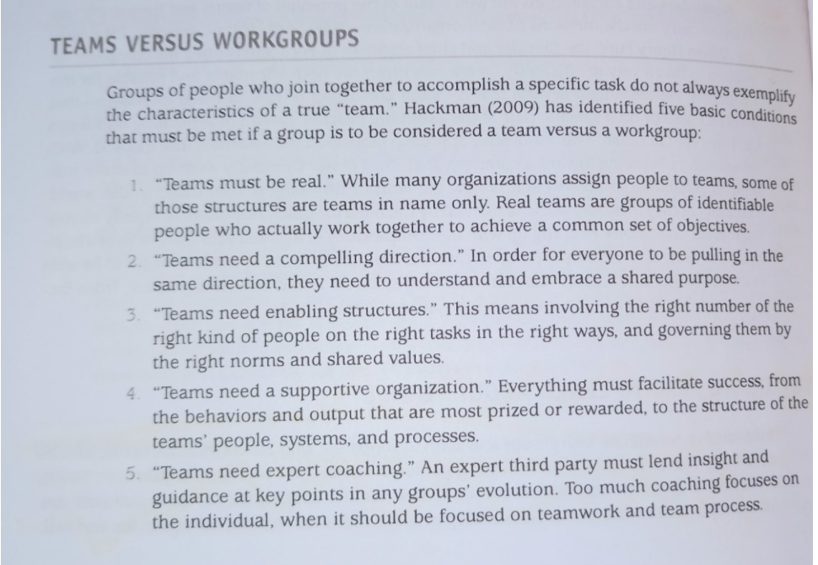 (Puranik, 2021)
Thus, it is possible to analyse team lacks the points mentioned above, as there is no communication between the team members and a lack of trust between them (nobody cares about anybody).

Models of team development

One of the fundamental models used in this situation is the five stages of a team development which include: forming, storming, norming, performing, Adjourning.
Because in general, teams progress through a predictable pattern in their growth. so, with these five stages can be describe the formation of teams showing each step of this development.
- Forming- The formation stage is distinguished by a high level of ambiguity regarding the team's goal, organization, and management.

- Storming- The storming stage is characterised by intra-fighting. Members acknowledge the team's existence but object to the limitations it places on their individualism.

- Norming- People feel like they are a member of the team and recognise that if they embrace other opinions, they can accomplish more.

- Performing- The team operates in an optimistic and positive environment where adaptability is emphasised, and hierarchy is minimised.

- Adjourning- The team evaluates the previous year and develops a strategy for shifting responsibilities and acknowledging individuals' accomplishments.

Students from the University of Wales have numerous differences, which is why they were chosen for group work (stage 1 forming). They simply cannot overcome their differences and seek a middle ground to comprehend and address these disputes, according to the study case.
This stage is characterized by storming, which is the stage of conflicts and disagreement.
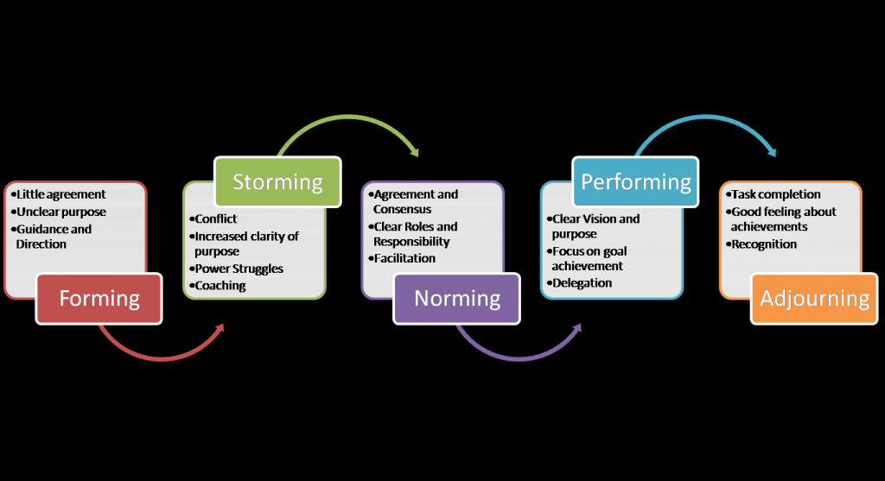
(Puranik, 2021)

Barriers to effective teamwork.

After identifying the various theories that are similar to the study case, it was time to identify the barriers that exist in this team.
Based on the information contained in the module The term barrier refers to an impediment, a stumbling block, or simply a difficulty that obstructs or partially obstructs the passage of a message and among them we highlight:
- Physical barriers
- Attitudes
- Emotional noise
- Language
- Physiological barriers
- Problems with structure design
- Cultural noise
- Lack of common experience
- Ambiguity and overuse of abstractions
- Information overload
- Jumping to conclusions

Those that can be identified in the study case are one of the points indicated above: Attitudes, language, lack of common experience, cultural noise.

Importance of team roles
What roles are needed to create a cohesive and effective team?
Belbin established the concept that a team need a balance of personality and functions to be effective.
As everyone knows their role in the team, everyone will be able to overcome any challenge and overcome the lack of communication. Therefore, Belbin has nine team roles to create a cohesive and effective team: plant, resource investigator, coordinator, modeler, monitor evaluator, team worker, implementer, finisher, and expert.
Belbin separated these nine roles to be able to separate the personalities, so that there is an understanding between the team, that's why Belbin separated each personality type with a specific function and divided them into 3 categories: Thought, Action and Social people.

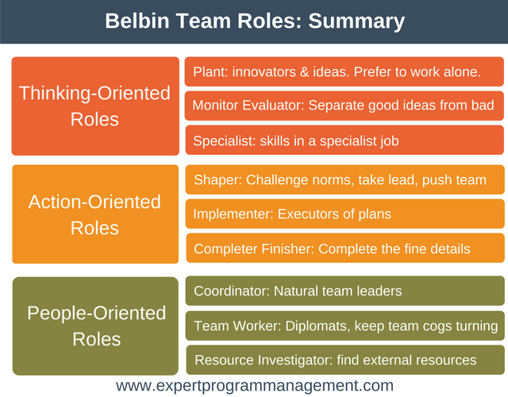

(Puranik, 2021)

What are the theories relating to this?
The mains theories that can be relating to this are theory and Coyle theory.
Because all of them show how to create, to manage a team and shows what stages the specific team are.
Tuckman has five stages that were mentioned above, so we have Coyle's theory that talks about three secrets for a successful team:

- Build safety
- Overcommunicate listening - Show everyone else that you are paying attention to what they are talking using nonverbal and verbal expression.

- Spotlight your fallibility early on - particularly if you are in charge.
“Yeah certainly, I may be incorrect,” for example.
“Can you tell me something I'm absent?”
“How do you feel?”

- Embrace the messenger - Whenever a team member gives you unfavourable criticism or terrible news, reply positively: "Thank you for informing us," "I am glad you informed me."

- Share vulnerability
- Make sure the leader is vulnerable first and often. - Inform your team the reality.
Ask inquiries, such as, "What is one thing that I do now that you’d want me to keep doing?"
Keep in mind that sensitivity is a quality, not a flaw.

- Deliver the negative stuff in person - Any bad news or criticism must be delivered making eye contact. Reconnect right away: "go have a drink and figure out how we are going to go ahead."

- Listen like a Trampoline - Add insight and drive new ideas with good communication, which entails something more than smiling attentively.
Assist and protect the other individual.
Assume a cooperative and helpful attitude. Inquire about previous preconceptions in a kind way. Provide ideas from time to time to bring up new options.

- Establish purpose
- Name and rank your priorities- You must also have an objective before moving toward it. Five or fewer people make up most effective organisations. In a competitive league, how members respect one other is paramount.

- Be ten times as clearer about priorities than you think you should be- Managers must not presume that their subordinates are familiar with or recall them. Priority should be written on the wall and in email signatures.
“What are we about?” is a good question to ask. “What are our plans for the future?”

Considering the theories mentioned above, it is possible to see that many advantages are presented, such as learning to work in a team, trying to understand and solve problems as a team, helping when someone needs it.
feel free to share your fears with the rest of the team and don't be intimidated by your teammate, try to get to know and learn from other cultures and be real with each other.
Just as a team has its strengths, it also has its weaknesses when the team is not coordinated, it generates many conflicts and lack of productivity it causes the lack of understanding between the team, they create small groups and stand against each other, they do not focus on the results to be achieved and lose business opportunities, they focus on their personal and not collective ambitions, they end up bringing interpersonal problems with another team member into the work.
I have personally experienced gender problems in the company I work for, due to lack of communication and understanding, small groups were created and the team was divided because we were from different countries and we spoke different languages ​​too but that is beside the point because we all spoke English but the big problem was the lack of understanding because sometimes when someone from another country needed help no one would offer to help but if someone from the same country asked they would help.

Conclusion
After much research and study in students of UWTSD case it can be concluded that follow this rules and stages everyone on the team will be happy.
Also, teamwork is much better when everyone contributes and following all the rules and phases mentioned above will guarantee good results, considering that it is very normal sometimes to have discussions in the team, but discussions healthy that in the end everyone concludes.
It is very important to know how to separate interpersonal problems within a team, and to solve these problems you can choose the brainstorm method along with Coyle's theory that says that everyone should feel free to express their ideas without fear of being judged.
Effective Teamwork and Communication Module students should have a meeting and apply the brainstorming method to solve their team's problems, try to have a good relationship with their peers and understand what ails them, keeping in mind that they are in the second phase (storming) should clarify some points that were not clear before and try to understand why the team's behaviour is knowing how to deal with differences.

References

Dictionary.com. (2021). Trust. Available: https://www.dictionary.com/browse/trust. Last accessed 17 June 2021.
Hoek, M., Groeneveld, S., Kuipers, B. (2016). Goal Setting in Teams: Goal Clarity and Team Performance in the Public Sector. SAGE JOURNALS . 38 (4), p472-493.
Puranik, A 2021, Creating Effective Teams, lectures notes, Effective team working & communications, lectures BMSW 4002, university of Wales, delivered 11 June 2021
Puranik, A 2021, Introduction to module and Defining Groups and Teams, lectures notes, Effective team working & communications, lectures BMSW 4002, university of Wales, delivered 28 May 2021.
Puranik, A 2021, Stages of Team Development & Team Roles, lectures notes, Effective team working & communications, lectures BMSW 4002, university of Wales, delivered 04 June 2021.

Walter, E. (1995). Communication. In Cambridge Dictionary. Cambridge University Press.
Walter, E. (1995). Respect. In Cambridge Dictionary. Cambridge University Press.

