
Component 1: Design and Implementation of a Relational Database System
Introduction to Web and Database Concepts - ACCA4023

Sadhana Jha

November 1, 2025
UNIVERSITY OF WALES TRINITY SAINT DAVID

Contents
Scenario Analysis 2
Entity Relationship Diagram (ERD) 2
1. List of attributes and their descriptions 2
2. List of relationships and their meaning. 2
3. ER diagram: 2
Normalization 2
Sample Data Population 2
Query Development 2
Testing and Validation 3
Design Decisions and Future Work 3
1. Design Decisions: 3
2. Future Work: 3
References: 3

Scenario Analysis
In order to digitally streamline their processes, the director of “AutoPark Management System” processes has asked me to create a Microsoft Access database. At the moment, all client data, vehicle arrivals and departures, slot specifics, and payment slip information are manually stored. They make several mistakes, misplace documents, and are unable handle it effectively
They seek a solution that stores all parking related data in a single database. This database may be used for things like tracking the automobiles that are present, displaying open slots in real time, storing customers, and logging payments, and with that there will be fewer mistakes, less paperwork, less time spent, and an overall improvement in efficiency and organization. [1]

Entity Relationship Diagram (ERD)

List of attributes and their descriptions
The parking management system is made up of six entities. Information required for system operation is stored by each entity.
The “Customer” entity contains data about vehicle owners as well as provide means for the systems to recognize its parking reservation users. It consists of: customer ID, full name, phone number, email, residential address.
The "Vehicle" entity will hold information for each vehicle registered. Attributes: vehicle ID, vehicle registration number, model, vehicle type, customer ID (foreign key associates each vehicle to its owner).
The "parking slot" entity keeps track of every parking space that the business offers. Site ID, site name, site location, total number of slots, and availability status are all included. Multiple parking spaces at various places are made possible by this entity. This enables the system to use a single record system to operate each parking location independently.
"Parking slot" contains details on every slot at the parking site, including slot ID, site ID, slot number/code, kind of slot, whether it is occupied or unoccupied, fee category based on slot type, and availability for specific users. A single site is linked to each slot. For the system to collect payments, generate receipts, monitor income, and generate revenue reports, each payment is linked to a specific customer's booking ID. [2]

ENTITY AND KEY FIELDS:

ENTITY KEY FIELDS

Customer Customer ID, Name, Phone, Email, Address

Vehicle Vehicle ID, Customer ID, RegNo, Make
Model, Type

Parking site Site ID, Site name, Location, Capacity, Status

Parking slot Slot ID, Site ID, Slot number, Slot type,
Availability status

Booking Booking ID, Customer ID, Vehicle ID, Slot
ID, Entry time, Exit time, Status

Payment Payment ID, Booking ID, Amount, Method
Payment date, Payment status

List of relationships and their meaning.
The system defines multiples key relationships between it’s entities to ensure accurate data organisation and efficient parking management
One customer may own multiple automobiles, which creates a customer-to-vehicle relationship. There can only be one customer per vehicle, this enables us to monitor every car that a single user owns.
There are numerous parking spots on a parking lot, however each spot is part of a single parking lot. Every parking spot should be able to be marked as either occupied or vacant.
Bookings and vehicles it keeps track of the parking history of cars throughout time. A single car might have several reservations for various parking times. However, only one car is linked to each reservation.
The difference between a parking site and a booking site is that the former allows many reservations at different times, while the latter assigns a specific slot to each reservation.
Financial transactions are handled from booking to payment. Typically, a single payment record is created for each reservation. However, you can configure the system to allow for multiple payments against reservations, this would be applied to refunds or partial payments.
RELANTIOSHIP CARDINALITY DESCRIPTION
RELANTIOSHIP: | CARDINALITY: | DESCRIPTION:
Parking site and parking slot | 1:M | There are numerous parking spaces in one location.
Customer vehicle | 1:M | One customer may own multiple vehicles
Customer booking | 1:M | One customer can make many bookings
Vehicle booking | 1:M | One vehicle may have many parking bookings
Parking a lot booking | 1:M | One parking slot can be booked many times in different periods
Booking payment | 1:1 | Each booking has one payment

CONSTRAINTS:
RELATIONSHIP | CONSTRAINTS
Parking site, parking slot | You can’t create a parking slot without an existing parking site
Customer vehicle | A vehicle can’t exist unless it belongs to a register customer
Customer booking | A booking must belong to a valid customer
Vehicle booking | A booking must reference a registered vehicle
Parking slot booking | A booking must have use an existing parking slot
Booking payment | A payment can’t exist without a valid booking

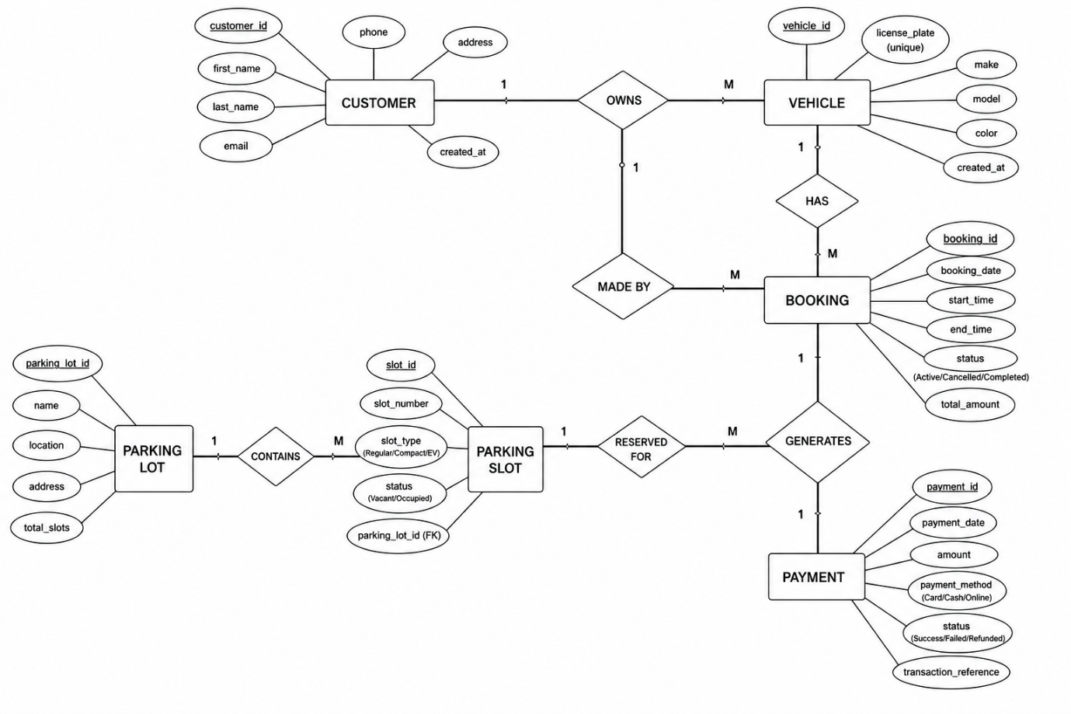
Figure 1

Normalization
Screenshot down below:
SCUSTOMER ID: | FULL NAME: | PHONE NUMBER: | EMAIL: | ADDRESS:
105 | Chantel Brown | 07568544323 | chanbrown1@gmail.com | London

Sample Data Population
To evaluate system relationships, queries, and data validation of the parking management system, realistic sample data was added to the database. While demonstrating how the system might function in a real parking management scenario, all information utilized is fictitious records to protect any sensitive data from being used.

Customer table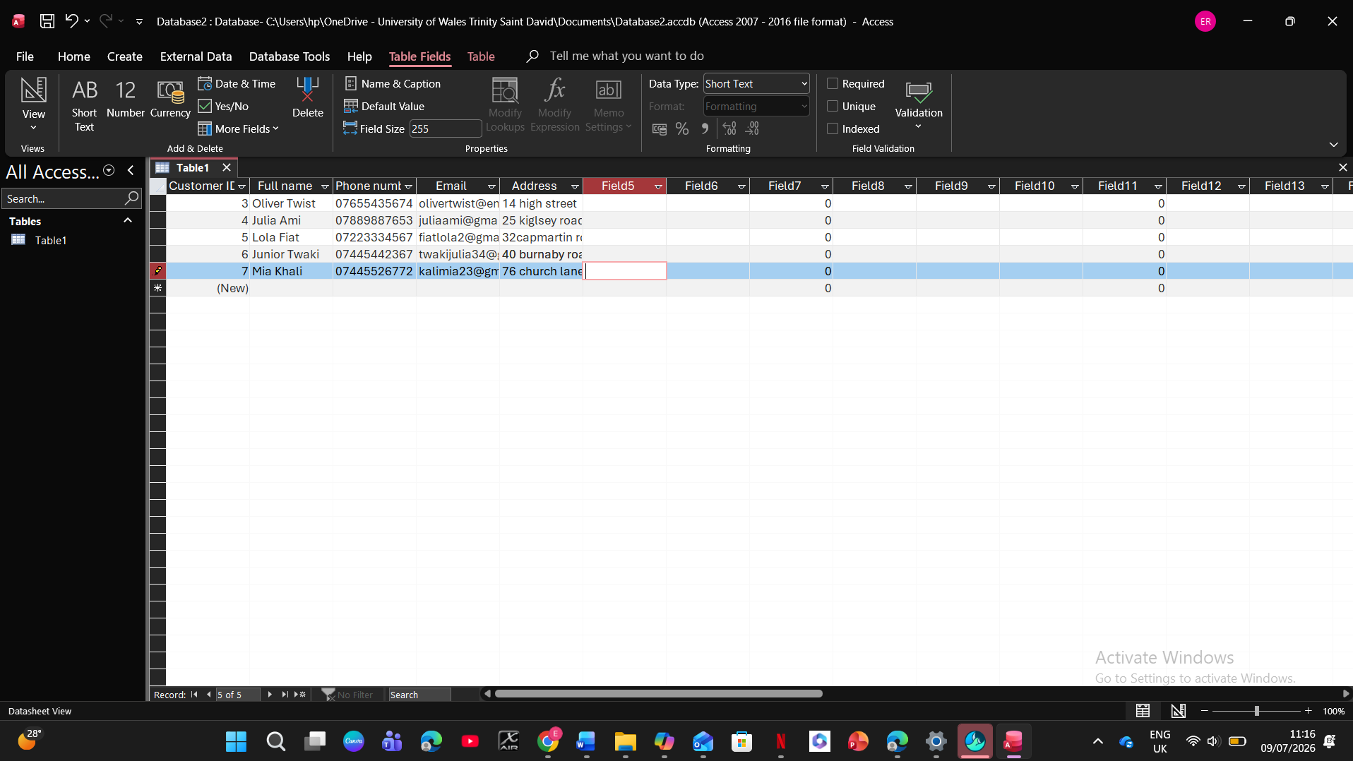
Vehicle table
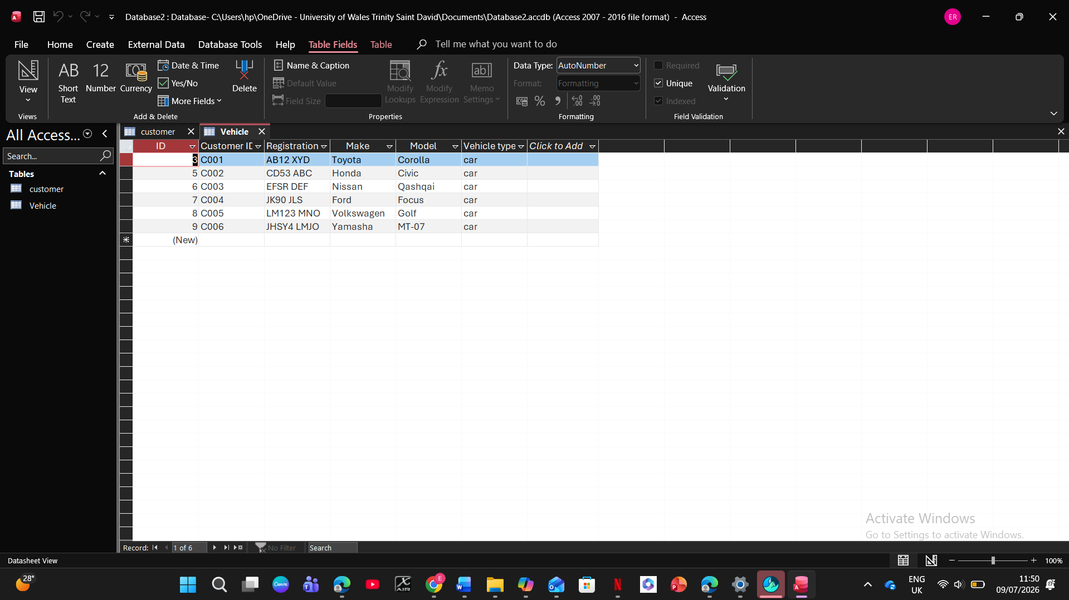

Booking
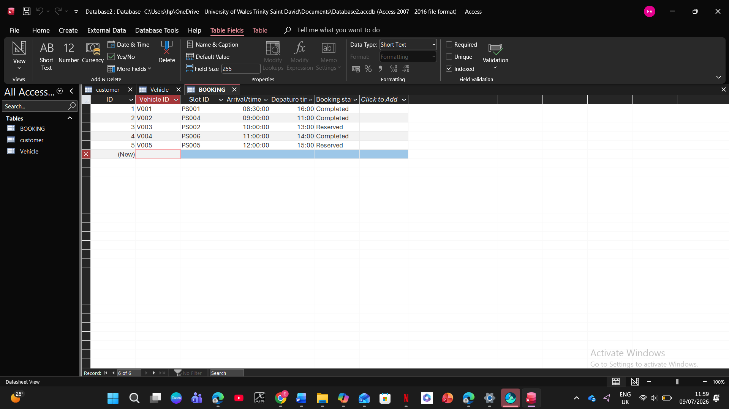
Payment
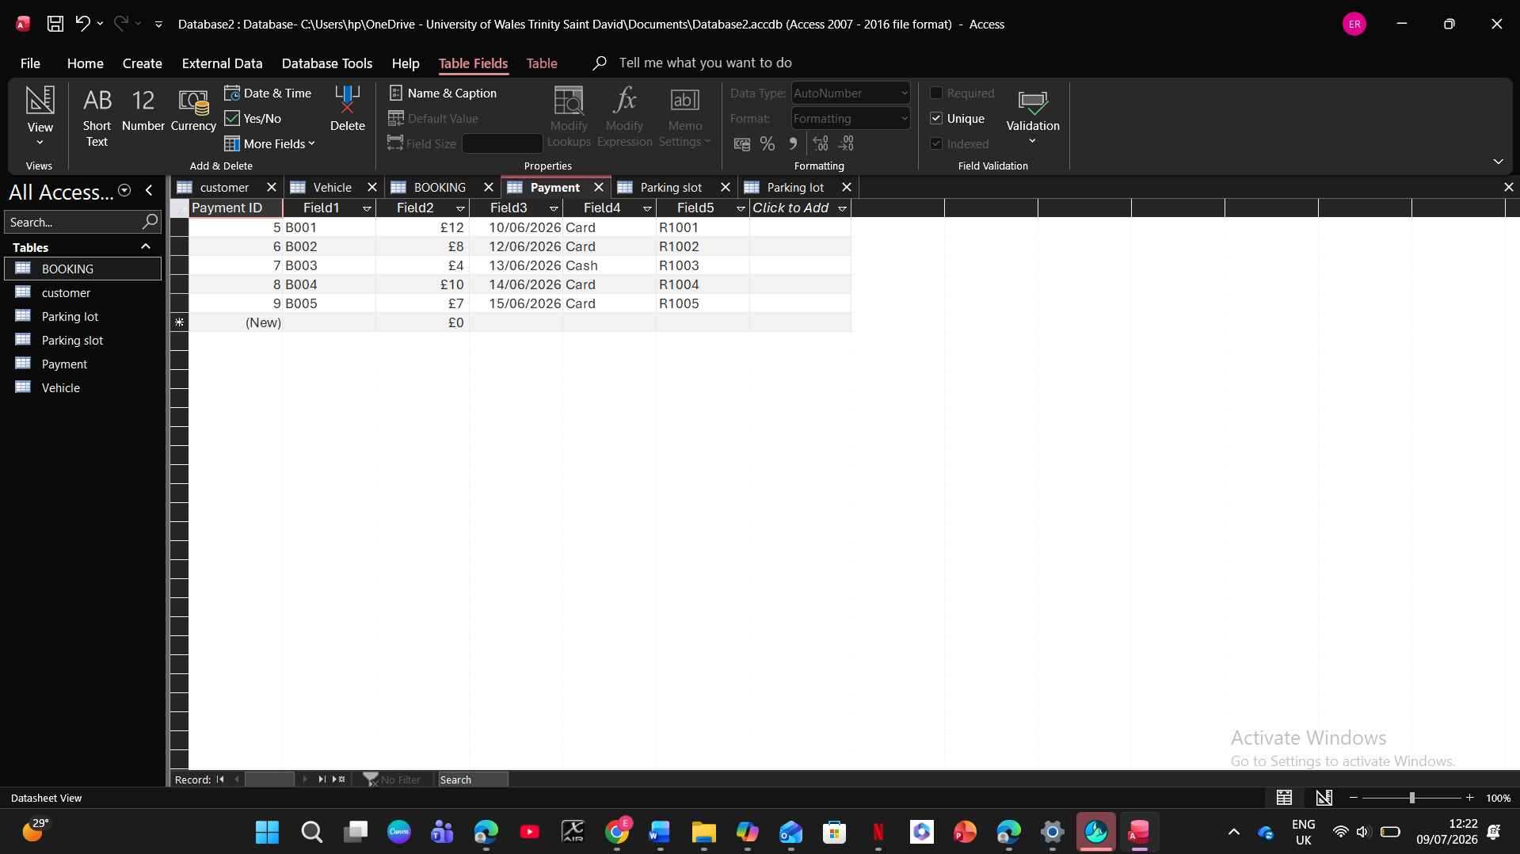

Parking slot
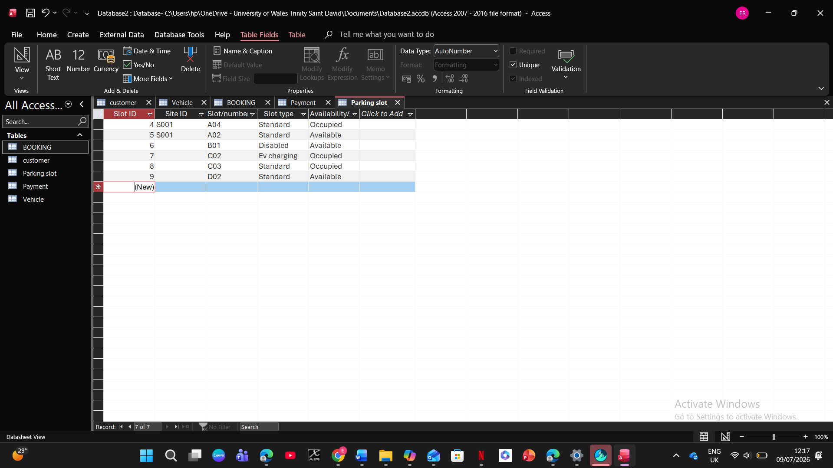
Parking Lot
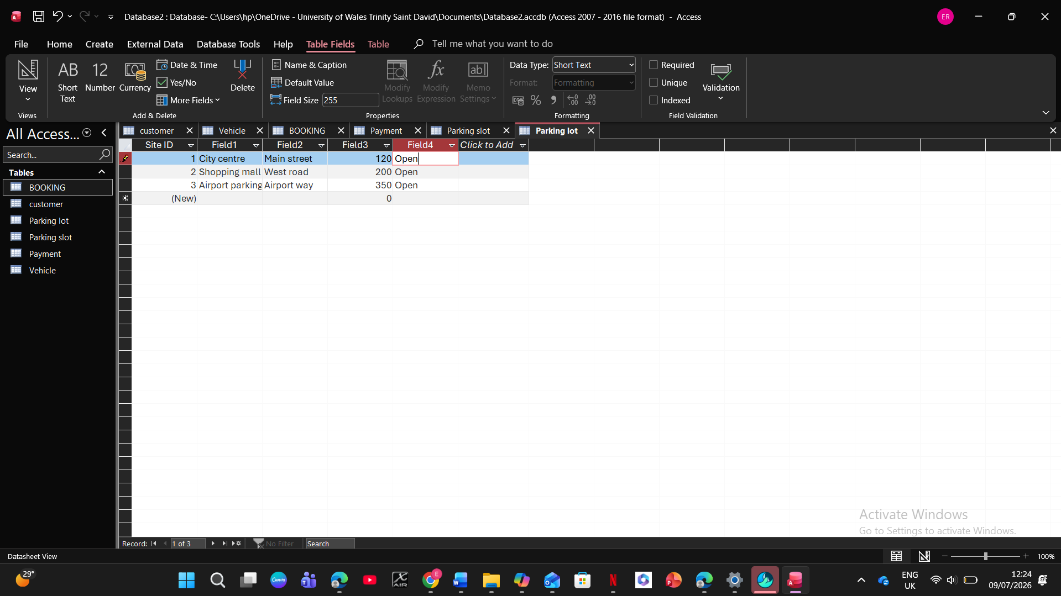

Query Development

Tables can be joined together according to their relationships using Microsoft Access queries. They will handle customer activity, payment, parking spot availability, and booking scheduling. Important database principles are presented by each of the four queries. To meet the demands of the company, keys, joins, and filtering were developed for every query. The goal, design, and anticipated result of the query are displayed with screenshots below.

Testing and Validation

To make sure that all functional requirements obtained during the design phase have been satisfied, the AutoPark Management System has undergone testing. To ensure that validation rules are in place, sample data was entered into the tables, table relationships were verified, queries were performed, and invalid data was attempted. To make sure the system produced the desired outcomes and could be utilized to support the daily administration of parking operations, each feature was tested separately.

Design Decisions and Future Work
Design Decisions:

Microsoft Access is the application database for the AutoPark Management System.
Using Microsoft Access [3] and a relational database strategy, the AutoPark Management System database was created. Prior to the implementation of this system, duplicate and inconsistent data would be recorded due to the human record-keeping method. Access now makes it possible to keep all of this data in one location.
Relations were used in the development of our database to reduce redundant data. A primary key and foreign keys to link to other tables are present in every item. We can utilize queries to obtain information while maintaining referential integrity.
Correctly connecting the six tables and allocating primary and foreign keys was one challenge encountered during database creation. Referential integrity planning prevented the creation of orphan records. Another problem was writing queries that combined multiple tables to produce a report. It took multiple attempts to understand how Microsoft Access handles joins and filtering.

Future Work:

By establishing connections, validation criteria, and queries [4] to enable dependable storage and simple access to clients, cars, parking locations, reservations, and payments, the client's requirements have been met. As a result, the AutoPark Management System offers an organized database that makes information management simple. Future enhancements are possible, although they are not required to accomplish the project's goals. A more user friendly design, increased task automation, and the capacity to handle more data for larger parking management organizations are some of these enhancements.

References:

[1] L. Delgado-Quirós and J. L. Ortega, “Research entity information and coverage in eight free access scholarly databases,” vol. 49, no. 6, pp. 1135–1153, 2025.
[2] P. Skavantzos and S. Link, “Entity/relationship graphs: Principled design, modeling, and data integrity management of graph databases,” vol. 3, no. 1, pp. 1–26, 2025.
[3] L. Bellatreche, P. Valduriez, and T. Morzy, “Advances in databases and information systems,” vol. 20, no. 1, pp. 1–6, 2018.
[4] H. K. Mohajan, “Two criteria for good measurements in research: Validity and reliability,” vol. 17, no. 4, pp. 59–82, 2017.

