Appendix 1
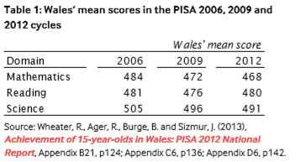
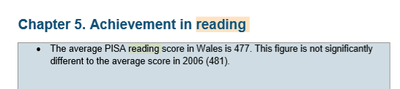

Appendix 2
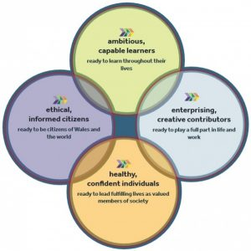

Appendix 3
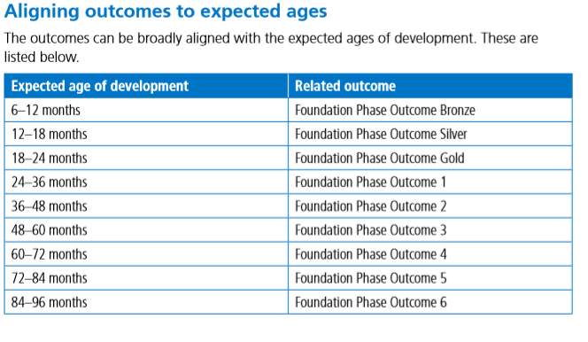

Appendix 4


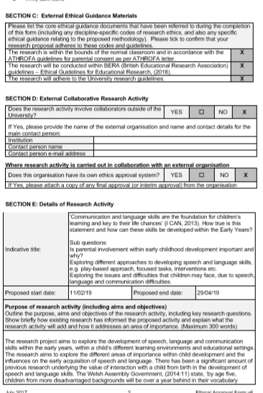
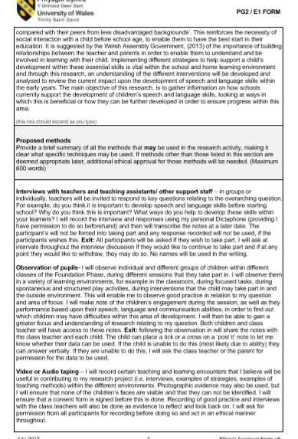
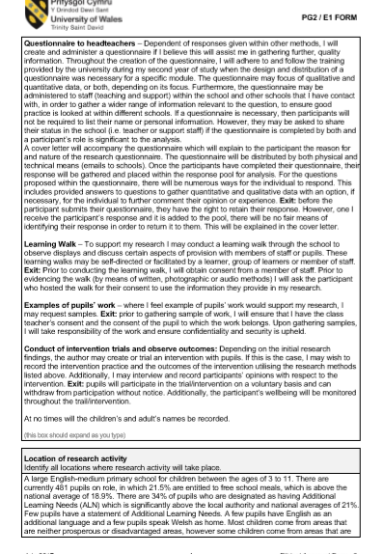

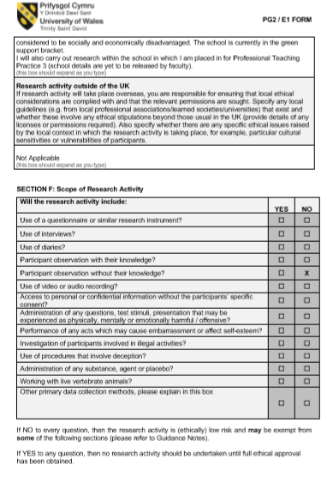

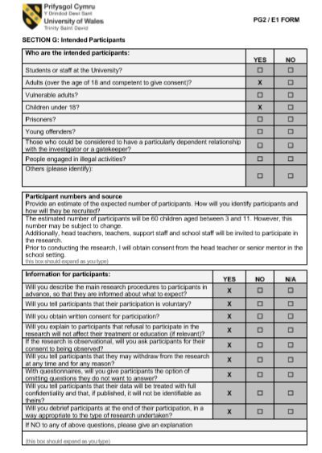

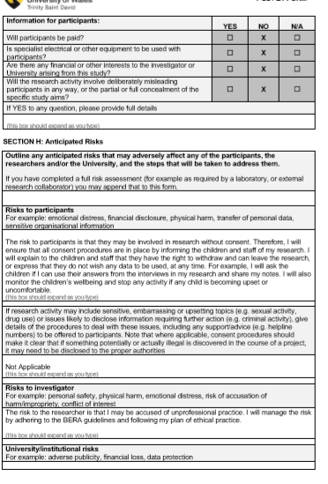

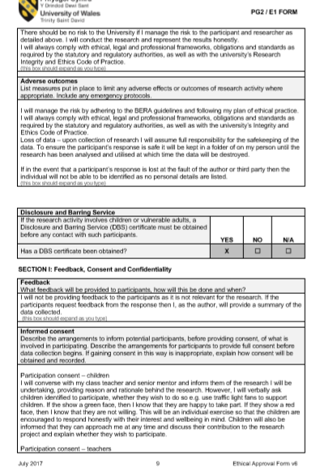
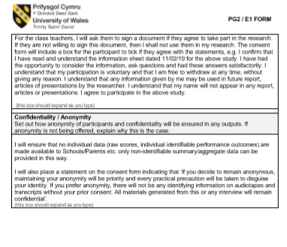


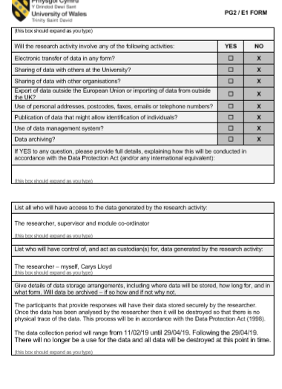
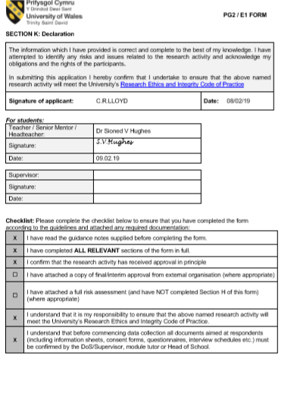

Appendix 5

Foundation Phase children questionnaire

Year Group: __________________ Age:

- How do you feel about reading?
______________________________________________________________________________________________________________________________________________________

- Do you read at home with an adult?

Yes/No

- Who do you read with the most?
______________________________________________________________________________________________________________________________________________________

- Do you listen to an adult reading a story throughout the day? If yes, then how often?

Yes/No Everyday Most Days Once a week

- Do you practise your letters and sounds at home with an adult? If yes, then how often?

Yes/No Everyday Most Days Once a week

- How do you feel about learning your letters and sounds?
______________________________________________________________________________________________________________________________________________________

- How do you feel about reading in school with a teacher?
______________________________________________________________________________________________________________________________________________________

- Do you own an Ipad, games console or television in your room? If yes, which one(s)?

Yes/No Ipad Games console Television

- Do you do/use this every day? If yes, then how often?
Yes/No Everyday Most Days Once a week

- Do you take part in Wellcomm or Speechlink activities? If yes, what do you do there?
Yes/No
______________________________________________________________________________________________________________________________________________________

- Do you go to speech therapy? If yes, what do you do there?
Yes/No _________________________________________________________________________________________________________________________________________________

Note: Questions will be asked in language appropriate to child’s age and understanding.
Note: All names and data will be anonymised when used for the purpose of this research.
Note: All children have the right to withdraw and have been asked whether they would like to continue and if the data collected can be used by myself. If a child is unable to give consent for this, the class teacher will have been asked also, providing the child is asked if they would like to take part first.

Appendix 6
Foundation Phase children questionnaire

Year Group: __________________ Age:

- How do you feel about reading?
6/8 – good
2/8 - happy

- Do you read at home with an adult?
8/8 - yes

- Who do you read with the most?
Mammy -6/8
Daddy – 2/8
On my own – 1/8
- Do you listen to an adult reading a story throughout the day? If yes, then how often?

Every day- 3/8
Most days –2/8
Once a week – 3/8
- Do you practise your letters and sounds at home with an adult? If yes, then how often?
Everyday – 4/8
Most days – 2/8
Once a week – 2/8
- How do you feel about learning your letters and sounds?
Good – 7/8
Okay – 1/8
- How do you feel about reading in school with a teacher?
Happy – 1/8
Good – 7/8
- Do you own an Ipad, games console or television in your room? If yes, which one(s)?

Ipad- 8/8
Games console – 0/8
Television – 3/8

- Do you do/use this every day? If yes, then how often?
Every day -3/8
Most days - 2/8
Once a week - 3/8
- Do you take part in Wellcomm or Speechlink activities? If yes, what do you do there?
Yes – 7/8
Not often – 1/8
- Do you go to speech therapy? If yes, what do you do there?
Yes – 3/8
No – 5/8
Note: Questions will be asked in language appropriate to child’s age and understanding.
Note: All names and data will be anonymised when used for the purpose of this research.
Note: All children have the right to withdraw and have been asked whether they would like to continue and if the data collected can be used by myself. If a child is unable to give consent for this, the class teacher will have been asked also, providing the child is asked if they would like to take part first.

Appendix 7
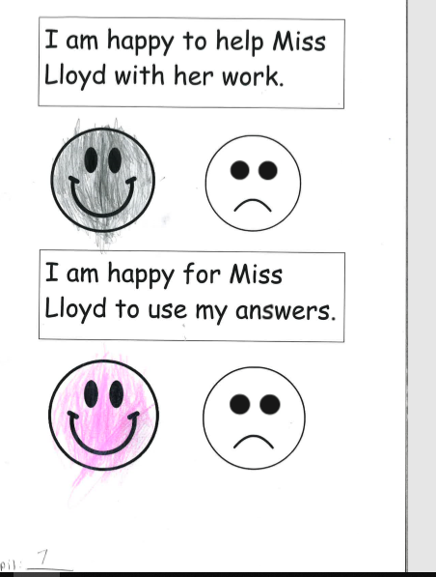

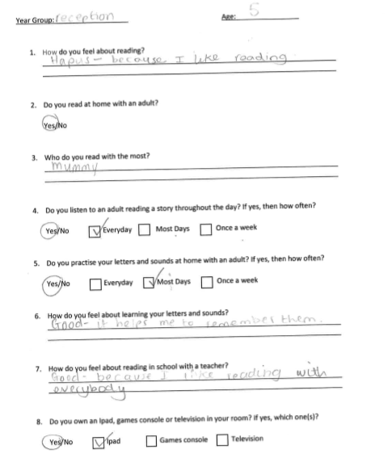

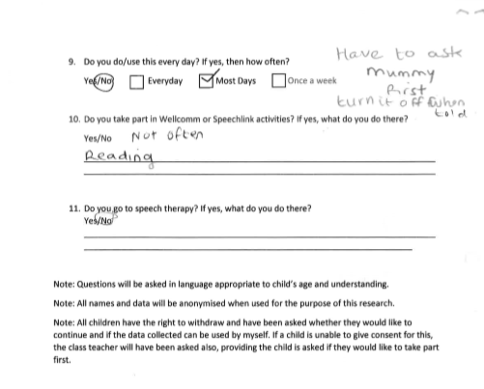

Appendix 8
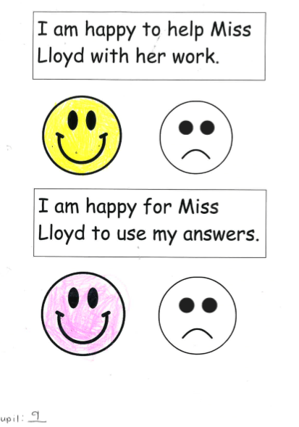

Appendix 9
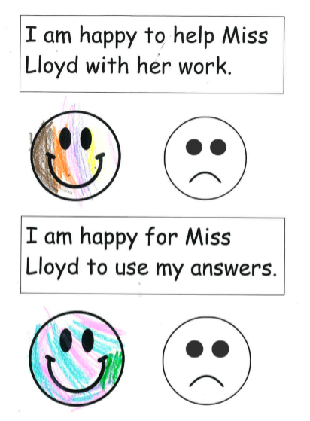

Appendix 10
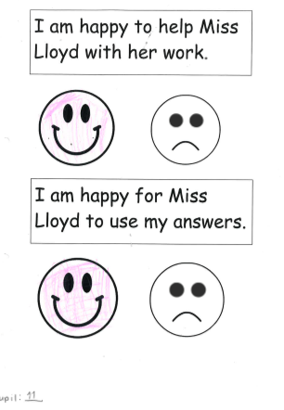

Appendix 11
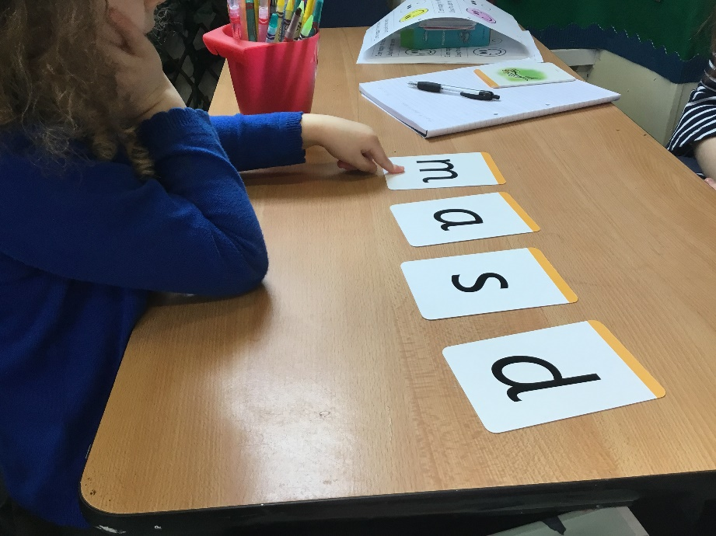

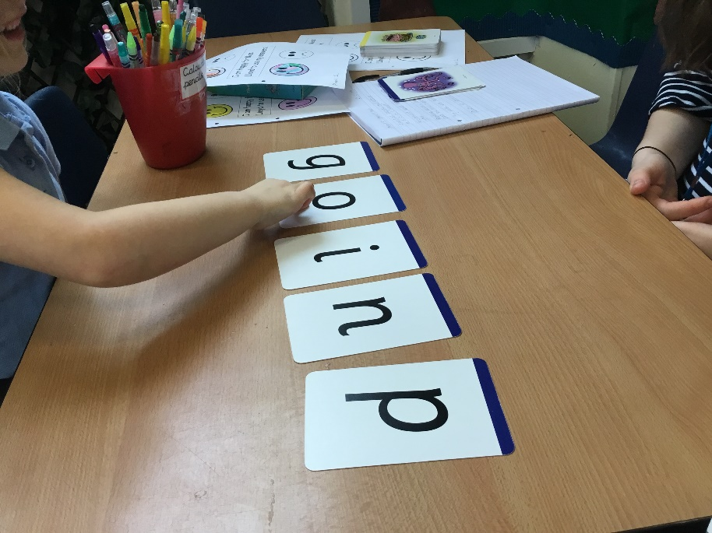

Appendix 12
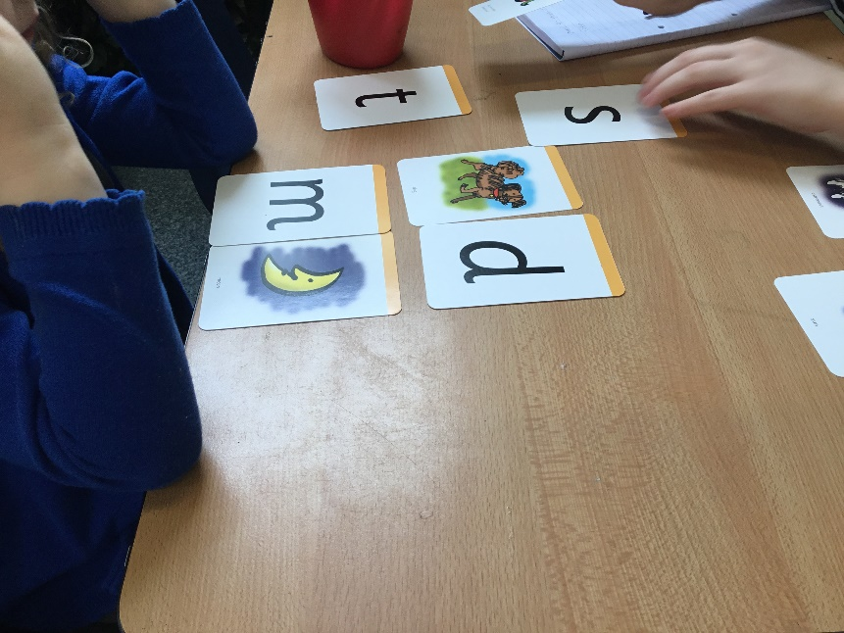

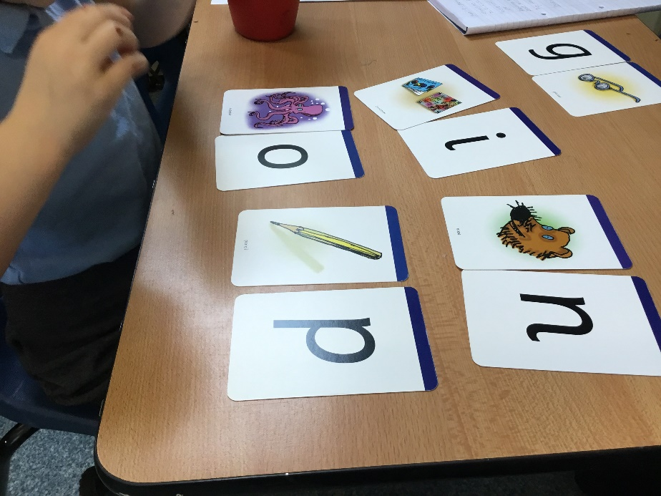

Appendix 13
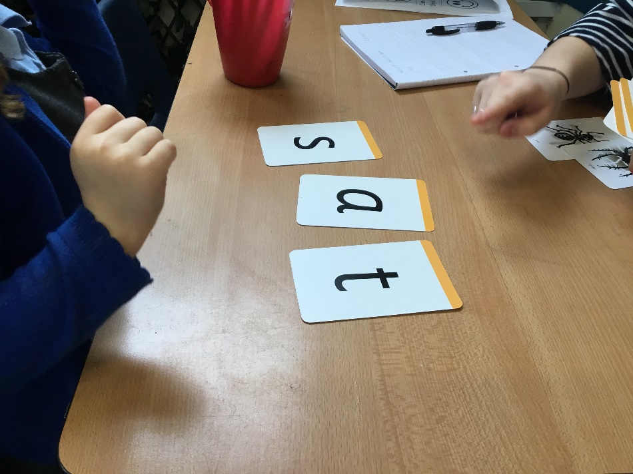
(Pupil 9 – able to put the word ‘sat’ into a sentence “I sat on the mat”).

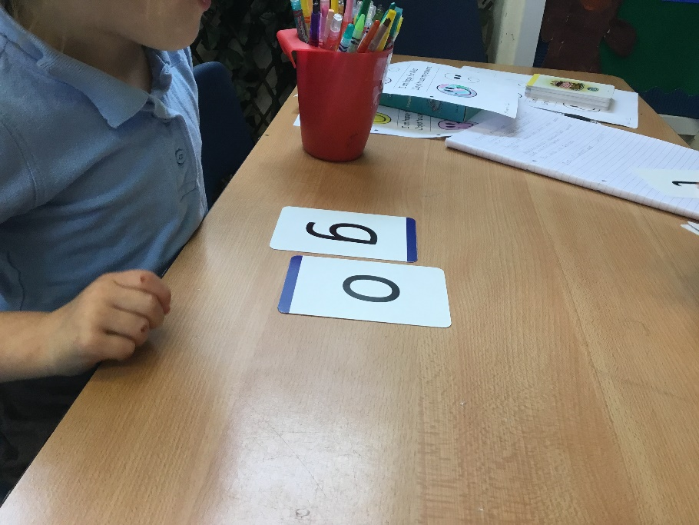
(Pupil 11 – only able to create 2 letter words. Unable to create sentences).

Appendix 14
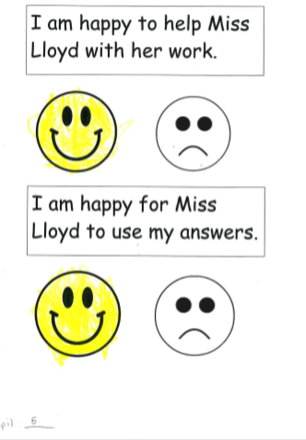

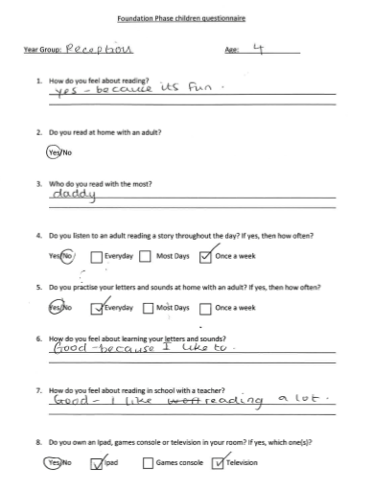
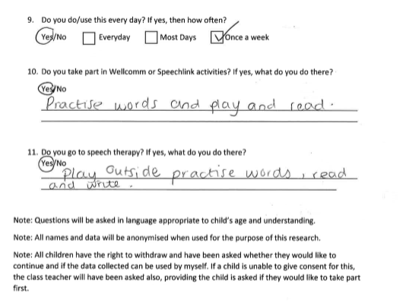

Appendix 15
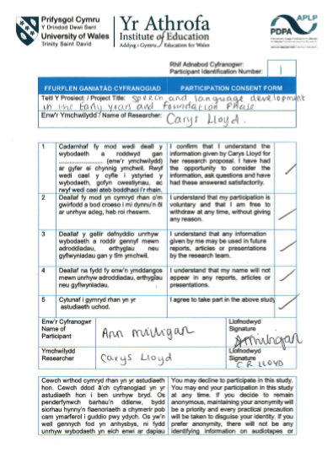

Speech therapist interview

- Being an outside agency, how do you work with schools?
- Children of school age who are identified with a speech or language issue are referred in by the ALNCO from the school.
- Information gathered by staff in contact with child – need to fulfil referral criteria.
- Speech link and language link assessments – computer-based programmes – type in child’s responses and programme will identify an area of need within their speech and language development.
- Child needs to have had an IEP specifically target their speech and language difficulties and need to have worked on those targets for at least a term and a half in house before being referred.
- Information from schools – assessment results, things they done, things they have improved in – any difficulties they are having in classroom environment.
- Accept referral and make appointment to see child in school – WG made a 14-week waiting period – must see the child within those 14 weeks or have a big fine – schools are aware so understand the importance of letting parents know the times and places to be.
- Write to the schools and parents and invite them in – case history from parents, medical background – family history.
- Chat with teachers for new information
- Assess child for issues referred by teachers – concerns over speech sounds or understanding and use of language instruction.
- Assess and feedback to teachers on what they sound and what they will do next to support that child in their needs.
- Next steps – therapy, working on a certain speech or language issue, programme of activities for schools to work with provision categorised as universal, target or specialist.
- Universal – speech and language link – wellcomm
- Targeted – advise school of what to do next – programme of resources above wellcomm and speech and language link
- Specialist – one to one therapy only a specialist can undertake.
- Important to have strong links with school as a child is in school every day – specialist: one a week, targeted may be once a term – need to maintain link to ensure child in progressing and targets are being met.

- Do you provide the schools with support or provision to use to continue to work on each child’s specific targets?
- Booklets or activities, websites – communication trust and ICAN have resources for teacher.

- Do you agree that language and communication skills are important for later life?
- Tied into learning foundations at early age – play – early vocab lack of understanding can affect play skills – delayed.
- 70% of young people in the youth offending system have some sort of speech, language and communication difficulty.
- Mental well-being – socially interact with people
- Therapists need to have a loader voice at the universal level to – schools prioritise time and funding for programmes.

- Why do you think that children may have difficulties in speech, language and communication?
- Physical difficulty - Cleft pallet or down syndrome or cerebral palsy
- Family history – autism, ADHD no verbal
- Not always evidence
- Some children are delayed in their development
- Still identify needs based on what is assessed and target needs towards that rather than if there is a definite or specific reason for the difficulty.

- Do you think parental involvement in children’s learning is important?
- School and parental involvement
- Try best to get parent involved
- Community clinics – don’t see teacher as teachers think it is just a medical thing.
- After attending school, therapist will ring parents when they get back to base to let them know what has taken place during the session and what they would like to see by the next week/ session.
- Important for parents to be on board with targets and get them involved so that child can progress in the best way possible.

- How long will a child take part in speech therapy?
- 2 factors – what the need is – focused on what they actually need – seen as long as need to be seen – until they feel that the child is in a place where they can stop
- Capacity – waiting list – short staffed – see a child for 6 weeks then provide them with support materials to work on target provided at home or in school.
- Frustrating as sometimes a child really needs to continue with therapy however need to stop to allow a space for another child who needs support.

- Do you work with flying start?
- Forms part of targeted provision – only targeted for certain families – based on postcode area however WG is seeing the positives of this provision in terms of speech and language development and well-being – looking at funding more money for it.
- Once a child is identified as having a persistent difficulty or need they will be referred to speech therapist for assessment and intervention.

- How is your service funded?
- speech therapist role funded by NHS – work within school – schools do not pay anything.
- In other parts of wales school see the importance and benefits of speech therapy and look for a speech therapist to work in the school – therefore have to pay the NHS for their services (private hire).
- 2 day a week – see children more often.
- Schools investing more money into speech and language development – very positive view.

- What activities do the children take part in within the sessions?
- Dependent on what the child needs
- Under age of 8 – games.
- Start with clear targets – specific sound, vocabulary, sentence structure, fluency or social skills – incorporated into session.
- Involving parent in game so they can take part and support at home.
- Target for the next week.

- Do you use play and multisensory activities to support children’s speech and language development?
- Dependent on age range – preschool complex needs – lots of play and sensory work
- Play form the first steps of language – not exposed to play can delay their development significantly
- Symbolic play – small world play – provide vocabulary
- Sensory experiences – build awareness – listening to different sounds
- Reading – opportunity to explore books in different ways – showing children pictures in book – don’t have to use the pictures on the page – use pictures and let children explore it in their own way.
- Link words and sounds to pictures to develop vocabulary to use in other areas of learning.

Appendix 16
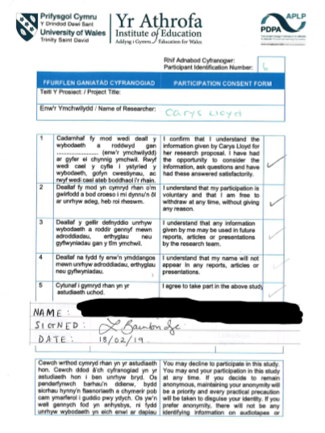

18th February 2019
Flying Start

Elklan programme
- Language builders for 0-3s
- Advice and activities to encourage the communication skills of babies and young children
www.elklan.co.uk
- Exploratory play
- Object permanence
- Container play
- Symbolic and imaginative play
- Social play

Adult interaction interventions
- 4 week programme – play – promote importance
- Language rich play environment

Flying start midwife
Young adults

Appendix 17

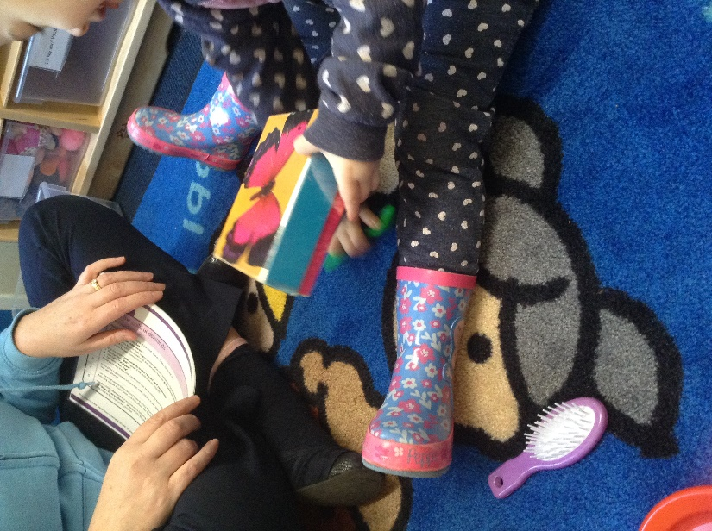
‘Put the scissors UNDER the box’,
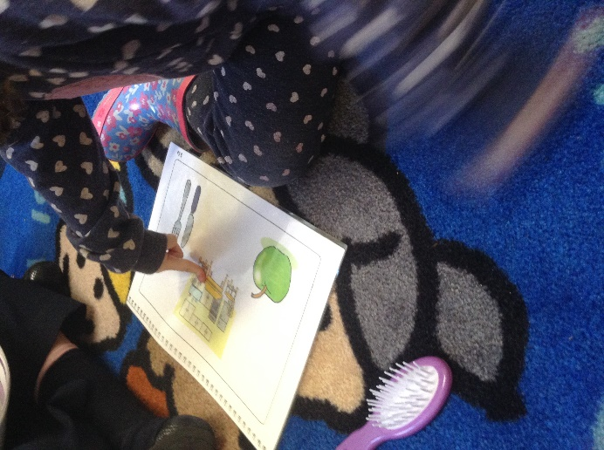
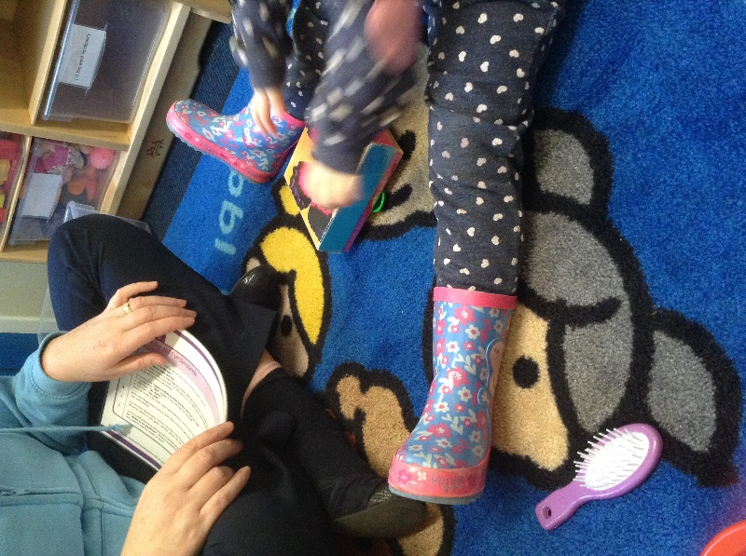
‘WHERE do we eat our lunch?’
Appendix 18
In a recent report, Ofsted found new teachers didn’t have a solid knowledge of language development and struggled to adapt their own language for those children with poor language skills. The need for high quality training during initial teacher education in these areas was highlighted as important in order to support teachers to do this.67 – p14 wag 2017

- It has been suggested that there has been a decrease in the attainment of speech and language development in children starting school. How do you agree or disagree with this statement based upon your past class experiences and observations? Please place a line through ONE only.

- Do you have any children with Speech, Language and Communication Needs (SLCN) in your class?

- Do you use any interventions to support these children with SLCN?

- Do you use play to support children with SLCN?

- Do any of the children with ALCN attend interventions with outside agencies?

- How often do you communicate with parents about their child(ren)’s progress? Please place a line through ONE only.

- Do you think that parents should be supported in understanding how to develop their children’s learning at home?

- Do you offer support to parents on developing their child(ren)’s learning at home?

Appendix 19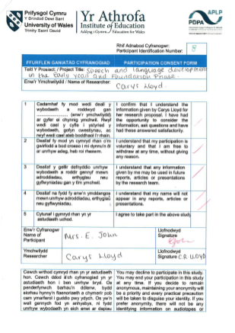
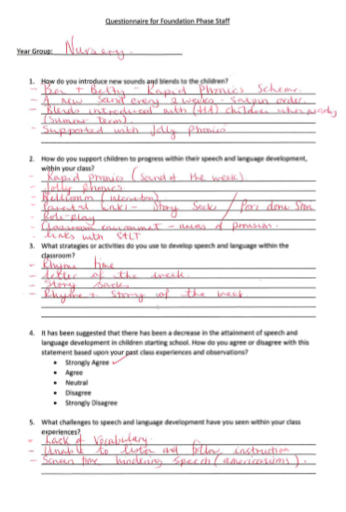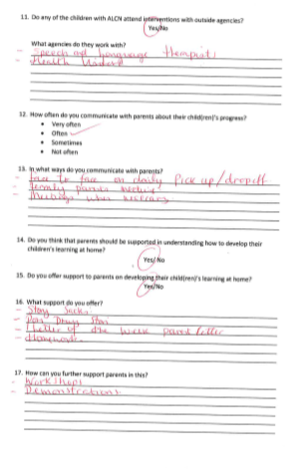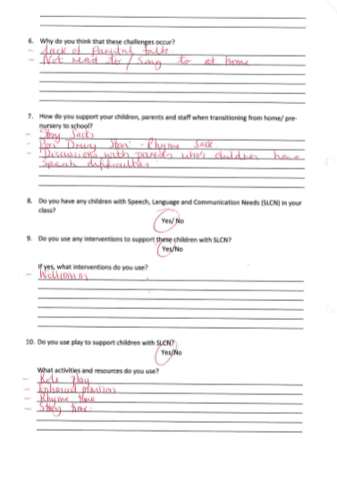

Appendix 20
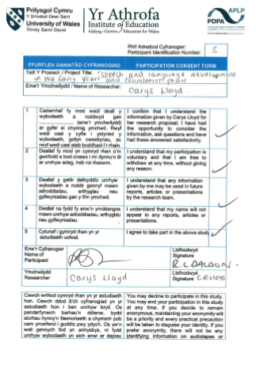
Questionnaire for Foundation Phase Staff

Year Group: ___Reception_RD - FPh Leader/SLT

- How do you introduce new sounds and blends to the children?
___________________________________________________________________________
_______________________________________________________________________________________________________________________________________________________________________________________________________________________________________________________________________________________________________________________________________________________________________________________
Bug Club Reading scheme (Phase by Phase)- Reception
Developing blending skills taught alongside to develop understanding
Daily activities and phonics sessions to reinforce
Activities to be completed at home
Balance of exploration, ICT and cross curricular activities

- How do you support children to progress within their speech and language development, within your class?
__________________________________________________________________________________________________________________________________________________________________________________________________________________________________________________________________________________________________________________________________________________________________________________________________________________________________________________________________
All children are screened in Reception on entry using Speech and language link screening tests – Shared with parents who require further intervention in school or speech referral
All children who accessed Wellcomm intervention are also screened in Reception
All intervention programmes run alongside additional activities planned for Reception
Children needing additional support have IEPs created to support intervention further

- What strategies or activities do you use to develop speech and language within the classroom?
___________________________________________________________________________
_______________________________________________________________________________________________________________________________________________________________________________________________________________________________________________________________________________________________________________________________________________________________________________________
Modelling speech and language
Daily reinforcement and homework activities
Language rich activities to immerse the children in speech and language
Activities are generally based around the development of language acquisition
Intervention programmes run throughout the week to support children needing additional support
IEP targets worked on throughout the week

- It has been suggested that there has been a decrease in the attainment of speech and language development in children starting school. How do you agree or disagree with this statement based upon your past class experiences and observations? Please place a line through ONE only.
- Strongly Agree (Previous Nursery teacher of 5 years)
- Agree
- Neutral
- Disagree
- Strongly Disagree

- What challenges to speech and language development have you seen within your class experiences?
___________________________________________________________________________
_______________________________________________________________________________________________________________________________________________________________________________________________________________________________________________________________________________________________________________________________________________________________________________________
Noticeable increase of children entering Nursery with speech, language and communication difficulties
Children unable to access age appropriate curriculum – Language and speech effect all areas of the curriculum
Differentiated curriculum
Children who struggle to engage
Use of TA to run intervention instead of supporting classroom provision
Lack of parental knowledge, understanding and support

- Why do you think that these challenges occur?
___________________________________________________________________________
_______________________________________________________________________________________________________________________________________________________________________________________________________________________________________________________________________________________________________________________________________________________________________________________
Lowered parental expectation
Amount children are allowed to play with devices
Children not be spoken to from an Early Age
Health Visitor pre-school check ups being given as a parental questionnaire to highlight concerns instead of an actual visit by a professional to make a judgment of language delay

- How do you support your children, parents and staff when transitioning from home/ pre- nursery to school?
___________________________________________________________________________
_______________________________________________________________________________________________________________________________________________________________________________________________________________________________________________________________________________________________________________________________________________________________________________________
Flying Start children will visit up to 4 times with their Key Worker prior to starting Nursery
Children age 3yrs are invited to visit the Nursery prior to start date. Meet the teacher and classroom. Explanation of Nursery curriculum and expectations of parents/carers – staggered entry and time limited entry to ensure positive transition from Home – School
Nursery – Reception - Time to visit their new classes and meet the teacher. Parents invited to meet the teacher and classroom

- Do you have any children with Speech, Language and Communication Needs (SLCN) in your class?
Yes/ No

- Do you use any interventions to support these children with SLCN?
Yes/No

If yes, what interventions do you use?
___________________________________________________________________________
_______________________________________________________________________________________________________________________________________________________________________________________________________________________________________________________________________________________________________________________________________________________________________________________
Speech Link
Language Link
Wellcomm
PECS
Makaton

- Do you use play to support children with SLCN?
Yes/No

What activities and resources do you use?
___________________________________________________________________________
_______________________________________________________________________________________________________________________________________________________________________________________________________________________________________________________________________________________________________________________________________________________________________________________
All activities in early Years are based around the philosophy of play and exploration
Activities to support audio and visual learners

- Do any of the children with ALCN attend interventions with outside agencies?
Yes/No

What agencies do they work with?
___________________________________________________________________________
_______________________________________________________________________________________________________________________________________________________________________________________________________________________________________________________________________________________________________________________________________________________________________________________
Speech and Language Team – specific programmes devised and programmes shared with school to help develop speech and language. Target often used in IEPS
Outreach for ASD support

- How often do you communicate with parents about their child(ren)’s progress? Please place a line through ONE only.
- Very often
- Often
- Sometimes
- Not often

- In what ways do you communicate with parents?
___________________________________________________________________________
_______________________________________________________________________________________________________________________________________________________________________________________________________________________________________________________________________________________________________________________________________________________________________________________
Daily contact with parents ensures that progress is shared regularly

- Do you think that parents should be supported in understanding how to develop their children’s learning at home?
Yes/ No

- Do you offer support to parents on developing their child(ren)’s learning at home?
Yes/No

- What support do you offer to parents?
___________________________________________________________________________
_______________________________________________________________________________________________________________________________________________________________________________________________________________________________________________________________________________________________________________________________________________________________________________________
Guidance for reading and writing
Number guidance
General Curriculum guidance
Information based on our class pages on website – Resources and Guidance
Information letters about what we are learning/new topics
Weekly homework support sheets

- How can you further support parents in this?
___________________________________________________________________________
_______________________________________________________________________________________________________________________________________________________________________________________________________________________________________________________________________________________________________________________________________________________________________________________
Speaking to parents needing further support
Parent workshops
Working closely with individual parents

- Please place any other information about speech and language development below.
From working 5 years in Nursery and moving to Nursery September 2018 I have seen a dramatic increase of Speech and Language difficulties. Children are joining us less ready to learn, not equipped with Early Years skills (esp PSD/Language). Children find it very hard to engage and ‘play’. Decline in Nursery rhymes known. Decline in Parental expectations and understanding of the importance of early reading and modelled play. I-pads/i-phones seem to be replacing tradition parenting activities. Ever increasing number of children not toilet trained. As a Nursery teacher I found myself speaking to parents about basic parenting skills – toilet training, bedtimes routines and behaviour strategies.
Decrease in the expectation parents have with their children and an increase in challenging behaviour where parents are asking for advice on how to manage behaviour.
As the Nursery teacher I would also liaise with the community Health Visitor alongside parents to ask for Speech and Language referral before moving into full time school. Harder to refer when in Reception
Support from Health Visit attached to Flying Start – Regular visits into the Nursery and support

Diolch/ thank you for taking part in my questionnaire.

Please note: all details and data will not be recorded and will be anonymous within the use of the research project.

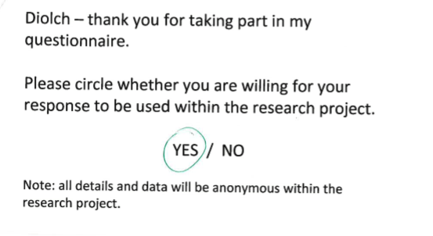
Appendix 21

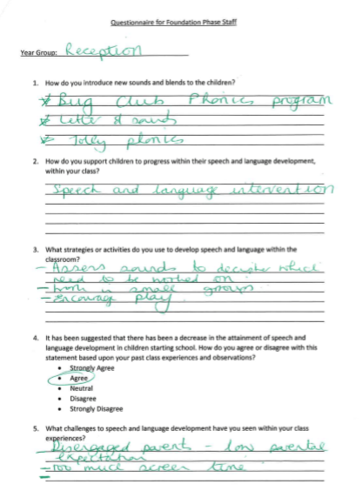
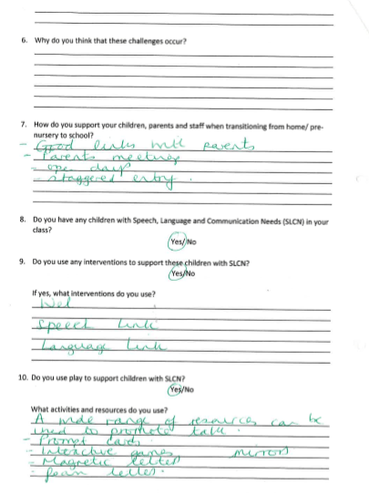

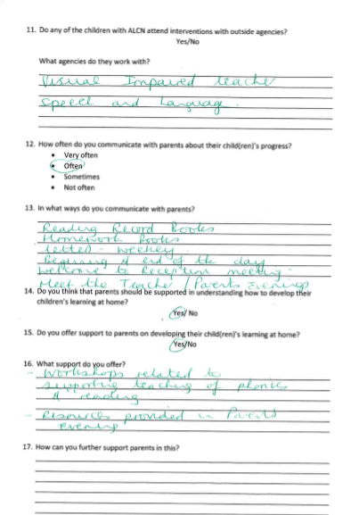

Appendix 22
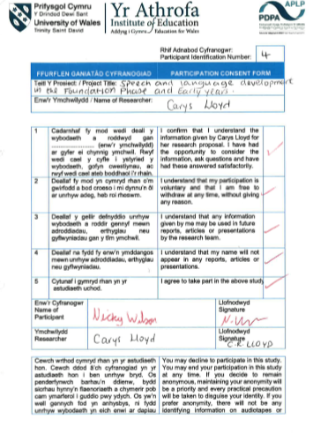
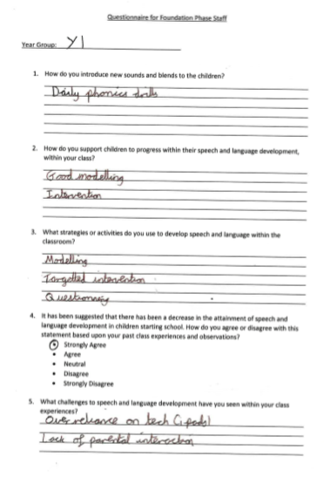
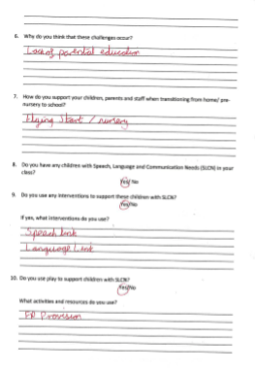
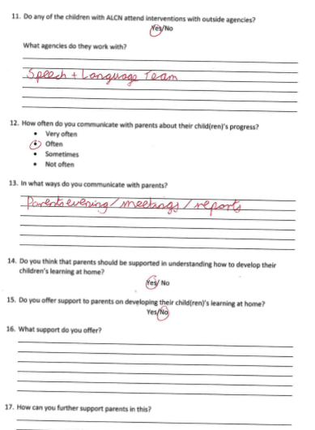

Appendix 23
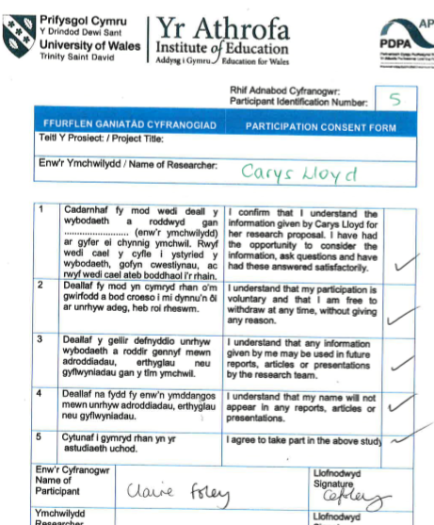
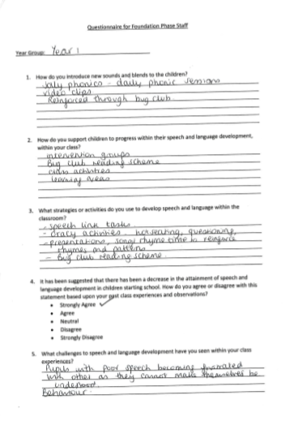
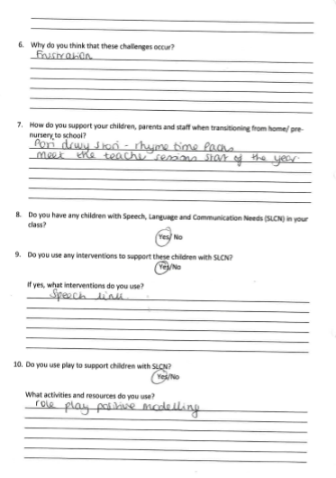
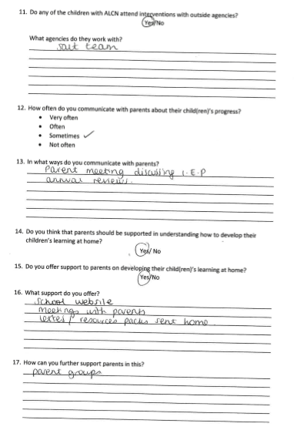
Appendix 24
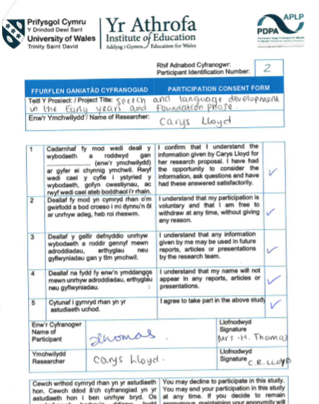

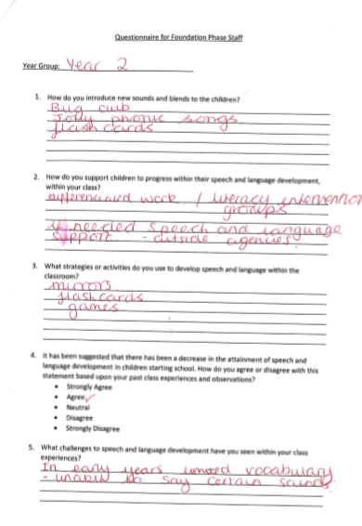
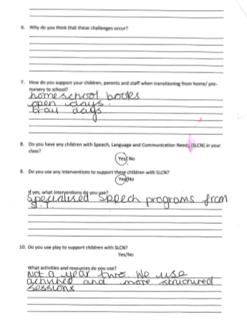
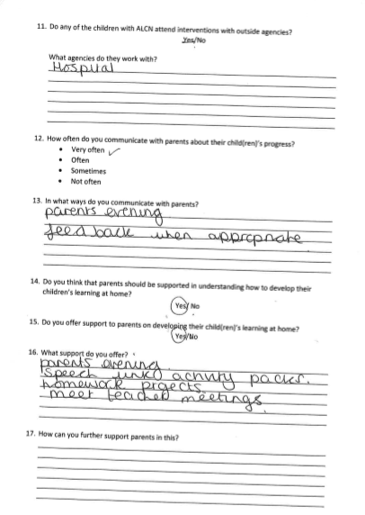

Appendix 26 – Electives report
NOTE: the elective presentation was originally written and presented in a powerpoint format, however, has been altered for the purpose of placing it in the appendix.

- ‘Communication and language skills are the foundation for children’s learning and key to their life chances’ (ICAN, 2013). How true is this statement and how can these skills be developed within the Early Years.
Sub topics:
Introducing sounds and blends.
Parental involvement
Interventions
Continuous and enhanced provision play – therapy
Difficulties – support strategies
Rationale
- Importance of early interaction and stages of development.
- Support from adults – knowing how to support them to reach their full potential.
- Importance of parental involvement in learning at home and being involved within the school community.
- Important for future life – Donaldson’s four purposes.
- Importance of pre-school learning.
- Previous engagement within topic – importance of supporting transition into school – increase in speech, language and communication needs.
- Research suggestions
Flying Start
- Elklan – trained staff.
- Encourage communication skills for babies and young children.
- Types of play
- Support from parents – 4 week programme
- Flying start midwife
- Wellcomm
- Outside agencies
Nursery
- Wellcomm
- Social interaction between children
- Singing nursery rhymes
- Sound of the week
- Support activities –jolly phonics, story sacks, Ben and Beti
- Parental involvement
- Outside agencies – flying start, speech therapy
- Sensory development – messy area, mark making
- Classroom set up – areas of continuous provision

Reception
- Wellcomm and speech link
- Structured activities – capital and lowercase letter recognition
- Reading – questionnaires
- Parental involvement
- Introducing sounds and blends
- Screen time
- Social interaction
- Classroom set up – opportunities so develop speech and language.
Year One
- Phonics – jolly phonics and read write ink
- Adapting rhymes to support learning of sounds
- New sound a day
- Recap on all sounds everyday
- Tricky words
- Repetition and rhyme
- Speech link
Year Two
- Introducing new sounds and words – phonics programmes
- Work with outside agencies
- Games, flashcards, modelling – develop speech and language
- Parental involvement – home to school books – communication
- Interventions
- Support for parents
Trial Activities
- Task: recognise sounds and identify the letters that make them. Create CVC words and use word in a sentence (dependent on ability).
- Aimed to observe the level of development within speech, against their age appropriate level.
- Child who stated that they read at home with an adult often, practised their sounds and enjoyed reading able to accomplish all three aims, compared to child who did not read or practise sounds as much at home.
- This can link to parental involvement – lack of support at home can affect progress.

Speech therapy
- Outside agency - referrals
- Speech link and language link assessments
- One to one therapy within school and at base
- Referrals from flying start
- Parental involvement – programmes and support provision
- Importance of play and social interaction from early age
- Causes of speech and language delay – physical condition – medical history – delay in development
- Fun games and play activities
- Multisensory approaches – listening to sounds, modelling – repeating words or sounds.
Family engagement
- Importance of reading to children and interacting at an early age – developing important skills
- Screen time – ipads, games consoles, tvs used for entertainment
- Play skills – flying start offer programme for developing play at home with parents
- School communicates very well with parents on daily basis – important for sharing child’s progress, raising any concerns.
- Family liaison officer works closely with parents and children – familiar to children
- Speech therapist in school Wednesday mornings – helps parents to understand and get involved with supporting child’s learning.

Future Development
- Key issues surrounding speech and language development.
- How to support children with speech, language and communication needs (SLCN).
- Further professional development
- Gather wider knowledge of how children learn in the Early Years.
- Good practice within schools

Reflection
- Many interventions
- Foundation phase – practise, repetition, modelling, play, interaction
- Parental involvement – interacting with parents everyday/ most days – discuss progress
- Support strategies within classroom
- Opportunities for speech and language development is constant

