
University of Wales Trinity Saint David
Wales Institute of Science and Art

Electronic Ignition & Fuel Injection Systems
Electrical Control Systems (ACHA4010)


Nathaniel Fullylove
2101005
April 2022

Contents Page

Table of Contents
Contents Page 2
1. Introduction 3
2. Methodology 4
2.1. Equipment Used 4
2.2 Safe Working Practice 4
2.3 Engine Systems used in Testing 4
2.3.1. Motronic Engine 4
2.3.2. LE3 Engine Sensor 7
2.4. Method Used for Testing 7
3. Results 9
3.1. Data from the Testing 9
3.1.1. LE3 System Data 9
3.1.2. Motronic System Data 15
4. Analysis 19
4.1. Analysis of the Data of both Engine Systems 19
4.2. Motronic Pin Identification: 19
4.3. Scope Pattern Analysis 20
4.4. Limitations of Testing 20
5. Possible Improvements to LE3 System 22
6. Conclusion 23
References 24

Introduction

This introduction will briefly introduce the topics that the report will be covering and will state the aims and objectives of the report.

This Technical Report will cover the engine testing of two engines, a Motronic Engine, and an LE3 Engine. It will go on to report on the findings from the testing of the two engines and will explain what said findings show. The report will cover findings from Bosch BEA 850 and provide graphs of data gathered in similar conditions to our testing. The report will also make comparisons between data gathered and data provided for the Motronic Engine, while constantly making reference to both of the engine specifications. The report will then go on to introduce some possible ideas that could improve one of the engine systems that are covered herein.

The Aims and Objectives of this Technical Report on Ignition & Fuel Injection Systems are to briefly cover the safety procedures involved when carrying out the engine testing and explain the two engines to give the reader of this report an idea about the engines that are being. It will then run through the method used to conduct the testing of the two engines so that the reader of this report could carry out the same testing for themselves if they so wished. Furthermore, the report will aim to provide the results actually gained and explain their relevance, including what all the data means. Finally, an aim of this report is to suggest some possible improvements on one of the engine systems, in the case of this report the BOSCH LE3 Engine system, and its few inherent weaknesses.

Methodology

Equipment Used

- Motronic Engine
- LE3 Engine
- Bosch BEA 850
- Multimeter

Safe Working Practice

- Wearing Personal Protective Equipment at all times when carrying out testing, which include, steel toe cap boots, dust coats, and eye protection.
- Carry out the university workshop induction to ensure you know how to act and follow it.
- Constantly be aware of your surroundings in the workshop as other work may be going on, so be alert.
- Follow the rules of the workshop.

Engine Systems used in Testing

Motronic Engine
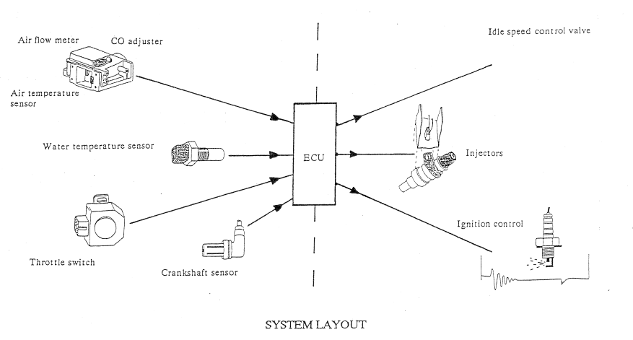
Figure 1 – System Layout for Motronic Engine

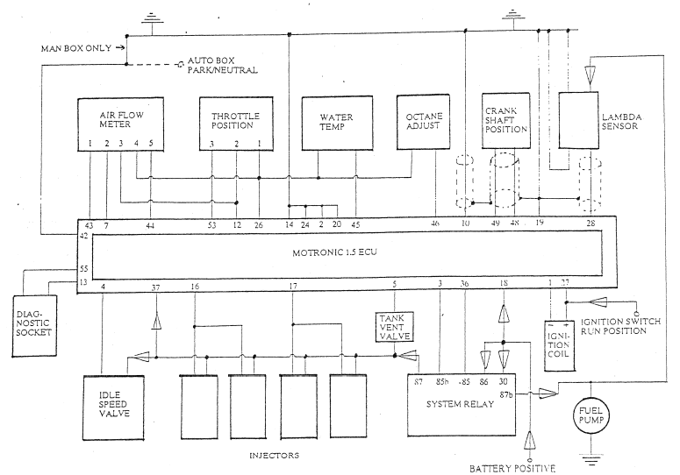
Figure 2 – Bosch Motronic 1.5 Engine System Wiring

The Bosch Motronic Engine system that is being investigated is a Vauxhall 2.0 Litre engine, fitted with the Motronic 1.5 system. The Motronic 1.5 system is an updated version on the 4.0 Motronic system, and the most visible differences from the 4.0 to the 1.5 version is that the throttle position switch has been upgraded to a throttle position sensor. Using a potentiometer or variable resistor allows all the throttle positions to be identified. The Motronic system is effectively an injection system and ignition system, that are all controlled by one ECU. The system in question also has the ability to control the idle speed control valve as well. The injection side of the engine system relies on the same principles of that used on the Bosch LE System, so we see some similarities between the two engine systems in the way they operate. On the Bosch Motronic Engine system, the ignition shares the sensors of the injection system so that accurate timing can be obtained and provide by the ECU. The sensors are also shared with the idle control valve system so that the correct idle speed can be maintained.
Due to the sensors on the Bosch Motronic system operating on an approximate 5 Volt supply, opposed to the Bosch LE system which uses battery voltage supply, the test specifications will differ in numerous areas. The ignition system operates on the variable dwell angle principle to ensure that the dwell time is correct irrespective of the engine speed and supply voltage or current flow through the primary circuit.
“Dwell time is measured in the number of degrees of the distributor’s rotation through which the contacts of the points are closed. This is also known as saturation time, or the time when the coil is producing a strong magnetic field in the primary side of the coil. If the dwell time is reduced, the voltage output of the coil is weak. If the dwell time is too long (the gap barely opens), an arc can travel across the points reducing the output of the coil and even damaging the coil or points.” (Understanding Ignition Dwell, n.d.)

The sensors on the Bosch Motronic engine system are very similar to those on the LE3 system, they are:
- Air Flow Meter, which incorporates the air temperature sensor.
- Water Temperature Sensor
- Throttle Position Sensor (Motronic 1.5)
- Crankshaft Sensor
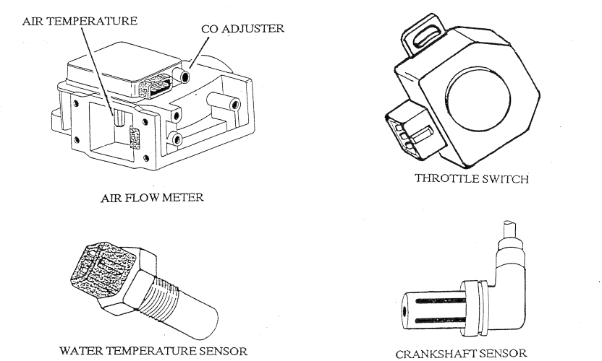
- CO Adjuster
Figure 3 – Motronic Engine System Components Labeled

LE3 Engine Sensor
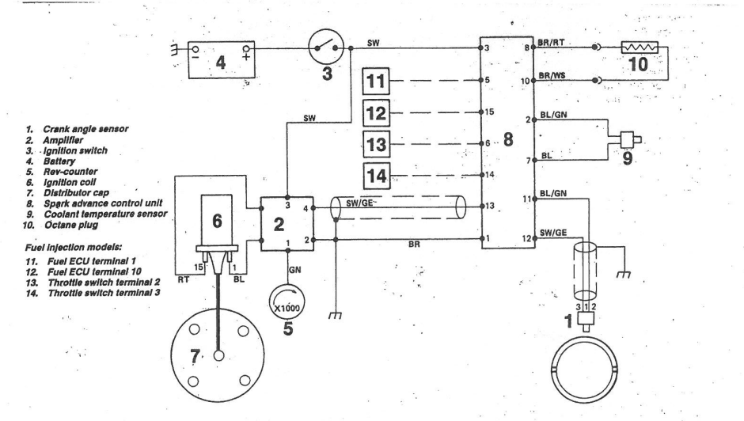
Figure 4 – Bosch LE3 Engine Schematic

From figure 4 we can see that the Bosch LE engine system has fewer connections compared to the Bosch Motronic engine system, as seen in Figure 2. The Bosch LE3 Engine system has a crank angle sensor, a rev counter, and a coolant temperature sensor.
An obvious dissimilarity of the Bosch LE3 system to the Bosch Motronic 1.5 system is that the LE3 system has more than one ECU, it has three, the Fuel management ECU along with the Spark advance control unit ECU, and the Amplifier. Another difference is that the Bosch Motronic 1.5 system can actually store data when the engine is turned off making it potentially the better system.

Method Used for Testing

To begin the testing of the engines the correct PPE must be worn at all times as mentioned earlier.
The first engine that was tested was the LE3 system, and before even turning on the engine a static check is done using a multimeter and connecting one cable from the multimeter to the black pin on the battery and connecting the other cable to the red pin to get a reading for the battery voltage. Then keeping the cable on the black pin on the battery, move the other cable that was on the red pin to the first pin of one of the ECUs, as the Bosch LE3 system has three. The first ECU tested was the Spark Advance Control Unit ECU, so insert the cable into the first pin on the Spark Advance Control Unit ECU making sure a connection is made, then write down the voltage shown on the multimeter, then repeat for all 15 pins in this specific ECU, although remembering pins 4 and 9 have no connections to them so readings cannot be taken for those. Then move onto the Amplifier ECU and do the same readings for the 4 pins. Finally take the readings of the Fuel Management ECU. This ECU has fifteen pins, with pins 6,7,9,11,13 all having no connections, so will give no reading.

Next, repeat the previous steps on the same engine this time with the ignition turned on. However, before turning on the ignition make sure the extractor fan is connected to the exhaust of the engine as to not let the fumes fill up the room and put everyone working on the engine in danger and to protect anyone else that may be in the work space working on other things. Once on, continue with the static check with the ignition on, recording all the results.
Following this, using a Bosch BEA 850 Emission Analyser, connect it to the engine remembering to put the dipstick thermometer in to measure the temperature at different points of engine running. As this tells you when to take the readings. Once the Emission Analyser is set up correctly on the engine, with it grounded to a good earthing point, the warm up phase can begin.
To begin, record the temperature of the engine when it is cold at the start of the testing, then at this temperature measure the injection on time. Then begin to run the engine until it reaches 20 degrees C, next measure the resistance and voltage on pin 8 and measure the injection on time on pin 3. After this raise the temperature to approximately 30 degrees C and repeat the same readings that were just done for 20 degrees C. Continue to increase the temperature by ten degrees completing the same steps and taking the measurements and recording the readings until you reach 60 degrees C. Throughout the testing make sure to look at the scope patterns and see how they differ under load, and while revving.

Moving on to the Motronic Engine System, the method for this is very similar to the LE3 system. The static check is exactly the same as the one completed on the LE3 system except all the pins that need checking are all on the one ECU. Check and write down all the voltages on all pins that have connections, then connect the extractor and turn the ignition on and repeat the steps for static check.
Once this is done proceed to the Warm Up Phase testing using the Bosch BEA 850 Emission Analyser where the engine is probed, and the data is recorded down. Initially the oil temperature is taken cold, to find a base temperature of the engine, this is done with the dipstick tool on the BOSCH BEA 850. There are six pins that need probing and values recording, Pin 45, voltage and Resistance, Pin 16, milliseconds, Pin 4, is a percentage on time, Pin 5, just checking if it is switching on or not, Pin 28, checking whether lambda is switching on, and then Pin 44. However, Pin 44 is only checked at temperatures of 20 and 80 degrees C. Fundamentally, the same steps have been taken as were done for the LE3 engine, just testing the pins stated for the Motronic engine, and going to 80 degrees C instead of 60 degrees C.

Results

Data from the Testing

LE3 System Data

Table 1 – LE3 Engine System Warm Up Phase Data

Temperature (Degrees C) | Pin 8 (Ω) | Pin 8 (V) | Pin 3 (ms)
20 | 1830 | 1.5 | 3.5
30 | 1020 | 1.1 | 3.4
40 | 770 | 0.9 | 3.2
50 | 530 | 0.7 | 2.8
60 | 400 | 0.5 | 2.8

Static Engine Temperature Degrees C = | 18.2
Cold Crank
First Injection (ms) = | 77.1
Normal Injection (ms) = | 6.4
Approx. 500ms of cranking to start

Static | Batter Voltage = | 12.26
Pin Number | Spark Advance Control Unit (V) | Amplifier (V) | Fuel Management ECU (V)
1 | 0 | 0 | 0
2 | 0 | 0 | 0
3 | 0 | 0 | 0
4 | No Connection | 0 | 0
5 | 0 | n/a | 0
6 | 0 | n/a | No Connection
7 | 0 | n/a | No Connection
8 | 0 | n/a | 0
9 | No Connection | n/a | No Connection
10 | 0 | n/a | 0
11 | 0 | n/a | No Connection
12 | 0 | n/a | 0
13 | 0 | n/a | No Connection
14 | 0 | n/a | 0
15 | 0 | n/a | 0

Table 2 – LE3 Engine System Static Check with ignition off

Table 3 – LE3 Engine System Static Check with Ignition on
Ignition On | Battery Voltage = | 11.98
Pin Number | Spark Advance Control Unit (V) | Amplifier (V) | Fuel Management ECU (V)
1 | 0.03 | 11.67 | 0.06
2 | 0.03 | 0.02 | 11.7
3 | 11.6 | 11.67 | 0
4 | No Connection | 0.13 | 0.02
5 | 0.06 | n/a | 0.03
6 | 0.03 | n/a | No Connection
7 | 2.47 | n/a | No Connection
8 | 0.95 | n/a | 1.97
9 | No Connection | n/a | No Connection
10 | 0.03 | n/a | 0.15
11 | 0.03 | n/a | No Connection
12 | 0.06 | n/a | 11.78
13 | 0.13 | n/a | No Connection
14 | 4.97 | n/a | 4.97
15 | 0.14 | n/a | 0.02

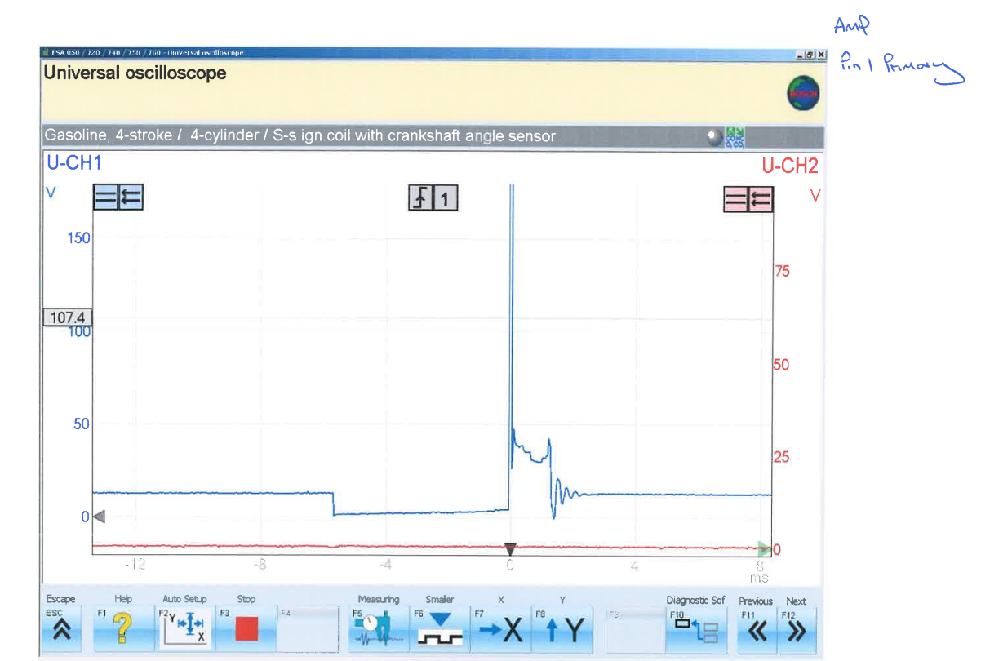
Figure 5 – Scope Pattern for Pin 1 on LE3 showing the primary wave form

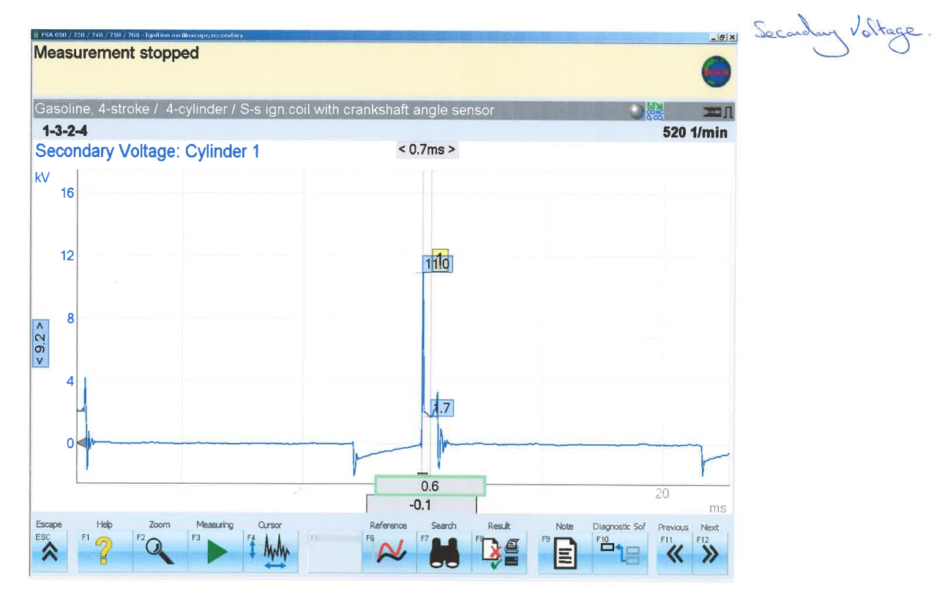
Figure 5 is showing the primary waveform of the system. In section A it is showing the potential voltage for the ignition coil. In section B it shows where the coil is grounded and has an earth. In Section C, the large spike is the back EMF and the whole of section C is covering the spark time for a spark plug. In section D, the first part of it is showing the resultant oscillations, and the rest is leading into Section A again to repeat the cycle.
Figure 6 – Scope Pattern for an LE3 System showing the Secondary Waveform

Figure 6 shows us that the section highlighted as A is the beginning of the Dwell period, where the charging of the secondary coil occurs from the primary coil, within the ignition coil. In the area highlighted as B it is showing the EMF of the coil as all the power that is built up on the secondary coil is discharged, and a spark jumps from one electrode to another. The next part highlighted C, which is showing the spark time, and eventually leading into the beginning of the dwell period again.
(Scoping and Interpreting Secondary Ignition Waveforms, n.d.)
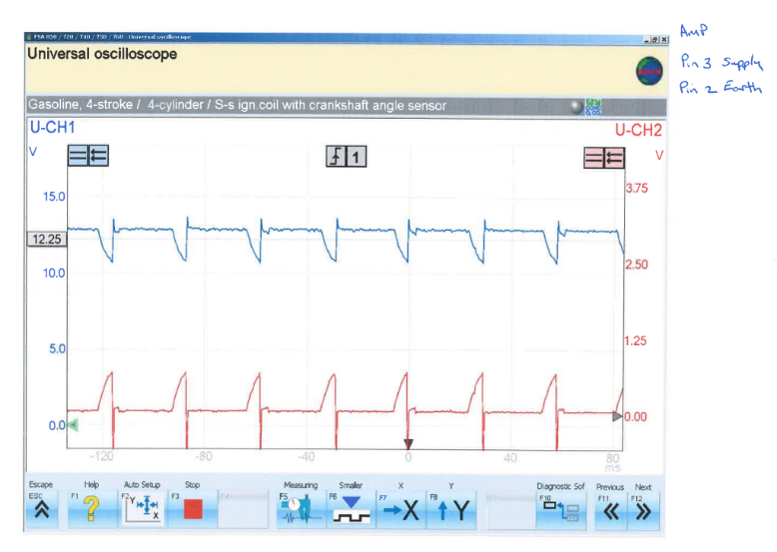

Figure 7 – Scope Pattern on LE3 showing Pins 3 and 2, Supply and Earth, respectively.

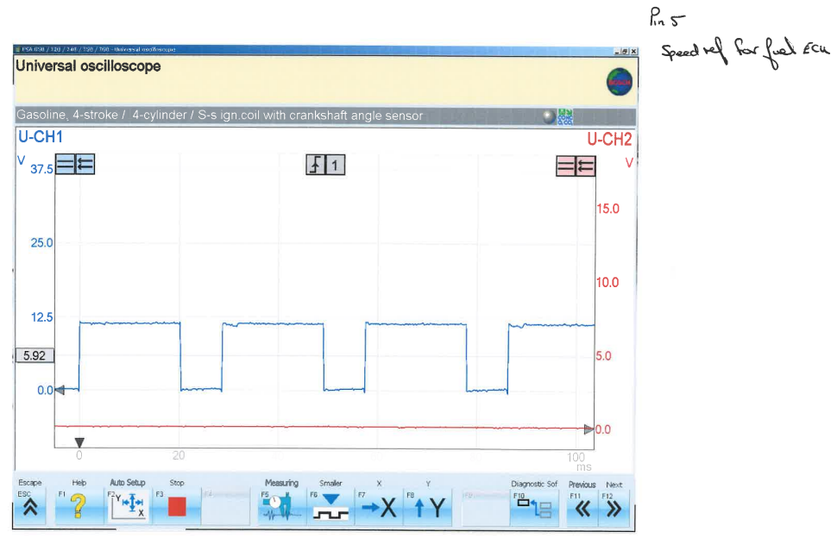

Figure 8 – Scope Pattern for LE3 showing Pin 5, which depicts the Speed Reference
Figure 8 shows how fast the crank shaft is spinning, and in turn how quickly the pistons are moving too.

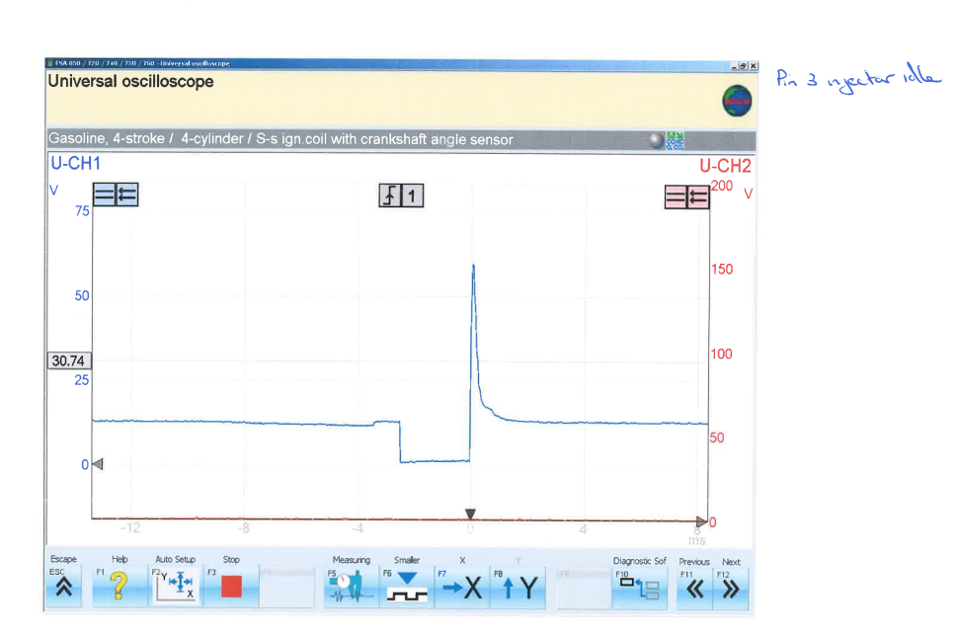
Figure 9 – Scope Pattern for Pin 3 on the LE3 system

In Figure 9 the Injector Idle scope pattern is shown. In section A this is where the injector is off, in B it is the period where the injector is on, known as the pulse time. The spike after section B is the Back EMF, then followed by the injector turning off again in section C.
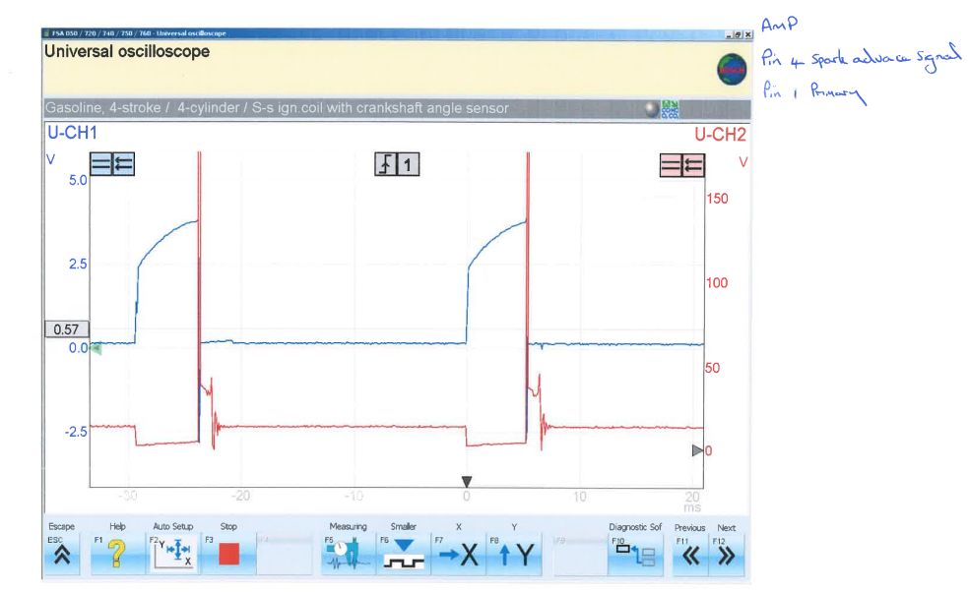

Figure 10 - Scope Pattern of Pin 4 and Pin 1 overlayed on an LE3 System

In Figure 10 it can be seen that the spark advance signal and the Primary waveform graphs when overlayed show that when the coil is grounded and building charge the spark is also building charge, and when the coil discharges, the spark occurs, as seen by the fact that when the back EMF occurs so does the voltage drop on the spark advance signal graph.

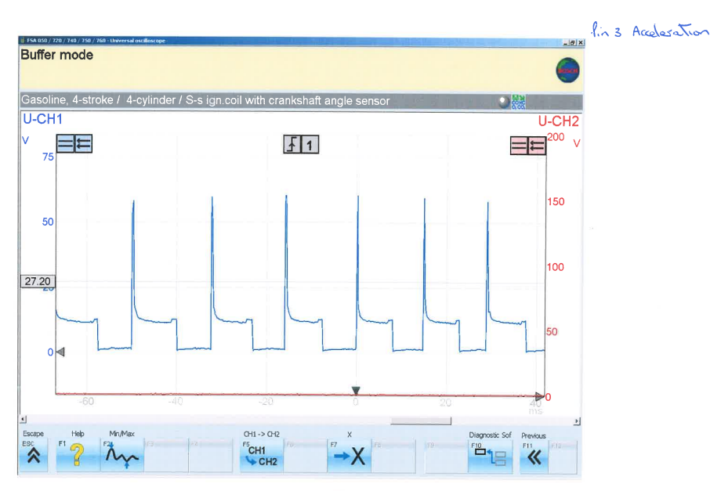

Figure 11 – Scope Pattern on an LE3 system, showing the acceleration
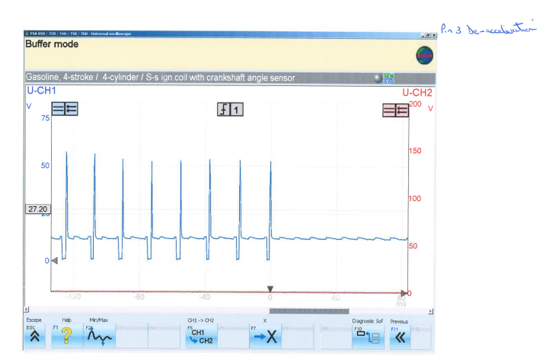
When the acceleration increases the amplitude does not change, but rather the frequency increases. When increasing the acceleration by a high amount very quickly, i.e. putting it under higher load the frequencies increase drastically, however because the engine realises that it is not actually under any load while testing it returns to a constant frequency.
Figure 12 – LE3 Scope Pattern showing de-acceleration

De-acceleration behaves similarly to acceleration, as seen in Figure 12

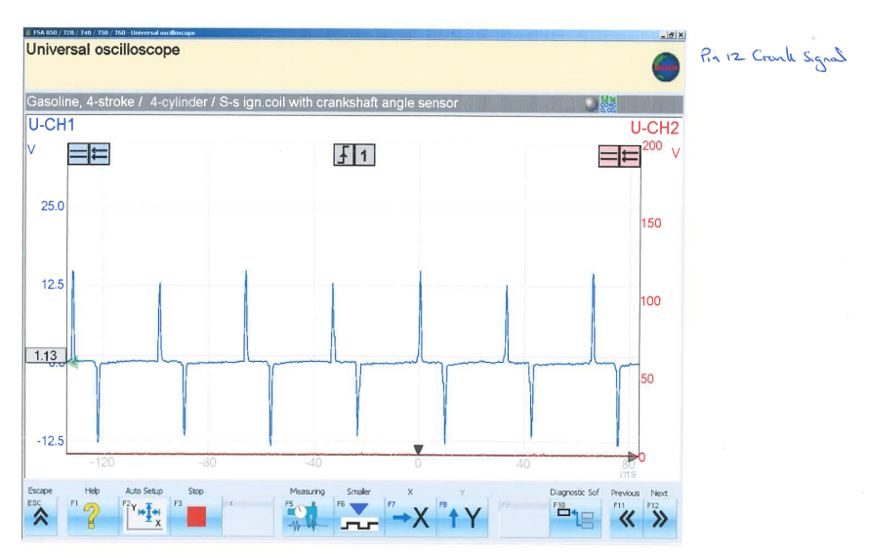
Figure 13 – Scope Pattern for LE3 System depicting the crank signal at Pin 12

Pin 12, the crank signal, is a very useful way of determining whether a cylinder is misfiring. This is due to the fact that as seen in Figure 13 there are spikes in the graph. These represent the sparks, so if one is missing then a cylinder is misfiring. The crank signal also determines what time a spark is needed to be produced and in which cylinder.
(Crankshaft Position Sensor: How It Works, Symptoms, Problems, Testing, n.d.)

Motronic System Data

Table 4 – Warm up Phase

A note to be mentioned is that the engine cooling fan was turned on for everything above 60 degrees C, so this will add electrical loading and have an effect on the results shown.
Pin 5 is the Tank Vent Valve; this helps keep emissions down by controlling the airflow getting into the charcoal canister.
Pin 28 is the Lambda Sensor, it is used by the ECU to control the fuel injection to allow the car to run efficiently
Pin 45 is NTC 2 which is the coolant temperature.
Pin 16 is the Injector on time.
Pin 4 is the Rotary Idle Valve, and it allows air to bypass the throttle plate so air can get to the ignition system better.

Table 5 – Pin 44 in warm up phase

Pin 44 is NTC1, NTC 1 is the Airflow temperature. Pin 44 is only measured at initial room and maximum testing temperature, 20 and 80 degrees C.
Battery Voltage = 12.37
Table 7 – Static Check Ignition On
Battery Voltage = 12.44V
Table 6 – Static Check Ignition Off
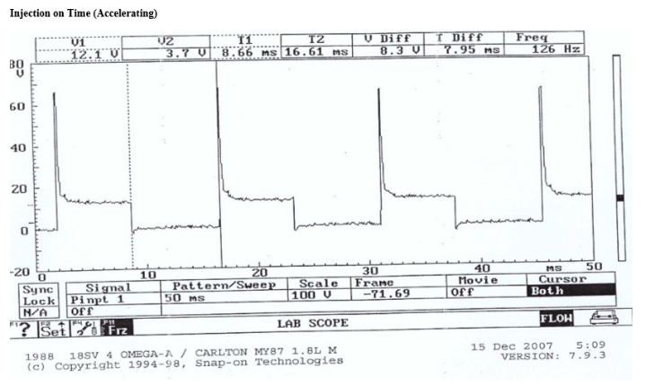
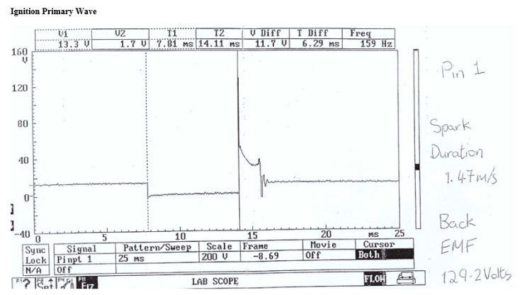
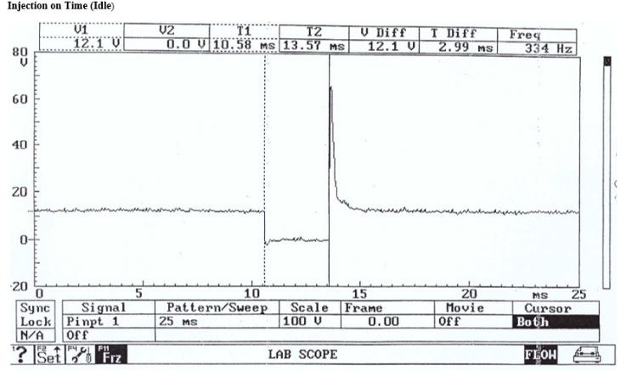
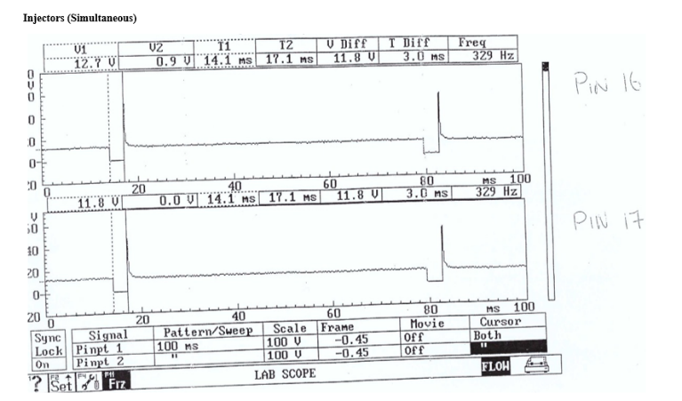
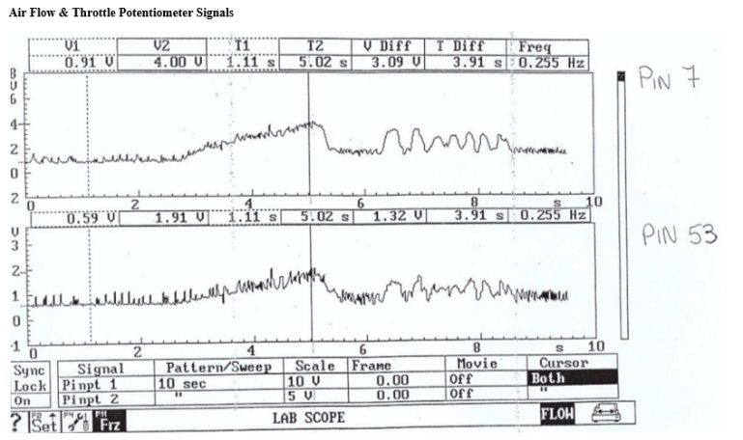
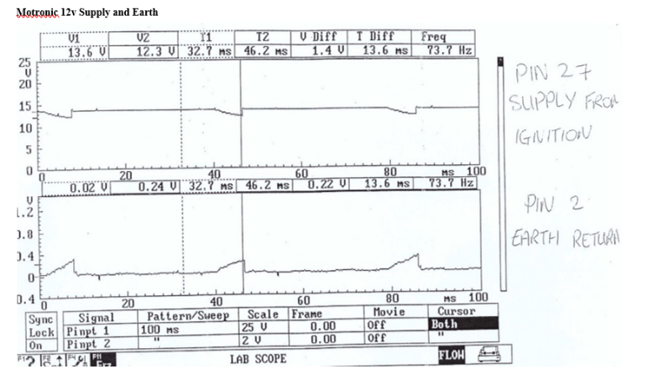
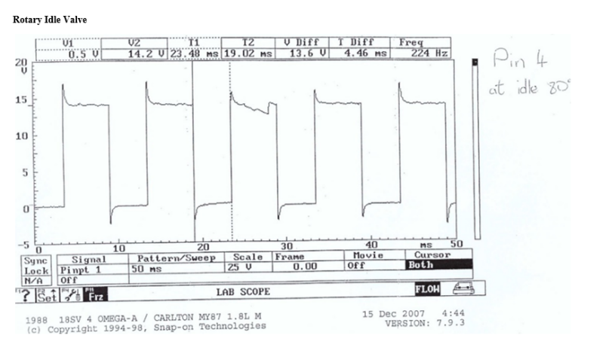
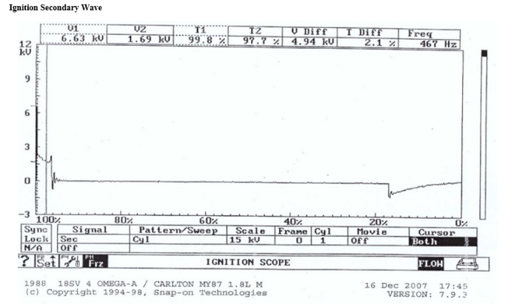
Figure 21 – Acceleration Injection on time Scope Pattern
Figure 20 - Injection on time (Idle) Scope Pattern
Figure 19 – Injectors Scope Pattern
Figure 18 – Air Flow and Potentiometer Scope Pattern
Figure 17 - Supply and Earth Scope Pattern
Figure 16 – Rotary Idle valve Scope Pattern
Figure 15 – Secondary Wave form Scope Pattern
Figure 14 – Primary Wave form Scope Pattern

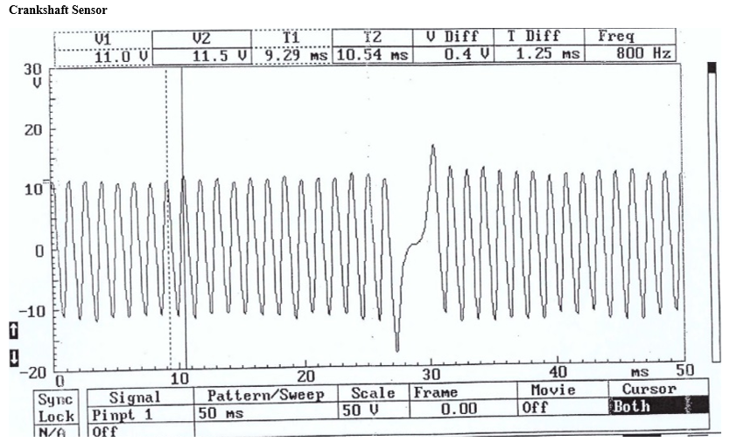
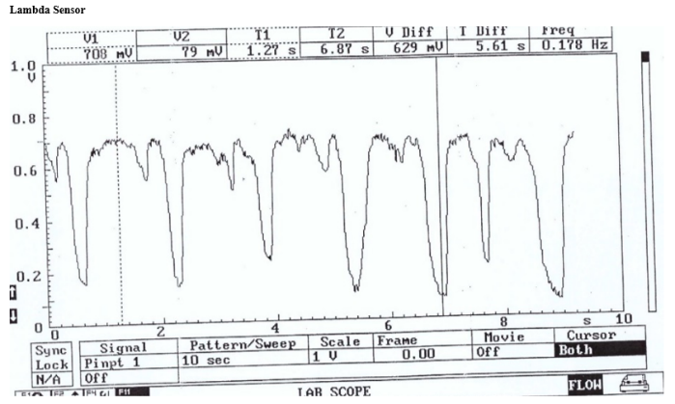
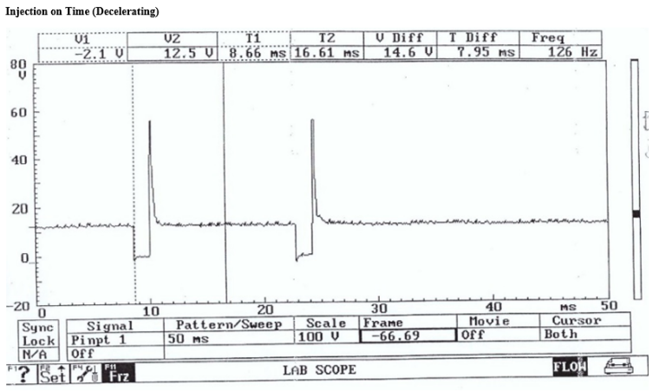
Figure 24 – Crankshaft Sensor Scope Pattern
Figure 23 – Lambda Sensor Scope Pattern
Figure 22 – Deceleration Scope Pattern

In figure 14 and 15, the scope patterns for Primary and Secondary waveform on the Motronic are very similar to that of the LE3 System.

Analysis

Analysis of the Data of both Engine Systems

Due to the Motronic system being more advanced than the LE3 system there were less components to take readings from. So comparatively the Motronic System has more data to analyse.
At the beginning of the warm up phase for the Motronic Engine System the cold crank had a temperature of 18 degrees C and a 20.3 ms injection on time compared to a 77.1 ms injection on time for the LE3 system which was at a temperature of 18.2 degrees C. Already a massive difference can be seen of approximately 57 ms at cold crank between the two systems. This shows that the older system is not as efficient as the new Bosch Motronic 1.5 system.
The LE3 system does not have a lambda sensor so is unable to be compared to the Motronic systems one, however the lambda switched on somewhere between 28 and 38 degrees C.
The LE3 System does not have a Tank Vent Valve, so again cannot be compared but on the Motronic System the Tank Vent Valve switched on between 40 and 51 degrees C.
A clear trend can be seen from Table 4 for Pin 4 of the Rotary Idle Valve of steadily decreasing as the temperature rises throughout the testing, until the temperature reached above 60 degrees C, where the percentage increased slightly. This was due to the engine cooling fan being turned on, so the increased electrical load caused it to rise momentarily.
Looking at Table 4 and Table 1, more specifically Pin 16 on Table 4 and Pin 3 on Table 1, we can see that the injection on time is actually very close between both engines and follows a similar trend to each other. This suggests that they are not that different efficiency wise.
Again, looking at Table 4 and Table 1, but Pin 8 on table 1 and Pin 45 on table 4, they both follow the same decreasing trends as the temperature increases. However, the voltages do fluctuate on pin 45 as the temperature increases but overall, it is still decreasing. Whilst still looking at Pin 45, but looking at the resistance column instead, we can see that the resistance is very similar in trends for both the LE3 System and the Motronic System. The trend being a steady decrease in resistance for the coolant temperature sensor.

Motronic Pin Identification:

These are the pins that are seen on Table 6 and 7
- Pins 2, 10, 14, 19, 20, 21, 24, 26, 42, 47 and 55 are all earths
- Pin 1 is the negative side of the Ignition Coil
- Pin 3 is the control circuit for Fuel Pump
- Pin 4 is the pulsed side of the Rotary Idle Valve
- Pin 5 is the pulsed side of the Tank Vent Valve
- Pin 6 is the 4WD ECU – A/T ECU – Fuel Tell-Tale Tamp
- Pin 7 is the load signal output from Airflow meter
- Pin 9 is the Speedometer, Mileage Frequency Sensor
- Pin 12 is the 5V supply to the Airflow Meter and Throttle Potentiometer
- Pin 13 is the Diagnostic Socket Supply
- Pin 16 is Pulsed side of the injectors (bank of two)
- Pin 17 is also Pulsed side of the injectors (bank of two)
- Pin 18 is Permanent Live – keep alive memory
- Pin 22 is the Engine Tell-Tale Warning Light
- Pin 27 is the Ignition Feed
- Pin 28 is the output from the Lambda Sensor
- Pin 32 is output to On-board Computer
- Pin 34 is to the A/T ECU
- Pin 36 is to the Control Circuit for supply to auxiliaries and ECU
- Pin 37 is a supply to the ECU and the On-board Computer
- Pin 40 and 41 is A/C
- Pin 43 is the output from CO Potentiometer – Not fitted with catalyser
- Pin 44 is output from NTC 1
- Pin 45 is an output from NTC 2
- Pin 46 is the input for the Octane Plug
- Pins 48 and 49 are output from the Crankshaft Sensor
- Pin 51 is the A/T ECU
- Pin 53 is the output from the Throttle Potentiometer

Scope Pattern Analysis

- Initially it was glaringly obvious how similar both of the primary and secondary waveform scope patterns were for both engine systems, as seen in Figures 5, 6, 14, 15.
- The LE3 system is missing scope patterns for things like Lambda Sensors, Airflow Sensor and Rotatory Idle Valve, so these are unable to be compared, however this tells us that the LE3 system can be improved to have the capability to record such scope patterns.
- The two acceleration scope patterns for both engine systems are similar. This tells us that the two engine systems are not affected by the differences in the technology used. However, the deceleration scope patterns do not look the same. This could be due to the fact that when the scope patterns were attained, they were focusing on different periods, but if you look on the graphs, the time periods for deceleration is very similar, so this leads me to believe that they look different due to the updated technology that is used in the Motronic engine system over the LE3 system.
- Looking at Figures 20 and 9, it can be seen that the actual injection on time at idle is the same at around 3ms, this shows that they are running at similar performance during idle.

Limitations of Testing

It is worth mentioning the limitations that appear during the engine testing as it allows one to fully understand the results. There are not massive amounts of limitations with the testing, but the limitations that are there will have an effect on the results.
The fact that the test was not done in a controlled environment, meaning the air temperature could have an effect on it, e.g. the testing started at around 18 degrees C as that was close to the room temperature. This means that the test was unable to start at colder temperatures to achieve a wider range of results, meaning full trends were unable to be seen from the data.
Another limitation was that the testing for Lambda was not accurate, it was checked once the next testing temperature was reached. This means that there was not an accurate recordable temperature where Lambda actually switches on, we only have a close guess. To obtain an accurate temperature at which Lambda switches on, you would have to purely test for it, and be continually testing for it.

Possible Improvements to LE3 System

One of the major improvements that could be made to the LE3 system is to only use one ECU rather than three. This would mean that when it comes to testing to see what is possibly wrong with the engine, the data can easily be accessed through the one ECU.
Another improvement that could be made is by removing the throttle switch and using a throttle potentiometer. This is because it does not require battery voltage supply, but only a 5v power supply. Due to the fact that the throttle switch is mechanical it means the readings can become inaccurate due to things like components wearing out. The Throttle Position Sensor or Throttle Potentiometer is crucial to making sure that the fuel system gets the correct amount of fuel and air mixture.
A third improvement could be the addition of an OBD, On Board Diagnostics system, to store any faults that occur when running, even when the engine is off. The Motronic Engine system has a similar system to this, but a much older version, one that was in the very early stages of development of OBD, so is a lot more basic than some of the OBD systems out there today. This would make testing drastically better and easier as the data can be stored and collected from previous engine testing, which gives you something to compare to.
A Tank Vent Valve and charcoal canister could be added to the LE3 system to help with the running of the engine and reduce the emissions created.

Conclusion

In conclusion, this report shows the data found from completing an engine testing of two Engine Systems, the Bosch Motronic 1.5 Engine system and the Bosch LE3 Engine system. It has then gone on to show all the data and to explain it. The report has also made an analysis of the data gathered and given some thoughts to how the older LE3 system could be improved. The report has further covered the health and safety required when working in the workshops and around engines to make sure the reader of the report is safe if they carry out the testing themselves. Scope Patterns of both engines have been provided in this report and have described a selection of them.
I therefore believe I have met the goals and aims set out in my introduction throughout this report on the Testing of Electronic Ignition and Fuel Injection Systems on the Motronic 1.5 and LE3 systems.

References

Crankshaft position sensor: how it works, symptoms, problems, testing. (n.d.). Retrieved April 25, 2022, from https://www.samarins.com/glossary/crank_sensor.html
Scoping and Interpreting Secondary Ignition Waveforms. (n.d.). Retrieved April 25, 2022, from https://www.autosuccessonline.com/scoping-and-interpreting-secondary-ignition-wave-forms/
Understanding Ignition Dwell. (n.d.). Retrieved April 24, 2022, from https://pertronixbrands.com/blogs/product-higlights/understanding-ignition-dwell

