Assignment Title: Academic Skills

Task 3 - Reflective Report

Student Name: Sorina Dascalescu
Student ID: 2328199
Lecturer name: Amitave Banik
Module name: Academic Skills
Module code: LCLM4001

Table of Contents
Introduction 2
Reflective Assessment of Academic Writing Skills 2
Conclusion 4
Introduction 5
Reflective Assessment of Note Taking Skills 5
Conclusion 6
Introduction 7
Reflective Assessment of Summarising Skills 7
Conclusion 8
References 9

The 6 stages of the Gibbs’ reflective cycle are used in this assessment for each of the 3 separate reflective tasks based on the 3 academic skills.
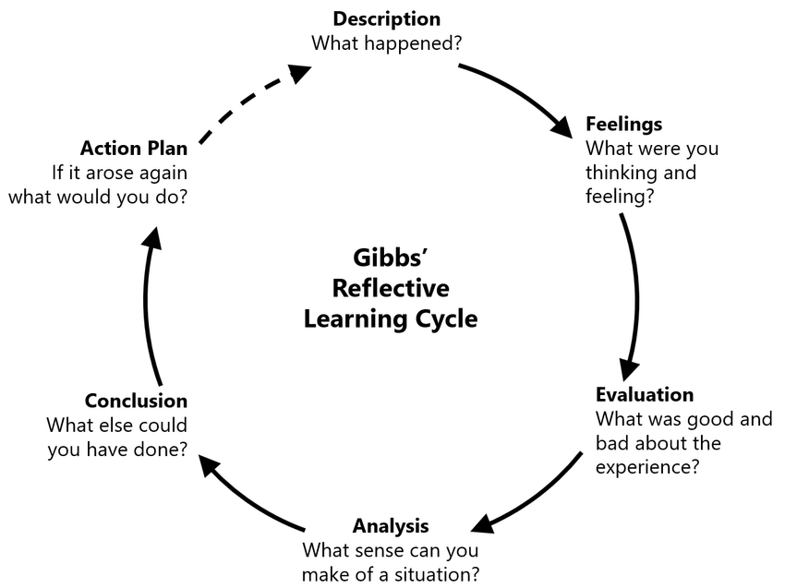
Figure 1: Gibbs’ Reflective Cycle
(Source: Harithuddin, 2021)

Introduction
This task is dedicated to presenting a reflective report on assessing the learning experience of this module based on the gains in academic writing skills.

Reflective Assessment of Academic Writing Skills
Description: In my course of developing academic writing skill, I was assigned the course materials to be involved in diverse activities to increase my proficiency in writing. In contrast, the module, in my opinion, is successful as it is not a simple way to learn that rather it is a structured form of learning. The module learning and the involved activities make the process of learning more productive and conversion of cognitive skills.
Feelings: At the beginning of this module, I was feeling insecure about my academic writing skills. At this stage, I felt that the barriers are prominent in this context whether I would need to work on developing the academic writing skills in my academic perception. The module learning on Academic Skills helped me to work on enormous progress in the areas of academic writing. Considering the academic writing aspect, I have focused on the art of structuring my essays well, using evidence-based arguments and sticking to academic conventions. In terms of academic writing, I have learned to structure my essays more effectively, incorporate evidence-based arguments, and adhere to academic conventions.
Evaluation: The peer review sessions stood useful for me as they offered me a platform for my peers to share their constructive feedback. This, in turn, helped me in improving my writing style. I have learnt to take the aid of these strategies to enhance my capability to organise information better during lectures. This was found effective in the reading sessions leading to more detailed and organised notes with a more comprehensive understanding. However, I found out that I could systemise the learning from this semester and the need to work hard was identified to me. However, I have realised that I will have my skills in this area nevertheless by the end of my formal education by focusing on the loopholes to support my career excellence and progress.
Analysis: The learning components helped me identify that I could improve my specific skill, among others, with the underlying causes of these advantages given below. I observed that the structure of the lessons gave me pleasure since I was able to predict the coming next and as a result, it gave me an edge as I easily learned new skills. This is exemplified in many ways such as, in the peer review sessions or due to the comments from colleagues' feedback.
Conclusion: At the same time, I have acquired some valuable knowledge and skills through structured activities such as SWOT, constructive feedback, and active engagement that will give me better support in my academic career. The newly gained competencies along with approaches would assist me to perform better in other subjects and future academic research projects.
Action Plan
Objectives | Actions | Resources | Timeline
To develop my academic writing skills | - I need to take a specific amount of time off for writing practice every week and work on what structure, argumentation, and clarity mean in academics.  - Asking my friends and instructors for feedback on the written work and being proactive towards restoring my shortcomings and mistakes are needed.  - Employing online sources and style guides to facilitate knowledge about academic writing rules and style guidelines is required. | Writing prompt instructions, following the writing styles in academic essays, taking aid from the peers’ feedback, taking guidance from different online sources | 1-2 weeks
Table 1: Action Plan for developing academic writing skills
(Source: Author)

Conclusion
The report helps in concluding that the learning experiences could help me in developing my academic skills with the aid of more practice.

Introduction
This task is designed to develop a reflective report on assessing the learning experience of this module based on the gains in academic writing skills.

Reflective Assessment of Note Taking Skills
Description: In my course of developing academic writing skill, I was assigned the course materials to be involved in diverse activities to increase my proficiency in note taking.
Feelings: The class sessions as the quiz and communication understanding helped me to identify that I would have to cope with the complex tasks of academic courses and articulate my thoughts to prove my competence. I have developed new knowledge and requisite skills and attitudes that have greatly contributed to my academic excellence.
Evaluation: As opined by Mahmood, Shafiq and Sharif (2022), peer-reviewed sessions are effective in developing academic skills with enhanced communication among peers in different subjects. Here, my note-taking skills have been identified as weak in front of various tools of note-taking including the Cornell method and mind mapping. There are different note-taking techniques such as the Cornell Method and mind mapping (Demirelli, İşler and Yüce, 2024). These techniques seem effective for me to organise information more efficiently during lectures and reading sessions, resulting in more comprehensive and organised notes.
Analysis: In terms of helping learners, they took part in their learning sessions, where most dealt with stages in writing such as taking down shorthand notes and summarising later. Moreover, the feedback tools in this module helped me with adequate support with which I could still expand what I learned from the module.
Conclusion: The final understanding related to my development was participating in the Academic Skills module that enforced a steady growth and refinement in my area of note taking.

Action Plan
Objectives | Actions | Resources | Timeline
To achieve better note-taking skills | - I will try various note-taking methods that include the brand of Cornell, mind maps, and the SQ3R.  - Attending a lecture course will help to gain extensive knowledge on the strategy of note-taking or even necessary guidance from the experts.  - A regular re-look on the notes and comparison of the outcomes will help to improve the notes to achieve consolidated learning and keep the main principles in mind. | Follow the note-taking templates, attend workshops to become accustomed to the note-taking sessions, practice note-taking with the aid of time-assorted websites and online workshops | 4 weeks
Table 2: Action Plan for developing academic writing skills
(Source: Author)

Conclusion
This is evident in following the gains that I have received with the help of my instructors and peers in the module learning.

Introduction
This assesment is developed in form of a reflective report on assessing the learning experience of this module based on the gains in summarising skills.

Reflective Assessment of Summarising Skills
Description: In my course of developing academic writing skill, I was assigned the course materials to be involved in diverse activities to increase my proficiency in summarising.
Feelings: In terms of dealing with the negativity involved in my skills, my emotions transitioned from being afraid to hopeful, while developing my skills to a sense of accomplishment.
Evaluation: I acquired valuable knowledge and skills with a major contribution to my academic performance and approach to learning. I always keep this in mind to put all the summaries of our assignments, which need me to use many words to express the complex idea of a single issue or phenomenon. It has enabled me to carry out analysis by ordering the extracted data properly and then sending it to other persons with a proper and clear understanding. My amateur self needs development to achieve excellence in the academic and professional ground by ensuring that I deserve another couple of study hours.
Analysis: Reflecting on my experiences in the Academic Skills module, I recognise significant improvements in the area of summarising skills. Through the various activities, workshops, and assignments, the peer review sessions were beneficial, as this included constructive feedback and guided me in refining my summarising style.
Conclusion: In addition to follow the efficiency required for developing the summarising skills, teamwork from the very beginning had encouraged me to get involved in every aspect of the module learning. Moreover, this helped me to make the gained theoretical knowledge workable.
Action Plan
Objectives | Actions | Resources | Timeline
To work on my summarising skills | - Regular practice for condensing the articles, talks, and any other academic materials, focusing on major principles and abstract ideas is effective to addressing the main issue within short summaries.  - I will participate in discussions with my peers or form study groups to discuss and upgrade approaches to information summarisation. Here, I can share hints and tips that help me make the best and most concise summaries.  - Asking instructors for recommendations in summarisation assignments and accepting improvement ideas from recommendations for later implementation are required. | Focusing on summarisation exercises, enhancing study potential by attending group meetings, working on instructor feedback | 4-5 weeks
Table 3: Action Plan for developing academic writing skills
(Source: Author)

Conclusion
I am optimistic that by working on the loopholes present in my academic skills, I would receive more benefits in maintaining my career excellence.

References
Demirelli, H., İşler, Y. and Yüce, Y.K. (2024) ‘A Mobile Application for Taking Notes Based on Cornell Technique’, Multimedia Technology and Enhanced Learning, pp. 3–19. Available at: https://doi.org/10.1007/978-3-031-50571-3_1.
Harithuddin, A.S.M. (2021) ‘A First Experience of Using Failure Report as a Reflective Tool in Engineering Education’, International Journal of Emerging Technologies in Learning (iJET), 16(18), p. 23. Available at: https://doi.org/10.3991/ijet.v16i18.24271.
Mahmood, S., Shafiq, F. and Sharif, N. (2022) ‘Importance of Peer Review Technique for Enhancing Learning and Teaching Quality at University Level’, Global Educational Studies Review, VII(II), pp. 361–374. Available at: https://doi.org/10.31703/gesr.2022(vii-ii).34.

