

Administration within contracts

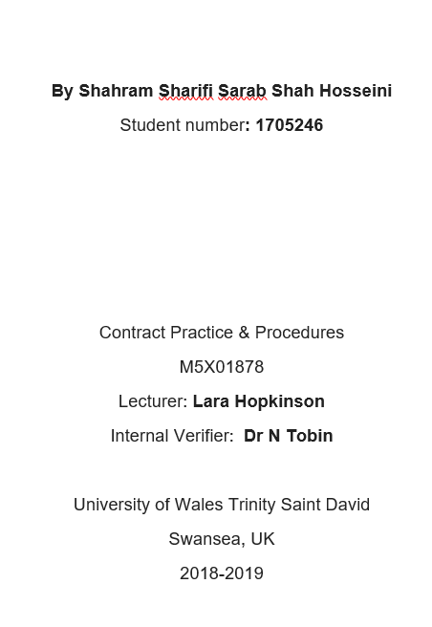
Contents
Introductions 3
Early evaluations of variations 3
Type of contract 3
Acceptability and Execution of variations 3
Tasks of the contract administrator for a variation 4
Issuing instructions 4
Valuation 4
Compensation event 4
Early warning notice 5
Conclusion 5
References 6

Introductions
In all construction projects, variation during construction is inevitable. These variations will certainly affect the costs and timing of the project and this means going away from the original contract, so the original contract must be revised. In this situation, the role of the contract administrator will be more important.
Contract administrator is determined by the client and is responsible for contract management. It should be noted that although the Contract administrator is appointed by the client, in many cases he must act impartially and honestly.
Any changes that make changes to the original scopes is a variation that can be include:

- Designs
- Quality
- Conditions
- Quantity
- Sequence of work

Regardless of the nature of the variation, any variation should be assessment by the Contract administrator.

Early evaluations of variations

Type of contract
Basically, the type of contract plays a crucial role in the tasks of the contract administrator. In other words, the type of contract specifies the duties and limits of the contract administrator. However, in the standard contracts, the nature of dealing with variations is specified. But each of these contracts deals by a different way.
In JCT, the contractor must submit a general plan (without details) immediately after the contract is made.
NEC provides a set of documents in more detail and on a regular basis, which will later be used in the archives of the construction process. (Neccontract. 2019)
The first step is to accept a variation to be acceptable and enforceable from the point of view of the contract and the parties involved in the contract. Therefore, the first step is to analyse the acceptability of the variation and its implementation.

Acceptability and Execution of variations
It should be noted that time variations are acceptable to not change the nature of the work or to remove the work. Otherwise, after the completion of the work, these variations have not been requested. A variation that is acceptable to the contract administrator should be process.
Under the law, variation is an agreement that Due to that, a change is made in the contract and then it is backed up. Therefore, this power is given to the contractor that do not accept some instructions for variation without having any legal consequences for him.

Tasks of the contract administrator for a variation
Standard contracts generally create clauses for contract management, with the help of which the contract administrator can continue the work without having to conclude a new contract. These clauses, along with the powers that give to the contract administrator, also limits him.
The contract administrator has two duties about the variations:
- Issuing instructions for making variations
- appropriate valuations to determine the amount of costs due to variations

Issuing instructions
Contract administrator is as a Client representative in this part. The contract administrator, as a representative of the client, is required to issue the instructions.
This instructions should be:
- Clear
- logically
- Based on contract
- Ability to run
- Depending on the implementation of the variations
Variations may lead to a change in costs. The amount of these changes is costly with expert valuation

Valuation
Contract administrator is as Judge in this part. At this stage, the manager should not consider himself a representative of the client, but must also be fair in the role of a judge in the valuation.it can be possible by:

- Agreement between parties
- Use an expert in the field of cost
- A predetermined method for valuation
- A quotation accepted by the client provided by the contractor (DESIGNINGBUILDINGS. 2018)

Usually it should be noted that the evaluation of variations is based on the prices by the contractor in the tender. But in NEC variations are evaluated in a different way.in NEC evaluation is on base the cost of variation’s effect plus fee( Northwood, T.E.R.R.Y & Collings, N.O.R.T.H.W.O.O.D (2011)).
Valuation do not include direct costs, but may include other costs incurred by the impact of these variations.

Compensation event
When an event occurs during the course of the work that causes a change in the completion of the project, in this case, usually an additional payment to the contractor must be made that known as compensation event in NEC contract.
Compensation event is similar to relevant matters and relevant events in JCT. The difference between these concepts is that NEC does not regard compensation as a kind of blame but as a kind of payment for risks. (Designingbuildings. 2018)
In compensation, the contract administrator notices that usually any risk not specifically related to the client is borne by the contractor. Compensation is only for events that are referred to in the contract as a compensation events. Otherwise, any claim from the parties is not acceptable about it.
Basically, there are special compensation in contracts (NEC) that the contract administrator can referred to those.
In NEC the only events involve compensation that the contractor notifies those to the contract administrator up to 8 weeks after these. That knows as early warning notice

Early warning notice
The contract administrator reviews only claims for compensation that has been notified to him in less than 8 weeks (Unless he has been aware of himself, he has not been informed by the contractor). After the request from the contractor, the contract administrator has one week to agree on this.in following that, the contractor has three weeks to prepare a quotation and then the contract administrator has to answer it by two weeks.

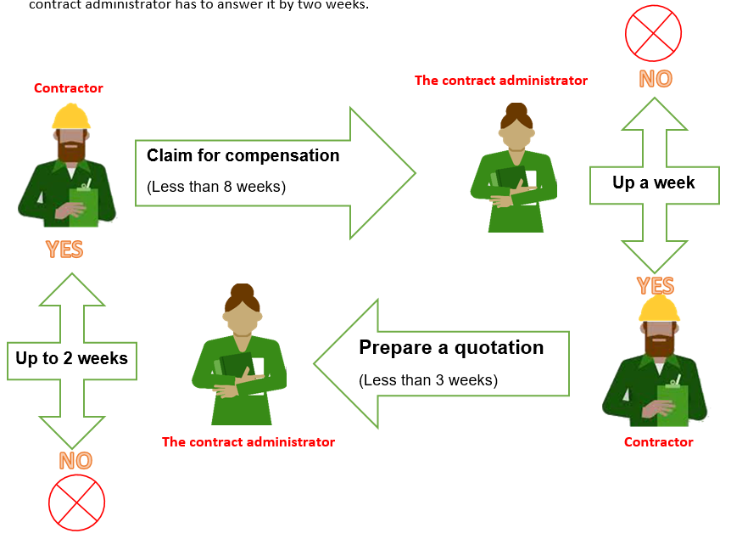
Figure (1): Diagram for claims for compensation

Any agreement must be made in the contract. So last step is Revise the contract and make it appropriate on base the new conditions.

Conclusion
However the contract administrator is representative of the client but he should be fair in the role of a judge.Programme is a contractual document under the NEC. So any change will show on a programme. The parties have to notify to each other as soon as aware a defects. The contract should keep up date on base the variation.

References
Designingbuildings. 2018. Compensation event. [Online]. [6 March 2019]. Available from: https://www.designingbuildings.co.uk/wiki/Compensation_event.
Designingbuildings. 2019. Variations in construction contracts. [Online]. [6 March 2019]. Available from: https://www.designingbuildings.co.uk/wiki/Variations_in_construction_contracts#Valuation_of_variations.
Neccontract. 2019. A COMPARISON OF NEC AND JCT. [Online]. [1 March 2019]. Available from: https://www.neccontract.com/getmedia/3d1b7c3f-097d-4504-8b1f-5a944dbc19dc/A-comparison-of-NEC-and-JCT.pdf.aspx.
Northwood, T.E.R.R.Y & Collings, N.O.R.T.H.W.O.O.D (2011). Contract administration. (1st ed.). UK: The Royal Institution of Chartered Surveyors (RICS).

