

Jessica Ellis
(1807462)
Assignment One

Assignment One

BMSP4004

generating Business Data and analysis

Contents

- Executive Summary

Executive Summary
The Carmarthen Business School (‘CBS’) is intent on creating a one day annual conference center with the primary objective of training people in creating social entreprises eg social responsibility and how to make it sustainable. In order to be sustainable, businesses can use their data anaylis to improve.
By exercising the use of their data, businesses can see what works and what doesn’t, so they can improve in all aspects and evade future failures. Data systems are imperitive for a business to achieve success, as they showcase the clarified internal intelligence and workings of said organization. Statistics and key information are stemmed from databases and can fuel their projections and decision making. This is because they have all of the information stored in one place.
Nevertheless, data systems require a wealth of man – inputted information to operate. This can be time consuming, and if manually inputted, there is a higher probability of producing errors. Furthermore, they need to be tailored to the organization and require maintainace to avert innaccurate or incorrect data. As the world is consisting developing, as does technology. Data systems need to be as air – tight as possible so information can not be corrosively manipulated, as this could have a detrimental effect on a business.

The CBS’ incentive is to locate a venue in which is suitable for their teaching of special needs students programme. As there are 35 members, the venue needs to be large enough for all attendees to be in the same room. As the training courses last all day, there also needs to be a refreshment area available, as well as space and electricity for projector presentations. Furthermore, as part of the training course consists of scenario role play for potentially difficult situations, such as students acting out, there needs to be adequate space to accomadate this. However, as three member are in wheel chairs, there needs to be disability appropriate access in and out of said venue. Lastly, as this programme is funded by the attendees, it has to be cost effective and reasonably accessible in terms of its location, especially as three individuals do not have their own transportation.

The programme Microsoft Access is a very good example of easy collation of data. It enables fields; queries LIST ALL TOOLS AND WHAT THEY ARE FOR

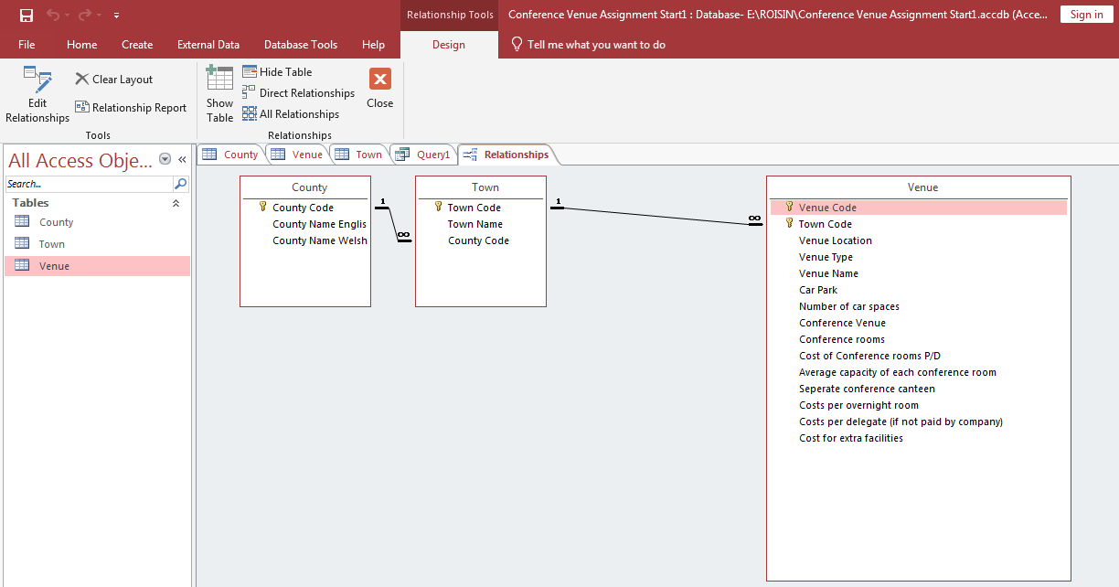

Explain how to make tables and form and the difference between them.


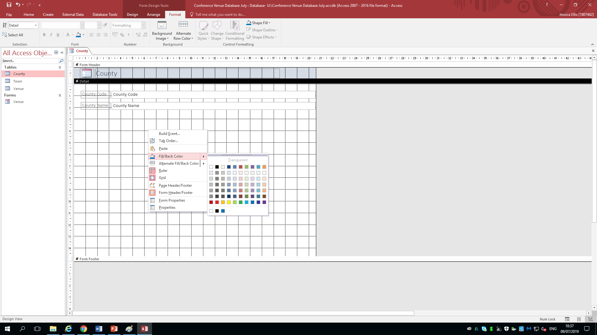
By exercising the Queries tool , it enables the user to dilute the information aquired as well as analyse the pro’s and con’s of (on this occasion) potential venues for The Carmarthen Business School. It prevents seiving through all of the data stored.
The use of colour is beneficial for the use of better engagement/ appeal; additionally making it also clearer to look at.

The Carmarthen Business School have opted for the heavily substancial ‘The Mansion House, Llansteffan’. The rationale is it ticks all the required boxes (as listed above). Although it charges for refreshments throughout the day, attendees have chosen to overcome this hurdle by bringing their own meals. The charge of the sectioned off breakfast room is just a £85 for 10 hours; this is under their budget of an individual £25 per head. The location is secluded, therefore they can fully engage in their training. In addition, the hotel provides free parking; a ramp for accessibility; has 30 tables to hand and has the added bonus of being the UK’s best bed and breakfast with incredible views; thus encouraging The Carmarthen Business School to feel safe looked after and, on the balance of probability more likel;y to fully appreciate their course due to the surroundings.

say what the report is used for eg invoice; order acquisitions; summary of counties associated with best hotels and explain why it is more intewrchangeable with other objects (tables forms report)

Bibliography
Photo Image One: https://www.reachmarketing.com/turn-down-the-churn

