Design Exercise

Name: Morgan jones
Student number: 1706863
Module : (CDA6004)
Course: Electric and Electronic Engineering

Contents
Name: Morgan jones 1
Introduction 3
Task 1 3
Types of Motor Controllers and Drives 3
Common DC Bus 3
Starters 3
Protection 3
Cost 3
Flexibility of Control System 3
Information Gathering Ability 3
Etc. 3
Discussion/Evaluation 3
Conclusion 3
Task 2 4
Rectification of Incoming Mains 4
Minimising Harmonic Noise 4
The effect of harmonics on power and power factor 4
Discussion(?) 4
Conclusion 4
Reference List 5

Introduction
This report will discuss the different types of motor controllers and drives, a research in different technologies for the motor drive system for the 5 motors in table 1. There will also be research into variable frequency drives, compare and contrast the use of Diodes, thyristors (SCRs) and IGBTs for rectification of the incoming mains. Research how harmonic noise can be minimised through careful rectifier design. There will also be research on harmonics effect power and power factor.

Task 1

Types of Motor Controllers and Drives
Motor Controllers and Drives are “electrical or electronic devices that regulate motor speed, torque, and position outputs. The drive modifies the power input to the motor to achieve the desired output. The controller circuits are commonly integrated with the drive circuits as one stand-alone unit, thus the terms motor drive and motor controller are frequently used interchangeably. There are four basic motor controller and drive types: AC, DC, servo, and stepper, each having an input power type modified to the desired output function to match with an application.” [1]
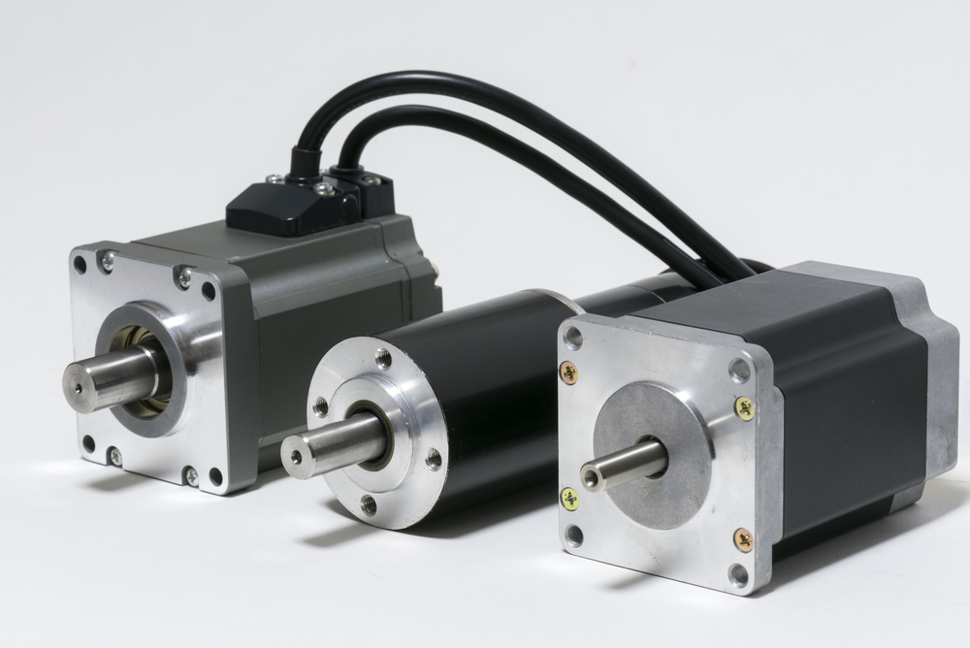
Figure 1 From left to right, an AC servo motor, a DC brush-less motor, and a stepper motor. [1]

Motor Controller and Drive Types

AC

The AC variable speed drive adjusts the power going into the electric motor by altering the power frequency going to the motor for the aim of controlling the torque and speed which are produced. The key things is to look at when choosing this drive is what it will be used on, the operational modes, motor classification , inverter classification, voltage classifications, the rating for power, communication system and specifications for what comes out or in . [1]

These are mostly used for the controlling the velocity of things like a fan or pump. They are called adjustable frequency or variable speed drives they are also called AC inverters. They are usually incorporated alongside the drive circuits which provides the instructions to the drive. [1]

DC

The DC variable speed drives are devices that adjust the ingoing power by modifying the continual or varying source to what comes out by changing the frequency or duration of the pulses. When looking at these drives consider what they will be used for, operating modes, motor type, loop system, voltage classification, power rating, outgoing signal types, operational modes, motor classification , inverter classification, voltage classifications, the rating for power, communication system and specifications for what comes out or in. They are mostly used to regulate the torque and the speed of machinery and electrically powered automobiles. They are typically incorporated alongside the drive circuits which provides the instructions to the drive. [1]

Servomotor

The servomotor drives are devices that alter ingoing power by regulating the continuous or fluctuating the current. The output consist of changing the pulse frequency or duration. When looking at these drives consider what they will be used for, operating modes, loop systems, power ratings, outgoing signal types, communication interface, along with the electronic requirements. These drives are mostly used in mobility management for industrial machines such as conveyors and could be DC or AC powered. They are typically incorporated alongside the drive circuits which provides the instructions to the drive. “Servo drives are also known as servomotor amplifiers.” [1]

Stepper

“Stepper drives are devices that adjust the input power by adjusting the constant or alternating current source to a pulsed, or "stepped," current output.” [1]
They are drives are used mainly for motion control device in manufacturing and construction and can regulate motor speed and torque or position. They are used in devices similar to a conveyor or OEM apparatus. They are typically incorporated alongside the drive circuits which provides the instructions to the drive. “Stepper drives are also known as pulse drives and step amplifiers. Stepper controllers are also known as motor indexers.” [1]
When choosing which stepper motor to be used the device it will be used on, the motor classification, operating mode, , power rating, outgoing signal type, transmission interface, electronic requirements should be considered. [1]

Motor Controllers and Drives — Applications and Industries

In contrast to the servomotors and steppers, generally AC and DC systems do not need a controller or drive as they are the simplest and have similar protection. An AC system will be used when the controlling of speed for an AC device is necessary for the reason that controlling speed using an AC induction is not normally performed. DC motors instead are basically speed manageable by simply changing the electrical energy running to the motor. The more recent model types of DC motor are not regulated mechanically and therefore need special controls to regulate the “magnetic field electronically. Servomotors and steppers need them because they are positioning devices as opposed to rotary motion machines and require controllers and drivers for their operation.” [1]
AC motors are used to monitor the speed that for fans and pumps as conventional controllers could curb the flow. AC systems are used to enhance efficiency by setting specific requirements. [1]

DC motors are being used to manage the magnets for DC using on AC power. These motors have minimal torque this makes them particularly ideal for winches or cranes this is because the loads will need to be raised without a “running start.” [1]
The Servomotors need information on location, speed and increase in speed. This system can be supplied with their drives that work with their motors. “While steppers do not require a feedback loop, some use one. Stepper motor manufacturers also usually supply drives for their specific motors. Most servo- and stepper-motor manufacturers provide charts as guides to which motors will work with which drives.” [1]

Considerations
Picking motor controllers and drives begins by recognizing the motor types. Consequent subordinate classifications to align with that basic knowledge.
If an AC drive is used on an induction motor it is because it is an economic solution with the required attributes, how often is the pump or fan in use with valves or ducts. Another factor for choosing an AC drive is dependant on the device, with continuous torque and varying torque being key categories. It can be used for changeable torque products such as “centrifugal fans, torque requirements vary with motor speed. For constant torque applications such as conveyors, torque requirements are the same regardless of motor speed. AC drives are usually designed for either variable or constant speed applications.” [1]
A DC motor using AC current are typically guided by utilizing thyristor-based bridge rectifiers that allow the AC current to in a single direction reproducing a DC supply. A DC motor working on DC system like a pallet jack is also using it for velocity and position adjustments.

Servomotors are able to work AC or DC, however they need controls since they require response information .

A Stepper motor typically does not need a response but will have to be set up when activated in order to ensure that the motor knows its location. From that point it measures the steps to trace its position. “Some steppers piggyback their drives directly on the motor frames.” [1]

Important Attributes

Semiconductor Device

“IGBTs and SCRs are used for medium and high voltage devices, while MOSFETs are used in low power applications.” [1]

Motor Input Phase

They are single or three-phase this is down to the current that is provided to them. However steppers is the exception in this context for the reason that phase refers to the design of the stepper motor itself as it is said to have a two or five-phase. [1]

Enclosures

Electric enclosures “are specified in accordance with NEMA or IEC criteria for environmental and ingress protection.” [1]

Drive Operating Mode

As previously mentioned, “AC drives are generally designed either as constant torque or variable torque depending on the application.” [1]

Motor drives
 | Motor A | Motor B | Motor C | Motor D | Motor E
Power | 500 kW | 80 kW | 10 kW | 5 kW | 1 kW
Phases | 3 | 3 | 3 | 3 | 1
Voltage | 400 | 400 | 400 | 400 | 230
Required to be Reversible? | Yes | Yes | No | Yes | No
Variable speed required? | Yes | Yes | Yes | No | No
Quantity Installed | 5 | 10 | 23 | 17 | 127
Example Application | Rolling Mill | Gantry Crane | Conveyor | Cutting machine | Pumps / Fans

ABB
ACS880-07, cabinet-built single drives | General purpose drive, ACS580 | ACS880-01 Industrial drive
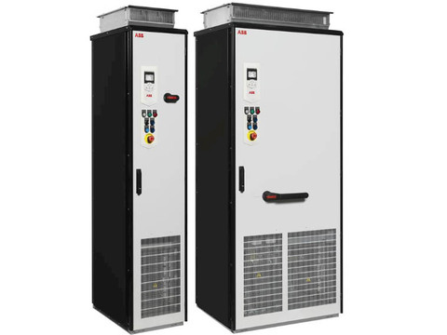 | 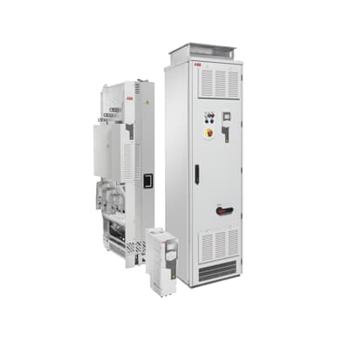 | 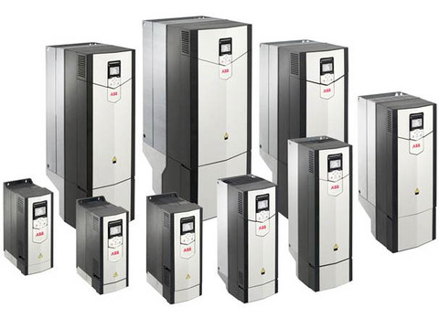
Power range 45 to 2800 kW  Built on ABB’s common drives architecture.  Compact design for custom made needs  IP22, IP42 and IP54 enclosure classes  Direct torque control (DTC) as standard  Integrated safety including STO as standard  Intuitive control panel with USB port  Choke as standard and EMC filter, brake chopper as options Supports a wide range of fieldbus protocols.  Flexible I/O and encoder options  Ambient temperature  Transport -40 to +70 °C  Storage -40 to +70 °C  Operation area -15 to +40 °C as standard (-01, -11, -31)  (air-cooled)  0 to +40 °C as standard (-07, -17, -37),  +40 to +55 °C with derating of 1%/1 °C (-01, -11, -31),  +40 to +50 °C with derating of 1%/1 °C (-07,-17,-37)  (liquid-cooled) 0 to +45 °C as standard (-07CLC, -17/37LC)  +45 to 55 °C with derating of 0.5%/1 °C (-07CLC, -17/37LC)  Cooling method  Air-cooled - Dry clean air  Liquid-cooled- Direct liquid-cooling Antifrogen® L -07CLC, -17/37LC  Without liquid-cooling unit - Incoming coolant temperature 0 to +40 °C as standard , +40 to +45 °C with derating of 2%/1 °C, +45 to +50 °C with derating of 2%/1 °C or 6%/1 °C 5)  With liquid-cooling unit- Incoming coolant temperature 0 to +36 °C as standard+36 to +46 °C with derating of 2%/1 °C  voltage and power range  3-phase, UN2 208 to 240 V, +10%/-15% (-01)  3-phase, UN3 380 to 415 V, +10%/-15% (-01, -11, -31),±10% (-07,-17-37)  3-phase, UN5 380 to 500 V, +10%/-15% (-01, -11, -31),±10% (-07,-17-37)  3-phase, UN7 525 to 690 V, +10%/-15% (-01),±10% (-07,-17,-37, -07CLC, -17/37LC)  0.55 to 250 kW (-01)  2.2 to 110 kW (-11, -31)  45 to 2800 kW (-07)45 to 3200 kW (-17, -37)  250 to 6000 kW (-07CLC, -17/37LC)  Frequency - 50/60 Hz ±5%  Power factor ACS880-01, -07 cosφ = 0.98 (fundamental),  -07CLC - cosφ = 0.93 to 0.95 (total)  ACS880-11, -31, cosφ = 1 (fundamental)  -17, -37, -17/37LC  Efficiency ACS880-01, -07, -07CLC, -17/37LC: 98%  (at nominal power) ACS880-11, -31, -17, -37: 97%  Motor connection  Voltage- 3-phase output voltage 0 to UN2 /UN3 /UN5 /UN7  Frequency - 0 to ±598 Hz ¹⁾ ²)  Motor control - Direct torque control (DTC) | Easy to select, install and use  All essential features built into the drive for minimized number of external components  Many built-in control functions for simplified automation and process control  Straightforward settings menu and assistants for fast commissioning  Energy efficiency features for optimal energy use  Connect to any automation system or use stand-alone  Wide availability and support  Designed for reliability and consistent high quality  Ambient temperature  Transport -40 to +70 °C  Storage -40 to +70 °C  Operation area -15 to +40 °C as standard (-01, -11, -31)  (air-cooled)  0 to +40 °C as standard (-07, -17, -37) +40 to +55 °C with derating of 1%/1 °C (-01, -11, -31)  +40 to +50 °C with derating of 1%/1 °C (-07,-17,-37)  (liquid-cooled)  0 to +45 °C as standard (-07CLC, -17/37LC)  +45 to 55 °C with derating of 0.5%/1 °C (-07CLC, -17/37LC)  Cooling method  Air-cooled Dry clean air  Liquid-cooled Direct liquid-cooling, Antifrogen® L -07CLC, -17/37LC  Without liquid-cooling unit  Incoming coolant temperature  0 to +40 °C as standard+40 to +45 °C with derating of 2%/1 °C+45 to +50 °C with derating of 2%/1 °C or 6%/1 °C 5)  With liquid-cooling unit  Incoming coolant temperature  0 to +36 °C as standard  +36 to +46 °C with derating of 2%/1 °  mains connection  Input voltage and output power range  3-phase, UN 200 to 240 V, +10%/-15%  ACS580-01: from 0.75 up to 75 kW  3-phase, UN 380 to 480 V, +10%/-15%  ACS580-01: from 0.75 up to 250 kW  ACS580-04: from 250 up to 500 kW  ACS580-07: from 75 up to 500 kW  Auto-identification of supply voltage  Frequency from 47 to 63 Hz  Power factor  cosφ = 0.98  Efficiency(at nominal power)98%  Motor connection  Voltage3-phase, from 0 to supply  Voltage  Frequency0 to 500 Hz  Motor control Scalar and vector control | Power range 0.55 to 250 kW  Built on ABB’s common drives architecture  IP20, IP21 and IP55 enclosure classes  Direct torque control (DTC) as standard  Integrated safety including STO as standard  Intuitive control panel with USB port  EMC filter, choke and brake chopper built-in  Supports a wide range of fieldbus protocols, I/O and encoder options  Flexible I/O and encoder options  Marine type approved design  Ambient temperature  Transport -40 to +70 °C  Storage -40 to +70 °C  Operation area -15 to +40 °C as standard (-01, -11, -31)  (air-cooled)  0 to +40 °C as standard (-07, -17, -37),  +40 to +55 °C with derating of 1%/1 °C (-01, -11, -31),  +40 to +50 °C with derating of 1%/1 °C (-07,-17,-37)  (liquid-cooled) 0 to +45 °C as standard (-07CLC, -17/37LC)  +45 to 55 °C with derating of 0.5%/1 °C (-07CLC, -17/37LC)  Cooling method  Air-cooled - Dry clean air  Liquid-cooled- Direct liquid-cooling Antifrogen® L -07CLC,  -17/37LC  Without liquid-cooling unit - Incoming coolant temperature 0 to +40 °C as standard , +40 to +45 °C with derating of 2%/1 °C, +45 to +50 °C with derating of 2%/1 °C or 6%/1 °C 5)  With liquid-cooling unit- Incoming coolant temperature 0 to +36 °C as standard+36 to +46 °C with derating of 2%/1 °C  voltage and power range  3-phase, UN2 208 to 240 V, +10%/-15% (-01)  3-phase, UN3 380 to 415 V, +10%/-15% (-01, -11, -31),±10% (-07,-17-37)  3-phase, UN5 380 to 500 V, +10%/-15% (-01, -11, -31),±10% (-07,-17-37)  3-phase, UN7 525 to 690 V, +10%/-15% (-01),±10% (-07,-17,-37, -07CLC, -17/37LC)  0.55 to 250 kW (-01)  2.2 to 110 kW (-11, -31)  45 to 2800 kW (-07)45 to 3200 kW (-17, -37)  250 to 6000 kW (-07CLC, -17/37LC)  Frequency - 50/60 Hz ±5%  Power factor ACS880-01, -07 cosφ = 0.98 (fundamental),  -07CLC - cosφ = 0.93 to 0.95 (total)  ACS880-11, -31, cosφ = 1 (fundamental)  -17, -37, -17/37LC  Efficiency ACS880-01, -07, -07CLC, -17/37LC: 98%  (at nominal power) ACS880-11, -31, -17, -37: 97%  Motor connection  Voltage- 3-phase output voltage 0 to UN2 /UN3 /UN5 /UN7  Frequency - 0 to ±598 Hz ¹⁾ ²)
[1] | [2] | [3]

Mitsubishi
FR-A800 | FR-D700 | FR-E700
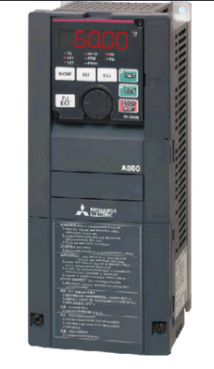 | 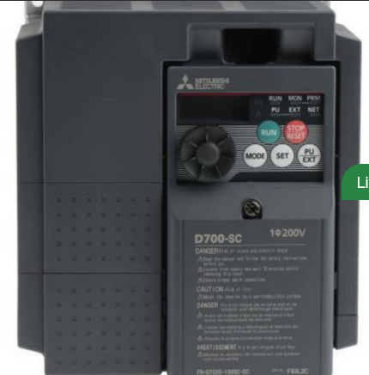 | 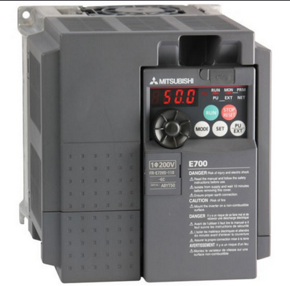
Up to 12 model variants  Inverter Ratings  Applicable motor capacity (kW)*1:  SLD – 0.75 to 355  LD up to 0.75 315  ND (initial setting) - 0.4 to 280  HD - 0.2 to 250  depending on model.  Rated capacity (kVA):  SLD -1.8 to 521  LD – 1.6 to 465  ND (initial setting) – 1.1 to 417  HD - 0.6 to 367  depending on model.  Rated current (A)  SLD - 4.6 to 683  LD – 4.2 to 610  ND (initial setting) – 3 to 547  HD – 1.6 to 481  depending on model.  Overload current rating  SLD - 110% 60 s, 120% 3 s (inverse-time characteristics) at surrounding air temperature of 40ºC  LD - 120% 60 s, 150% 3 s (inverse-time characteristics) at surrounding air temperature of 50ºC  ND (initial setting) - 150% 60 s, 200 % 3 s (inverse-time characteristics) at surrounding air temperature of 50ºC  HD - 200% 60 s, 250% 3 s (inverse-time characteristics) at surrounding air temperature of 50ºC  Rated input AC voltage and frequency - Three-phase 200 to 500 V and 50/60Hz depending on model.  Rated input current (A)  Without DC reactor  SLD Up to 269  LD up to 255  ND (initial setting) up to 266  HD up to 216  With DC reactor  SLD Up to 475  LD up to 432  ND (initial setting) up to 346  HD up to 288  depending on model.  Power supply capacity (kVA)  Without DC reactor  SLD Up to 103  LD up to 97  ND (initial setting) up to 101  HD up to 82  With DC reactor  SLD Up to 181  LD up to 165  ND (initial setting) up to 132  HD up to 110  depending on model.  Cooling system – Natural – Forced air  Common Specs  Control method  Soft-PWM control, high carrier frequency PWM control (selectable among V/F control, Advanced magnetic flux vector control, Real sensor less vector control), Optimum excitation control, Vector control*1, and PM sensor less vector control  Output frequency range  0.2 to 590 Hz (The upper-limit frequency is 400 Hz under Advanced magnetic flux vector control, Real sensor less vector control, Vector control, and PM sensor less vector control.  frequency setting and resolution  Analog input  0.015 Hz/60 Hz at 0 to 10 V/12 bits (terminals 2 and 4)  0.03 Hz/60 Hz at 0 to 5 V/11 bits or 0 to 20 mA/approx. 11 bits (terminals 2 and 4), at 0 to ±10 V/12 bits (terminal 1)  0.06 Hz/60 Hz at 0 to ±5 V/11 bits (terminal 1)  Digital input  0.01 Hz  Frequency accuracy  Analog input  Within ±0.2% of the maximum output frequency (25 ± 10°C)  Digital input0.  01% or less of the set output frequency | Applicable motor capacity (kW)  0.1 to 15  depending on model.  Rated capacity (kVA)  0.3 to 23.1  depending on model.  Rated current (A)  0.8 to 58.0  depending on model.  Overload current rating  150% 60s, 200% 0.5s (inverse-time characteristics)  Voltage  Three-phase 200 to 480V  depending on model  Permissible AC voltage fluctuation  170 to 480V and 50Hz/60Hz  Permissible frequency fluctuation ±5%  Power supply capacity (kVA)  0.4 to 28.0  Depending on model  Cooling system  Self-cooling, Forced air cooling  Approximate mass (kg)  0.5 to 6.5  Depending on model  Control method  Soft-PWM control/high carrier frequency PWM control (V/F control, General-purpose magnetic flux vector control, and Optimum excitation control are available)  Output frequency range  0.2 to 400Hz  Frequency setting resolution  Analog input  0.06Hz/60Hz (terminal2, 4: 0 to 10V/10bit)  0.12Hz/60Hz (terminal2, 4: 0 to 5V/9bit)  0.06Hz/60Hz (terminal4: 0 to 20mA/10bit)  Digital input  0.01Hz  Frequency accuracy  Analog input  Within ±1% of the max. output frequency (25°C ±10°C)  Digital input  Within 0.01% of the set output frequency  Regenerative braking torque  150%, 100%, 50%, 20% | overload capacity  ND (normal duty)  60 seconds overload 150  %3 seconds overload  200 %  Ambient temperature 50°C  Models  Power supply  FR-E720S-mSC: 1-phase, 200–240 V AC (–15 %, +10 %)FR-E740-mSC: 3-phase, 380–480 V AC (–15 %, +10 %)  Ambient temperature–10 ºC to +50 °C (non-condensing)Storage temperature–20 °C to +65 °C  Relative humidity  Max. 90 % (non-condensing)Installation  Altitude Max.1000 m above sea level  Protection IP20  Shock resistance 10 G  Vibration resistance Max. 0.6 G
  type | Rated current(A) | Rated motor capacity (kW)
  FR-E720S-008SC-EC | 0.8 | 0.1
  FR-E720S-015SC-EC | 1.5 | 0.2
  FR-E720S-030SC-EC | 3.0 | 0.4
  FR-E720S-050SC-EC | 5.0 | 0.75
  FR-E720S-080SC-EC | 8.0 | 1.5
  FR-E720S-110SC-EC | 11 | 2.2
  FR-E740-016SC-EC | 1.6 | 0.4
  FR-E740-026SC-EC | 2.6 | 0.75
  FR-E740-040SC-EC | 4.0 | 1.5
  FR-E740-060SC-EC | 6.0 | 2.2
  FR-E740-095SC-EC | 9.5 | 3.7
  FR-E740-120SC-E | 12 | 5.5
  FR-E740-170SC-E | 17 | 7.5
  FR-E740-230SC-EC | 23 | 11
  FR-E740-300SC-EC | 30 | 15
[4] | [5] | [6]

Danfoss
FC 103 | FC 202
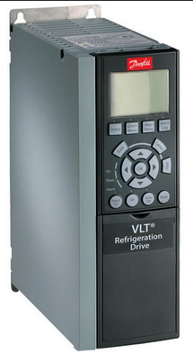 | 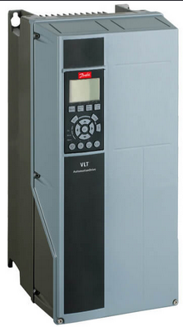 | 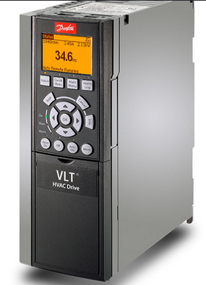
Main supply (L1, L2, L3)  Supply voltage  3 x 200-240 V AC ......1.1-45 kW  3 x 380-480 V AC ......1.1-450 kW  3 x 525-600 V AC ......1.1-90 kW  3 x 525-690 V AC ......75-630 kW  Supply frequency 50/60 Hz  Displacement power factor(cos ф) near unity > 0.98  Output voltage  0-100% of supply voltage  Output frequency (dependent on power size 0-590 Hz  Control card  USB interface 1.1 (Full Speed)  USB plug Type “B”  RS485 interface Up to 115 kBaud  Max. load (10 V )15 mA  Max. load (24 V )200 mA | Main supply (L1, L2, L3)  Supply voltage  1 x 200-240 V AC .....1.1-22 kW  1 x 380-480 V AC......7.5-37 kW  3 x 200-240 V AC .....0.25-160 kW  3 x 380-480 V AC ....0.37-1000 kW  3 x 525-600 V AC ....0.75-90 kW  3 x 525-690 V AC ....11-1400 kW  Supply frequency 50/60 Hz  Displacement power factor(cos ф) near unity> 0.98  Output voltage  0 – 100% of supply voltage  Output frequency (dependent on power size) 0-590 Hz  Switching on output Unlimited  USB interface1.1 (Full Speed)  USB plug Type “B”  RS485 interface Up to 115 kBaud  Max. load (10 V )15 mA  Max. load (24 V )200 mA | Main supply (L1, L2, L3)  Supply voltage  200-240 V AC  380-480 V AC  525-600 V AC  525-690 V AC  Supply frequency 50/60 Hz  Displacement power factor(cos ф) near unity> 0.98  Output voltage  0-100% of supply voltage  Output frequency 0-590 Hz  Switching on output unlimited  USB interface 1.1 (Full Speed)  USB plug Type “B”  RS485 interface Up to 115 kBaud  Max. load (10 V )15 mA  Max. load (24 V) 200mA
[8] | [9] | [10]

Schneider Electric
ATV340 | ATV600 | ATV900
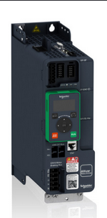 | 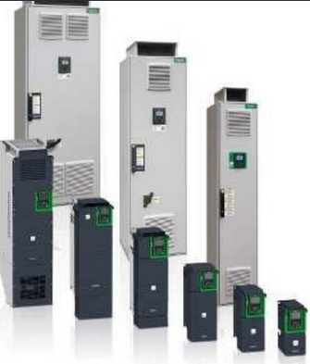 | 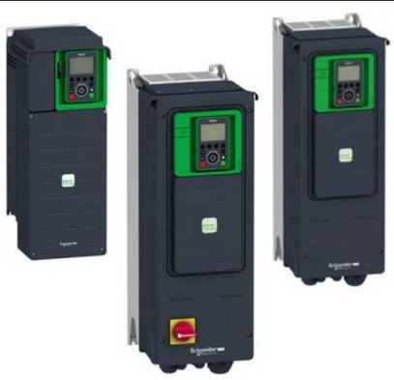
Power range for 50..60 Hz supply  Single-phase 200...240 V  Three-phase 200...240 V  Three-phase 380...480 V  Three-phase 380...500 V  Three-phase 525...600 V  Output frequency 0.1...599 Hz  Control type  Asynchronous motor  U/F ratio (2 points, 5 points, energy saving, quadratic), flux vector control without sensor (standard and energy saving)Voltage vector control without sensor, current vector control with sensor, U/F 5 points, energy saving mode  Synchronous motor  Vector control without sensor  Analog inputs  3: 1 bipolar differential input ±10 V, 1 voltage input (0...10 V), and 1 current input (0-20 mA)  2: 1 configurable input (voltage/current/thermal probe) and 1 bipolar differential input ±10 V c3: Configurable as voltage (0...±10 V c) or current (0-20 mA/4-20 mA), including 2 for probes (PTC, PT100, PT1000, or KTY84)  2: 1 configurable input (voltage/current/thermal probe) and 1 bipolar differential input ±10 V c  Digital inputs  6: 4 configurable inputs (positive or negative logic), 1 input with PTC probe, 1 x 20 kHz pulse input5 + 2: 5 configurable inputs (positive or negative logic) and 2 that can be configured as digital input or output8: Configurable inputs (positive or negative logic)5 + 2: 5 configurable inputs (positive or negative logic) and 2 that can be configured as digital input or output  Analog outputs1: Configurable as voltage (0...10 V) or current (0-20 mA)1: Configurable as voltage (0...10 V c) or current (x...20 mA)2: Configurable as voltage (0...10 V c) or current (x...20 mA)1: Configurable as voltage (0...10 V c) or current (x...20 mA)  Digital outputs1: Configurable as sink or source2: Assignable1: Assignable2: Assignable  Relay outputs2: 1 with NO/NC contacts and 1 with NO contacts | Line supply 380 V - 480 V  ND up to 315 kW  HD up to 250 kW  ND up to 500HP  HD up to 400HP | Mounting type  Wall-mounting or Floor-standing  Degree of protection  IP20 and IP21/UL Type 1  IP21/UL Type 1 without braking unit  IP55  IP55 with Vario disconnect switch  IP21 without braking unit  Power range for 50...60 Hz line  Three-phase: 200...240 V (kW/HP)  Three-phase: 380...440 V (kW)  Three-phase: 380...480 V (kW/HP)  Three-phase 500...690 V (kW/HP)  Markets  Oil & gas  Mining, minerals & metals  Consumer packaged goods (CPG)  Water & wastewater
[11] | [12]

Task 2

Rectifiers
In the context of variable frequency drives, compare and contrast the use of the following for rectification of the incoming mains:

Diodes
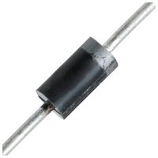
Figure 2 Semiconductor Diode
Most frequently used variable frequency drive used to rectify AC to DC is a semiconductive diode. There are multiple reasons for this. Firstly the diodes are essentially needed since they allow the current to go in one way and stop coming in a additional paths. It allows the AC voltage to be positive or negative after it is rectified or more specifically the AC current is rectified. For voltage to be rectified capacitors are required. Another reason to use of diodes as the main component is down to how cheaply they are priced compared unlike other technologies. A diode is more robust than other semiconductor components. Another reason is that the option for the “diodes logic is the absent of control electronics to bring the diode in or out conduction.” [8]
“ The commutation process happens naturally so the control is not needed. Because of the use of diodes, several options are available: Diodes act like switches without leakage current or voltage drop, The switching occurs without time delay, Assume a perfect three phase sinusoidal input voltage, Assume a constant output current” [8]

Thyristors (SCRs)
A Thyristor is the name for a series of high-speed switching devices often used in AC power management and AC to DC switching this includes Silicon Controlled Rectifiers(SCRs) and triacs. The SCR is a very common type of thyristor and several examples of common SCR packages are shown in Figure 3. There are multiple types offered which are able to switch loads from a few watts to tens of kilowatts. The “SCR acts basically as a SILICON RECTIFIER diode, with the usual anode and cathode connections, but with an additional CONTROL terminal, called the GATE. Hence the name Silicon Controlled Rectifier.” [9]

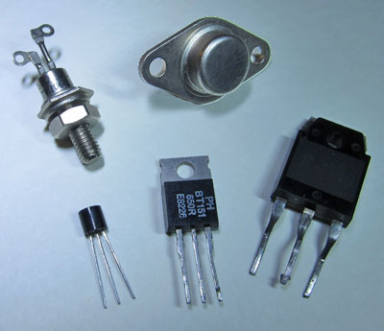
Figure 3 SCR Package [9]
“A certain voltage can trigger the gate whilst the anode is more positive than the cathode will switch the SCR on to allow current to flow between anode and cathode. This current will continue to flow, even if the trigger voltage is removed, until anode to cathode current falls to very nearly zero due to external influences such as the circuit being switched off, or the AC current waveform passing through zero volts as part of its cycle.” [9]

IGBTs
“An insulated-gate bipolar transistor (IGBT) is a three-terminal power semiconductor device primarily used as an electronic switch which, is used to combine high efficiency and fast switching. It consists of four alternating layers (P-N-P-N) that are controlled by a metal-oxide-semiconductor (MOS) gate structure without regenerative action. Although the structure of the IGBT is topologically the same as a thyristor with a 'MOS' gate (MOS gate thyristor), the thyristor action is completely suppressed and only the transistor action is permitted in the entire device operation range. It switches electric power in many applications: variable-frequency drives (VFDs), electric cars, trains, variable speed refrigerators, lamp ballasts, air-conditioners and even stereo systems with switching amplifiers.” [10]
“Since it is designed to turn on and off rapidly, amplifiers that use it often synthesize complex waveforms with pulse-width modulation and low-pass filters. In switching applications modern devices feature pulse repetition rates well into the ultrasonic range—frequencies which are at least ten times the highest audio frequency handled by the device when used as an analog audio amplifier.” [10]

Minimising Harmonic Noise through careful rectifier design

Three phase rectifier
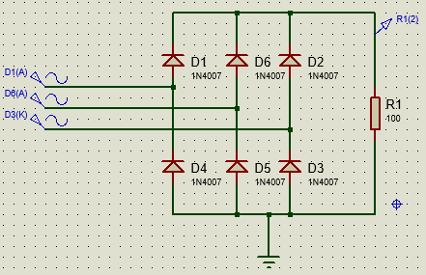
Figure 4
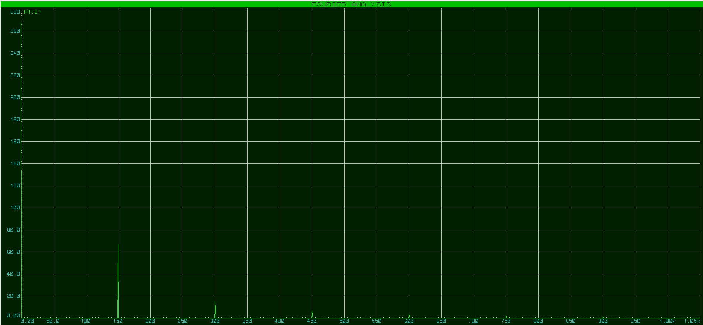
Figure 5

Half wave rectifier
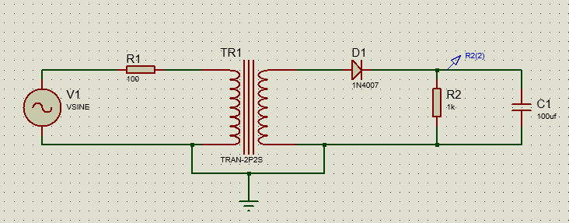
Figure 6
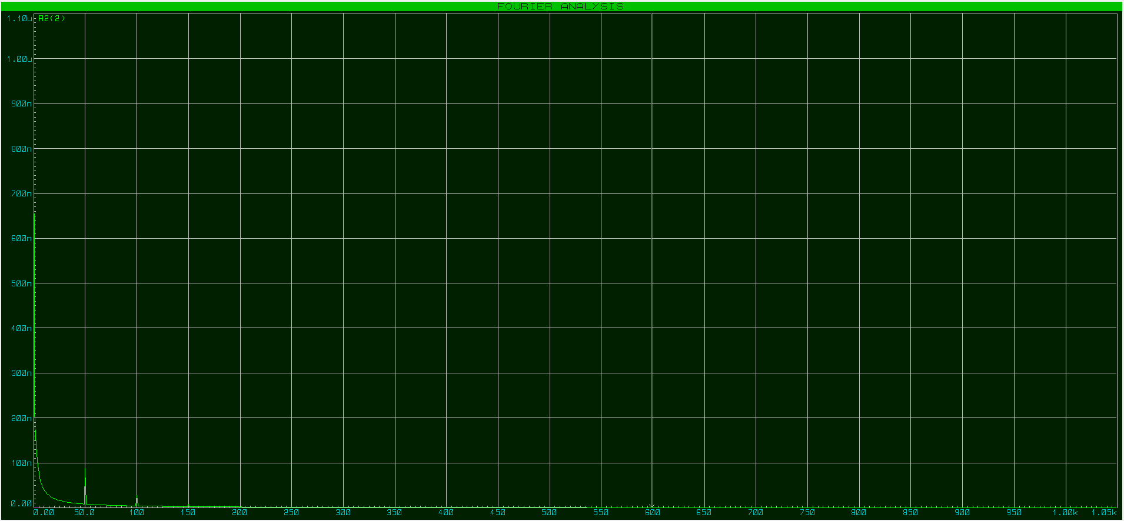
Figure 7

Full wave rectifier
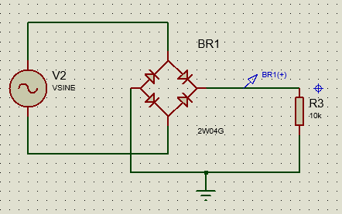
Figure 8

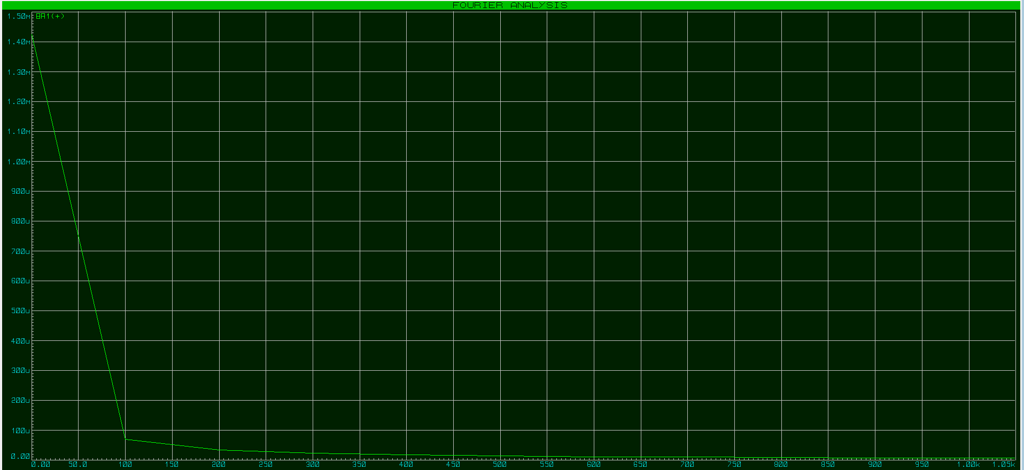
Figure 9

As you can see from the above figures 5,7 and 9 the harmonics vary from circuit to circuit in some circuits you have a high frequency of harmonics in other there is a lower frequency this is down the number of phase and components in the circuit.

The effect of harmonics on power and power factor
Harmonics are created by nonlinear loads attached to the supply system and are going through the system impedances which then interferes with the supply voltage. [16]
Harmonics can happen in Industrial equipment, AC and DC motors, Uninterruptible Power Supplies (UPS), Office equipment and Household appliances. [16]
These harmonics increase the r.m.s. in a system which then weakens the supply voltage condition. They will strain the electronic devices and possibly harm equipment. They could disturb normal operations and increase costs. [16]

If there is a harmonic present there could be “overheating of transformers, motors and cables, thermal tripping of protective devices and logic faults of digital devices.” Also, the life expectancy of the device is diminished by higher operational temperatures. [16]
Capacitors are particularly sensitive to the harmonics in the supply voltage as “capacitive reactance decreases as the frequency increases.” This implies that a comparatively tiny ratio of harmonic voltage can result in a substantial electric current in the capacitors circuit. [16]

Problems associated with harmonics.
1) Mains voltage distortion
2) Losses of electrical energy
3) Increase in the apparent power and over-sizing of sources
4) Damage to capacitors
5) Harmonic resonance
6) Transformer and neutral conductor overload due to excessive zero-phase currents
7) Conductor losses (skin effect)
8) Negative rotation sequences in motors
9) Overheating of transformers
10) Nuisance tripping
11) Zero-crossing noise
12) Failure of stand-by generating sets

[13]

References

[1] | [Online]. Available: https://www.thomasnet.com/articles/instruments-controls/types-of-motor-controllers-and-drives/. [Accessed April 2021].
[2] | [Online]. Available: https://new.abb.com/drives/low-voltage-ac/industrial-drives/acs880-single-drives/acs880-07. [Accessed April 2021].
[3] | [Online]. Available: https://new.abb.com/drives/low-voltage-ac/general-purpose/acs580. [Accessed April 2021].
[4] | [Online]. Available: https://new.abb.com/drives/low-voltage-ac/industrial-drives/acs880-single-drives/acs880-07. [Accessed April 2021].
[5] | [Online]. Available: https://www.quantum-controls.co.uk/variable-speed-drive/mitsubishi/a800/. [Accessed April 2020].
[6] | [Online]. Available: https://www.quantum-controls.co.uk/variable-speed-drive/mitsubishi/d700/. [Accessed April 2021].
[7] | [Online]. Available: https://www.quantum-controls.co.uk/variable-speed-drive/mitsubishi/e700/. [Accessed April 2021].
[8] | [Online]. Available: https://www.quantum-controls.co.uk/wp-content/uploads/product-sheets/variable-speed-drives/danfoss/FC103/brochure.pdf. [Accessed May 2021].
[9] | [Online]. Available: https://www.quantum-controls.co.uk/wp-content/uploads/product-sheets/variable-speed-drives/danfoss/FC202/catalog.pdf. [Accessed April 2021].
[10] | [Online]. Available: https://www.quantum-controls.co.uk/variable-speed-drive/danfoss/fc102/. [Accessed April 2021].
[11] | [Online]. Available: https://www.quantum-controls.co.uk/variable-speed-drive/schneider-electric/atv340/. [Accessed May 2021].
[12] | [Online]. Available: https://www.quantum-controls.co.uk/variable-speed-drive/schneider-electric/atv600/. [Accessed May 2021].
[13] | [Online]. Available: http://www.vfds.org/variable-frequency-drive-rectifier-245010.html. [Accessed April 2021].
[14] | [Online]. Available: https://learnabout-electronics.org/Semiconductors/thyristors_60.php. [Accessed May 2021].
[15] | [Online]. Available: https://moodle.uwtsd.ac.uk/mod/resource/view.php?id=173735. [Accessed May 2021].
[16] | Schneider Electric, [Online]. Available: https://www.electrical-installation.org/enwiki/Problems_arising_from_power-system_harmonics. [Accessed May 2021].
[17] | [Online]. Available: https://inverterdrive.com/file/Understanding-effects-of-Power-Factor-Harmonics. [Accessed May 2021].

