How important was the visibility of the relics in the design of saint’s reliquaries?

The canonisation of saints and the presentation of their relics as a place of pilgrimage, was a prominent aspect of culture within the medieval period, and can be seen throughout the movement of thousands of pilgrims throughout England, Rome and Jerusalem. Pilgrimage provided laity, clergy and royalty the chance to pay penance, to ask for assistance from a particular saint, for the chance of miracles and to aid the salvation of the soul in the afterlife. For example, in the place where King Oswald was killed it was said that ‘how great his faith was towards God, and how remarkable his devotion, has been made evident by miracles even after his death.’ (Bede’s Ecclesiastical History). Many miracles were carried out at the place of a saint’s shrine, including the exorcism of demons and the curing of the sick. Pilgrimage itself can be defined in many ways. The definition that I will be referring through throughout this essay is presented by Webb: ‘Journeying to a sacred place in search of enlightenment’. (Webb, Pilgrimage in Medieval England). In order to understand and explore whether the visibility of relics in the design of saint’s reliquaries is important, it is first necessary to define what a reliquary is, in order to focus the exact scope and extent of my enquiry: ‘a container where religious objects connected with a saint are kept’. (Collins Dictionary). In response to this, I will be focusing on the Paten of St. Bernward, an ostensorium holding a relic of the True Cross, a liturgical paten and various remains relating to a further eight saints. As well as this example of a ‘translucent reliquary’ (Bagnoli, Relic Wrapping), I will also be exploring the growing popularity and formation of foramina tomb-shrines, most specifically that of St Bertram. One defining factor most noticeable throughout this explanation is the relationship that the visitor holds with the deceased, and how this influences the visibility of the relics that they provide. For example, ‘saints were confidents and friends, helpers and protectors’ and so the need for visibility could be of lesser importance than that of the spiritual presence, as I will explore in due course. (Rosewell, Saints, Shrines and Pilgrims).
An example of how visibility was of equal importance if not greater than that of the design of a saint’s reliquary can be seen in the paten of St. Bernward, which holds a variety of relics ranging from the tenth to fifteenth century, and now displayed in the Cleveland Museum of Art, though originally founded in Germany. (See Figure One). This reliquary, referred to as an example of a ‘translucent’ reliquary due to the visitors ability to view all relics held on either side of the ostensorium, encompasses eight relics of various saints including Godehard, Lawrence and Servatius, all wrapped in silk, as well as a splinter of the cross used at The Crucifixion. (Treasures of Heaven). Its centre piece is a paten, which is typically used during the Eucharist. This reliquary is an example of the small amount of concern that those displaying the relics have to consider, with no need to protect the obvious visibility of the relics from the eyes of the visitors due to the way in which they have come across this relic in the first place. Pilgrims, who have travelled so far to witness this commemoration of a saint and his relics, understand the importance and fragility of a relic such as the paten of St. Bernward. This would therefore extract the need to protect a relic from vandalism, as the rapport between both the visitor and the relic explore the understanding for respect that the relic requires. For example, ‘Egeria describes how before a relic of the True Cross, pilgrims would “stoop down and touch the Holy Wood…with their forehead…and eyes…but no one puts out their hands to touch it’. (Bagnoli). Pilgrims did not visit sites of pilgrimage exclusively to touch things. It is true that visibility may be restricted in the design of a saint’s reliquary for its own protection. However, the use of this such reliquary is also important. An ostensorium is made out of ‘glass, crystal [and other materials]…to allow the contents to be readily distinguished’. (Catholic Online). This clearly supports the idea that the prime function of an ostensorium is to be seen, admired, and reflected upon. Therefore, the visibility of the relics is important in the design of the reliquaries as it not only has spiritual value, but also it is an ornamental aspect to the church and a reflection of the clergy’s status within society; as seen in the decision to use transparent glass to ‘show off’ the relics. To have relics related to the saints under ecclesiastical possession makes a massive statement of their piety but also allows the church to make a financial income. Accounts have been written that speak of churches and parishes charging people money to visit the relics of certain saints. Through the function of a reliquary in the sense of the paten of St. Bernward, and the passive nature of the pilgrims themselves, as well as the display of richness and piety which comes with displaying a relic in a clearly visible part in the design of the reliquary, displays the importance of visibility to both the pilgrim and the church.
However, the importance of the visibility of relics in the design of saint’s reliquaries can also be argued to be of not great importance, to those who possessed the relics, and those who visited them. As stated by Bagnoli, ‘the visibility of bones was not a prerequisite for experiencing sacred matter’. (Bagnoli). To see the actual remains or relics of a beloved saint was not the main incentive for a pilgrim in the medieval period and was not needed to have just as a fulfilled and ‘enlightened’ journey. For example, pilgrims went to visit the Holy Sepulchre, the place of both the crucifixion and the tomb of Christ, because it was empty: ‘a testimony to the resurrection’ (Birch). It can also be argued that hiding the relics and remains through a reliquary design focused on confinement ‘confirmed and enhanced their special status as objects of divine power’. (Bagnoli). This can be expressed through the increasing popularity of foramina tomb-shrines to commemorate the life and death of saints, as opposed to the display of human skulls to present the remains of saints after death. Focusing on foramina tomb-shrines, it is not the visibility of the relics which is of importance, but the relationship between person and reliquary. Unlike the paten of St. Bernward which we explored previously, foramina tomb-shrines enabled those visiting to get up and close with those they seek help and health from with accounts stating that ‘pilgrims were able to insert their heads to kiss and lick the coffin and receive its curative powers’. (Rosewell). The structure of the reliquary was simple: it held the remains of the dead in a coffin-shaped stone structure, which was then covered by a second layer which displayed three holes on either side which allowed visitors to touch the shrine. (See figure two). This is seen in the foramina tomb-shrine of St. Bertram, king of Mercia in the seventh and eighth century, who became a hermit and lived the rest of his life following his religious calling. (Orthodox Outlet). This is an effective example of ‘[concealment]…to highlight the absence of the sacred’. (Bagnoli). Here, it is not the visibility of relics which is important in the design on reliquaries but the physical barrier between the living and the dead, and the psychological relationship built between visitor and relic, with a belief that the inability to witness the remains of the dead, establishing their sacred status, enhances their divine power.
Finally, through the examples of both visible and hidden relics in reliquaries as seen in the paten of St. Bernward and the foramina tomb-shrine of St. Bertram, it can be concluded that the visibility of the relics in the design of saint’s reliquaries, was not as important as one may think when first approaching this topic. Rather, it is the spiritual connection between the dead and the living which is of greater interest to the favours of those on pilgrimage. Of course, it cannot be denied that visual displays of relics in reliquaries were a great financial income, but the spiritual value, at least in the case of an ornament as opposed to a tomb-shrine, cannot be compared to that of sacred portrayal and power which a saint supposedly expresses in confinement/ lack of presence.

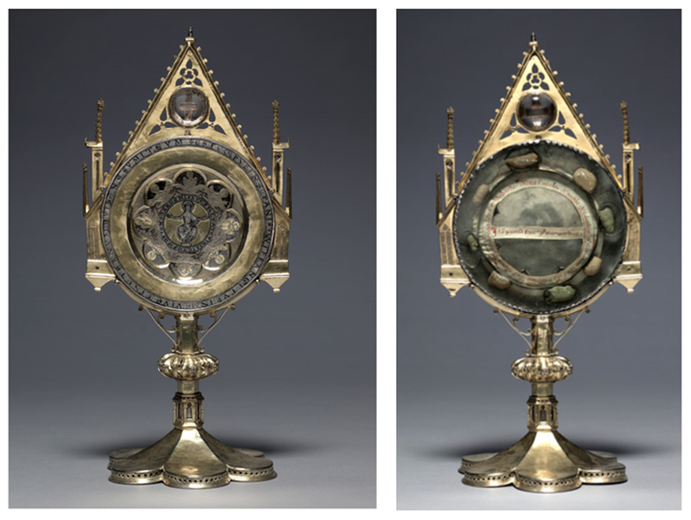
Figure One: Ostensorium holding the paten of St. Bernward and a splinter of the True Cross; 1100-1600 AD

Figure Two: Foramina Tomb-Shrine of St. Bertram
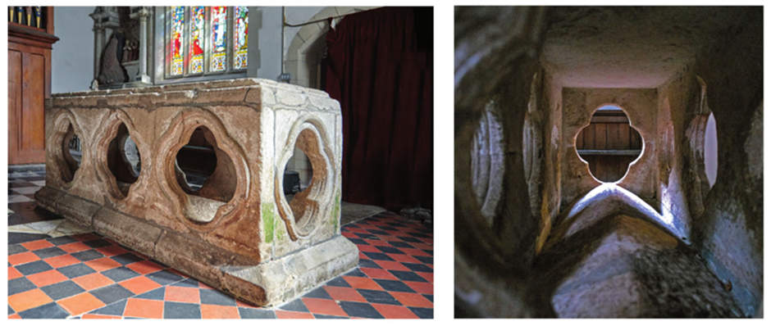

Bibliography

Bagnoli, M., ‘Dressing the Relics: Some thoughts on the custom of Relic Wrapping in Medieval Christianity’, Matter of Faith: an interdisciplinary study of relics and relic veneration in the medieval period, (British Museum).
Bede, Ecclesiastical History of England, trans. A.M. Sellar (London: George Bell and Sons, 1907).
Birch, D.J., Pilgrimage to Rome in the Middle Ages: Continuity and Change (Woodbridge: Boydell Press, 1998), p.24.
Catholic.Org, Ostensorium, Catholic Org Online, available from https://www.catholic.org/encyclopedia/view.php?id=8122, accessed on [31/01/2019].
Collins Dictionary, Reliquary, Collins Dictionary Online, available from https://www.collinsdictionary.com/dictionary/english/reliquary, accessed on [31/01/2019].
OODEGR, St. Bertram, Orthodox Outlet for Dogmatic Enquiries, available at http://www.oodegr.com/english/biographies/arxaioi/Bertram_Mercia.htm, accessed on [31/01/2019].
Oxford Dictionaries, Paten, Oxford Dictionaries Online, available from https://en.oxforddictionaries.com/definition/paten, accessed on [31/01/2019].
Rosewell, R., Saints, Shrines and Pilgrims (Shire Publications, 2017).
Saints, Relics and Devotion in Medieval Europe, Relics and Reliquaries, Treasures of Heaven, available from https://projects.mcah.columbia.edu/treasuresofheaven//relics/Ostensorium-with-Paten-of-St-Bernward.php, accessed on [31/01/2019].
The Church of the Holy Sepulchre, Home, The Church of the Holy Sepulchre Online, available from https://churchoftheholysepulchre.net/, accessed on [31/01/2019].
Webb, D., Pilgrimage in Medieval England (London: Hambledon and London, 2000).

