SIMONA MARILENA PATRASCU
STUDENT ID:2123259 | WORD COUNT:2060
Business plan— I & P DOMESTIC SERVICES
Managing Enterprise in the 21st Century (BMSW4006_CARD)

Introduction
“It’s not about ideas. It’s about making ideas happen.”
—Scott Belsky, co-founder of Behance
In 2016 when I arrived in the UK, I worked for a cleaning company and since then my dream has been to open my own business. Now, 7 years later when I restarted my studies, my business idea came from the desire to set up as a family business and together with my mother, sister-in-law and father to start this business on our own. The name of the business comes from the initials of the family name, and this idea came from me.

Business description
I & P Domestic Services I&P Domestic Services is a company that provides ironing and laundry services.

This company was founded in 2022 by Simona Patrascu, with the help of my sister-in-law and my parents.
My company provides different offers for any kind of salary, we use vegan/Bio products.

Legal status
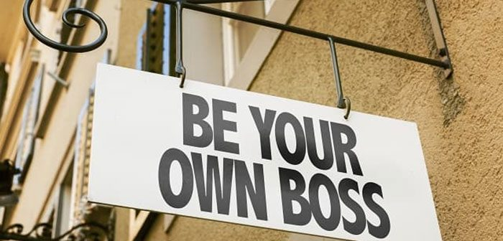
“Even if you have all the money you need, you still need a business plan. A plan shows how you’ll run your business. Without a plan, you don’t Know where you’re going, and you can’t measure your progress. Sometimes, after writing a business plan, you may change your approach, or even decide not to go into a certain business at this time.”

Eugene Kleiner
Venture Capitalist
This type of company is owned and controlled by a single person. There is no legal distinction between owner and company. This means that all liabilities and after-tax profits are personal and this is known as "unlimited liability". Professional service providers such as plumbers, hairdressers, and electricians are often sole proprietorships.
Sole proprietorships tend to be easier to set up and dissolve, less regulated, more freedom for owners to choose, and relatively lower running costs. Owners are responsible for maintaining day-to-day financial records, but delegate annual accounting responsibilities to a professional accountant.
On the other hand, sole proprietorships are difficult to survive, and owners often work long hours and only get a few days off. And with no one to share responsibility with, business weaknesses can be exposed.
For this business idea we chose to be a sole trader because it is a family business and we want to start without support from the state or loans. and as a small family business, we want to stand up by our own forces without having debts that, if something happens, we cannot afford to pay them.

Mission statement

A mission statement is used by a company to briefly and concisely describe its purpose. Statements are generally short, one sentence or a short paragraph. A mission statement defines the industry a company belongs to and why it exists or what purpose it serves. Every company should have a brief statement of purpose that excites people about what the company is doing and motivates them to join the organization. A mission statement also aims to define the company's corporate strategy and is usually a few sentences long.
My business mission statement is:

Domestic services, nice and clean, Easy life, Happy families!

Company aim’s
Aim's goal is a declaration of intent. They are usually written in rough strokes. Decide what you want to achieve at the end of your project.
“People with goals succeed because they know where they are going...It's as simple as that."- Earl Nightingale
- Good services for special prices
- Profit from the beginning
- Be in top 5 laundry companies in the city
- Cover all the cost made in the past

According to (Lifehack,2019) Mother Teresa said,
“Yesterday is gone. Tomorrow has not yet come. We have only today.”
So, I think that all you have to do is to be confident in your own strength and believe that the way you got through today you will get through tomorrow and that's the only way you'll be successful

Company objectives
Business objectives are specific, measurable results that a company wishes to achieve as the organization grows. Pay attention to the details when creating a set of business goals. This means analyzing, evaluating and understanding where you are now and where you want to be in the future.
- Create a website
- Conduct marketing research
- Collaboration with big companies

Financial resources
One or more sources of funding refers to where a company obtains funds to finance its operations. Companies can raise funds from internal or external sources.
Internal Funding Sources
Internal funding sources refer to funds generated by an enterprise. There are several internal methods a company can use such as owner's equity, retained earnings and asset sales.
Ownership capital refers to the money invested by the owner of the business. This is often derived from personal savings. Personal savings is money saved by an entrepreneur. This funding source is interest-free and therefore does not cost the company anything.
Retained earnings are what you can keep some or all of the money in your business and reinvest to grow when the business is profitable. This funding source may be a desirable funding source as it does not accrue interest and does not require dividend payments.
Asset sales include the sale of company-owned products. This can be used when a company can no longer use a product or needs to raise funds quickly. Business assets available for sale include machinery, equipment and excess inventory.
External Sources
External sources refer to funds that come from outside the entity. There are several outside avenues available to companies such as family and friends, bank loans and overdrafts, venture capitalists and business angels, new partners, equity issues, trade credits, leasing, installment purchases and government grants.
Family and Friends - Businesses may borrow or receive money from family and friends, but may not have to pay it back or may be able to pay it back with little or no interest.
A bank loan is money borrowed from a bank by an individual or business. Bank loans are repaid with interest over an agreed period of time, often several years. Asset sales include the sale of company-owned products. This can be used when a company can no longer use a product or needs to raise funds quickly. Business assets available for sale include machinery, equipment and excess inventory.
External Sources
External sources refer to funds that come from outside the entity. There are several outside avenues available to companies such as family and friends, bank loans and overdrafts, venture capitalists and business angels, new partners, equity issues, trade credits, leasing, installment purchases and government grants.
Family and Friends - Businesses may borrow or receive money from family and friends, but may not have to pay it back or may be able to pay it back with little or no interest.

- Personal savings is money that has been saved up by an entrepreneur. This source of finance does not cost the business, as there are no interest charges applied.
- Family
- Savings

Cashflow
Cash flow is the net amount of cash and cash equivalents entering and exiting a business. Money received represents inflows and money spent represents outflows.
A company's ability to create value for its shareholders is fundamentally determined by its ability to generate positive cash flow and, more specifically, its ability to maximize long-term free cash flow (FCF). FCF is the money a company makes from normal operations after deducting all capital expenditures (CapEx).
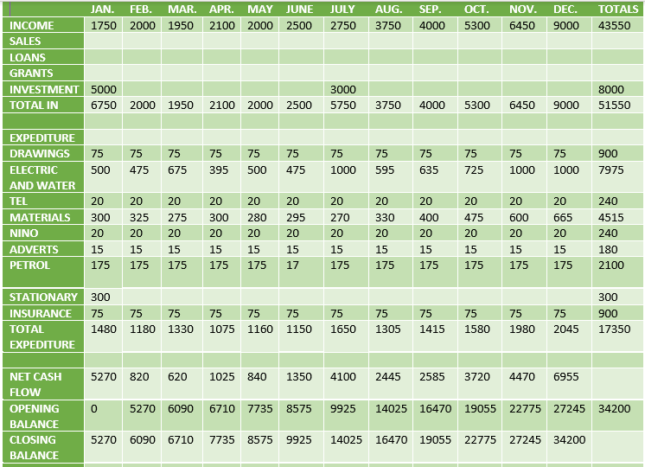

Location
For the first year, I decided that my business will start in the house where we live for the first 3 years, so that later we can raise money to buy our own location and to be able to expand the business.
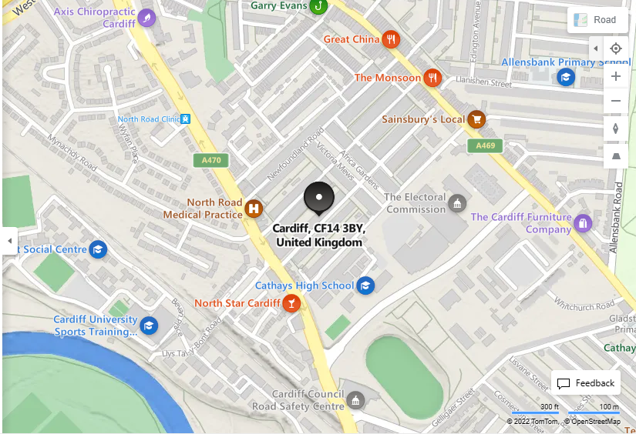

Company hierarchy
Corporate hierarchies are one of many ways companies can organize their workforce. Companies use this framework to clearly define the chain of command and improve communication. Learning about the corporate hierarchy will help you fit into the structure of the company and grow within it. This article describes the structure of the business hierarchy and its various levels.
In this business I have chosen my family members as employees as follows:
- Paulina Ilie (my mother)-employed, she will take care of ironing the clothes, it is a job that requires a lot of patience and skill
- Ruxandra Ilie(my sister in low)- employed-she will take care of both washing and drying the clothes, as well as ironing and this job is one that requires attention to the materials that each piece of clothing has
- Mihai Ilie (my father)-delivery driver- he will take care of the collection and safe delivery of the clothes as well as the delivery of the bags for the next order, I have great confidence in my father as an employee because he has over 6 years of experience in deliveries only in Cardiff
And of course, that in my business I also need an accountant to take care of the accounting records.
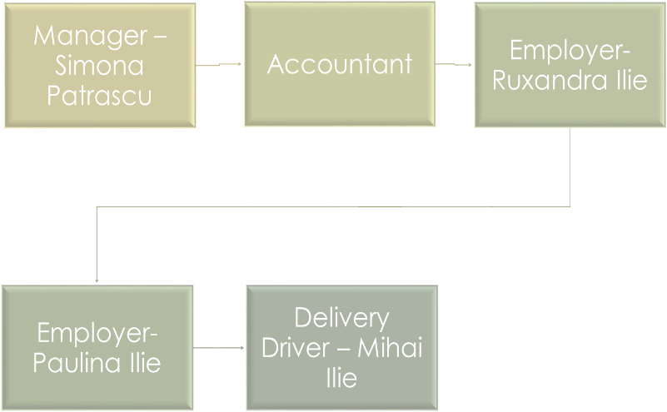

SWOT ANALYSIS
A SWOT analysis is a planning tool which seeks to identify the Strengths, Weaknesses, Opportunities and Threats involved in a project or organization. It's a framework for matching an organization's goals, programs and capacities to the environment in which it operates.
(CIPD,2021)
SWOT stands for Strengths, Weaknesses, Opportunities, and Threats, and SWOT analysis is a technique for evaluating these four aspects of a business.
A SWOT analysis is a tool that helps you analyze what your business is doing best today and develop a winning strategy for the future. A SWOT can also reveal areas that are holding back your business or that your competitors may take advantage of if you don't protect yourself.
A SWOT analysis looks at both internal and external factors, that is, what is happening inside and outside the organization. Therefore, some of these factors are under your control and others are beyond your control. In any case, discovering, recording and analyzing as many factors as possible will clarify the wisest course of action.
STRENGTH
-high quality services
-modern technologies
-fast delivery
-good reputation
WEAKNESS
-fake reviews in social media
-easy to imitate the business model
-wrong delivery

OPPORTUNITIES
-improving delivery
-collaboration with big companies
THREATS
-local laundry companies
-Government regulations(taxes)
-pandemics and wars
-energy cost prices

PROMOTION ACTIVITY
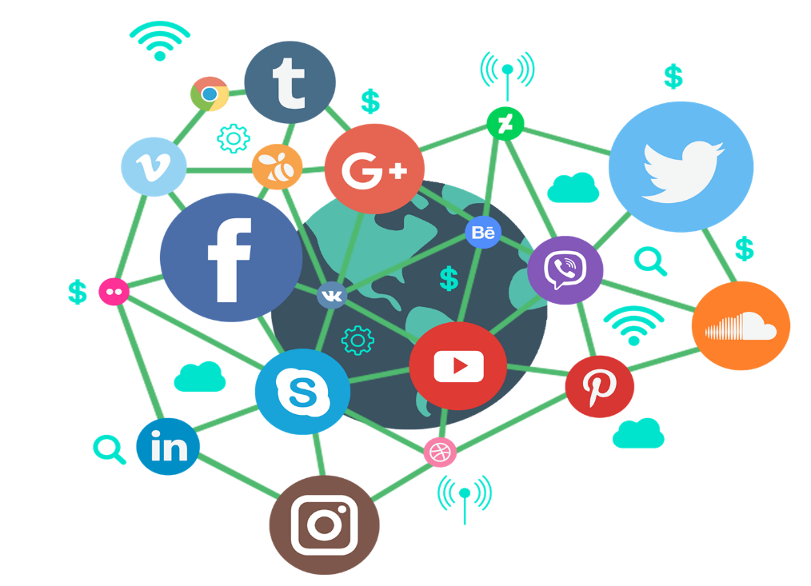
In order to promote this business, I thought of some cheaper methods that would bring a big profit in the business:
-Facebook
-Instagram
-Tik-Tok
-APP
-Website
-Flayer
-Paid Marketing

In this business it is very important to have ideas to promote your business, and nowadays there are many promotion platforms both paid and free, but one of the most important is "from one person to another", like a chain, the recommendation is very important

MARKETING AND PR STRATEGY
Market research is a technique used to collect data about what you want to know, interpret later, and ultimately make the right decisions.
Market research is the process by which companies attempt to systematically collect data in order to make better decisions. But the real value lies in how you can use all the data you get to get a better understanding of the consumers in your market.
The process of market research can be conducted through the use of surveys, interacting with groups of people also known as samples, conducting interviews, and other similar processes.
The primary purpose of conducting market research is to understand or study the market associated with a particular product or service to determine how subjects will respond to the product or service. Information obtained from conducting market research may be used to tailor marketing/promotional activities or to determine consumer feature priorities/service needs, if any.
According to my searches, the best price-quality offers to start such a business was in the Curry's store, where they have a wide variety of washing machines, dryers and ironing stations.
Marketing Relation is defined as the process of planning, executing and evaluating programs that encourage purchase and consumer satisfaction through credible communication of information and impression that identify companies and their products with the needs, wants, concerns and interests of consumers. (Harris,1991)
The global dry cleaning and laundry services market size is estimated at USD 79.91 billion by 2027 and is expected to grow at a compound annual growth rate (CAGR) of 3.4% during the forecast period.
Due to their affordability and convenience, increasing consumer acceptance of dry cleaning and laundry services is driving the market. Moreover, increasing consumer spending on such services is likely to drive market growth over the forecast period.

LEAFLEATS AND CARDS
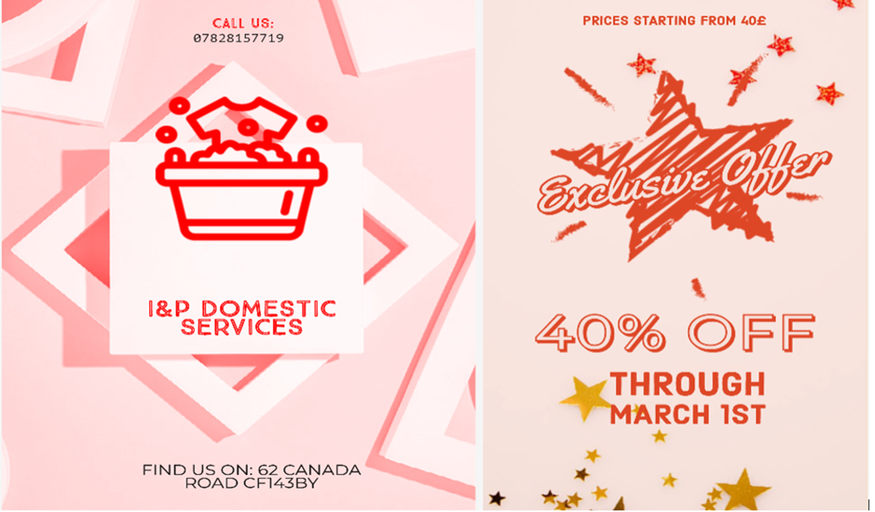

REFERENCES LIST:
1.Chen, J. (2020). Mission Statement. [online] Investopedia. Available at: https://www.investopedia.com/terms/m/missionstatement.asp. (Accessed 9/march/2023)
2. www.prospects.ac.uk. (n.d.). Types of business | Prospects.ac.uk. [online] Available at: https://www.prospects.ac.uk/jobs-and-work-experience/self-employment/types-of-business#:~:text=makes%20a%20loss.-.(Accessed 9/march/2023)
3. www.oberlo.com. (2023). 200 Inspirational Quotes to Motivate You Today - Business Quotes Daily. [online] Available at: https://www.oberlo.com/blog/best-inspirational-business-quotes?fbclid=IwAR2zsOiYzjBAlJzObUAndCrLtqMc1q14a7KQ5kX1s0Q5ktTxjkE2fW_-Mcg#:~:text=Best%20business%20quotes%20of%20all%20time%201%20%E2%80%9CThe [Accessed 12 Mar. 2023].
4. Abrams, R. (2003). The successful business plan : secrets & strategies. Palo Alto: Planningshop.
5. Bozzo, D. (2014). 10 Secrets of Happy Families. [online] Better Chicago. Available at: https://better.net/chicago/life/family/10-secrets-of-happy-families/.
6. Meah, A. (2016). 50 Inspirational Quotes On Goals To Help You Get Focused On Success | AwakenTheGreatnessWithin. [online] Available at: https://www.awakenthegreatnesswithin.com/50-inspirational-quotes-on-goals-to-help-you-get-focused-on-success/ [Accessed 13 Mar. 2023].
7. CIPD (2021). SWOT Analysis. [online] CIPD. Available at: https://www.cipd.co.uk/knowledge/strategy/organisational-development/swot-analysis-factsheet#gref.
8. https://www.currys.co.uk/appliances/laundry/washing-machines?srcid=198&cmpid=ppc~gg~0100%20(Text%20Ads)%20MDA%20-%20Laundry%20-%20Washing%20Machines%20-%20Generic%20(x)%20Exact~Sale%20Washing%20Machines%20(E)~Exact~71700000016755630~&mctag=gg_goog_7904&kwid=GOOGLE&device=c&ds_kids=43700014400126113&tgtid=0100%20(Text%20Ads)%20MDA%20-%20Laundry%20-%20Washing%20Machines%20-%20Generic%20(x)%20Exact&gclid=Cj0KCQjwk7ugBhDIARIsAGuvgPbb6cn2jFO2MpVxkVrqwhdQ4sa-3xHxAQzhjkgvRWRQ8r5CW6lhG_4aAkgGEALw_wcB&gclsrc=aw.ds
9. www.grandviewresearch.com. (n.d.). Dry-cleaning & Laundry Services Market Size Report, 2020-2027. [online] Available at: https://www.grandviewresearch.com/industry-analysis/dry-cleaning-laundry-services-market
10. Amiso M. George PhD (2000) The New Public Relations: Integrating Marketing and Public Relations Strategies for Student Recruitment and Institutional Image Building–A Case Study of the University of Texas at San Antonio, Journal of Nonprofit & Public Sector Marketing, 7:4, 17-31
11. CFI Team (2022). Mission Statement. [online] Corporate Finance Institute. Available at: https://corporatefinanceinstitute.com/resources/management/mission-statement/.

12. learn.solent.ac.uk. (n.d.). Writing Dissertations: Aims and objectives. [online] Available at: https://learn.solent.ac.uk/mod/book/view.php?id=116233&chapterid=15294#:~:text=Aims%20are%20statements%20of%20intent.
13. Novuna. (n.d.). How To Set Business Objectives In Your Business Plan. [online] Available at: https://www.novuna.co.uk/business-finance/resource-centre/smart-business-planning/1-setting-business-objectives/#:~:text=Business%20objectives%20are%20the%20specific.
14. Investopedia. (n.d.). What Is Cash Flow? [online] Available at: https://www.investopedia.com/terms/c/cashflow.asp#:~:text=The%20term%20cash%20flow%20refers.
15. Indeed Career Guide. (n.d.). What Is a Business Hierarchy and How Does It Work? [online] Available at: https://www.indeed.com/career-advice/career-development/business-hierarchy.
16. BBC (2022). Internal and external sources of finance - Sources of finance - Eduqas - GCSE Business Revision - Eduqas. [online] BBC Bitesize. Available at: https://www.bbc.co.uk/bitesize/guides/zj7yy9q/revision/1#:~:text=A%20source%20or%20sources%20of.
17. Mind Tools Content Team (2022). MindTools | Maintenance. [online] www.mindtools.com. Available at: https://www.mindtools.com/amtbj63/swot-analysis.
18. QuestionPro (2019). Market research: Definition, methods, types and examples | questionpro. [online] QuestionPro. Available at: https://www.questionpro.com/blog/what-is-market-research/.

