

NAME: Shabana Qamar
Student Number: 2333635
Module: Changemakers: Creativity and Value creation
Module: BMHP5014
Assignment Title: Component: 2: Written Assignment (Report)
Lecturer: Parese Ahmed


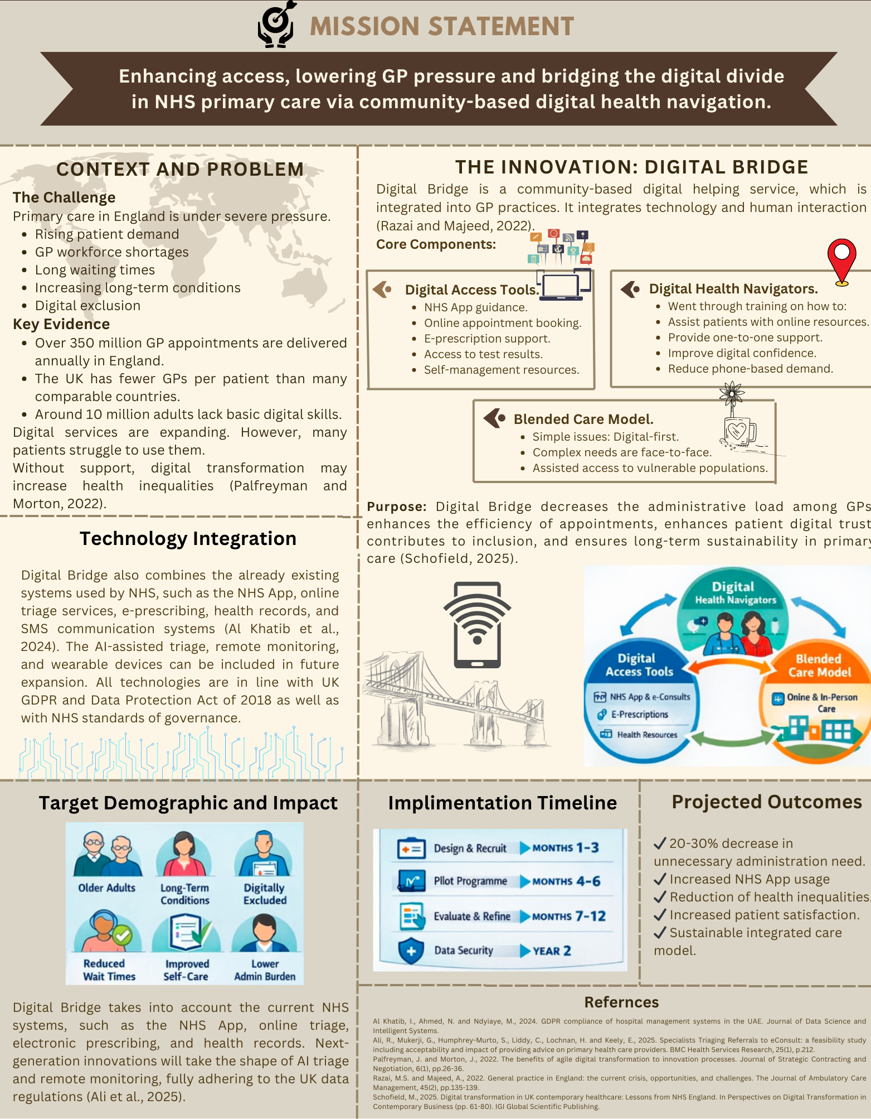

Directed to: An NHS Integrated Care Board Leader.
Dear Integrated Care Board Leader,
My proposal is an innovation that aims to solve the increasing pressures that are being experienced by primary care in England. GP practices are under long-term pressure because of a growth in patient demand, long-term illness, staffing issues, and waiting times. Simultaneously, the NHS is becoming more digitized. Although this change is a great opportunity, I feel that it can be a contributor to increasing the gap in health inequalities unless those vulnerable groups are well supported.
In response to this challenge, I have produced Digital Bridge, which is a community-based digital health navigating model to be built in GP practices. I wish to integrate technology with systematic human support through this initiative to enhance access and administrative load and create inclusive digital change in NHS primary care.
I have created Digital Bridge as a direct answer to the existing crisis in general practice. Over 350 million GP contacts are provided every year in England, and the UK still records the lowest GP to patient ratios relative to other comparable health systems (Schofield, 2025). I understand that clinicians are overwhelmed by administrative and non-clinical activities. At the same time, in the UK, approximately 10 million adults are not digitally savvy. The NHS App and online triage platforms have diversified, but still, many patients do not know how to use them. In the absence of some kind of structure, I think digital-first models can unwittingly disadvantage the neediest.
I will bring trained Digital Health Navigators to GP practices and specific community hubs through Digital Bridge. These non-clinical workers will assist patients to use digital services (NHS App, online booking, electronic prescribing, and self-management). I would make their position facilitative and not clinical. They will offer individual advice, help create an account, comprehend digital practices, and instill trust in the use of digital healthcare technologies.
I have designed this model in terms of a blended care approach. My suggestion would be that the routine and simple issues should be managed digitally where necessary and complex or sensitive issues should be managed face to face. In the case of digitally disadvantaged or vulnerable people, I will make sure that they are assisted to get access instead of being redirected out of care. That way, I will be able to enhance efficiency without affecting equity.
I expect that Digital Bridge will have a quantifiable effect. To patients, I hope there will be better access, reduced waiting time, increased digital confidence, and self-management skills. In terms of practices, I suppose that the initiative would decrease the phone congestion, reduce the workload of administrators, and enable GPs to concentrate on complicated clinical demands (Phiri et al., 2023). On a system level, I would have Digital Bridge promote the resilience, sustainability, and alignment of workforce to the NHS Long Term plan.
I am sure this proposal is timely. General practice is often said to be in crisis, and technology is not the solution to systematic tension. I am not suggesting that digital replacement should be provided, but instead that digital integration be facilitated by human intervention. To my mind, the sustainable change should be innovative and inclusive.
Implementation Plan
I suggest Digital Bridge implementation in four phases that are planned for 12-24 months.
Phase 1: Design and Stakeholder Engagement (Months 1-3)
I will discuss the model with GP practices, Integrated Care Boards, community organizations, and digital inclusion charities to improve the model. At this stage, I will create distinct job descriptions of Digital Health Navigators and work out training models that will include NHS systems, awareness protection, and data protection models (Razai and Majeed, 2022).
Phase 2: Pilot Program (Months 4-6)
I will assess the model in few GP practices across one ICB area and focus on the areas with significant deprivation and digital inaccessibility. My baseline metrics will be the rates of appointments, the demand of phones, the use of the NHS App, and patient satisfaction.
Phase 3: Review and Improvements (Months 7-12)
I will perform quantitative and qualitative assessments to assess the outcomes of administrative reduction, patient engagement, and equity. Staff and patient feedback will enable me to fine-tune the model and determine its cost-effectiveness.
Phase 4: Scale and Integration (2nd Year)
After assessment, I will consider expanding the model to the entire region of ICB. I will uphold duplication by using standardized training packages and online toolkits and incorporate the project into long-term workforce planning plans.
Stakeholders and Resources
To effectively bring about Digital Bridge, I will collaborate with the key stakeholders such as GP practice managers, Integrated Care Boards, NHS England digital transformation teams, local authorities, community centers, digital inclusion charities, and IT systems providers (Atella and Chiari, 2025).
I am aware that sufficient resources are necessary. I will request the Digital Health Navigators to be recruited with the help of funding, formal training sessions, designated working areas in GP practices, and specific evaluation assistance.
Regulatory and Governance Issues
I shall make certain that everything about Digital Bridge is in line with UK GDPR, Data Protection Act 2018, and NHS Digital governance standards (Palfreyman and Morton, 2022). I will need Digital Health Navigators to undergo mandatory data protection training and work under a strict confidentiality agreement (Ali et al., 2025). I will also ensure that I have clear professional boundaries so that the non-clinical staff are never given independent authority to make clinical decisions.
Value and Feasibility
I consider that Digital Bridge supports the priorities of NHS in enhancing access, minimizing health disparities, and reinforcing the sustainability of primary care (Egho-Promise et al., 2025). This innovation can make sense I have designed it in such a way that it will utilize the available NHS digital infrastructure as opposed to necessitating novel technological creation. I will maximize the effect and minimize expense by developing infrastructures (like the NHS App) and online triage and electronic prescribing.
I recognize obstacles such as lack of funds, opposition to change and fears of overlapping roles. Nevertheless, I will overcome them by gradual piloting, demarcation of workers, and open assessment (Shahid et al., 2022). There is an indication that the digital innovation assisted by human facilitation scores higher in adoption and sustainability compared to technology.
I believe that Digital Bridge will be able to gain a 2030% decrease in unnecessary administrative demand, enhance digital interaction, patient satisfaction, and decrease digital exclusion in selected communities (Al Khatib et al., 2024).
Scaling and Future Adaptation
I would like to have Digital Bridge expand throughout the Integrated Care System and venture into the community pharmaceutical, outpatient services, and chronic disease management programs. In subsequent stages, I would consider the implementation of AI-based triage, tools of remote monitoring, and wearables and still retain human supervision to provide ethical and fair delivery.
Call to Action
I am hereby requesting the Integrated Care Board to endorse the pilot implementation of Digital Bridge in a chosen area. Investing in community-based digital health navigation will help to reduce the load on GPs, enable patients, and support the idea that digital transformation will not divide primary care, but will instead make it stronger.
I think that digital bridge can provide long-term, fair, and effective healthcare to communities where we operate through strategic leadership and collaborative effort. Thanks, your consideration is appreciated.

Reference
gho-Promise, E., Egho-Promise, O., Asante, G. and Balisane, H., 2025. Impact of GDPR on Healthcare Data Security Practices. In Securing Health (pp. 175-202). CRC Press.

Palfreyman, J. and Morton, J., 2022. The benefits of agile digital transformation to innovation processes. Journal of Strategic Contracting and Negotiation, 6(1), pp.26-36.

Phiri, P., Cavalini, H., Shetty, S. and Delanerolle, G., 2023. Digital maturity consulting and strategizing to optimize services: overview. Journal of Medical Internet Research, 25, p.e37545.

Al Khatib, I., Ahmed, N. and Ndyiaye, M., 2024. GDPR compliance of hospital management systems in the UAE. Journal of Data Science and Intelligent Systems.

Ali, R., Mukerji, G., Humphrey-Murto, S., Liddy, C., Lochnan, H. and Keely, E., 2025. Specialists Triaging Referrals to eConsult: a feasibility study including acceptability and impact of providing advice on primary health care providers. BMC Health Services Research, 25(1), p.212.

Atella, V. and Chiari, L., 2025. Digital Disruption in Healthcare: What It Means for the NHS.

Razai, M.S. and Majeed, A., 2022. General practice in England: the current crisis, opportunities, and challenges. The Journal of Ambulatory Care Management, 45(2), pp.135-139.

Schofield, M., 2025. Digital transformation in UK contemporary healthcare: Lessons from NHS England. In Perspectives on Digital Transformation in Contemporary Business (pp. 61-80). IGI Global Scientific Publishing.

Shahid, J., Ahmad, R., Kiani, A.K., Ahmad, T., Saeed, S. and Almuhaideb, A.M., 2022. Data protection and privacy of the internet of healthcare things (IoHTs). Applied sciences, 12(4), p.1927.

Sinnott, C., Ansari, A., Price, E., Horder, K., Alboksmaty, A., Willars, J., Beech, J., Alderwick, H. and Dixon-Woods, M., 2026. Experience of access to general practice in England: qualitative study and implications for the NHS 10-year plan. bmj, 392.

