Student name: Tasmia bano
Student id: 2433992
Lecturer: Aishat Bakre
Module code: LCHS4003_BIRM
Module: Introduction to health and social care

Table of Contents
Task 1 2
Task 2 2
Introduction 2
Origins of NHS 3
Current Structure of the NHS 3
Conclusion 3
References 4

Task 1
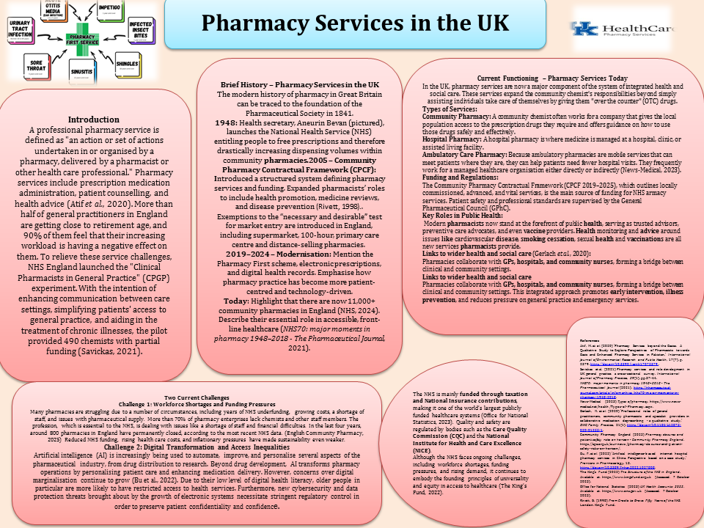

Task 2
“Origins and Current Structure of the National Health Service (NHS)”

Introduction:
The National Health Service Act of 1946 became operative on July 5, 1948. Private health care, which is mostly financed by private insurance, has continued alongside the NHS. A comprehensive health service for England and Wales was to be established, according to the Act. The United Kingdom's National Health Service (NHS) has gradually adapted to a variety of changing health needs as well as developments in organisational and technical domains (McKee et al., 2021). This article examines the current structure of the National Health Service (NHS), which was established during second world war and continues to offer integrated healthcare across the United Kingdom.

Origins of NHS
Prior to the establishment of NHS in 1948, healthcare was given through private medical clubs, work clubs, voluntary hospitals, charities, occupational medical services and fee-for-service insurance, friendly societies and public medical services. The combination of public, private, and nonprofit health care suggests that Britain's mixed economy has been successful (Harris and Cresswell, 2023). William Beveridge (1879–1963), a social economist, believed that poverty, illness, and lack of access to healthcare were important socioeconomic problems that needed to be addressed. The post-war Labour administration led by Prime Minister Clement Attlee and Health Minister Aneurin Bevan responded by passing the National Health Service Act (1946). In 1948, the NHS was founded on July 5th. On this day, nurses, doctors, hospitals, dentists, opticians and chemists were combined (Campbell, 2022). It was the first health system in a Western nation to offer free medical care to all citizens. The NHS's founding represented a significant turning point in the welfare state's evolution and reflected the equality and shared responsibility ideals that still guide healthcare in the UK today.

Current Structure of the NHS
The UK's National Health System has grown to rank among the biggest healthcare systems globally. NHS England supports and oversees the commissioning of health services in addition to allocating funds to the various NHS divisions. The government provides most of the funding for its health services, and the majority of that money comes from taxes that UK individuals pay (Integration and innovation: working together to improve health and social care for all (HTML version), 2021). Compassion, respect and decency, and a commitment to high-quality care are among the fundamental values of the NHS. Everyone is important, and helping patients together makes their lives better. ICSs are also in charge of integrating health and social care services and enhancing community health in general. NHS England and Integrated Care Systems (ICSs), which organise and coordinate healthcare at the local level, offer daily services. The Department of Health and Social Care (DHSC) is in charge of the NHS in England (Gregory, 2024).
NHS care may be categorised into four key areas: primary care, secondary care, and tertiary care. The Department of Health and Social Care is in charge of the NHS, which is the greatest healthcare system. Taxes and National Insurance contributions provide the majority of its funding. Organisations like the National Institute for Health and Care Excellence (NICE) and the Care Quality Commission (CQC) enforce quality and regulation by guaranteeing safety and evidence-based practice.

Conclusion
In the UK, healthcare has transformed as a result of the National Health Service. The NHS, which was once an ideal, has evolved into a contemporary system that offers free, universal healthcare. Its foundations reflect a history of social justice and group well-being, and its present structure offers strong and all-encompassing regulated care at all levels. It is hardly hyperbole to say that the NHS is the cornerstone of British society and basic public health, even though the institution may nevertheless face challenges.

References

Campbell, D. (2022) 'Nye Bevan’s dream: a history of the NHS,' The Guardian, 19 August. https://www.theguardian.com/society/2016/jan/18/nye-bevan-history-of-nhs-national-health-service.
Gregory, P. (2024) Structure of the NHS - the Medic Portal. https://www.themedicportal.com/application-guide/the-nhs/structure-of-the-nhs/.
Harris, B. and Cresswell, R. (2023) 'The legacy of voluntarism: Charitable funding in the early NHS,' The Economic History Review, 77(2), pp. 554–583. https://doi.org/10.1111/ehr.13280.
Integration and innovation: working together to improve health and social care for all (HTML version) (2021). https://www.gov.uk/government/publications/working-together-to-improve-health-and-social-care-for-all/integration-and-innovation-working-together-to-improve-health-and-social-care-for-all-html-version.
England, N.H.S. (2019) NHS england and NHS improvement. Diagnostic imaging dataset annual statistical release, 20, p.2020.
McKee, M. et al. (2021) 'The changing health needs of the UK population,' The Lancet, 397(10288), pp. 1979–1991. https://doi.org/10.1016/s0140-6736(21)00229-4.

