STRATEGIC MANAGEMENT

Name:YIMING WU
Student ID:1805141

Executive summary
The purpose of the report is carrying out a strategic analysis of the Topshop, UK. First, the study involves providing some background information about Topshop. Then, it comprises carrying out a thorough evaluation of the market environment may have an impact on the business functions of the company. The political condition of the UK is currently affected by the Brexit that is changing the purchasing power of customers. Due to the decrease in pounds rate, export has become expensive for the country. Customers prefer buying online and hence, Topshop is recommended to focus on e-commerce.
Further, the increasing rate of obesity needs to be considered by the company for developing its new product range. Recognizing the negative impact of manufacturing cotton clothes on the environment, Topshop has become a part of the Better Cotton Initiative. The firm needs also focusing on complying with legislative needs.
Topshop requires considering the changing environmental forces continuously for upgrading its strategies accordingly. With the growing intensity of market competition, consumers have become inclined toward purchasing cheaper clothes from online retailers. Therefore, reducing the products price is a necessity for Topshop. Further, it needs adopting modern technology for offering virtual changing room ad mirror to the customers for gaining their attention. Online fashion advice can also be given for appealing to more customers.

Table of Contents
1.0 Introduction 4
2.0 Organizational analysis of Topshop 4
2.1 External environmental analysis: 5
2.2 Internal environmental analysis 10
2.2 Strategic Drift- 14
2.3 Main findings 20
3.0 Conclusion 21
4.0 Recommendations 21
References 23

1.0 Introduction
The purpose of this paper is gaining an in-depth understanding of the problems and tools of strategic management system for companies. Therefore, the Topshop Company is taken for carrying out a comprehensive analysis of the important activities conducted by the company. Several essential management tools are used here for analyzing the internal and external market environmental forces influencing its strategic decisions. First, the paper involves examining the background of Topshop and then evaluating its vital activities, and associated issues are applying a range of theories comprising PESTEL, 4 types of change and Strategic Drift and then an overall presentation of the findings is done. Based on the analysis, overall conclusion and recommendation is provided.

2.0 Main Findings of Strategic analysis:

2.1 PESTEL analysis-
Changes in the business environment can provide significant opportunities for the corporation and can create notable threats too. For instance, opportunities can occur from new technologies that facilitate companies reaching to new customers, from new investment system, companies can capitalize on better machinery, and modified government policies can excavate new markets. Threats may contain deregulation, which discloses a business to a deepened competition, a dwindling demand or rising rate of interest that can cause challenges if the company has a debt burden (Mindtools, 2019). Rastogi and Trivedi (2016) stated that PESTEL analysis is a widely used and straightforward technique that facilitates the organization analyzing the political, economic, scion-cultural, technological and legal changes in the business environment. Thus, it helps the marketer seeing the bigger picture of change forces that the company is exposed to. From this, the firm can take benefits of the existing opportunities.
Political- These forces decide the degree to which a country's government can influence the specific industries or the economy. For example, by imposing a new duty or tax, the government can change the total revenue generating the process of a firm. Political forces include fiscal policy, tax policies, and trade tariffs and so forth that a government can levy across the financial year and it may influence the economic environment mainly (Rastogi and Trivedi, 2016).
Brexit hurts Topshop’s business, as the company has several stores across Europe and hence, it needs compromising some trading and legal standards due to the change of payable amount. Moreover, the transfer of products abroad would lose its monetary value; the currency of the UK dropped for Brexit. Furthermore, changes and modification in trading laws because of government bills can affect the business in HongKong and US stores. Import, export rates, tax rates and rules can change and rise that will make the global trading difficult. Thus, it can affect the transportation of Topshop products to international locations (En.portal.santandertrade, 2019).
Further, the updated minimum wage needs employees of 25 years and more age to be paid £7.20 per hour (GOV, 2019). Hence, Topshop requires providing payments to the employees meeting the standard of minimum wages. The firm requires hiring people having transferrable skills and dismissing its less competent workers.
Economical- These factors influence financial performance, which affects the company directly and have muffled long-term impacts. For instance, the increased inflation rate of the economy would influence the pricing strategy of a company. Additionally, it also affects the buying power of consumers and changes the models of demand/supply for the economy. The economic factors may contain interest rates, inflation rate, economic development pattern, foreign exchange rates and more. It also decides the foreign direct investment based on particular industries, who are experiencing this analysis (Sammut‐Bonnici and Galea, 2015).
The profit rate of Topshop has started declining because of the presence of competitors, which offer cheaper products online such as ASOS, Misguided and BooHoo. Also, reduction in the exchange rate has made thee exporting more costly. The exchange rate for pound had reduced as £1is worth €1.11 currently. The Consumer Price Index is increased to 1% from 0.6% that has increased the price of retail products and services. Arcadia is part of the ACT that is a group for employees within the textile industry. It can raise wages rates globally influencing the charges for the brand (Quartz, 2019). In the UK and US, the recession is 2009 has had a knock-on impact making people concerned about their spending pattern. Therefore, it may affect the target market of Topshop. As of 2017, the interest rate is set to rise by 0.5%, ensuring the decline interest rates in prior years that may provide higher purchasing power to the customers (Santandertrade, 2019).
Social- social forces consider all events affecting the community and the market socially. Hence, the disadvantages and advantages to the people of the region in which the business is taking place also require to be considered (Sammut‐Bonnici and Galea, 2015). According to Rastogi and Trivedi (2016),these measures include population dynamics, cultural expectations, healthy consciousness, norms, global warming, and career attitudes and so on. These factors inspect the social aspects of the market and assess factors such as demographics, cultural trends, political analytics and so forth. For example, purchasing trends of western nations such as the US The demand is higher at the time of the holiday season.
Customers now have become more inclined toward online shopping that has decreased the number of customers go to the Topshop stores. Furthermore, the arrival of inexpensive online retailers also prevents customers from shopping from Topshop due to its high price. The standard of living of people is developing each day, and so their demand is. 79% of customers of Topshop is aged 16-34 years, and most of them have their income, job and savings. It influences the growing independent spending pattern of women (targeted segment) affects Topshop positively (Independent, 2019). Topshop needs considering another critical factor of higher interest that is plus size dresses that can fit larger women, as the obesity rate is increasing continuously in the UK.
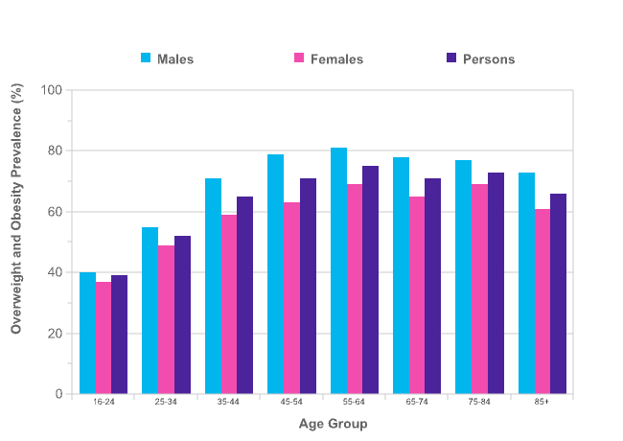
Figure 1: Obesity in the UK
(Source:Independent, 2019)
Technological- The technological factors include technological innovation that may influence industrial operations and the market unfavourably or favourably. It refers to research and development, automation and the extent of technical awareness possessed by an exchange. The technological factor needs to be considered all the time, as it becomes outdated soon after being launched into the market (Sammut‐Bonnici and Galea, 2015).
Technological advancement and the rise of e-commerce has enabled Topshop offering products online for attracting young customers unusually. Moreover, it helps the company connecting with its customers through social media. Customers can check the availability of its products online and can locate a Topshop store easily using store locator. Moreover, the sales in retail e-commerce increased to 76.41 billion GBP in 2018 that gives a growth opportunity to Topshop.Apart from that, the virtual trail room and mirrors are new trends that enable customers trying the dress before buying it (Statista, 2019). It can be a marketing street, Topshop can move forward. Another emerging trend that Topshop can take into account is creating a new website that forms a virtual fashion impression for buyers. Using this website, Topshop can provide styling advice to the customers considering their image and body type. Thus, customers will be able to buy dresses that suit them best. Therefore, it can attract more customers.
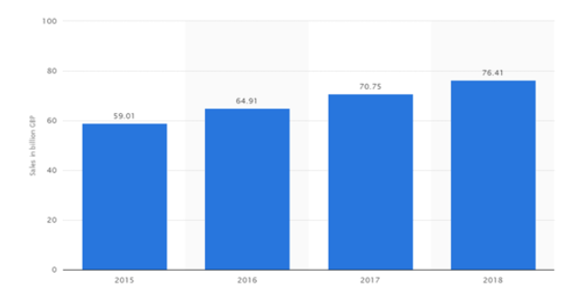
Figure 2: Retail e-commerce sales in the UK 2015-2018
(Source: Statista, 2019)
Legal-It considers all the legal aspects such as taxation, employment, quotas, imports, exports and resources. These forces gave both internal and external sides. Specific laws are there that influence the business environment in a particular country while individual policies are there that organizations manage for themselves. The legal analysis reflects both the approaches and then charts out the strategies in dainty of these legislations including safety standards, consumer laws, labour law and more (Rastogi and Trivedi, 2016).
Topshop must follow all the legislative rules properly for avoiding scandals and problems that it has faced in the past. For instance, the company was criticized for paying low that is £4.3/day to the employees making the Ivy Park range (Arcadiagroup, 2019). As per the new rule, the minimum wage is £7.20/hour for workers aged above 25 years. Topshop needs to follow this while paying employees (GOV, 2019). Further, all its design need to be legally trademarked for avoiding unlawful copying of styles and designs.
Environmental- Environmental factors contain all the factors that affect or are decided by the surrounding environment. These factors comprise of weather, climate, global changes, locations, environmental offsets, ground contaminations, ground conditions, neighbouring water sources and so forth (Rastogi and Trivedi, 2016).
A higher need is there for recycling the fashion items after use or modifying the products and buying products with longer lifecycles in fashion has become essential, mainly for the older generation. All those cotton products are damaging the environment because of pesticides applied. It can affect the soil and water sources. Therefore, new sustainable fabrics including bamboo, banana and hemp woven fabrics are being manufactured (Butler, 2019). Hence, the Arcadia group is a part of the Better Cotton Initiative.
It is important for conducting business sustainably following the environmental standards and therefore Topshop developed a range named 'reclaim' using eco-friendly materials. Besides, the firm is also a part of the Better Cotton Initiative (Arcadiagroup, 2019).

2.2 Four Generic types of change-
As per the model, there are four generic changes adaptation, reconstruction, revolution and evolution. Topshop over the years have brought about changes that are situational and depend on the nature of the organisational requirement.
Adaptation Strategy: The adaptive strategy is the strategy which the business enterprise undertakes without changing the culture of the organisational but gradually improves their business output in the market. In case of Topshop, the fashion industry has high amount of competition. In order to attract the attention of the target customers Topshop focussed their clothing quality to gain a competitive advantage in the market. In the high-street fashion Topshop has been able to withstand its position and gain competitive advantage over cheaper brands like Boohoo. In a survey among the consumers between the ages of 18-24 years, Topshop ranks among the choice of retailers for affordable, high street and quality clothing within UK (YouGov, 2019). The sector of Topshop is catering to mass-market apparel retail for which a large collection of clothing for different purpose and occasions need to be present in the brand portfolio. The brand carefully designs and manufactures its clothes in such a way that the core vision of the brand is not lost in the process (YouGov, 2019). Therefore keeping up with the fast fashion and high-street styles is important so that the consumer would look trendy while wearing the clothes. Topshop has another business strategy of collaborating with celebrities in its business. This marketing technique increases the desirability of the brand in the perceptions of the consumer. It is expected that the followers of the celebrity, in case of Topshop being Kate Moss, will be attracted to buy clothing from the endorsed brand. In this context, Topshop also promotes its clothing line by collaborating with high-end and high-street fashion labels like Miss Selfridges. This also facilitates the brand to be desirable in the high-street fashion. Miss Selfridges launched their sustainable denim range with Topshop that would increase the target segmentation of the company. The products are made from organic cotton free from pesticide, chemical and genetically modified organisations which in turn helps to cultivate a sustainable environment. Another important aspect of the business of Topshop is the implementation of the standardisation and the adaptation within the physical stores like Nordstrom (Wahba, 2019). The brick and mortar stores of Topshop have a general layout and as elaborate as other high-street fashion labels like ZARA. The company has started offering special products as a method of adaptive strategy in some of stores in London. They are also reading for other departmental stores to reach more customers (Wahba, 2019). This saves the costing of the company to build their own physical store. Another strategy adapted by Topshop was using a mixture of both Asian and Western ethnicity models for promoting their opening in China.
Turnaround or Reconstruction Strategy: This strategy is taken buy enterprise with respect to the market environment rapidly to keep up with the competition in the industry. This strategy however, does not require any changes within the organisational culture but the business process. Topshop has been able to revolutionise its business sales by transforming the business process by utilising digital transformation. The exceptional digital promotion and the content management have gained its popularity among the target customers. The informative nature of the website and easy navigation of the web page have captivated the attention of the buyers in the industry (Stevens, 2019). In the depth of the economic downturn the company was still able to manage huge amount of business revenue by maintaining their competitive advantage. The incorporation of the social media proportioning has also facilitated their position as mass-market retailer of fashion. The collections of feedback from the consumers are obtained through digital communication. The communication channels are improved with the help of content management and consumer interaction for encouraging the purchase decision of the consumers. The strategic decision is also a brilliant way of interacting with consumers in a cost effective manner (Stevens, 2019).
Revolution: This strategy is the fundamental change that the business enterprises undertake by changing the different business fronts within the industry. These changes occur within short period of time to meet the high-demand of the consumers. This is generally a countermeasure as a risk management strategy. In case of Topshop, for meeting the expectation of the consumers and improve the platform of consumer interaction. The Topshop website added a section where the customers could upload pictures and showcase the clothing so that other customers would be influenced to make the purchase. This acts a method of allowing consumers and budding fashion bloggers to post trending fashion items that is easier to identify. The individual preferences of the customers can be easily showcased in the company’s website making it easier for consumers with similar taste in fashion make purchase from Topshop. In September of 2016, Topshop implemented another business strategy to provoke the purchasing decision making of the consumers by introducing Runway-to-Retail strategy (Bailey, 2019). This also called the shoppable runway where the retailers of high-street fashion conduct fashion shows with invited guests and showcase their seasonal collection. This strategy is mainly adopted by high-end luxury brands like Burberry, Givenchy, Gucci etc., in order to maintain the exclusivity and uniqueness of their products. The designers carefully curate the looks on runway models where the trends and styles are showcased making it easier to capture the imagination of the consumers (Bailey, 2019). This is an important step in the fashion industry where the luxury as well as high-street fashion brands are embracing the fast-fashion strategy. This would allow the shoppers physically explore the trends, looks and fashion for themselves and develop connectivity with the brand itself. The enlisting of the Topshop brand within the London fashion week has improved the status of the company. This also exposed the collection of products in front of the high-end luxury consumers though the runway showcasing in London fashion week.
Evolution: This strategy is the transformational change which the business enterprise implements gradually in an interrelated manger. It will take a longer time to implement the cultural change within the organisation for the betterment of the business process. CSR activities are an important aspect of business in any industry. Inclusion of CSR activities for a fashion industry is remarkable and revolutionary. Topshop announced the launch of its vegan shoe collection from April of 2019 (Arcadia Group Limited, 2019). This is an important step for Topshop since they got an approval from PETA for the show collection manufactured in Spain. The animal product free items would be attractive for many vegan consumers all over the world. There also has not been any compromise in the style and finish of the items where the popular patterns like animal prints, nude, tan and other classic colour and patterns are provided. The mother company of Topshop is now a pioneer of spearheading resistance against microfiber pollution on an international scale (Arcadia Group Limited, 2019). The pollution is caused from the microfibers that are shed from the clothing items at the time of washing and deposits in the rivers, soils, lakes, sediments and ocean water affecting the usable as well as consumable water. The company, Arcadia Group is collaborating with oil and detergent manufacturing companies to establish the reduction of microfiber generation. The gathering of evidence and supporting the research for knowledge sharing is also important step for changing the culture of the fashion industry. The company is taking a step into galvanising the actions within the fashion industry to promote responsible fashion retail practices. Even with the microbeads that are produced from cosmetic and personal care products are being looked into reduce the pollution. As per the instructions from the UK government, the banning of microbead generating products is initiated in 2018 (Arcadia Group Limited, 2019).

2.3 Strategic Drift-
It is the affinity for strategies to grow gradually based on cultural and historical influences, however, fail to keep speed with the fluctuating environment. It has four stages including incremental change, strategic drift, flux and transformational change or death. Several examples of companies are there that failed to survive in the marketplace due to strategic drift. For example, Kodak failed to counter to the continuous development and acceptance of digital photography in spite of invented such technology. Another example is Nokia, which lost its dominance over the international market in manufacturing and selling mobile phones due to failure to adopt smartphone technology at the right time (Grant, 2015).
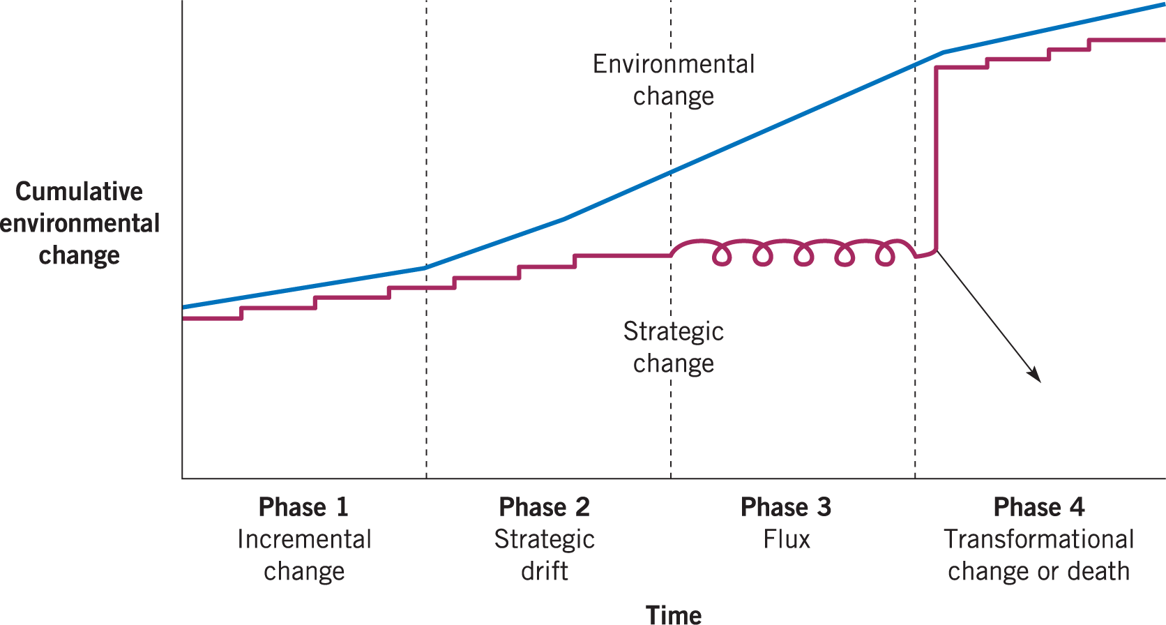
Figure 3: Strategic Drift
(Source: Grant, 2015)
The above examples show how even a globally leading corporation can experience ultimate failure for not keeping pace with the changing business environment and accepting the new trends at the right time. Hence, for avoiding such strategic drift, a high need is there for Topshop to respond quickly to the changing demands and trends in the market promptly before it becomes too late. After analyzing the external environment for Topshop, the changes in the external environment are identified. These changes need to be taken into consideration for avoiding strategic drift.
The current strategic position of Topshop is shown in the following image, which reveals that Topshop is such a brand that offers high-quality products for a high price. It mainly attracts high-profile customers. Primark, New Look and H&M are not doing well, as although, they provide low-priced products; however; the products are of low quality. Hence, they cannot benefit from such products ranges in the long run. However, ZARA can capture a better market with just slightly more price for better quality products comparing to Topshop. Hence, it influences customers to purchase reputedly from Zara. Although ASOS sells products online only, it also gives fierce competition to Topshop with its strong presence.
Moreover, it offers the right quality products at a lower price to Topshop (Sites, 2019). For that reason, there are several factors that Topshop needs considering while making its incremental strategic change. The company needs bringing gradual changes to its pricing strategy build on the prior successful strategy. It has been using the premium pricing strategy for a long time. However, with the increased rate of competition from online and offline fashion brands and customs' inclination toward buying the right quality products at a cheaper price form online, Topshop needs redesigning its pricing. Either the firm can launch a new range of products targeting the price-sensitive people, or it can reduce the price of its existing products for avoiding the loss of market share.

High quality
Low price
Low quality
High price
Zara
River Island
Urban Outfitters
ASOS
Primark
New Look
H&M
Topshop
Figure 4: Topshop positioning against competitors
(Source: Sites, 2019)
Topshop maintains its active window display that shows celebrities. It attracts people, as the screen develops a brand persona and the lifestyle that the company offers. The company is known for its unique designs.
Moreover, it maintains a strong presence on social media and being a part of the large Arcadia Group strengthens its image more. However, there is a high need for overcoming core rigidities such as premium pricing, focusing mostly on offline stores, offering products only for women and so forth for eluding strategic drift. The firm needs to increase its focus on developing a strong presence in online as well so that it does not lose the customers, who like to shop online instead of visiting stores personally.
According to Garner et al. (2014), the propensity to strategic drift appears due to different reasons such as the shackled relationship with customers, employees and suppliers that the company does not want to disturb and reluctant to adopt a change, which needs moving away from previously successful strategies. For example, the offline stores, high-quality clothing and high price all were successful strategies of Topshop. However, currently, the financial performance of the company is declined. The retail industry has been struggling for the last few years because of the economic climate. It led to the decreases sales of companies including the Arcadia Group. Topshop faced £10.9m loss due to the threatening retail landscape in 2018 (Smith, 2019). Some of the highest weaknesses of the company include recent negative publicity for Sir Philip Green, who is accused of racism and sexism. Therefore, Beyonce has taken away her share of 50% and now holds it solely.
Moreover, the high price does not match some of the Topshop products (TheNational, 2019).
Furthermore, the company does little ads on TV and hence, fails to reach people, who do not use social media. The brand lacks ethical and sustainable range that is also a significant weakness of the firm. Therefore, Topshop needs advertising its products on TV, newspapers and billboards too for drawing the attention of customers, who are not that much active on social media. For Topshop, several opportunities are there in the market that need to be grabbed at the right time by turning its weaknesses into strengths. For example, the company increase the number of its products of sustainable ranges that would attract customers having a real urge for the environment. Besides, the firm can collaborate with more celebrities, who have a plus size for making the advertisements more enticing to the customers having obesity. Developing a homeware range and a stylish product range for overweight women can also help the entity appealing new demography positively. This introduction of new rage would help Topshop avoiding to reach at the flux period when performance decreases and the firm becomes disconnected with the environment. As stated by (Dess et al. 2016), a flux period mainly occurs when a strategic change is implemented but without a clear direction. Thus, it creates managerial changes and conflicts, internal incongruity regarding appropriate strategies and customers become estranged due to poor performance. Consequently, the organization is either taken over or bankrupted or applies transformational changes.
Topshop faces threats from online retailers like Missguided, Asos and BooHoo, as they retailer cheaper products. Moreover, cheaper substitutes to Topshop products are available in H&M, and New Look is threatening for Topshop. Further, the virtual mirrors and changing room introduced by the Charlotte Tilbury and online styling advice launched by dressipi.com would also threaten Topshop, if it fails to adopt these new advanced technologies. By enabling its website to offer virtual changing rooms with mirrors, Topshop can help its customers trying the products before buying and thus, making the right choice. Besides, offering them advice in purchasing considering their figure type and size, it can facilitate customers purchasing the best suitable product for them. Thus, customer loyalty and satisfaction can be gained.
Hence, for evading strategic drift, Topshop needs looking at the environmental changes regularly, so that it can modify its existing strategies and adopting new one for keeping pace with the changes that occur in the environment. The company has young talented designers, who create stunning designs for people. However, the company needs updating itself by monitoring the rapid changes in demand and other environmental factors continually, as overlooking them can hurt the business.

2.4 Main findings from the strategic frameworks:

3.0 Conclusion
Topshop is a part of the high Arcadia Group, and the company focuses on maintaining relevance with the changing preference and demand regarding style and design of its clothing. However, the strategies it implements related to its products, pricing, promotion, placing and positioning needed to be changed and upgraded at times for avoiding strategic drift. The rapidly changing environment can influence the corporation negatively if it fails to monitor the changes and modifies its strategies accordingly. Currently, the firm is facing financial loss due to the harsh retail climate that needs to be overcome by implementing innovative strategies.
After carrying out the complete analysis of the external environment and strategic activities of Topshop, it is found that the company is attempting to maintain its pace with the changing environment by being a part of the Better Cotton Initiative and offering uniquely designed clothes by talented global designers. However, the business environment is shifting fast along with the demand for ethical clothes, plus size clothes, better quality at a lower price. Moreover, the customer is also fascinated with the virtual changing room and mirror launched by Charlotte Tilbury. It shows several forces that needed to be taken into account by the Topshop for maintaining a suitable pace with the changing environment and not losing connection. In the UK, the rate of obesity is rising, and hence, women with heavyweight face challenges in getting clothes that are perfect for their figure and stylish at the same time. As Topshop uses celebrities for promoting its brand, it can approach some plus size celebrities to endorse their new product range that needs to be designed especially for obese women. Further, considering the changing wage rate and exchange rate, there is a need for redesigning the pricing strategy, so that it can attract a reasonable amount of customers. The challenging retail environment has also affected the purchasing power of customers, and hence, they prefer buying clothes at a cheaper rate from online stores like New Look, Misguided and others. Thus, the online shopping trend is affecting the profitability and business of Topshop, as it is failing to attract customer in-store.

4.0 Recommendations
Based on the key findings, the following recommendations are provided to Topshop:
Incorporating virtual mirror and changing room-Customers of today have become highly tech-savvy, and for them, any modern technology is fun and attracting. They would love to shop with Topshop if the firm can provide the service of trying dresses before making a purchase. Moreover, it is also essential for staying competitive and updated with new technology.
Hiring style experts for offering online advice to customers- Customers often feel confused about what to buy that suits them best. Styling experts can resolve this confusion by suggesting customers the clothes suitable for their figure type. As not many companies offer this opportunity, it can be beneficial for Topshop to introduce the service for regaining customer attention.
Developing a new product range for plus size women-The number of obese women in the UK is rising, and they feel under confident whenever it comes to buy and wear a dress that makes them look good. Hence, introducing such a range will be an appreciative step for those women. The firm can endorse this range though advertising the products by plus size celebrities.
Reconsidering its pricing strategy- As Topshop is facing tough competition from the cheap online fashion retailers, it needs redeveloping its product pricing and making it a bit lower. It will help the organization getting its loyal customers back, who love the Topshop brand.
Compliance with the legal requirements- Topshop has faced the legal issue for paying lower wages to the worker below the national minimum wage rate. Such kind of ethical incident often ruins the brand image of a company brutally. A responsible organization must protect the rights of all its stakeholders. Hence, besides offering fair wages to the workers, Topshop needs to be aware of other legal requirements too for avoiding such scandal in future.
Focusing more on e-commerce to in-store- As the rate of e-commerce in the retail industry is rising continuously in the UK, Topshop needs developing its e-commerce strategy stronger. Now, most of the people do not want to waste their time by going to the shop for shopping for clothes. Therefore, the trend of online shopping has grabbed attention nowadays. Again, for maintaining relevancy with the pattern, Topshop needs designing its e-commerce site in an appealing way with exciting offers, products and services and displaying the clothes in an attracting way so that customers cannot resist them from buying. Thus, it can increase its profit rate that is important for balancing the loss incurred recently.

References
Arcadia Group Limited. 2019. Latest News - Arcadia. [online] Available at: https://www.arcadiagroup.co.uk/fashion-footprint/about/news [Accessed 10 May 2019].
Arcadiagroup. 2019. Topshop - Arcadia. [online] Available at: https://www.arcadiagroup.co.uk/brands/topshop [Accessed 9 May 2019].
Bailey, C. 2019. Topshop introduces runway to retail business strategy. [online] WGSN Insider. Available at: https://www.wgsn.com/blogs/topshop-introduces-runway-to-retail-london-fashion-week/ [Accessed 10 May 2019].
Butler, S. 2019. Is fast fashion giving way to the sustainable wardrobe?. [online] the Guardian. Available at: https://www.theguardian.com/business/2018/dec/29/fast-fashion-giving-way-sustainable-wardrobe [Accessed 10 May 2019].
Cancer research UK 2019. Cancer Research UK. Overweight and obesity statistics. [online] Available at: https://www.cancerresearchuk.org/health-professional/cancer-statistics/risk/overweight-and-obesity#heading-Two [Accessed 9 May 2019].
Dess, G. G., Eisner, A., and McNamara, G., 2016, Strategic Management: Texts and Cases, McGraw-Hill
En.portal.santandertrade. 2019. Economic and political outline United Kingdom - Santandertrade.com. [online] Available at: https://en.portal.santandertrade.com/analyse-markets/united-kingdom/economic-political-outline [Accessed 10 May 2019].
Garner, J., Stead, W., and Stead, E., 2014, Sustainable Strategic Management 2nd edition, London: England: Greenleaf Pub.
GOV. 2019. National Minimum Wage and National Living Wage rates. [online] Available at: https://www.gov.uk/national-minimum-wage-rates [Accessed 10 May 2019].
Grant, R.M., 2015, Contemporary Strategy Analysis: Texts and Cases 9th edition
Independent. 2019. Someone worked out how much money women spend on their appearance in a lifetime and it's horrifying. [online] Available at: https://www.independent.co.uk/life-style/fashion/average-british-woman-spend-70000-appearance-lifetime-cosmetics-beauty-products-groupon-uk-a7623201.html [Accessed 9 May 2019].
Mindtools. 2019. PEST AnalysisIdentifying Big Picture Opportunities and Threats. [online] Available at: https://www.mindtools.com/pages/article/newTMC_09.htm [Accessed 9 May 2019].
Quartz. 2019. For many Brits, the pound is already worth less than one euro. [online] Available at: https://qz.com/807316/sterling-euro-exchange-rate-the-british-pound-is-now-worth-less-than-the-euro-at-many-uk-airports/ [Accessed 10 May 2019].
Rastogi, N. and Trivedi, M.K., 2016. PESTLE technique – a tool to identify external risks in construction projects. International Research Journal of Engineering and Technology (IRJET), 3(1), pp.384-388
Sammut‐Bonnici, T. and Galea, D., 2015. PEST analysis. John Wiley & Sons, Ltd
Santandertrade. 2019. Reaching the British consumer - Santandertrade.com. [online] Available at: https://en.portal.santandertrade.com/analyse-markets/united-kingdom/reaching-the-consumers [Accessed 9 May 2019].
Sites. 2019. Competitors - TOPSHOP. [online] Available at: https://sites.google.com/site/topshopyellowgroup/competitors [Accessed 10 May 2019].
Smith, S. 2019. Topshop posts £10.9m loss as it grapples with tough retail environment. [online] The Telegraph. Available at: https://www.telegraph.co.uk/business/2018/05/23/topshop-posts109m-loss-grapples-tough-retail-environment/ [Accessed 10 May 2019].
Statista. 2019. E-commerce share of UK retail sales 2015-2018 | Statistic. [online] Available at: https://www.statista.com/statistics/285978/e-commerce-share-of-retail-sales-in-the-united-kingdom-uk/ [Accessed 10 May 2019].
Stevens, B. 2019. Topshop and Asos top the UK's most influential social media list. [online] Retail Gazette. Available at: https://www.retailgazette.co.uk/blog/2017/08/topshop-asos-top-uks-influential-social-media-list/ [Accessed 10 May 2019].
TheNational. 2019. Alleged sexist and racist behaviour of Sir Philip Green revealed. [online] Available at: https://www.thenational.ae/world/europe/alleged-sexist-and-racist-behaviour-of-sir-philip-green-revealed-1.823450 [Accessed 10 May 2019].
Wahba, P. 2019. Why Online Retailers Are Flocking to Nordstrom. [online] Fortune magazine. Available at: http://fortune.com/2016/03/21/nordstrom-ecommerce-2/ [Accessed 10 May 2019].
YouGov. 2019. Why Topshop may reassess its strategy to stay in fashion among 18-24s. [online] Available at: https://yougov.co.uk/topics/consumer/articles-reports/2017/08/24/why-topshop-may-reassess-its-strategy-stay-fashion [Accessed 10 May 2019].

Appendix: Background of the organization
Topshop formerly Top Shop is a multinational fashion retailing company of Britain. It was created in 1964 with headquarters in London. It retails clothes, makeup, shoes and accessories. The company has 500 shops around the world among which, 300 shops are located in the UK. The rest are in the United States, United Arab Emirates, Canada, Kuwait, Australia, Chile, Germany, Israel, Malaysia and many more. Additionally, it also conducts online retailing in several of its markets. The company is a part of the Arcadia Group, which began its operation in the 1900s. Since that time, it kept growing continuously. In the middle of 1960, Topshop was unveiled as a young fashion department. It is now an international strength in fashion. The team of the company is diverse and dynamic that performs best. With its more than 1000 employees, the firm is at the centre of the Arcadia. Topshop is the original victor of uniqueness. The diversity of the brand is confirmed around trend-led attire in a variety of sizes from small to tall and motherhood, on high, must-have accessories, multipurpose denim providing that sees one twosome of jeans retailed in every 5 seconds. Thus, the company is renowned as the unique design traitor and supporter of developing talent (Arcadiagroup, 2019).

