A COMPARISON OF THE MARKETING METHODS OF TWO MULTINATIONAL HOTEL BRANDS

MOXY and SIX SENSES

Student Name

Catalina Chirila

Student ID number

2233497

Marketing Essentials BMIH4005

Lecturer

Chris Wilkin

WORDCOUNT: 1591
INTRODUCTION

The aim of this essay is to provide an overview of Moxy and Six Senses and the reasons why these multinational hotel chains have been chosen for the marketing analysis. To continue, the case study will evaluate the marketing choices, marketing positions, marketing strategies and considerations regarding the organization sustainability strategies and green messaging. The main reason behind choosing Moxy Hotels and Six Senses Resorts and Spa is that it is challenging to analyse the marketing segment, positions and strategies these two companies have adopted as their target market might be the same but their positioning statement is quite different. The essay will compare the hotel brands marketing choices, market positions and strategies and will provide an insight on the businesses marketing considerations regarding sustainability and green messaging using a SWOT and PESTLE analysis as well as highlighting the 7Ps for each hospitality company.

MAIN BODY

Moxy is a fun and affordable hotel brand from Marriott International that aims to meet all its guests needs with its 60 interactive hotels across North America, Europe, and Asia Pacific. Moxy prioritizes uniqueness, deviance, and open-mindedness and has a mechanical design with compact but modern guestrooms and lively common areas (Moxy Hotels - Brand Overview, 2023). On the other hand, Six Senses is a luxury hospitality with a focus on ethical behaviour and environmentally friendly accommodations including clubs, homes, retreats, and spas. Six Senses targets younger customers, especially families ,who wants to mark important occasions like marriages and engagements (Segmentation portfolio, 2019). The CEO of Six Senses considers this demographic crucial to the company success, and has resources like committed team support, targeted marketing, and innovative sales platforms to achieve market leadership (Five Star Luxury Resorts: Exotic Spas: Development, 2023). Young people are vital to Six Senses, according to Neil Jacobs, CEO of Six Senses. Moreover, they choose resorts knowing that the hospitality company stance on sustainability and well-being resonates strongly with their generation (Debenham, 2019).

Among the valuable instruments for business and decision-making is a SWOT evaluation (see Appendix 1). For the companies to build on strengths, reduce weaknesses, take advantage of the opportunities and neutralize the threats, this study will apply the SWOT analysis on both hotels (SWOT analysis, 2023). The strengths of Moxy include being a new concept, having a standardized structure, being part of a well-known hotel group, offering innovation in the market, and having a focus on sustainability. On the other hand, Six Senses appeals to both families and couples, has a great reputation, is established worldwide, and is currently investing in sustainability. The main weakness of Moxy is that some customers may find it challenging to understand the unconventional aspect of the hotel, such as the lack of a front reception. Meanwhile, the high prices of Six Senses are a potential drawback. Another valuable instrument for business is PESTLE analysis (see Appendix 2). Political factors such as travel restrictions imposed by the government can negatively impact the hospitality and tourism industries. Economic factors like the appeal of a destination and the value of its domestic currency also affect the industry. Social factors like the rise of Airbnb as an alternative for travelers during busy times and the need for comfort during holidays are important considerations for hotels. Technological advancements like the use of social media and mobile applications are important tools for hoteliers but should be used with caution. Legal factors like innkeeper regulations that ensure the safety and well-being of guests must also be taken into account. The unpredictability of weather and seasonal variations are also factors that hotel operators must consider when setting room rates (Frue, 2022).

The 7Ps marketing model is a structure created to assist firms in creating an all-encompassing marketing plan (see Appendix 3). The 7Ps concept should enable a new company to create a comprehensive marketing plan from zero (Brooks, 2022). Starting with product, both Moxy Hotels and Six Senses Resorts and Spa offer accommodation, food and beverages. However, Six Senses Resorts and Spa takes it a step further by providing wellness services, making it a more comprehensive package. In terms of promotion, both companies use similar marketing channels such as content marketing, social media, and search engine marketing. However, Six Senses Resorts and Spa also incorporate print advertising into their promotional mix.
When it comes to price, Moxy Hotels offer lower prices compared to Six Senses Resorts and Spa. This is due to the target audience and the services offered by each company. Moxy Hotels target the younger generation and party-goers, while Six Senses Resorts and Spa target families, couples, and holidaymakers who are willing to pay more for a relaxing and nature-filled holiday. In terms of place, Moxy Hotels are located in North America, Europe, and the Pacific Region, while Six Senses Resorts and Spa are located in countries like Maldives, Fiji, Thailand, Vietnam, Oman, Portugal, Bhutan, Indonesia, and Turkey. This difference in location reflects the target audience and the type of holiday experience each company offers.
When it comes to people, Moxy Hotels target millennials and the young generation, while Six Senses Resorts and Spa target families, couples, and holidaymakers who want to relax and enjoy nature. This difference in target audience affects the marketing mix, as well as the services and amenities offered by each company.

The market segment for hotel Moxy is the young, playful vacationer seeking a reasonably priced but still sleek accommodation option (Hahn, 2021).The new hotel brand was created to attract individuals who want more than simply a place to stay. This group of tourists is both cost-conscious and demanding, while also attempting to maintain social connections (Scholz, 2018).The brand called Moxy was created to appeal to younger customers, particularly the renowned millennials. Moxy Hotels provides a distinctive low-cost hospitality experience, emphasising the service rather than the commodity; the concept is to offer a pleasant and uplifting environment for younger people, with a suitable area in well-known locations (Moxy's positioning statement, 2019). The LEED certification is a victory for better, more green development. Moxy Copenhagen Sydhavnen has now obtained the highest LEED certification (Moxy Copenhagen, 2021).Six Senses, which debuted in the hospitality industry in 1995, has established itself as a leader in sustainability practices. By showcasing that social responsibility and luxurious accommodations can go hand in hand, Six Senses has set a new standard in the hospitality sector. From bustling city centres to remote private islands, the commitment of Six Senses to help travellers rediscover themselves, others, and the world around them remains unwavering. Every aspect of the company, from the design of its buildings to the preparation of its cuisine, reflects this mission and is guided by eco-friendly and socially conscious principles. Overall, Six Senses continues to be a trailblazer in the hospitality sector, offering elevated and responsible experiences to travellers. (Source: Sixsenses.com Corporate Fact Sheet, 2023). In a larger sense, Six Senses creates strategic alliances with NGO in the fields of trade, society, culture, and preservation. This includes working with the United States Coalition on Sustainability and SustainChainTM to interconnect efforts and develop alternatives (Plastic freedom 2022, 2023).

According to SimilarWeb (see Appendix 4), Moxy Hotels has a global rank of 486,166 and a monthly pageview count of approximately 60,000. The majority of its traffic comes from the United States (43.52%), followed by the United Kingdom (14.13%) and Germany (8.70%). The website's visitors are predominantly young and male, with a higher education level and an interest in travel and tourism. Moxy also collaborated with Snapchat personalities to produce Snapisodes that resemble TV travel specials. The influencers featured Moxy's newest and most luxurious locations in these Snapisodes (Social Tables, 2021). Six Senses, on the other hand, has a global rank of 675,475 and a monthly pageview count of approximately 40,000. Its traffic is also primarily from the United States (39.07%), followed by the United Kingdom (14.19%) and France (7.51%). The website's visitors are predominantly older and female, with a higher income level and an interest in luxury and travel. In terms of engagement, both Moxy Hotels and Six Senses have similar engagement metrics, with a bounce rate of approximately 50% and an average session duration of approximately 2 minutes. Based on the SimilarWeb data, we can conclude that both Moxy Hotels and Six Senses are targeting similar geographic markets, with the majority of their traffic coming from the United States, the United Kingdom, and Germany. However, there are some differences in the demographic profiles of their visitors, with Moxy targeting younger and more budget-conscious travellers, while Six Senses targets older and more affluent travellers.

Conclusion

In conclusion, Moxy Hotels and Six Senses Resorts and Spa are two unique and dynamic multinational hotel chains with different marketing positions, strategies, and considerations. Moxy Hotels focus on affordability, fun, and uniqueness, whereas Six Senses prioritizes sustainability, well-being, and ethical behaviour. Both companies aim to provide top-notch services to their guests, but their target market and marketing message are different. The case study highlights the importance of sustainability and green messaging for both companies and the role it plays in their marketing considerations. The analysis of their marketing choices, market positions, and strategies using the SWOT, PESTLE and 7Ps will provide a comprehensive overview of their marketing strategies and how they aim to achieve their goals.The main objective of this essay was to present an overview of Moxy Hotels and Six Senses, the marketing choices the business made, their current market positions and the strategies they are currently using. To continue, the essay has concluded with considerations the companies have made within their marketing regarding sustainability.

References:

Brooks, A. (2022) The marketing mix: Building a strategy with the 7ps, Venture Harbour. Available at: https://www.ventureharbour.com/marketing-mix/ (Accessed on 09.02.2023)

Corporate fact sheet - sixsenses.com (2023) Corporate fact sheet - sixsenses.com. Available at: https://www.sixsenses.com/media/14175/six-senses-corporate-fact-sheet.pdf. (Accessed on 09.02.2023)

Debenham , Mark. “IHG Further Expands Luxury Footprint with Acquisition of Six Senses Hotels Resorts Spas.” InterContinental Hotels Group PLC, 13 Feb. 2019, https://www.ihgplc.com/en/news-and-media/news-releases/2019/ihg-further-expands-luxury-footprint-with-acquisition-of-six-senses-hotels-resorts-spas. (Accessed on 09.02.2023)

Employment, S.B.and T. (2023) SWOT analysis, Business Queensland. corporateName=The State of Queensland; Available at: https://www.business.qld.gov.au/running-business/planning/swot-analysis#:~:text=A%20SWOT%20analysis%20helps%20you%20assess%20internal%20factors%20that%20might,results%20from%20the%20SWOT%20analysis (Accessed on 09.02.2023)

Five Star luxury resorts: Exotic Spas: Development (2023) Five Star luxury resorts: Exotic Spas: Development, Five Star Luxury Resorts | Exotic Spas. Available at: https://www.sixsenses.com/en/about-us/development#:~:text=Six%20Senses%20was%20founded%20in,outstanding%20beauty%20of%20their%20location (Accessed on 09.02.2023)

Frue, K. (2022) Pestle analysis for hotel industry, PESTLE Analysis. Available at: https://pestleanalysis.com/pestle-analysis-for-hotel-industry/ (Accessed on 09.02.2023)

Hahn, J. (2021) Norway's most sustainable hotel opens in Bergen, THP News. Available at: https://tophotel.news/norways-most-sustainable-hotel-opens-in-bergen/ (Accessed on 09.02.2023)

Moxy Copenhagen is awarded the prestigious Sustainability Certificate LEED Platinum (2021) Moxy Copenhagen is awarded the prestigious Sustainability Certificate LEED Platinum, Core Hospitality. Available at: https://www.corehospitality.dk/nyheder/moxy-copenhagen-is-awarded-the-prestigious-sustainability-certificate-leed-platinum/ (Accessed on 09.02.2023)

Moxy Hotels - Brand Overview (2023) Moxy Hotels, Marriott International Newscenter (US). Available at: https://news.marriott.com/brands/moxy-hotels/#:~:text=Moxy%20is%20a%20playful%2C%20affordable,check%2Din%20at%20the%20Bar (Accessed on 09.02.2023)

Moxy's positioning statement, T. (2019) Moxy's positioning statement, blogmarketing1819b_8.1. Available at: https://blogmarketing81.home.blog/2019/05/20/moxys-positioning-statement/ (Accessed on 09.02.2023)

Plastic freedom 2022 (2023) Plastic freedom 2022, Plastic Freedom 2022. Available at: https://www.sixsenses.com/en/sustainability/plastic-freedom-2022 (Accessed on 09.02.2023)

Scholz, L. (2018) The Moxy Hotels: Creating Experiences as the new marketing approach (by Lea Scholz), The Moxy Hotels: Creating Experiences as the New Marketing Approach (by Lea Scholz). Available at: https://www.linchikwok.net/2018/04/the-moxy-hotels-creating-experiences-as.html (Accessed on 09.02.2023)

Segmentation portfolio, P.byT. (2019) Segmentation portfolio, blogmarketing9113BC_10.3. Available at: https://sixthsense513094188.wordpress.com/2019/11/24/segmentation-portfolio/ (Accessed on 09.02.2023)

Social Tables (2021) Why Marriott's marketing strategy is above the rest, Social Tables. Available at: https://www.socialtables.com/blog/hotel-sales/marriotts-marketing/ (Accessed on 09.02.2023)

“The Booming Development of Six Senses – an Exclusive Interview with CEO Neil Jacobs.” CPPLUXURY, 8 Sept. 2017, https://cpp-luxury.com/the-booming-development-of-six-senses-an-exclusive-interview-with-ceo-neil-jacobs/. (Accessed on 09.02.2023)

APPENDICES

1.SWOT ANALYSIS
Moxy Hotels SWOT
Strengths  - new concept  - structure standardization  - part of a renowned hotel group  - innovation on the market  - Sustainability | Weaknesses  - notion that some customer may find difficult to comprehend  - non-conventional hotel (e.g. no front desk/reception)  - tight niche
Opportunities  - business growth, being the first brand with this concept has a potential to dictate the market | Threats  - By opening up a new market, the company might have made it possible for several companies to enter it, resulting in competitors that won't encounter the same difficulties that the company did.

Six Senses SWOT
Strengths  - Attractive concept for both families and couples  - Great reputation  - Present worldwide  - Keen in investing in sustainability | Weaknesses  - Focuses only on a particular market segment  - High prices
Opportunities  - business growth, being the first brand with this concept has a potential to dictate the market | Threats  - Large competition  - The need to invest more money on sustainability, being present in exotic area next to seas or oceans

2. PESTLE ANALYSIS FOR MOXY
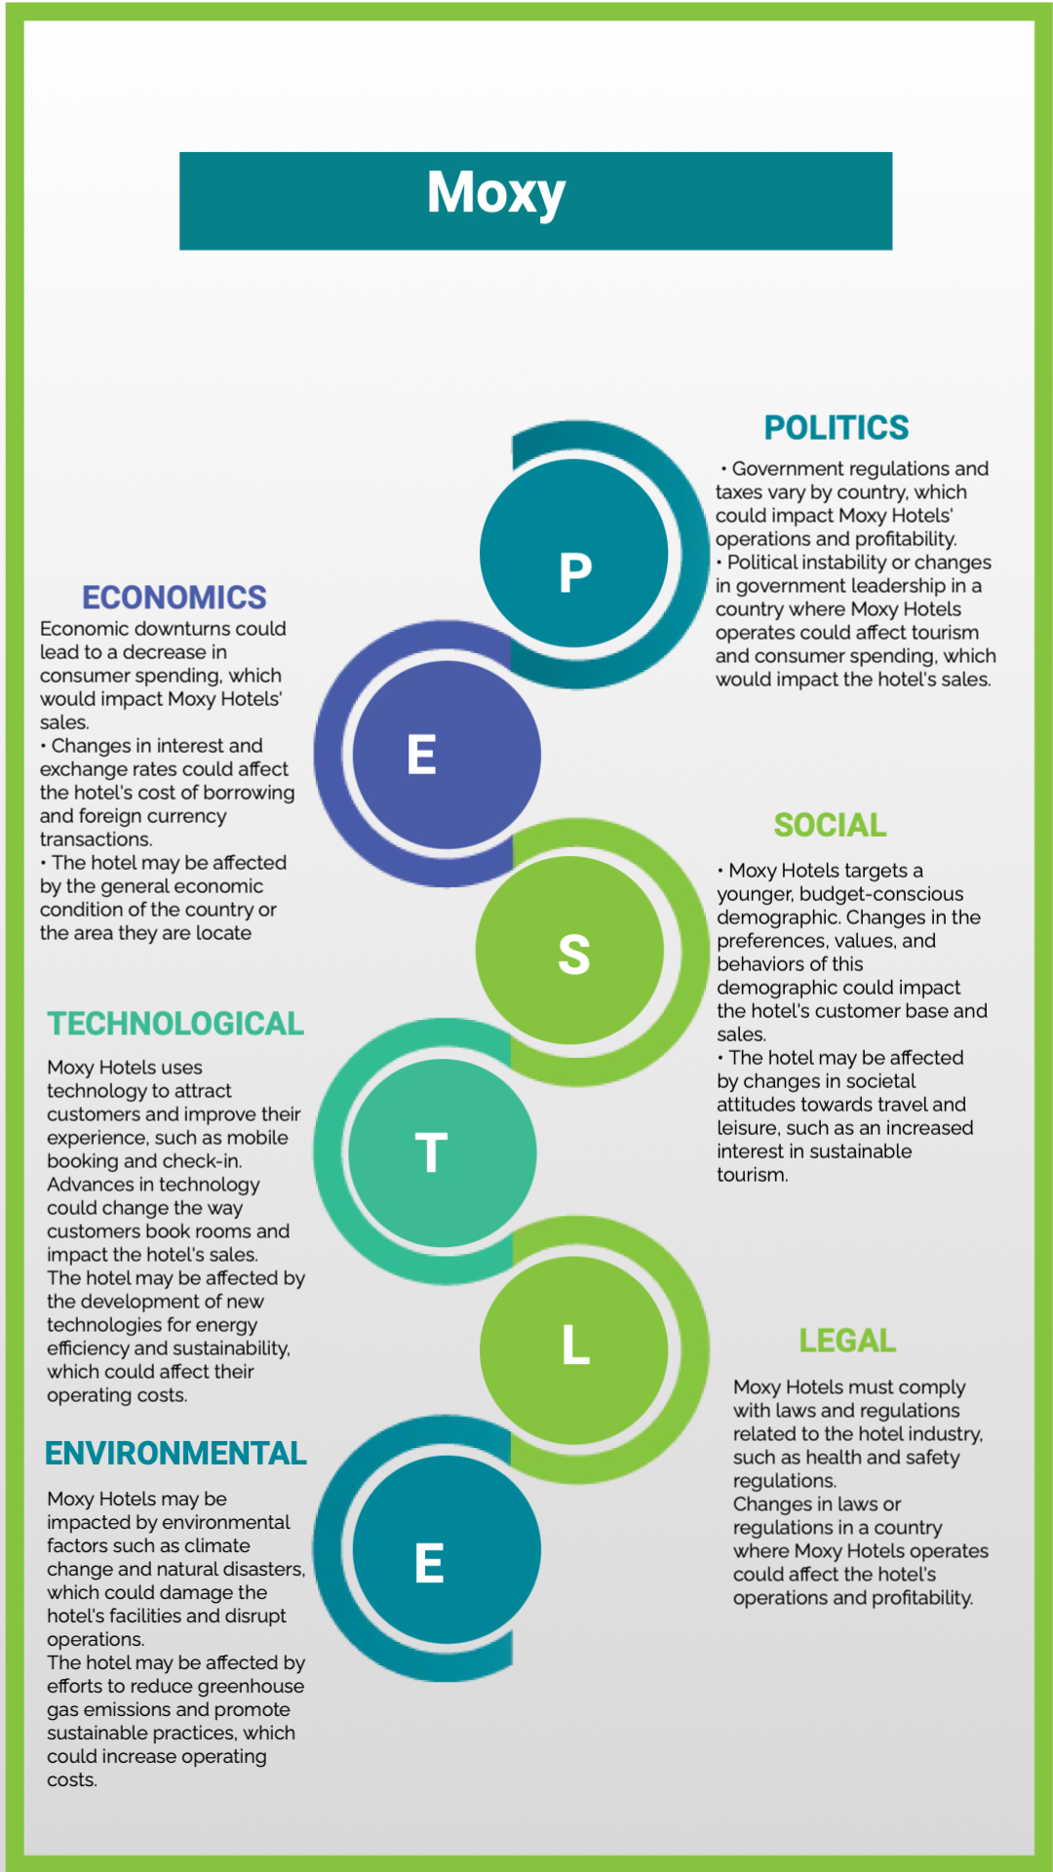

3. 7 Ps

7Ps | Moxy Hotels | Six Senses Resorts and Spa
Product | Accommodation, food and beverages | Accommodation, food and beverages, wellness
Promotion | Content marketing, social media, search engine marketing, public relations, display ads, email marketing, blog and video ads (youtube) | Content marketing, social media, search engine marketing, public relations, display ads, email marketing, print advertising
Price | Prices vary across locations, lower cost than Six Senses | Prices vary across locations, higher prices than Six Senses
Place | North America, Europe, and Pacific Region | Maldives, Fiji, Thailand, Vietnam, Oman, Portugal, Bhutan, Indonesia, Turkey
People | Millennials, young generation, party-goers | Families, couples, holidaymakers who want to relax and enjoy nature
Process | Non-conventional, booking online and using digital keys, no front-desk | Online booking and front-desk services
Physical evidence | Website, online brochures, building structure | Website, uniform, printed leaflets and brochures, hotel design, organic cosmetics for customers

4. SimilarWeb

