Student Name: Tefik Leshkov
Student ID: 2316010
Module tutor: Nadeem Mirza
Word count: 2189 (excl. Exec Summary)
Strategic management and sustainability
COMPONENT 2: Written report
LCBB6015

Table of Contents
1) Executive Summary 2
2) Introduction to the Strategy 2
3) Overview & Background of Tesla, Inc. 3
4) Strategic Intent: Vision, Mission & Objectives: 3
3.1) Vision 3
3.2) Mission 3
3.3) Objectives 4
5) Current Performance 4
6) Strategy Analysis & Competitive Landscape 5
5.1 External Environmental Audit 5
5.2 Internal Environmental Audit 6
7) Strategy Formulation: From Hardware to Intelligence Platform 8
Pillar 1: Autonomous Mobility - Robotaxi Deployment and FSD Licensing 8
Pillar 2: Optimus and the Humanoid Robotics Platform 9
Pillar 3: Energy Intelligence Platform (AI-Managed Grid) 10
8) Conclusion & Recommendations 10
9) References 11

1) Executive Summary
Tesla, Inc. represents one of the most strategically audacious experiments in modern industrial history. What began as a niche electric sports car manufacturer in 2003 has evolved, through deliberate and sequenced strategic logic, into a vertically integrated technology and energy company whose ambitions extend well beyond the automobile. This report conducts a comprehensive strategy formulation plan for Tesla, examining its competitive environment, strategic intent, current performance, and the pathway forward.
The central thesis of this report is that Tesla's competitive advantage is not merely technological — it is architectural. Through what Musk publicly termed the 'Secret Master Plan', Tesla engineered a three-stage capital cascade: using the Roadster to prove viability and attract early adopters, channelling those revenues to fund the premium Model S and Model X, and then directing those profits into the mass-market Model 3 and Model Y. Each stage generated not only revenue but billions of real-world driving miles, producing the proprietary dataset that now powers Tesla's Full Self-Driving (FSD) system — arguably the most valuable and defensible asset in the automotive sector.
This report argues that Tesla's forward strategy must now leverage this data advantage into autonomous mobility-as-a-service (MaaS), software subscription revenue, and AI-driven energy management. Drawing on PESTEL, Porter's Five Forces, SWOT, VRIO, and Value Chain analysis, the report concludes with concrete strategic recommendations designed to sustain Tesla's first-mover advantage in an increasingly crowded competitive landscape.

2) Introduction to the Strategy
Strategy is not merely a plan — it is a theory of competitive advantage. As Grant (2021) defines it, strategy is 'the means by which individuals or organisations achieve their objectives' through the deliberate alignment of resources, capabilities, and environmental opportunity. For organisations operating in hypercompetitive, technology-intensive industries, strategic management is not an optional discipline; it is an existential one.
The automotive industry stands at one of the most consequential inflection points in its 130-year history. The convergence of electrification, artificial intelligence, connectivity, and shifting consumer behaviour is not simply disrupting existing business models — it is making them structurally obsolete. Firms that fail to manage this transition strategically risk rapid marginalisation, regardless of their historical market position (Teece, 2018).
The purpose of this report is to conduct a rigorous strategy formulation plan for Tesla, Inc., evaluating its external and internal environment, articulating its strategic intent, assessing current performance, and proposing a forward-looking strategy grounded in evidence and theory. The report proceeds as follows: Section 3 provides a background on the firm; Section 4 articulates Tesla's strategic intent; Section 5 evaluates current performance; Section 6 conducts a competitive environment analysis; Section 7 formulates strategy; and Section 8 presents conclusions and recommendations.
This structured approach reflects the rational planning model of strategic management (Ansoff, 1987), while acknowledging that in practice, emergent strategies — those that arise from organisational learning and environmental response — are equally important to understanding Tesla's trajectory (Mintzberg, 1994).

3) Overview & Background of Tesla, Inc.
Tesla, Inc. was incorporated in July 2003 by Martin Eberhard and Marc Tarpenning in San Carlos, California, with Elon Musk joining as Chairman of the Board in 2004 following a significant early investment. The company's stated founding mission was — and remains — 'to accelerate the world's transition to sustainable energy' (Tesla, 2024). This mission is notable for its scope: it is not merely a product mission or a profit mission, but an explicitly civilisational one, a framing that has shaped the firm's strategic choices in profound ways.
Tesla operates across two primary business segments: automotive and energy generation and storage. The automotive segment encompasses the design, development, manufacturing, and sale of electric vehicles, including the Model S (luxury saloon), Model X (luxury SUV), Model 3 (mid-range saloon), Model Y (mid-range SUV), Cybertruck (full-size electric pickup), and the Semi (electric heavy goods vehicle). The energy segment includes the Powerwall (residential battery), Megapack (utility-scale battery), and Solar Roof products. In addition, Tesla operates a rapidly growing services division encompassing its Supercharger network, vehicle insurance, and the Full Self-Driving (FSD) software subscription.
The company is headquartered in Austin, Texas, with major manufacturing operations (Gigafactories) in Fremont (California), Austin (Texas), Berlin (Germany), and Shanghai (China). As of 2024, Tesla employs approximately 140,000 people globally and operates in over 50 countries (Tesla Annual Report, 2023). It is listed on the NASDAQ under the ticker TSLA and, at its peak in 2021, reached a market capitalisation exceeding $1 trillion, making it one of the most valuable companies in the world. This background establishes Tesla not as an automotive company that adopted technology, but as a technology company that chose the automobile as its initial vehicle for transformation.

4) Strategic Intent: Vision, Mission & Objectives:

3.1) Vision
Tesla's corporate vision is 'to create the most compelling car company of the 21st century by driving the world's transition to electric vehicles' (Tesla, 2024). This vision is distinctive in that it frames success not in purely financial terms, but in terms of industrial and ecological transformation. It reflects what Hamel and Prahalad (1994) termed 'strategic intent' - a sustained obsession with winning that transcends short-term competitive concerns and mobilises the entire organisation around an ambitious, long-horizon goal.

3.2) Mission
Tesla's mission - to accelerate the world's transition to sustainable energy - functions as both a strategic anchor and a market positioning statement. It justifies vertical integration into energy storage and solar, explains Tesla's open patent strategy (Musk, 2014), and provides a coherent narrative that differentiates the brand from legacy automakers. Critically, as Grant (2021) notes, missions work best when they are distinctive, achievable, and motivating — Tesla's mission scores highly on all three criteria.

3.3) Objectives
Tesla's stated strategic objectives include achieving 20 million vehicle sales annually by 2030 (a roughly tenfold increase from 2023 volumes); deploying 1,500 GWh of energy storage globally; achieving full autonomy via the FSD platform; and generating most of the revenue from software, services, and energy rather than vehicle sales (Tesla, 2023).

5) Current Performance
Tesla's most recent performance data spans FY2024 and FY2025 and presents a company during a painful but strategically deliberate transition. In FY2024, total revenue held near-flat at $97.7 billion, with automotive revenue declining 6% to $77 billion as continued price reductions eroded margins, and GAAP net income falling 52% to $7.15 billion (Tesla Annual Report, 2024). FY2025 brought further contraction: revenue fell to $94.8 billion - the first annual revenue decline in Tesla's history — with GAAP net income at $3.79 billion and deliveries falling 8.6% to 1.64 million vehicles, a second consecutive annual decline (Tesla Annual Report, 2025). BYD surpassed Tesla as the world's largest battery electric vehicle manufacturer in 2025, delivering 2.26 million units (CNBC, 2026). Structural causes include an ageing model lineup, intensifying Chinese competition, and pronounced brand damage in European markets stemming from CEO Musk's political activities.
These headline pressures, however, obscure two developments of genuine strategic significance. The energy generation and storage division delivered $12.8 billion in revenue in FY2025 — a 67% increase over 2024 — with deployments of 46.7 GWh, up 49% year-on-year and representing a 214% increase over 2023's 14.7 GWh (Tesla Investor Relations, 2026). Gross margin in this segment reached 26.2% in 2024 and continued strengthening through 2025, making energy structurally more profitable than the automotive business (Tesla Annual Report, 2024). Simultaneously, Q3 2025 demonstrated recovery capacity, with record quarterly revenue of $28.1 billion and record free cash flow, lifting the balance sheet to $41.6 billion (Tesla Q3 2025 Update).
Most consequentially, June 2025 saw the commercial launch of Tesla's Robotaxi service in Austin — the first revenue-generating fully autonomous passenger service in the company's history (Tesla Q2 2025 Update). FSD subscriptions doubled during 2025, reaching 1.1 million active users, while cumulative FSD miles surpassed 8.5 billion by early 2026 and are accruing at roughly one billion miles every seven weeks (Basenor, 2026; Yahoo Finance, 2026). Tesla's current performance is therefore two stories simultaneously: a hardware business under pressure, and an AI platform business accelerating — a tension that Section 6 addresses directly.

6) Strategy Analysis & Competitive Landscape

5.1 External Environmental Audit

5.1.1 PESTEL Analysis

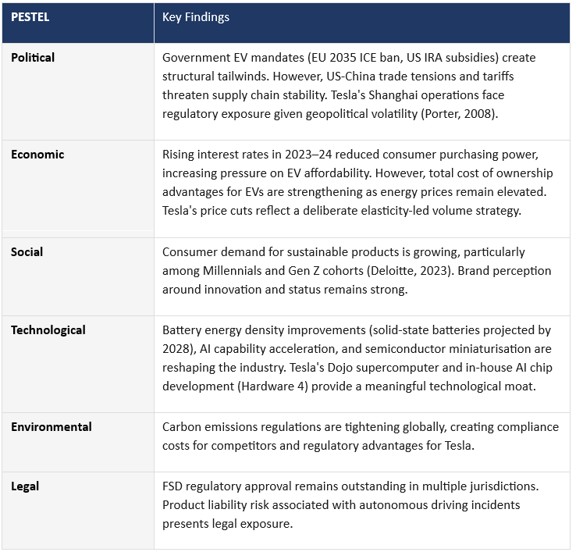

5.1.2 Porter's Five Forces

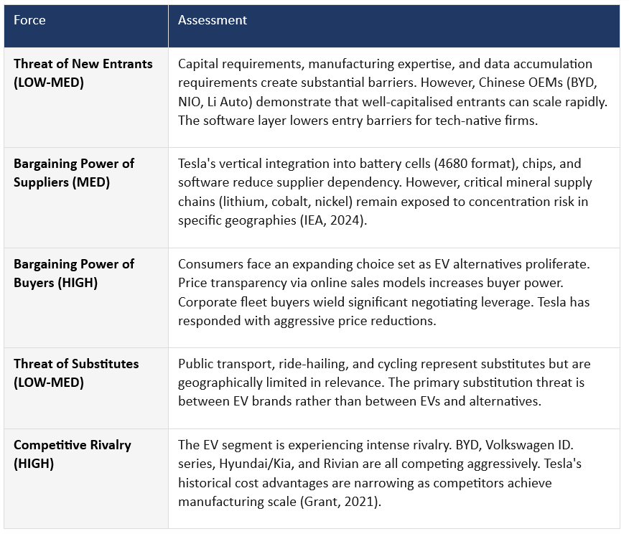

5.2 Internal Environmental Audit

5.2.1 SWOT Analysis

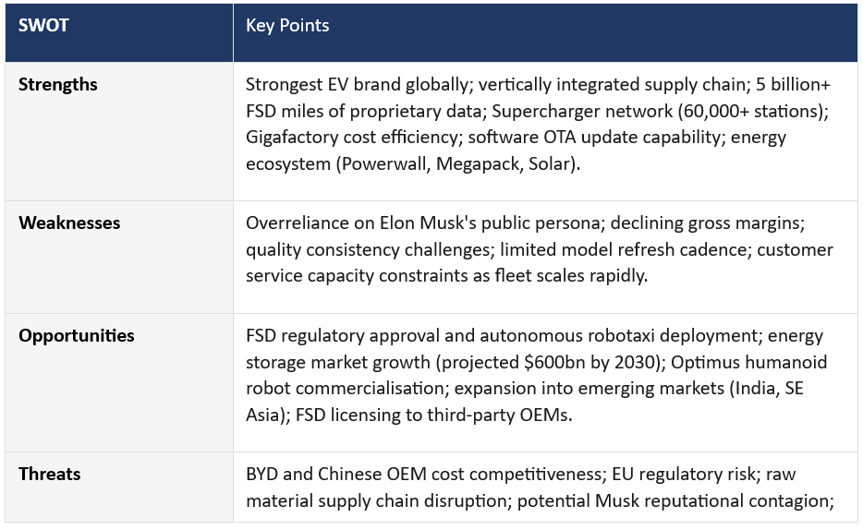

5.2.2 VRIO Analysis
The VRIO analysis confirms that Tesla's most strategically durable competitive advantages reside in its FSD data accumulation, its Dojo supercomputing capability, and its brand-mission narrative. These resources satisfy all four VRIO criteria — they are valuable, rare, inimitable, and supported by organisational infrastructure. Manufacturing scale and the Supercharger network, while significant, are increasingly replicable by well-resourced competitors and therefore constitute competitive parity rather than sustained advantage (Barney, 1991).

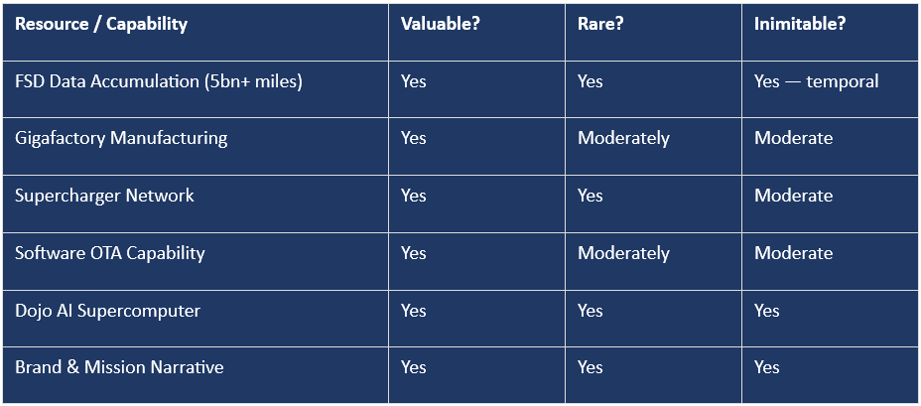

5.2.3 Value Chain Analysis
Porter's Value Chain framework (1985) reveals that Tesla's competitive advantage is concentrated in two primary activities and one support activity. In operations, Tesla's in-house battery cell production, proprietary manufacturing automation, and flexible multi-powertrain Gigafactory design deliver structural cost advantages. In marketing and sales, the direct-to-consumer sales model eliminates dealership margins, enables data capture at point of sale, and facilitates a consistent brand experience. In technology development (a support activity), Tesla's investment in AI inference hardware, the Dojo supercomputer, and the FSD software stack represents the highest-value locus of competitive differentiation. Over-the-air software updates function as a perpetual value chain extension, allowing Tesla to improve the vehicle post-sale — a capability no legacy automaker has successfully replicated at scale (Teece, 2018).

7) Strategy Formulation: From Hardware to Intelligence Platform
The strategic recommendation for Tesla's next phase centres on a transition from being primarily a vehicle manufacturer to becoming an intelligence platform — a company whose primary value driver is the proprietary AI and data infrastructure that happens to reside inside (and increasingly beyond) its vehicles. This is not a departure from Tesla's competitive history; it is the logical fulfilment of it.
The proposed strategy comprises three interconnected pillars:

Pillar 1: Autonomous Mobility - Robotaxi Deployment and FSD Licensing
Tesla's most immediate and transformative strategic priority is the full commercial scaling of its autonomous mobility business. The Robotaxi service, launched in Austin in June 2025, represents the first revenue-generating deployment of unsupervised autonomous driving in Tesla's history - and the opening move in what the company describes as its transition from an EV manufacturer to an AI and services company (Tesla Q2 2025 Update). The economic logic is compelling: an autonomous fleet eliminates driver labour costs entirely, while Tesla's software-derived margins on FSD subscriptions - already reaching 1.1 million active users by end of 2025 - are structurally superior to any hardware sale (Yahoo Finance, 2026). Plans to expand into seven additional US cities in H1 2026 signal the beginning of genuine network scaling.

Simultaneously, Tesla holds a strategically potent option in FSD licensing to third-party OEMs - an approach mirroring the Intel Inside model, embedding Tesla's AI as an industry standard while every licensed mile compounds the proprietary training dataset further (Parker, Van Alstyne and Choudary, 2016). The strategic logic here is a self-reinforcing flywheel: more miles driven improves FSD, which accelerates regulatory approval, which expands the network, which generates more miles and more data. Once activated at scale, this positive feedback loop creates the kind of winner-take-most dynamics that define technology platform markets.

Pillar 2: Optimus and the Humanoid Robotics Platform
The second pillar represents Tesla's most asymmetric strategic bet - and its least appreciated competitive advantage. The Optimus humanoid robot programme applies the same end-to-end neural network architecture, the same vision-based sensor stack, and the same real-world training methodology that produced FSD to an entirely new physical domain: general-purpose labour. The addressable market is extraordinary - Morgan Stanley (2023) estimates the global humanoid robotics market could reach $6 trillion by 2040 - dwarfing both the automotive and energy storage sectors. Tesla's competitive advantage here is not the robot hardware itself, which competitors can replicate, but the AI training infrastructure and the data engine that underpins it.
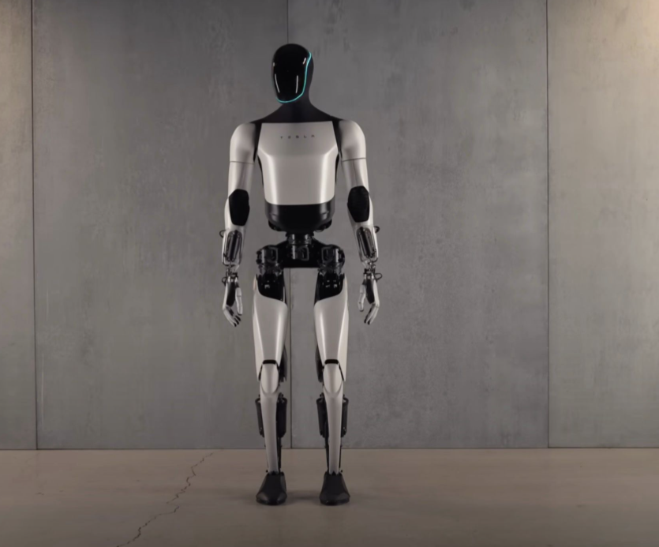

Every Optimus unit deployed in a Tesla factory - Fremont is already being repurposed for Optimus mass production following the discontinuation of Model S and X - generates training data that improves the next generation of the system (RoboForex, 2026). Musk has projected production of one million Optimus units annually by 2030, and with Gen 3 announced for unveiling in Q1 2026, the programme is transitioning from prototype to production reality. Applying Teece's (2018) Dynamic Capabilities framework, Optimus represents Tesla sensing an emerging opportunity of civilisational scale, seizing it through existing AI infrastructure, and reconfiguring its manufacturing operations — Fremont — to serve the new strategic priority.

Pillar 3: Energy Intelligence Platform (AI-Managed Grid)
Tesla's energy division is systematically undervalued in strategic analyses focused exclusively on automotive competition. The Megapack product is not simply a battery - it is a node in an AI-managed distributed energy grid. As renewable intermittency increases globally, the ability to deploy, manage, and optimise grid-scale storage through machine learning becomes increasingly critical infrastructure. Tesla's Autobidder software already uses AI to trade energy in real-time markets. The proposed strategy accelerates this dimension, positioning Tesla's energy AI as the operating system for the global energy transition. This is consistent with Tesla's mission (sustainable energy), leverages its existing VRIO-confirmed capabilities in AI and data, and opens an addressable market that dwarfs the automotive sector (BloombergNEF, 2023).

8) Conclusion & Recommendations
Tesla's strategic journey is a masterclass in sequenced resource allocation. What Musk articulated in 2006 was not a secret - it was a patient theory of how to build a technology company using an automobile as the delivery mechanism. The Roadster funded the S and X. The S and X funded the 3 and Y. The 3 and Y generated the 8.5 billion miles of FSD training data that now underpin every dimension of Tesla's forward strategy (Basenor, 2026). No competitor can buy that time back.
Tesla's primary competitive advantage is no longer its cars - it is its data, its AI infrastructure, and its increasingly sovereign compute capability. The three-pillar strategy proposed herein applies a single compounding capability - real-world AI trained on physical data - to three markets where it is decisive: autonomous mobility, humanoid robotics, and AI infrastructure. Each pillar reinforces the others. FSD miles improve Optimus models. Terafab chips accelerate both.
Five recommendations follow:
1) Scale the Robotaxi network across the seven targeted US cities in H1 2026.
2) Pursue selective FSD licensing to OEMs in markets where Tesla's share is limited.
3) Transition Optimus from factory deployment to commercial sale before competitors narrow the AI training gap.
4) Treat Terafab as foundational infrastructure - chip sovereignty underpins every other pillar.
5) Finally, the board must address governance: brand damage and related-party risks from Musk's external activities are the one strategic threat that execution alone cannot solve.

9) References
Ansoff, H.I. (1987) Corporate strategy. Revised edn. London: Penguin.
Basenor (2026) Tesla FSD passes 8 billion miles: the massive data gap widens, 27 February. Available at: https://www.basenor.com/blogs/news/tesla-fsd-passes-8-billion-miles-the-massive-data-gap-widens
Barney, J.B. (1991) 'Firm resources and sustained competitive advantage', Journal of Management, 17(1), pp. 99–120.
BloombergNEF (2023) Energy storage market outlook 2023. London: Bloomberg Finance LP.
CNBC (2026) Tesla (TSLA) Q4 2025 vehicle deliveries report, 2 January. Available at: https://www.cnbc.com/2026/01/02/tesla-tsla-q4-2025-vehicle-deliveries.html
Deloitte (2023) 2023 global automotive consumer study. London: Deloitte LLP. Available at: https://www2.deloitte.com/global/en/pages/manufacturing/articles/global-automotive-consumer-study.html
Grant, R.M. (2021) Contemporary strategy analysis. 10th edn. Chichester: Wiley.
Hamel, G. and Prahalad, C.K. (1994) Competing for the future. Boston: Harvard Business School Press.
Henderson, B.D. (1979) Henderson on corporate strategy. Cambridge, MA: Abt Books.
IG International (2026) Tesla Q4 2025 earnings preview: new products face profitability test, 21 January. Available at: https://www.ig.com/en/news-and-trade-ideas/Tesla-4Q25-earnings-preview-260121.
International Energy Agency (2024) Global EV outlook 2024. Paris: IEA. Available at: https://www.iea.org/reports/global-ev-outlook-2024.
Merritt, S. (2025) Tesla FSD annual mileage data 2021–2025 [Post on X]. Available at: https://twitter.com/SawyerMerritt
Mintzberg, H. (1994) The rise and fall of strategic planning. New York: Free Press.
Morgan Stanley (2023) Humanoid robots: the next big thing in automation. New York: Morgan Stanley Research.
Musk, E. (2006) The secret Tesla Motors master plan (just between you and me). Available at: https://www.tesla.com/blog/secret-tesla-motors-master-plan-just-between-you-and-me
Musk, E. (2014) All our patent are belong to you. Available at: https://www.tesla.com/blog/all-our-patent-are-belong-you
Musk, E. (2023) Tesla investor day 2023 [Transcript]. Austin, TX: Tesla, Inc.
Parker, G., Van Alstyne, M. and Choudary, S.P. (2016) Platform revolution. New York: W.W. Norton.
Porter, M.E. (1985) Competitive advantage: creating and sustaining superior performance. New York: Free Press.
Porter, M.E. (2008) 'The five competitive forces that shape strategy', Harvard Business Review, 86(1), pp. 78–93.
RoboForex (2026) Tesla, Inc. (TSLA) stock analysis and forecast for 2026. Available at: https://roboforex.com/beginners/analytics/forex-forecast/stocks/stocks-forecast-tesla-tsla/
Teece, D.J. (2018) 'Business models and dynamic capabilities', Long Range Planning, 51(1), pp. 40–49.
TeslaNorth (2025) Tesla's Full Self-Driving surpasses 3.6 billion miles driven, 28 March. Available at: https://teslanorth.com/2025/03/28/teslas-full-self-driving-surpasses-3-6-billion-miles-driven/
Teslarati (2026) Tesla Q4 and FY 2025 earnings results, 28 January. Available at: https://www.teslarati.com/tesla-tsla-q4-and-fy-2025-earnings-results/
Tesla, Inc. (2024) Annual report 2024 (Form 10-K). Austin, TX: Tesla, Inc. Available at: https://ir.tesla.com
Tesla, Inc. (2025) Q2 2025 update. Austin, TX: Tesla, Inc. Available at: https://ir.tesla.com
Tesla, Inc. (2025) Q3 2025 update. Austin, TX: Tesla, Inc. Available at: https://ir.tesla.com
Tesla, Inc. (2026) Annual report 2025 (Form 10-K). Austin, TX: Tesla, Inc. Available at: https://ir.tesla.com.
Tesla, Inc. (2024) Mission and impact. Available at: https://www.tesla.com/impact.
Tesla Investor Relations (2025) Tesla fourth quarter 2024 production, deliveries and deployments. Available at: https://ir.tesla.com/press-release/tesla-fourth-quarter-2024-production-deliveries-and-deployments.
Tesla Investor Relations (2026) Tesla fourth quarter 2025 production, deliveries and deployments. Available at: https://ir.tesla.com/press-release/tesla-fourth-quarter-2025-production-deliveries-deployments.
Yahoo Finance (2026) Tesla stock climbs on Q4 earnings beat, Optimus robots on track, 29 January. Available at: https://finance.yahoo.com/news/tesla-q4-earnings.

