Name: Ryan Alderson
Module: Networks and Cyber Security Essentials
Assignment Title: Secure the network from common threats and attacks

Table of Contents
Abstract 2
Introduction 2
Task 1 2
Task 2 3
Task 3 5
Task 4 7
Conclusion 8

Abstract

This report covers the topics I learned about during the Networks and Cybersecurity module in relation to a specific problem. The problem is for a fictional company “Olive-Oyl” who have had issues securing the network for the organisation, which has caused them a few problems.

Introduction

Throughout this report I have tried to give a description on what the different cybersecurity threats and attacks are, the possible Cybersecurity threats that “Olive-Oyl” are susceptible to and possible security breaches that could happen in this organisation. I have also tried my best to design what the Network topology could look like for this organisation and what security polices users and employees should follow when accessing this network.

Task 1

      - Based on the above stated scenario, what are the possible security breaches could have led the network to this situation?

Possible Security Breach 1: Customers
Reason: In the above scenario, customers who sit-out for a cup of coffee were given access to ‘Complimentary Wi-Fi”. However, this Wi-Fi was on the same network as the one running the business applications. The problem with this is that the Customers could potentially access the Business applications and the data associated with them (databases, files etc).

Possible Security Breach 2: Sales Executives
Reason: Wimpy decided to diversify his job responsibility to the sales executives, meaning that they may have been given more work than their job role was supposed to have. He then gave them full access to all Business Applications which was a threat as the Sales Executives may have been unhappy with Popeye and with full access, they could do anything on the system/network such as deleting important files or giving access to others who shouldn’t have.

Possible Security Breach 3: Disgruntled ex-employee Jack
Reason: Jack, a former Sales head, was sacked by Popeye. There was no mention of a SLAM process (Starters, Leavers and Movers Process) so Jack may still have had access to the systems after leaving the company, as his user account may have not been deleted.

Task 2

- Write a brief review on different types of threats, vulnerabilities and attacks to give an overview for Popeye to understand the importance of Cybersecurity. Add a brief note on “.meds” file format attack which infected Popeye’s “Olive-Oyl” retail showroom workstation.

Threats:
The Oxford Dictionary definition of cyber threat is a little lacking: "The possibility of a malicious attempt to damage or disrupt a computer network or system." This definition is incomplete without including the attempt to damage or steal data as this is also a major reason being cybersecurity attacks. [1]

Types of threats:

The types of cybersecurity threats that we face are:

- Information theft: Where someone gains unauthorised access to a computer to steal confidential information. The data can then either be sold or used in a malicious way, such as stealing secret research information from a rival company.
- Data loss and manipulation: Breaking into a computer to destroy or alter data records. For example, gaining access to a database and deleting important information or changing crucial data such as price information.
- Identity theft: where someone’s personal information is stolen and then used to apply for credit or make online purchases. This is probably the most common threat and it happens to millions of people per year.
- Denial-of-Service (DoS): where a machine or network is shut down making it inaccessible to its intended users. This is accomplished by flooding the target with traffic or sending it information that triggers a crash. [2]
- Ransomware: is a type of malware that prevents users from accessing their system or personal files and demands ransom payment in order to regain access. An example of this was the “WannaCry” cyber attack on the NHS in 2017. [3]

These are some of the main cybersecurity threats. However, it’s worth noting that all of these threats can come from internal sources such as employees, as well as external sources such as hackers that everyone normally associates these type of threats with. For example, in the case of Olive-Oyl, they were susceptible to many of these threats (one of which actually happened) due to the vulnerabilities of their network which I’ll discuss below.

Vulnerabilities:
Some of the main security vulnerabilities according to The National Common Vulnerabilities and Exposures (CVE) database are:
- Poor back-up and recovery processes
- Weak authentication management
- Poor network monitoring
- End-user errors and/or misuses
- Inadequate end-point security

In the case of Olive-Oyl, there was no mention of a backup and recovery process. Due to this, the files that were encrypted using the .meds file format attack, were as good as gone as the attackers had the only copies of these because there were no backups.

The weak authentication management and network monitoring of the network was also a major problem here. For example, the authentication process was weak because the ex-employee was still able to access the system even though he had left the company. However, even if the authentication process was weak, you could identify this issue quickly with good network monitoring and seeing the user carrying out harmful actions, but once again the monitoring was also poor.
The ease with which the hacker was able to enter the system also shows that the endpoint security wasn’t great either. There was no mention of firewalls around Olive-Oyl’s network, or network access control.

The network cybersecurity cube is a great tool of checking whether your organisations network is as secure as it can be and this is what Olive-Oyl should look at before deciding how to set up their network.

Attacks:

There are a number of cyber security attacks that can be harmful to an organisation. Some of the main ones are:
- Malware: a term used for all malicious software. Malware disrupts a network through a vulnerability such as a user clicking on a harmful link or email attachment that then installs harmful software on a computer. This software can then block key files or parts of the system (ransomware which I discussed above) or secretly obtain information from the computer without the using knowing (also known as Spyware). [4]
- Phishing: This is where fraudulent emails are sent from someone claiming to be a reputable source such as a bank, with the intention of stealing credit/debit card information or installing Malware.
- Man-in-the-middle attack: This is where attackers interrupt traffic on a network and then steal the data. This is very common on unsecure public Wi-Fi, where attackers place themselves between a users’ device and the network without the user knowing.
- Denial-of-service: As discussed earlier, this is where a machine or network is shut down making it inaccessible to its intended users. This is accomplished by flooding the target with traffic or sending it information that triggers a crash.
- SQL injection: Where an attacker inserts a malicious SQL query into an organisations website or systems search box with the intention of getting sensitive data out.

These are not all the types of cybersecurity attacks. Many other attacks exist and the number of different cybersecurity attacks are increasing and becoming more complex by the day. [1]

.meds file format

A .meds file format attack is a ransomware attack that encrypts your files on your computer and the hacker then demands you pay them to restore them. The issue with this is that the files are encrypted with a unique decryption key which makes it impossible for you to restore the files without the key.

As you can see, this can be a massive problem for companies, especially if they only have one copy of the affected data or files as in Olive-Oyl’s case.

The only way to recover this data is to pay the hackers unfortunately, as there is no other solution.

This makes it even more important to safeguard against this by install some antivirus software that makes sure no ransomware is installed on your machine and to regularly back up data and files to an external device, so that it doesn’t matter if your files do get encrypted, as you have other copies of it.

Task 3

- Demonstrate Popeye, how security could be implemented in his network infrastructure.

Packet tracer course certificate:

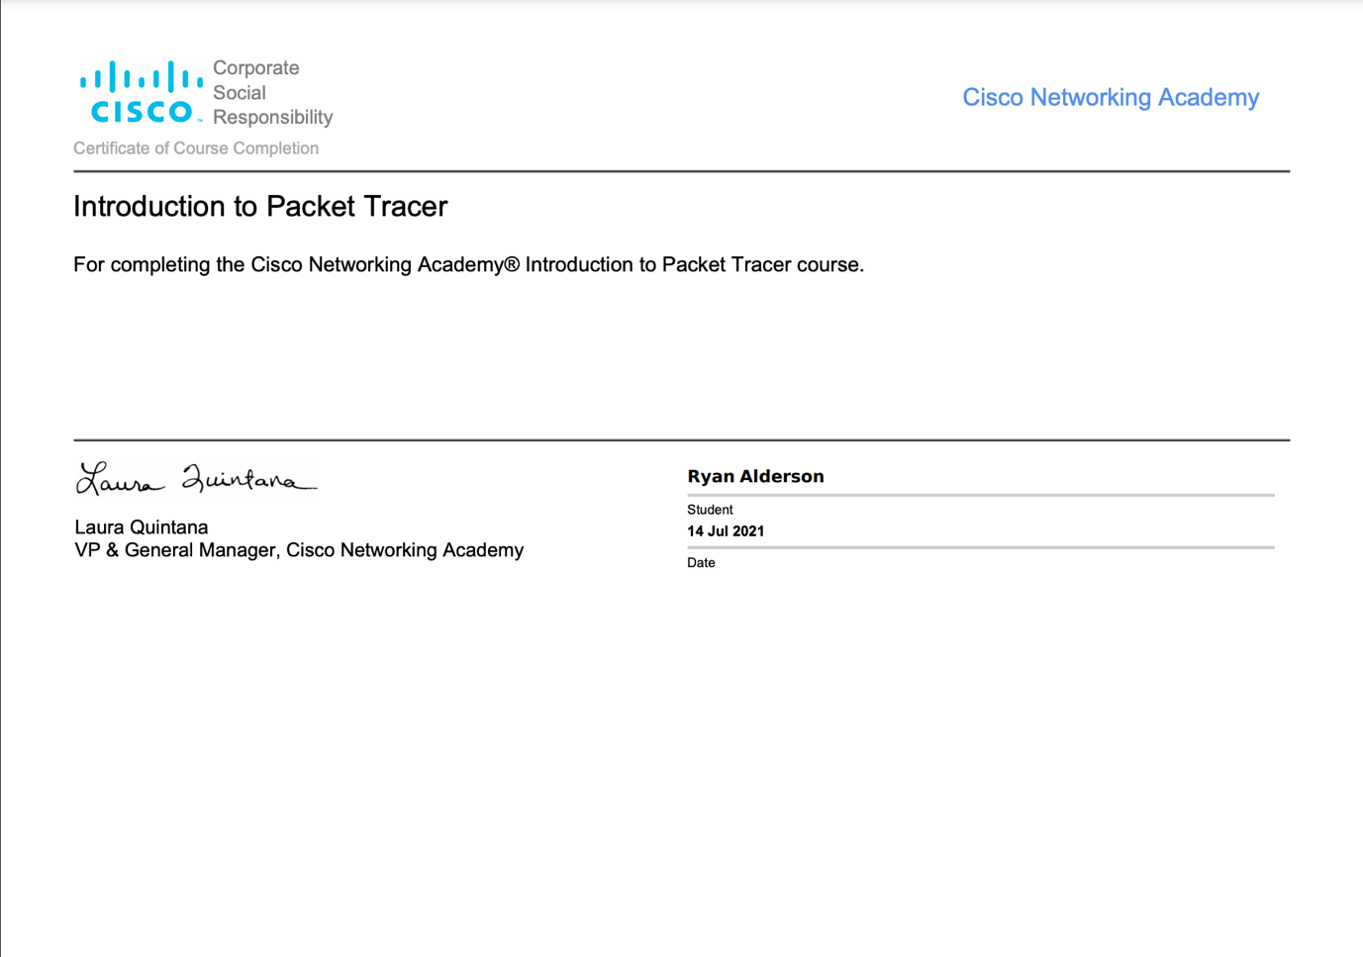

Issues sharing the badge digital link. Cisco Website gives an error so I’ve provided a screenshot of the certificate instead.

Physical and Logical topology based on the scenario screenshot:
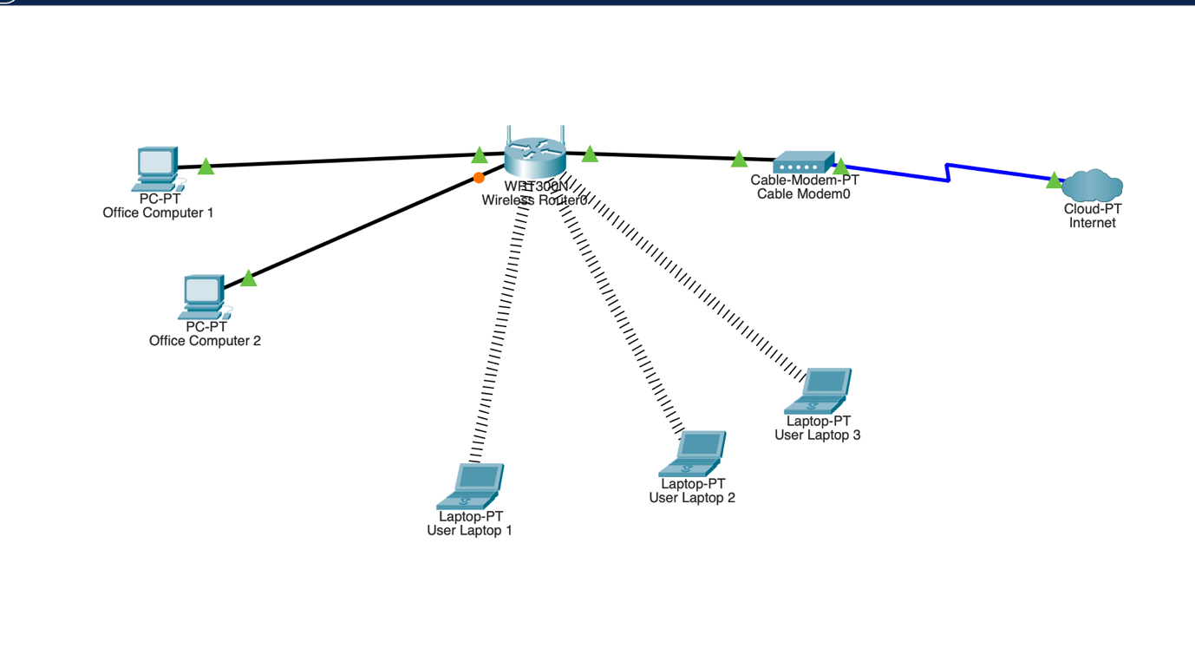
Haven’t included mobile phones here but they would connect to the Network in the same way. I could also improve it by adding a network switch so that more devices could connect to the router.

Security devices that could be added to the network to secure it:
- Firewalls to block malicious connections between this network and other networks [5]
- Antivirus and Anti malware Software to make sure no malicious file get on to the network
- Network access control to make sure that devices connecting to the network are secure before allowing them to access the network [6]
- A VPN to authenticate the communication between the network and the end user devices [7]

Task 4

- Draft a guideline for Olive-Oyl staff members, and customers to responsibly use their digital space.

When using this network, please adhere to the following rules [8]:

Employees:
- Employees should only use the network for work related activities, not for personal use
- Should only have access to parts of the network that their job requires
- Clean desk policy. Documents shouldn’t be left on the desk which could give access to the network to unauthorised users, such as passwords and usernames
- Workstation should always be locked when not in use
- Should not access any unverified/unsecured websites
- Employees who leave the organisation should have their access revoked immediately
- No external devices should be inserted into any machines on the network, such as USB sticks which could contain harmful files or for extracting confidential data from the system
- Employees shouldn’t try to access the network from unapproved, insecure network locations such as a coffee shop, pub or restaurant
- Should not share any usernames or passwords for accessing the network
- Should not download any files or Software on to their computer (from the internet or any other external source) without permission from the Service Desk department

External Users:
- Should not download any malicious files on to the network
- Should not access any unsecured websites
- Should not carry out any illegal activity on the network such as hacking, fraud or piracy
- Must only use the network for personal use such as checking emails, accessing secure websites
- Must only use the network using their Guest User account
- Should not carry out any workload intensive tasks such as Bitcoin mining

Conclusion

I have tried my best to use all of what I learned throughout this module to come up with possible solutions to Olive-Oyl’s problems in this report. I know it’s not perfect as a lot of these concepts are completely new to me but I feel like I have learned a lot during this module and this has given me a good grounding to further my knowledge in Networks and Cybersecurity.

References
[1] Anonymous (). Cyber Attack - What Are Common Cyberthreats?. Available: https://www.cisco.com/c/en_uk/products/security/common-cyberattacks.html [Accessed Jul 19, 2021].
[2] Anonymous (). What is a denial of service attack (DoS) ?. Available: https://www.paloaltonetworks.com/cyberpedia/what-is-a-denial-of-service-attack-dos [Accessed Jul 19, 2021].
[3] Anonymous (). Investigation: WannaCry cyber attack and the NHS - National Audit Office (NAO) Report. Available: https://www.nao.org.uk/report/investigation-wannacry-cyber-attack-and-the-nhs/ [Accessed Jul 19, 2021].
[4] S. Ambore et al, "A resilient cybersecurity framework for Mobile Financial Services (MFS)," Journal of Cyber Security Technology, vol. 1, (3-4), pp. 202-224, 2017. Available: https://doi.org/10.1080/23742917.2017.1386483. DOI: 10.1080/23742917.2017.1386483[AccessedJul 19, 20212021 ].
[5] Anonymous (-06-04T08:11:30+00:00). Network Device Security: Guide + Recommended Software - DNSstuff. Available: https://www.dnsstuff.com/network-device-security [Accessed Jul 20, 2021].
[6] Anonymous "Network Security Devices You Need to Know About," Available: https://blog.netwrix.com/2019/01/22/network-security-devices-you-need-to-know-about/.
[7] Anonymous "14 Network Security Tools and Techniques," 2019. Available: https://blog.gigamon.com/2019/06/13/what-is-network-security-14-tools-and-techniques-to-know/.
[8] G. Hayslip. (-03-16T06:00-05:00). 9 policies and procedures you need to know about if you’re starting a new security program. Available: https://www.csoonline.com/article/3263738/9-policies-and-procedures-you-need-to-know-about-if-youre-starting-a-new-security-program.html [Accessed Jul 20, 2021].

