
Skills for the Workplace
Module Assignment Submission
Student Name: | Jessica Catherine Valdivia Canales
Student Number: | 1917878
Module No: | BMSK4006
Module Title: | Managing Enterprise in the 21st Century Part 1

Statement of Confirmation of Authenticity
By the act of making this submission, the student declares that this is the work of the student named above. The work has not, in whole or in part, been knowingly presented elsewhere for assessment, or where assessment has been built on a previous assessment, this has been identified. Where materials have been used from other sources it has been properly acknowledged. If this statement is untrue, the student acknowledges that an assessment offence has been committed.
Attention is drawn to the plagiarism and unfair practice policies of both the University and of ILM.
Table of Contents
Executive Summary 3
Business Overview 4
Markets and Competition 6
Target Markets 6
Competition 6
Sales and Marketing 7
Product Positioning 7
Marketing 7
Sales 7
Management 8
Key Personnel 8
Advisors and support services 8
Operations 8
Premises and Equipment 8
Employees 8
Suppliers 9
Financial Forecast 9
Sales 9
Cashflow 10
Profitability 10
Conclusion 10
References 11
Appendices 12
Appendix A 12
Appendix B 13
Appendix C 14
Appendix D 16
Appendix E 17
Appendix F 18
Appendix G 21
Appendix H 27

Executive Summary
This assignment outlines a business plan for a south Wales company called Assetivo Ltd. which provides consultancy services in asset management and reliability. Target markets were identified including food and beverage manufacturers, automotive, and oil and gas. Competition to Assetivo was researched and found to be small and medium companies in England selling similar services. For product pricing, Assetivo decided to go for neutral pricing to align itself with its smaller competitors. Marketing and sales consisted of a website, blogs, case studies, LinkedIn activity, and approaching potential clients with leaflets and attending trade shows. Key personnel identified were the director/owner and the financial accountant to drive the business forward. Also, a small number of advisers were identified. Assetivo will have a relatively small requirement for premises and equipment on start up as it is a services consultancy. Two employees were identified as necessary to start the business: a consultant and a financial accountant, and a limited number of suppliers were needed for software and training. The financial forecast for Assetivo was strong with a turnover of £125,600.00 in the first year, positive rolling 12-month cash flows, and a profit of £58,060.00.

Business Overview
In terms of a business plan, Burns P. (1996) described this as the most important step in a new business, helping to the owner to focused ideas, set objectives, and monitor the performance. Also stressed as very important is to attract external investors and any finance needed for the company.
The business plan is a long-term view of the business and its environment and a should emphasise the strengths and recognise the weaknesses of the proposed business.

This business plan will focus on a company called Assetivo which is already in operation. It began as an idea a few years ago when my husband was doing his Master’s degree in Maintenance Engineering & Asset Management at the University of Manchester. Working for a services company at the time, he realised that he could not develop professionally as he would have liked as an employee. The idea became more stronger when thinking about the potential market in Wales and the lack of business competitors in this region. There was higher competition in England and overseas. Also, he thought he had the right technical and basic business knowledge to start his own company, he had my support with the finance and administration knowledge and was good at managing his own time. One objective was that with our own business, we could save enough money be retired at an earlier age. Dr. Wilson (2016), described if you want to ensure similar standard of living, must supplement your State Pension with your own savings, in our case in the 40s the ideal percentage to save is 20% of the salary.

Assetivo was set up as a limited company in November 2019. The AAT course book in Advanced Bookkeeping (2018) describes the key feature of a Limited Company as follows: “the liability of the owners of the company is limited to their investment in the company. As the company is a separate legal entity, should the business fail and be liquidated, the maximum amount that the owners lose is the amount of capital they have agreed to invest in the company”.

Assetivo is a modern consultancy focused on supporting industrial clients to optimise their physical asset life cycle costs. The physical assets may be equipment such as fans, pumps, motors and turbines in factories with the focus on reducing equipment breakdowns and increasing asset reliability. Assetivo has its own model to drive companies to higher performance and lower risks and costs (Figure 1). Also, Assetivo fundamentally believes in the tangible benefits of training. It is a key foundational component of its Asset Management & Reliability Model (figure 2). The company offers training in several areas: Root Cause Analysis, Introduction to Reliability, Introduction to Condition Monitoring, Lubrication Management, and Asset Management. Also, Assetivo is based in south Wales and there is no local competition in this area offering the same professional services.
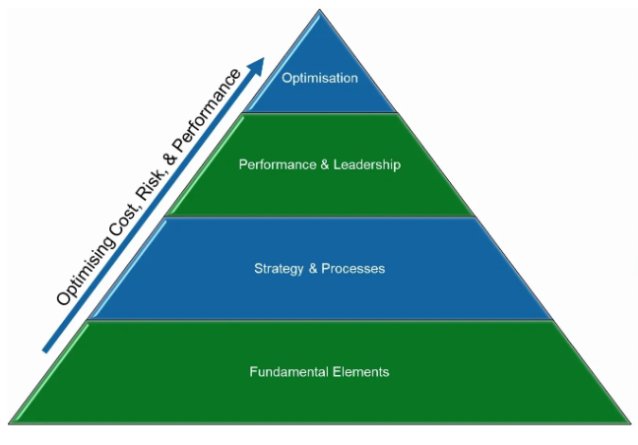
Figure 1 Asset Management and Reliability Maturity Pyramid (source: www.assetivo.com)

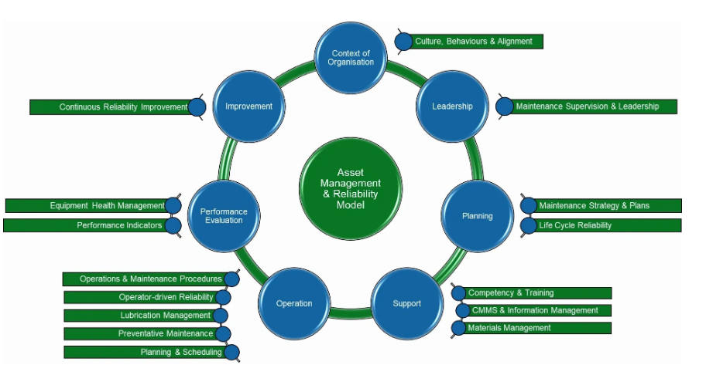
Figure 2 Asset management & reliability model (source: www.assetivo.com)

Markets and Competition

Target Markets
Assetivo’s target market will be a medium to large manufacturers and process industries such as food and beverage, chemicals, automotive, energy, and oil and gas industries covering United Kingdom and Saudi Arabia. See Appendix A for UK manufacturing output by region (£s) and the levels of manufacturing business productivity index 2016 in the United Kingdom. In Wales alone there is a manufacturing output of £10.9bn and so a significant opportunity. Also, the target market for the training services is for all the business, organisations, or industries, in the UK and globally.

The market trends for our business and services are moving towards digitalization, IIoT (Industrial Internet of things) and Industry 4.0. For this reason, we will be considering having a strategic partnership with a software/hardware company who provide cloud-connected sensors and asset health measurement devices and services. The owner previously worked for one company and he knows how they work.

After doing the PEST and SWOT Analysis on Assetivo, we can clearly see and understand the external and internal factors can affect to our business (see appendix B). These include opportunities for growth in specialist areas, threats from decreasing industry in Wales, and technological changes such as Industry 4.0 and IIoT.

Competition
In terms of small consultancies that focus on asset management, asset reliability and maintenance improvement, there are no known companies in Wales that provide this service. This may be due to a smaller manufacturing base. All UK competition to Assetivo is in England and Scotland. Appendix C identified details of advantages and disadvantages of our competitors. There are similar, small businesses to Assetivo in England who are successful and fully loaded with work. Larger companies have a very strong advantage over Assetivo and many existing customers.
The advantages of Assetivo is we are a local business based in Swansea, south Wales and therefore we are the only business of its type in the region, although the company has already formed a strategic partnership with a services provider in Saudi Arabia and another consultancy based in Manchester. Assetivo is agile, flexible, good value for money but has a high standard of quality. The senior consultant is qualified, bilingual and with more than 10 years of experience. Our main disadvantages are that we are new in the market, we do not have a well-known reputation and we need to build our list of customers.

Sales and Marketing

Product Positioning
Assetivo offers very similar services to our smaller competitors. The intention is to differentiate on flexibility and range of services. For example, we will offer condition monitoring services – something that the others do not offer. We can also offer technical writing services. Our consultancy and project prices are going to be in the range of the average of the market. This is known as ‘neutral pricing’ and according to Smith (2011) a company has ‘negated the potential to use prices as a means to capture market share’. He further refers to it as the ‘zone of indifference’ and this is a sign of Assetivo taking a cautious, initial approach to pricing. The market prices range is between £750 and £1,000 pounds per day of services for short to medium terms projects and work packages. Our company will be focusing the prices in the average of £625 to £750 depending on the region, industry and quantity of work is required. It will also depend if Assetivo is selling direct to clients or via an intermediary who will also take a percentage of the profit. An example of Assetivo’s typical pricing strategy is at Appendix C.

Marketing
First, we will do some research about manufacturing companies in our target market, advertising through leaflets and business card sending to those potential customers in the region. Also, we plan to produce regular content, writing website blogs and posts on LinkedIn, emailing, and connecting with collaborators and taking part in trade or exhibition shows. In terms of unique selling points (USPs), Assetivo has developed its own ‘asset management & reliability model’ (Figure 2 above) and benchmarking tools to use on customer sites. Rickman C. (2005) suggested the USP is a differentiating factor, when you researched about your competitors to see if you can uncover products, services or extras the competition does not offer.

Sales
Our active selling will be through researching about the manufacturer’s businesses in the target market, sending to them our advertising leaflet (Appendix D) and business cards and offering a free 2 hours consultation on their site or organization.

Management

Key Personnel
The owner/director is the main person in this business having the professional education, skills and experience in the area and services Assetivo is offering. Also, another employee is the finance accountant who is skilled and finishing her studies in United Kingdom to get the British standards qualification and recognition (Appendix G).
The results for Assetivo regarding the questionnaire “own enterprise and strength and weakness”, represent a total of 24.9 points which means we “are on the verge of being ready, but you (Assetivo) may be wise to spend some time strengthening some of your weakness (Appendix F).

Advisors and support services
Assetivo will have a qualified Finance Accountant as an employee, who will manage all the administration and paperwork in the company. Also doing the bookkeeping, payroll, payments, reports, bank reconciliation, trial balance and final preparation for the company. Assetivo will also use associate consultants and engineers on projects which require added resources. Furthermore, to date, Business Wales has provided a level of free business advice:
- How to tender for jobs.
- Search Engine Optimisation.
- Digital Marketing.

Operations

Premises and Equipment
Our company for start with an office at home, and a remote Finance Accountant. The equipment we need is two laptops, mobile phones, accountancy software, and specialist reliability software. Also, a range of PPE is needed for visits to factories.

Employees
Assetivo will be start with two employees: the owner as the Reliability/Asset Management Consultant and the finance accountant. Both need to be highly skilled in their respective fields as well as having business skills. Curriculum Vitae for both employees are attached at Appendix G. Assetivo will need to inform HM Revenue and Customs (HMRC) that it is registered as an employer (PAYE).

Suppliers
Our principal supplier will be the reliability and accountancy software companies and their training and customer support for the first year. As a services companies, raw materials are not required. Only occasional training and software upgrades. In terms of back up for the software services, we have found an associate engineer who is an expert in the software an can provide services to Assetivo. The business is also trying to find a second option / expert who knows well the product.

Financial Forecast

Sales
Assetivo as a company is expecting to grow its volume of business in Saudi Arabia and south Wales. The expectation is that annual sales revenue will increase to £100K to 140K. The estimates are as follows:
Saudi Arabia: Asset management services – around £100K to £120K.
South Wales: Reliability, maintenance, and condition monitoring services - around £5K to £10K.
Global: Training services – around £5K to £10K.
We are expected in the second year of the business to grow sales and be a VAT (Value Add Tax) registered trader in the UK, to the standard – rated 20% on our services. This could be more attractive to taxable companies because they can claim this 20% VAT on their business. HM Revenue and Customs (HMRC, 2020), described a VAT registered business may reclaim any VAT they have paid on business-related goods or services.
The AAT course book Level 3 Indirect Tax FA (2019) describes the VAT registration (20% standard rate) of a Limited Company or sole trader is compulsory if the taxable person meets one of the following two test:
- Historic test - If the turnover over the previous 12 months exceeds the registration limit of £85,000.
- And future test - if the taxable turnover over the next 30 days is likely to exceed the registration limits of £85,000.
If either test passed, the taxable person must notify HMRC within 30 days of the date of the historic test, and without delay for the future test.

Cashflow
The Assetivo cash flow projection for the next 12 months is presented in Appendix H. The projection shows a turnover of £125,600.00 (Total Sales); a positive rolling 12-month cashflow; and a profit of £58,060.00 (total sales minus all the expenses and owners’ drawings).

Profitability
Assetivo expects to be profitable under normal operations given that it a services company with little need to purchase and transform materials. During this first year of business, and at the end of the first project in Saudi Arabia, we expect to perform two more follow on project. Though this is currently in a proposal stage with our Saudi Arabia partners. Also, there are other proposals for business in the Middle East. And as it Is mentioned before on the Sales, we expect this year to bring some more customers from South Wales, through the advertising of the leaflet attached in appendix D.

Conclusion
This assignment outlined a business plan for Assetivo Ltd. The target markets were identified, and competition is in the form of small and medium consultancies mainly based in England. Assetivo will have challenges due to a lack of exposure to many clients, i.e. not well-known yet. Assetivo decided to use neutral pricing to make it like other smaller competitors. The initial approach to marketing and sales will be web-based content and approaching potential clients with leaflets and attending trade shows. A potential advantage for Assetivo is that it will need very little start up resources and only requires two key, skilled personnel. To conclude, this assignment has been a good exercise in seeing the value in starting a business and the potential problems and opportunities. Finally, it can be seen that when forecasting financial performance over a 12-month period, the future of Assetivo appears to be strong with a likely turnover of £125,600.00, positive rolling 12-month cash flows, and a possible profit of £58,060.00.
hythythhtytyt

References

- AAT Course Book (2018), “Advanced Bookkeeping”: BPP Learning Media Ltd. London.
- AAT Course Book (2019), “Indirect Tax FA”: BPP Learning Media Ltd. London.
- Burns P. (1996) The business plan. In: Burns P., Dewhurst J. (eds) Small Business and Entrepreneurship: Macmillan Small Business Series. Palgrave, London
- Dr. Wilson N. (2016), “The rough guide to retirement”: CEO, Legal & General. Rough Guide. UK.
- HM Revenue and Customs (2020), “Businesses and charging VAT”:[online] Available at: https://www.gov.uk/vat-businesses [Accessed 10 July 2020]
- Rickman C. (2005), “The small business start-up workbook”: How to books Ltd. United Kingdom.
- Smith T. (2011), “Pricing Strategy: Setting Price Levels, Managing Price Discounts and Establishing Price Structures”: Cengage Learning. USA.

Appendices

Appendix A

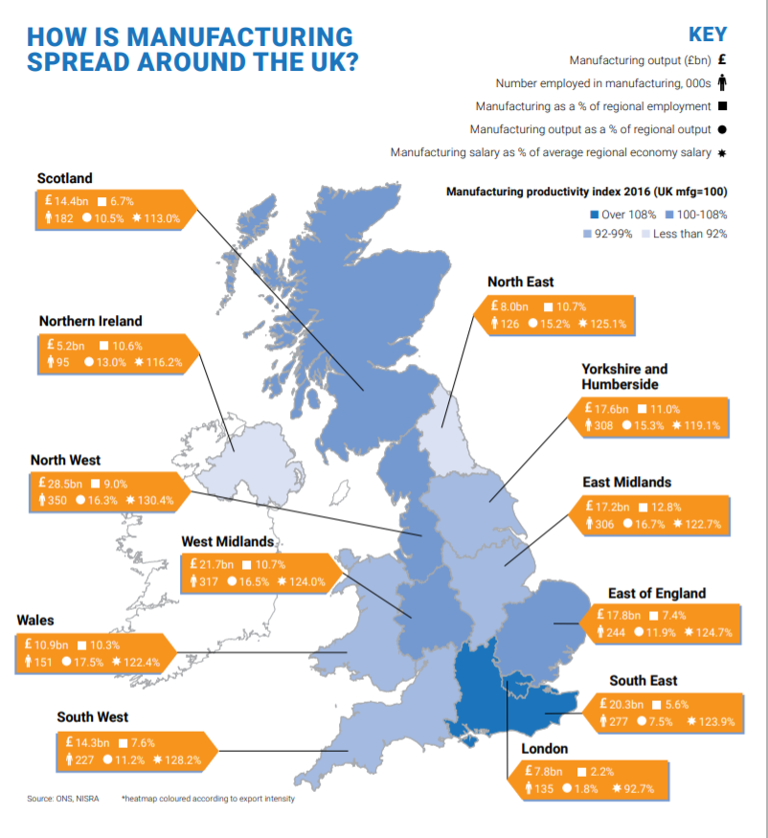

Source: https://www.makeuk.org/insights/publications/uk-manufacturing-the-facts-2019-20

Appendix B
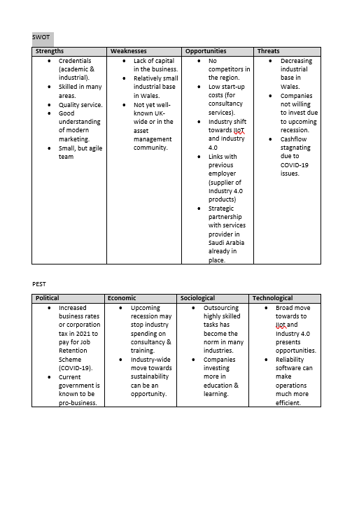

Appendix C
Assetivo’s competitors are:
Competitor | Size | Advantages | Disadvantages
PRS “Pro-reliability Solutions” – England. | Small, 1-2 employees. | - Affordable to all sizes of manufacturers.  - Intends to grow and develop own reliability software.  - Well-known and respected in industry. | - Doesn’t have the capacity to fulfil all work in all geographical areas.
Uptime Consultant – England | Small, 1 employee. | - Affordable to medium to large manufacturers. | - Only focusses on work in England.  - Not intending to grow.
ARMS Reliability – England & Global | Medium, 10 – 15 employees (UK). | - Expanding globally into software also.  - Very well-recognised brand name globally.  - Has strong strategic partnerships with other companies. | - Expensive – main market is large companies and oil & gas.
53 degrees North – England | Medium, 10 -20 employees | - Growing with good investment.  - Modern with modern organisational methods. | - Expensive - main market is large companies.  - Not 100% focussed on asset management & reliability
AVT Reliability – England | Medium-Large, 80+ employees (UK) | - Growing, but focussing more on IIOT technologies – not asset management.  - Has strong financial position from parent company.  - Strong list of existing customers. | - Expensive - main market is large companies.  - Not known as a reliability services company (despite the name).

Competitor’s websites:
(https://pro-reliabilitysolutions.com/)
(https://www.uptimeconsultant.co.uk/)
(https://www.armsreliability.com/)
(https://www.53northgroup.com/)
(https://www.avtreliability.com/)

Appendix D
Assetivo’s typical pricing strategy:

Appendix E
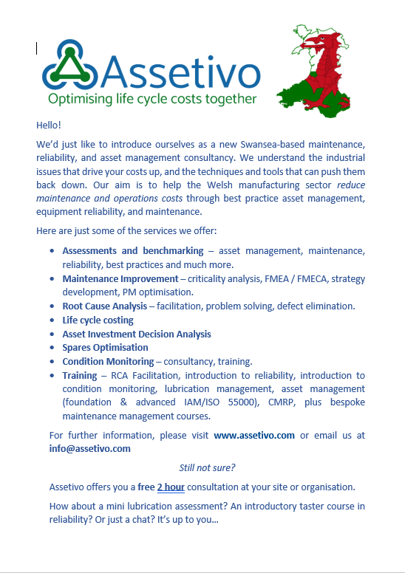

Appendix F
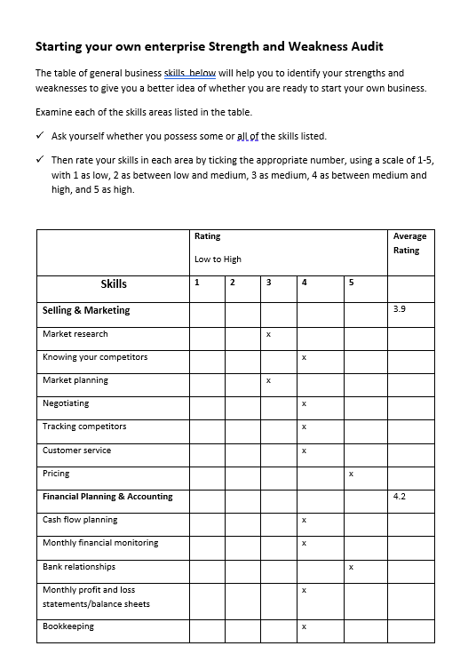
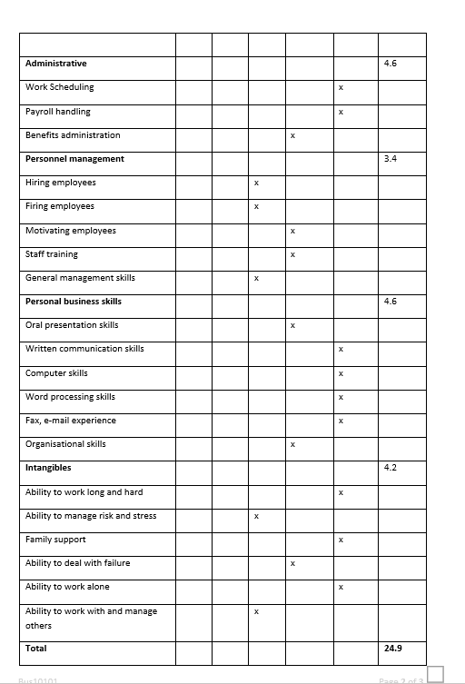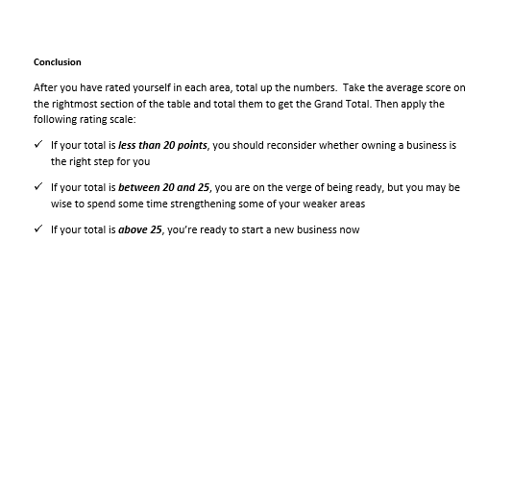

Appendix G
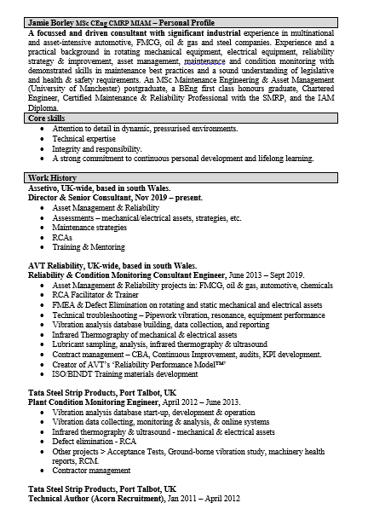
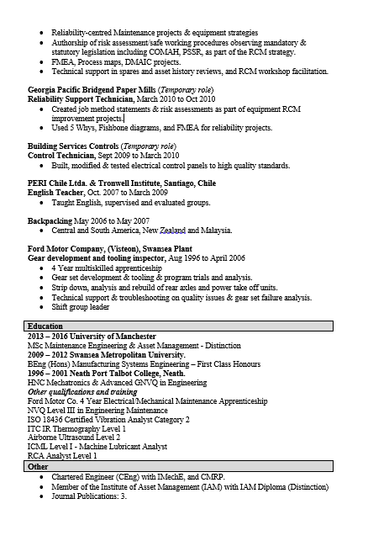
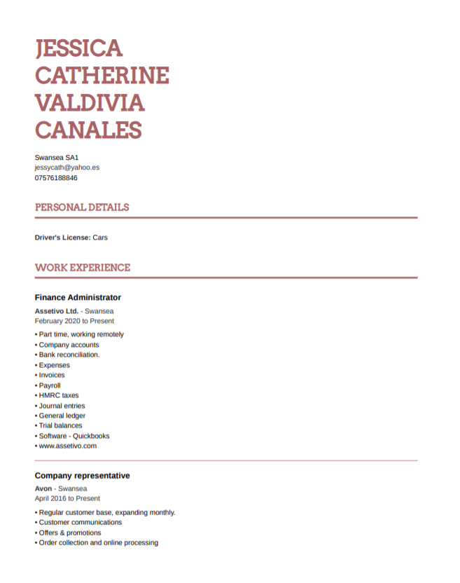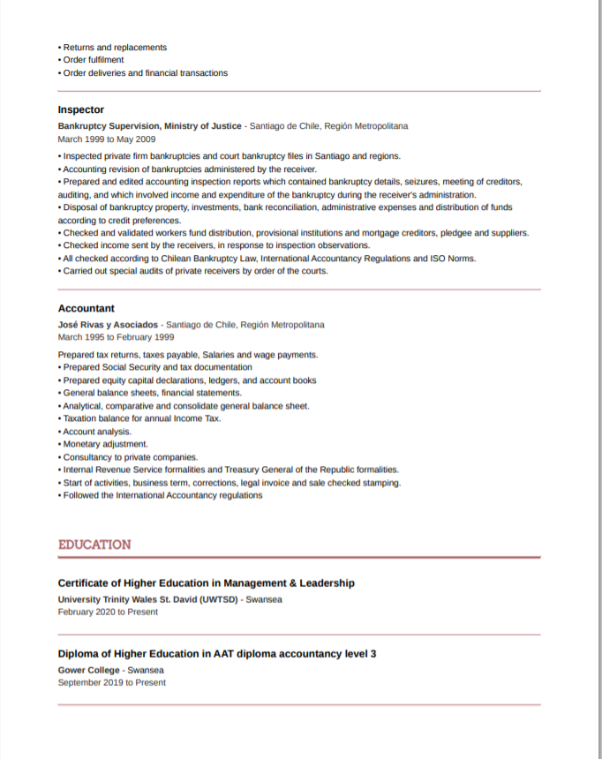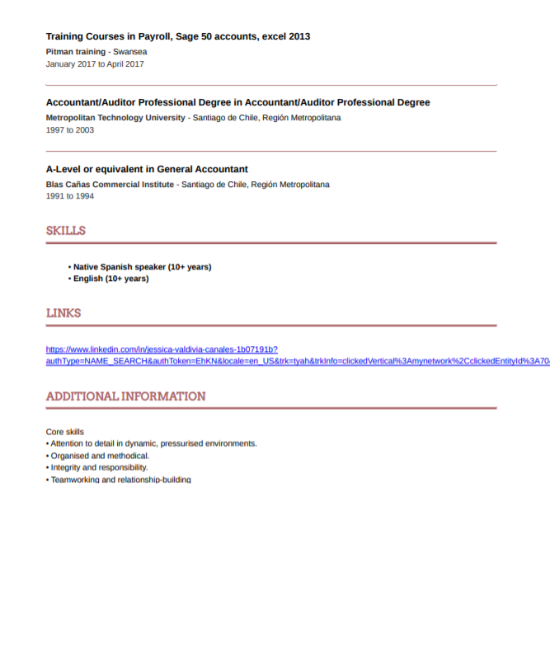

Appendix H



