- Katy evans Report.
- 1806982

Executive Summary.
Introduction.
History of tesco
Customer relationship strategy
Benefits gained from Marketing
Data Collection
Ethics & sustainabilty/Tesco’s policies.
Carroll’s CRS model.
Segmentation & loyalty ladder.
Conclusion.
Recommendations
References.

Executive Summary.
The Chief Executive officer of Marketing week commissioned the report on the 10th February, 2022. The report is to examine and outline the impact on CRM and the Ethical and sustainability policies and practices at Tesco organisation. This report will include valid critical analysation using tools and models that can help Improve Tesco’s CRM, the research used throughout will include, Website, textbooks, and Article sources outlining how Tesco engaged with its customers through segmentation and loyalty ladders.

Introduction.
Tesco occupies a unique place in British retail, visited by millions but controversial to many.. It's the UK's biggest retailer by sales and also the nation's biggest private employer, with more than 330,000 staff working in 3,146 stores.

Tesco and it’s History.
From a Market Stall to one of the Leading Brands Supermarket, and one of the most Successful Organisations, Tesco has come a long way from where it started in 1919-Back then Sales Figures were £4 per day, with the CEO (Jack Cohen) making £1 profit.
By the 1950’s came Rapid Expansion and within 5 years ‘500’ stores opened. (Our history 2017)
By the 1990’s Tesco saw a Decline in Profits due to the Recession, Although Recession hit hard, Tesco became the Britain’s largest retail store. Tesco seemed to be back on the up and by 2007 Profits Exceed £2bn and the UK market share, reaches a high of 31.2% . In 2011, Tesco’s profits hit a record high of £3.8bn, Although the years to follow Tesco hit financial difficulty and by 2013 they announced their first annual profit drop, Market Share had dropped to 28.7% and stores such as Aldi and Lidl gained ground over them. (Kirk,2014)
By 2016 the Company starts to Profit once more but the Growth remains the same.
The Organisation was then faced with its Competitors Aldi and Lidl, who were beating them on price, but had said they won 206,000 more Consumers and Shaking hands with ‘Bookers’ the largest cash and carry and was said to have saved at least £200m with the the increase of the importing of goods, Tesco boasts of being one of the largest and most successful superstores in the U.K their Profit Margin today is 2.6bn. (Thomas, 2018)

Customer relationship marketing strategy.
CRM plays a vitally important role in Tesco. , it is no longer paving the way for Competitive Advantages but more so for the survival of its long term needs and wants not only for the Organisation but for the Employees, and Customers.
CRM models show the importance of CRM to an organisation, it shows how the organisation is able to manage their relationships with their customers. This tool, is used to store and manage Data on each customer, winning over customers trust and overtime nurturing it to gain loyalty. There are a few CRM Models but all have the same outcome, models such as, Segmentation model & the loyalty ladders are frameworks & tools Tesco use to monitor & differentiate each customer.
(Framework shown in appendix CRM frameworks)
Tesco is able to identify the customer, and differentiate them by their value to the organisation, and where their loyalty lies. (Bean, 2020)
Whenever you ask Management about the Importance of CRM and how and why it collects data on each Consumer. They will respond by saying ‘CRM, is a part of Culture and is a Necessity, to maintain the success of the organisation and having an excellent relationship with their customers and stakeholders, this is imperative. (Buttle & Turnbull, 2004)

Benefits gained from marketing strategies.
CRM is not only used to uphold and sustain recognition from customers, It’s also used to gain loyalty and keep the customer interested in the organisation, stakeholders such as suppliers, and employees have to feel satisfied or would be inclined to go elsewhere, Especially in today’s thriving market, Organisations are Accentuating long term Relationships with their Customers, and suppliers because of their competitors such as Sainsbury they also are using a loyalty scheme called the Nectar card, so staying ahead of the game and current trends is key. Aldi and Lidl are more competitive on price but don’t offer club rewards, a lot of customers have switched to these stores especially now as the economy is struggling and more people are out of work due to covid-19.

The four P’S are vitally important for any organisation to be on top of their game:
- PRODUCT.
- PRICING.
- PLACE.
- PROMOTION.
These for P’s are determined by external and internal factors, and with the economy and environmental changes happening at rapid speed it is vital that Tesco stay consistent to keep winning the customer loyalty. (Twin, 2021)
Traditional transactional marketing is great when the economy is booming, although in current climate Example: the Pandemic and Climate Change are influences that are causing people to be more inclined to strive towards a more Ethical and Sustainable approach to shopping. (Twin, 2021)
Tesco’s development over the years has relied heavily on its CRM it’s played an important role in the effectiveness of its sales & profits, like any other organisation CRM is a tool with great effectiveness, This comes with organisational commitment from, Hierarchy & employees.. According to a book called “The intention Economy” economy grows around the BUYER not the SELLER, buyers of course are the first source of money, the intention is to attract buyers & to keep them interested in your products, but also how the organisation is run through Ethics & sustainability, does this way of shopping fit in with their values & beliefs. (Searls, 2012)

Data Collection.
Tesco is well known for its club-card and points system, This loyalty scheme is a powerful tool of CRM. Research, statistical data, and analysis is also influential. By collecting data through club-card, cookies, online shopping or via email this identifies shoppers habits, Tesco can offer more benefits to customers, like offering savings, rewards, and recommending products that are best suited, it gives a more personal experience for shoppers. Tesco state that they share personal data with trusted partners. Eg: this could be for delivery purposes, Tesco promise data is kept safe by using computer safeguards, data encryption and monitoring accounts to keep fraudsters away. (Your data journey)
Tesco has been noted as one of the best Practitioners in CRM, recognising customer’s needs and wants, all this comes from understanding customers by the collection of data. This can happen from a combination of the company’s culture, and insight of the customer, this focuses on Employee as well as Management. They uses a continual process of CRM, always refining and creating new ideas, this involves the Training of staff so they are kept up to date with current climates. Armstrong, et al (2009) agreed that like Sainsbury’s who are a main competitor toTesco, the loyalty scheme has been a motivation in sustaining customer loyalty. Customers have said that nearness and cost effective is key, and availability of products is also an important aspect. Customers have always been priority and keeping up with trends such as, “The Electronic means of Communication” is now the most modern form of CRM for the organisation. Other than Profitability, Tesco rely heavily on their customers, to stay a dominating organisation. Tesco remain attentive with customer demands, Although loyalty cannot be viewed as blindness, it is important that Tesco analyse other forms of CRM.. for example: Technological innovations, Which Tesco do very well. Online shopping has become very popular especially more recently. This is due to external factors such, such as the pandemic. (Hassan & Parvez, 2013)
According to ‘Scoring Points’ a book written about how “Tesco is winning Customer Loyalty” arguably the club-card is the most successful form of developing relationships with customers, furthermore adaptations in technology and Tesco bank has over 3 million customers. It was the because of the club card scheme that Tesco gained intel on customers. Tesco say that they may well have become successful without the club card, but not as quickly. Customers relationships with Tesco is the main focus and, the reason behind the success. Because customers have remained loyal. (Humby et al., 2004) There has been some Critique about the club card in recent past, when Tesco revamped its club-card customers reported to have felt cheated, Tesco were offering customers a chance to exchange their points for days out, holidays and eating at some restaurants. All this seemed fantastic, but ‘Anika Newjoto’ editor at shopper points UK stated that “customers were not getting time to use their points and Tesco hadn’t been open and honest about the time frame in which the vouchers had to be used” Tesco hit back by saying “like any business the club-card isn’t free from mishap and this was a valid reason to learn, refine, and move forward”. (Smithers, 2018)

Ethics and sustainability.
Tesco’s policies.

- Group anti bribery policy- Bribery cause conflict and corruption and cause distrust.
- Group conflicts- a conflict of interest is when your personal interests are brought into the workplace and have negative influences over the decisions made at work, this could harm business.
- Information and data systems according to Tesco is their most valuable assets. Data is handled carefully using Security Systems.
- Human Rights. Tesco claim they work top a high standard in creating Job Opportunities, ensuring working hours and wages are fair, Health and Safety is always adhered to, Freedom of association and no discrimination takes place, Tesco state that they uphold human rights and are in full support of the united declaration of human rights and against child labour.
- Food sourcing from UK farming.
(Ethics and Compliance policies 2022)

By law every organisation has a duty of care to its consumers from handling and, ensuring goods are supplied at a high standard, consumer safety is vital.
Policies are classed as normative Ethics, this is what Tesco evaluates as what is right and wrong, these policies help people understand what is morally right or morally wrong, they tell people what to do and what not to do, although these must be followed at all times as strict policies of Tesco, it doesn’t necessarily mean that individuals believe this to be true, descriptive Ethics is peoples views on how to act or behave, and this describes how people act, although when working in any organisation policies must be adhered, and if your values and beliefs aren’t aligning then it could create hostility. Customers have to believe that Tesco do what’s right in regards to ethically & sustainably sourcing their products, although this hasn’t always been the case. (Difference Between Normative Ethics and Descriptive Ethics - Pediaa.Com, 2022)
Tesco pride themselves in fair trade. Responsible sourcing director, Giles Bolton says, respect and advancing human rights is a vital role within the organisation, although Tesco work hard there are sometimes obstacles and breaches of their standards have taken place. In particular health and safety. Recognising this has been an issue they have teamed up with the global federation of trade unions, working on issues that aim to always help workers in every area, not just employees in stores. (Tesco, 2022)
Carroll’s social responsibility model.
According to “Carroll” CRS involves the codes & conduct of an organisation so it becomes economically influential & profitable, Tesco has adapted these responsibilities well, they listen to the people and understand that their influence impacts the environment, and society. Tesco hasn’t always been perfect but does uphold their promises, because they have such a large customer base they have been able to offer 16,000 jobs, in past years, Tesco rank higher than other supermarkets such as Sainsbury’s in being sustainable, Sainsbury by 2020 say that they are 42% more sustainable than they were, but are striving towards becoming more greener, Tesco have reached 99% of their goals. Although Waitrose and Co-Operative rank the highest, Tesco still has work to do. (Jones, 2021)

Carroll’s model (Pyramid) shows the stages of corporate responsibility that Society, consumers & culture expects from an organisation, is it Ethical, is it sustainable or striving to be sustainable, especially now with Climate change being a huge part of civilisation. She argues organisations have economic responsibilities not just by rewarding customers, but offering fair pay to employees. Tesco admit that their stores have faced another blow recently, where female workers took the company to court for unfair pay, they argued that men were being paid more and equal rights were not being adhered to. (Munbodh, 2021)

The organisation has to work in a manner to abides by laws, and have ethical responsibilities, If an organisation such a Tesco applies ethical and sustainability goals and keeps striving towards economic growth, they could well become the leading supermarket above Waitrose and Marks & Spencer by being more sustainable and beating them on price and customer loyalty. (Teaching guide: Carroll's corporate social responsibility pyramid, n.d.)
(Carroll’s model shown in appendix, ethics & sustainability)

Amongst many ethical issues for Tesco are, Climate change, Environmentalist changes, pollutions and toxins, and factory farming. Although now Tesco are aiming towards a more greener future after facing issues in the past. (How ethical is Tesco plc? | Ethical Consumer, 2022)
In 2008 Tesco were renowned for selling good quality products at good prices and became one of the leading retail stores, However the low cost on goods came under Accusation that these prices were unethical due to sourcing foods outside of the UK which in some aspects were illegal. (Dresser, 2022)

Since then, Tesco have joined WWF, a four year partnership aimed to change the world in the loss of of Wildlife this is known as the global food system. According to WWF, although they are a very different organisation to Tesco, they share the same goal, to make affordable, healthy and sustainable food available for everyone. Unfortunately wildlife populations are declining by 60%, carbon emissions deforestation and overfishing play a heavy role in this crisis. Food production gives off more green gases than all the cars, trucks and planes in the world. Tesco have actioned a “little helps plan” and this aims to commit to its customers that deforestation will be eliminated, although this was promised by 2020 and is an ongoing process, by 2025 they have stated that their packaging will be fully recyclable or compostable. This plan is to encourage customers to eat more sustainable by restoring nature, in food production and fully recycling. They believe that it’s possible for British farms to produce enough food & help sustain jobs and offer jobs to those who want it, WWF have vowed to help Tesco in the transition in productivity of British sourced foods only, eliminating deforestation from sourcing foods outside the uk, also providing support in sourcing 100% certified seafood products. (Three ways we’re fighting for your world with Tesco, 2022)
Although these promises have been made & mostly adhered to unfortunately for Tesco, they faced huge fines in September 2020, Three of its stores in England were fined a total of £7.5 million for selling food past its sell by date, the retailer pleaded guilty to a staggering 22 offences, the retailer sold 67 items which were out of date between 2015-2017 in three different outlets. Environmental health officers were called by unhappy customers and upon visit they found six items out of date on display way beyond their display dates, furthermore separate complaints were made in 2017 where 25 items were deemed unfit for sale, this type of backlash unfortunately doesn’t align with the promises Tesco have made in sustaining good healthy food, this could lead to a loss of custom. (Tesco fined £7.5 million for out-of-date food sales, 2022)

Segmentation and loyalty ladder.

Tesco has an award winning segmentation analysis, they have been on a mission to understand what their customers really want. They works towards understanding their pain points & strive towards improving their knowledge of each customers Persona, and behaviours and measure these by understanding in store & online shoppers. One of their sole purpose was to gain knowledge in understanding where the shopping trips declined across all of their stores, first they started out by analysing feedback from each store, they aimed to explore customers experience at an Inferior level, This would help them to identify what steps needed to be taken to improve the customers shopping experience on all levels. Identifying what times of the day were more popular than others, and focusing on areas of the store that were popular than others. The conclusion of this analysis was to have a clear plan that could be communicated across the regions.
Tesco stated that “Having a large customer viewpoint, was key to accomplishing this type of arrangement, having this type of operation will allow the customer to have a voice and input within the activity, this in turn allows us to self serve the customers trends based on their sentiments. (Fern Roberts, Customer insights Manager)
With this level of feedback it enables store managers to create new processes to improve consumer satisfaction, this increases customer loyalty as they believe the customer has an easy shopping journey, this is vital for the success of the organisation and with the help from, In-moment an analysis looking into data, Amongst the feedback In-moment found that five areas that define customer experience is, cleanliness, items being readily available, waiting times, customer service, and most importantly Pricing. Tesco continues to work with in-moment to keep their feedback programme fresh & up to date, this is done by a continuous approach to reviewing surveys and analysing data, this will be used to as information in maintaining a healthy relationship with its customers in a more effective manner which in turn will create more LOYAL customers. (2022)

External Factors.
There are Environmental Factors that influence marketing decisions at Tesco such as Covid & inflation, environmental influences that impact marketing decisions are identified through the process of environmental scanning these include Political, economic, social, technological & legal factors (PESTLE) these factors affect all stakeholders and the degree of competition within the industry. Not all products and services at Tesco will be attractive to all people, because of the needs & wants amongst people, therefore Tesco engages in Segmentation to analyse their target market. It divides a population into groups according to their needs and wants. Tesco concentrated on what their target consumer wants and develops products and services that are suitable for this certain group. They place them in segments from age, buying habits, distance from stores, needs and goals.
would provide data enabling Tesco to become more personal with shoppers, and identify consistent shoppers to those who just flutter by, Those with a higher income would prefer to maybe shop at places like Waitrose, as they prefer prioritise quality over price, although chains like Aldi and Lidl aim to attract customers who want to effectively save on shopping, which means they would compromise quality with cost. Shoppers habits may change depending on current situations. For example in todays current global and financial crisis, this has had a big impact on buying habits, this change has put pressure on Tesco to re-analyse their marketing strategy and becoming more cost effective above all else. Keeping up with current trends is a must in these difficult times. (Dudovskiy, 2016)

In the UK Tesco compared to other supermarkets are leading the way in regards to customer marketing, this is all to do with-loyalty programmes, and a consistent adaptation to adding value at every customer touch point, essentially customers become loyal by being made to feel special, relating with their audience enhances trust & gains loyalty & more profit. The loyalty ladder(see appendix 4.0 loyalty ladder image) begins at the point where the customer hasn’t yet bought the product, then once that individual has purchased the product they become what’s known as a “Trialist” if the customer is happy they then buy that product again and then they are known as a “repurchaser” therefore leading to a consistent buying habit from that individual known as “brand insistent” that customer starts from being a prospect and then moves up the ladder becoming a client and then reaches the top becoming an advocate. The idea is to make the customer become a partner in marketing, this is a tool used by Tesco & they do it well by collecting Data and using current customers to become advocates. (Friesner, 2021)

Throughout the pandemic, Tesco say that gaining customer loyalty and support was vitally important, not only to survive but for customers to feel that they were being looked after, building trust was essential but Tesco admit it was difficult. They had no choice but to go through significant changes not only on pricing but adapting to a new way of life. Data analytics worked as a big differentiator to understand more on the customer through this difficult time. Because of inflation prices soared and customers were inclined to go elsewhere so Tesco had to look at other marketing strategies to keep the custom. The price on food is set to soar by 5% the pressure this will put on low income families is a problem, although Tesco chairman said “that basic foods prices would remain the same, and only certain products would go up in price, and that their prices are still competitive with Aldi” (Hotten, 2022)

The team were trained up to understand the stated & latent behavioural changes in customers, and during the pandemic the chain became stronger and adapted well gaining financial benefits and trust from their audience. Tesco believe that Data and insights are the only way in leading the market in this current climate. They noticed there was a significant increase to online activity and customers wanting fresher and healthier food, delivery to vulnerable people was vital, Tesco admits it needs to solve problems with its delivery service, since online sales have soared throughout the pandemic. They are currently in the process of trialing a new partnership with Deliveroo, online is a hot market at the moment, although Tesco are unaware of the economic proposition, but are sure it will gain extra loyalty points. (How analytics helped Tesco improve its customer satisfaction amid Covid: An Economic Times Coverage - Tesco, 2022)

conclusion.
In reference to the above discussion, CRM plays a vital Role in Tesco, not only does it gain beneficial data to improve customer loyalty, by identifying customers on a more personal level it also helps to identify their buying habits. This effectively helps Tesco to place customers into segments in regards to loyalty, and the loyalty ladder. This is important as it helps in making the customer feel special, being approached on a more personal level is sure to gain loyalty. The organisation has proven it is able to adapt to current climates such as global warming, the pandemic, and inflation, particularly focusing their efforts around “Deforestation” these are extremely important to the organisation and society. Customers are more attracted to sustainability and ethically sourced products, Tesco seem to working hard in striving towards these goals. This also gains trust and relationships with customers and stakeholders.Tesco overall are doing well with CRM, although there has been some hiccups along the way, strategies like, teaming up with WWF is a great incentive in gaining more customers, and will further increase trust within the organisation amongst all stakeholders. The loyalty scheme is well thought out and attracts new customers daily as well as withholding existing customers through benefits and rewards. Tesco are continuing to improve as an organisation in all aspects in regards to CRM.

Recommendations.
- Focusing on areas such as food-sell by dates must be adhered to according to food standards.
- Sourcing foods from British Farms and encouraging more jobs.
- Cutting out plastic packaging and striving towards a more sustainable product and focusing on Renewable energy.
- Delivery services are vital for vulnerable people, especially in times of Crisis, teaming up with Deliveroo is looking promising. More delivery slots needed.
- Improving technology with current trends is Vital, although Tesco already does this very well.
- Continuation of the promotion of Healthy Eating. Offering these products at affordable prices will be sure to gain new custom. Remain consistent on price even because of inflation.
- Continue to remain at a competitive advantage, by offering ethically sourced products at affordable prices, being consistent with branding and pricing. Customers do not like products they enjoy buying increasing in price.
- Continuing to meet the needs of customers, regularly asking questions and taking the feedback as vital.
- Delivering real help through customer service effectively and professionally, using social media platforms is a great way for all employees to be at hand for any issues that arise.
- Always above all else have positive outcomes.

Loyalty ladder.
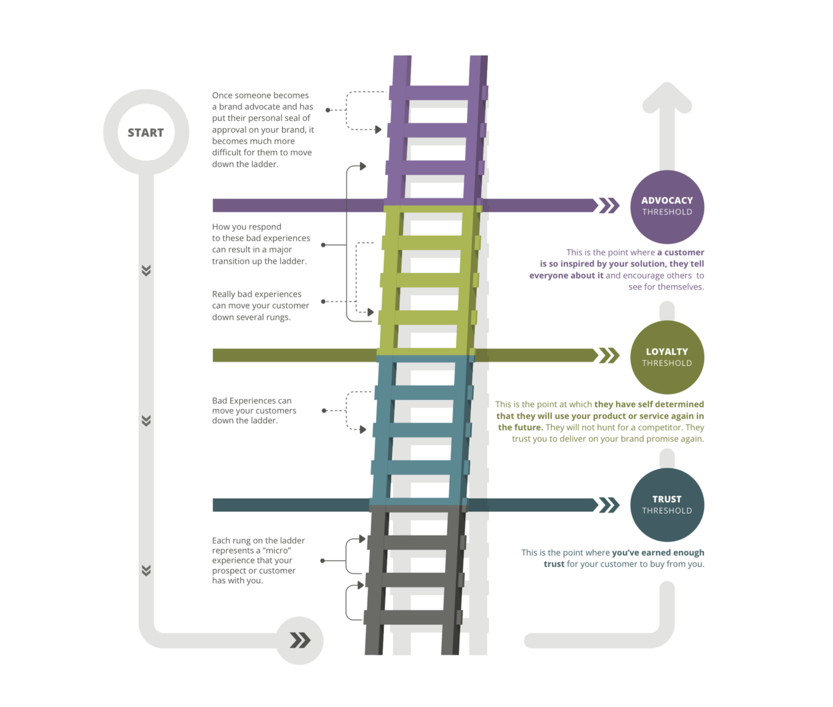

Segmentation model.

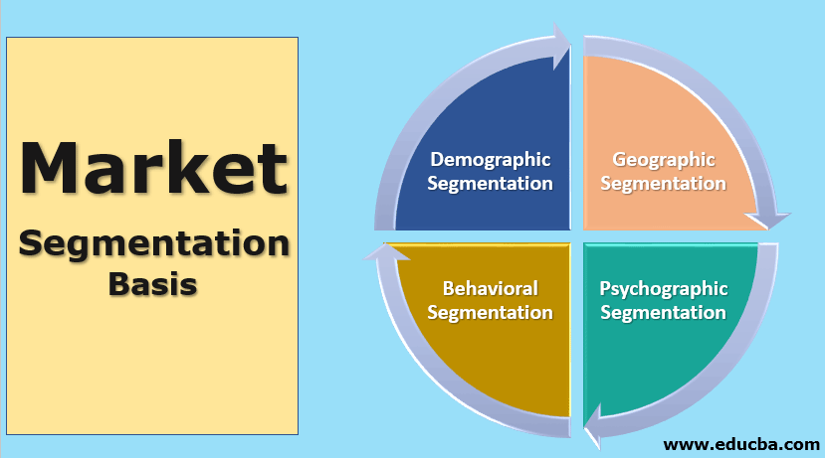

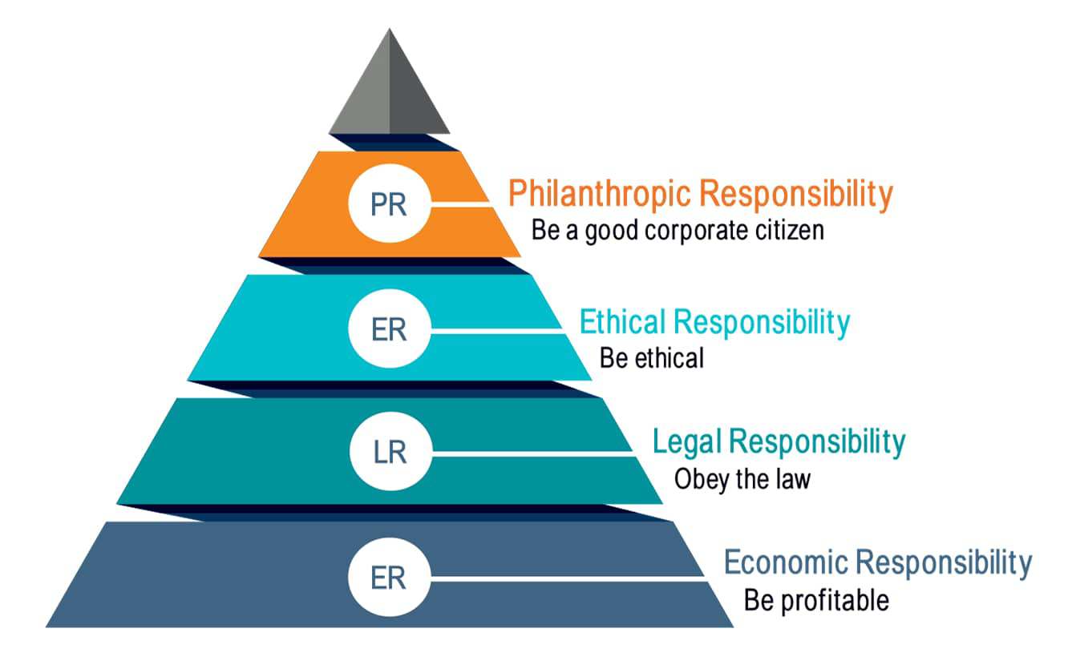
Carroll’s CSR Model.

- 8.0 References.
- 2022. [online] Available at: <https://www.tescoplc.com/sustainability/documents/policies/sourcing-timber-responsibly/> [Accessed 21 February 2022].

- 2022. [online] Available at: <https://www.tescoplc.com/blog/protecting-workers-rights-in-global-food-supply-chains/> [Accessed 21 February 2022].

- Inmoment.com. 2022. [online] Available at: <https://inmoment.com/wp-content/uploads/2021/09/CS-01592-GB-01-Tesco-CX-Elite-Award-Focus-Story.pdf> [Accessed 21 February 2022].

- Pediaa.Com. 2022. Difference Between Normative Ethics and Descriptive Ethics - Pediaa.Com. [online] Available at: <https://pediaa.com/difference-between-normative-ethics-and-descriptive-ethics/amp/> [Accessed 21 February 2022].

- Dudovskiy, J., 2016. Tesco Segmentation, Targeting and Positioning - Research-Methodology. [online] Research-Methodology. Available at: <https://research-methodology.net/tesco-segmentation-targeting-and-positioning-2/> [Accessed 21 February 2022].

- Friesner, V., 2021. Loyalty Ladder - Marketing Teacher. [online] Marketing Teacher. Available at: <https://www.marketingteacher.com/the-loyalty-ladder/> [Accessed 21 February 2022].

Hotten, R., 2022. Worst to come for food price rises - Tesco - BBC News. [online] BBC News. Available at: <https://www.bbc.co.uk/news/business-60279019.amp> [Accessed 22 February 2022].

- Tesco. 2022. How analytics helped Tesco improve its customer satisfaction amid Covid: An Economic Times Coverage - Tesco. [online] Available at: <https://www.tescobengaluru.com/news/how-analytics-helped-tesco-improve-its-customer-satisfaction-amid-covid-an-economic-times-coverage/> [Accessed 21 February 2022].

- Jones, H., 2021. Climate change: How Sainsbury’s and Tesco compare. [online] Metro.co.uk. Available at: <https://metro.co.uk/2021/10/25/climate-change-how-sainsburys-and-tesco-compare-15474988/amp/> [Accessed 22 February 2022].

- Food Safety News. 2022. Tesco fined £7.5 million for out-of-date food sales. [online] Available at: <https://www.foodsafetynews.com/2021/04/tesco-fined-7-5-million-for-out-of-date-food-sales/> [Accessed 21 February 2022].

- WWF. 2022. Three ways we’re fighting for your world with Tesco. [online] Available at: <https://www.wwf.org.uk/updates/three-ways-were-fighting-your-world-tesco> [Accessed 21 February 2022].

- Bean, J., 2020. What is a CRM Model? - Business 2 Community. [online] Business2community.com. Available at: <https://www.business2community.com/sales-management/what-is-a-crm-model-02235682?amp=1> [Accessed 3 February 2022].

- n.d. [online] Available at: <https://www.tescoplc.com/sustainability/documents/policies/sourcing-timber-responsibly/> [Accessed 26 January 2022].

- Dresser, G., 2022. Tesco branded 'unfair and unethical'. [online] This is Money. Available at: <https://www.thisismoney.co.uk/money/news/article-1509764/Tesco-branded-unfair-and-unethical.html> [Accessed 26 January 2022].

- Ethical Consumer. 2022. How ethical is Tesco plc? | Ethical Consumer. [online] Available at: <https://www.ethicalconsumer.org/company-profile/tesco-plc> [Accessed 26 January 2022].

- Anon, 2022. Ethics and compliance policies. Tesco PLC. Available at: https://www.tescoplc.com/about/how-we-do-business/ethics-and-compliance-policies/ [Accessed January 26, 2022].

- Anon, Our history. Tesco PLC. Available at: https://www.tescoplc.com/about/our-history/ [Accessed January 21, 2022].

- Anon, Your data journey. Tesco. Available at: https://www.tesco.com/help/privacy-and-cookies/privacy-centre/tesco-and-your-data/your-data-journey/ [Accessed January 25, 2022].

- Buttle, F. &amp; Turnbull, J., 2004.
- Hassan, A. &amp; Parvez, M., 2013. A comparative case study investigating the adoption of Customer Relationship Management (CRM) the case of Tesco and Sainsbury's. International Journal of Managing Value and Supply Chains, 4(1), pp.1–10.

- Humby, C., Hunt, T. &amp; Phillips, T., 2004. Scoring points: How tesco is Winning Customer Loyalty, Sterling, VA: Kogan Page..Smithers, R., 2018. Tesco revamps Clubcard Rewards scheme. The Guardian. Available at: https://www.theguardian.com/business/2018/jan/15/tescos-revamps-clubcard-rewards-scheme [Accessed January 25, 2022].

- Thomas, D., 2018. Tesco profits rebound as turnaround continues. BBC News. Available at: https://www.bbc.co.uk/news/business-43722494 [Accessed January 24, 2022].

- Twin, A., 2021. The 4 PS of Marketing. Investopedia. Available at: https://www.investopedia.com/terms/f/four-ps.asp [Accessed January 26, 2022].

- Kirk, A., 2014. Tesco share price timeline: One chart showing the dramatic decline of the supermarket giant. [online] CityAM. Available at: <https://www.cityam.com/tesco-share-price-timeline-one-chart-showing-fall-supermarket-chain/?amp=1> [Accessed 21 January 2022].

- Searls, D., 2012. The intention economy. Boston, Mass.: Harvard Business Press, p.6.

- Ethical Consumer. 2022. How ethical is Tesco plc? | Ethical Consumer. [online] Available at: <https://www.ethicalconsumer.org/company-profile/tesco-plc> [Accessed 26 January 2022].

- Aqa.org.uk. n.d. Teaching guide: Carroll's corporate social responsibility pyramid. [online] Available at: <https://www.aqa.org.uk/resources/business/as-and-a-level/business-7131-7132/teach/teaching-guide-carrolls-corporate-social-responsibility-pyramid> [Accessed 27 January 2022].

